Supplementary material
High-resolution dual-polarity molecular imaging platform unraveling spatial metabolic heterogeneity in multiple plant tissues

Table of Content
Figure/Table | Title
Figure S1 | TEM image of pristine MoS2, GO and Au@MoS₂/GO nanocomposites.
Figure S2 | HRTEM images of pristine MoS₂, GO and Au@MoS₂/GO nanocomposites.
Figure S3 | HAADF-STEM and corresponding elemental mapping images of different Au@MoS₂/GO nanocomposites.
Figure S4 | Mass spectrometry of various metabolites by using Au@MoS₂/GO, MoS₂, GO nanosubstrates and DAN, CHCA matrices in positive and negative mode.
Figure S5 | Background of different matrices and nanosubstrates in the positive and negative modes.
Figure S6 | UV-visible spectrometry of Au@MoS₂/GO, MoS₂, and GO.
Figure S7 | Total ion intensity of HN and BP at different laser energies under positive and negative modes.
Figure S8 | Optical images of the Au@MoS₂/GO flexible film morphology, cutting and storage.
Figure S9 | SEM element mapping and typical energy dispersive X-ray spectroscopy (EDX) spectra for Au@MoS₂/GO film surface.
Figure S10 | SEM element mapping and typical energy dispersive X-ray spectroscopy (EDX) spectra for the cross sections of Au@MoS₂/GO film.
Figure S11 | Aqueous contact angle measurements of GO, MoS₂, and Au@MoS₂/GO films.
Figure S12 | MS images of representative metabolite standards using the AMG-LDI-MSI platform in positive and negative ion modes.
Figure S13 | Systematic stability tests of the AMG-LDI-MSI platform.
Figure S14 | SOFG staining and morphological images of rhizome, main root, and branch root tissues in the Panax ginseng.
Figure S15 | Spatial distribution of major metabolites in the tricarboxylic acid (TCA) metabolic pathway in P. ginseng roots.
Figure S16 | Single-color MS images and overlay image of region-specific metabolite ions in P. ginseng main root imprint.
Figure S17 | Representation of ions with region-specific distribution visualized in Panax quinquefolium main root tissue using the AMG-LDI-MSI platform in positive ion mode.
Figure S18 | Optical images of frozen slices of C. pinnatifida fruit of different thicknesses.
Figure S19 | Spatial distribution of major metabolites in the biosynthesis pathway of phenolic acids in C. pinnatifida fruit.
Figure S20 | Spatial distribution of major metabolites in the metabolism pathway of glycine, serine and threonine in S. baicalensis root nodule.
Figure S21 | SOFG staining and morphological images of S. baicalensis root nodule.
Figure S22 | The MS/MS spectrum of ginsenoside Rb2.
Figure S23 | The MS/MS spectrum of ginsenoside Rb1.
Figure S24 | The MS/MS spectrum of ginsenoside Rg1.
Figure S25 | The MS/MS spectrum of sinapic acid.
Figure S26 | The MS/MS spectrum of malic acid.
Figure S27 | The MS/MS spectrum of citric acid.
Figure S28 | The MS/MS spectrum of caffeic acid.
Figure S29 | The MS/MS spectrum of fumaric acid.
Figure S30 | The MS/MS spectrum of dihydroartemisinic acid.
Figure S31 | The MS/MS spectrum of succinic acid.
Figure S32 | The MS/MS spectrum of ferulic acid.
Figure S33 | The MS/MS spectrum of feruloylquinic acid.
Figure S34 | The MS/MS spectrum of caffeoylquinic acid.
Figure S35 | The MS/MS spectrum of hydroxycinnamic acid.
Figure S36 | The MS/MS spectrum of phenyllactic acid.
Figure S37 | The MS/MS spectrum of wogonin.
Figure S38 | The MS/MS spectrum of farrerol.
Figure S39 | The MS/MS spectrum of luteolin.
Figure S40 | The MS/MS spectrum of baicalein.
Figure S41 | The MS/MS spectrum of coumarin.
Figure S42 | The MS/MS spectrum of sucrose.
Figure S43 | The MS/MS spectrum of glucose.
Figure S44 | The MS/MS spectrum of artemisinin.
Figure S45 | The MS/MS spectrum of glutamine.
Figure S46 | The MS/MS spectrum of tryptophan.
Figure S47 | The MS/MS spectrum of histidine.
Figure S48 | The MS/MS spectrum of glucuronic acid.
Table S1 | List of tentatively identified metabolites in P. ginseng roots by AMG-LDI-MSI platform
Table S2 | List of tentatively identified metabolites in C. pinnatifida fruit by AMG-LDI-MSI platform
Table S3 | List of tentatively identified metabolites in A. annua leaf by AMG-LDI-MSI platform
Table S4 | List of tentatively identified metabolites in S. baicalensis root nodule by AMG-LDI-MSI platform
Table S5 | Determination of representative metabolites in P. ginseng root tissues by high resolution MS/MS
Table S6 | Determination of representative metabolites in C. pinnatifida fruit by high resolution MS/MS
Table S7 | Determination of representative metabolites in A. annua leaf by high resolution MS/MS
Table S8 | Determination of representative metabolites in S. baicalensis root nodule by high resolution MS/MS

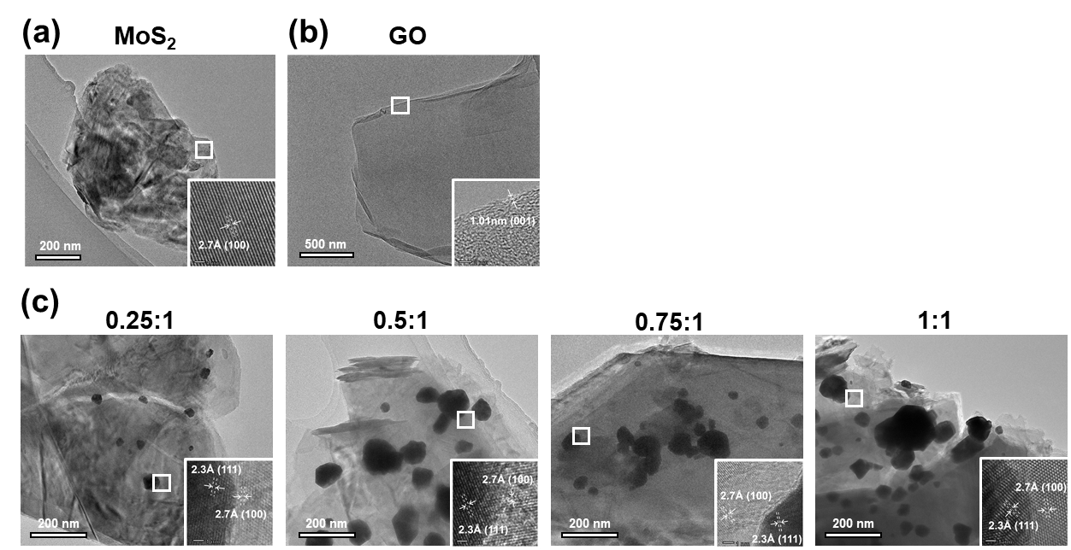
Figure S1. TEM image of pristine MoS₂, GO and Au@MoS₂/GO nanocomposites.
(a) few layer MoS₂ nanosheets. (b) signal layer GO nanosheets. (c) different Au@MoS₂/GO nanocomposites.

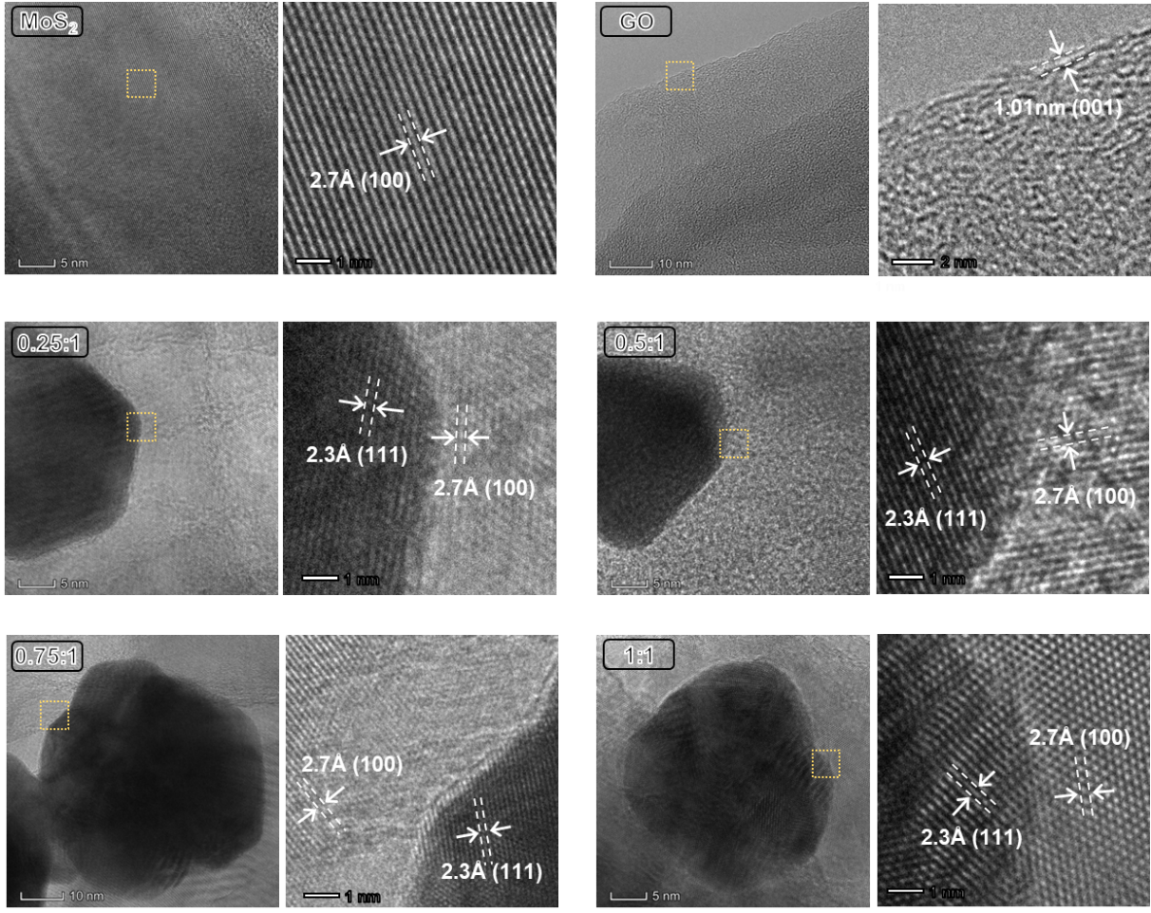
Figure S2. HRTEM images of pristine MoS₂, GO and Au@MoS₂/GO nanocomposites.

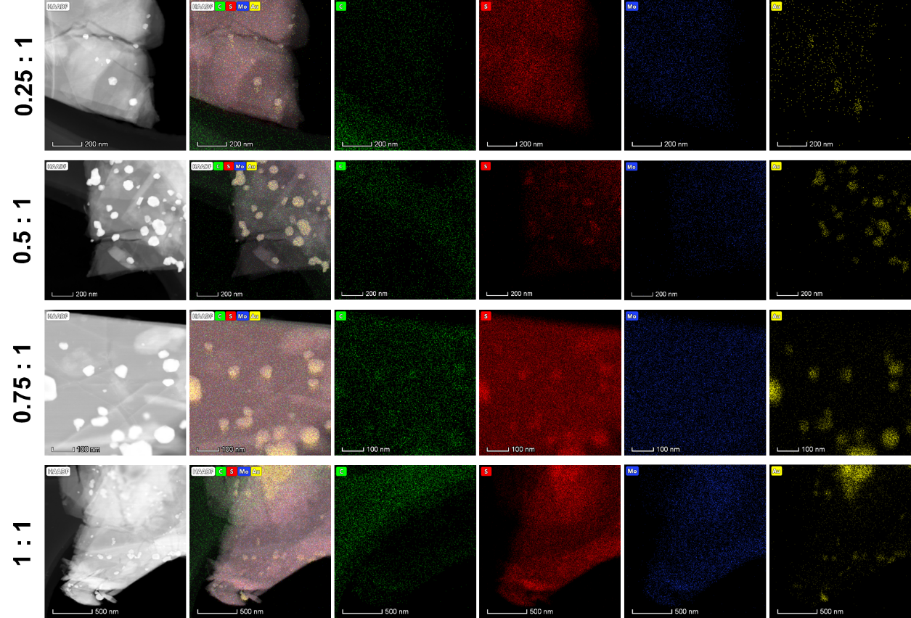
Figure S3. HAADF-STEM and corresponding elemental mapping images of different Au@MoS₂/GO nanocomposites.

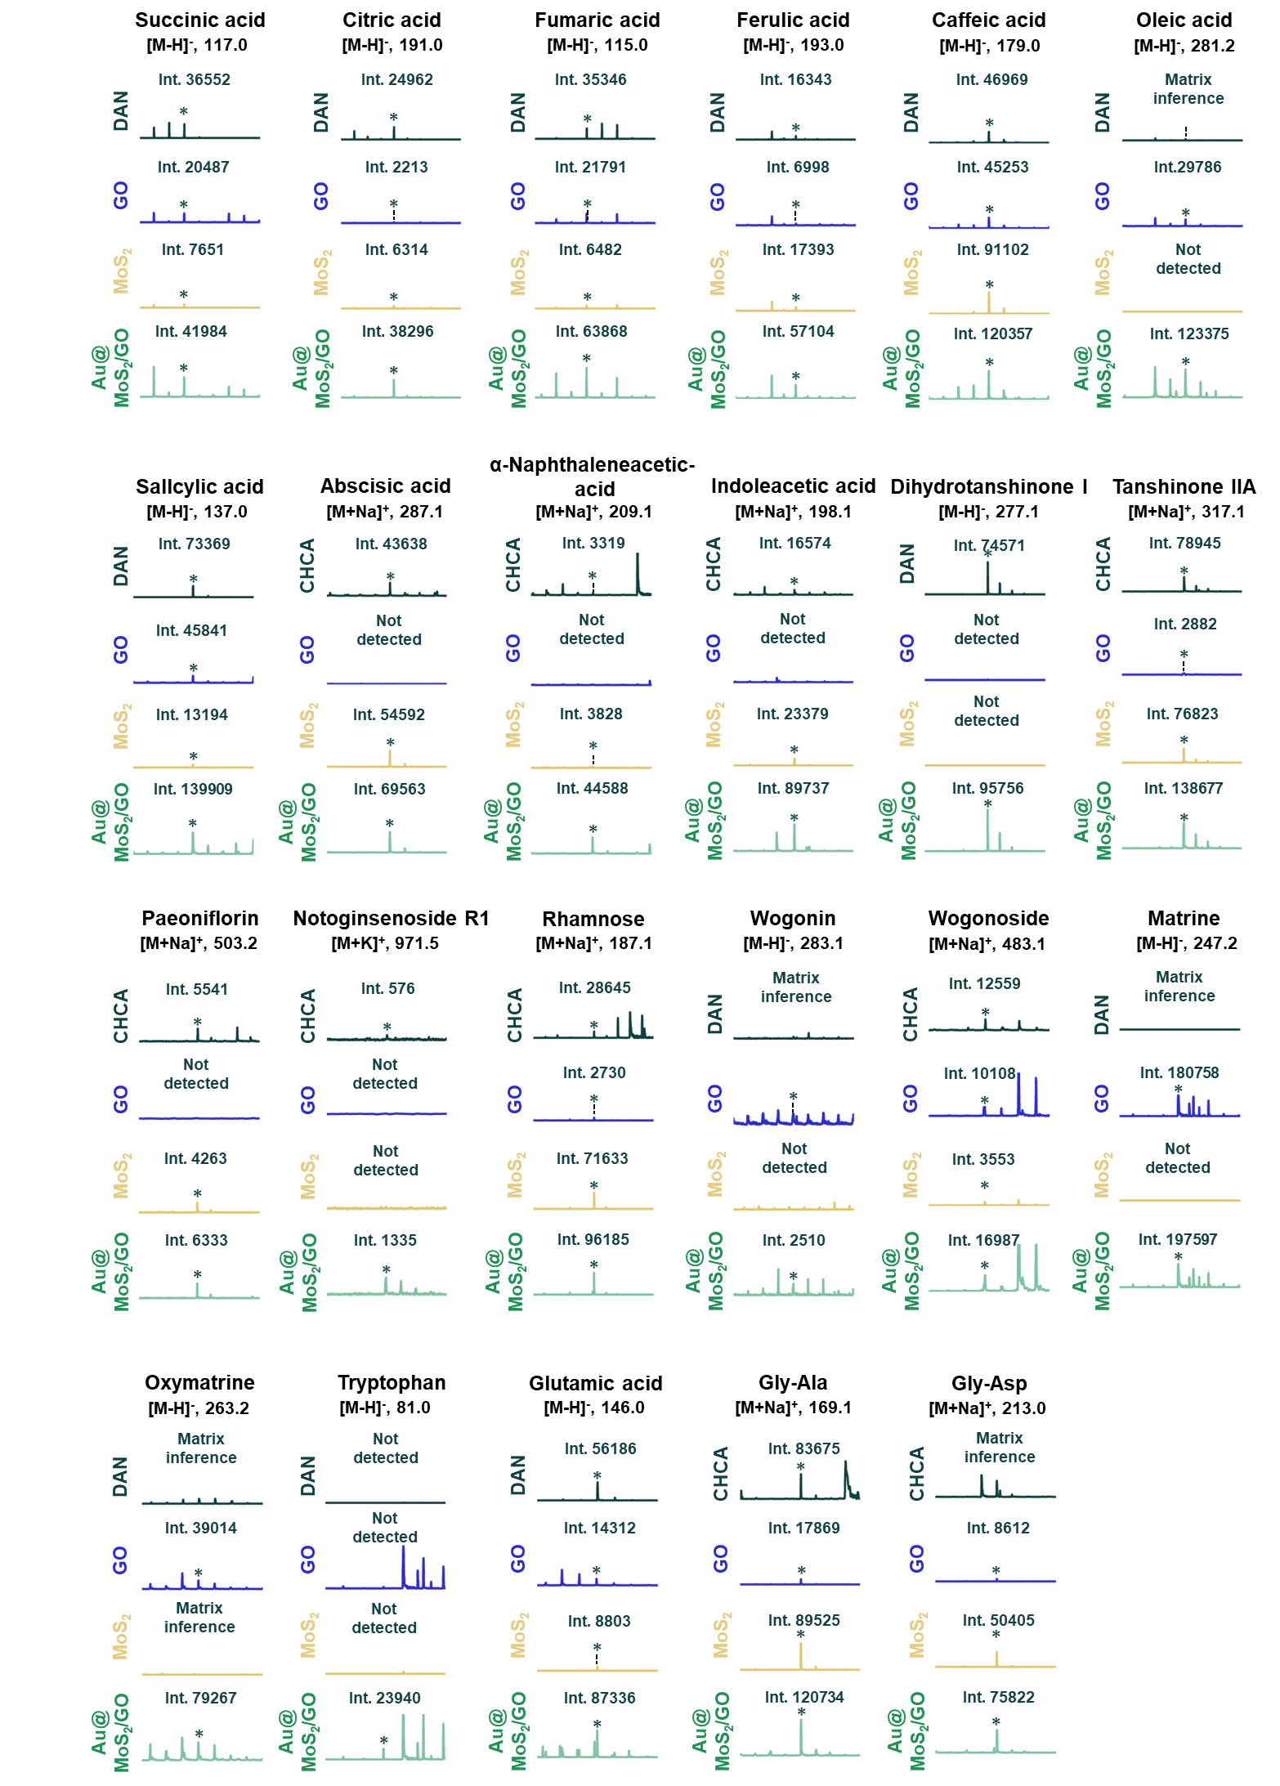
Figure S4. Mass spectrometry of various metabolites by using Au@MoS₂/GO, MoS₂, GO nanosubstrates and DAN, CHCA matrices in positive and negative mode.
* Represent the target peak.
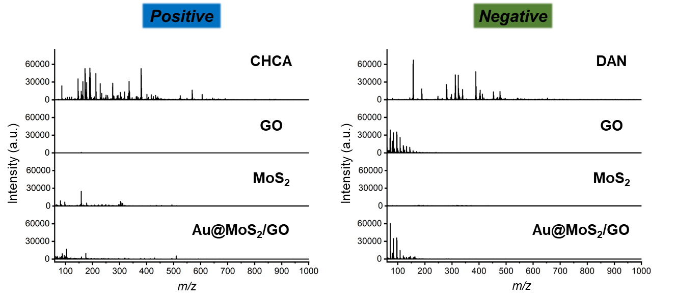
Figure S5. Background of different matrices and nanosubstrates in the positive and negative modes.

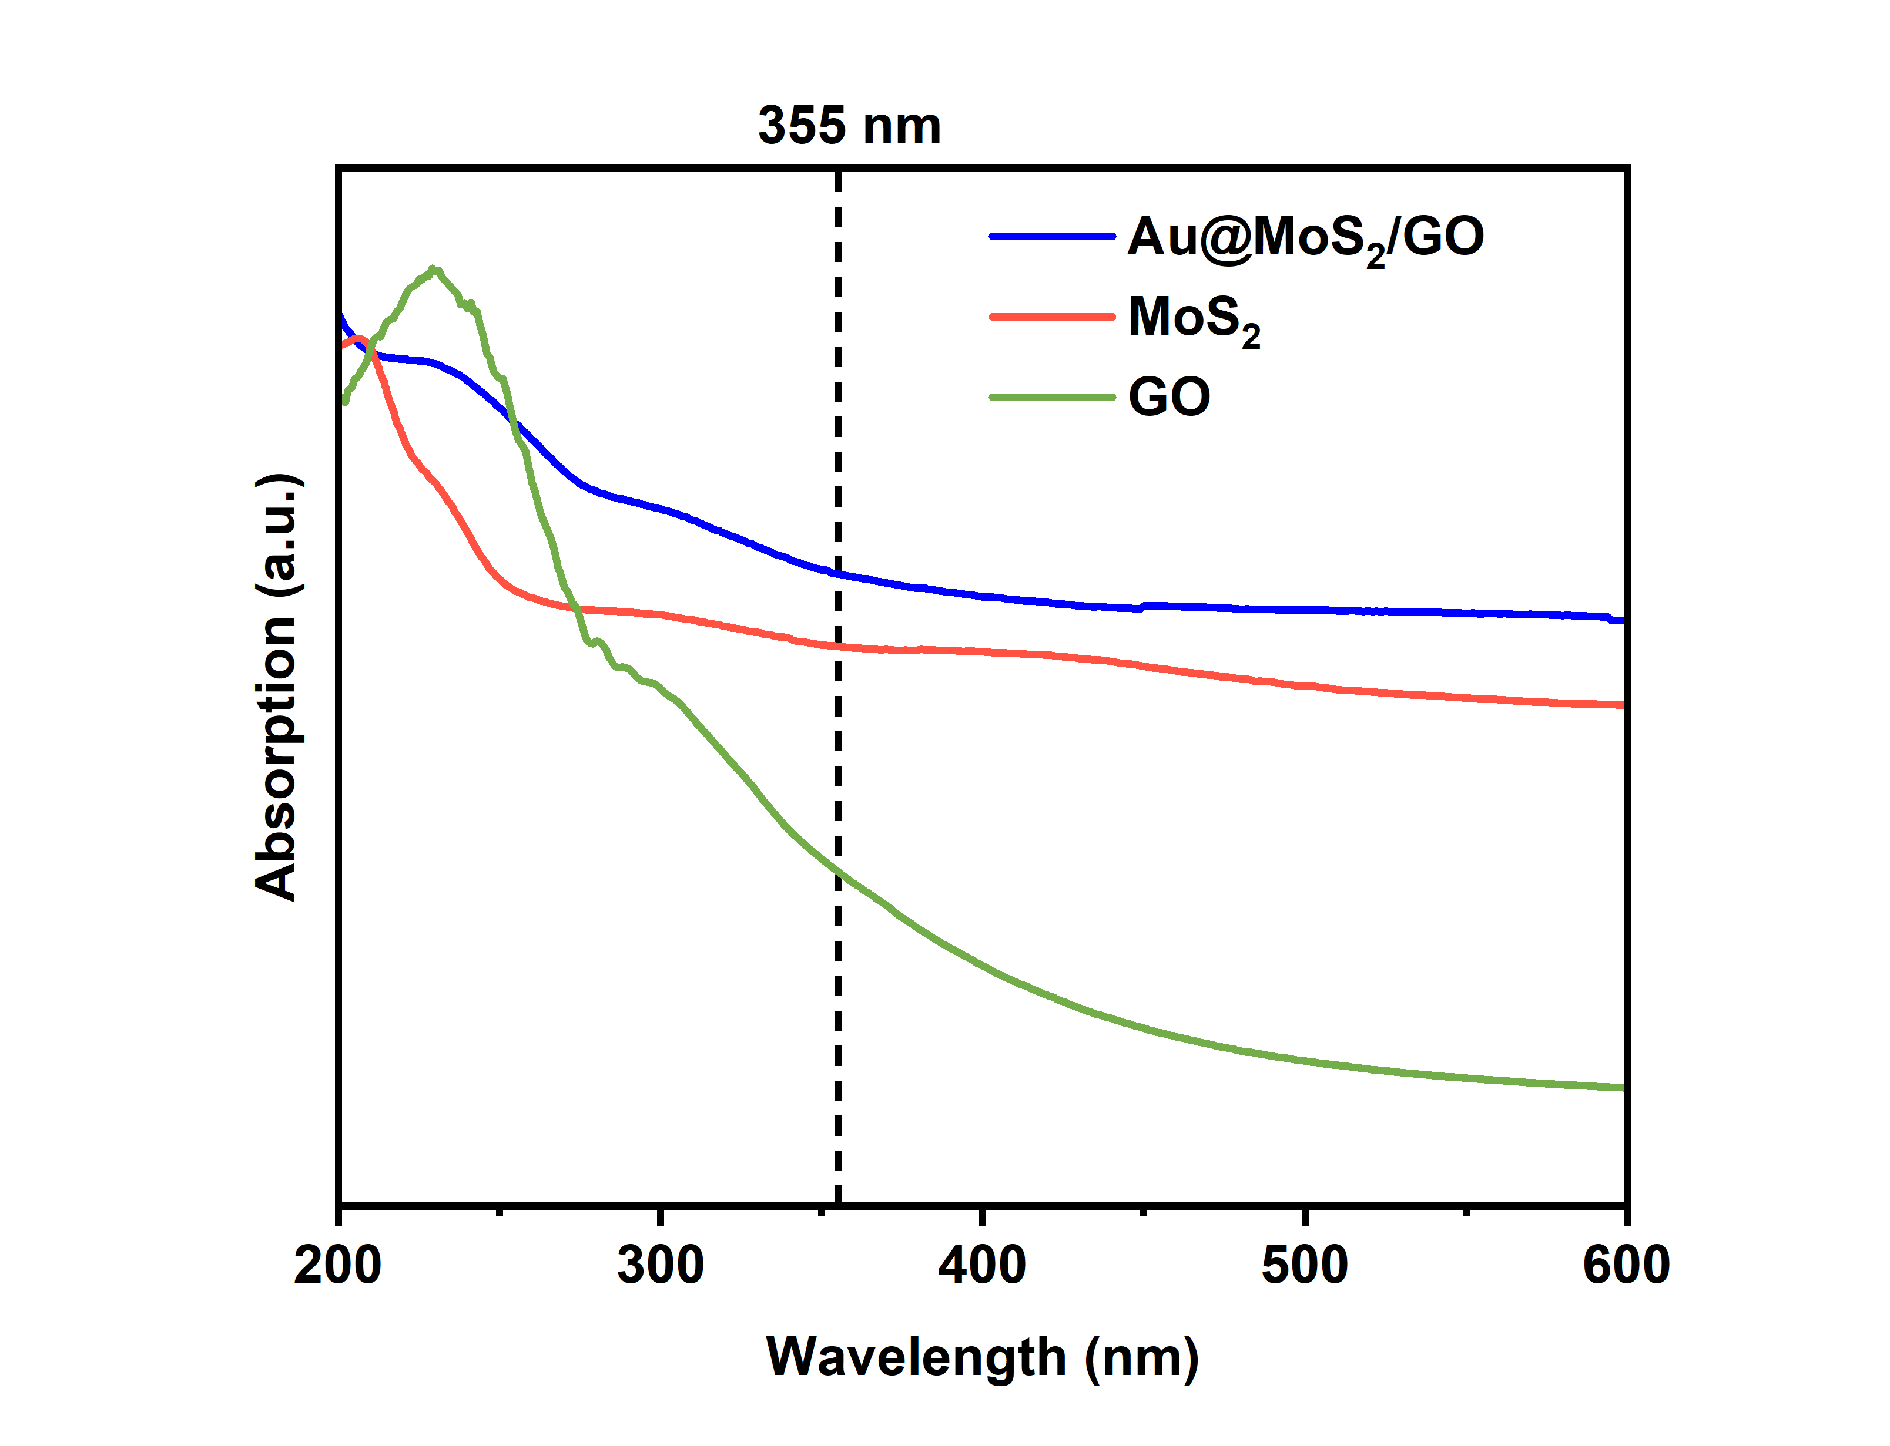
Figure S6. UV-visible spectrometry of Au@MoS₂/GO, MoS₂, and GO.

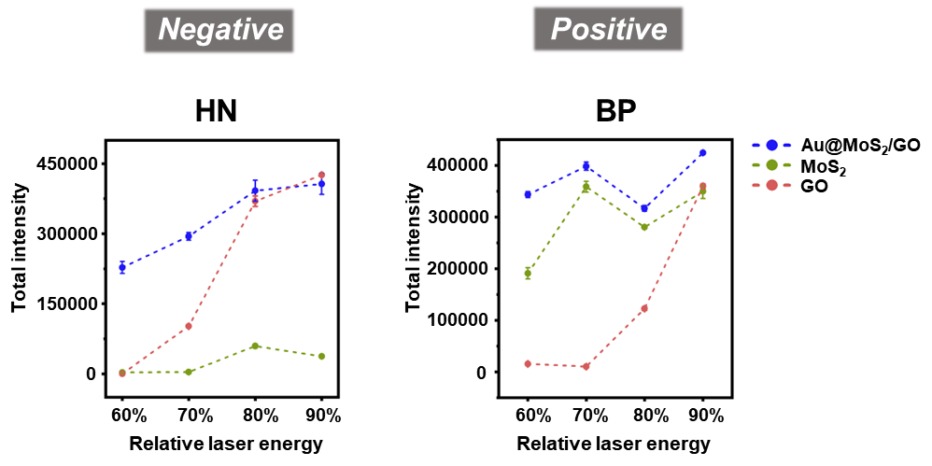
Figure S7. Total ion intensity of HN and BP at different laser energies under positive and negative modes.

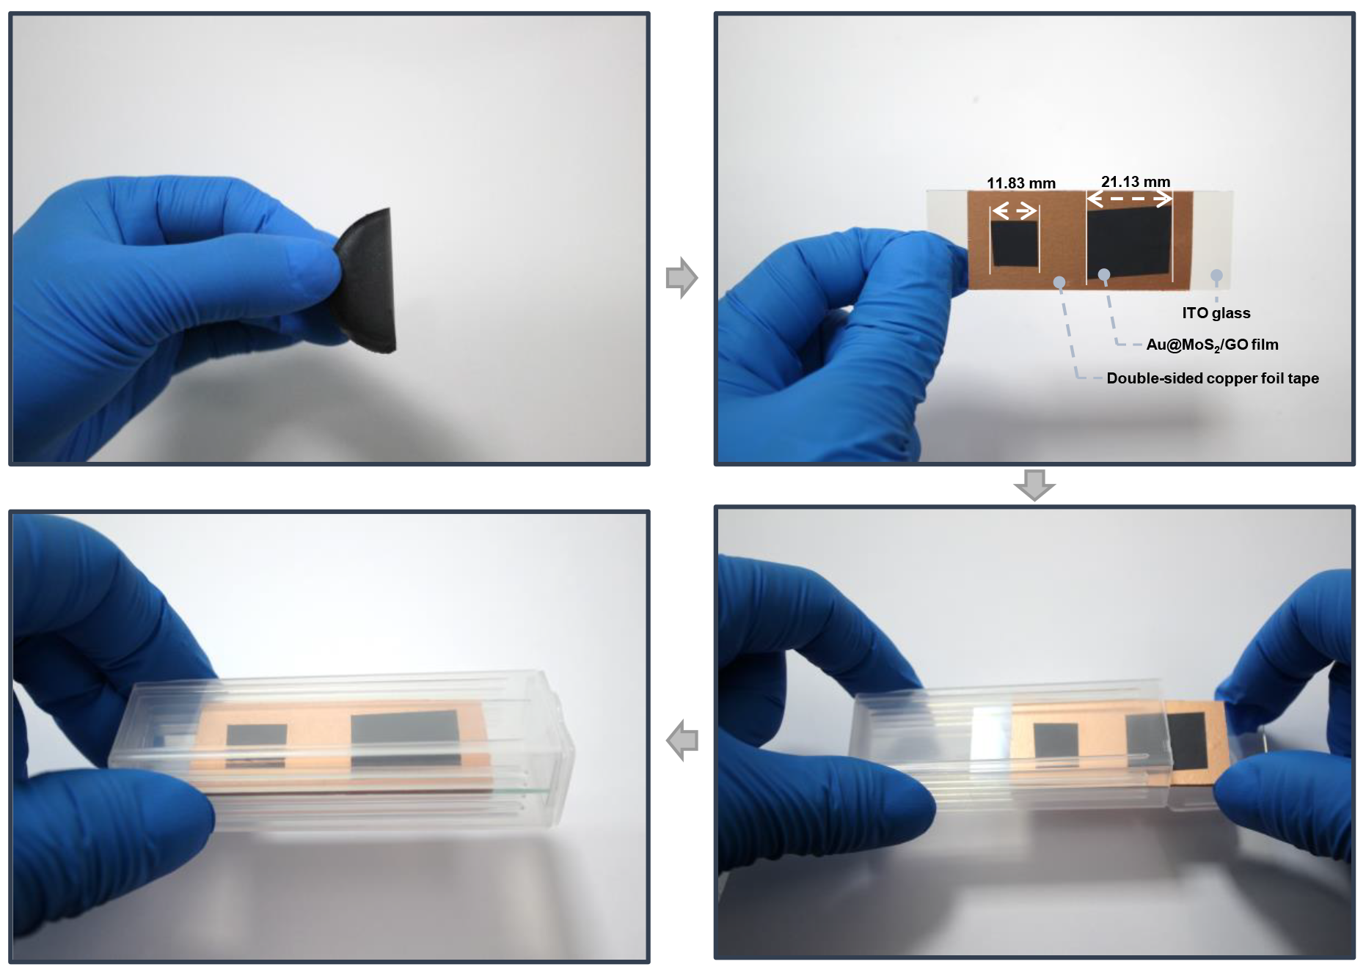
Figure S8. Optical images of the Au@MoS₂/GO flexible film morphology, cutting and storage.

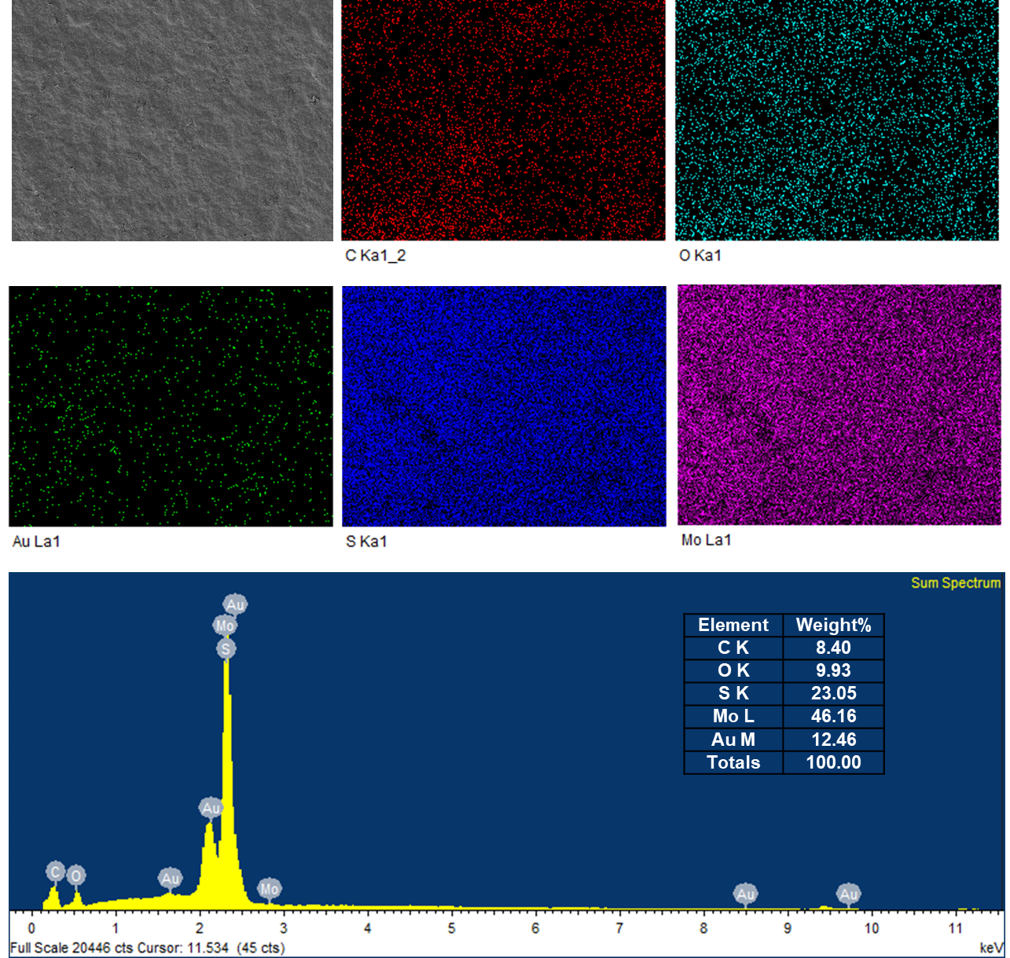
Figure S9. SEM element mapping and typical energy dispersive X-ray spectroscopy (EDX) spectra for Au@MoS₂/GO film surface.

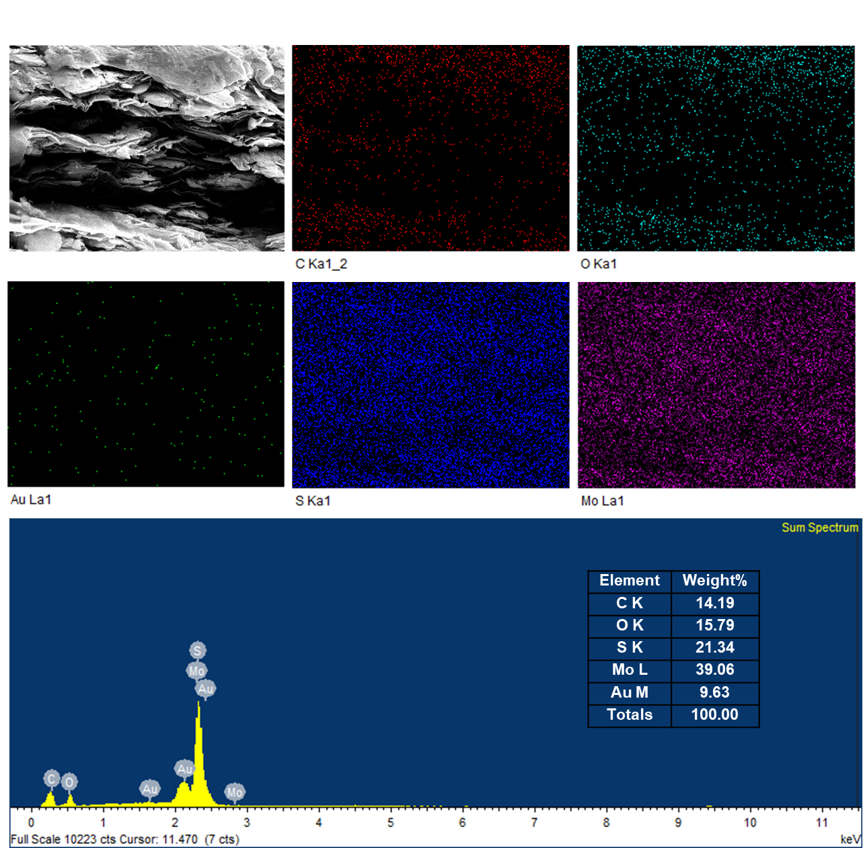
Figure S10. SEM element mapping and typical energy dispersive X-ray spectroscopy (EDX) spectra for the cross sections of Au@MoS₂/GO film.

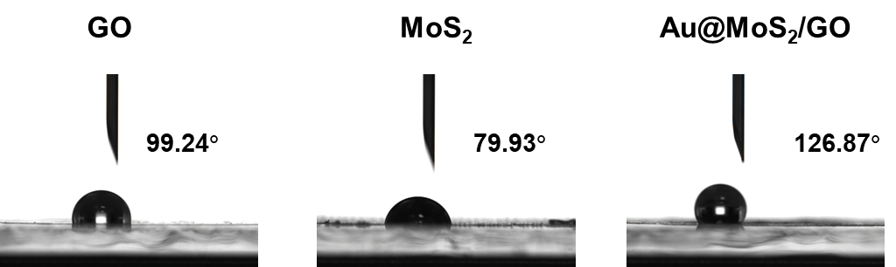

Figure S11. Aqueous contact angle measurements of GO, MoS₂, and Au@MoS₂/GO films.

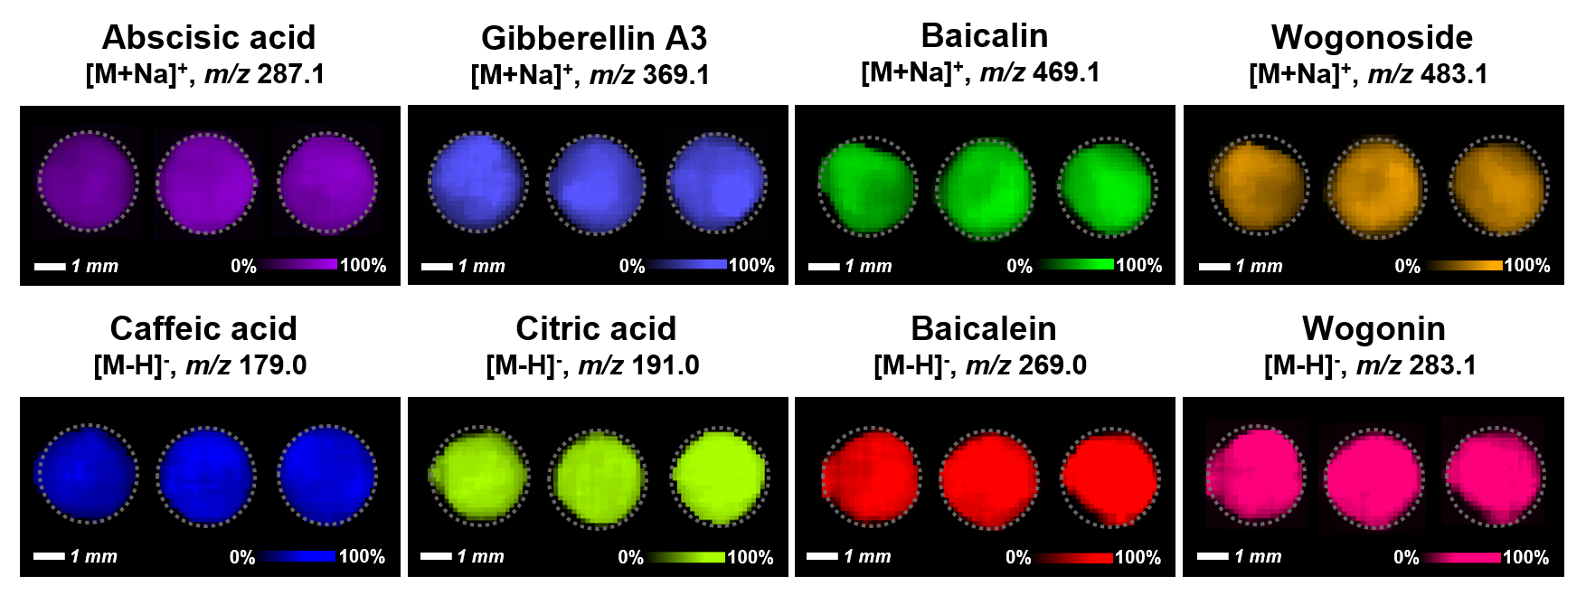
Figure S12. MS images of representative metabolite standards using the AMG-LDI-MSI platform in positive and negative ion modes.

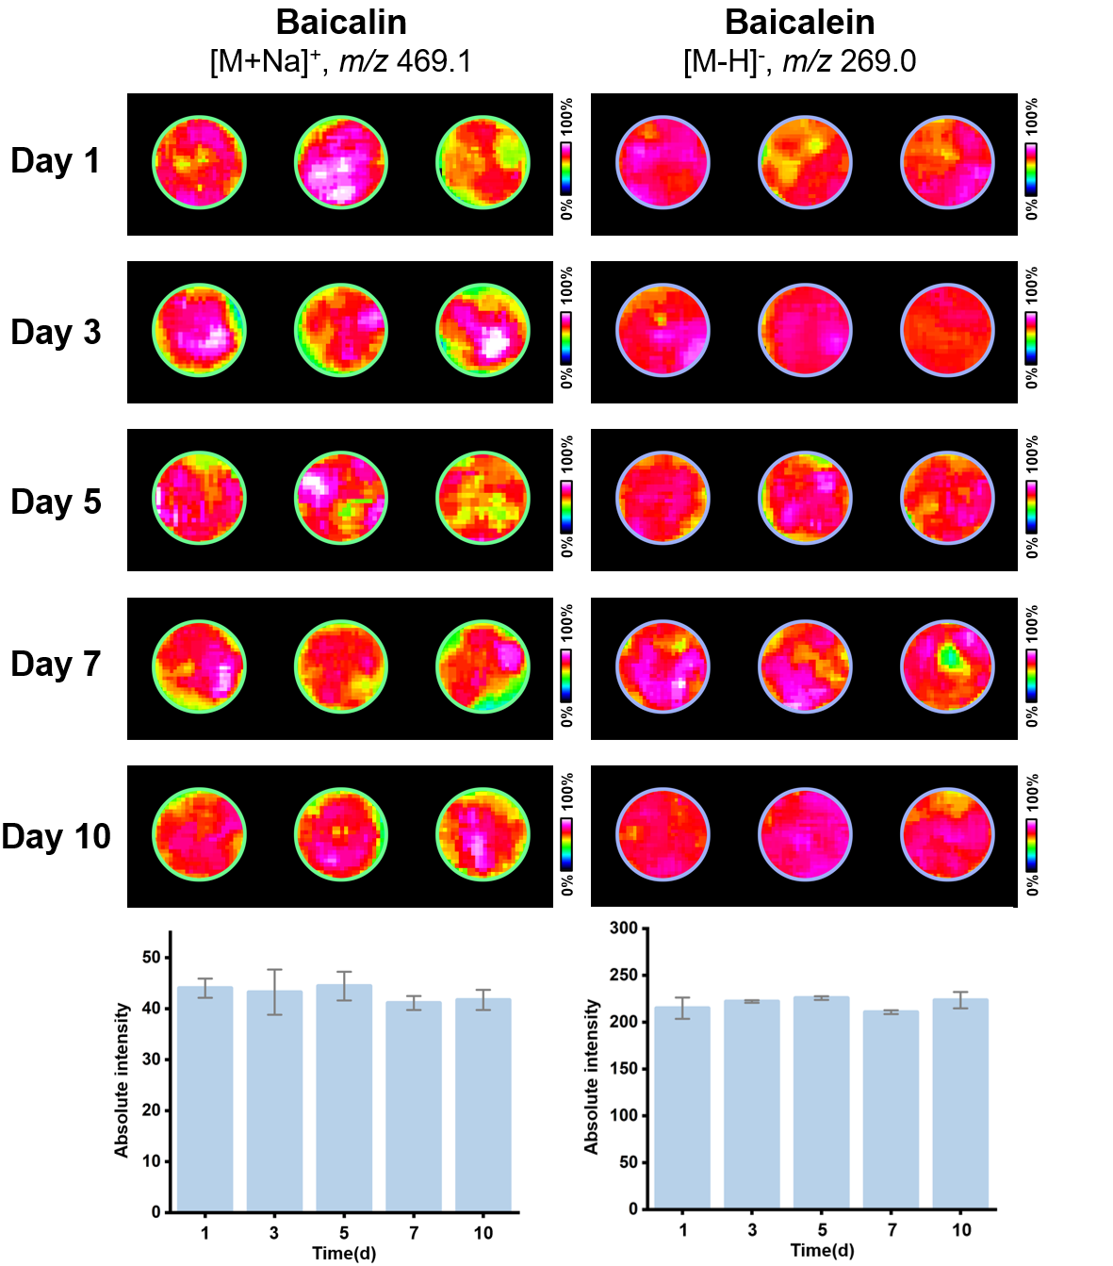
Figure S13. Systematic stability tests of the AMG-LDI-MSI platform.

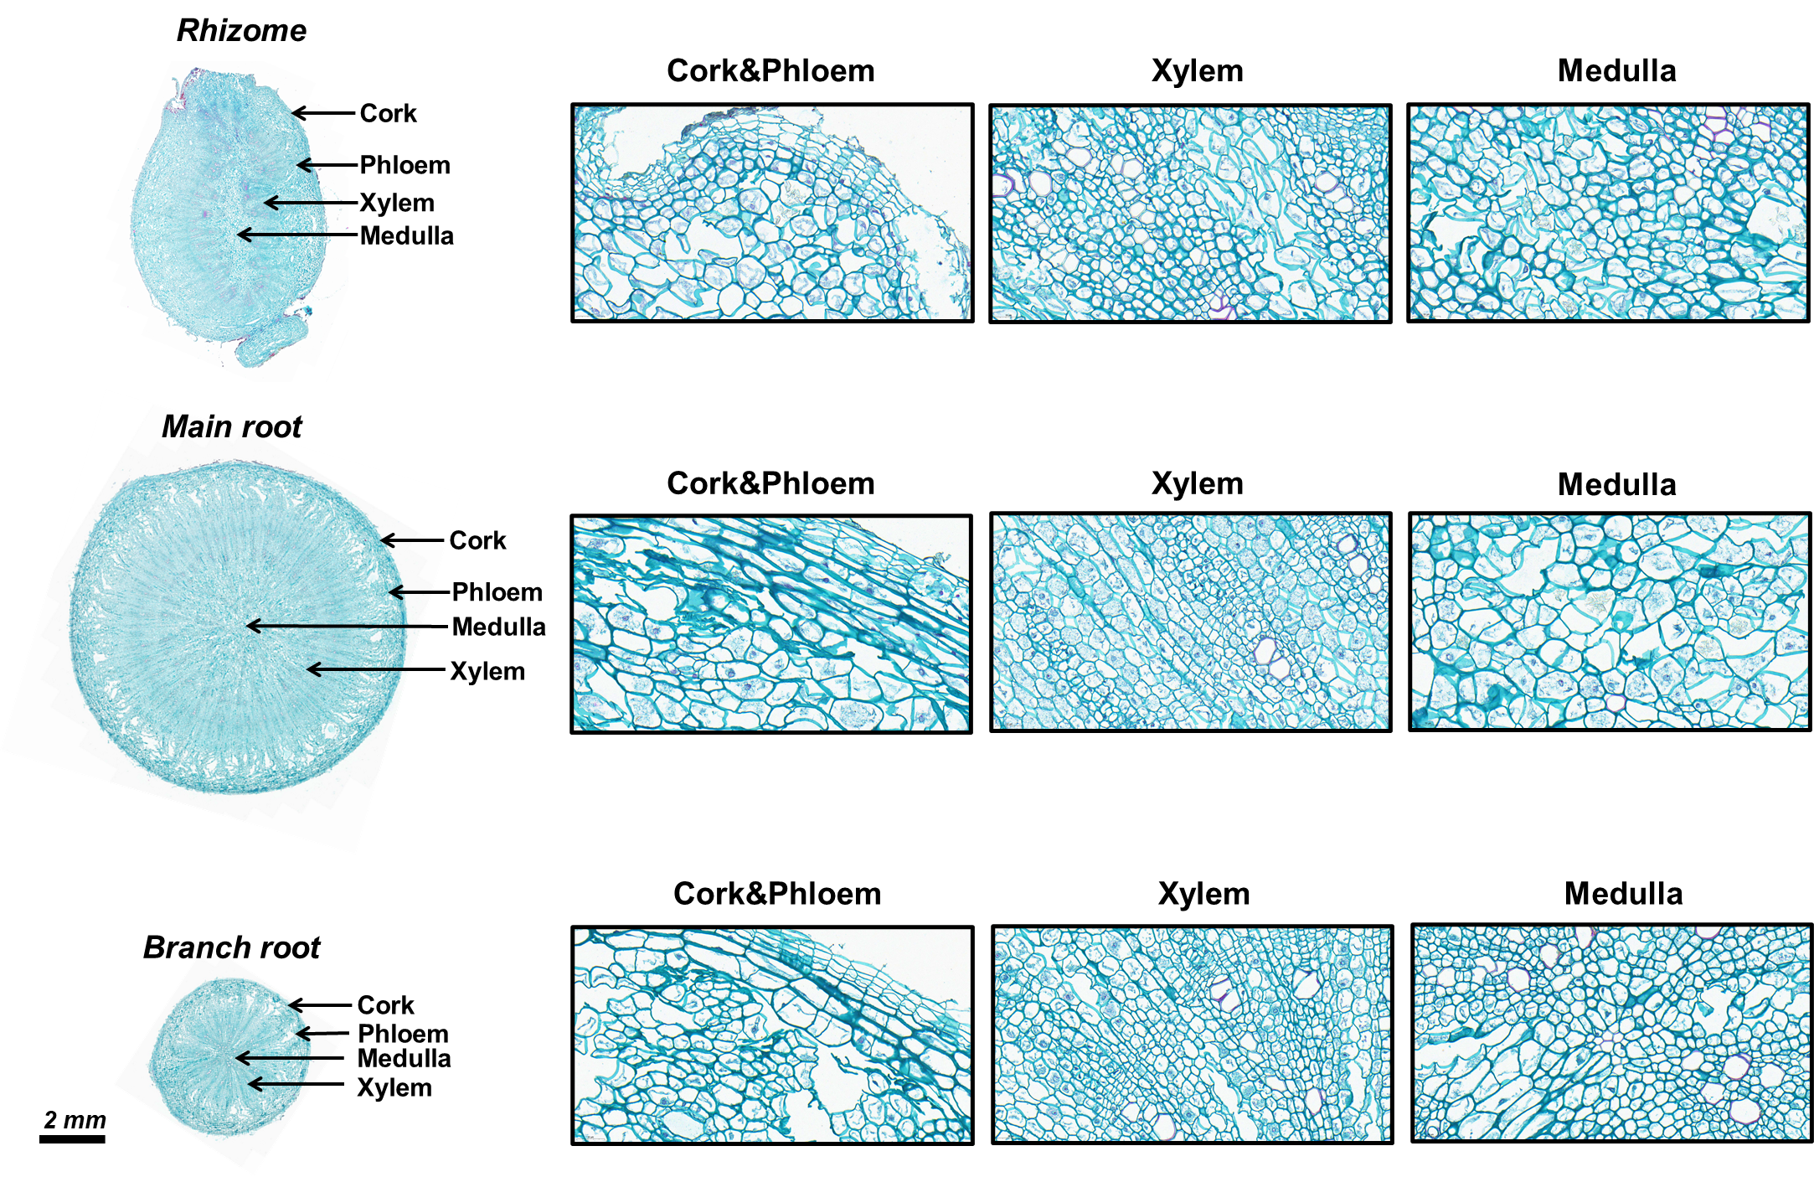
Figure S14. SOFG staining and morphological images of rhizome, main root, and branch root tissues in the Panax ginseng.
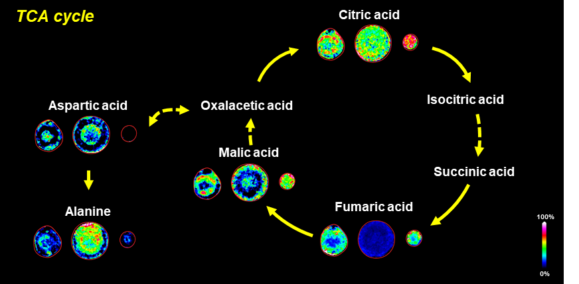
Figure S15. Spatial distribution of major metabolites in the tricarboxylic acid (TCA) metabolic pathway in P. ginseng roots.

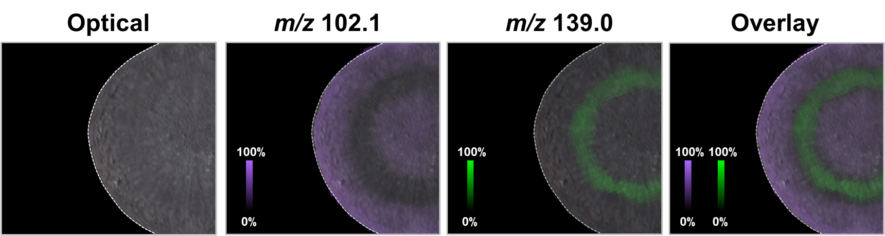
Figure S16. Single-color MS images and overlay image of region-specific metabolite ions in P. ginseng main root imprint.

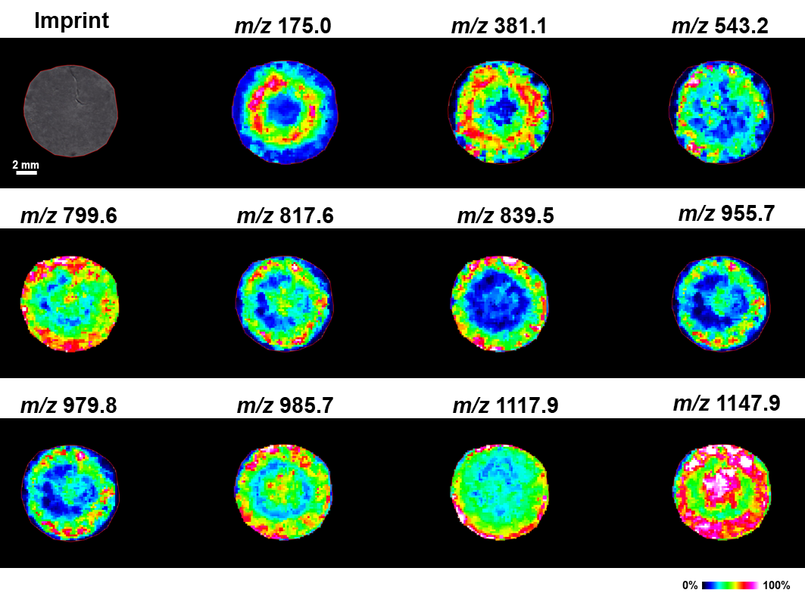
Figure S17. Representation of ions with region-specific distribution visualized in Panax quinquefolium main root tissue using the AMG-LDI-MSI platform in positive ion mode.
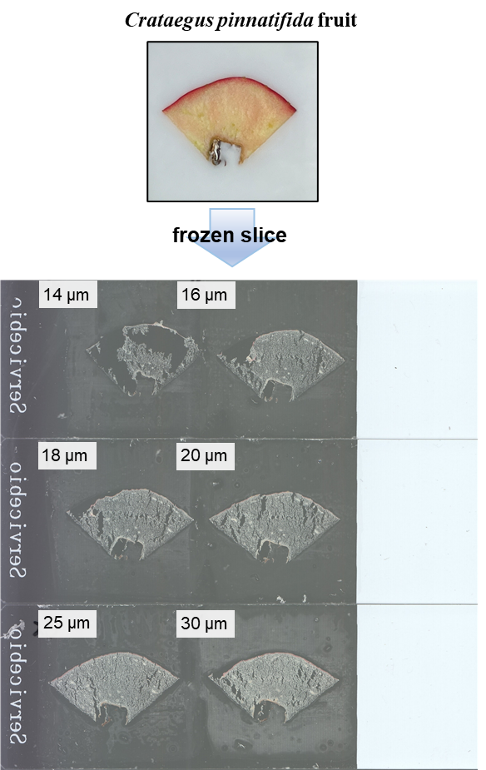
Figure S18. Optical images of frozen slices of C. pinnatifida fruit of different thicknesses.

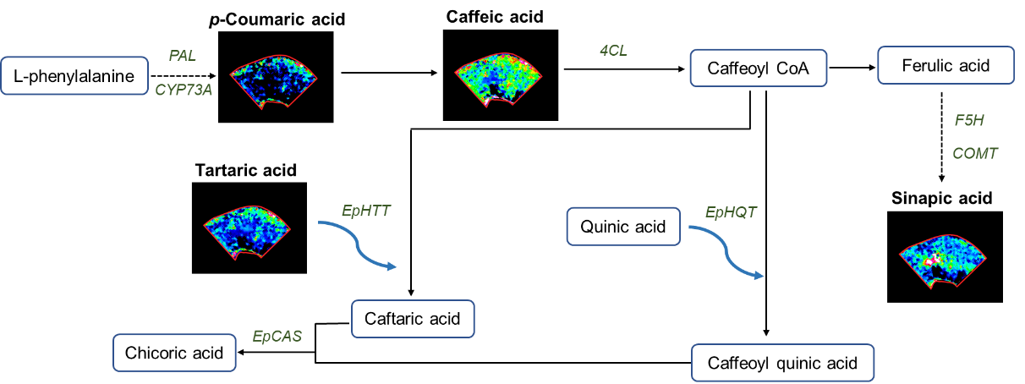

Figure S19. Spatial distribution of major metabolites in the biosynthesis pathway of phenolic acids in C. pinnatifida fruit.

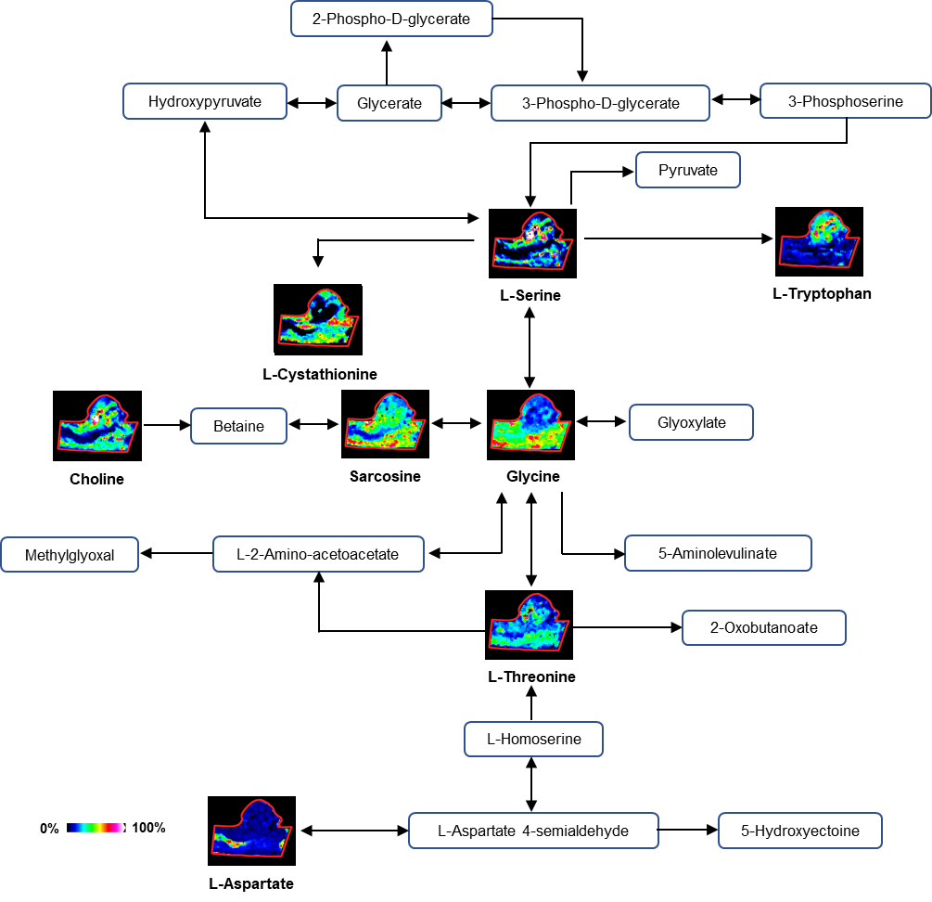

Figure S20. Spatial distribution of major metabolites in the metabolism pathway of glycine, serine and threonine in S. baicalensis root nodule.

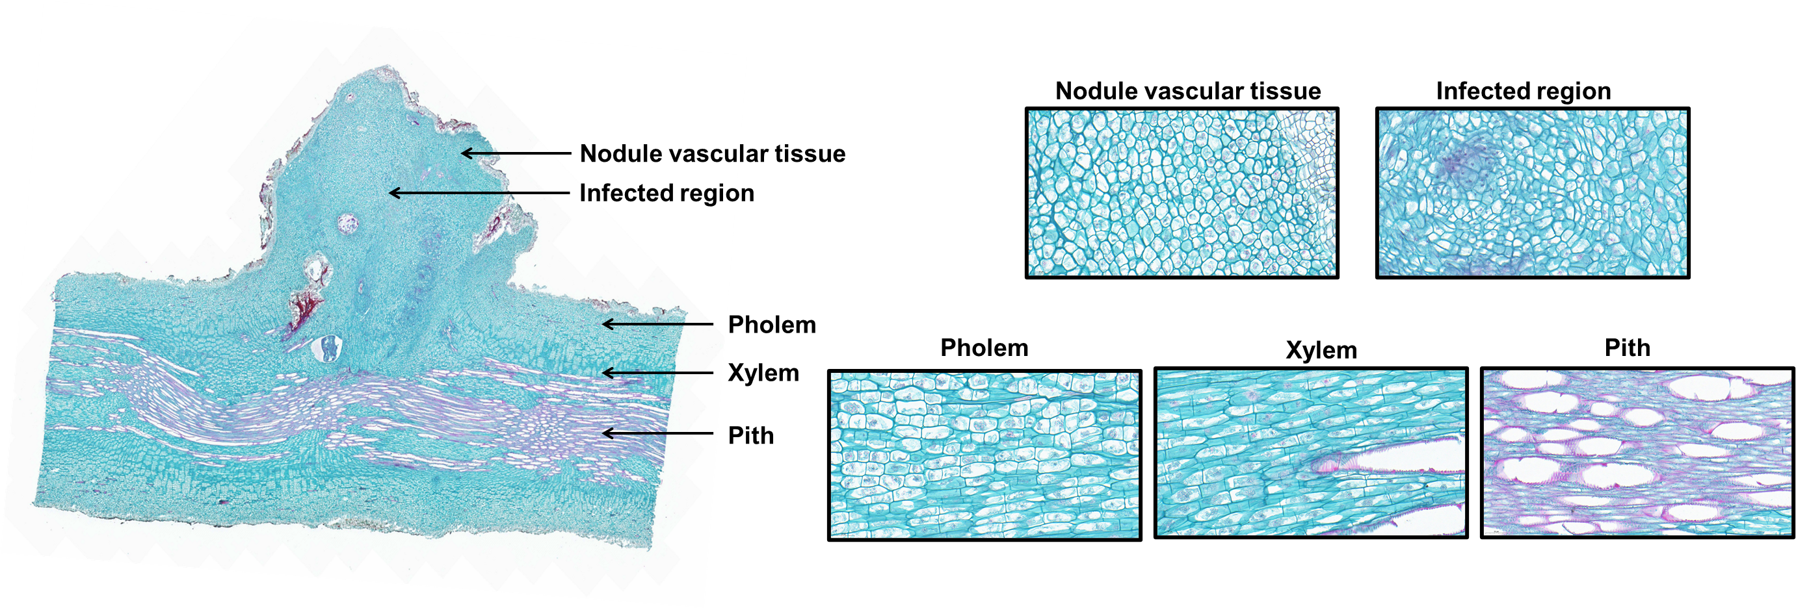
Figure S21. SOFG staining and morphological images of S. baicalensis root nodule.

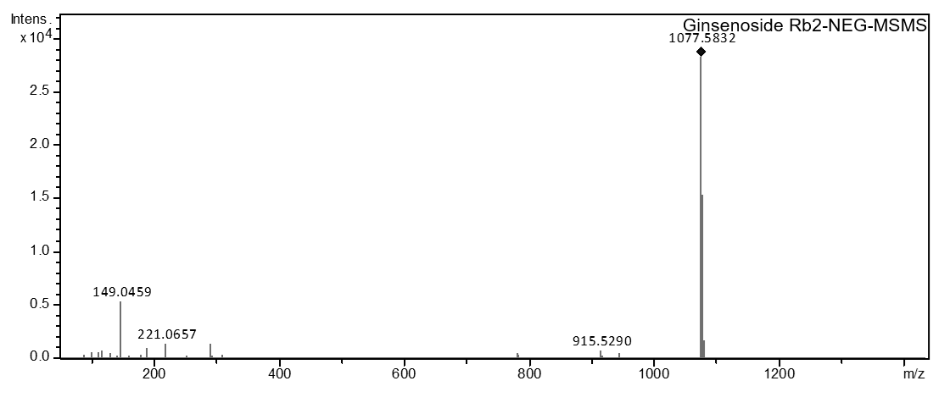
Figure S22. The MS/MS spectrum of ginsenoside Rb2.

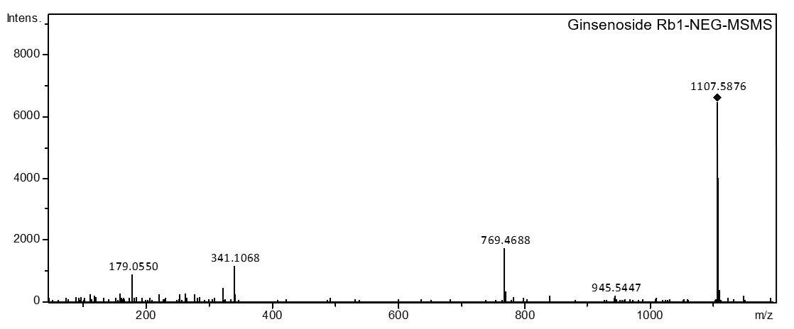
Figure S23. The MS/MS spectrum of ginsenoside Rb1.

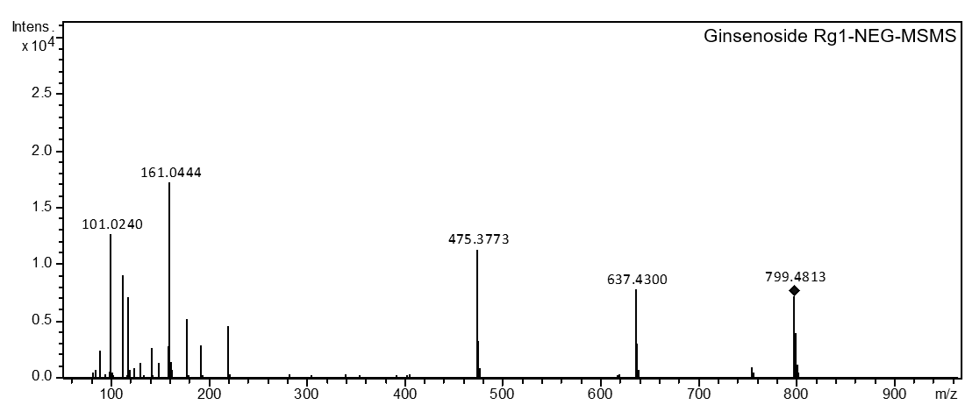
Figure S24. The MS/MS spectrum of ginsenoside Rg1.

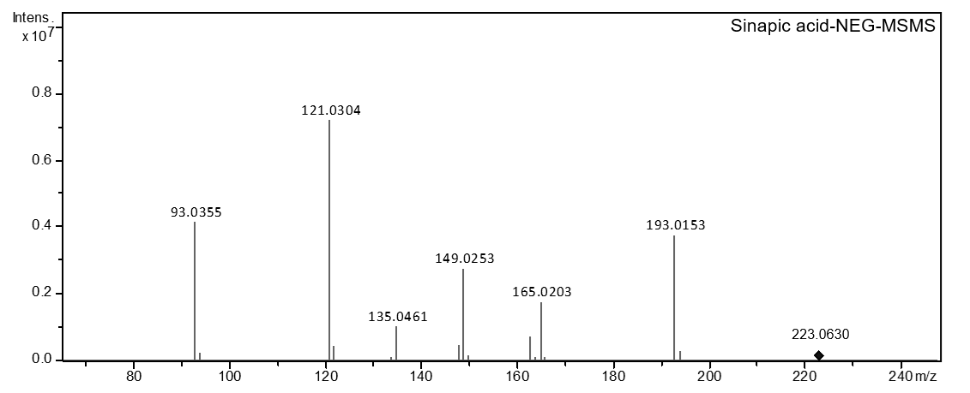
Figure S25. The MS/MS spectrum of sinapic acid.

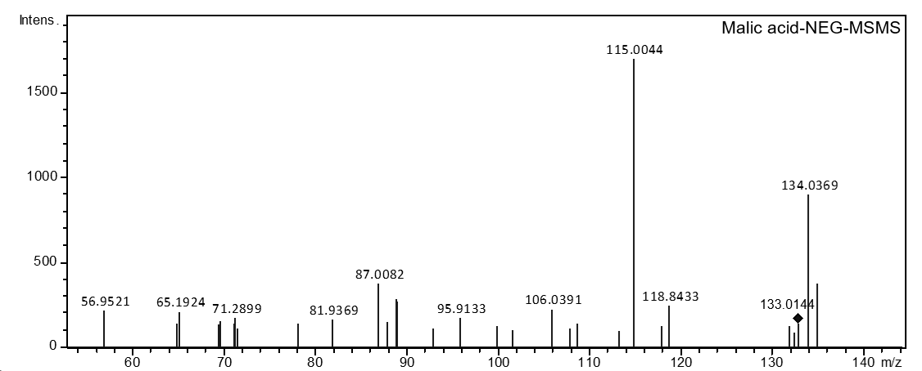
Figure S26. The MS/MS spectrum of malic acid.

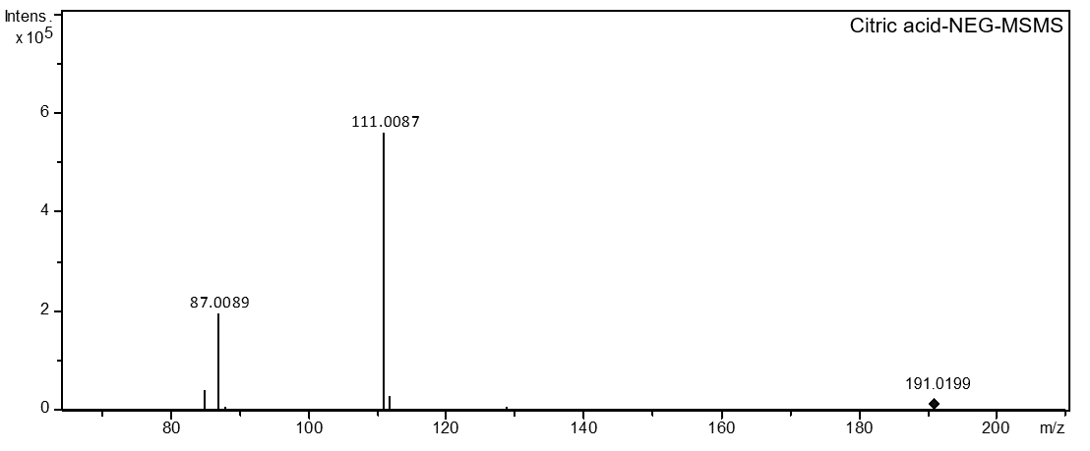
Figure S27. The MS/MS spectrum of citric acid.

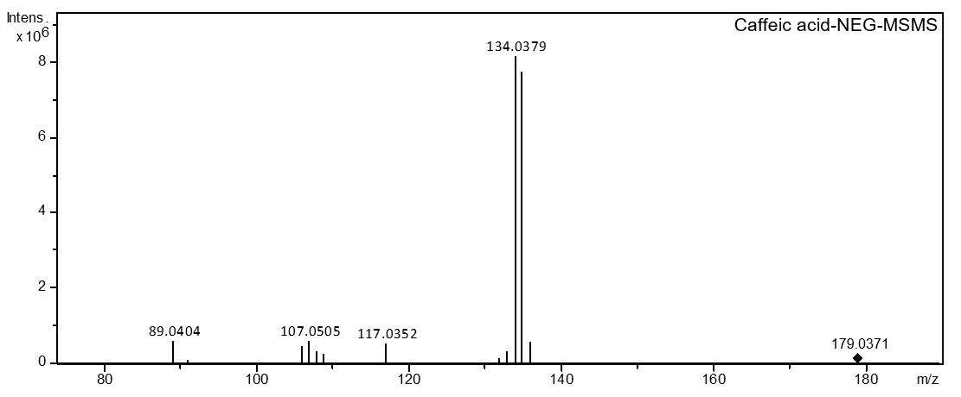
Figure S28. The MS/MS spectrum of caffeic acid.

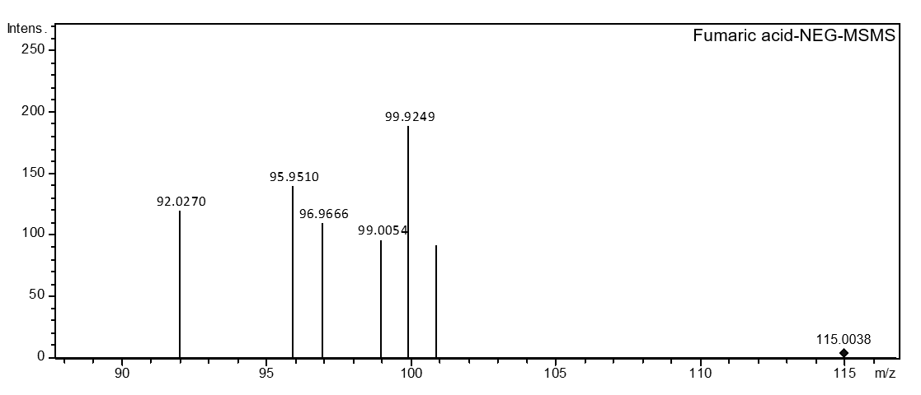
Figure S29. The MS/MS spectrum of fumaric acid.

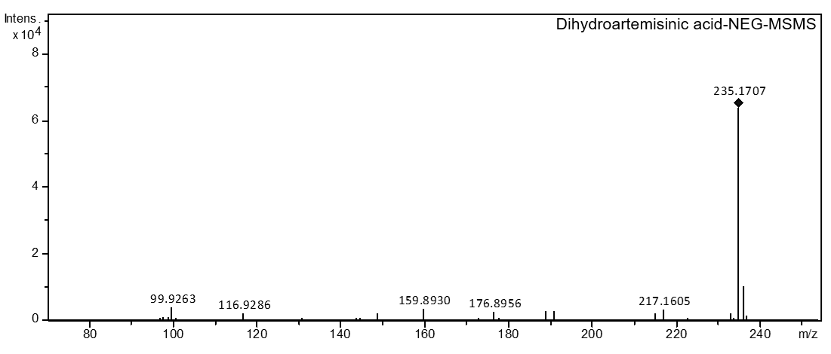
Figure S30. The MS/MS spectrum of dihydroartemisinic acid.

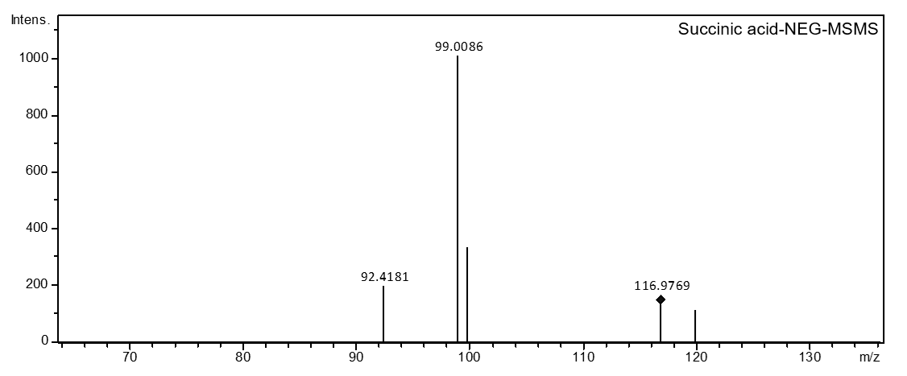
Figure S31. The MS/MS spectrum of succinic acid.

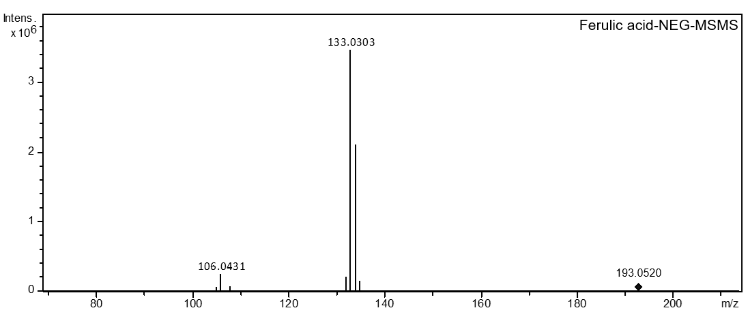
Figure S32. The MS/MS spectrum of ferulic acid.

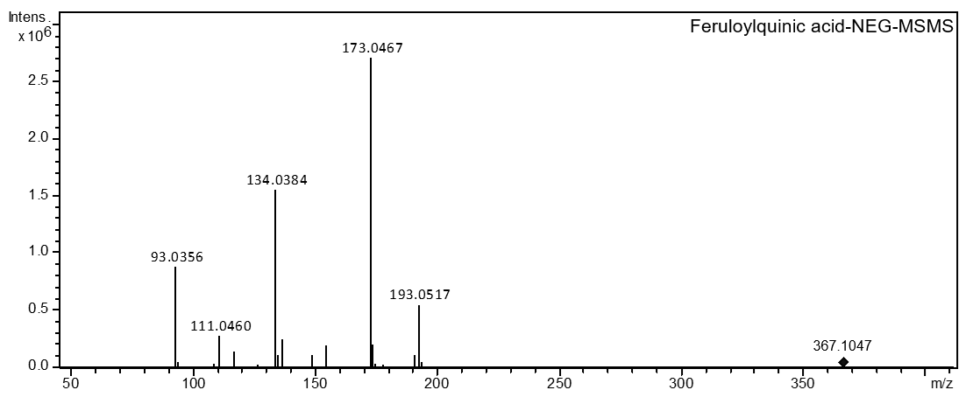
Figure S33. The MS/MS spectrum of feruloylquinic acid.

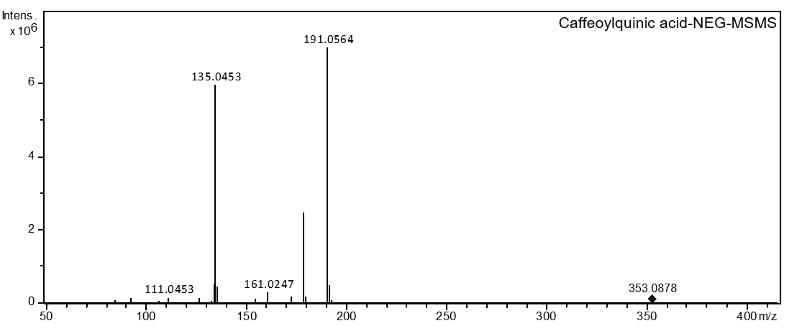
Figure S34. The MS/MS spectrum of caffeoylquinic acid.

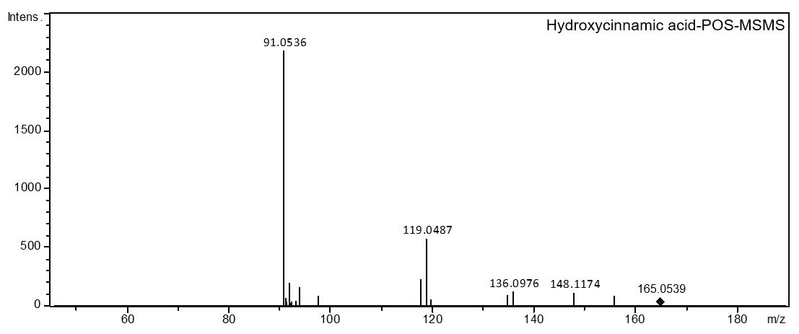
Figure S35. The MS/MS spectrum of hydroxycinnamic acid.

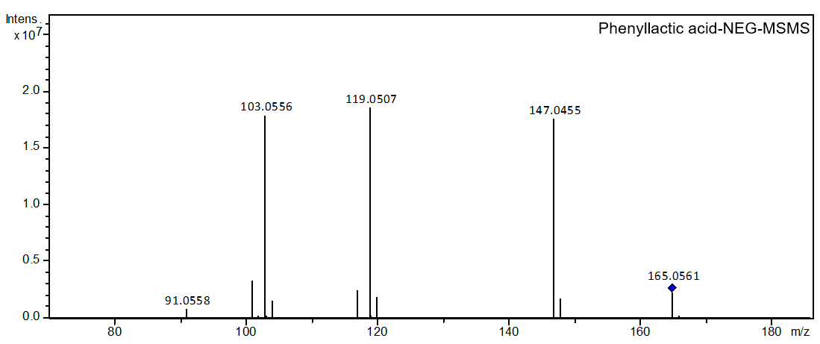
Figure S36. The MS/MS spectrum of phenyllactic acid.

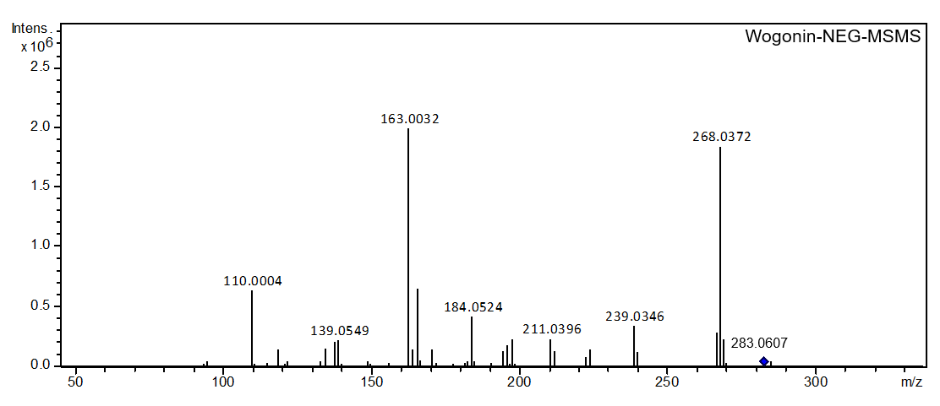
Figure S37. The MS/MS spectrum of wogonin.

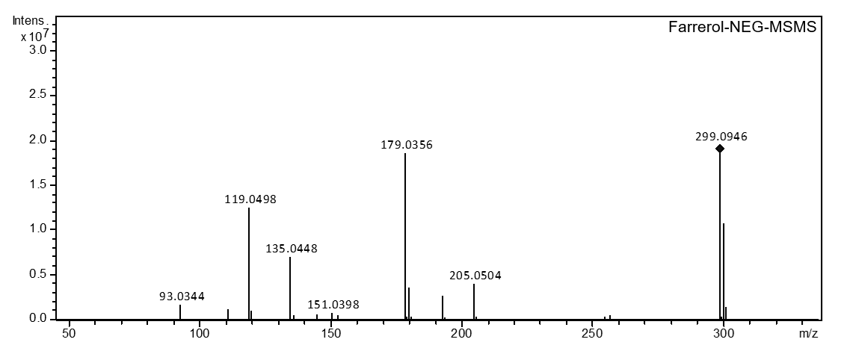
Figure S38. The MS/MS spectrum of farrerol.

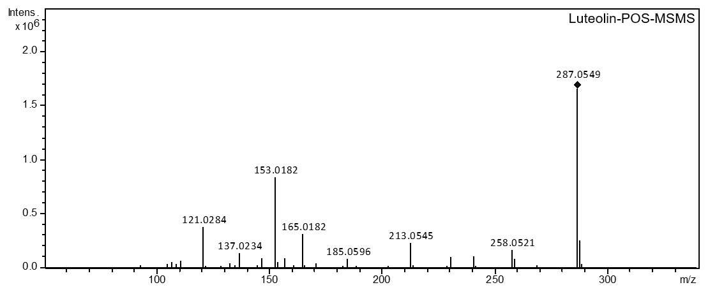
Figure S39. The MS/MS spectrum of luteolin.

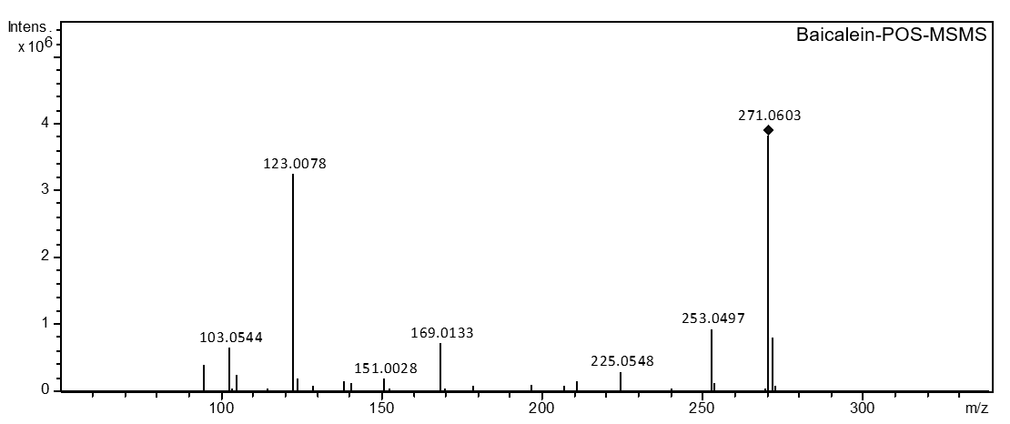
Figure S40. The MS/MS spectrum of baicalein.

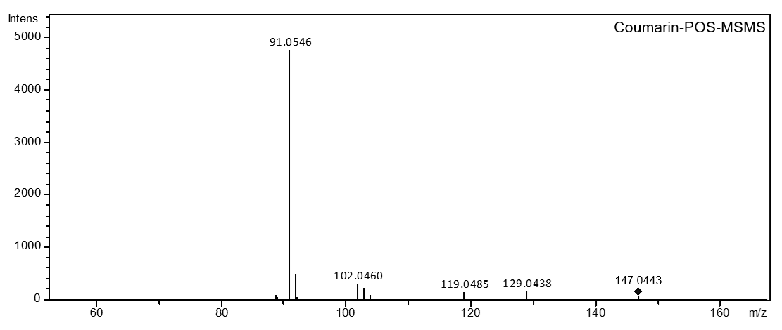
Figure S41. The MS/MS spectrum of coumarin.

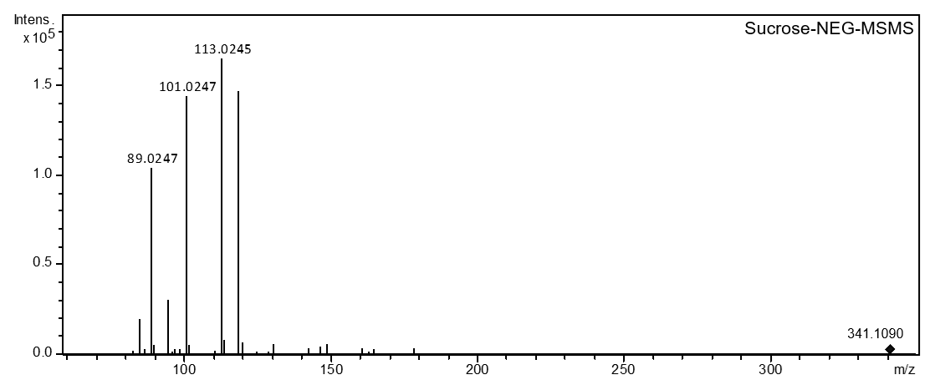
Figure S42. The MS/MS spectrum of sucrose.

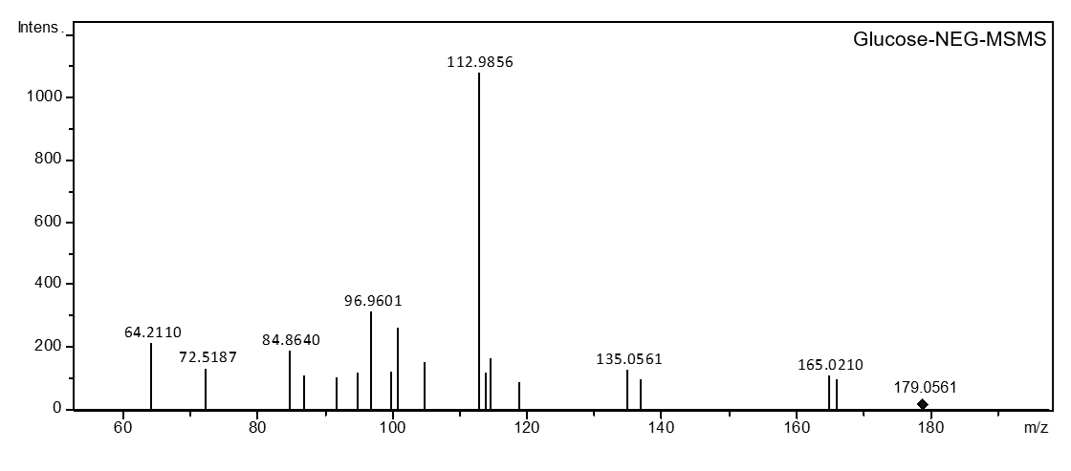
Figure S43. The MS/MS spectrum of glucose.

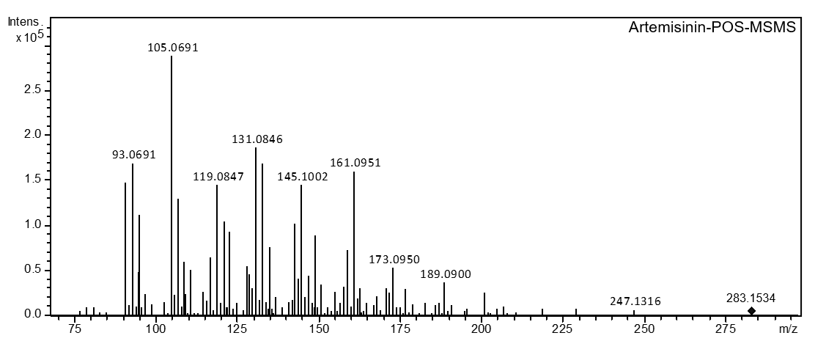
Figure S44. The MS/MS spectrum of artemisinin.

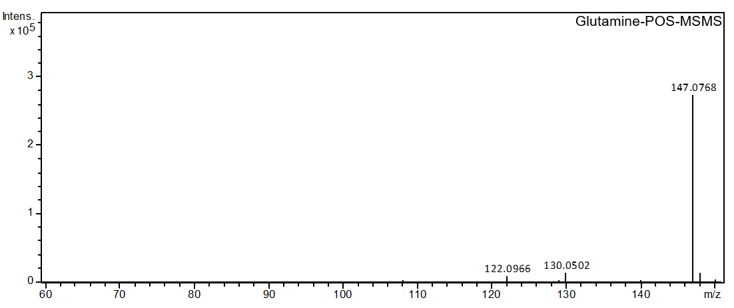
Figure S45. The MS/MS spectrum of glutamine.

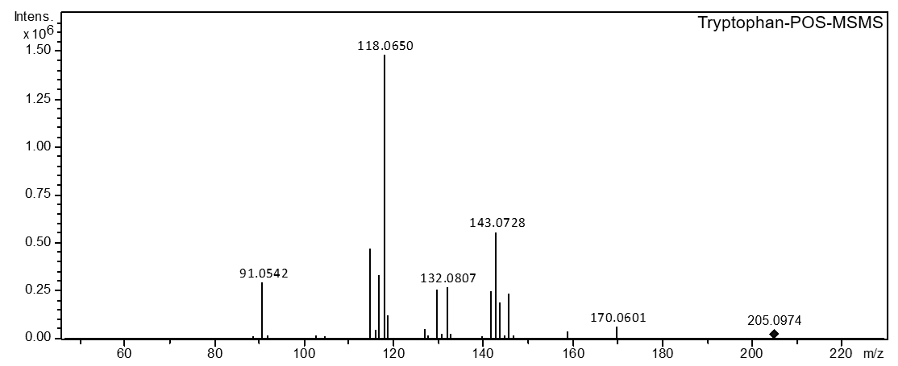
Figure S46. The MS/MS spectrum of tryptophan.

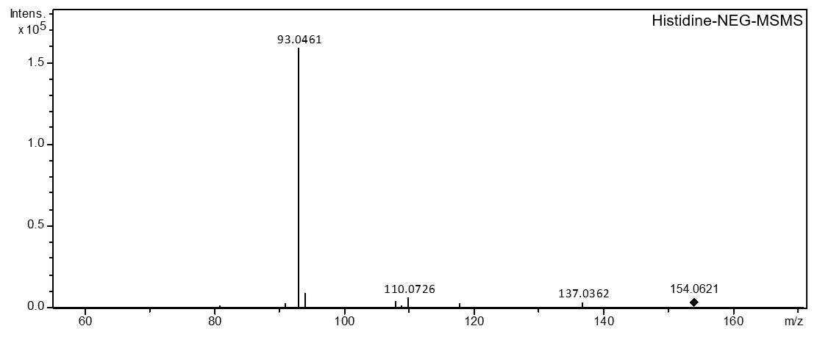
Figure S47. The MS/MS spectrum of histidine.

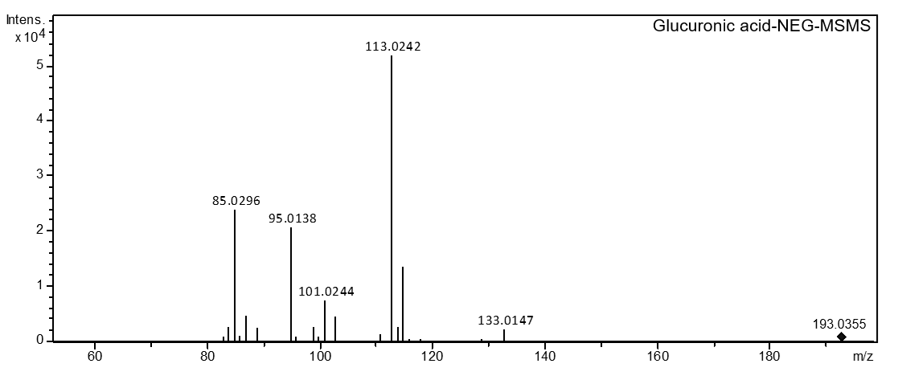
Figure S48. The MS/MS spectrum of glucuronic acid.

Table S1. List of tentatively identified metabolites in P. ginseng roots by AMG-LDI-MSI platform

Compound | Molecular Formula | Measured  (m/z) | Calculated  (m/z) | Error  (△ppm) | Adduct
Ginsenoside Re | C48H82O18 | 985.513 | 985.519 | 6.09 | M+K
Ginsenoside Ro | C48H76O19 | 979.487 | 979.491 | 4.08 | M+Na
Ginsenoside Rc/Rb2 | C53H90O22 | 1117.556 | 1117.554 | 1.79 | M+K
Ginsenoside Rb1 | C54H92O23 | 1147.566 | 1147.562 | 3.49 | M+K
Ginsenoside Rg1 | C42H72O14 | 839.455 | 839.452 | 3.57 | M+K
Leu-Ala | C9H18N2O3 | 241.095 | 241.093 | 8.30 | M+K
Glu-Leu | C11H20N2O5 | 299.100 | 299.102 | 6.69 | M+K
Tryptophan | C11H12N2O2 | 205.097 | 205.096 | 4.88 | M+H
Pipecolic acid | C6H11NO2 | 128.071 | 128.07 | 7.81 | M-H
Pyroglutamic acid | C5H7NO3 | 130.050 | 130.049 | 7.69 | M+H
Aspartic acid | C4H7NO4 | 134.045 | 134.046 | 7.46 | M+H
Alanine | C3H7NO2 | 90.055 | 90.054 | 11.10 | M+H
Glutamine | C5H10N2O3 | 147.076 | 147.075 | 6.80 | M+H
Histidine | C6H9N3O2 | 156.077 | 156.076 | 6.41 | M+H
Sinapic acid | C11H12O5 | 223.060 | 223.061 | 4.48 | M-H
Citric acid | C6H8O7 | 191.019 | 191.018 | 5.24 | M-H
Hydroxycinnamic acid | C9H8O3 | 163.039 | 163.038 | 6.13 | M-H
Caffeoylquinic acid | C16H18O9 | 353.087 | 353.085 | 5.66 | M-H
Ferulic acid | C10H10O4 | 193.050 | 193.051 | 5.18 | M-H
Malic acid | C4H6O5 | 133.013 | 133.012 | 7.52 | M-H
Terephthalic acid | C8H6O4 | 165.018 | 165.019 | 6.06 | M-H
Fumaric acid | C4H4O4 | 115.003 | 115.002 | 8.70 | M-H
Sucrose | C12H22O11 | 381.079 | 381.081 | 5.25 | M+K
Gentianose | C18H32O16 | 543.132 | 543.136 | 7.36 | M+K
Glucose | C6H12O6 | 219.027 | 219.029 | 9.13 | M+K

Table S2. List of tentatively identified metabolites in C. pinnatifida fruit by AMG-LDI-MSI platform

Compound | Molecular Formula | Measured  (m/z) | Calculated  (m/z) | Error  (△ppm) | Adduct
Maleic acid | C4H4O4 | 115.003 | 115.002 | 8.70 | M-H
Succinic acid | C4H6O4 | 117.018 | 117.017 | 8.55 | M-H
Malic acid | C4H6O5 | 133.013 | 133.012 | 7.52 | M-H
Ethylbenzoic acid | C4H6O6 | 149.008 | 149.009 | 6.71 | M-H
Phenyllactic acid | C9H10O3 | 165.039 | 165.038 | 6.06 | M-H
Caffeic acid | C9H8O4 | 179.034 | 179.033 | 5.59 | M-H
Dihydroxybenzoic acid | C7H6O4 | 153.018 | 153.017 | 6.54 | M-H
Citric acid | C6H8O7 | 191.019 | 191.018 | 5.24 | M-H
Hydroxycinnamic acid | C9H8O3 | 163.039 | 163.038 | 6.13 | M-H
Choline | C5H14ON+ | 104.107 | 104.107 | 0.00 | M
Naringenin | C15H12O5 | 295.058 | 295.06 | 6.78 | M+Na
Germacrone | C15H22O | 241.156 | 241.157 | 4.15 | M+Na
Sucrose | C12H22O11 | 381.079 | 381.081 | 5.25 | M+K
Xylose | C5H10O5 | 189.016 | 189.015 | 5.29 | M+K
Glucose | C6H12O6 | 219.027 | 219.028 | 4.57 | M+K

Table S3. List of tentatively identified metabolites in A. annua leaf by AMG-LDI-MSI platform

Compound | Molecular Formula | Measured  (m/z) | Calculated  (m/z) | Error  (△ppm) | Adduct
Artemisinin | C15H22O5 | 281.138 | 281.14 | 7.11 | M-H
Arteannuin A | C13H18O2 | 205.122 | 205.123 | 4.88 | M-H
Arteannuin B | C15H20O3 | 247.133 | 247.135 | 8.09 | M-H
Dihydroxybenzoic acid | C7H6O4 | 153.018 | 153.017 | 6.54 | M-H
Piperitone | C10H16O | 175.109 | 175.108 | 5.71 | M+Na
Luteolin | C15H10O6 | 285.039 | 285.041 | 7.02 | M-H
Benzylideneheptanal | C11H6O4 | 201.018 | 201.017 | 4.97 | M-H
Coumarin | C9H6O2 | 147.044 | 147.045 | 6.80 | M+H
Feruloylquinic acid | C17H20O9 | 367.102 | 367.104 | 5.45 | M-H
Farrerol | C16H12O6 | 299.055 | 299.054 | 3.34 | M-H
Dihydroartemisinic acid | C15H24O2 | 235.169 | 235.167 | 8.50 | M-H

Table S4. List of tentatively identified metabolites in S. baicalensis root nodule by AMG-LDI-MSI platform

Compound | Molecular Formula | Measured  (m/z) | Calculated  (m/z) | Error  (△ppm) | Adduct
Serine | C3H7NO3 | 106.050 | 106.049 | 9.43 | M+H
Proline | C5H9NO2 | 116.071 | 116.07 | 8.62 | M+H
Cysteine | C3H7NO2S | 122.027 | 122.026 | 8.19 | M+H
Valine | C5H11NO2 | 118.086 | 118.085 | 8.47 | M+H
Sarcosine | C3H7NO2 | 90.055 | 90.054 | 11.10 | M+H
Glycine | C2H5NO2 | 76.039 | 76.038 | 13.15 | M+H
Tryptophan | C11H12N2O2 | 205.097 | 205.095 | 9.75 | M+H
Aspartic acid | C4H7NO4 | 134.045 | 134.044 | 7.46 | M+H
Threonine | C4H9NO3 | 120.066 | 120.065 | 8.33 | M+H
Aminobutyric acid | C4H9NO2 | 104.071 | 104.07 | 9.61 | M+H
Choline | C5H14ON+ | 104.107 | 104.107 | 0.00 | M
Erythritol-phosphate | C8H14N2O4 | 241.059 | 241.057 | 8.30 | M+K
Baicalein | C15H10O5 | 269.044 | 269.046 | 7.43 | M-H
Hydroxy-methoxy-isoflavone | C16H12O4 | 267.065 | 267.067 | 7.49 | M-H
Glucuronic acid | C6H10O7 | 195.050 | 195.049 | 5.13 | M+H
Cys-Cys | C6H12N2O3S2 | 247.018 | 247.016 | 8.10 | M+Na
Wogonin | C16H12O5 | 283.060 | 283.062 | 7.07 | M-H
Dihydroxy-methylenedioxy-isoflavone | C17H14O5 | 297.076 | 297.078 | 6.73 | M-H
Dihydroxy-flavone | C15H10O4 | 253.050 | 253.049 | 3.95 | M-H
Dimethylbenzoic acid | C9H10O2 | 149.060 | 149.059 | 6.71 | M-H

Table S5. Determination of representative metabolites in P. ginseng root tissues by high resolution MS/MS

Molecular Formula | Compounds | Parent ion (Da) | Molecular weight  (Da) | Ionization model | Characteristic fragment ion  (Da)
C48H82O18 | Ginsenoside Re | 945.5473 | 946.5501 | [M-H]- | 783.4916, 637.4324
C48H76O19 | Ginsenoside Ro | 955.4909 | 956.4981 | [M-H]- | 793.4460, 731.4371, 523.3849
C53H90O22 | Ginsenoside Rc | 1077.5893 | 1078.5924 | [M-H]- | 945.5496, 783.5106, 765.4722
C53H90O22 | Ginsenoside Rb2* | 1077.5797 | 1078.5924 | [M-H]- | 945.5380, 149.0388
C54H92O23 | Ginsenoside Rb1* | 1107.5945 | 1108.6029 | [M-H]- | 945.5398, 769.4692, 179.0557
C42H72O14 | Ginsenoside Rg1* | 799.4852 | 800.4922 | [M-H]- | 799.4852, 637.4286, 475.3762
C9H18N2O3 | Leu-Ala | 203.1422 | 202.1317 | [M+H]+ | 161.1336,145.1016, 128.0618, 95.0822
C11H20N2O5 | Glu-Leu | 261.145 | 260.1372 | [M+H]+ | 157.1023, 131.0832
C11H12N2O2 | Tryptophan* | 205.0972 | 204.0893 | [M+H]+ | 143.0711, 118.0676
C6H11NO2 | Pipecolic acid | 130.0904 | 129.079 | [M+H]+ | 84.0813, 74.0482
C5H7NO3 | Pyroglutamic acid | 130.0497 | 129.0426 | [M+H]+ | 84.0459, 56.0498
C4H7NO4 | Aspartic acid | 134.0439 | 133.0375 | [M+H]+ | 88.0374
C11H12O5 | Sinapic acid* | 223.0608 | 224.0685 | [M-H]- | 193.0190, 165.0532, 149.0292,
C6H8O7 | Citric acid* | 191.02 | 192.027 | [M-H]- | 111.0085, 87.0083
C9H8O3 | Hydroxycinnamic acid* | 165.0537 | 164.0473 | [M+H]+ | 119.0485, 91.0528
C16H18O9 | Caffeoylquinic acid* | 353.0867 | 354.0951 | [M-H]- | 191.0554, 179.0344
C10H10O4 | Ferulic acid* | 193.0501 | 194.0579 | [M-H]- | 133.0321, 106.0408
C6H9N3O2 | Histidine* | 154.0626 | 155.0695 | [M-H]- | 137.0351, 110.0719, 93.0454
C12H22O11 | Sucrose* | 341.1084 | 342.1162 | [M-H]- | 113.0206, 89.0223
C4H6O5 | Malic acid* | 133.0149 | 134.0215 | [M-H]- | 115.0058, 89.0244, 71.0163
C8H6O4 | Terephthalic acid | 165.0197 | 166.0266 | [M-H]- | 121.0344, 74.0431
C3H7NO2 | Alanine | 88.048 | 89.04713 | [M-H]- | /
C5H10N2O3 | Glutamine* | 147.072 | 146.0691 | [M+H]+ | 130.0511
C4H4O4 | Fumaric acid* | 115.004 | 116.011 | [M-H]- | 99.9257
C18H32O16 | Gentianose | 503.1607 | 504.169 | [M-H]- | 323.0979, 179.0560
C6H12O6 | Glucose* | 179.056 | 180.0634 | [M-H]- | 112.9841
*Represent compounds identified with standards.

Table S6. Determination of representative metabolites in C. pinnatifida fruit by high resolution MS/MS

Molecular Formula | Compounds | Parent ion (Da) | Molecular weight  (Da) | Ionization model | Characteristic fragment ion  (Da)
C9H8O3 | Hydroxycinnamic acid* | 165.054 | 164.0473 | [M+H]+ | 119.0483, 91.0543
C5H14ON+ | Choline | 104.1062 | 104.1075 | [M]+ | 60.0805
C15H12O5 | Naringenin | 273.0754 | 272.0685 | [M+H]+ | 153.0209, 119.0539, 91.0551
C15H22O | Germacrone | 219.1737 | 218.1671 | [M+H]+ | 203.1454, 173.0959, 145.0993, 98.9765
C4H4O4 | Maleic acid | 115.0042 | 116.011 | [M-H]- | 71.0135
C4H6O4 | Succinic acid* | 117.0197 | 118.0266 | [M-H]- | 99.0078
C4H6O5 | Malic acid* | 133.0149 | 134.0215 | [M-H]- | 115.0058, 71.0153
C4H6O6 | Ethylbenzoic acid | 135.0456 | 136.0524 | [M-H]- | 107.0569, 89.0448
C5H10O6 | Phenyllactic acid* | 165.0561 | 166.063 | [M-H]- | 147.0432, 119.0501
C9H8O4 | Caffeic acid* | 179.0354 | 180.0423 | [M-H]- | 134.0368, 117.0344
C12H22O11 | Sucrose* | 341.1085 | 342.1162 | [M-H]- | 113.0211, 89.0255
C5H10O5 | Xylose | 149.0455 | 150.0528 | [M-H]- | 75.0086, 59.0135
C6H12O6 | Glucose* | 179.0554 | 180.0634 | [M-H]- | 112.957
C7H6O4 | Dihydroxybenzoic acid | 153.0196 | 154.0266 | [M-H]- | 109.0415, 78.9613
C6H8O7 | Citric acid* | 191.0199 | 192.027 | [M-H]- | 111.0086, 87.0086
*Represent compounds identified with standards.

Table S7. Determination of representative metabolites in A. annua leaf by high resolution MS/MS

Molecular Formula | Compounds | Parent ion (Da) | Molecular weight (Da) | Ionization model | Characteristic fragment ion (Da)
C15H22O5 | Artemisinin* | 283.1541 | 282.1467 | [M+H]+ | 173.0954, 131.0854
C13H18O2 | Arteannuin A | 207.138 | 206.1301 | [M+H]+ | 149.0939, 119.0867, 95.0846, 67.0535
C15H20O3 | Arteannuin B | 249.1484 | 248.1407 | [M+H]+ | 231.1392, 185.1320, 143.0849
C7H6O4 | Dihydroxybenzoic acid | 153.0194 | 154.0266 | [M-H]- | 109.0351
C10H16O | Piperitone | 153.1261 | 152.1201 | [M+H]+ | 121.0266, 107.0884, 91.0533, 77.0392
C15H10O6 | Luteolin* | 287.0551 | 286.0477 | [M+H]+ | 241.0493, 153.0172
C11H6O4 | Benzylideneheptanal | 203.03915 | 202.1358 | [M+H]+ | 143.0191, 101.0084, 82.9979
C9H6O2 | Coumarin* | 147.0433 | 146.0368 | [M+H]+ | 91.0537
C17H20O9 | Feruloylquinic acid* | 367.1024 | 368.1102 | [M-H]- | 193.0505, 134.0370
C16H12O6 | Farrerol* | 299.0779 | 300.0998 | [M-H]- | 179.0324, 119.0482
C15H24O2 | Dihydroartemisinic acid* | 235.17 | 236.1771 | [M-H]- | 217.1621, 159.8912
*Represent compounds identified with standards.

Table S8. Determination of representative metabolites in S. baicalensis root nodule by high resolution MS/MS

Molecular Formula | Compounds | Parent ion (Da) | Molecular weight (Da) | Ionization model | Characteristic fragment ion (Da)
C3H7NO3 | Serine | 106.0482 | 105.042 | [M+H]+ | 71.0422, 60.0405
C5H9NO2 | Proline | 116.0697 | 115.0633 | [M+H]+ | 70.0644
C3H7NO2S | Cysteine | 122.0859 | 121.019201 | [M+H]+ | 105.0618，79.0469
C5H11NO2 | Valine | 118.0855 | 117.079 | [M+H]+ | 72.0804, 57.0571, 55.0542
C3H7NO2 | Sarcosine | 90.0532 | 89.0471 | [M+H]+ | 59.9271, 49.0150
C2H5NO2 | Glycine | 76.0375 | 75.0315 | [M+H]+ | 51.0235
C11H12N2O2 | Tryptophan* | 205.097 | 204.0899 | [M+H]+ | 146.0629, 118.0673
C4H7NO4 | Aspartic acid | 134.0438 | 133.0375 | [M+H]+ | 88.0373
C4H9NO3 | Threonine | 120.0696 | 119.0577 | [M+H]+ | 102.0540, 74.0387, 56.0409
C4H9NO2 | Aminobutyric acid | 104.1053 | 103.0633 | [M+H]+ | 87.0427, 69.0327, 58.0645
C5H14ON+ | Choline | 104.1061 | 104.1075 | [M]+ | 60.0809
C8H14N2O4 | Erythritol-phosphate | 240.9866 | 202.0242 | [M+K]+ | 98.9748
C15H10O5 | Baicalein* | 271.0601 | 270.0528 | [M+H]+ | 253.0438, 169.0163, 123.0060
C16H12O4 | Hydroxy-methoxy-isoflavone | 269.0806 | 268.0736 | [M+H]+ | 254.0569, 241.0487, 226.0631,139.0015
C6H10O7 | Glucuronic acid* | 193.0365 | 194.0427 | [M-H]- | 133.0143, 113.0264, 85.0293
C6H12N2O3S2 | Cys-Cys | 223.0288 | 224.0289 | [M-H]- | 207.0093, 149.0113, 74.9957
C16H12O5 | Wogonin* | 283.0628 | 284.0685 | [M-H]- | 268.0436, 239.0350, 184.0530, 163.0031
C17H14O5 | Dihydroxy-methylenedioxy-isoflavone | 297.0475 | 298.0477 | [M-H]- | 264.9850, 235.2135, 197.0292, 183.0139, 149.0106
C15H10O4 | Dihydroxyflavone | 253.0504 | 254.0579 | [M-H]- | 209.0687, 143.0548, 63.0276
C9H10O2 | Dimethylbenzoic acid | 149.0612 | 150.0681 | [M-H]- | 141.0902, 105.0691, 59.0124
*Represent compounds identified with standards.

