AlkaPlorer: A Database-driven Explorer for Natural Alkaloids and Derivatives
Jiahao Li^{1,†}, Tao Zeng^{2,†}, Hongquan Xu¹, Xu Kang¹, Minghui Liang³, Ruibo Wu^{1,}*
¹ School of Pharmaceutical Sciences, Sun Yat-sen University, Guangzhou 510006, China
² School of Pharmaceutical Sciences, Hainan University, Haikou 570228, China
³ School of Pharmaceutical Sciences, Guangzhou Medical University, Guangzhou 511436, China
†These authors contributed equally to this work.
*Correspondence: Ruibo Wu (wurb3@mail.sysu.edu.cn)
Table S1. Bioactivity data in AlkaPlorer: categories, activity records, and alkaloid counts.
Target type | Counts | Alkaloids
Organism | 413,652 | 8,236
Single Protein | 224,480 | 6,540
Cell Line | 177,498 | 9,182
Others | 144,049 | 8,508

Table S2. Top 10 single protein by bioactivity alkaloids abundance
Target name | Alkaloids
Acetylcholinesterase | 925
Tyrosyl-DNA phosphodiesterase 1 | 863
Cytochrome P450 3A4 | 727
Histone deacetylase 6 | 704
Replicase polyprotein 1ab(SARS-CoV-2) | 681
Cytochrome P450 2D6 | 632
Cytochrome P450 2C9 | 606
Cytochrome P450 2C19 | 592
Monoamine oxidase A | 591
Cytochrome P450 1A2 | 589

Table S3. Top 10 cell lines by bioactivity alkaloids abundance
Cell-Line | Alkaloids
A549 | 2,586
MCF7 | 2,098
HCT-116 | 1,432
HL-60 | 1,326
HT-29 | 1,224
HepG2 | 1,205
MDA-MB-231 | 1,188
K562 | 1,154
NCI-H460 | 1,146
HeLa | 1,024

Table S4. Top 10 organism by bioactivity alkaloids abundance
Organism | Alkaloids
Staphylococcus aureus | 2,169
Plasmodium falciparum | 2,059
Escherichia coli | 1,830
Candida albicans | 1,396
SARS-CoV-2 | 1,064
Pseudomonas aeruginosa | 1,038
Bacillus subtilis | 948
Mus musculus | 900
Rattus norvegicus | 738
Mycobacterium tuberculosis | 682
Table S5. Systematic functional comparison between AlkaPlorer and major natural product databases that include alkaloids (COCONUT, NPASS, LOTUS, GNDC and DNP).
Function/Database | AlkaPlorer | COCONUT | NPASS | LOTUS | DNP | GNDC
Numbers of alkaloids | 136,881 | 169,393 ª | Not directly accessible ^{b} | Not directly accessible ^{b} | Access restricted ^{c} | 492,014
Presence of literature evidence | Fully supported | Partially supported | Fully supported | Fully supported | Access restricted | N/A
Real-time data statistical analysis | Available | N/A | N/A | N/A | N/A | N/A
Systematic classification of alkaloids | Available | N/A | N/A | N/A | N/A | N/A
Reactions information | Available | N/A | N/A | N/A | N/A | N/A
Activities Information (Literature-based) | Available | N/A | Available | N/A | N/A | N/A
Activities Information (Predicted) | N/A | N/A | Available | N/A | N/A | Available
Intelligent literature retrieval function | Available | N/A | Available | N/A | N/A | N/A
Latest update of the database | 2025-NOV | 2024-NOV | 2025-JUN | 2021-MAY | 2025 | 2025-APR
All database features and data were accessed by webserver on December 20, 2025.
a. COCONUT originally contained 186,359 alkaloids. After removing entries flagged as “REVOKED” due to insufficient evidence, 169,393 alkaloids remained.
b. “Not directly accessible” indicates that LOTUS and NPASS do not provide a dedicated interface or page that allows direct access to all alkaloid entries within the database.
c. DNP is a commercial database and requires a paid subscription for access; it is not open source.
Table S6. Summary of record retention after each step of the three-step curation pipeline
Steps | Record retention
First collection | 599,355
Evidence filtering | 180,844
Structure validation | 142,425
InChIKey-based deduplication | 129,501
After manual extraction | 136,881
As Table S6 and Table S7 shows, to assess the classification performance of DeepSeek-R1, we manually curated a benchmark set consisting of 50 positive samples (papers explicitly reporting newly discovered alkaloids) and 50 negative samples. DeepSeek-R1 correctly identified 49 out of 50 positive papers and 46 out of 50 negative papers. The resulting performance metrics were: 95.0% accuracy, 92.5% precision, 98.0% recall, and 95.1% F1-score. These results indicate that DeepSeek-R1 provides high reliability for initial large-scale screening, although all final decisions were still confirmed by manual expert curation.
Table S7. Evaluation of DeepSeek-R1 for identifying papers reporting new alkaloids.
 | Actual positive (n = 50) | Actual negative (n = 50)
Predicted positive | 49 | 46
Predicted negative | 1 | 4
Table S8. Classification performance metrics of DeepSeek-R1 in detecting newly reported alkaloids.
Metric | Value
Accuracy | 95.0%
Precision | 92.5%
Recall | 98.0%
F1-score | 95.1%
Table S9. Key Structures in Biosynthesis structure Tree
Class name | Key Structure
True alkaloids | Biosynthesized from amino acid and containing heterocyclic nitrogen atoms.
Protoalkaloids | containing non-heterocyclic nitrogen compounds biosynthesized from amino acids.
Pseudoalkaloids | containing non-amino acid precursor-derived compounds.
L-tyrosine or L-phenylalanine-derived alkaloids | 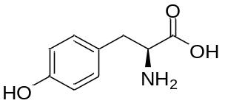
L-ornithine-derived alkaloids | 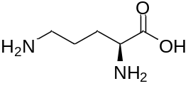
L-lysine-derived alkaloids | 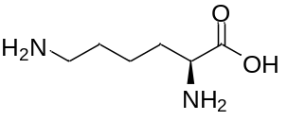
L-histidine-derived alkaloids | 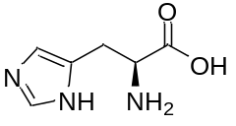
L-tryptophan-derived alkaloids | 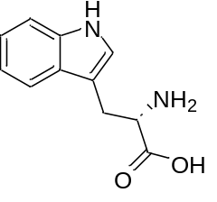
Aspartate-derived alkaloids | 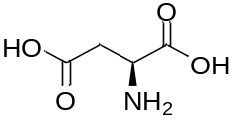
Anthranilic acid-derived alkaloids | 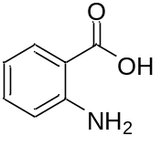
Indole alkaloids | 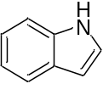
Quinoline alkaloids | 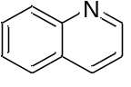
Pyrroloindole alkaloids | 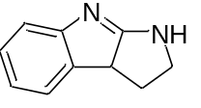
Pyrimidine-containing alkaloids | 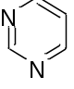
Isoquinoline alkaloids | 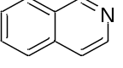
Tropane alkaloids | 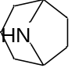
Pyrrolizidine alkaloids | 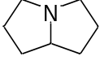
Pyrrolidine alkaloids | 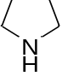
Quinolizidine alkaloids | 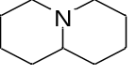
Piperidine alkaloids | 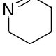
Pyridine alkaloids | 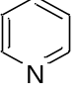
Quinazoline alkaloids | 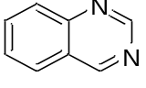
Acridone alkaloids | 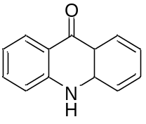
Amino acid alkaloids | 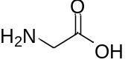
Piperazine alkaloids | 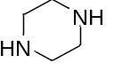
Imidazole alkaloids | 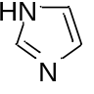
Oxazole alkaloids | 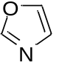
Thiazole alkaloids | 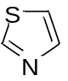
Nitriles alkaloids | 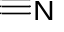
Pteridine alkaloids | 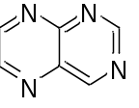
Diazene-containing alkaloids | 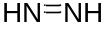
Nitro group-containing alkaloids | 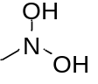
Phenazine alkaloids | 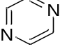
Arginine-derived alkaloids | 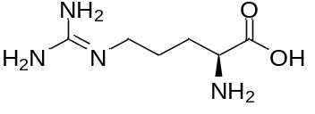
Guanidine alkaloids | 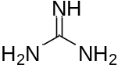
Tetrahydroisoquinoline alkaloids | 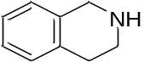
Phenoxazine alkaloids | 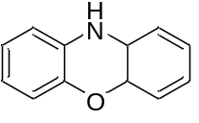
Purine alkaloids | 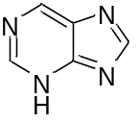
Iboga type | 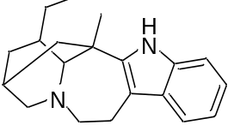
Monoterpene indole alkaloids | 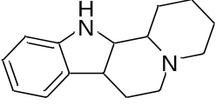
Corynanthe | 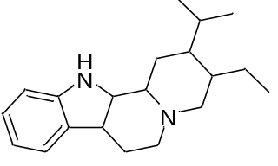
Aspidosprma | 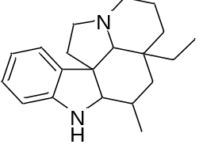
Benzylisoquinoline alkaloids | 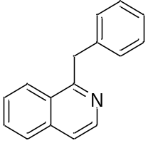
Bisbenzylisoquinoline alkaloids | 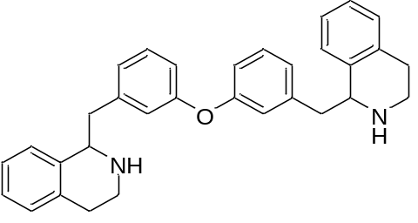
Aporphine isoquinoline alkaloids | 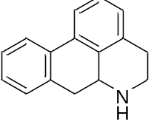
Naphthylisoquinoline alkaloids | 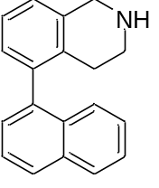
Ergot alkaloids | 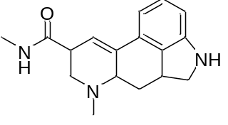
Spirobenzylisoquinoline alkaloids | 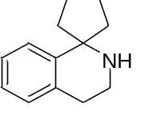
Stemona alkaloids | 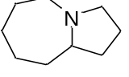
Indolizidine alkaloids | 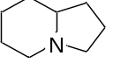

Table S10. Parameters of the embedding model.
Model | MTEB | MTEB (Retrieval task) | CMTEB | CMTEB (Retrieval task)
Qwen Text-embedding-v4 (2048 dimensions) | 71.58 | 61.97 | 71.99 | 75.01
Qwen3-Embedding-0.6B | 64.33 | 64.64 | 66.33 | 71.03
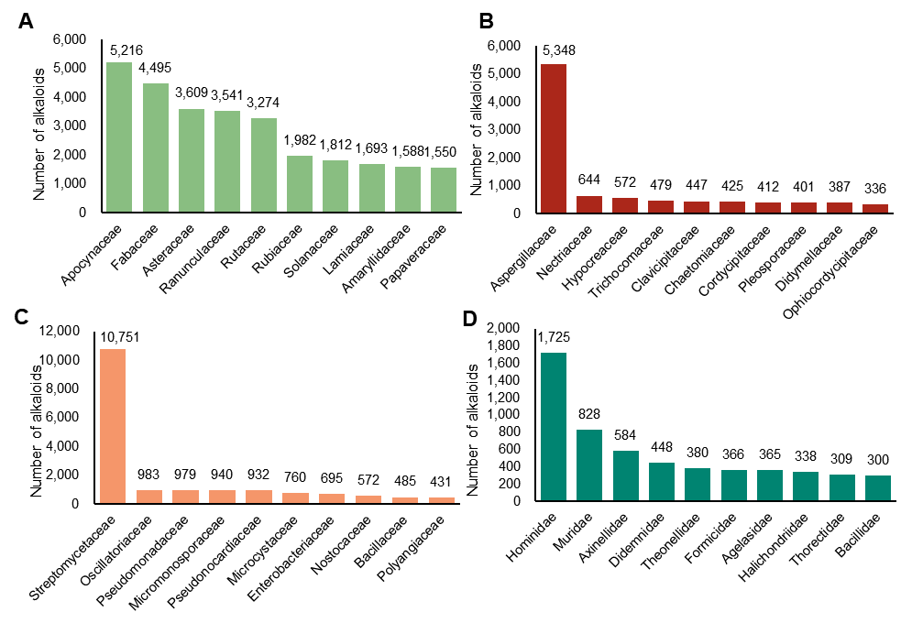
Figure S1. Number of alkaloids from the top 10 families in (A) Viridiplantae, (B) Fungi, (C) Bacteria, and (D) Metazoa.
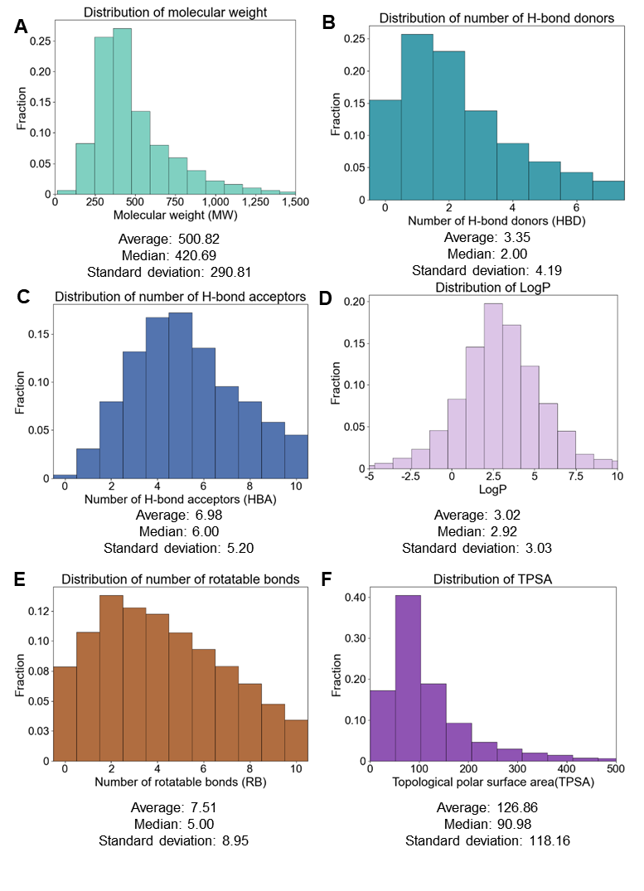
Figure S2. Statistical distribution of descriptors for alkaloids in AlkaPlorer.
(A) Molecular weight, (B) Number of H-bond donors, (C) Number of H-bond acceptors, (D) LogP, (E) Number of rotatable bonds, (F) Topological polar surface area (TPSA)
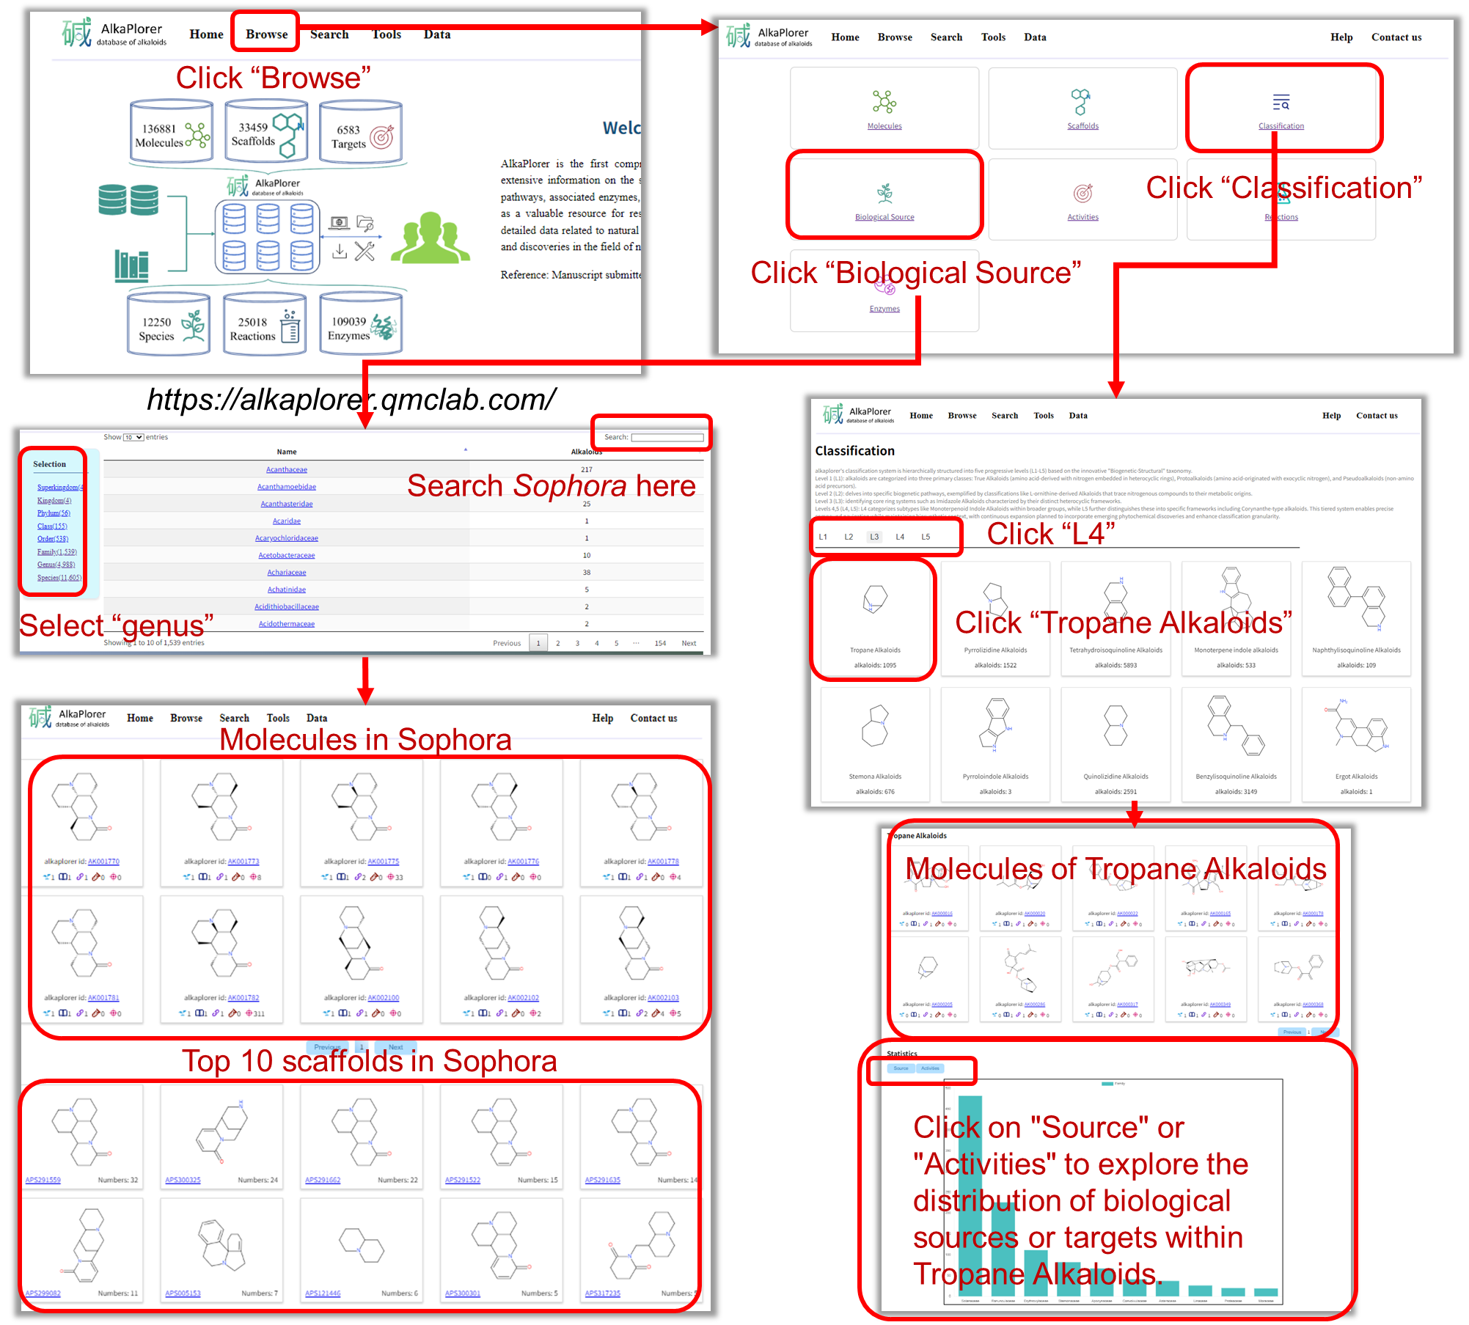
Figure S3. Step-by-step guide for exploring tropane alkaloids and the alkaloid profiles of the genus Sophora in AlkaPlorer.
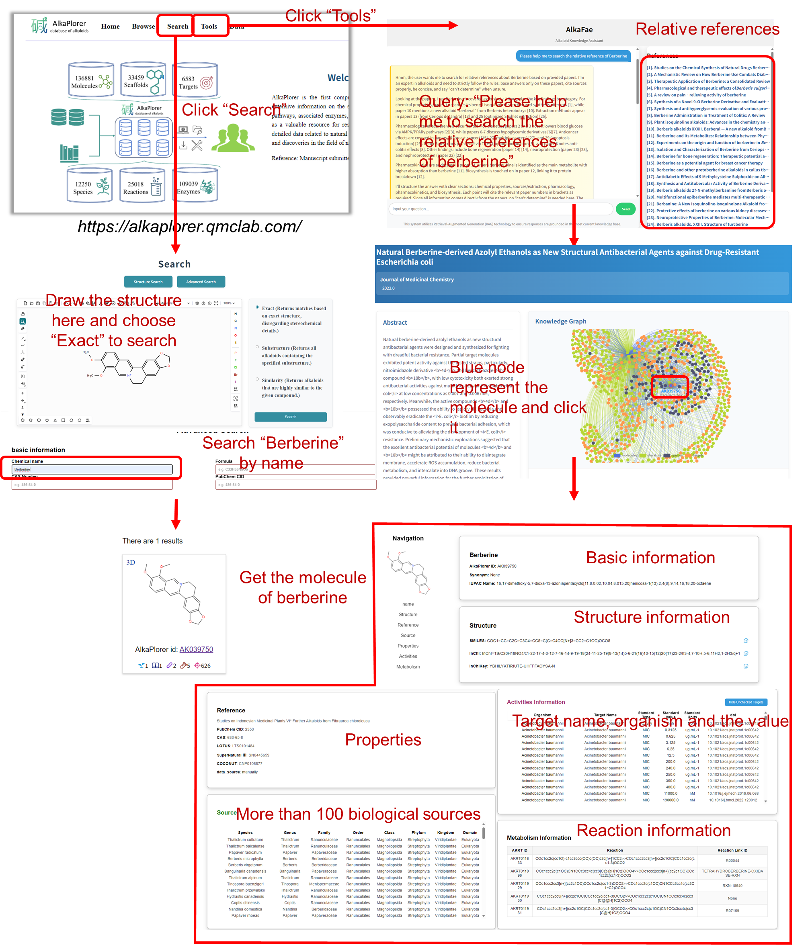
Figure S4. Step-by-step guide for retrieving a specific alkaloid, using berberine as an example, through three different search methods in AlkaPlorer.
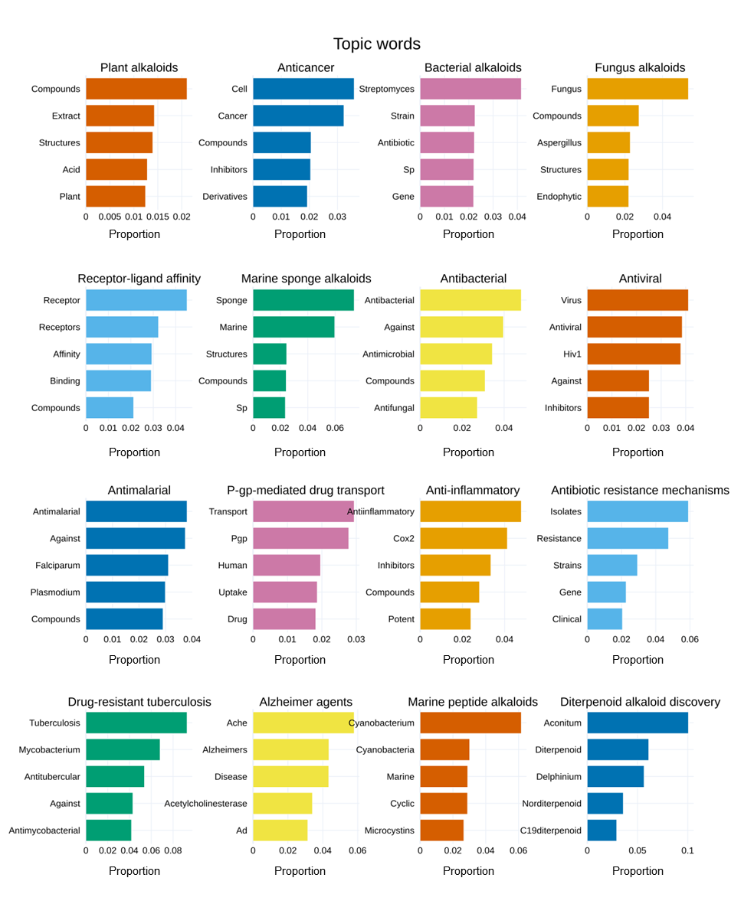
Figure S5. ​Top keyword distribution across themes.
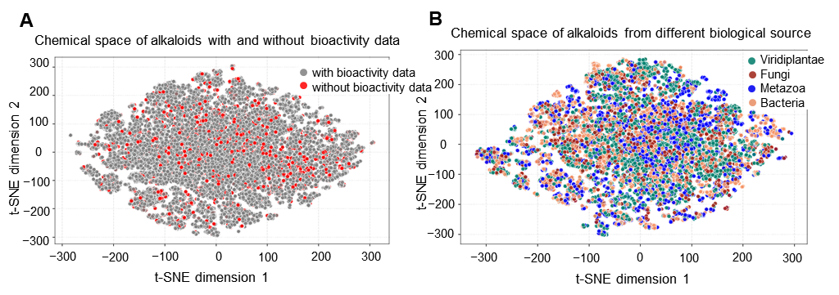
Figure S6. Comparative chemical space analysis of the alkaloid library.
(A) Chemical space of alkaloids with or without bioactivity data. (B) Chemical space of alkaloids from different biological source.
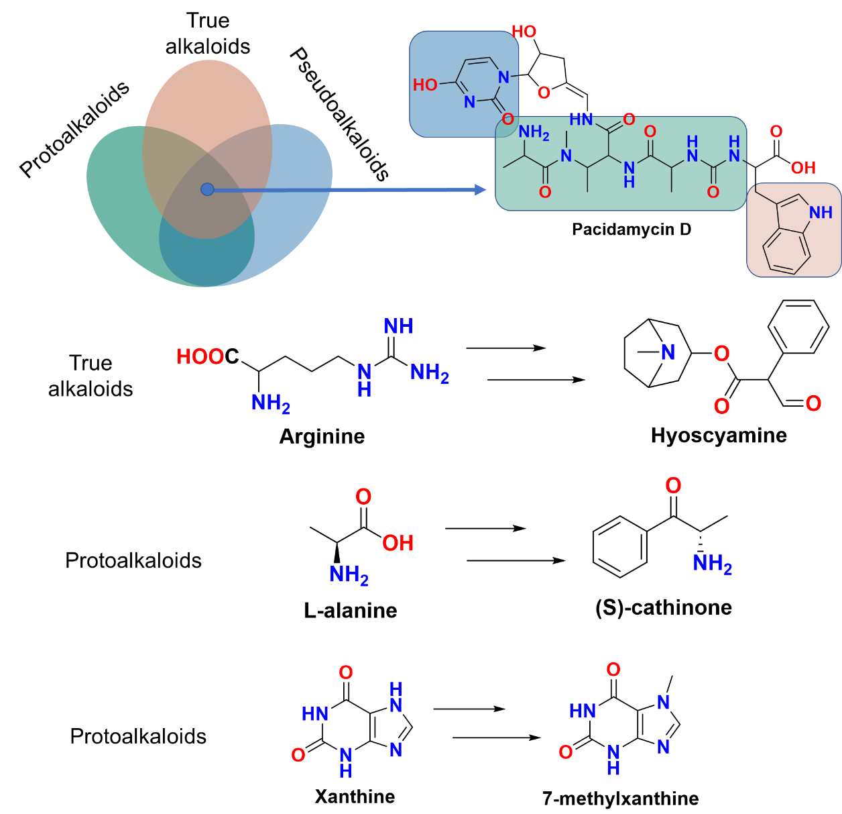
Figure S7. Examples of true alkaloids, protoalkaloids and pseudoalkaloids.

