Supplemental Information

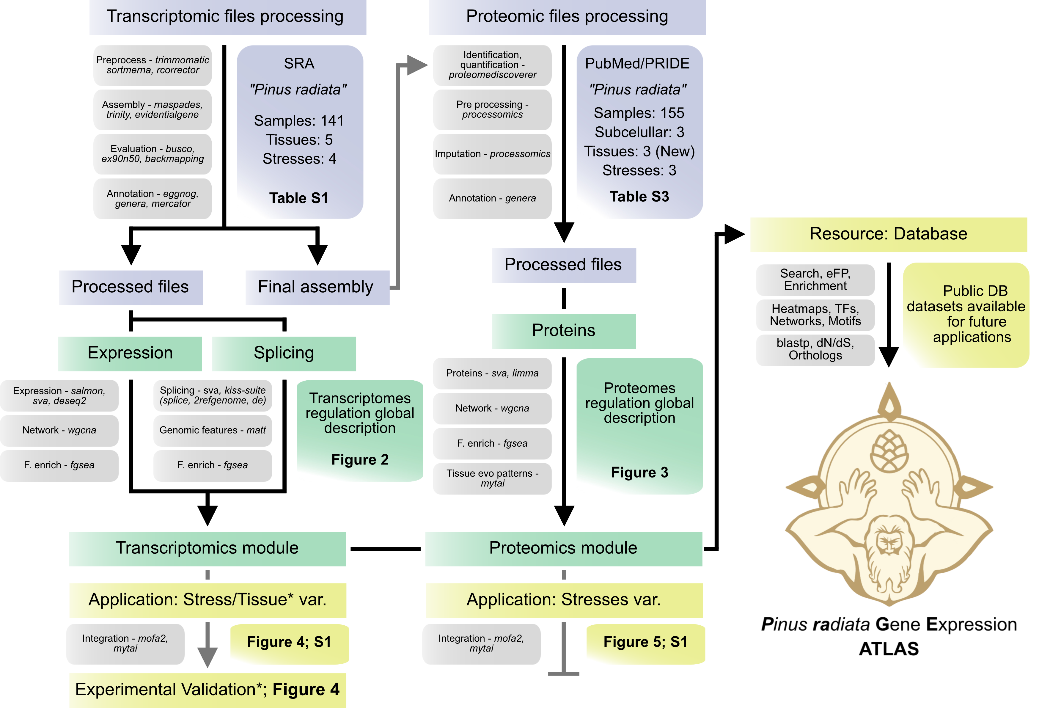

Figure S1. Overview of the methods workflow.

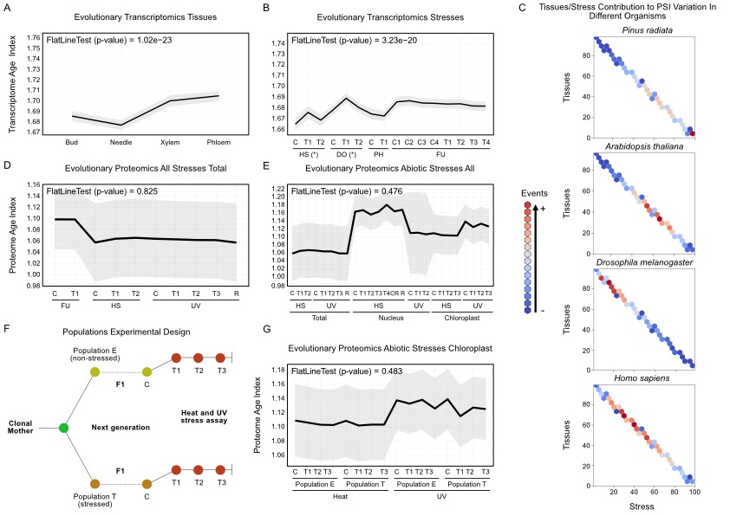
Figure S2. Evolutionary transcriptomics and proteomics patterns, tissues vs stress contribution to global PSI variation in different species and populations experimental design. A) Transcriptomic Age Index (TAI) of tissues corresponding high values to younger genes. Flat line test p-value < 0.05 highlights a significant evolutionary pattern. B) Transcriptomic Age Index (TAI) corresponding high values to younger genes. HS = heat; DO = Dothistroma; PH = Phytophthora; FU = Fusarium. Individual stress experiments with significant evolutionary patterns are highlighted with “*”. C) Comparison of the relative contribution to the total PSI variation of the tissue samples vs stress experiments in each species. The total PSI variation for each AS event is calculated as the sum of two relative contributions: (i) the PSI range across tissues, (ii) the maximum difference between PSI among stress experiments (see Methods). Colours represent the number of AS events found on each intersection between the relative contributions (in percentage) for each set of samples. D) Proteomic age index (PAI) of all stresses total proteomes corresponding high values to younger protein genes. E) Proteomic age index (PAI) of abiotic stresses all proteomes corresponding high values to younger protein genes. F) Intergenerational stress populations experimental design. The divergent local-environment conditions involved, setting Population T as reference, +50 meters elevation, +44 mm mean rainfall, and +1.72 mean ºC. Nevertheless, PopE plants were fertirrigated during the dry months. G) Proteomic age index (PAI) of abiotic stresses chloroplast proteomes corresponding high values to younger protein genes.
Table S1. Transcriptomic data collection, consensus assembly evaluation, and transcription factors and regulators identified.
Table S2. Primers used for the validation of tissues/age-induced alternative splicing.
Table S3. Proteomic data collection.

