Supplementary Information
Supplementary Figure 1. The structure of reverse transcription primer used for MP3RNA-seq.
Gray part: anchored oligo d(T) and a base “V” (V = A or C or G). Blue part: unique molecular identifiers (UMIs). Red part: barcode 1, specific for each well of plate. Yellow part: the 5ʹ Illumina sequencing adaptor.

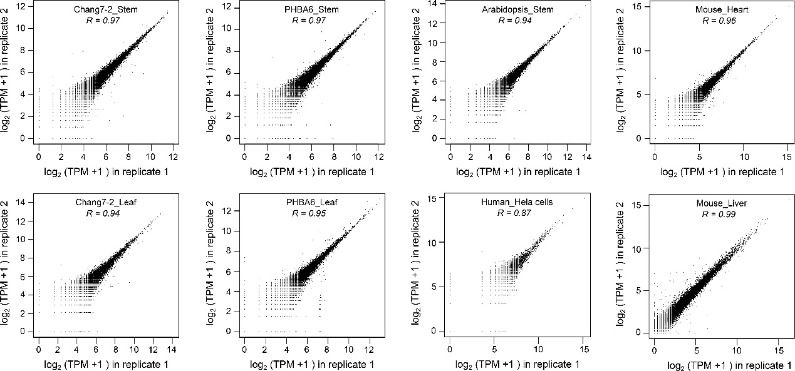
Supplementary Figure 2. Correlation between technical replicates of MP3RNA-seq.
We calculated the expression level (TPM) for each replicate separately and compared them to one another. The normalized data of log₂ (TPM value + 1) was used to calculate the correlation coefficient.
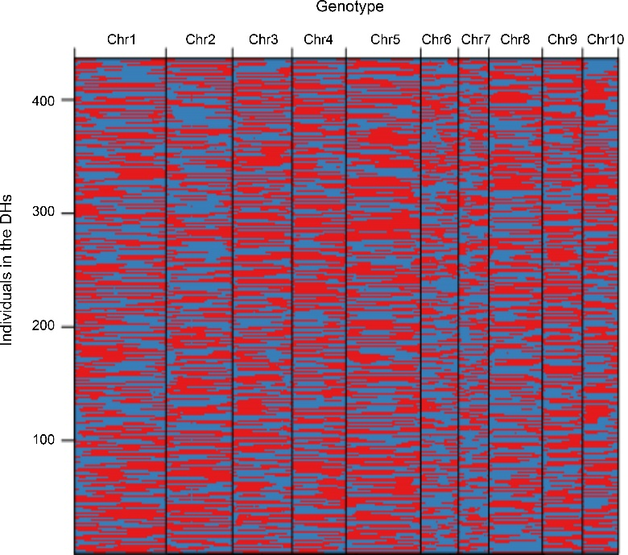
Supplementary Figure 3. Genetic linkage map of DH population.
Physical position was based on B73 RefGen_V4 sequence. Red: Chang7-2 genotype. Blue: PHBA6 genotype.
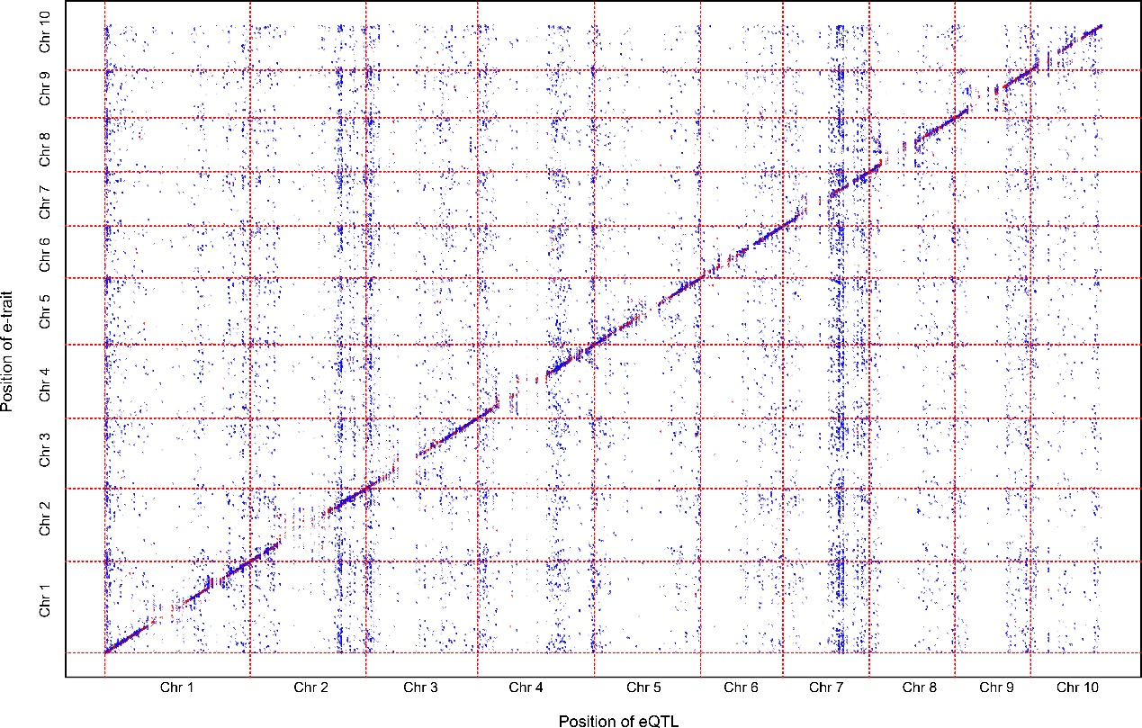
Supplementary Figure 4. Genomic distribution of eQTLs identified in the DH population.
Genomic distribution of eQTLs. Each point in the figure corresponds to an eQTL peak identified. The x-axis indicates the physical positions of the peak of eQTL, and the y-axis shows the genomic positions of the genes (e-traits). eQTLs which explained more than 20% of gene expression variation were plotted in red, otherwise were plotted in blue.
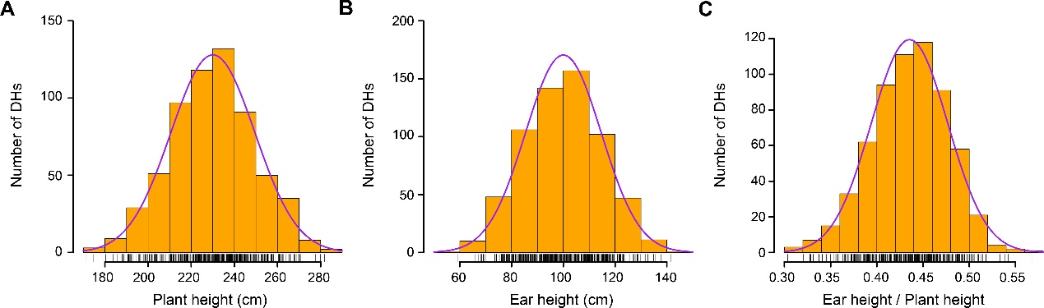
Supplementary Figure 5. The distribution of phenotypic traits of PH, EH, and EH/PH in the DH population.
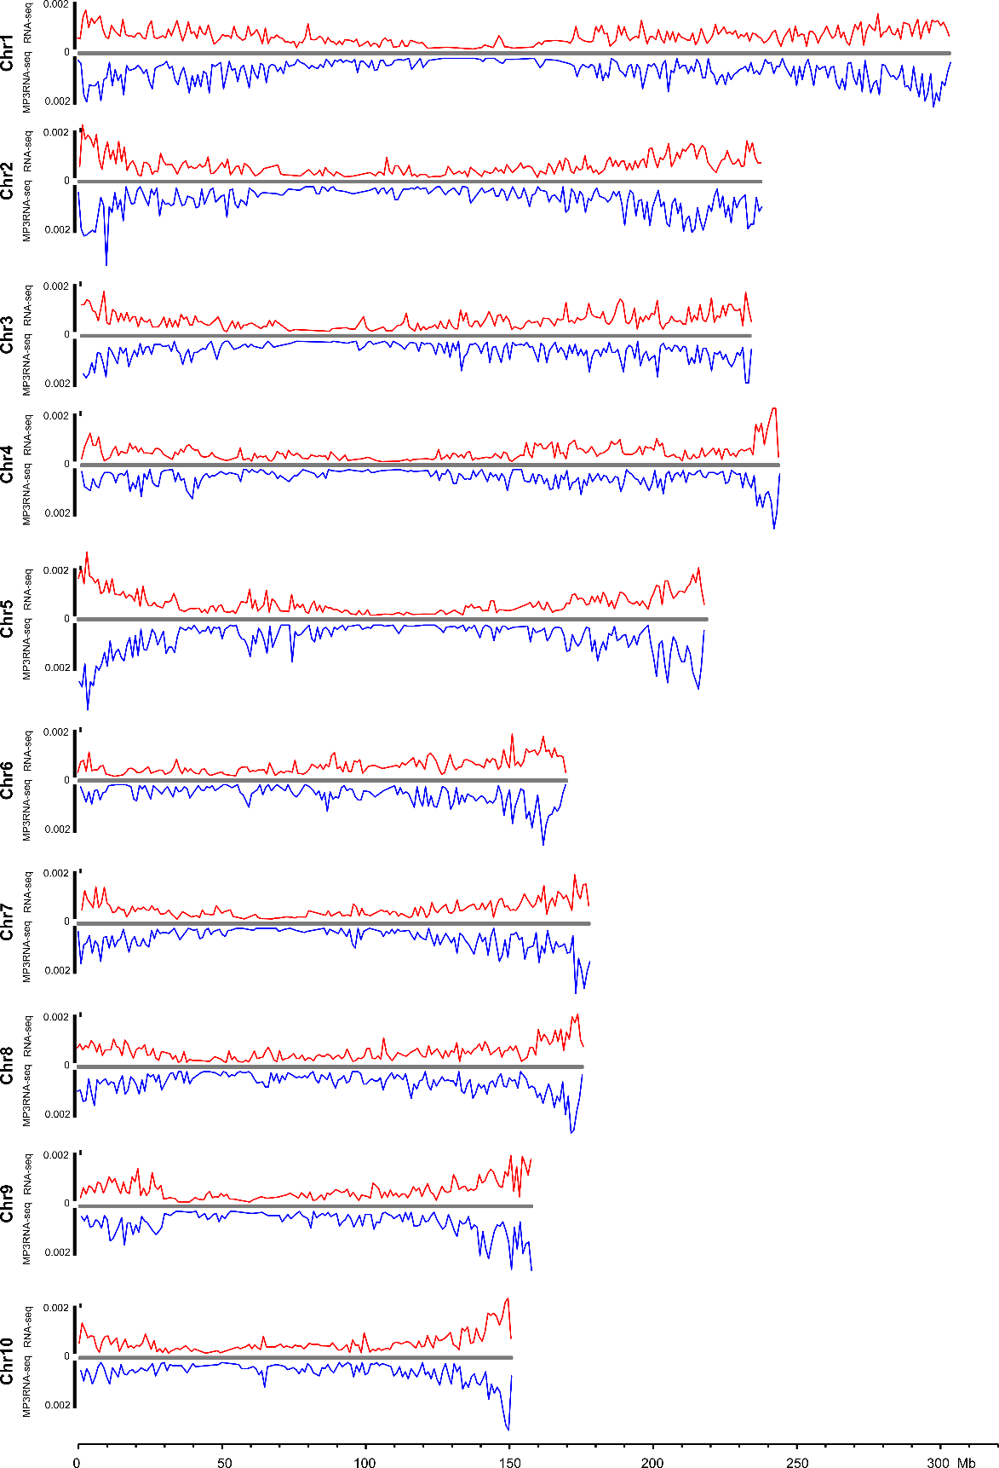
Supplementary Figure 6. Comparison of the density of SNPs along the chromosomes for SNPs identified by MP3RNA-seq and RNA-seq.
MP3RNA-seq and RNA-seq data of Chang7-2_stem was used for analysis.
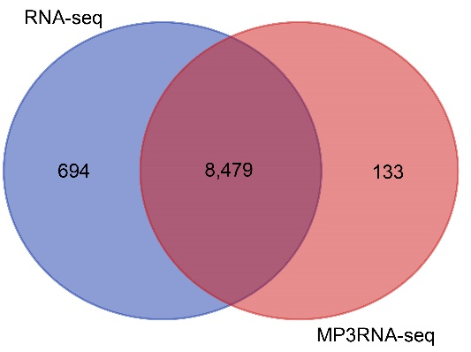
Supplementary Figure 7. Comparison of the genes with SNPs within their 3ʹ end regions identified by MP3RNA-seq and RNA-seq.
For RNA-seq, the genes identified with SNPs in the last 300 bp of transcripts were used for comparation. MP3RNA-seq and RNA-seq data of Chang7-2_stem was used for analysis.

Supplementary Table 1. A rough estimation of the total cost for library construction and sequencing of MP3RNA-seq.
Process | Cost for 96 samples
First-strand cDNA synthesis | $ 340
Second-strand cDNA synthesis | $ 7
Sample cleanup | $ 5
Tagmentation with Tn5 | $ 6
PCR enrichment | $ 2
Sequencing | $ 240
Total | $ 600
Average cost per sample | $ 6.25
Note: the cost was estimated based on that 96 samples were pooled together for MP3RNA-seq library construction.

Supplementary Table 2. Summary of MP3RNA-Seq read mapping results.
Sample | Raw reads  number | Uniquely mapped reads |  | Uniquely mapped and non-duplicated reads |  | Mapped exon reads |  | Expressed  gene number  (TPM > 1) | Cor. with  RNA-seq (r)
Sample | Raw reads  number | Number | %¹ | Number | %¹ | Number | %² | Expressed  gene number  (TPM > 1) | Cor. with  RNA-seq (r)
Chang7-2_leaf_1 | 1,560,099 | 829,976 | 53.20 | 625,920 | 40.12 | 486,040 | 77.65 | 18,705 | 0.87
Chang7-2_leaf_2 | 868,326 | 492,733 | 56.75 | 376,497 | 43.36 | 295,113 | 78.38 | 17,057 | 0.87
Chang7-2_stem_1 | 1,896,747 | 1,102,525 | 58.13 | 839,210 | 44.24 | 690,958 | 82.33 | 19,793 | 0.89
Chang7-2_stem_2 | 2,345,496 | 1,448,131 | 61.74 | 1,101,277 | 46.95 | 914,893 | 83.08 | 20,439 | 0.89
PHBA6_leaf_1 | 1,927,976 | 994,473 | 51.58 | 750,214 | 38.91 | 585,800 | 78.08 | 19,324 | 0.87
PHBA6_leaf_2 | 1,722,964 | 873,031 | 50.67 | 655,467 | 38.04 | 504,024 | 76.90 | 18,968 | 0.88
PHBA6_stem_1 | 2,187,493 | 1,328,317 | 60.72 | 1,009,352 | 46.14 | 843,161 | 83.53 | 20,052 | 0.89
PHBA6_stem_2 | 2,048,427 | 1,127,211 | 55.03 | 856,920 | 41.83 | 711,828 | 83.07 | 19,723 | 0.89
Arabidopsis_stem_1 | 745,841 | 542,543 | 72.74 | 407,419 | 54.63 | 367,493 | 90.20 | 17,912 | 0.91
Arabidopsis_stem_2 | 783,862 | 616,240 | 78.62 | 461,366 | 58.86 | 422,478 | 91.57 | 18,146 | 0.92
Mouse_liver_1 | 6,842,911 | 5,120,594 | 74.83 | 3,145,151 | 45.96 | 2,602,097 | 82.73 | 14,397 | -
Mouse_liver_2 | 22,381,125 | 17,207,028 | 76.88 | 9,262,241 | 41.38 | 7,561,383 | 81.64 | 14,594 | -
Mouse_heart_1 | 1,579,942 | 1,051,507 | 66.55 | 699,628 | 44.28 | 394,535 | 56.39 | 15,791 | -
Mouse_heart_2 | 1,541,031 | 1,050,663 | 68.18 | 727,587 | 47.21 | 410,259 | 56.39 | 15,828 | -
Human_HeLa_cells_1 | 220,376 | 98,974 | 44.91 | 76,761 | 34.83 | 61,446 | 80.05 | 14,896 | -
Human_HeLa_cells_2 | 285,715 | 139,281 | 48.75 | 106,069 | 37.12 | 85,562 | 80.67 | 16,243 | -
Note: %¹: percentage of reads according raw reads; %²: percentage of reads according uniquely mapped and non-duplicated reads.
Supplementary Table 3. Summary of RNA-Seq read mapping results.
Sample | Raw reads  number | Uniquely mapped reads |  | Uniquely mapped and  non-duplicated reads |  | Mapped exon reads |  | Expressed  gene number  (FPKM > 1)
Sample | Raw reads  number | Number | %¹ | Number | %¹ | Number | %² | Expressed  gene number  (FPKM > 1)
Chang7-2_leaf | 20,915,164 | 15,946,149 | 76.24 | 12,013,021 | 57.44 | 11,260,787 | 93.74 | 18,423
Chang7-2_stem | 21,529,916 | 16,893,344 | 78.46 | 12,996,304 | 60.36 | 12,108,841 | 93.17 | 18,594
PHBA6_leaf | 20,947,534 | 16,563,802 | 79.07 | 12,142,091 | 57.96 | 11,551,336 | 95.13 | 18,681
PHBA6_stem | 21,277,486 | 15,331,522 | 72.06 | 11,208,939 | 52.68 | 10,605,414 | 94.62 | 18,688
Arabidopsis_stem | 21,635,742 | 19,483,027 | 90.05 | 13,637,081 | 63.03 | 13,551,847 | 99.37 | 18,381
Note: %¹: percentage of reads according raw reads; %²: percentage of reads according uniquely mapped and non-duplicated reads.
Supplementary Table 4. Genomic distribution of SNPs used for genotype analysis.
Genomic region | SNP number | Percentage (%)
Exon | 30,621 | 85.45
Intron | 2,895 | 8.08
Upstream | 123 | 0.34
Downstream | 1,779 | 4.96
Intergenic | 418 | 1.17
Total | 35,836 | 100

Supplementary Table 5. Summary of the genetic linkage map of the DH population.
Chr | Genetic  Distance  (cM) | Physical  interval  (Mb) | Mean of  linkage interval  (cM) | Mean of  physical interval  (Mb) | Max of  linkage interval  (cM) | Max of  physical interval  (Mb) | Recombination  ratio | Crossover
1 | 118 | 306 | 0.240 | 0.063 | 1.054 | 15.603 | 0.384 | 2.356
2 | 111 | 244 | 0.319 | 0.069 | 4.928 | 10.891 | 0.454 | 2.186
3 | 97 | 236 | 0.270 | 0.074 | 5.209 | 8.111 | 0.412 | 1.929
4 | 75 | 245 | 0.283 | 0.086 | 2.532 | 17.568 | 0.304 | 1.500
5 | 93 | 224 | 0.245 | 0.056 | 1.782 | 4.081 | 0.415 | 1.860
6 | 72 | 173 | 0.289 | 0.087 | 2.532 | 12.173 | 0.414 | 1.436
7 | 86 | 182 | 0.403 | 0.113 | 8.851 | 13.779 | 0.472 | 1.672
8 | 75 | 181 | 0.267 | 0.063 | 1.659 | 5.863 | 0.414 | 1.491
9 | 69 | 159 | 0.296 | 0.074 | 2.030 | 13.308 | 0.432 | 1.374
10 | 61 | 151 | 0.306 | 0.079 | 2.532 | 7.159 | 0.404 | 1.202
Total | 857 | 2,101 | 0.403 | 0.113 | 8.851 | 17.568 | 0.410 | 17.006
Note: Recombination ratio: (length of linkage map)/(length of physical map), with a unit of cM/Mb.

Supplementary Table 6. Number of eQTL mapped for each gene
Number of eQTL | Gene number | Percentage (%)
1 | 7,977 | 52.02
2 | 4,965 | 32.38
3 | 1,829 | 11.93
4 | 450 | 2.93
5 | 87 | 0.57
6 | 21 | 0.14
7 | 6 | 0.04

Supplementary Table 7: eQTL summary
Type | number | Percentage (%) | R² (%)*
cis-eQTL | 8,144 | 31.57 | 28.43
trans-eQTL | 17,653 | 68.43 | 6.93
Total | 25,797 | 100 | 17.68
*: Average expression variation explained by eQTL for each type.
Supplementary Table 8: QTL identified for PH, EH, and EH/PH.
Trait | QTL | Chr | Peak_position (Mb) | Left_position (Mb) | Right_position (Mb) | Physical length% (Mb) | Peak_LOD | R2# | Additive*
PH | qPH2 | 2 | 21.816 | 16.410 | 30.304 | 13.894 | 8.072 | 5.814 | 7.454
 | qPH4 | 4 | 160.463 | 146.707 | 165.122 | 18.414 | 9.468 | 6.082 | -11.210
 | qPH5 | 5 | 209.619 | 197.252 | 210.195 | 12.942 | 9.813 | 9.054 | 10.324
 | qPH6 | 6 | 117.250 | 100.496 | 122.043 | 21.548 | 6.521 | 3.344 | -8.697
 | qPH7 | 7 | 164.337 | 159.796 | 166.617 | 6.821 | 12.753 | 9.492 | 11.150
 | qPH10 | 10 | 114.053 | 77.701 | 121.922 | 44.221 | 5.692 | 2.262 | 5.658
EH | qEH2a | 2 | 2.109 | 0.040 | 3.402 | 3.362 | 6.521 | 8.591 | 4.831
 | qEH2b | 2 | 21.386 | 19.968 | 29.818 | 9.850 | 17.840 | 10.937 | 9.138
 | qEH3 | 3 | 184.686 | 180.801 | 189.138 | 8.337 | 10.631 | 8.537 | -7.840
 | qEH4 | 4 | 241.017 | 239.538 | 241.796 | 2.258 | 6.196 | 2.076 | 4.902
 | qEH5 | 5 | 211.464 | 194.478 | 212.393 | 17.915 | 6.505 | 3.766 | 5.428
 | qEH6 | 6 | 90.174 | 78.624 | 99.390 | 20.767 | 8.374 | 4.350 | -7.017
 | qEH7 | 7 | 136.722 | 134.904 | 150.909 | 16.005 | 7.813 | 6.167 | 6.208
 | qEH8 | 8 | 130.405 | 123.104 | 136.180 | 13.076 | 11.813 | 7.777 | -7.632
EH/PH | qEH/PH1 | 1 | 23.604 | 18.004 | 25.770 | 7.766 | 5.046 | 2.108 | -0.013
 | qEH/PH2a | 2 | 2.253 | 1.968 | 3.402 | 1.434 | 5.000 | 7.727 | 0.014
 | qEH/PH2b | 2 | 28.155 | 21.199 | 29.818 | 8.619 | 11.101 | 5.400 | 0.021
 | qEH/PH3 | 3 | 183.449 | 182.900 | 186.199 | 3.299 | 19.691 | 13.000 | -0.030
 | qEH/PH4 | 4 | 240.651 | 239.934 | 241.710 | 1.777 | 9.705 | 3.787 | 0.019
 | qEH/PH6 | 6 | 4.640 | 0.170 | 60.132 | 59.962 | 6.291 | 3.712 | -0.018
 | qEH/PH8 | 8 | 123.949 | 120.902 | 127.371 | 6.469 | 20.824 | 13.525 | -0.032
%: 1.5-LOD support interval of the QTL. #: Average expression variation explained by eQTL for each type.
*: Additive effect: positive values of the additive effect indicate that alleles from PHBA6 were in the direction of increasing trait score. Negative values of the additive effect indicate that alleles from Chang7-2 were in the direction of increasing trait score.

Supplementary Table 9: Pearson correlation coefficients among different traits.
Lower left, the correlation coefficients; Upper right, p-values of correlation test.
 | EH | PH | EH/PH
EH |  | < 2.2E-16 | < 2.2E-16
PH | 0.7611 |  | 1.59E-09
EP/PH | 0.7937 | 0.2393

Supplementary Table 10: Comparison of detected QTLs between this study and previous studies.
Trait | QTL | Chr | Peak_position  (Mb) | Physical length  (Mb) | Overlapped  QTL* | Reference
PH | qPH2 | 2 | 21.816 | 13.894 | umc1845-bnlg0166 | Salvi et al.
 |  |  |  |  | umc1261–umc1845 | Park et al.
 | qPH4 | 4 | 160.463 | 18.414 | q1PH4-2 | Ku et al.
 | qPH5 | 5 | 209.619 | 12.942 | q1PH5 | Ku et al.
 |  |  |  |  | q3PH5 | Ku et al.
 | qPH6 | 6 | 117.250 | 21.548 | umc1014-umc1762 | Tang et al.
 |  |  |  |  | umc1656-umc1796 | Yan et al.
 |  |  |  |  | umc1595-phi031 | Yan et al.
 | qPH7 | 7 | 164.337 | 6.821 | q1PH7 | Ku et al.
 |  |  |  |  |  | Ku et al.
EH | qEH2b | 2 | 21.386 | 9.850 | qEH2 | Wang et al.
 | qEH3 | 3 | 184.686 | 8.337 | q1EH3-2 | Ku et al.
 |  |  |  |  | umc1400- umc1286 | Tang et al.
 | qEH5 | 5 | 211.464 | 17.915 | bmc1208-umc1019 | Tang et al.
 |  |  |  |  | phi087-bnlg2305 | Yan et al.
 | qEH6 | 6 | 90.174 | 20.767 | qEH6 | Wang et al.
 | qEH7 | 7 | 136.722 | 16.005 | bnlg1305-bnlg339 | Yan et al.
 |  |  |  |  | qEH7 | Wang et al.
 | qEH8 | 8 | 130.405 | 13.076 | umc1950–umc1309 | Park et al.
EH/PH | qEH/PH3 | 3 | 183.449 | 3.299 | qEP3a | Wang et al.
 | qEH/PH6 | 6 | 4.640 | 59.962 | qEP6 | Wang et al.
 | qEH/PH8 | 8 | 123.949 | 6.469 | qEP8 | Wang et al.
*: QTLs identified in previous studies

References:
Ku, L., Zhang, L., Tian, Z., Guo, S., Su, H., Ren, Z., Wang, Z., Li, G., Wang, X., and Zhu, Y. (2015). Dissection of the genetic architecture underlying the plant density response by mapping plant height-related traits in maize (Zea mays L.). Molecular Genetics & Genomics 290: 1223-1233.
Park, K.J., Sa, K.J., Kim, B.W., Koh, H.J., and Ju, K.L. (2014). Genetic mapping and QTL analysis for yield and agronomic traits with an F 2:3 population derived from a waxy corn × sweet corn cross. Genes. Genom. 36: 179-189.
Sibov, S.T., Jr, D.S.C., Garcia, A.A., Silva, A.R., Garcia, A.F., Mangolin, C.A., Benchimol, L.L., and de Souza, A.P. (2003). Molecular mapping in tropical maize (Zea mays L.) using microsatellite markers. 2. Quantitative trait loci (QTL) for grain yield, plant height, ear height and grain moisture. Hereditas 139: 107-115.
Tang, Z., Yang, Z., Hu, Z., Zhang, D., Lu, X., Jia, B., Deng, D., and Xu, C. (2013). Cytonuclear epistatic quantitative trait locus mapping for plant height and ear height in maize. Mol. Breeding 31: 1-14.
Wang, B., Liu, H., Liu, Z., Dong, X., Guo, J., Li, W., Chen, J., Gao, C., Zhu, Y., and Zheng, X. (2018). Identification of minor effect QTLs for plant architecture related traits using super high density genotyping and large recombinant inbred population in maize (Zea mays). BMC Plant Biol. 18: 17.
Yan, Z., Yong-Xiang, L.I., Yang, W., Liu, Z.Z., Cheng, L., Bo, P., Tan, W.W., Di, W., Shi, Y.S., and Sun, B.C. (2010). Stability of QTL across environments and QTL-by-environment interactions for plant and ear height in maize. J. Integr. Agr. 9: 1400-1412.

