Supporting Information
Development of Genome-wide Insertion/Deletion Markers in Rice Based on Graphic Pipeline Platform
Yang Lü^{1,4}, Xiao Cui^{1,4}, Rui Li¹, Piaopiao Huang¹, Jie Zong², Danqing Yao³, Gang Li³, Dabing Zhang¹, Zheng Yuan^{1,*}
¹State Key Laboratory of Hybrid Rice, School of Life Sciences and Biotechnology, Shanghai Jiao Tong University, Shanghai 200240, China;
²Novel Bioinformatics Company, Shanghai 200240, China;
³Shanghai Agricultural Technology Extension and Service Center, Shanghai 201103, China.
⁴These authors contribute equally to this work.
* To whom correspondence should be addressed. Tel: 0086-21-34204869; Fax: 0086-21-34204869; E-mail: zyuan@sjtu.edu.cn.

Table S1. Default parameters setting for primer design in Primer3 software.
Default parameters | Value
Product size | 80-200
Excluded region ª | InDels
Primer product optimal size | 0
Primer GC clamp | 1
Primer Max end stability | 100
Primer min size | 20
Primer Max size | 28
Primer optimal size | 25
Primer Min Tm | 53
Primer Max Tm | 62
Primer optimal Tm ^{b} | 57
Primer Max different Tm | 4
Primer Min GC content | 35
Primer Max GC content | 70
Primer optimal GC content | 45
ª Excluded region: insertion/deletion sequences regions.
^{b} Primer optimal Tm: The thermodynamic parameters (Breslauer et al. 1986).

Table S2. Distribution pattern of e-PCR validated markers with different InDels in length in Nipponbare and 93-11 using AGA-pipe.
Interval |  |  | Class width | Frequency | Percent | Cumulative
Lower |  | Upper | Class width | Frequency | Percent | Frequency | Percent
5 | < | 10 | 5 | 4879 | 37.7 | 4,879 | 37.7
10 | < | 15 | 5 | 3,174 | 24.5 | 8,053 | 62.2
15 | < | 20 | 5 | 1,702 | 13.1 | 9,755 | 75.4
20 | < | 25 | 5 | 1,169 | 9.0 | 10,924 | 84.4
25 | < | 30 | 5 | 706 | 5.5 | 11,630 | 89.8
30 | < | 35 | 5 | 530 | 4.1 | 12,160 | 93.9
35 | < | 40 | 5 | 228 | 1.8 | 12,388 | 95.7
40 | < | 45 | 5 | 147 | 1.1 | 12,535 | 96.8
45 | < | 50 | 5 | 106 | 0.8 | 12,641 | 97.7
50 | < | 55 | 5 | 85 | 0.7 | 12,726 | 98.3
55 | < | 60 | 5 | 60 | 0.5 | 12,786 | 98.8
60 | < | 65 | 5 | 52 | 0.4 | 12,838 | 99.2
65 | < | 70 | 5 | 35 | 0.3 | 12,873 | 99.5
70 | < | 75 | 5 | 33 | 0.3 | 12,906 | 99.7
75 | < | 80 | 5 | 22 | 0.2 | 12,928 | 99.9
80 | < | 85 | 5 | 12 | 0.1 | 12,940 | 100
85 | < | 90 | 5 | 4 | 0.0 | 12,944 | 100

Table S3. Statistical analysis of md-InDels and hq-InDels of Kasalath and 9311 against Nipponbare genome.
Chromosome | Nipponbare ª/Kasalath ^{b} |  | Nipponbare/9311 ^{c}
Chromosome | md-InDels ^{d} | hq-InDelse ^{f} | md-InDels | hq-InDels
chr01 | 13,464 | 5,622 | 12,376 | 5,020
chr02 | 9,277 | 3,817 | 10,636 | 2,224
chr03 | 9,878 | 4,552 | 9,032 | 1,996
chr04 | 7,367 | 2,803 | 6,396 | 2,136
chr05 | 8,146 | 3,405 | 6,469 | 4,310
chr06 | 8,158 | 3,308 | 7,494 | 3,967
chr07 | 7,467 | 3,029 | 7,371 | 2,503
chr08 | 6,813 | 2,965 | 6,810 | 2,800
chr09 | 5,918 | 2,259 | 6,417 | 2,967
chr10 | 5,863 | 2,342 | 5,785 | 2,777
chr11 | 6,492 | 2,497 | 5,637 | 2,842
chr12 | 5,887 | 2,247 | 6,125 | 2,524
Total | 94,730 | 38,846 | 90,548 | 36,066
Frequency (per 1 Mb) | 24.7 | 10.1 | 23.7 | 9.4
ª Nipponbare reference genome (IRGSP build 5).
^{b} Kasalath reference genome
^{c} 93-11 reference genome (GeneBank accession--GCA_000004655.2).
^{d} md-InDels: the lengths of InDel polymorphisms were from 6 to 100 bp.
^{e} hq-InDels: md-InDels with no other polymorphisms more than 6 bp in length existed in the 300 bp region flanking the Indel.
^{f} Frequency: markers per BAC according to Nipponbare genome.

Table S4. Statistical analysis of InDels under different sequencing depth among Wu-Yun-Geng7 (WYG7), Guang-Lu-Ai4 (GLA4) and Nipponbare genome.
Length of | WYG7/GLA4 |  |  |  | GLA4/Nipponbare |  |  |  | WYG7/Nipponbare
polymorphism | x2 | x5 | x10 | x17 ª | x2 | x5 | x10 | x17 | x2 | x5 | x10 | x17
1-5 bp | 17,622 | 81,492 | 167,130 | 203,250 | 17,401 | 80,087 | 160,511 | 193,295 | 6,528 | 20,509 | 34,569 | 39,988
6-100 bp ^{b} | 3,683 | 16,255 | 34,794 | 45,437 | 3,730 | 16,137 | 33,432 | 43,138 | 886 | 3,252 | 6,301 | 7,517
>100 bp | 322 | 1,530 | 3,325 | 4,454 | 367 | 1,682 | 3,520 | 4,574 | 85 | 365 | 692 | 846
Percentage of md-InDels | 0.17 | 0.16 | 0.17 | 0.18 | 0.17 | 0.16 | 0.17 | 0.18 | 0.12 | 0.13 | 0.15 | 0.16
ª x2, x5, x10, x17: the re-sequencing depth of GLA4 and WYG7.
^{b} 6-100 bp: md-InDels.

Table S5. Distribution pattern of e-PCR validated markers with different InDels in length in WYG7 and GLA4 with re-sequencing depth of 10.
Interval |  |  | Class width | Frequency | Percent | Cumulative
Lower |  | Upper | Class width | Frequency | Percent | Frequency | Percent
5 | < | 10 | 5 | 6107 | 40.0 | 6,107 | 40.0
10 | < | 15 | 5 | 4042 | 26.5 | 10,149 | 66.5
15 | < | 20 | 5 | 2045 | 13.4 | 12,194 | 79.9
20 | < | 25 | 5 | 1186 | 7.8 | 13,380 | 87.7
25 | < | 30 | 5 | 738 | 4.8 | 14,118 | 92.5
30 | < | 35 | 5 | 512 | 3.4 | 14,630 | 95.8
35 | < | 40 | 5 | 267 | 1.7 | 14,897 | 97.6
40 | < | 45 | 5 | 151 | 1.0 | 15,048 | 98.6
45 | < | 50 | 5 | 89 | 0.6 | 15,137 | 99.2
50 | < | 55 | 5 | 65 | 0.4 | 15,202 | 99.6
55 | < | 60 | 5 | 26 | 0.2 | 15,228 | 99.8
60 | < | 65 | 5 | 25 | 0.2 | 15,253 | 99.9
65 | < | 70 | 5 | 7 | 0.0 | 15,260 | 100.0
70 | < | 75 | 5 | 3 | 0.0 | 15,263 | 100.0
75 | < | 80 | 5 | 2 | 0.0 | 15,265 | 100.0

Table S6. Cultivars information used in this study.
Group | Symbol | Sample ID | Origin | Status | NCBI Accession
Indica | 93-11 | GCA_000004655.2 | China | Elite | ASM465v1
Indica | GLA4 | 1121494 | China | Improved | ERX005522
Indica | GYT | IRGC 51300 | China | Landrace | SRX025250
Indica | ACH | IRGC 51250 | China | Landrace | SRX025249
Indica | P165 | IRGC 43545 | Indonesia | Landrace | SRX025248
Indica | JC91 | IRGC 9177 | India | Elite | SRX025263,SRX025239
Indica | IR36 | IRGC 30416 | Brazil | Improved | SRX025238,SRX025268
Indica | LP | IRGC 27762 | Thailand | Landrace | SRX025237,SRX025288
Indica | G57 | IRGC 8231 | Vietnam | Landrace | SRX025223,SRX025276
Indica | MH63 | 2222351 | China | Landrace | -
Indica | IR26 | IR26 | Philippines | Landrace | -
Japonica | NIP | NIP | Japan | Elite | -
Japonica | NK | 112150 | Japan | Elite | ERX005523
Japonica | WYG7 | WYG7 | China | Landrace | SRX876438
Japonica | CDF | IRGC 50448 | Brazil | Elite | SRX025229,SRX025295
Japonica | LEM | IRGC 66756 | TX, USA | Elite | SRX025235,SRX025289
Japonica | Om | 217425 | Japan | Elite | DRX000450
Japonica | HM | IRGC 2540 | Japan | Elite | SRX025275,SRX025225
Japonica | CDJ | IRGC 55471 | South Korea | Landrace | SRX025279,SRX025222
Japonica | DJ | Dongjin | Japan | Landrace | -
Japonica | ZH | ZH-11 | China | Landrace | -
GLA4: Guang-Lu-Ai4, GYT: Guan-Yin-Tsan, ACH: Ai-Chiao-Hong, P165: Popot 165, LP: Leung Pratew, G57: Gie 57, MH63: Minghui 63. NIP: Nipponbare, NK: Nongken-58, WYG7: Wu-Yun-Geng7, CDF: Canella De Ferro, LEM: Lemont, Om: Omachi, HM: Haginomae Mochi, CDJ: Chodongji, DJ: Dongjin, ZH: Zhonghua-11.
The sample ID of GLA4, MH63, NK and Om are NCBI BioSample ID.
“-“: not available on NCBI.
Table S7. Mapping information of all available re-sequence data used in this study.
Subgroup | Cultivar | Reads Length | Insert Size | Mapped reads | Mapping rate | Depth | Coverage ª | No. of InDels ^{b}
Japonica | WYG7 | 98 | 200 | 139,147,023 | 97.56% | 34.14 | 95.19% | 9,099
Japonica | NK | 41 | 400 | 120,042,416 | 99.04% | 11.53 | 91.76% | 1,641
Japonica | OM | 76 | 260 | 257,128,128 | 98.89% | 46.24 | 95.03% | 8,800
Japonica | HM | 45, 101 | 187,480 | 85,225,909 | 98.84% | 17.25 | 94.00% | 8,472
Japonica | CDF | 45, 101 | 187,480 | 79,611,621 | 96.20% | 16.48 | 89.51% | 20,662
Japonica | CDJ | 45, 101 | 187,480 | 76,303,523 | 98.39% | 15.96 | 92.33% | 8,316
Japonica | LEM | 45, 101 | 187,480 | 62,140,254 | 96.02% | 12.59 | 88.47% | 17,045
Indica | GLA4 | 74 | 400 | 85,941,415 | 92.70% | 14.88 | 85.57% | 53,472
Indica | GYT | 101 | 480 | 58,344,850 | 92.56% | 13.58 | 81.08% | 49,400
Indica | ACH | 101 | 480 | 59,406,435 | 94.86% | 13.8 | 80.92% | 49,562
Indica | G57 | 45, 101 | 187,480 | 70,723,185 | 91.88% | 14.5 | 86.25% | 55,716
Indica | IR36 | 45, 101 | 187,480 | 77,700,964 | 91.03% | 15.42 | 85.32% | 56,867
Indica | JC91 | 45, 101 | 187,480 | 71,513,182 | 92.55% | 14.98 | 85.08% | 53,174
Indica | LP | 45, 101 | 187,480 | 64,238,200 | 86.26% | 13.08 | 85.44% | 53,625
Indica | P165 | 101 | 480 | 57,016,321 | 91.92% | 13.22 | 82.33% | 53,173
ª Coverage: The genome coveragewas calculated at a minimum sequencing depth of 2 to reference genome.
^{b} No. of InDels: md-InDels of each cultivar against Nipponbare reference genome.

Cultivar 1
Reference Genome
Cultivar 2
Deletion
Insertion
Figure S1. InDels identification using re-sequencing data mapping strategy.
Reference genome is used as a ‘bridge’ to compare two cultivars with NGS data. Orange thick line represents reference genome (such as Nipponbare IRGSP build 5). Orange thin line represents re-sequencing reads (such as Wu-Yun-Geng7 or Guang-Lu-Ai4). Blue dashed implies the InDel polymorphism (insertion or deletion).

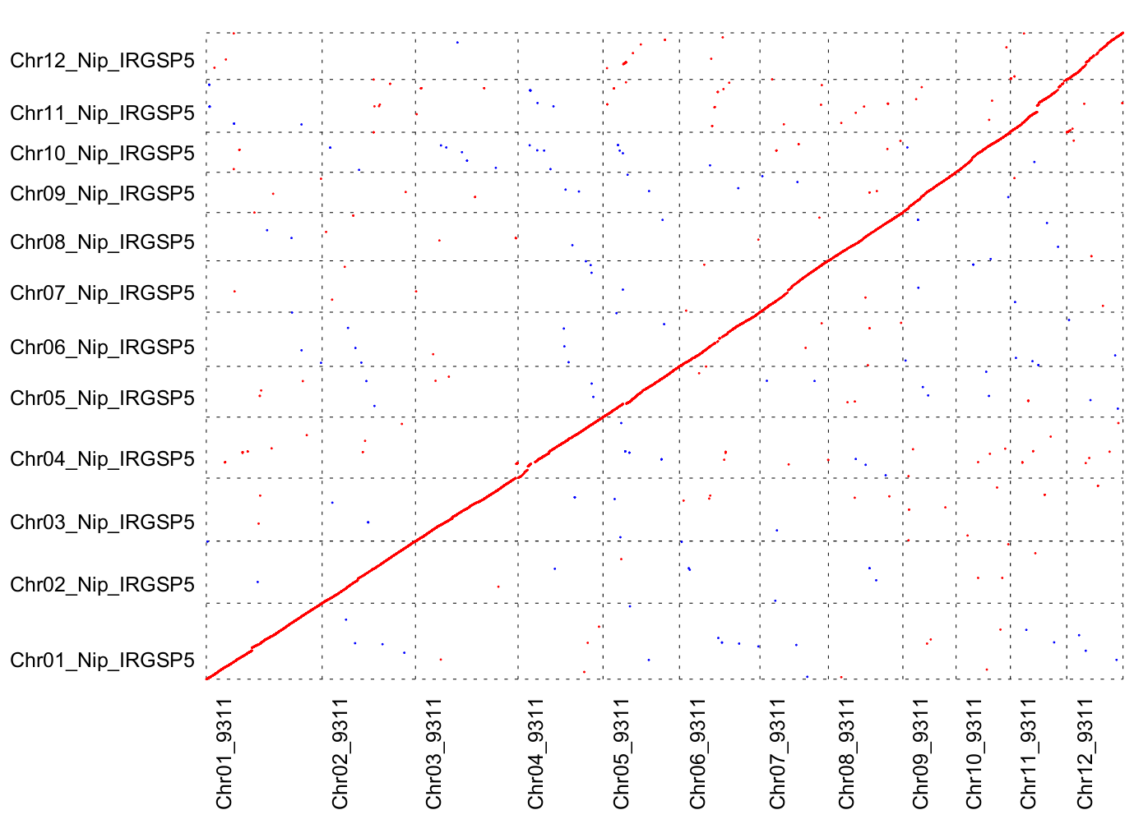
Figure S2. Collinearity analysis between Nipponbare and 93-11 genome.
Red line shows the collinearity of Nipponbare with 93-11 genome. Red dots or blue dots represent structure variation.

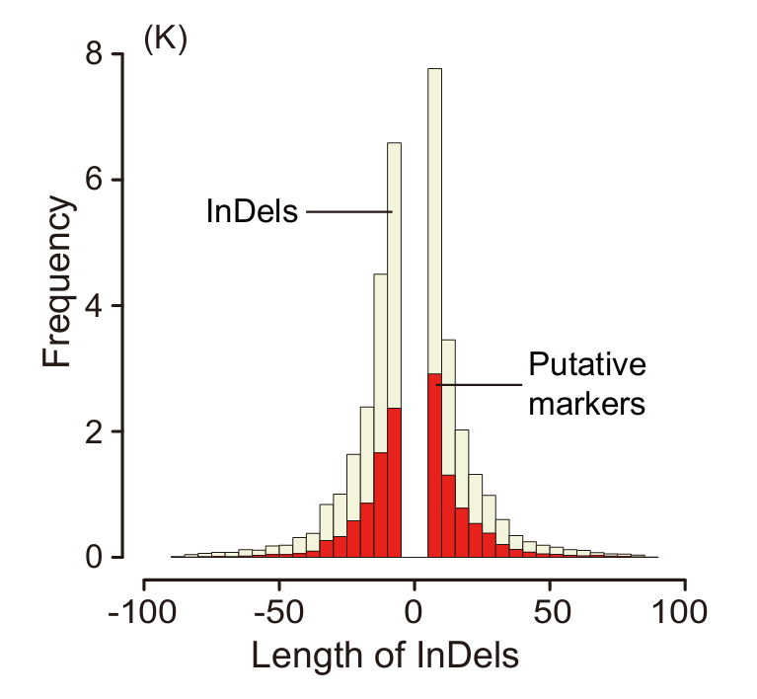
Figure S3. The length distribution pattern of InDels and e-PCR validated markers in Nipponbare/93-11 genome using AGA-pipe.

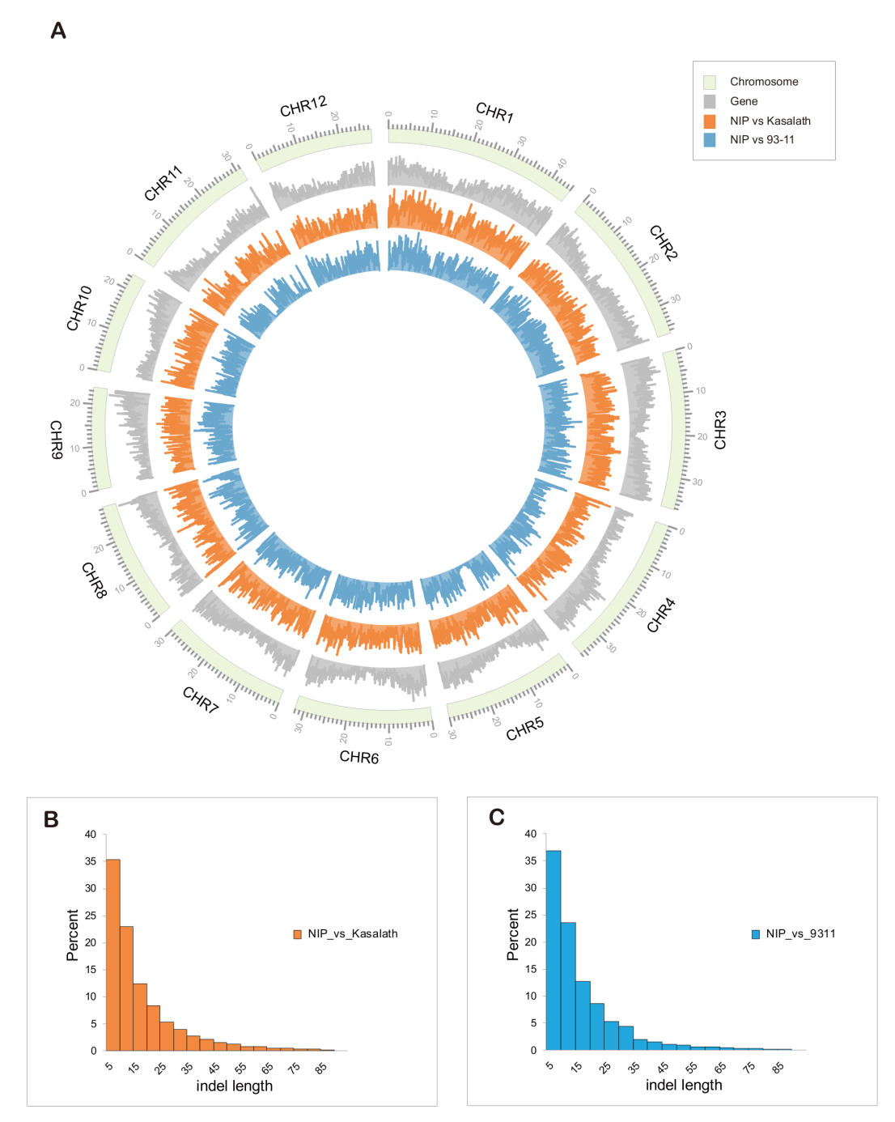
Figure S4. Distribution of hq-InDels of 93-11 and Kasalath against Nipponbare reference genome.
36,066 and 38,846 hq-InDels were detected in Nipponbare/93-11, Nipponbare/Kasalath respectively. Layers in (A) are the distribution of chromosomes (in beige), genes (in grey), InDels in Nipponbare/Kasalath (in orange), InDels in Nipponbare/93-11 (in blue) from inward orientation (100 Kb each bin, max = 50). (B) and (C) show that the length of most InDels are between 6 bp and 50 bp. The density of InDels was 9.4 per 100 Kb in Nipponbare/93-11 genome, 10.1 per 100 Kb in Nipponbare/Kasalath genome. NIP: Nipponbare.

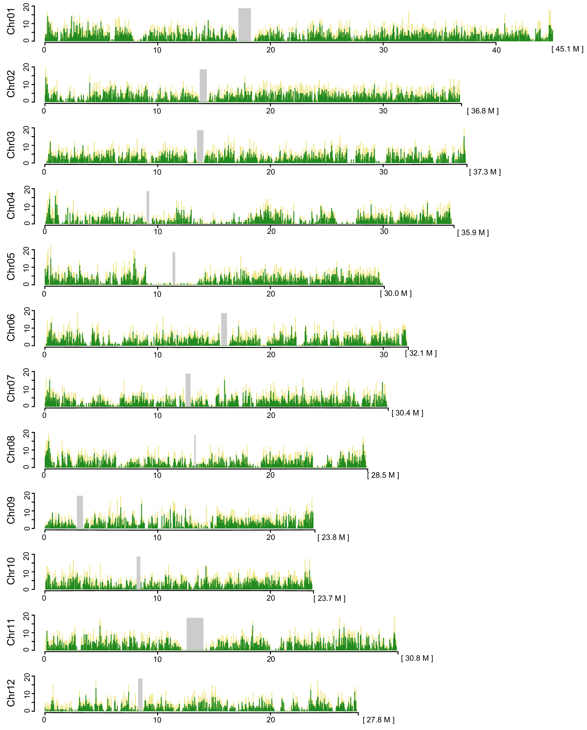
Figure S5. Distribution of md-InDels and e-PCR validated markers in WYG7/GLA4 when the sequencing depth was 10.
The x-axis represents the physical distance along each chromosome in 40 Kb windows. The total size of each chromosome of Nipponbare reference genome is shown in brackets. The y-axis indicates the number of md-InDels (in orange) and corresponding e-PCR validated markers (in green). The gray areas show centromere regions.

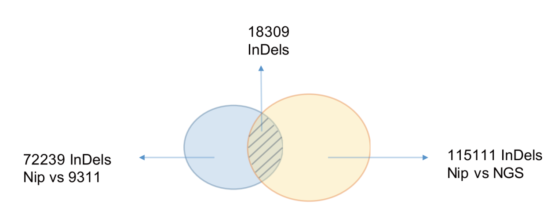
Figure S6. The overlapped md-InDels between NGS mapping and genome alignment.

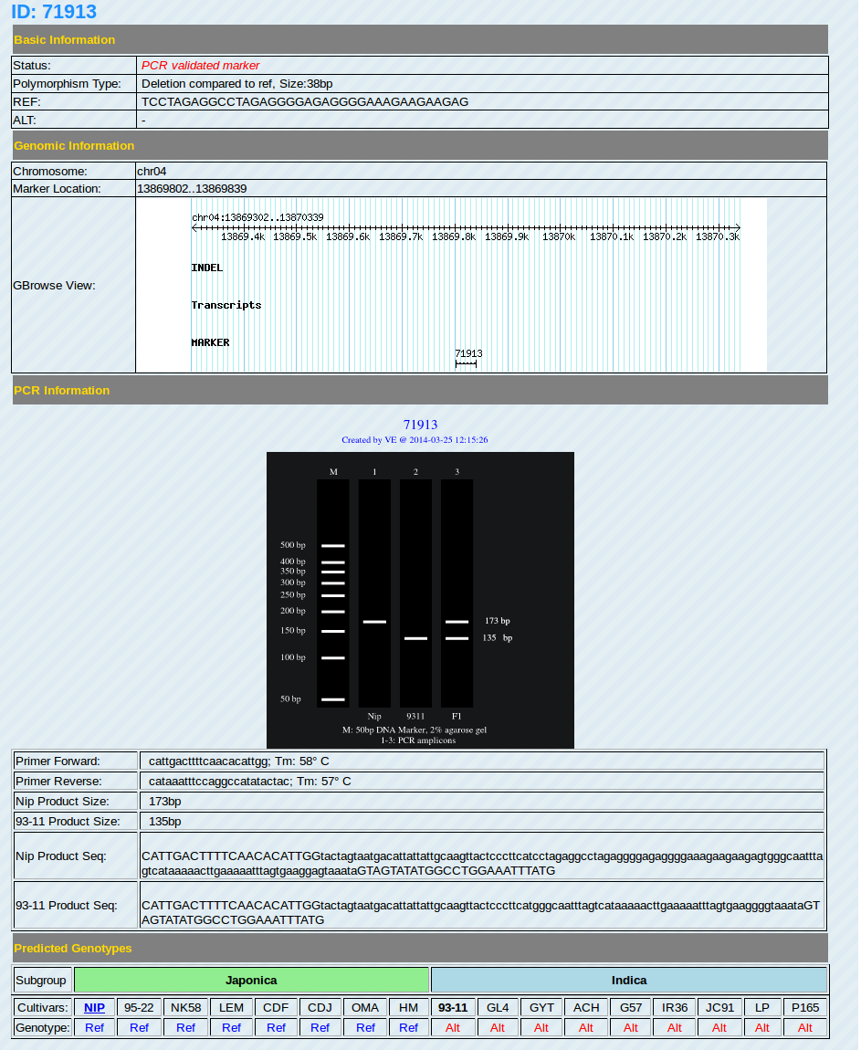
Figure S8. The detail information of one classical InDel marker, including the location on chromosome, information of primers and products.

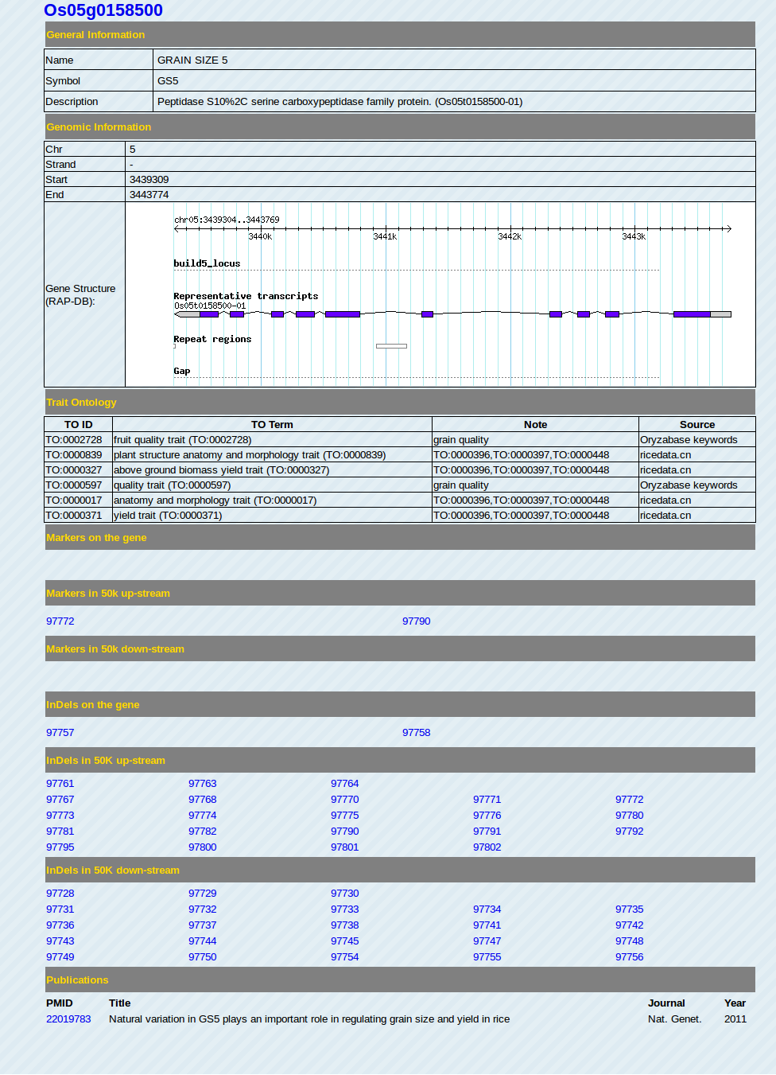
Figure S9. The detail information of a trait gene, including gene structure, trait ontology, InDels/markers nearby and relevant publication.

Figure S10. NGS-pipe for InDel markers development under LONI processing pipeline environment.
The NGS-pipe consisted of data quality control (green), reads mapping (yellow), InDels calling (purple), primer design and check (blue) modules. The dark dot in the NGS-pipe is for input, including reference genome and NGS data, parameters and switch (Flow control).

REFERENCE
Breslauer KJ, Frank R, Blocker H, Marky LA (1986) Predicting DNA duplex stability from the base sequence. Proc. Natl. Acad. Sci. U. S. A. 83: 3746-3750

