Supporting Information

Program manual

Knockout Mode
Step 1:
Copy the coding sequence (CDS) of target gene, and then paste it into the textbox on the left of the Search PAMs Button. You can click the Reset Button if you copied the wrong CDS.
Set the parameters for Searching, including the Searching start point & end point (where you want to cut using Cas9, the default is from the first nucleotide to the 300th, the length can't be less than 25 bp), GC content of the PAMs (Not confirmed Parameter, but set around 50%).
Click the Search PAMs button! You'll get a list of PAMs. If there is none, adjust your parameters or input another sequence, and Search again!
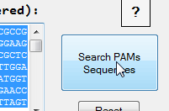
Step 2:
After you pressed the Search PAMs button, the Export to FASTA button will be enabled. Click it! Save searched PAMs in a given name (Default name is PAMs.fasta) and an easy-remembering folder (Put it on desktop is a nice choice).
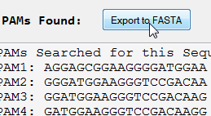
Step 3:
First you have to make sure you have Internet connection. Click the Goto BLAST Homepage linker, or open your favorite Internet Browser (IE, chrome, Firefox or anyone), and navigate to NCBI BLAST page, choose the genome you want BLAST (Human, Mouse, Oryza sativa... i.e., the background genome). Go to Supplement Information 2 for BLAST parameters used for human, mouse, Drosophila melanogaster and Danio rerio.
Then upload the PAMs.fasta (or whatever you named it) by clicking the Browser button, navigate to PAMs.fasta contenting folder, choose PAMs.fasta file, then click OK.
Click BLAST, you're way to go!
NCBI Website: http://BLAST.ncbi.nlm.nih.gov/Blast.cgi
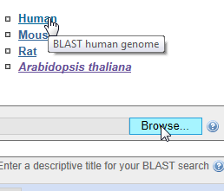
Step 4:
When BLAST was done, click the download link on the top of the webpage, then it expanded. Choose the text format (the First one) to download, save it in a nice folder. It may takes a little bit time before the result is fully downloaded (depend on your internet connection and the result file size). MAKE SURE you downloaded the whole result, or ERROR will be appeared (Supplement Information 3). DON’T press the RESET button below the Searching PAMs button, for it will erase all the PAMs saved in the memory, also you can't load the Result, ‘cause that button is disabled! But you can re-input the sequence used before, and the same parameter setting, then press the Search button to generate same spacers, and you can load your BLAST result next.
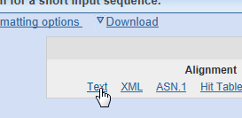
Step 5:
When the Result file was downloaded, press the Load Blast Result button (Enabled after you pressed the Search PAMs Button). Navigate to the Blast Result File just downloaded (DO not choose a wrong file!), then press OK, your results will be loaded into the program. Your spacer score will be appeared in the list below. If there are some possible PAMs, your optimal spacer will be selected in the Combo Box below (If you don't like the chosen one, you can choose another one).
You can set the filter parameters manually to adjust the result, but normally you don't want to do that! Seed is the seed sequence of the PAM (default is 7), which is very important for CRISPR-cleavage, one of this seed is not matched, the cut will not be happen.
Reject zone is the zone before the PAM, like the seed, but if all the nucleotides in the zone is matched in another place of the genome, then the PAM is rejected, that's why I called it reject zone.
Buffer zone is an expansion of Seed, in this zone, you allow some of the nucleotides (the number is Buffer Threshold) can be mismatched. So if a BLAST block is past the filter then the score add 1. Surely, there always be at least one, the sequence itself, if there is not, that PAM may located in the join of two separated exon, and it will be rejected by the program. Do not worry about that.
You can double-click the list, if you want to see the filtered results to compare PAMs and spacers, a window will be appeared including all filtered BLAST blocks for this PAM. You can also Export all the result to a result file by clicking the Export Result Button to save it.
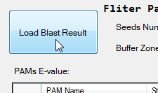
Step 6:
Generally the best PAM (one has the Smallest Score, 1 is the best score) will be selected, but if you don't want the select one, you can always choose another one, rejected PAMs will not appear in the combo box.
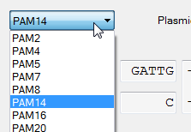
Step 7:
Choose the destination plasmid for CRISPR. Different groups have developed different plasmid because they use different restrict enzymes. If the one you are going to use is not shown at the dropdown box, you can create a new one by choosing the Create new Plasmid, you just have to give it a different name and the right connecting fragments (if one of the four is none, leave it blank).
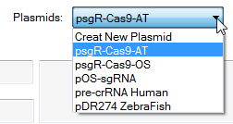
Step 8:
When all of the hard work is done, copy the Left Primer (LP) & the Right Primer (RP) in the Primers for the PAM textbox, then send it to your favorite Primer synthesis producer. The Primers (LP & RP) in the textbox are all shown from 5’ to 3’.
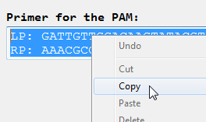

Chromosome Imaging Mode
Step 1:
Copy the proper sequence of the fragment you want to use chromosome imaging, then paste it into the textbox, the one on the left of the Search PAMs Button. You can click the Reset Button if you copied the wrong sequence.
Set the parameters for Searching, include the Number of PAMs you want to use for imaging, (the default is 26, you can set it to any number you want as long as not less than 1 to your sequence permit you to search that much), GC content of the PAMs (Not confirmed Parameter, but set around 50%).
The length of the PAMs usually set from 17 to 28, but you can set it to any length you want, you may aware that if the length is too short it may not well targeted. Distance between adjacent PAMs is the least space between adjacent PAMs, set to 30, you can change it to larger or smaller, but if it is too small, it may not have a good result, because dCas9 takes some spaces on the chromosome.
You can restore the parameters to default value by pressing the Restore Parameters button at any time.
Click the Search PAMs button! You'll get a list of PAMs. If there is not enough for you, adjust your Parameters, and Search again!
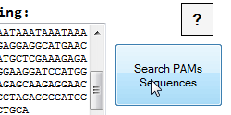
Step 2:
After you pressed the Search PAMs Button, the Export PAMs button will be enabled. Click it! Save searched PAMs in a given name (Default name is PAMs' Info for Imaging.txt) & an easy-remembering folder. You can also Export Primers for the PAMs, we set the vector to be pSLQ1371 for now, if there is another one appears, and we will add it to the program in the future. If it's not what you wanted, export the PAMs, and add the other parts by using EXCEL.
You can select one or more spacers in the PAM cluster view, their positions and distribution will be shown at the graph box. When the full length checkbox is selected, the graph will be displayed using the whole input sequence length, if not, the graph will be shown using the length of the sequence from first nucleotide to the last PAM found in the list.
Click Export Left Primers using sgRNA vector (pSLQ1371) button (the biggest one!), you're way to go! Save it & send it to your favorite primer synthesis producer!
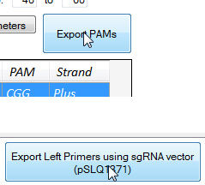

Parameters for BLAST
Except Arabidopsis thaliana and Oryza sativa, Human, mouse, Drosophila melanogaster and Danio rerio genome contains a lot of different assemblies, it’s a little bit more complex when using NCBI for BLAST.
Parameters used for BLAST in different species:
Species | Database | Entrez query
Human | CHM1_1.1 assembly
Human | GRCh38 reference assembly | GRCh38 Primary Assembly NOT scaffold
Mouse | GRCm38.p2 reference assembly | GRCm38.p2 C57BL/6J NOT contig NOT PATCHES
Mouse | Mm_Celera assembly | NOT unplaced
Drosophila melanogaster | Genome | complete sequence
Danio rerio | Genome | NOT unplaced
Arabidopsis thaliana | Genome
Oryza sativa | Genome
Other species | Genome, only complete chromosome sequence

In “Standard Nucleotide BLAST”, set the Database to NCBI Genomes (chromosome), choose your destination organism and fill the Entrez Query as listed above.

NOTES
BLAST result file: Download the result file completely, or ERROR will force the program to close. The size of the result file is different from one and another, usually from 5 to 30 Mb depend on your gene and background genome. If the file is not completely downloaded, download it again. If an ERROR shut down the program, please rerun the program from the beginning.
Parameters: Usually, you don’t have to change any of the parameters here, changes of the parameters only when you are not happy with the result. New settings and features will be added as the development of the CRISPR-Cas system.

Plasmids
Plasmids Name | Reference
psgR-Cas9-AT | (Mao et al. 2013)
psgR-Cas9-OS | (Mao et al. 2013)
pOS-sgRNA | (Miao et al. 2013)
Pre-crRNA Human | (Cong et al. 2013)
pDR274 ZebraFish | (Feng et al. 2013)

References
Cong L, Ran FA, Cox D, Lin SL, Barretto R, Habib N, Hsu PD, Wu XB, Jiang WY, Marraffini LA, Zhang F (2013) Multiplex genome engineering using CRISPR/Cas systems. Science 339: 819-823
Feng ZY, Zhang BT, Ding WN, Liu XD, Yang DL, Wei PL, Cao FQ, Zhu SH, Zhang F, Mao YF, Zhu JK (2013) Efficient genome editing in plants using a CRISPR/Cas system. Cell Res 23: 1229-1232
Mao Y, Zhang H, Xu N, Zhang B, Gou F, Zhu JK (2013) Application of the CRISPR-Cas system for efficient genome engineering in plants. Mol Plant 6: 2008-2011
Miao J, Guo DS, Zhang JZ, Huang QP, Qin GJ, Zhang X, Wan JM, Gu HY, Qu LJ (2013) Targeted mutagenesis in rice using CRISPR-Cas system. Cell Res 23: 1233-1236

