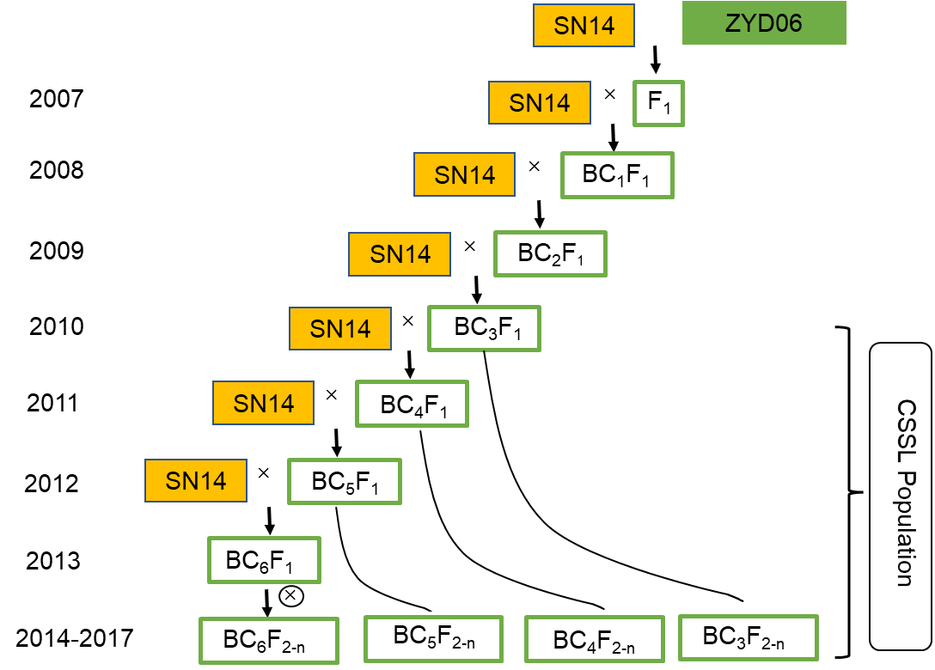
Figure S1. Diagram illustrating the construction of 208 chromosome segment substitution lines (CSSLs) using the cultivated soybean variety Suinong14 (SN14) and the wild soybean ZYD06.

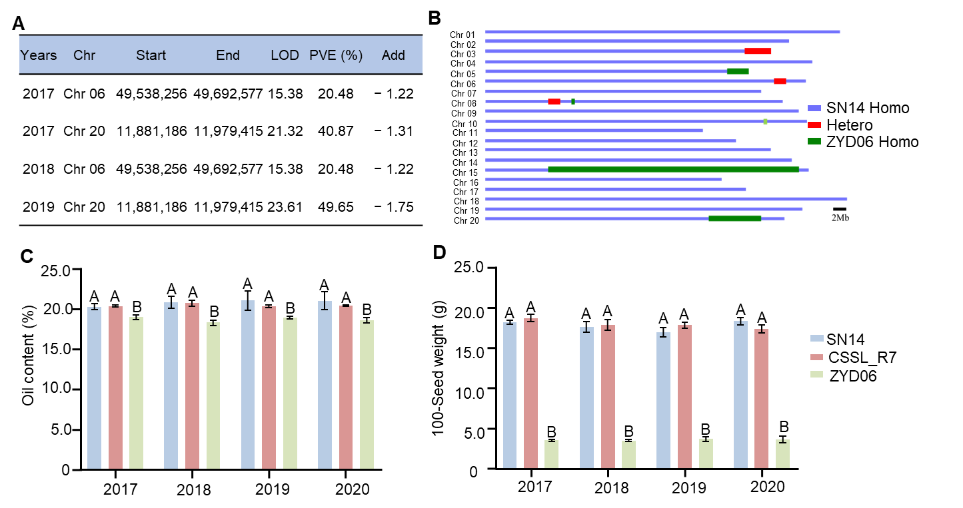
Figure S2. Selection of the CSSL_R7 for mapping of seed protein content QTLs.
(A) Two QTLs were detected consistently on chromosomes Gm06 and Gm20 in the CSSL population. (B) Locations of substituted segments in the CSSL_R7 genome. (C) Seed morphology of CSSL_R7 and its two parents, the donor parent ZYD06 and receptor parent SN14. Bar = 1 cm. (D) Seed protein contents of CSSL_R7 and its parents. Different uppercase letters indicate significant differences (P ≤ 0.01, ANOVA).

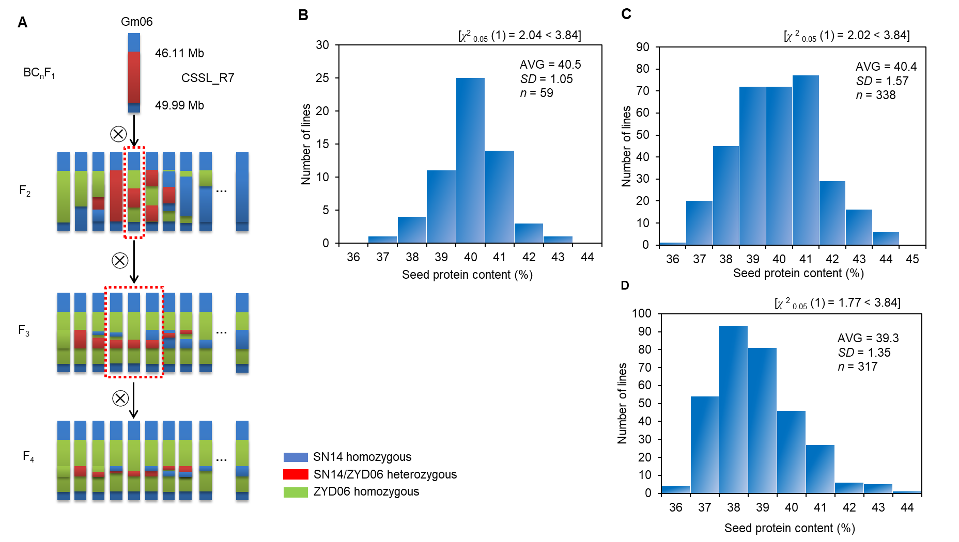
Figure S3. Construction of genetic populations and distributions of seed protein content in different genetic populations.
(A) Process of population construction. (B–D) Distribution of seed protein content in the F₂ (B), F₃ (C), and F₄ (D) populations. AVG, average value. SD, standard deviation. n, number of lines. χ² tests for goodness of fit were performed at a 0.05 significance level.

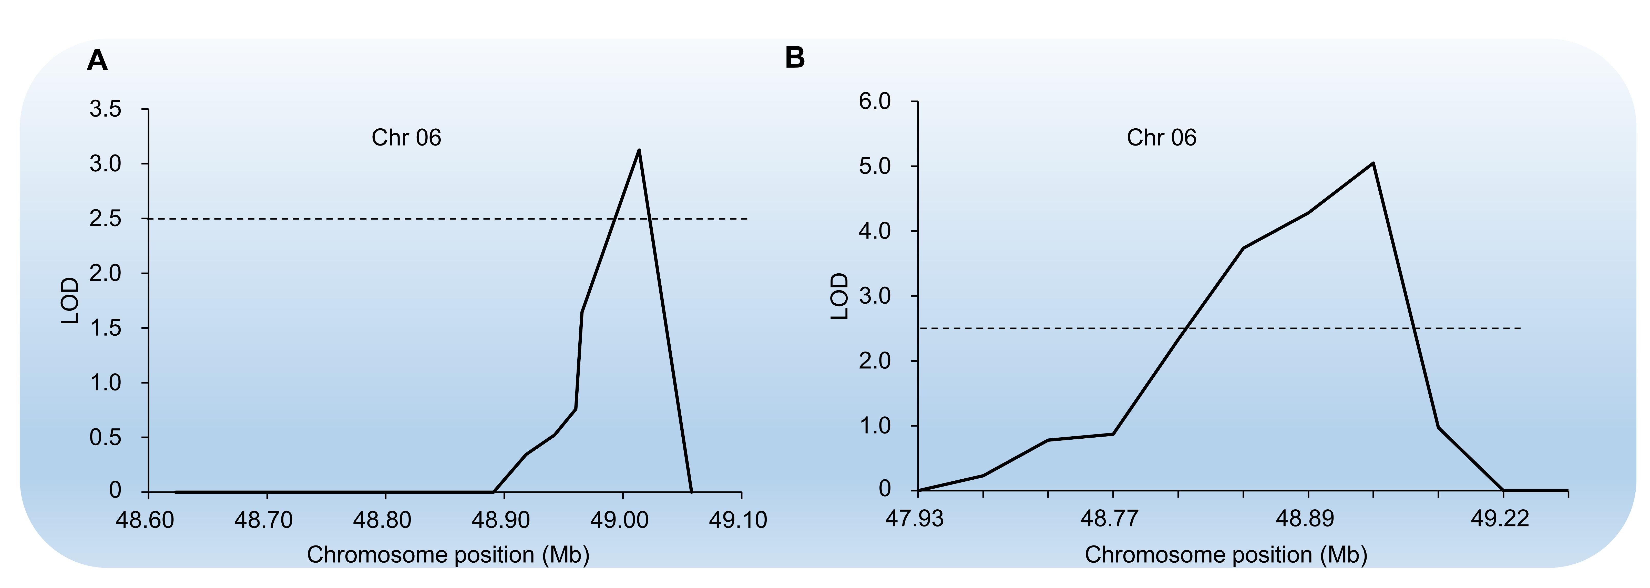
Figure S4. QTLs for seed protein content were located on chromosome 6
A QTL for seed protein content was mapped to soybean chromosome 6 in the (A) F₃ and (B) F₄ populations by composite interval mapping with QTL IciMapping software. The QTL threshold was LOD ≥ 2.5.

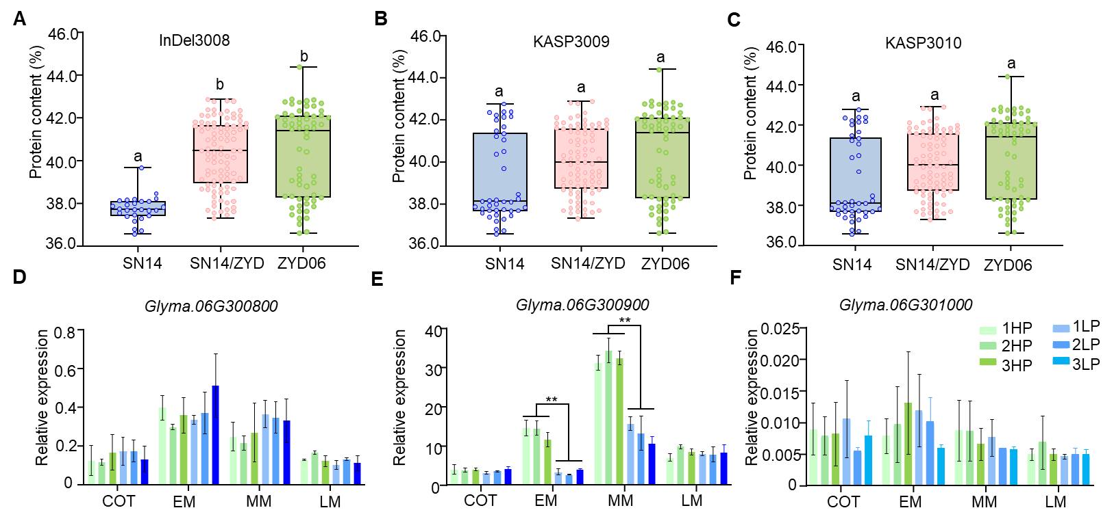
Figure S5. Characterization of candidate genes in the QTL by marker analysis and gene expression.
(A–C) Seed protein content is shown for lines with different genotypes marked by (A) InDel3008, (B) KASP3009, and (C) KASP3010 in F₄ RHLs. Uppercase letters indicate significant differences among parents and the heterozygous genotype (P < 0.05, ANOVA followed by LSD). (D–F) Expression of (D) Glyma.06G300800, (E) Glyma.06G300900, and (F) Glyma.06G301000 in high-protein (HP) and low-protein (LP) materials from the F₄ population at four seed developmental stages: cotyledon (COT), early maturity (EM), middle maturity (MM), and late maturity (LM).

3010_SN14 MPEAPSHYLCNKPNGKLDDGGATNTSIIIEHNNKKALKYIEDVTSNADEIQKRVLAEILS 60
3010_ZYD06 MPEAPSQYLCNKPNGKLDDGGATNTSIIIEHNNKKALKYIEDVTSNADEIQKRVLAEILS 60
****** *****************************************************
3010_SN14 CSAHVEYLQRHGLEGRTDRETFKKIMPVVTYEDLKPDIDRIANGDASPILCSKPISEFLT 120
3010_ZYD06 CSAHVEYLQRHGLEGRTDRETFKKIMPVVTYEDLKPDIDRIANGDASPILCSKPISEFLT 120
************************************************************
3010_SN14 SSGTSGGERKLMPTIEDELERRSLLYSLLMPVMDQFVPGLDKGKGMYFLFIKSESKTPGG 180
3010_ZYD06 SSGTSGGERKLMPTIEDELERRSLLYSLLMPVMDQFVPGLDKGKGMYFLFIKSESKTPGG 180
************************************************************
3010_SN14 LLARPVLTSYYKSSHFKNKTHGLNFDPYTNYTSPIETILCQDSYQSMYSQMLCGLSQNEH 240
3010_ZYD06 LLARPVLTSYYKSSHFKNKTHGLNFDPYTNYTSPIETILCQDSYQSMYSQMLCGLSQNEH 240
************************************************************
3010_SN14 VLRVGSVFASGFIRALKFLEKHWESLCHDIRNGTIDHEITDSTVREAIMKILKPNPKLAD 300
3010_ZYD06 VLRVGSVFASGFIRALKFLEKHWESLCHDIRNGTIDHEITDSTVREAIMKILKPNPKLAD 300
************************************************************
3010_SN14 FIEGECKKGLWKGIITRLWPNTKYVDVIVTGTMAQYIPMLDYYSNGLPLVCTMYASSECY 360
3010_ZYD06 FIEGECKKGLWKGIITRLWPNTKYVDVIVTGTMAQYIPMLDYYSNGLPLVCTMYASSECY 360
************************************************************
3010_SN14 FGLNLNPLCDPSEVSYTLVPTMAYFEFLPLNKMKGHANSISHTEQELLVDLVDVELDQEY 420
3010_ZYD06 FGLNLNPLCDPSEVSYTLVPTMAYFEFLPLNKMKGHANSISHTEQELLVDLVDVELDQEY 420
************************************************************
3010_SN14 ELVVTTYAGLYRYRVGDILRVAGFKNNAPQFNFVCRKNVVLSIDSDKTDEVELQNAVKNG 480
3010_ZYD06 ELVVTTYAGLYRYRVGDILRVAGFKNNAPQFNFVCRKNVVLSIDSDKTDEVELQNAVKNG 480
************************************************************
3010_SN14 AKHLATLGASLTEYTSCADTSTIPGHYVLYWEINMNNNDQTPIPSSVFEECCFAVEGSLN 540
3010_ZYD06 AKHLATLGASLTEYTSCADTSTIPGHYVLYWEINMNNNDQTPIPSSVFEECCFAVEGSLN 540
************************************************************
3010_SN14 SVYRQGRVSESIGPLEIKIVENGTFDKLMDFALSQGASINQYKTPRCVKYAPIVELLDSK 600
3010_ZYD06 SVYRQGRVSESIGPLEIKIVENGTFDKLMDFALSQGASINQYKTPRCVKYAPIVELLDSK 600
************************************************************
3010_SN14 TVSNYFSPKCPQWVPGHKKWCMYP 624
3010_ZYD06 TVSNYFSPKCPQWVPGHKKWCMYP 624
************************
Figure S6. Alignment of Glyma.06G301000 protein sequences from two parents SN14 and ZYD06.
Red amino acids differ between the two parents.

3011_SN14 MCKEAAPPLPQIHCDFSS----------------TRLWAAKVLSFSLLFRDHLLLRAAAF 44
3011_ZYD06 MCKEAAPPLPQIHCDFSSTRPHVPAKNRALRVQSTRLWAAKVLSFSLLFRDHLLLRAAAF 60
****************** **************************
3011_SN14 NHSRVLCVSAGAGHEVAALRCLGIDDVTGVEILESPPLVRRADPHNLPFFDGVFDLAFTA 104
3011_ZYD06 NHSCVLCVSAGAGQEVAALRLLGIDDVTGVEILESPPLVRRADPHNLPFFDGVFDLAFTA 120
*** *********:***********************************************
3011_SN14 RFDEALFAAEMERVIRPGGACVVLVAESGEDEVREVVGLFRNSRLVRWSNVSDWNENGQC 164
3011_ZYD06 RFDEALFAAEMERVIRPGGACVVLVAESGEDEVREVVGLFRNSRLVRWSNVSDWNENGQC 180
************************************************************
3011_SN14 SFEN 168
3011_ZYD06 SFEN 184
****
Figure S7. Alignment of Glyma.06G301100 protein sequences from two parents SN14 and ZYD06.
Red amino acids differ between the two parents.

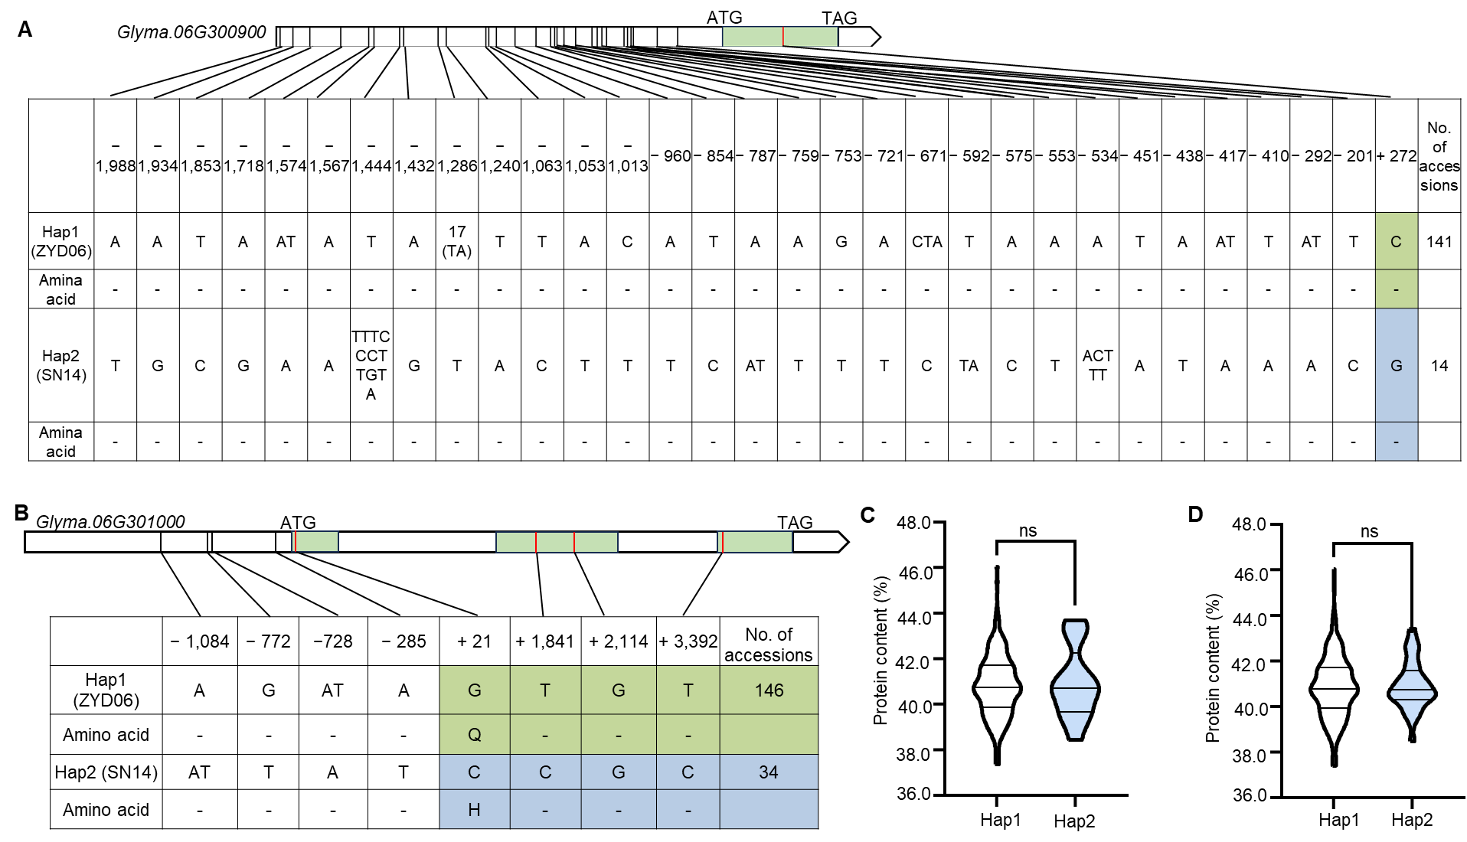
Figure S8. Haplotype analysis of the candidate genes Glyma.06G300900 and Glyma.06G301000.
(A–B) Haplotypes were identified in the promoter (3 Kb) and genic regions of (A) Glyma.06G300900 and (B) Glyma.06G301000 in the CSSL population. (C–D) Seed protein contents of (C) Glyma.06G300900 and (D) Glyma.06G301000 (P ≤ 0.05, two-tailed Student’s t-test).

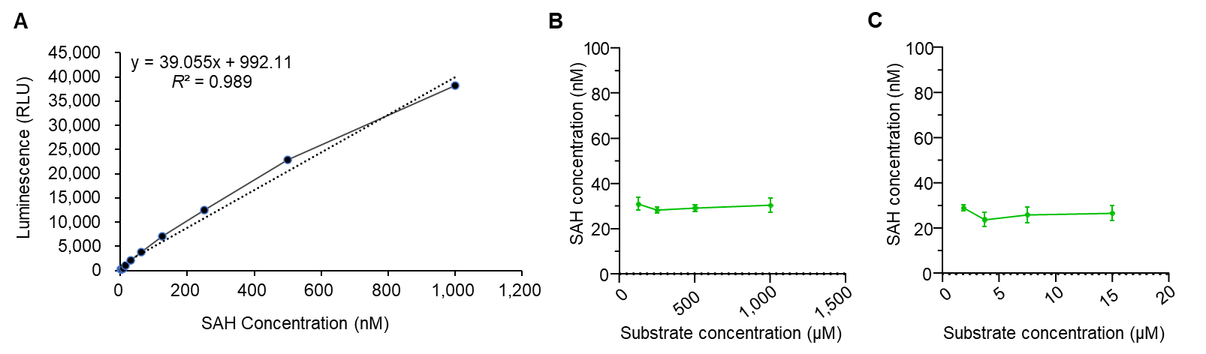
Figure S9. Methyltransferase activity assays.
(A) An SAH standard curve was constructed to calculate methyltransferase activity. (B–C) GmMET^{ZYD06} methyltransferase activity was measured using total soybean RNA (B) and total protein (C) as substrates.

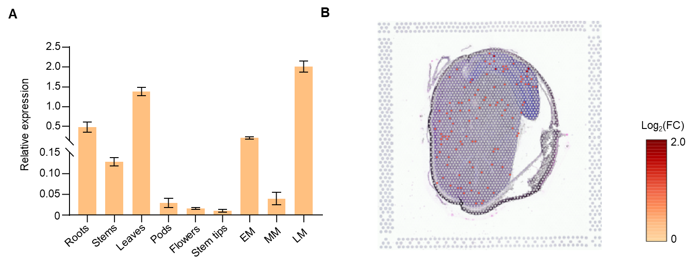
Figure S10. Expression patterns of GmMET.
(A) Relative expression of GmMET in multiple soybean tissues measured by RT-qPCR. (B) Distribution of GmMET transcripts in a seed longitudinal section as captured by single-cell sequencing data.

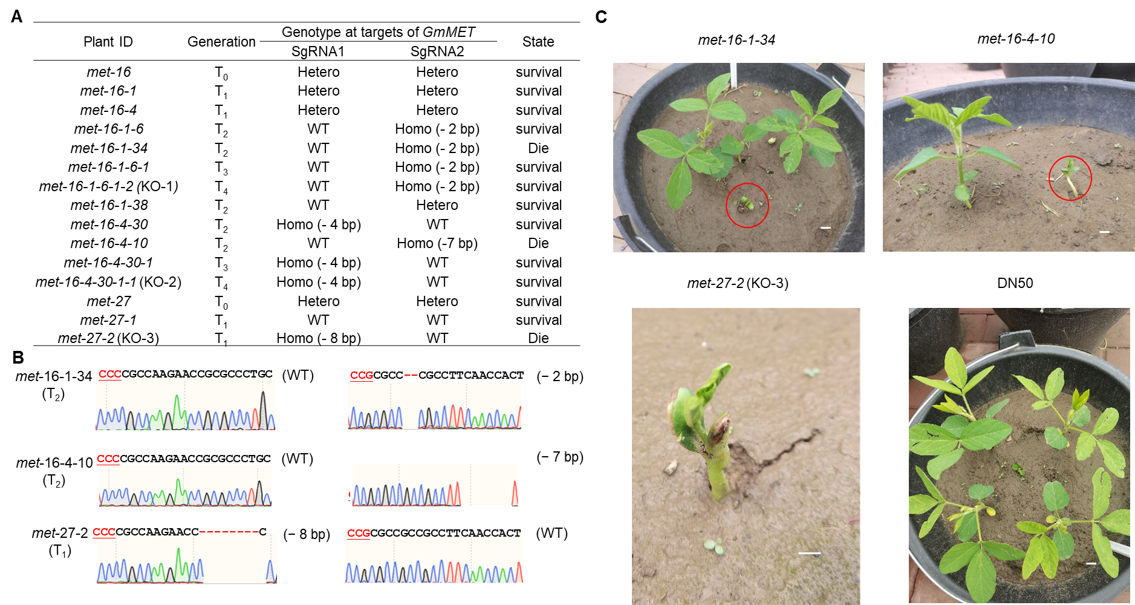
Figure S11. Some gmmet mutants exhibited a lethal phenotype.
(A) Mutant genotypes and growth status of different lines. Sanger sequences of three different knockout lines (B) and the lethal phenotypes of these three lines (C). Scale bars, 2 cm.

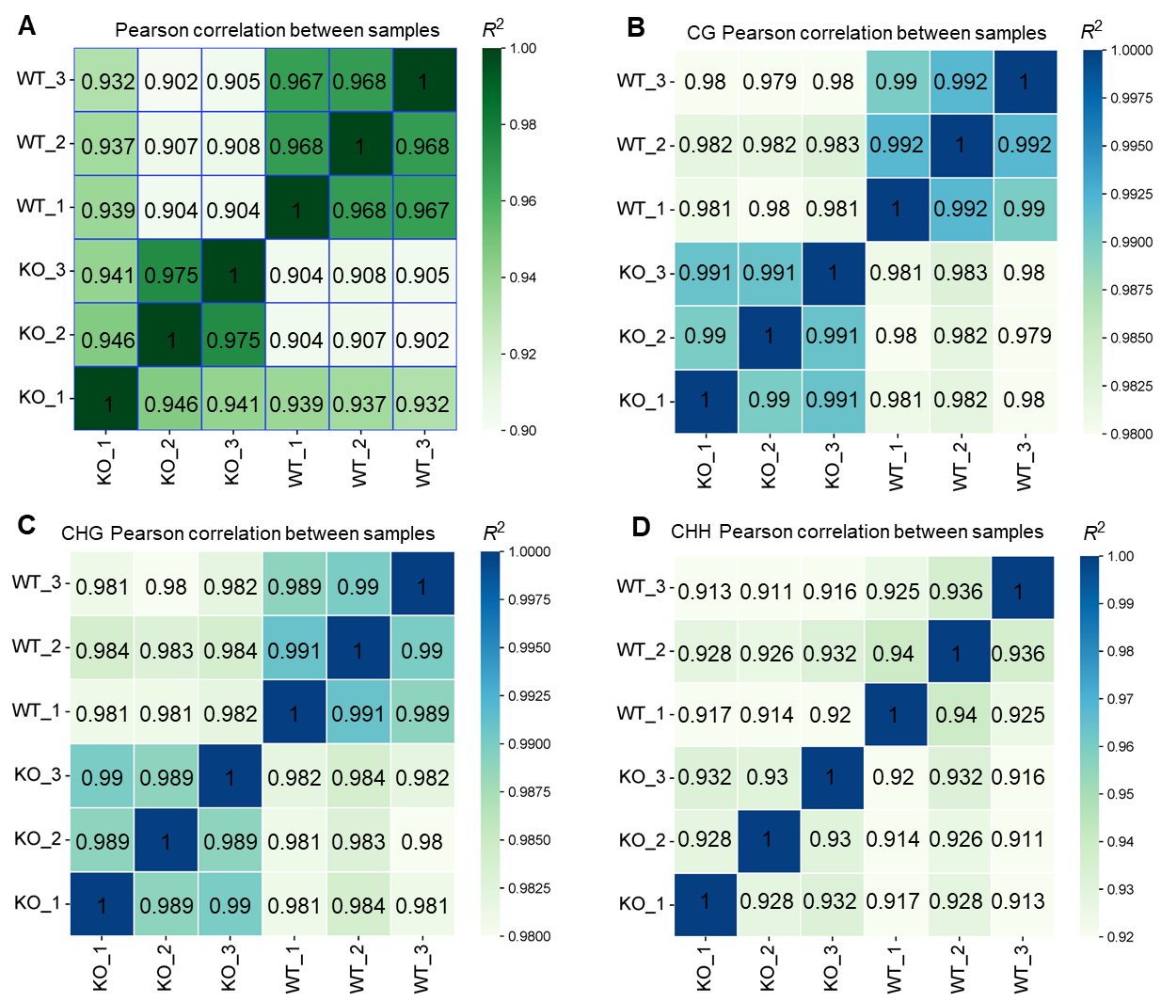
Figure S12. Correlations for RNA-seq data and methylation data.
Correlations between pairs of biological replicates for (A) RNA-seq data and (B–D) methylation data from (B) CG, (C) CHG, and (D) CHH contexts. Values represent R², the square of the Pearson correlation coefficient.

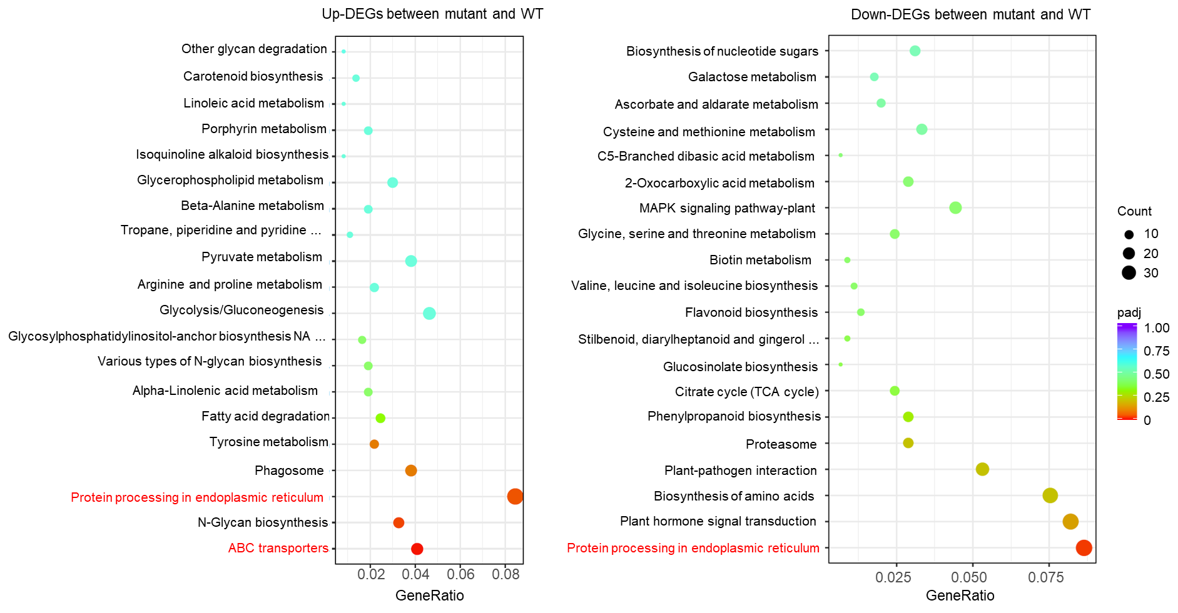
Figure S13. Top 20 KEGG annotations of all up- and downregulated DEGs between WT and the GmMET-KO mutant.
A darker red color indicates a lower padj-value, and a larger circle indicates a larger number of DEGs.

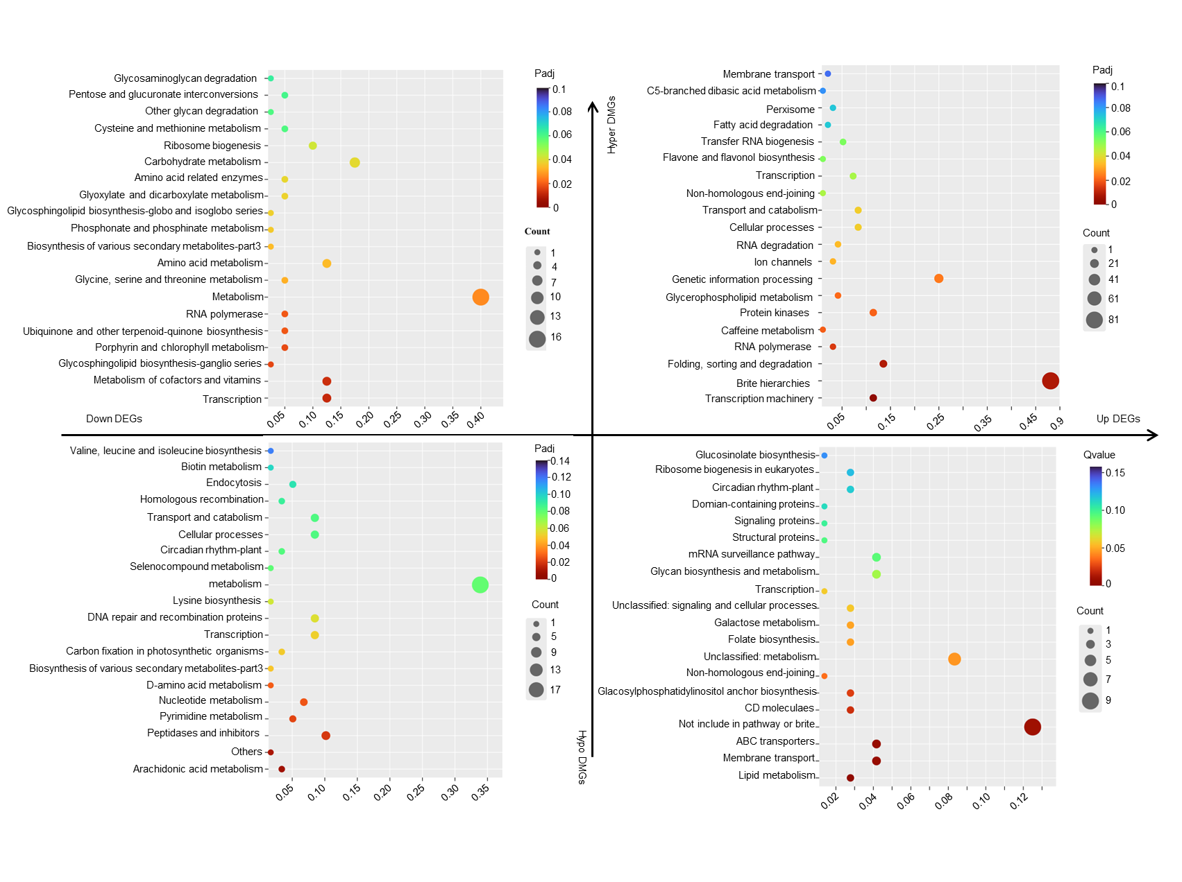
Figure S14. Top 20 KEGG annotations of the 564 DEGs that were also located in DMRs (i.e., DEG/DMGs).
The 564 DEGs are divided into four quadrants (hypo-up, hypo-down, hyper-up, and hyper-down) according to the values of log₂(Fold change) and diff.Methy. A darker red color indicates a lower padj-value, and a larger circle indicates a larger number of DEGs.

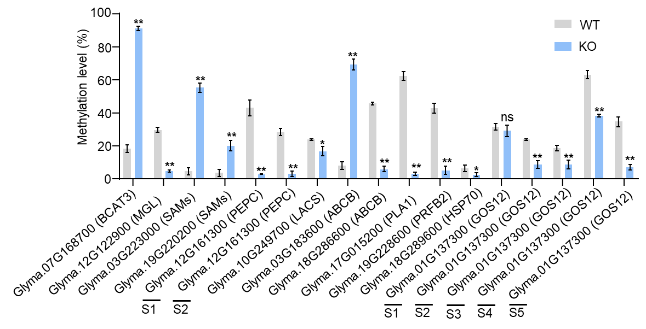
Figure S15. Gene methylation levels of the 12 most important candidate genes shown in Table S7.
Methylation levels were determined by McrBC-qPCR. Values are the mean ± SD of three biological replicates. (*P ≤ 0.05, **P ≤ 0.01; Student’s t-test). The 'S' denotes the different sites marked below the short lines.
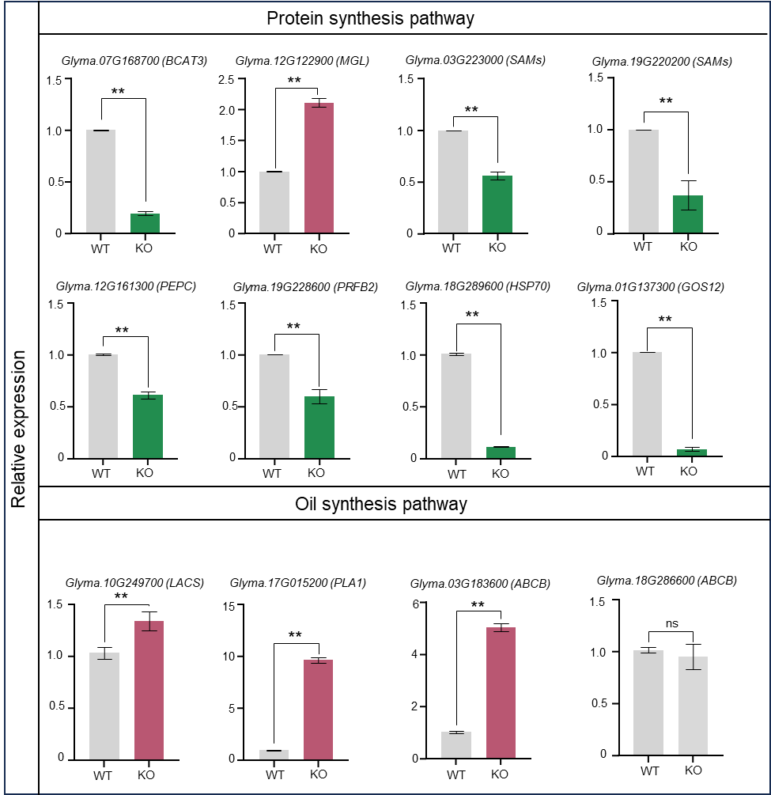
Figure S16. Gene expression levels of the 12 most important seed protein/oil related genes shown in Table S7.
Gene expression levels in KO-1 and WT seeds determined by RT-qPCR and normalized to that of GmActin2. Values are the mean ± SD of three biological replicates. **, significantly different at P ≤ 0.01; *, significantly different at P ≤ 0.05 (Student’s t-test).

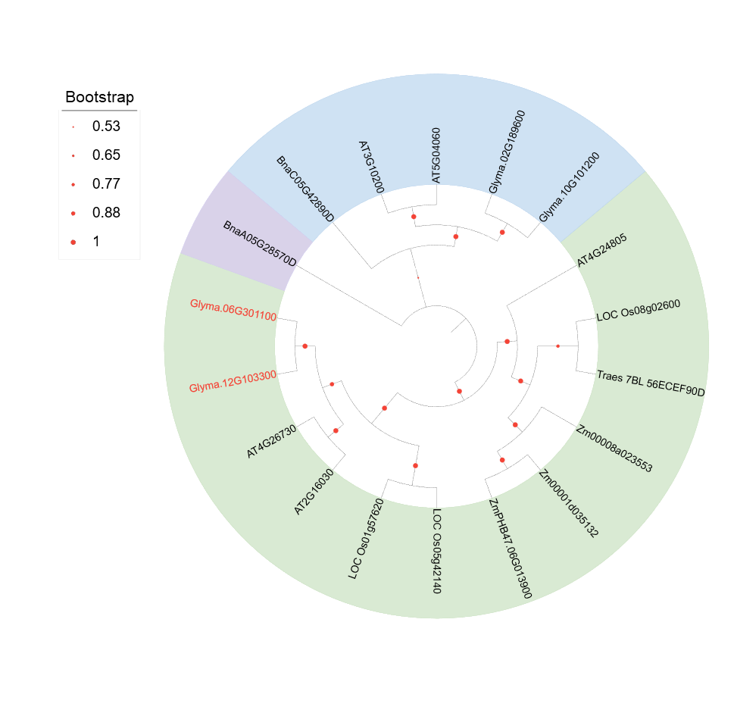
Figure S17. Phylogenetic tree of GmMET and its homologs from other plant species. Protein sequences were downloaded from Phytozome 13 (https://phytozome-next.jgi.doe.gov/). GmMET and its closest soybean homolog are indicated in red.

Table S1. Phenotype statistics of CSSLs protein content
Year | Min (%) | Max (%) | Mean (%) | SD | Skewness | Kurtosis
2017 | 37.0 | 46.76 | 41.08 | 1.81 | 0.64 | 0.82
2018 | 37.39 | 46.04 | 40.8 | 1.31 | 0.6 | 1.17
2019 | 37.15 | 47.42 | 41.08 | 1.51 | 0.6 | 1.71
2020 | 37.74 | 52.54 | 42.65 | 1.53 | 1.28 | 8.76

Table S2. QTL mapping of protein content in CSSLs by CIM method
Years | Chr.ID | Start Position (bp) | End Position (bp) | LOD value | PVE (%) | Add
2017 | Chr01 | 2,574,180 | 2,628,990 | 6.73 | 5.51 | 0.46
2017 | Chr06 | 49,538,256 | 49,692,577 | 15.37 | 20.48 | − 1.21
2017 | Chr08 | 9,566,485 | 9,704,559 | 5.65 | 4.37 | − 0.99
2017 | Chr12 | 37,697,326 | 37,747,493 | 13.88 | 16.92 | 0.96
2017 | Chr13 | 28,854,714 | 28,922,936 | 3.34 | 2.29 | 0.59
2017 | Chr20 | 11,881,186 | 11,979,415 | 21.31 | 40.87 | − 1.3
2017 | Chr20 | 47,187,567 | 47,258,980 | 6.78 | 5.56 | − 0.63
2018 | Chr06 | 49,538,256 | 49,692,577 | 15.37 | 20.48 | − 1.21
2018 | Chr13 | 15,388,673 | 15,835,853 | 5.92 | 9.55 | 0.8
2018 | Chr15 | 5,652,830 | 5,711,761 | 6.41 | 10.57 | − 0.81
2018 | Chr17 | 12,643,685 | 12,763,512 | 2.61 | 4.1 | − 0.62
2018 | Chr20 | 7,789,504 | 7,935,977 | 8.19 | 14.25 | − 0.95
2019 | Chr08 | 42,933,873 | 42,969,936 | 2.64 | 1.81 | − 1.18
2019 | Chr08 | 43,840,064 | 43,923,144 | 2.64 | 1.81 | − 1.18
2019 | Chr15 | 4,500,961 | 4,541,989 | 8.71 | 8.85 | − 1.52
2019 | Chr17 | 7,376,750 | 7,940,696 | 8.23 | 9.31 | 0.73
2019 | Chr17 | 9,453,048 | 9,481,091 | 6.9 | 6.87 | − 0.75
2019 | Chr20 | 11,881,186 | 11,979,415 | 23.61 | 49.65 | − 1.74
2020 | Chr06 | 45,358,202 | 45,424,432 | 10.89 | 30.69 | − 1.89
2020 | Chr08 | 43,959,712 | 43,999,954 | 2.64 | 1.81 | − 1.18
2020 | Chr12 | 35,628,027 | 35,982,201 | 4.57 | 10.53 | 1.06
2020 | Chr15 | 3,204,973 | 3,578,591 | 3.43 | 6.67 | − 0.94
2020 | Chr17 | 11,056,195 | 11,367,752 | 8.04 | 8.38 | − 0.83
2020 | Chr19 | 46,391,451 | 46,417,246 | 3.54 | 3.42 | − 0.55

Table S3. QTL mapping of protein content in F₂ population by CIM method
Chr.ID | Marker | P value | Significance
Gm03 | SSR_03_1408 | 0.688 | -
Gm03 | SSR_03_1418 | 0.423 | -
Gm03 | SSR_03_1455 | 0.630 | -
Gm03 | SSR_03_1471 | 0.335 | -
Gm03 | SSR_03_1481 | 0.496 | -
Gm03 | SSR_03_1490 | 0.243 | -
Gm03 | SSR_03_1512 | 0.872 | -
Gm03 | SSR_03_1530 | 0.429 | -
Gm03 | SSR_03_1543 | 0.090 | -
Gm03 | SSR_03_1547 | 0.832 | -
Gm03 | SSR_03_1351 | 0.786 | -
Gm03 | SSR_03_1359 | 0.620 | -
Gm03 | SSR_03_1377 | 0.368 | -
Gm03 | SSR_03_1400 | 0.214 | -
Gm06 | SSR_06_ 1600 | 0.221 | -
Gm06 | SSR_06_1627 | 0.221 | -
Gm06 | SSR_06_1652 | 0.001 | **
Gm06 | SSR_06_1673 | 0.001 | **
Gm06 | SSR_06_1689 | 0.008 | **
Gm06 | SSR_06_1702 | 0.034 | *
Gm06 | SSR_06_1717 | 0.008 | **
Gm06 | SSR_06_1730 | 0.003 | **
Gm06 | SSR_06_1751 | 0.002 | **
Gm06 | SSR_06_1760 | 0 | ***
Gm06 | SSR_06_1774 | 0.034 | *
Gm08 | SSR_08_0562 | 0.482 | -
Gm08 | SSR_08_0577 | 0.531 | -
Gm08 | SSR_08_0592 | 0.365 | -

Table S4. Primers used in the present study
Primer name | Sequence information | Purpose
BARCSOYSSR_03_1408F | CGCACGTATAATTAGAATCTGTCA | Construction of linkage map in F₂ population
BARCSOYSSR_03_1408R | CGAACAAATAAGGGCTCTCG | Construction of linkage map in F₂ population
BARCSOYSSR_03_1418F | GGCGGTTTCAAAAACATGAC | Construction of linkage map in F₂ population
BARCSOYSSR_03_1418R | TAAAGGCCGGAAGAGCATTA | Construction of linkage map in F₂ population
BARCSOYSSR_03_1455F | TTGACAAGTAAAACATGCAAACATT | Construction of linkage map in F₂ population
BARCSOYSSR_03_1455R | CATAGGCACTTTGATGCCCT | Construction of linkage map in F₂ population
BARCSOYSSR_03_1481F | GGAACGATATCTACTCTCTCCTGAA | Construction of linkage map in F₂ population
BARCSOYSSR_03_1481R | TGGGTGAGTACCTATTATGGCT | Construction of linkage map in F₂ population
BARCSOYSSR_03_1490F | GGTGTAAACAGTGGCGGAGT | Construction of linkage map in F₂ population
BARCSOYSSR_03_1490R | AAAACCATTAATTTATTAAGGAACGA | Construction of linkage map in F₂ population
BARCSOYSSR_03_1512F | AAATCAATTTTACTCGGATGAACA | Construction of linkage map in F₂ population
BARCSOYSSR_03_1512R | TTCTATTAGGTCCATGCCCG | Construction of linkage map in F₂ population
BARCSOYSSR_03_1547F | GGCCAAAAGCAATACCAGAA | Construction of linkage map in F₂ population
BARCSOYSSR_03_1547R | GGCCAAAAGCAATACCAGAA | Construction of linkage map in F₂ population
BARCSOYSSR_03_1359F | GGCAAAGTTAAGAATTGGATCG | Construction of linkage map in F₂ population
BARCSOYSSR_03_1359R | TTGGGTGGGGGTACATTACT | Construction of linkage map in F₂ population
BARCSOYSSR_03_1377F | TGGTACCCATGCACAATAGC | Construction of linkage map in F₂ population
BARCSOYSSR_03_1377R | AACATGTGTTTCATGATGGCA | Construction of linkage map in F₂ population
BARCSOYSSR_03_1400F | CCTGCTGAAATCCCATTGTT | Construction of linkage map in F₂ population
BARCSOYSSR_03_1400R | ATCACCATTCTTCACTCGCC | Construction of linkage map in F₂ population
BARCSOYSSR_06_1600F | GCCATGTGCGATCGATATTT | Construction of linkage map in F₂ population
BARCSOYSSR_06_1600R | GACGTTACAAAATTGTCTCCACC | Construction of linkage map in F₂ population
BARCSOYSSR_06_1627F | TGTTGGAGTGGTATGTTTTTCAA | Construction of linkage map in F₂ population
BARCSOYSSR_06_1627R | CAGAGTGTTTCATCCCGTCA | Construction of linkage map in F₂ population
BARCSOYSSR_06_1652F | TACTCGGATTTGTCTTCGGG | Construction of linkage map in F₂ population
BARCSOYSSR_06_1652R | TCCTAACGATAACAACCGCC | Construction of linkage map in F₂ population
BARCSOYSSR_06_1673F | GAGGGGTTTGTTGGGTTCTT | Construction of linkage map in F₂ population
BARCSOYSSR_06_1673R | TTGTGCGCTGTGTTTGATTT | Construction of linkage map in F₂ population
BARCSOYSSR_06_1751F | AATTATCCATTCAAGTATTTCCTCTT | Construction of linkage map in F₂ population
BARCSOYSSR_06_1751R | TGATTCATCACAACAAATTACAGA | Construction of linkage map in F₂ population
BARCSOYSSR_06_1760F | TTTTTCAAGCTCCACCATCC | Construction of linkage map in F₂ population
BARCSOYSSR_06_1760R | CATGACTTGGTGAGGCATTG | Construction of linkage map in F₂ population
BARCSOYSSR_06_1774F | CAAGTAACAGTCGCAAGCCA | Construction of linkage map in F₂ population
BARCSOYSSR_06_1774R | ACTCCTCTCTCCTTCCAGCC | Construction of linkage map in F₂ population
BARCSOYSSR_06_1717F | TTAGTGTCATTGCTATATTACTCGCT | Construction of linkage map in F₂ population
BARCSOYSSR_06_1717R | AATCCAATTATGTAGTTGATCAAGATT | Construction of linkage map in F₂ population
BARCSOYSSR_06 1730F | ACCGAGGTTGATGACGATGT | Construction of linkage map in F₂ population
BARCSOYSSR_06 1730R | GGAATTGAACGAATATAAAGGCA | Construction of linkage map in F₂ population
BARCSOYSSR_08_0592F | TGATATGCATAGCGGAAGGA | Construction of linkage map in F₂ population
BARCSOYSSR_08_0592R | TTTCTACGCATGCCTTTGTT | Construction of linkage map in F₂ population
BARCSOYSSR_03_1530F | CACAAACAGCTTTCGTTGGA | Construction of linkage map in F₂ and F₃ population
BARCSOYSSR_03_1530R | CTGCTTGCTTTTGGCTTTGT | Construction of linkage map in F₂ and F₃ population
BARCSOYSSR_03_1543F | CAACAATGTCCGTTTTTGACA | Construction of linkage map in F₂ and F₃ population
BARCSOYSSR_03_1543R | CCAGAGGTTGGGAAAATGAG | Construction of linkage map in F₂ and F₃ population
BARCSOYSSR_03 1471F | TGTTTTGACAGAAGGAACTTGA | Construction of linkage map in F₂ and F₃ population
BARCSOYSSR_03 1471R | CGGTAAGGTATAGCTCCACCAA | Construction of linkage map in F₂ and F₃ population
BARCSOYSSR_03_1351F | AGAGAAGAATGCCATTTGCG | Construction of linkage map in F₂ and F₃ population
BARCSOYSSR_03_1351R | CAACAAGATGAATATTGCAAAAGA | Construction of linkage map in F₂ and F₃ population
BARCSOYSSR_06_1702F | TTCGCTCATCCGACTAGGAC | Construction of linkage map in F₂ and F₃ population
BARCSOYSSR_06_1702R | TCAAGCTAGCTACATGGCCC | Construction of linkage map in F₂ and F₃ population
BARCSOYSSR_08_0562F | TAGAACACTGTCCAAGGGGG | Construction of linkage map in F₂ and F₃ population
BARCSOYSSR_08_0562R | ATGTGTTGGCAGCAATAGCA | Construction of linkage map in F₂ and F₃ population
BARCSOYSSR_08_0577F | TGTTCCTGGCCAAAAGCTAC | Construction of linkage map in F₂ and F₃ population
BARCSOYSSR_08_0577R | CAACGGTAATAGTAATAACGACGA | Construction of linkage map in F₂ and F₃ population
BARCSOYSSR_06_1681F | TGTTAATTTGTCTGTGAATAAATGAAT | Construction of linkage map in F₃ population
BARCSOYSSR_06_1681R | AATAATAGGCAACGCATAATTAGTCT | Construction of linkage map in F₃ population
BARCSOYSSR_06_1685F | GTCTTGCGCGCATTGTCT | Construction of linkage map in F₃ population
BARCSOYSSR_06_1685R | TGTGATATCAACACTCCTCAAATAAA | Construction of linkage map in F₃ population
BARCSOYSSR_06_1689F | AACTTCTGCCTCCCCTCTGT | Construction of linkage map in F₃ population
BARCSOYSSR_06_1689R | CCCCTGCCACTTTCTGATAA | Construction of linkage map in F₃ population
BARCSOYSSR_06_1692F | CAAAGTTCATACAAAAACCGTGA | Construction of linkage map in F₃ population
BARCSOYSSR_06_1692R | CAGTTTCAAAATAAATCGTGC | Construction of linkage map in F₃ population
BARCSOYSSR_06_1697F | CATCTCTAACCCGCATTGGT | Construction of linkage map in F₃ population
BARCSOYSSR_06_1697R | GAGGAAGCGGAAGTGATTGA | Construction of linkage map in F₃ population
BARCSOYSSR_06_1708F | ATGCAGCTAAAACCCGATGT | Construction of linkage map in F₃ population
BARCSOYSSR_06_1708R | GGGCTGCATTTTGGTGTAGT | Construction of linkage map in F₃ population
BARCSOYSSR_06_1706F | TGCCCATAAAACTTCTGCCT | Construction of linkage map in F₃ population
BARCSOYSSR_06_1706R | TGTGTGGATTTTACCTCTCTTCA | Construction of linkage map in F₃ population
BARCSOYSSR_06_1687F | TTACATCCCTGCTGCATTTTT | Construction of linkage map in F₃ population
BARCSOYSSR_06_1687R | TTGTAAGAAAAACCATCAAAAACA | Construction of linkage map in F₃ population
BARCSOYSSR_06_1684F | ACACACGCACACACATCCTT | Construction of linkage map in F₃ population
BARCSOYSSR_06_1684R | TTTTCGAGGTTTTTGTAGCCA | Construction of linkage map in F₃ population
BARCSOYSSR_06_1707F | GGGTTCCAACTTGCAGGATA | Construction of linkage map in F₃ population
BARCSOYSSR_06_1707R | GTTTCTGCCAAACACCAACA | Construction of linkage map in F₃ population
InDel 2967F | TTTGGAAATTGGGGTCTCTG | Construction of linkage map in F₃ population
InDel 2967R | GCCCCACCAACACACTCTAA | Construction of linkage map in F₃ population
InDel 2996-3F | TGAATGGAATAAAGAAACCATGT | Construction of linkage map in F₃ population
InDel 2996-3R | TCCAGGCCAATCAATATGAA | Construction of linkage map in F₃ population
InDel 2965F | GTGCGCCACCTACTTTCAGT | Construction of linkage map in F₃ population
InDel 2965R | TGCTAATAATGGGGAATCAACA | Construction of linkage map in F₃ population
InDel 3011F | TGACAAGGTGGAGGAGATGA | Construction of linkage map in F₃ population
InDel 3011R | GGAGAAGGAGAGGACCTTGG | Construction of linkage map in F₃ population
InDel 3001-3F | TTCTAGCATAAATTTTAAAGGGTGAAA | Construction of linkage map in F₃ population
InDel 3001-3R | GCGTTAAGAAGATTCGTTTTTGT | Construction of linkage map in F₃ population
BARCSOYSSR_06_1720F | TCGGCAAGACTGTGACTTGT | Construction of linkage map in F₃ and F₄ population
BARCSOYSSR_06_1720R | GCGAACACACACACACACAT | Construction of linkage map in F₃ and F₄ population
BARCSOYSSR_06_1722F | TCCCCTCTGTCTAAGCTAGGTG | Construction of linkage map in F₃ and F₄ population
BARCSOYSSR_06_1722R | TGTTGGTTATCATAAATCTCCGA | Construction of linkage map in F₃ and F₄ population
InDel 2970-1F | AACGATCAAAATCATGGCAAG | Construction of linkage map in F₃ and F₄ population
InDel 2970-1R | GATGAAGCATTGGCACAGAA | Construction of linkage map in F₃ and F₄ population
InDel 2996-1F | TTCCCGACCAATTTCATTTC | Construction of linkage map in F₃ and F₄ population
InDel 2996-1R | TCCCTGGATTCTTATCAGAAGATACT | Construction of linkage map in F₃ and F₄ population
InDel 2992F | GAACTTACGTTGTCATCATTTGC | Construction of linkage map in F₃ and F₄ population
InDel 2992R | GGGGTTTTGGAATTATTTCAGT | Construction of linkage map in F₃ and F₄ population
InDel 3001-1F | CATCGTGGGTCTTAACAAGTGA | Construction of linkage map in F₃ and F₄ population
InDel 3001-1R | TTGAGACCACGAGCTGGTTA | Construction of linkage map in F₃ and F₄ population
InDel 2982-1F | TGAAGATATACTTTTGTAACGGCATAA | Construction of linkage map in F₄ population
InDel 2982-1R | CAGCAACGATACAATGCAGAA | Construction of linkage map in F₄ population
InDel 3007F | CATCGTTTTCCCGTTCTTTC | Construction of linkage map in F₄ population
InDel 3007R | CGGGCTTAGGAGTCCAGAGT | Construction of linkage map in F₄ population
InDel 3005F | TGAAATTCAATGACATGAAAACTATG | Construction of linkage map in F₄ population
InDel 3005R | TGATTGATGTAAAATGTGAAACCTG | Construction of linkage map in F₄ population
InDel 3003F | TCAAAAGGCTTACAACGTCAAG | Construction of linkage map in F₄ population
InDel 3003R | TTCTTCAGTTCAGCTCTTTTGC | Construction of linkage map in F₄ population
InDel 3008F | AAGTATCAACCCAAAGTCGCTA | Construction of linkage map in F₄ population
InDel 3008R | GCATATACTGAAAGAAAGGCGG | Construction of linkage map in F₄ population
KASP 3009F-FAM | gaaggtgaccaagttcatgctTCTGCGTCTCCGCTGGCGCCGGCCAG | Construction of linkage map in F₄ population
KASP 3009F-HEX | gaaggtcggagtcaacggattTCTGCGTCTCCGCTGGCGCCGGCCAC | Construction of linkage map in F₄ population
KASP 3009R-Common | AGACTCCGCCACGAGAACAACGC | Construction of linkage map in F₄ population
KASP 3010F-FAM | gaaggtgaccaagttcatgctGGTTCGACGAGGCGCTGTTT | Construction of linkage map in F₄ population
KASP 3010F-HEX | gaaggtcggagtcaacggattGGTTCGACGAGGCGCTGTTC | Construction of linkage map in F₄ population
KASP 3010R-Common | CCAGTCAGAAACATTACTCCACC | Construction of linkage map in F₄ population
qRT-PCRGlyma.06G301100-F | TGAGGGAGGTTGTTGGATTATT | RT-qPCR analysis of the endogenous transcript of GmMET
qRT-PCRGlyma.06G301100-R | CAAAAGAACACTGGCCATTCTC | RT-qPCR analysis of the endogenous transcript of GmMET
Actin2-F | CGGTGGTTCTATCTTGGCATC | RT-qPCR analysis of the endogenous transcript of GmMET
Actin2-R | GTCTTTCGCTTCAATAACCCTA | RT-qPCR analysis of the endogenous transcript of GmMET
GmMET-F | ATGTGTAAAGAAGCCGCACCTC | gene cloning
GmMET-R | CTAGTTCTCAAAAGAACACTGGCCA | gene cloning
GmMET-4T-F | gatctggttccgcgtggatccATGTGTAAAGAAGCCGCACCTC | methyl transferases activity
GmMET-4T-R | gacccgggaattcggggatccCTAGTTCTCAAAAGAACACTGGCCA | methyl transferases activity
GmMETsgRNA1-F | ggattGCAGGGCGCGGTTCTTGGCG | The oligos used in constructing the sgRNA1 vector
GmMETsgRNA1-R | AAACCGCCAAGAACCGCGCCCTGCA | The oligos used in constructing the sgRNA1 vector
GmMETsgRNA2-F | ggattgAGTGGTTGAAGGCGGCGGCG | The oligos used in constructing the sgRNA2 vector
GmMETsgRNA-2-R | AAACCGCCGCCGCCTTCAACCACTCA | The oligos used in constructing the sgRNA2 vector
Bar-F | GCGGTACCGGCAGGCTGAAG | CRISPR/Cas9 vector detection
Bar-R | CCGCAGGAACCGCAGGAGTG | CRISPR/Cas9 vector detection
Crispr-F | ggcgggaaacgacaatctgatc | CRISPR/Cas9 vector detection
met-F | ACCACGCGCCGAGGAAG | Target detection
met-R | TGACGTCGTCGATGCCGAG | Target detection
Fu28-GmMET-F | attgattagagatcttctagaATGTGTAAAGAAGCCGCACCTC | Construction of overexpression vectors
Fu28-GmMET-R | aatgtcgacggtaccggatccCTAGTTCTCAAAAGAACACTGGCCA | Construction of overexpression vectors
METCDS-F | TGAGGGAGGTTGTTGGATTATT | Overexpression DNA detection
GFP-R | GTCCTTGAAGAAGATGGTGC | Overexpression DNA detection
qRT-PCRGlyma.07G168700-F | ACCACACCTTGCATCTCGTG | RT-qPCR Validation
qRT-PCRGlyma.07G168700-R | CGGACTCGTACTTAGCCCA | RT-qPCR Validation
qRT-PCRGlyma.12G122900-F | TACTCTCCCAAGGTGGAATGC | RT-qPCR Validation
qRT-PCRGlyma.12G122900-R | TGTGGTTGGTATGCAGCGTT | RT-qPCR Validation
qRT-PCRGlyma.03G223000-F | CAGTGGATGTCTTGCTGGGT | RT-qPCR Validation
qRT-PCRGlyma.03G223000-R | TTGAGGAGGTCTTTTTCACCCT | RT-qPCR Validation
qRT-PCRGlyma.19G220200-F | TGACCTTGGGGAGGAGTTCA | RT-qPCR Validation
qRT-PCRGlyma.19G220200-R | TCATCGCAGCAAAGCATTCA | RT-qPCR Validation
qRT-PCRGlyma.12G161300-F | GCATGCACCAAAGGGTGTTT | RT-qPCR Validation
qRT-PCRGlyma.12G161300-R | GGCATCTTAACCACCTCACGTA | RT-qPCR Validation
qRT-PCRGlyma.05G012300-F | AATGGTTAACGATTGGAGTTGC | RT-qPCR Validation
qRT-PCRGlyma.05G012300-R | GAGATTTACTGCTGCTTTTCCC | RT-qPCR Validation
qRT-PCRGlyma.10G249700-F | GACTGTGACTCATACTCATCGT | RT-qPCR Validation
qRT-PCRGlyma.10G249700-R | GTGAACTTGAACTTAACGGACC | RT-qPCR Validation
qRT-PCRGlyma.03G183600-F | ACCAAGGGAATGACAGACGA | RT-qPCR Validation
qRT-PCRGlyma.03G183600-R | GAATGAGAGGTGGTGACCCA | RT-qPCR Validation
qRT-PCRGlyma.18G286600-F | CTGCTGAGGTGAGGTGACTC | RT-qPCR Validation
qRT-PCRGlyma.18G286600-R | AAACACTTGGGATTCAAGCAGC | RT-qPCR Validation
qRT-PCRGlyma.17G015200-F | AGTTGTTTCCGATGTCCCTTGT | RT-qPCR Validation
qRT-PCRGlyma.17G015200-R | AGTCGAAAAATAACTTGAATCGTCA | RT-qPCR Validation
qRT-PCRGlyma.19G228600-F | TGCATGTTCAGCGTCTGAGG | RT-qPCR Validation
qRT-PCRGlyma.19G228600-R | CTGACTGCGCAAGCCAAATA | RT-qPCR Validation
qRT-PCRGlyma.18G289600-F | GAAAACTAGCCCCGCTTTGC | RT-qPCR Validation
qRT-PCRGlyma.18G289600-R | AGCACTACACTGTCTAAATCTGCT | RT-qPCR Validation
qRT-PCRGlyma.03G171100-F | AGATCTCTTCTTTCTCTACGCC | RT-qPCR Validation
qRT-PCRGlyma.03G171100-R | GTTCATGGCGACTTGATTCTTG | RT-qPCR Validation
qRT-PCRGlyma.02G195400-F | CAGTTGTATTGCTGACCGATGG | RT-qPCR Validation
qRT-PCRGlyma.02G195400-R | AATTGCCAAACAGCTCTGCC | RT-qPCR Validation
qRT-PCRGlyma.10G082400-F | CTTAGCGCAGAGTTTAAGAAGC | RT-qPCR Validation
qRT-PCRGlyma.10G082400-R | CCTTCAGCTTCTTCTTCAAACC | RT-qPCR Validation
qRT-PCRGlyma.01G137300-F | CGAGAGTCGCGACAAAAGTT | RT-qPCR Validation
qRT-PCRGlyma.01G137300-R | GCGAGCTGTGGTTGATCTCT | RT-qPCR Validation
qRT-PCRGlyma.16G010800-F | CCATTTGAGCCGCTGAATTAAA | RT-qPCR Validation
qRT-PCRGlyma.16G010800-R | GCGAAAATTTCCCCGTTTTAGA | RT-qPCR Validation
methylationlevel-Glyma.07G168700-F | CTTCTCATTCTCAAGGTCTT | Methylation level verification
methylationlevel-Glyma.07G168700-R | TTACAATCAAACAACGGAAGCA | Methylation level verification
methylationlevel-Glyma.12G122900-F | AGAGGGTCTGCCTGCATTTC | Methylation level verification
methylationlevel-Glyma.12G122900-R | TAAGGACTGCCTGCCACAAG | Methylation level verification
methylationlevel-Glyma.03G223000-F | TAGTGTTGATGCCTCATGCCG | Methylation level verification
methylationlevel-Glyma.03G223000-R | TTGTTCAGAAACAGGAAAGCACA | Methylation level verification
methylationlevel-Glyma.19G220200-F | GCCACTGATGAAACCCCTGA | Methylation level verification
methylationlevel-Glyma.19G220200-R | GGTCAGCAGCAATTTGGTCA | Methylation level verification
methylationlevel-Glyma.12G161300-1-F | TGCCAAAGACATCACTCCTGA | Methylation level verification
methylationlevel-Glyma.12G161300-1-R | CCTTGGAATAATTCAACTGC | Methylation level verification
methylationlevel-Glyma.12G161300-2-F | AGCTTGACCACTTTTGTCCTGA | Methylation level verification
methylationlevel-Glyma.12G161300-2-R | TTGTGAATAGATGACAGTGT | Methylation level verification
methylationlevel-Glyma.12G161300-3-F | ATGCCTTTAGAAATTGCTTC | Methylation level verification
methylationlevel-Glyma.12G161300-3-R | AAATCATGCTCGGTTTGCATT | Methylation level verification
methylationlevel-Glyma.05G012300-F | GGAAACCTTGTGCAACAGAGC | Methylation level verification
methylationlevel-Glyma.05G012300-R | AGTACTCAAACAGAACAGAGGGT | Methylation level verification
methylationlevel-Glyma.10G249700-F | GCGCTCAGTTGACACCTTTC | Methylation level verification
methylationlevel-Glyma.10G249700-R | TCCATGATAAATCAAACCAG | Methylation level verification
methylationlevel-Glyma.03G183600-F | ATCCAACTCGCCCGGATATG | Methylation level verification
methylationlevel-Glyma.03G183600-R | CTTGCTCGGCTACTTTCCCA | Methylation level verification
methylationlevel-Glyma.18G286600-F | ATGTCTAAGCCTTGTCTAGT | Methylation level verification
methylationlevel-Glyma.18G286600-R | TCATGGGAGACTCACTCTTGT | Methylation level verification
methylationlevel-Glyma.17G015200-F | AGCTTACACAATTGCCACGC | Methylation level verification
methylationlevel-Glyma.17G015200-R | ACAGTAAGTGGGGCTAGGACT | Methylation level verification
methylationlevel-Glyma.19G228600-F | AAATAAGCCGAGAGCACGGT | Methylation level verification
methylationlevel-Glyma.19G228600-R | ATGAAGTGAGTCCCCACCGA | Methylation level verification
methylationlevel-Glyma.18G289600-F | TCGGAGATGCCGCTAAGAAC | Methylation level verification
methylationlevel-Glyma.18G289600-R | GGCTTCCACAATTGTAACCCG | Methylation level verification
methylationlevel-Glyma.01G137300-1-F | AGAGTTAATGAATTCAGTGA | Methylation level verification
methylationlevel-Glyma.01G137300-1-R | GTGGGTTAAACAAATTCTTG | Methylation level verification
methylationlevel-Glyma.01G137300-2-F | TGACAAGACAAGACACACTGCT | Methylation level verification
methylationlevel-Glyma.01G137300-2-R | CTACACAAATGTTGACTGGGT | Methylation level verification
methylationlevel-Glyma.01G137300-3-F | GCCCTTCCTTCTCAAGATCCG | Methylation level verification
methylationlevel-Glyma.01G137300-3-R | TGGACACCCCTATTGACCCA | Methylation level verification
methylationlevel-Glyma.01G137300-4-F | TGGCAGACATCAGGCAGTATG | Methylation level verification
methylationlevel-Glyma.01G137300-4-R | CACCACTGGCCAATGAAGAAA | Methylation level verification
methylationlevel-Glyma.01G137300-5-F | CAGAATATGCCAATCAAATC | Methylation level verification
methylationlevel-Glyma.01G137300-5-R | TTTCTCCCTTGTGTGGCGTC | Methylation level verification
methylationlevel-Glyma.01G137300-6-F | TCGAGCAATGGCCTAAGGAAT | Methylation level verification
methylationlevel-Glyma.01G137300-6-R | AATAAAATGTATGTGCACCTC | Methylation level verification
methylationlevel-Glyma.09G250400-F | GGTCGTCGACAGGTCTTCTC | Methylation level verification
methylationlevel-Glyma.09G250400-R | CTTGTACCACAGGGTTGCCA | Methylation level verification
methylationlevel-Glyma.02G303800-F | ATTTGCTTATATATAATGCC | Methylation level verification
methylationlevel-Glyma.02G303800-R | ATGCAAGATTCGACTATAATT | Methylation level verification

Table S5. QTL mapping for grain protein content in F₃ and F₄ population
Population | Left Marker | Right Marker | LOD value | PVE (%) | Add | Size (Kb)
F₃ | InDel3001 | InDel3011 | 5.05 | 9.59 | 0.46 | 244
F₄ | InDel3008 | InDel3011 | 3.13 | 31.33 | 0.61 | 48.88

Table S6. DEGs related to the fatty acid metabolism and glycerophospholipid metabolism, protein processing in endoplasmic reticulum and biosynthesis of amino acids
Gene_ID | Orthologue in A. thaliana | Mutant VS WT
Gene_ID | Orthologue in A. thaliana | log₂(FC) |  | Diff_methy | Anotation
Fatty acid metabolism and glycerophospholipid metabolism
Glyma.19G000700 | AT5G08570 | 1.37 |  |  | Pyruvate kinase
Glyma.05G000700 | AT5G08570 | 1.09 |  |  | Pyruvate kinase
Glyma.10G201100 | AT3G52990 | 2.83 |  |  | Pyruvate kinase
Glyma.18G130600 | AT1G59900 | 3.91 |  |  | Pyruvic dehydrogenase
Glyma.14G121400 | AT1G43800 | 2.97 |  |  | SAD, Stearoyl-acyl carrier protein desaturase
Glyma.10G249700 | AT3G05970 | 1.09 | 0.63 |  | LACS6, Long chain acyl-CoA synthetase 6
Glyma.12G047400 | AT1G49430 | 5.42 |  |  | LACS6, Long chain acyl-CoA synthetase 6
Glyma.10G241700 | AT1G68530 | 1.08 |  |  | KCS6, Very-long-chain beta-ketoacyl-CoA synthase
Glyma.05G012300 | AT1G08510 | − 2.09 | 0.77 |  | FATB, Palmitoyl-acyl carrier protein thioesterase
Glyma.11G093800 | AT3G21090 | 2.05 |  |  | ABCG15, ABC transporter
Glyma.03G183600 | AT2G36910 | 2.30 | − 0.48 |  | ABCB1, ABC transporter
Glyma.13G142100 | AT2G36910 | 5.58 |  |  | ABCB1, ABC transporter
Glyma.02G094800 | AT3G55320 | 1.06 |  |  | ABCB20, ABC transporter
Glyma.10G290800 | AT3G55320 | 1.11 |  |  | ABCB20, ABC transporter
Glyma.18G286600 | AT3G55320 | 1.10 | − 0.78 |  | ABCB20, ABC transporter
Glyma.18G062000 | AT5G05580 | 1.61 |  |  | FAD3, Fatty acid desaturase 3
Glyma.18G244500 | AT3G03310 | 2.03 |  |  | PLA1, Phospholipase A1
Glyma.17G015200 | AT1G61850 | 1.76 | − 0.87 |  | PLA1, Phospholipase A1
Glyma.13G347600 | AT1G55020 | 1.54 |  |  | LOX1, Lipoxygenase 1
Glyma.20G054100 | AT3G45140 | 1.55 |  |  | LOX2, Lipoxygenase 2
Glyma.16G008700 | AT1G17420 | 1.20 |  |  | LOX3, Lipoxygenase 3
Glyma.03G008300 | AT4G00400 | − 1.84 |  |  | GPAT, Glycerol-3-phosphate O-acyltransferase
Glyma.10G011000 | AT4G01950 | − 5.69 |  |  | GPAT, Glycerol-3-phosphate O-acyltransferase 3
Glyma.07G069700 | AT4G00400 | − 1.39 |  |  | GPAT, Glycerol-3-phosphate O-acyltransferase
Glyma.17G053300 | AT2G19450 | 1.16 |  |  | DGAT, Diglyceride acyltransferase
Glyma.13G108100 | AT5G13640 | 1.43 |  |  | PDAT, Phospholipid:diacylglycerol acyltransferase
Glyma.08G316700 | AT5G54940 | − 1.35 |  |  | EIF1, Translation initiation factor 1
Glyma.15G089800 | AT4G18040 | − 1.56 |  |  | EIF4E, Translation initiation factor 4E
Protein processing in endoplasmic reticulum
Glyma.07G060900 | AT2G04520 | − 1.01 |  |  | EIF1A, Translation initiation factor 1A
Glyma.18G024800 | AT2G40290 | − 1.16 |  |  | EIF2, Translation initiation factor 2
Glyma.11G232500 | AT2G40290 | − 1.36 |  |  | EIF2, Translation initiation factor 2
Glyma.19G228600 | AT1G56350 | − 1.24 | − 0.74 |  | PRFB2, Peptide chain release factor 2
Glyma.19G208000 | AT3G62910 | − 1.47 |  |  | PRFB1, Peptide chain release factor 1
Glyma.18G289600 | AT5G02500 | − 4.20 | − 0.54 |  | HSP70, Heat shock protein 70
Glyma.03G171100 | AT5G02500 | − 1.19 | 0.46 |  | HSP70, Heat shock protein 70
Glyma.18G289100 | AT5G02500 | − 2.44 |  |  | HSP70, Heat shock protein 70
Glyma.09G131500 | AT5G52640 | − 1.25 |  |  | HSP90, Heat shock protein 90
Glyma.13G311600 | AT5G22060 | − 1.11 |  |  | Chaperone protein dnaJ 2
Glyma.12G190100 | AT5G22060 | − 1.33 |  |  | Chaperone protein dnaJ 2
Glyma.01G137300 | AT2G45200 | − 1.21 | 0.23 |  | GOS12, Golgi SNARE protein
Glyma.05G133100 | AT1G55860 | 1.66 | 0.91 |  | UPL1, Ubiquitin-protein ligase
Glyma.04G096900 | AT1G55860 | 1.07 | 0.61 |  | Ubiquitin-protein ligase
Glyma.11G107500 | AT4G38600 | 1.25 | 0.31 |  | E3 ubiquitin-protein ligase
Glyma.17G037600 | AT3G17205 | 1.03 | 0.41 |  | E3 ubiquitin-protein ligase
Glyma.12G151200 | AT4G03510 | 2.97 | 0.82 |  | RMA1
Biosynthesis of amino acids
Glyma.06G301900 | AT4G15180 | 1.30 |  |  | Protein-lysine N-methyltransferase
Glyma.03G119900 | AT1G73100 | 1.12 |  |  | Protein-lysine N-methyltransferase
Glyma.02G060500 | AT2G23740 | 1.61 | − 0.41 |  | Protein-lysine N-methyltransferase
Glyma.18G061100 | AT3G47340 | − 1.75 |  |  | Glutamine-dependent asparagine synthetase
Glyma.11G171400 | AT3G47340 | − 1.66 |  |  | Glutamine-dependent asparagine synthetase
Glyma.18G017200 | AT5G10240 | − 1.10 |  |  | Glutamine-dependent asparagine synthetase
Glyma.07G168700 | AT3G49680 | − 2.05 | 0.10 |  | Transaminase B
Glyma.12G122900 | AT3G58610 | − 1.29 | − 0.42 |  | Dihydroxyisovalerate dehydrogenase
Glyma.13G367900 | AT1G80560 | − 1.05 |  |  | L-leucine biosynthesis
Glyma.10G172700 | AT1G64660 | − 1.58 |  |  | MGL, Methionine lyase
Glyma.13G001200 | AT1G64660 | − 3.55 |  |  | MGL, Methionine lyase
Glyma.03G223000 | AT1G02500 | − 1.23 | 0.35 |  | SAMS, S-adenosylmethionine synthetase
Glyma.19G220200 | AT4G01850 | − 2.02 | − 0.45 |  | SAMS, S-adenosylmethionine synthetase
Glyma.02G255400 | AT2G40000 | − 2.20 |  |  | Nematode resistance protein-like HSPRO2
Glyma.14G061200 | AT2G40000 | − 1.85 |  |  | Nematode resistance protein-like HSPRO2
Glyma.11G228100 | AT2G40000 | − 1.55 |  |  | Nematode resistance protein-like HSPRO2
Glyma.18G029300 | AT2G40000 | − 1.31 |  |  | Nematode resistance protein-like HSPRO2
Glyma.06G235500 | AT5G53970 | − 1.36 |  |  | TAT, Tyrosine aminotransferase
Glyma.13G319000 | AT1G08250 | − 3.56 |  |  | ADT6, Arogenate dehydratase/prephenate dehydratase 6
Glyma.18G102800 | AT4G27070 | − 1.04 |  |  | Tryptophan synthase beta
Glyma.12G181800 | AT1G08250 | − 2.41 |  |  | ADT6, Arogenate dehydratase/prephenate dehydratase 6
Glyma.12G085500 | AT1G08250 | − 2.19 |  |  | ADT6, Arogenate dehydratase/prephenate dehydratase 6
Glyma.12G161300 | AT3G14940 | − 2.18 | − 0.57 |  | PPC, Phosphoenolpyruvic carboxylase

Table S7. Overlapping DEGs and DMGs related to the seed protein and oil content
Gene Name | Gene ID | start | end | length | C_context | CK_meanMethy | KO_meanMethy | region
BCAT3 | Glyma.07G168700 | 28,059,168 | 28,059,311 | 145 | CHG | 0.026506554 | 0.12429557 | promoter
MGL | Glyma.12G122900 | 13,436,799 | 13,436,886 | 89 | CG | 0.478417139 | 0.05743083 | exon
SAMS | Glyma.03G223000 | 43,750,896 | 43,750,993 | 99 | CG | 0.071645778 | 0.42323843 | exon
SAMS | Glyma.19G220200 | 47,772,989 | 47,773,104 | 117 | CG | 0.466235495 | 0.02089066 | exon
PEPC | Glyma.12G161300 | 30,474,578 | 30,474,750 | 174 | CG | 0.673222714 | 0.10380989 | exon
PEPC | Glyma.12G161300 | 30,474,813 | 30,474,962 | 151 | CG | 0.590591397 | 0.04489843 | exon
LACS6 | Glyma.10G249700 | 47,861,939 | 47,862,095 | 158 | CG | 0.21152382 | 0.84173258 | exon
ABCB | Glyma.03G183600 | 40,728,664 | 40,729,146 | 484 | CG | 0.555474087 | 0.07506072 | exon
ABCB | Glyma.18G286600 | 56,954,249 | 56,954,348 | 101 | CG | 0.813572417 | 0.03266773 | intron
PLA1 | Glyma.17G015200 | 1,137,227 | 1,137,297 | 72 | CG | 0.892798491 | 0.02152267 | intron
PRFB2 | Glyma.19G228600 | 48,526,618 | 48,526,685 | 69 | CG | 0.830087203 | 0.09426376 | exon
Hsp70 | Glyma.18G289600 | 57,177,905 | 57,178,224 | 321 | CG | 0.568756497 | 0.02641123 | exon
GOS12 | Glyma.01G137300 | 47419618 | 47,419,722 | 106 | CHG | 0.550166131 | 0.29766853 | intron
GOS12 | Glyma.01G137300 | 47,419,900 | 47,420,157 | 259 | CHG | 0.382792921 | 0.15782533 | intron
GOS12 | Glyma.01G137300 | 47,423,583 | 47,423,645 | 64 | CG | 0.033049681 | 0.98912089 | intron
GOS12 | Glyma.01G137300 | 47425844 | 47,426,152 | 310 | CG | 0.956825623 | 0.25755804 | intron
GOS12 | Glyma.01G137300 | 47,429,005 | 47,429,097 | 94 | CHG | 0.897450124 | 0.74917816 | intron
SEIPIN | Glyma.09G250400 | 47,497,693 | 47,497,757 | 65 | CG | 0.482314001 | 0.02639008 | promoter
NFYA | Glyma.02G303800 | 49,720,722 | 49,720,991 | 270 | CG | 0.621829672 | 0.13902431 | exon

Table S8. Amino acid content of soybean seeds from transgenic GmMET knockout lines.
Index | Compounds | KO-1-1 | KO-1-2 | KO-1-3 | CK-1 | CK-2 | CK-3 | Mean (KO-1) | Mean (WT) | Fold Change | Log₂(FC) |  | Type
Glu | L-Glutamic acid | 1,747,19.00 | 1,796,325.00 | 1,966,341.00 | 2,031,198.00 | 2,195,642.00 | 2,365,963.00 | 1,836,619.00 | 2,197,601.00 | 1.20 | 0.26 | down
Asp | L-Aspartate | 383,679.50 | 390,697.00 | 37,6995.5 | 454,400 | 534,948.9 | 343,919.00 | 383,790.70 | 444,422.70 | 1.16 | 0.21 | down
Arg | L-Arginine | 98,330.07 | 119,376.90 | 97,751.51 | 149,846.30 | 167,645.6 | 149,641.4 | 105,152.80 | 155,711.10 | 1.48 | 0.57 | down
Lys | L-Lysine | 14,132.54 | 13,966.35 | 14,388.85 | 15,097.58 | 16,397.61 | 14,055.35 | 14,162.58 | 15,183.51 | 1.07 | 0.1 | down
Thr | L-Threonine | 41,337.71 | 36,444.18 | 39,860.03 | 48,787.68 | 52,269.67 | 54,070.62 | 39,213.97 | 51,709.33 | 1.32 | 0.4 | down
Ala | L-Alanine | 45,187.35 | 30,733.17 | 37,672.49 | 40,761.40 | 45,084.55 | 54,071.83 | 37,864.34 | 46,639.26 | 1.23 | 0.3 | down
Leu | L-Leucine | 9,844.56 | 8,684.09 | 8,832.02 | 14,743.95 | 14,553.7 | 17,608.00 | 9,120.22 | 15,635.22 | 1.71 | 0.78 | down
Ile | L-Isoleucine | 7,517.88 | 7,072.78 | 7,006.10 | 10,180.09 | 8,757.61 | 10,605.59 | 7,198.92 | 9,847.76 | 1.37 | 0.45 | down
Homoserine | Homoserine | 2,189.27 | 1,949.56 | 1,953.69 | 3,055.37 | 4,133.35 | 5,125.44 | 2,030.84 | 4,104.717 | 2.02 | 1.02 | down
Val | L-Valine | 2,0359.63 | 17,630.12 | 21,760.89 | 32,692.38 | 30,600.94 | 29,678.92 | 19,916.88 | 30,990.75 | 1.56 | 0.64 | down
Tyr | L-Tyrosine | 21,566.86 | 19,769.32 | 31,063.98 | 7,761.39 | 7,858.14 | 7,613.30 | 24,133.39 | 7,744.28 | 0.32 | − 1.64 | up
Phe | L-Phenylalanine | 33,238.84 | 38,941.68 | 38,759.91 | 13,847.18 | 12,810.84 | 12,293.55 | 36,980.15 | 12,983.86 | 0.35 | − 1.51 | up
Tyr | L-Tyrosine | 21,566.86 | 19,769.32 | 31,063.98 | 7,761.39 | 7,858.14 | 7,613.30 | 24,133.39 | 7,744.28 | 0.32 | − 1.64 | up
Met | L-Methionine | 31,826.06 | 26,595.57 | 23,607.05 | 13,708.35 | 16,625.92 | 15,670.38 | 27,342.89 | 15,334.88 | 0.56 | − 0.83 | up

