BnaA3.AHK2 modulates seed weight and size development through a non-canonical cytokinin signaling pathway in Brassica napus
Yushun Jiao^{1†}, Baoling Liang^{1†}, Pengfei Wang¹, Shizhen Guo¹, Hao Wang¹, Lihong Dai¹, Xiang Li¹, Shengzhe Lin¹, Dawei Zhao¹, Qiang Xin³, Cheng Dai¹, Guangsheng Yang^{1, 2}, Dengfeng Hong^{1, 2*}
¹National Key Laboratory of Crop Genetic Improvement, College of Plant Science and Technology, Huazhong Agricultural University, Wuhan 430070, China
²Hubei Hongshan Laboratory, Wuhan 430070, China
³Shanghai Key Laboratory of Plant Molecular Sciences, College of Life Sciences, Shanghai Normal University, Shanghai, China

SUPPORTING INFORMATION
Figure S1. Phenotype analysis of yield related traits between NIL plants.
Figure S2. Comparison of the cell size in aleurone layer and the timing of endosperm cellularization between NIL plants.
Figure S3. Phenotype analysis of yield related traits in complementation transgenic plants.
Figure S4. Analysis of the variations of BnaA3.AHK2.
Figure S5. Expression and motif analysis of DEGs.
Figure S6. BnaA3.AHK2 has no effect on the cytokinin responses.
Figure S7. Protein-Protein Interaction Analysis of downstream genes of BnaA3.AHK2
Figure S8.Phenotype analysis of yield related traits and haplotype distribution of BnaA3.AHK2.
Table S1. TSW summary of BnaA3.AHK2 transgenic lines.
Table S2. TSW summary of improve lines and hybrids.
Table S3. TSW summary of different haplotypes of BnaA3.AHK2.
Table S4. Haplotype frequencies of BnaA3.AHK2 in natural population.

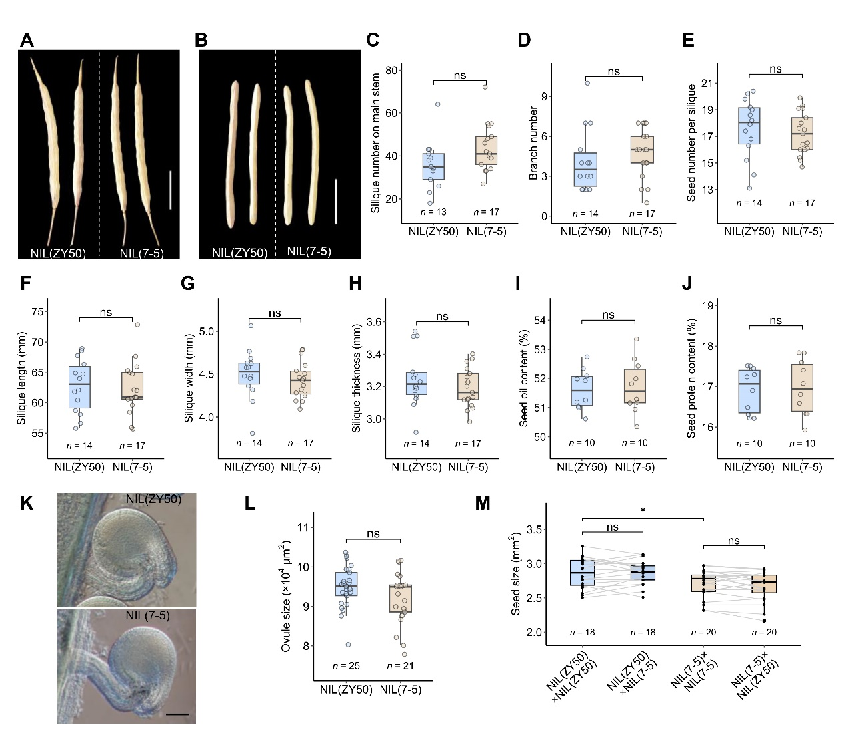
Figure S1. Phenotype analysis of yield related traits between NIL plants.
(A and B) Silique (A) and valve (B) phenotype of NIL plants at mature stage. Scale bar = 2 cm.
(C-J) Comparison of silique number on main stem (C), branch number (D), seed number per silique (E), silique length (F), silique width (G), silique thickness (H), seed oil content (I) and seed protein content (J) between NIL plants.
(K) Ovule phenotype of NIL plants at stage 13 (buds about to open). Scale bar = 100 μm. (L) Comparison of the ovule size of NIL plants at stage 13.
(M) Comparison of the seed size of reciprocal crossing between NIL plants. Two-tailed t-tests were used for statistical analysis in (C-J) and (L). Two-tailed paired t-tests were used for (M). ns, not significant; *P < 0.05.
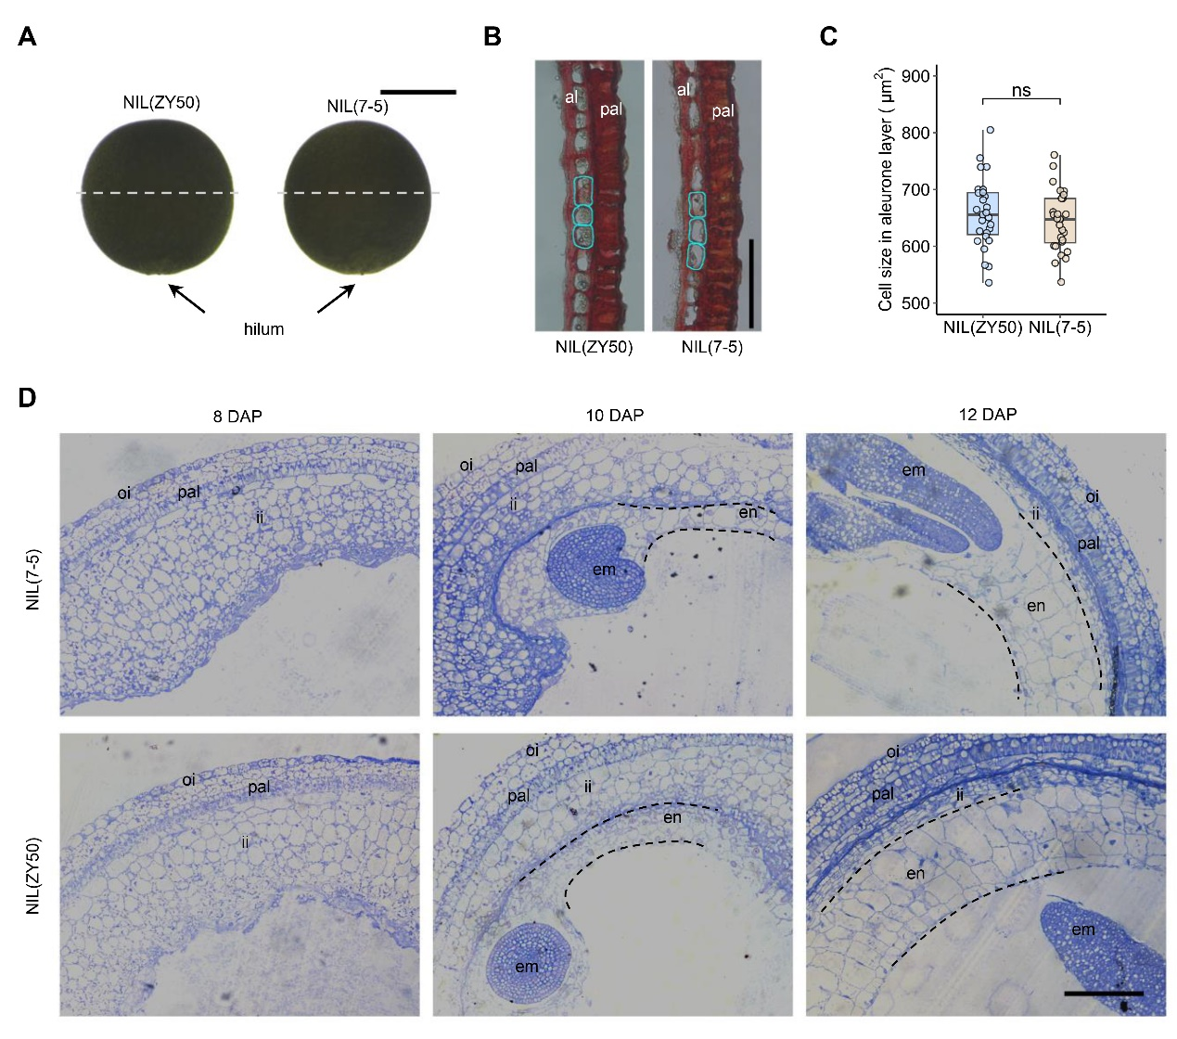
Figure S2. Comparison of the cell size in aleurone layer and the timing of endosperm cellularization between NIL plants.
(A) NIL seeds showing the section sites. Bar = 1 mm.
(B) Cross sections of NIL seed coats. al, aleurone layer; pal, palisade layer. Bar = 100 μm.
(C) Statistics of the cell size in aleurone layer of NIL seeds. n = 27, 28.
(D) Cross sections of NIL seeds at different development stages. DAP, days after pollination; oi, outer integument; ii, inner integument; pal, palisade layer; em, embryo; en, endosperm. Bar = 200 μm. Two-tailed t-tests were used for statistical analysis. ns, not significant.

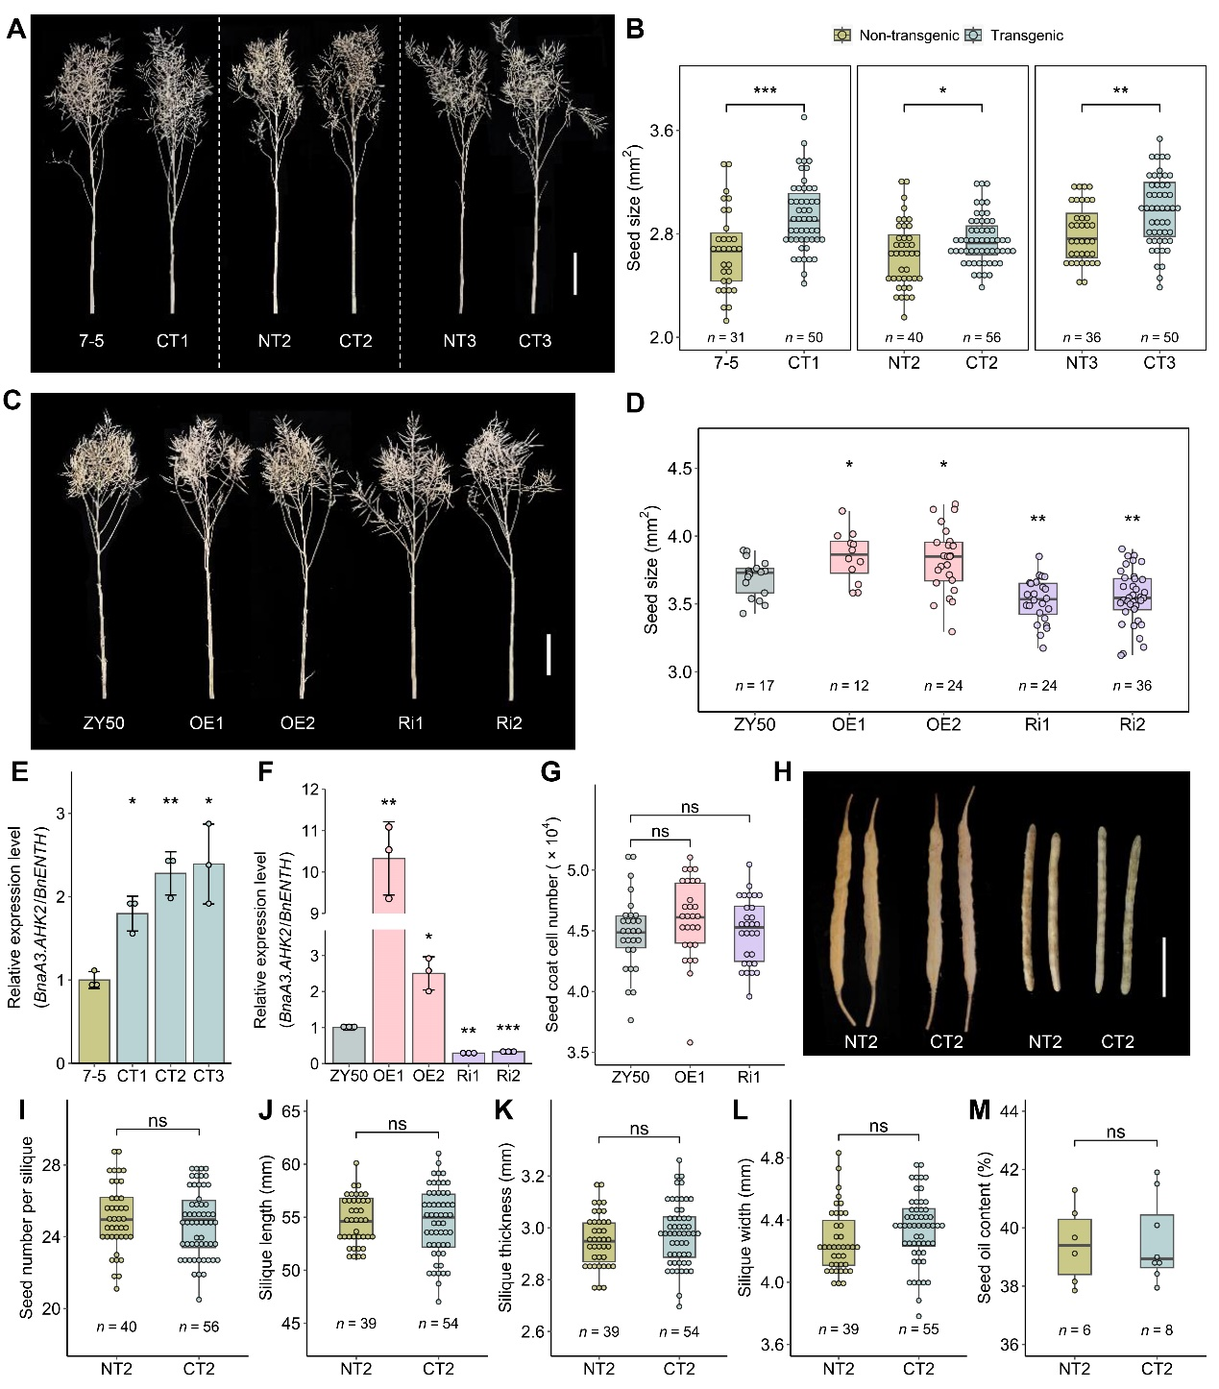
Figure S3. Phenotype analysis of yield related traits in complementation transgenic plants.
(A) Phenotype of BnaA3.AHK2 transgenic plants (CT1, CT2 and CT3) and corresponding non-transgenic plants (7-5, NT2 and NT3). Scale bar = 20 cm.
(B) Comparison of the seed size of plants described in (A).
(C) Phenotype of wild-type ZY50, BnaA3.AHK2 overexpression plants (OE1, OE2) and RNAi plants (Ri1, Ri2). Scale bar = 20 cm.
(D) Comparison of the seed size (H) of plants described in (C).
(E) Relative expression level of BnaA3.AHK2 in 7-5 and complementary lines.
(F) Relative expression level of BnaA3.AHK2 in ZY50, over-expressing (OE) and RNAi (Ri) lines.
(G) Statistics of seed coat cell number in OE, RNAi lines and wild-type ZY50.
(H) Silique and valve phenotype of complementary line CT2 and its corresponding wild-type line NT2. Scale bar = 2 cm.
(I–M) Comparison of seed number per silique (I), silique length (J), silique thickness (K), silique width (L), and seed oil content (M) between CT2 and NT2 lines. Two-tailed t-tests were used for statistical analysis. ns, not significant; *P < 0.05; **P < 0.01; ***P < 0.001.

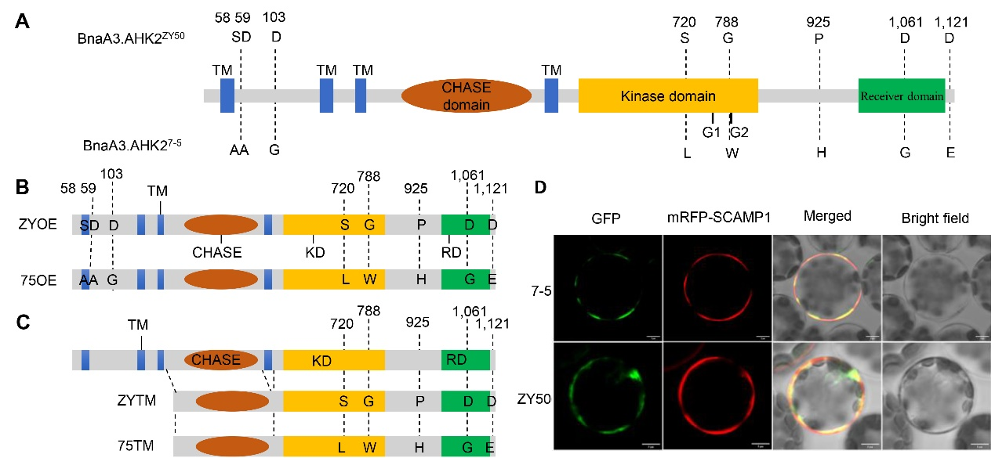
Figure S4. Analysis of the variations of BnaA3.AHK2.
(A) Amino acid variations between the two genotypes of BnaA3.AHK2. The eight amino acid divergence was shown. G1 and G2 are the putative ATP binding sites.
(B) Schematic representation of the proteins expressed in Arabidopsis triple mutants.
(C) Schematic representation of the proteins used in the phosphorylation assay. The transmembrane region was removed in the assay. TM, transmembrane; CHASE, CHASE domain; KD, kinase domain; RD, receiver domain.
(D) Subcellular localization of BnaA3.AHK2 in protoplasts of Aribidopsis. Upper, BnaA3.AHK2⁷⁻⁵-GFP; lower, BnaA3.AHK2^{ZY50}-GFP; mRFP-SCAMP1 (pBI221), Plasma membrane marker. Scale bar, 5 μm.

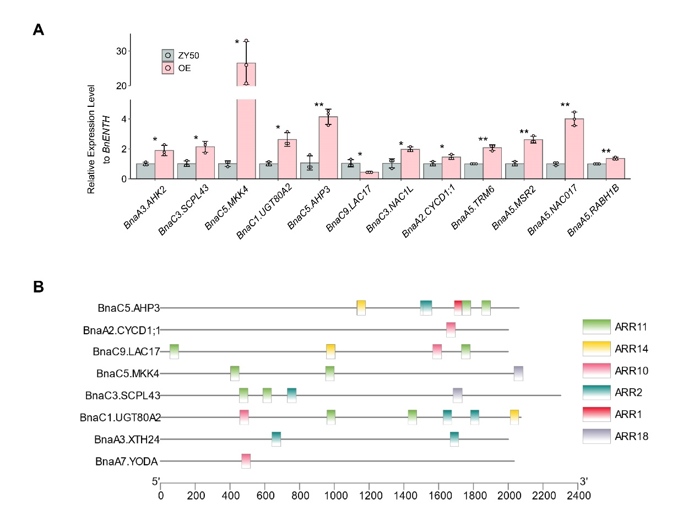
Figure S5. Expression and motif analysis of DEGs.
(A) qRT-PCR analysis of DEGs.
(B) Motif analysis in the promoter region of DEGs. Two-tailed t-tests were used for statistical analysis. *P < 0.05, **P < 0.01.

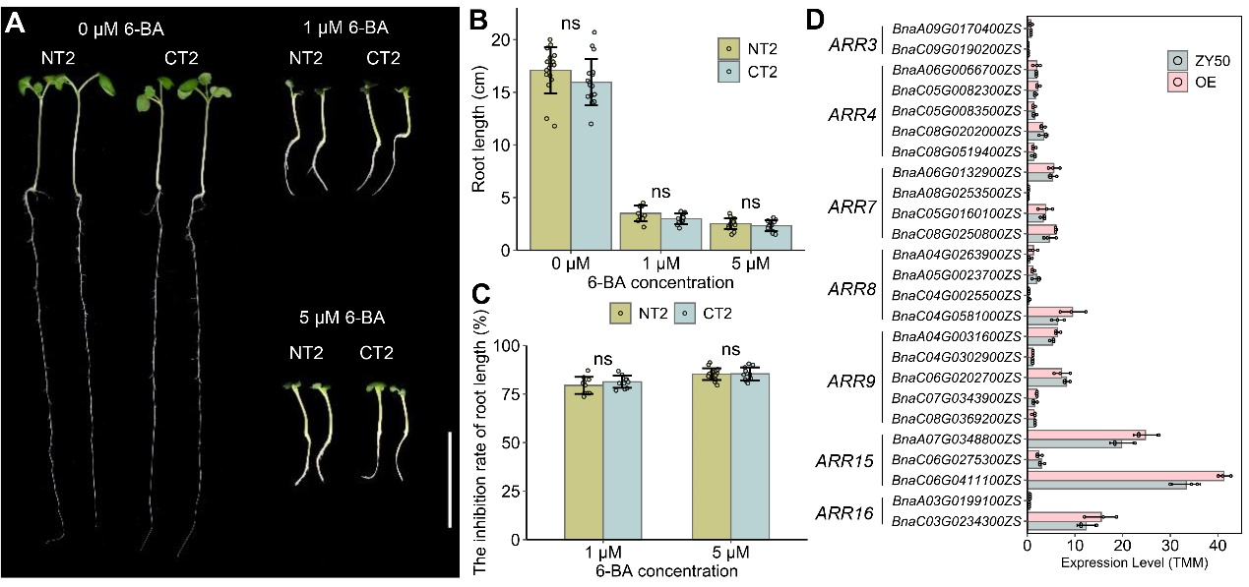
Figure S6. BnaA3.AHK2 has no effect on the cytokinin responses.
- Seedling phenotypes of complementary line CT2 and wild type NT2 at 2 weeks after sowing.
(B-C) Comparison of root length (A) and the inhibition rate of root length (B) of seedlings described in (A).
(D) The expression levels of type-A ARRs in BnaA3.AHK2-OE plants. Two-tailed t-tests were used for statistical analysis. ns, not significant.

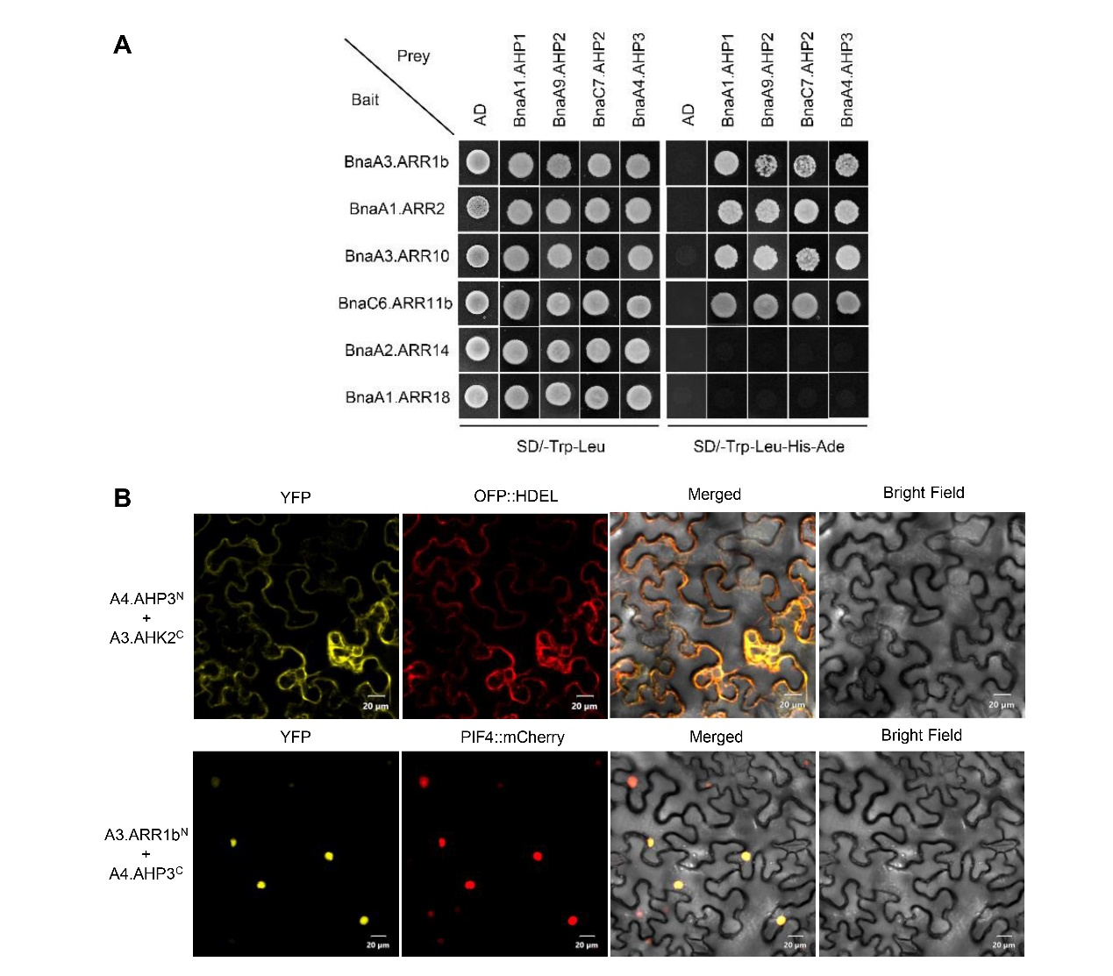
Figure S7. Protein-Protein Interaction Analysis of downstream genes of BnaA3.AHK2
(A) Yeast two hybrid (Y2H) assay showing protein interaction between Bna.AHPs and Bna.ARRs.
(B) Bimolecular fluorescence complementation (BiFC) analysis of protein interactions between A3.AHK2, C7.AHP2, and A3.ARR10 proteins in Nicotiana benthamiana.

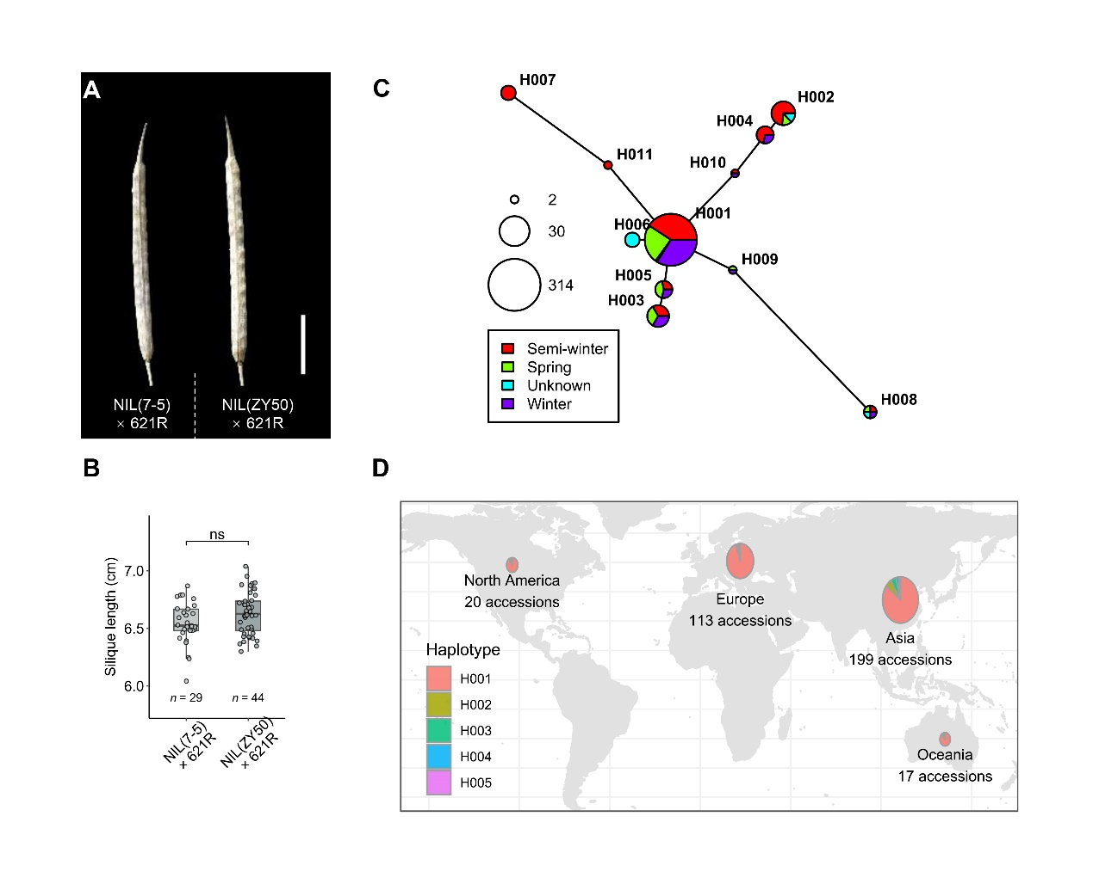
Figure S8. Phenotype analysis of yield related traits and haplotype distribution of BnaA3.AHK2.
(A) Silique phenotype of of hybrids derived from “NIL(7-5) × 621R” and “NIL(ZY50) × 621R”. Scale bar = 2 cm.
(B) Comparison of silique length between the hybrids.
(C-D) Haplotype network (C) and geographical distribution (D) of different haplotypes of BnaA03.AHK2.

Table S1. TSW summary of BnaA3.AHK2 transgenic lines.
Complementary lines | Thousand seed weight (g) |  |  |  | OE lines | Thousand seed weight (g) |  |  | Ri lines | Thousand seed weight (g)
Nontransgenic | 3.18  (7-5) |  | 3.14  (NT2) | 3.25  (NT3) | Nontransgenic | 5.55 (ZY50) |  |  | Nontransgenic | 5.55 (ZY50)
transgenic | 3.42  (CT1) |  | 3.33  (CT2) | 3.50  (CT3) | transgenic | 5.92  (OE1) |  | 5.99  (OE2) | transgenic | 5.14  (Ri1) |  | 5.27  (Ri2)
Increase | 0.23 |  | 0.19 | 0.25 | Increase | 0.37 |  | 0.45 | Decrease | 0.41 |  | 0.27
Increase % | 7.27 |  | 6.09 | 7.78 | Increase % | 6.71 |  | 8.09 | Decrease % | 7.31 |  | 4.94
Average increase % |  | 7.05 |  |  | Average increase % |  | 7.40 |  | Average decrease % |  | 6.12

Table S2. TSW summary of improve lines and hybrids
Lines | Thousand seed weight (g) | Increase (g) | Increase %
NIL(7-5) × 621R | 3.55 | 0.19 | 5.35
NIL(ZY50) × 621R | 3.74 | 0.19 | 5.35
621R | 2.86 | 0.20 | 6.99
621R(A3-2) | 3.06 | 0.20 | 6.99
616A × 621R | 3.41 | 0.31 | 9.09
616A × 621R(A3-2) | 3.72 | 0.31 | 9.09
RG430A × 621R | 4.12 | 0.15 | 3.64
RG430A × 621R(A3-2) | 4.27 | 0.15 | 3.64

Table S3. TSW summary of different haplotypes of BnaA3.AHK2
Haplotype | Accession numbers | Thousand seed weight (g) | Standard deviation
H001 | 310 | 3.58 | 0.46
H002 | 13 | 3.82 | 0.33
H003 | 12 | 3.69 | 0.35
H004 | 7 | 3.75 | 0.59
H005 | 7 | 3.57 | 0.52

Table S4. Haplotype frequencies of BnaA3.AHK2 in natural population
Frequency (%) | H001 | H002 | H003 | H004 | H005
Winter | 93.0 | 0.0 | 3.5 | 1.8 | 1.8
Spring | 89.4 | 2.4 | 4.7 | 0.0 | 3.5
Semi-winter | 85.3 | 7.3 | 2.7 | 3.3 | 1.3
EU1950-1980 | 97.5 | 0.0 | 0.0 | 1.2 | 1.2
EU1981-2000 | 87.5 | 3.1 | 3.1 | 3.1 | 3.1
CN1950-1980 | 96.1 | 1.3 | 2.6 | 0.0 | 0.0
CN1981-2000 | 84.5 | 4.2 | 4.2 | 2.8 | 4.2
CN2000-2011 | 48.0 | 28.0 | 12.0 | 12.0 | 0.0

