Supporting Information

Supporting Figures

Figure S1. Comparative morphological features of M. archiducis-nicolai and M. ruthenica (A) M. archiducis-nicolai exhibits elongated rhizomes (arrow), a key morphological adaptation for nutrient storage and overwintering in alpine environments. (B) In contrast, M. ruthenica develops a more robust root system but lacks prominent rhizome formation.

Figure S2. Genome survey analysis of M. archiducis-nicolai and M. ruthenica based on K-mer frequency distributions

GenomeScope2 shows the frequency distribution of K-mer occurrences in M. archiducis-nicolai (A) and M. ruthenica (B). Genome assembly metrics revealed the following characteristics for M. archiducis-nicolai versus M. ruthenica: genome size = 936.65 vs. 891.17 Mb; heterozygosity rate = 1.25% vs. 1.01%; and repetitive sequence content = 66.2% vs. 66.1%.

Figure S3. Hi-C chromatin interaction maps of M. archiducis-nicolai and M. ruthenica

Genome-wide contact matrices showing pairwise interaction frequencies across eight chromosome groups in M. archiducis-nicolai (A) and M. ruthenica (B). The characteristic diagonal patterns (darker red) represent enriched intra-chromosomal contacts, demonstrating stronger interactions within chromosomes than between chromosomes (off-diagonal regions). Color intensity scales with interaction frequency.

Figure S4. Comparative analysis of LTR retrotransposon insertion ages in M. archiducis-nicolai and M. ruthenica genomes

(A) Frequency distribution of insertion times for full-length LTR retrotransposons in M. archiducis-nicolai. (B) Corresponding distribution in M. ruthenica. The insertion age patterns reveal distinct bursts of transposable element activity, reflecting species-specific evolutionary dynamics of genome expansion and rearrangement. The x-axis represents insertion time estimated from LTR divergence (Mya), while the y-axis shows normalized retrotransposon counts.
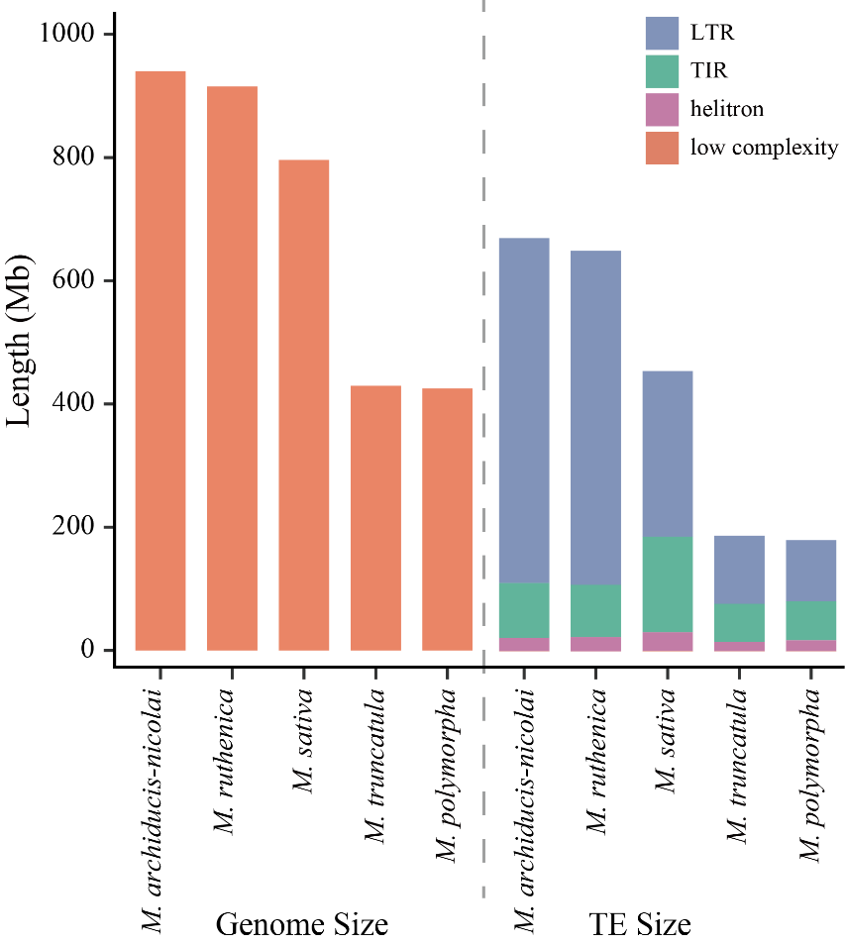

Figure S5. Genome size and transposon element length in five Medicago species

Figure S6. Go enrichment analysis of significantly expanded gene families in M. archiducis-nicolai and M. ruthenica

(A) M. archiducis-nicolai. (B) M. ruthenica. Top enriched GO terms (Biological Process) are displayed, ranked by significance P-value. Terms associated with environmental adaptation are highlighted.

Figure S7. Structural variation of chromosome 4 in M. archiducis-nicolai

(A-C) Hi-C maps of M. archiducis-nicolai (A), M. ruthenica (B), and M. sativa ssp. caerulea (C). Red dashed boxes in (B) and (C) mark the region missing in M. archiducis-nicolai chromosome 4. (D) Dotplot between M. archiducis-nicolai and M. ruthenica, with the red dashed box indicating a chromosome 4 translocation. (E-F) Distribution of TEs and species-specific genes in both species. The highlighted region corresponds to the translocation region, suggesting TE involvement and subsequent gene loss in M. archiducis-nicolai.

Figure S8. GO enrichment of M. ruthenica species-specific genes in the chromosome 4 region is absent from M. archiducis-nicolai

Bubble plot showing the top enriched Gene Ontology biological process (GO-BP) terms for M. ruthenica species-specific genes corresponding to the missing segment on M. archiducis-nicolai chromosome 4 (see Figure S7). The x-axis represents the GeneRatio, the y-axis lists significantly enriched GO terms, and bubble size indicates the number of genes assigned to each term. Bubble colour denotes the adjusted P-value, and red-labelled terms highlight major stress-response pathways.

Figure S9. Correlation analysis between genome size and transposable element (TE) content in five Medicago genomes

(A) Linear regression of genome size against LTR retrotransposon (LTR-RT) cumulative length. (B) Genome size versus non-LTR retrotransposon (non-LTR-RT) content. (C-D) Associations between genome size and major LTR-RT subfamilies: (C) Gypsy and (D) Copia elements. Coefficient of determination (R²) and statistical significance are indicated for each correlation (*P < 0.05; **P < 0.01).

Figure S10. Distribution of synonymous substitution rates (Ks) for different gene duplication types in M. archiducis-nicolai and M. ruthenica

(A) M. archiducis-nicolai. (B) M. ruthenica. Vertical dashed lines indicate significant Ks peaks corresponding to putative duplication events. The x-axis shows Ks values (log scale), while the y-axis represents gene pair density.

Figure S11. GO enrichment analysis of rhizome-specific unique genes in M. archiducis-nicolai

The dot color represents the P-value scale, the dot size corresponds to the number of genes per term, and terms functionally associated with rhizome morphogenesis are highlighted in red.

Figure S12. WGCNA analysis of rhizome development in M. archiducis-nicolai

(A) Sample clustering dendrogram showing outlier detection and sample relationships. (B) Cluster dendrogram of co-expression modules with color coding indicating distinct gene groups. (C) Expression validation of hub genes across four developmental tissues: Q.R (root), Q.R.D (rhizome basal), Q.R.M (rhizome middle), and Q.R.U (rhizome tip). Gene expression was validated using RNA-Seq (TPM values, bars) and RT-qPCR (lines), with error bars representing the standard deviation (SD) of three biological replicates.

Figure S13. Hierarchical clustering analysis of thermal stress responses in two Medicago species

(A-B) Heatmap visualization of sample clustering based on Pearson correlation coefficients under cold stress (4°C) for (A) M. archiducis-nicolai and (B) M. ruthenica. (C-D) Corresponding heatmap analysis under heat stress (40°C) for (C) M. archiducis-nicolai and (D) M. ruthenica. Color gradient represents standardized expression values (Z-scores) of differentially expressed transcripts, with dendrogram branch lengths indicating sample similarity (1 - Pearson r).

Figure S14. Comparative analysis of DEGs under thermal stress in M. archiducis-nicolai and M. ruthenica

(A) Venn diagram of cold-responsive DEGs (FDR < 0.01, |log₂FC| ≥ 2) in two species. (B) The overlapping cold-responsive DEGs show conserved expression patterns (Z-score normalized log₂(Fold Change); red: upregulation, blue: downregulation). (C) Corresponding Venn analysis of heat-responsive DEGs. (D) Expression patterns of shared heat-responsive genes.

Figure S15. Weighted gene co-expression network analysis (WGCNA) of cold stress-responsive DEGs in M. archiducis-nicolai and M. ruthenica

(A) Module-trait relationships in M. archiducis-nicolai show significant associations (|correlation| > 0.5, P < 0.05) between gene modules and cold treatment duration. The red/green color scale indicates positive/negative correlations, respectively. (B) Protein-protein interaction network of the top 15 hub genes from the MEblack module in M. archiducis-nicolai. (C) Corresponding module-trait analysis for M. ruthenica. (D) Hub gene network (top 15 nodes) from M. ruthenica’s MEblue module.

Figure S16. Weighted gene co-expression network analysis (WGCNA) of heat stress-responsive DEGs in M. archiducis-nicolai and M. ruthenica

(A) Module-trait relationships in M. archiducis-nicolai show significant associations (|correlation| > 0.5, P < 0.05) between gene modules and heat treatment duration. The red/green color scale indicates positive/negative correlations, respectively. (B) Protein-protein interaction network of the top 15 hub genes from the MEgreenyellow module in M. archiducis-nicolai. (C) Corresponding module-trait analysis for M. ruthenica. (D) Hub gene network (top 15 nodes) from M. ruthenica’s MEblack module.

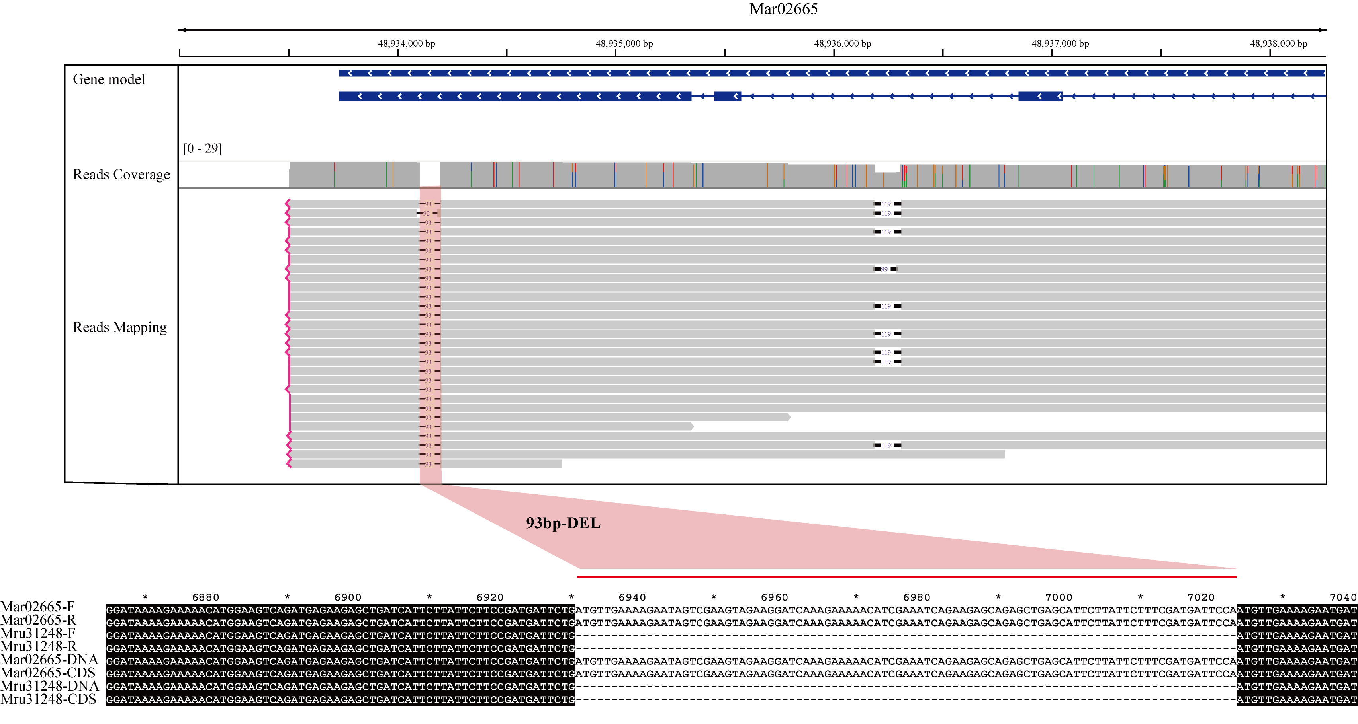
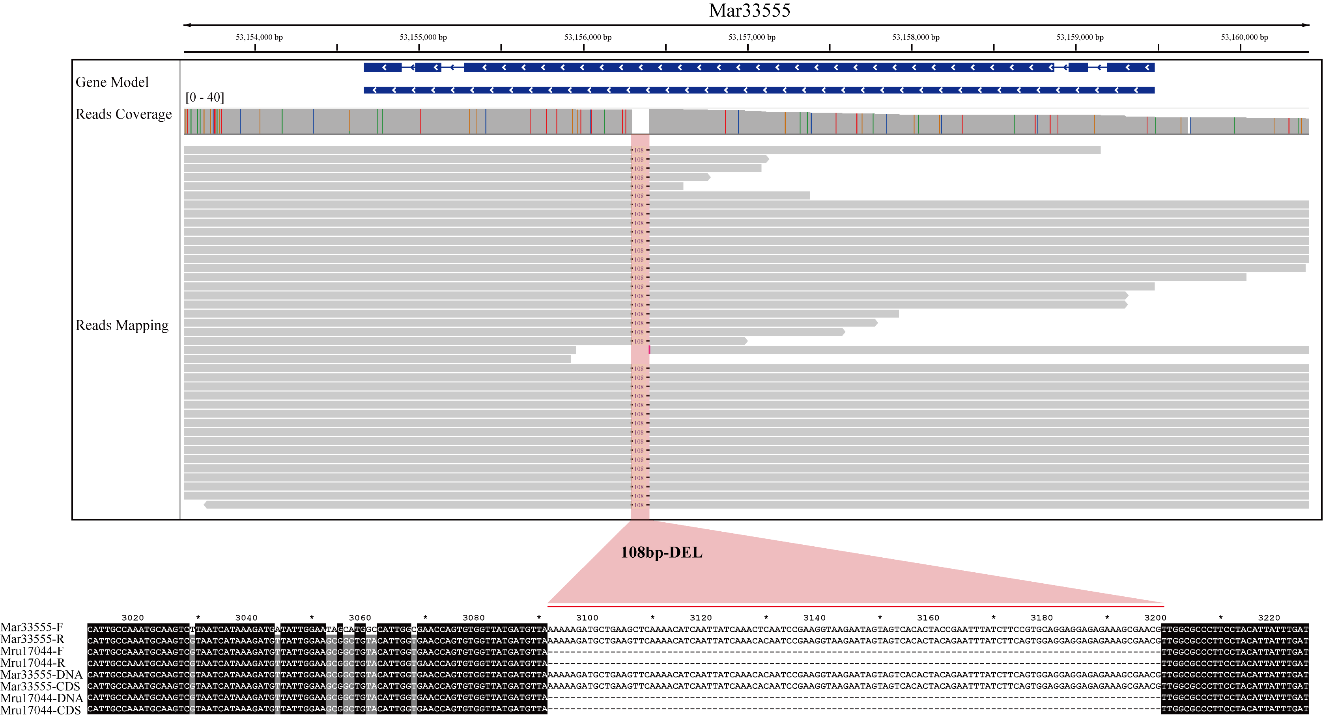

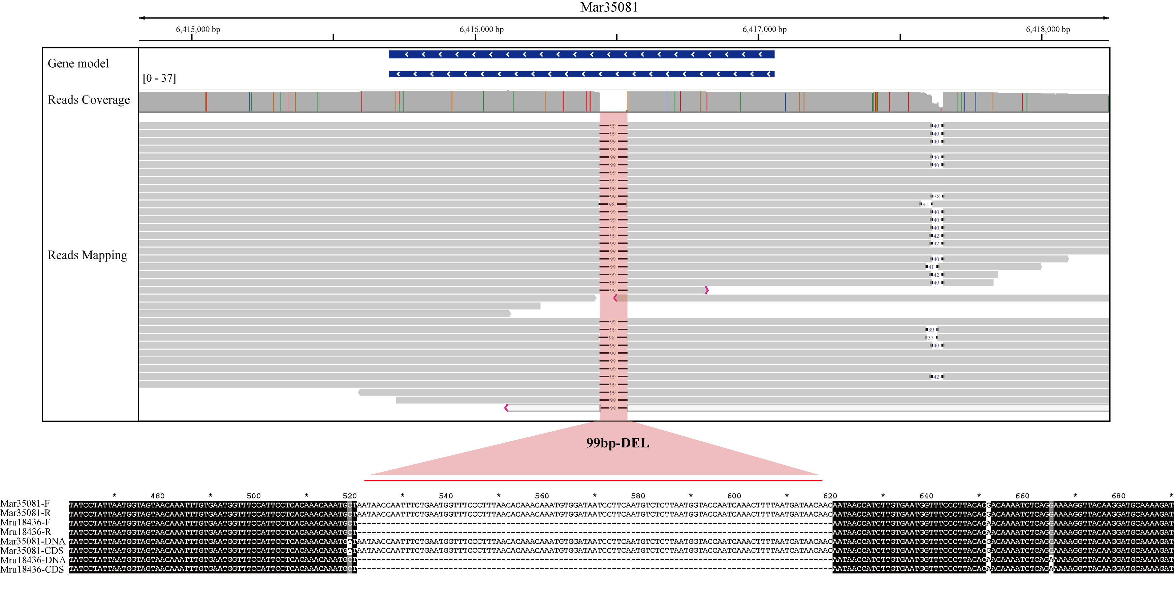
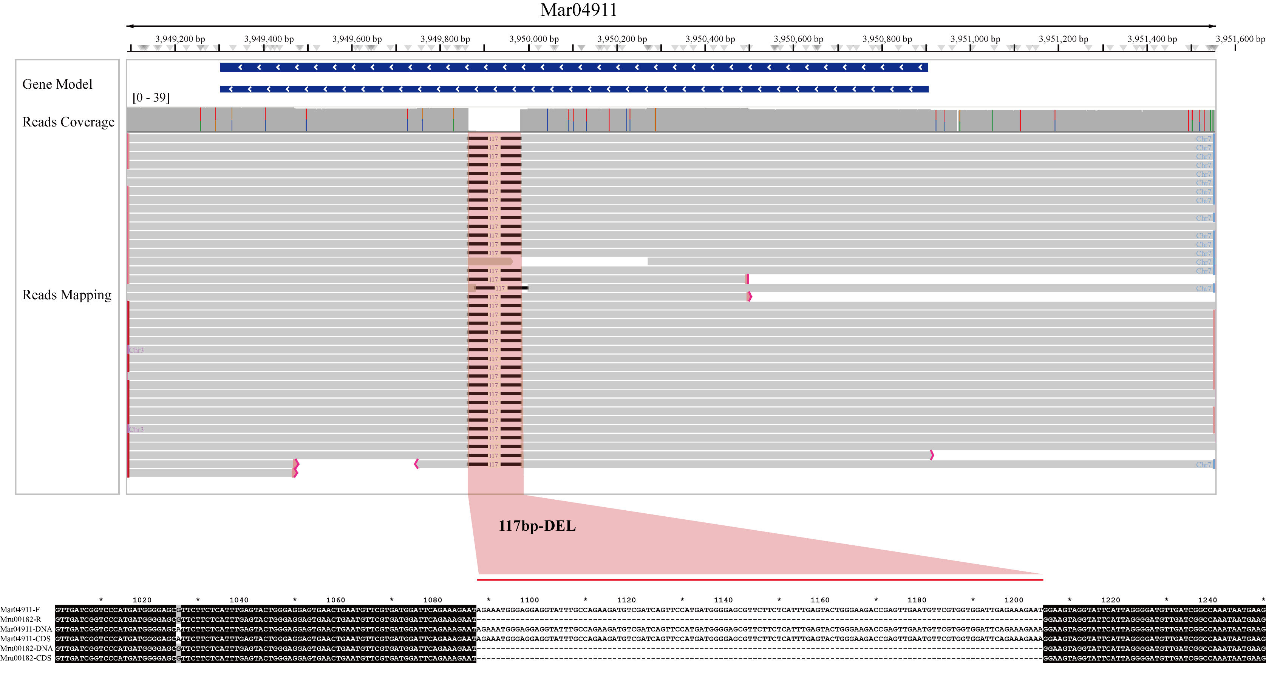

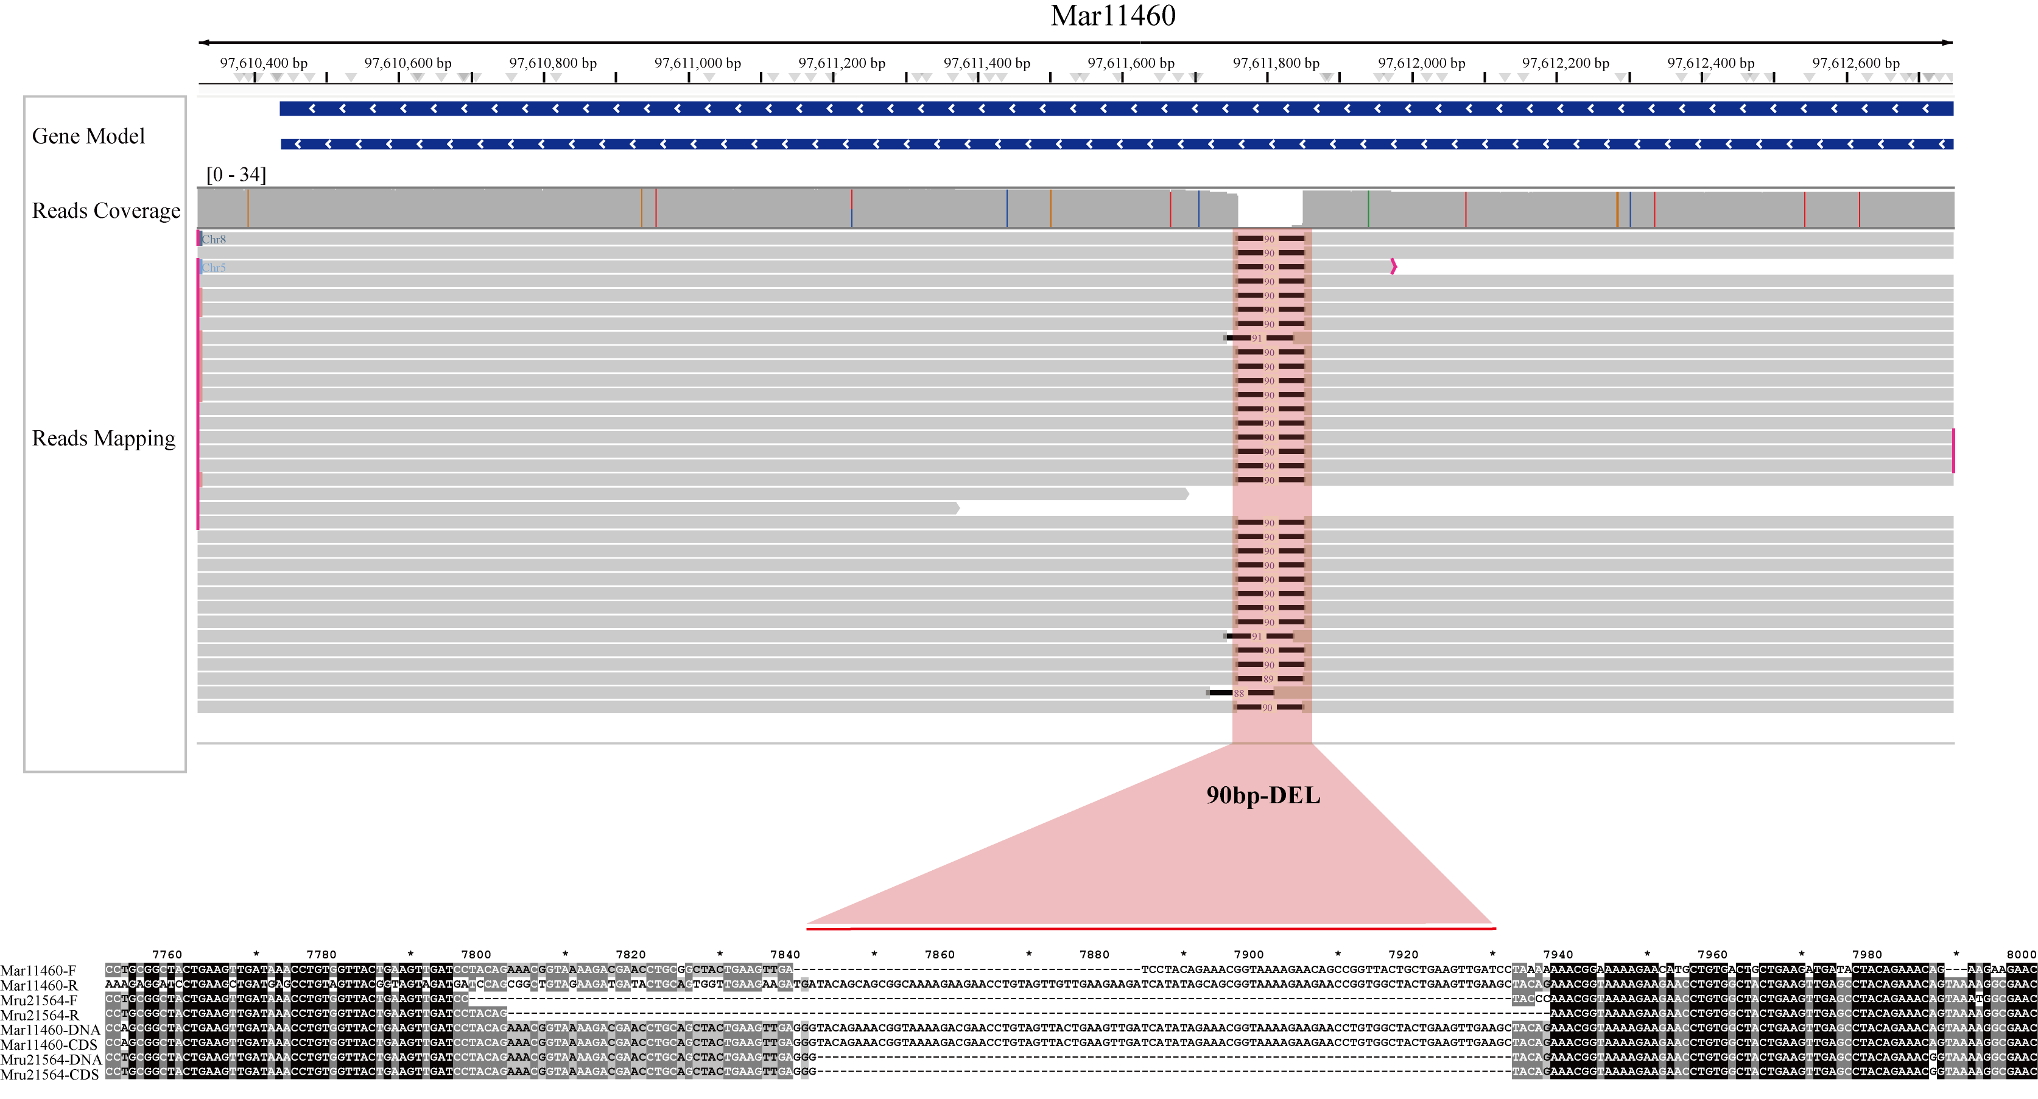
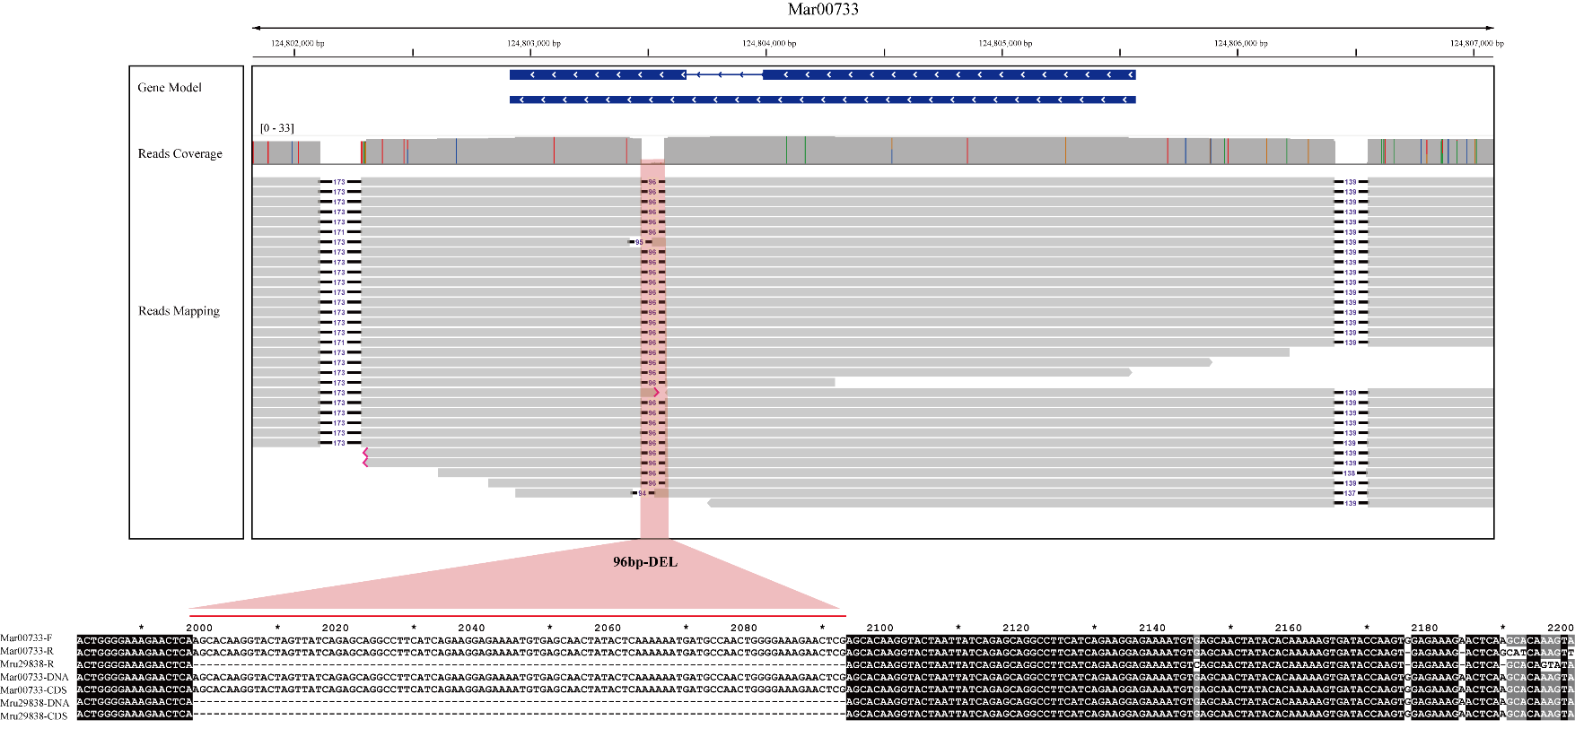

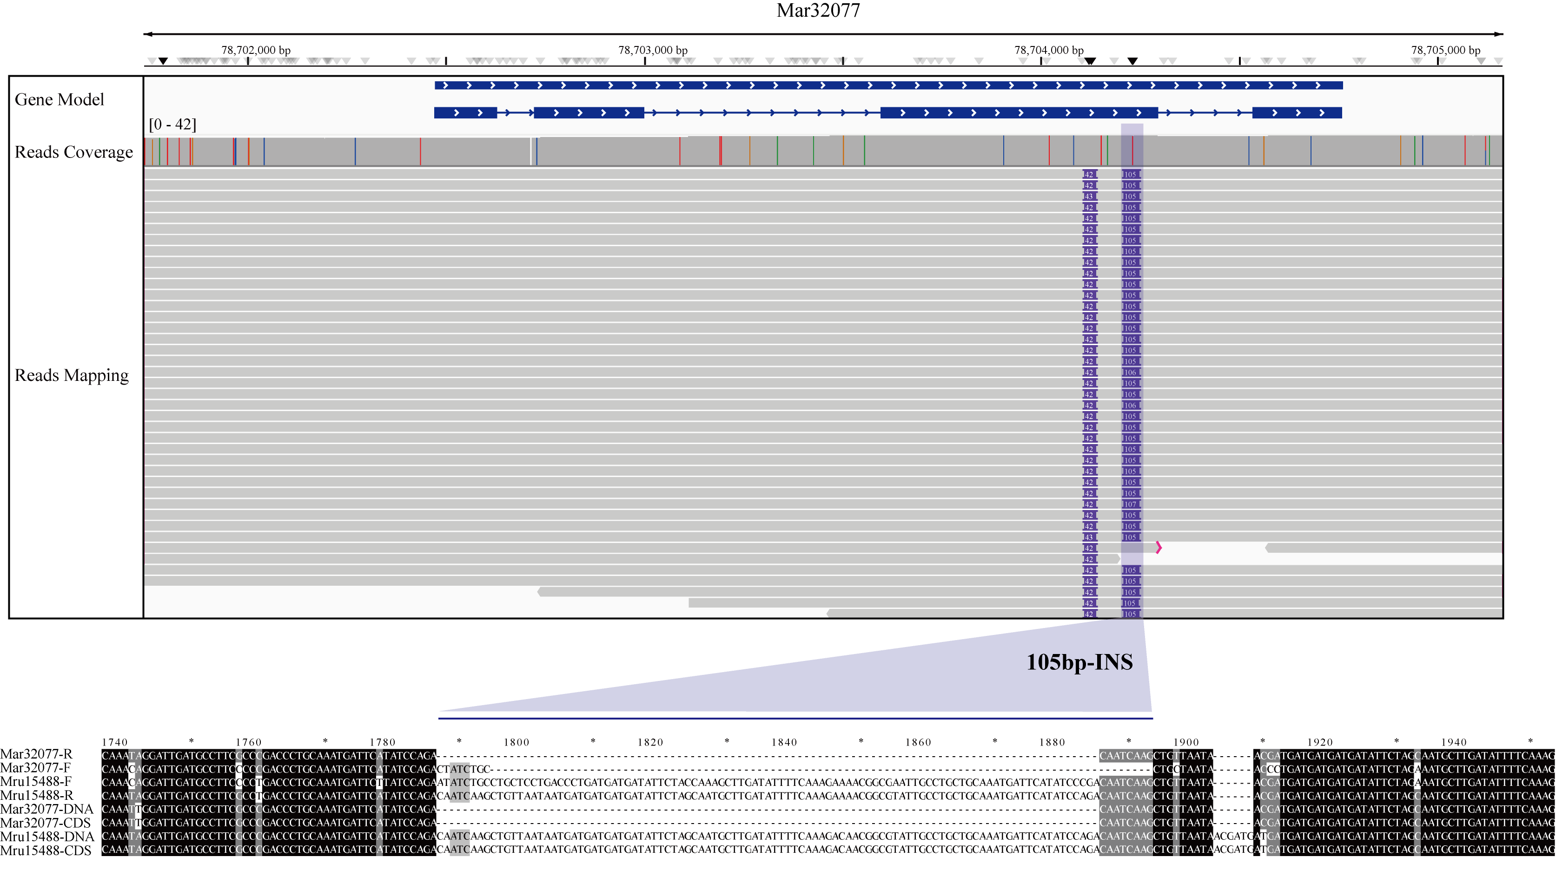
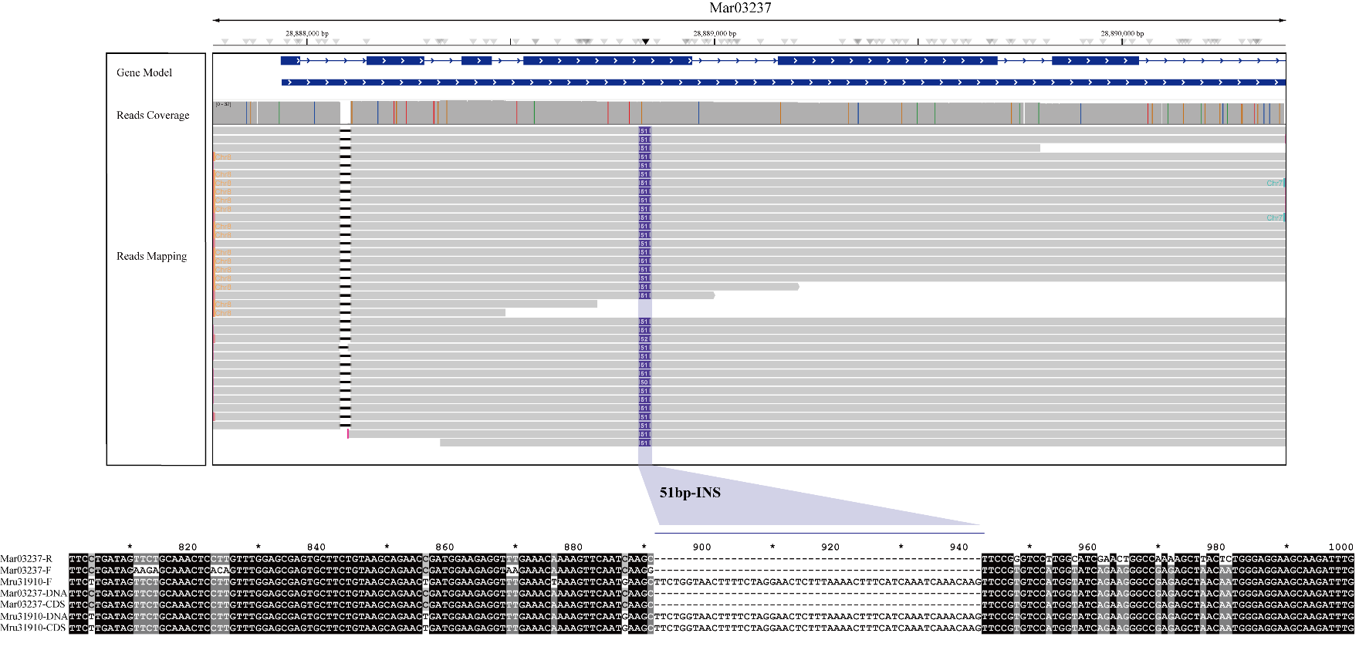
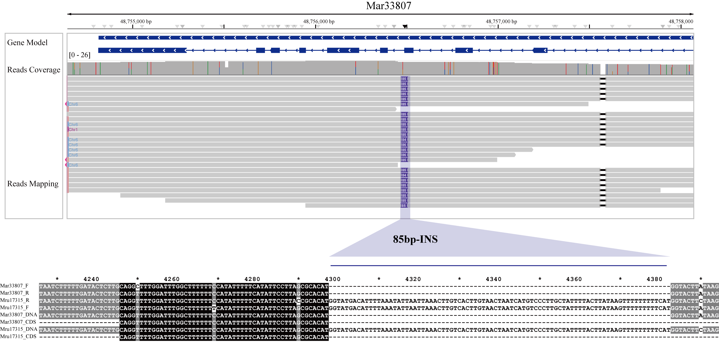
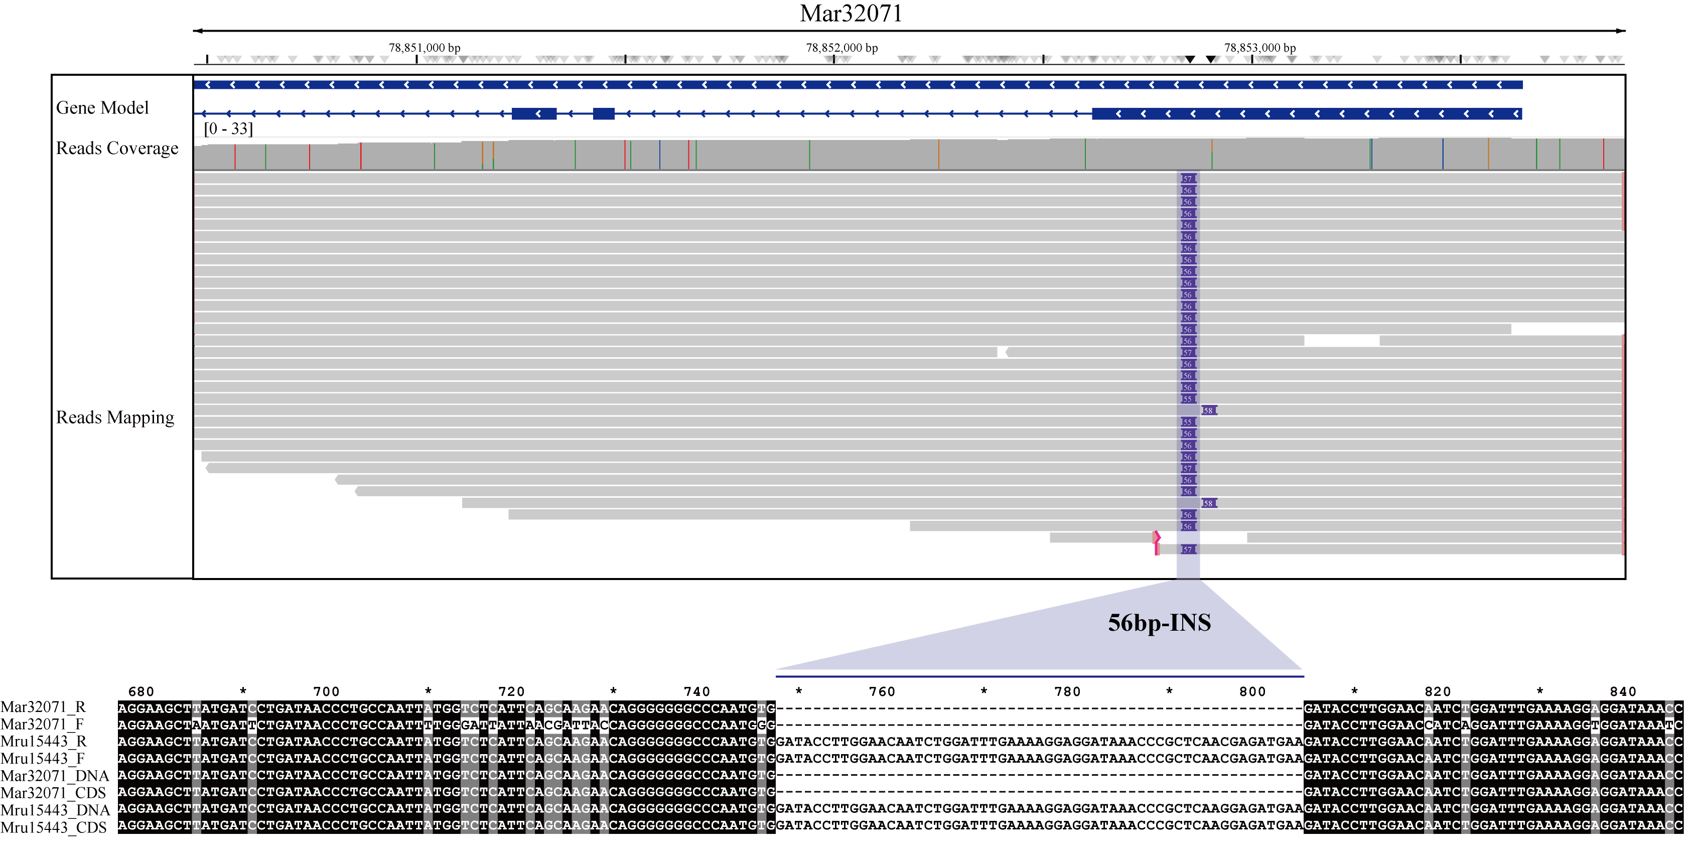

Figure S17. Validation of randomly selected high-impact SVs. The top panel shows read coverage and mapping support from HiFi long-read data at the SV locus. The bottom panel shows PCR amplification and sequence alignment confirming the deletion, providing experimental validation for the predicted SV.

Supporting Tables

Table S1. Summary statistics of sequencing reads generated in this study
Statistics | M. archiducis-nicolai | M. ruthenica
HiFi reads
HiFi reads count | 3,424,710 | 1,912,270
Subreads length (bp) | 51,403,172,470 | 32,333,698,628
HiFi reads depth | 54.68 | 35.33
Subread N50 (bp) | 15,122 | 16,854
Average subread (bp) | 15,009.50 | 16,908.54
Longest subread (bp) | 50,126 | 46,786
Illumina reads
Illumina reads count | 340,001,750 | 396,450,098
Illumina reads length (bp) | 50,848,362,158 | 59,467,514,700
Illumina depth | 54.09 | 64.99
HI-C reads
HI-C reads count | 754,002,072 | 635,569,398
HI-C reads length (bp) | 112,413,208,488 | 95,335,409,700
Hi-C depth | 119.58 | 104.18

Table S2. Assembly statistics of the two contig-level genomes
Statistics | M. archiducis-nicolai |  | M. ruthenica
Statistics | Contig Size (bp) | Contig Number | Contig Size (bp) | Contig Number
Contig N50 | 105,979,910 | 4 | 26,260,662 | 13
Contig N60 | 90,909,591 | 5 | 22,179,700 | 17
Contig N70 | 56,418,457 | 7 | 16,945,023 | 22
Contig N80 | 53,287,167 | 8 | 12,175,339 | 29
Contig N90 | 46,143,357 | 10 | 8,725,364 | 37
Total contig number | -- | 32 | -- | 102
Genome contig size (bp) | 940,034,534 |  | 915,088,293

Table S3. Assembly statistics of the two scaffold-level genomes
Statistics | M. archiducis-nicolai |  | M. ruthenica
Statistics | Scaffold Size (bp) | Scaffold Number | Scaffold Size (bp) | Scaffold Number
Scaffold N50 | 126,103,759 | 4 | 111,184,367 | 4
Scaffold N60 | 116,385,664 | 5 | 109,823,785 | 5
Scaffold N70 | 105,979,910 | 6 | 108,718,203 | 6
Scaffold N80 | 99,430,624 | 7 | 106,633,929 | 7
Scaffold N90 | 99,430,624 | 7 | 85,943,030 | 8
Total scaffold number | -- | 20 | -- | 28
Genome scaffold size (bp) | 937,918,196 |  | 879,660,993
Genome anchored rate | 99.78% |  | 96.13%

Table S4. Comparison among different M. ruthenica genome assemblies
Statistics | Mru (Yin et al. 2021) | Mru (Wang et al. 2021) | Mru#
Sequence platform | PacBio CLR | PacBio CLR | PacBio HiFi
Sequencing depth | 104 | 105.4 | 35.33
Number of contigs | 2648 | 2083 | 102
Contig N50 (kb) | 683.58 | 632.05 | 26,260.66
Largest contig (bp) | 9,005,889 | 3,319,504 | 47,598,362
Mean scaffold length (bp) | 997,309.88 | 997,309.88 | 32,682,039.04
ScaffoldN50 (bp) | 112,688,965 | 99,386,155 | 111,184,367
Largest scaffold (bp) | 118,854,195 | 120,346,191 | 123,357,133
Gaps | 2,262 | 1,501 | 88
Assembly size (Mb) | 903.56 | 904.13 | 915.09
Anchored rate | 91.69% | 91.30% | 96.13%
Repeat_percentage (%) | 68.63% | 57.00% | 71.02%
Annotation BUSCO (%)* | 93.9% | 92.1% | 93.0%
* Assessment based on embryophyta_odb10 1614 databases.
# Represents the genome used in this study.

Type | M. archiducis-nicolai |  | M. ruthenica
Type | Number | Percentage | Number | Percentage
Complete BUSCOs (C) | 1,521 | 94.2% | 1,501 | 93.0%
Complete and single-copy BUSCOs (S) | 1,458 | 90.3% | 1,421 | 88.0%
Complete and duplicated BUSCOs (D) | 63 | 3.9% | 80 | 5.0%
Fragmented BUSCOs (F) | 8 | 0.5% | 11 | 0.7%
Missing BUSCOs (M) | 85 | 5.3% | 102 | 6.3%
Total | 1,614 | -- | 1,614 | --

Table S5. BUSCO assessment of the two Medicago genome assemblies
*Assessment with the Embryophyta odb10 database.

Table S6. Annotation of repetitive elements in the two Medicago species
Class |  | M. archiducis-nicolai |  |  | M. ruthenica
 |  | Count | Masked (bp) | %masked | Count | Masked (bp) | %masked
LTR
 | Copia | 140,130 | 193,551,914 | 20.59% | 127,304 | 160,507,354 | 17.54%
 | Gypsy | 294,036 | 227,381,246 | 24.19% | 188,455 | 243,060,927 | 26.56%
 | unknown | 199,607 | 139,012,149 | 14.79% | 210,821 | 138,482,934 | 15.13%
TIR
 | CACTA | 21,518 | 10,308,741 | 1.10% | 21,690 | 10,385,768 | 1.13%
 | Mutator | 140,873 | 45,916,465 | 4.88% | 116,033 | 39,267,827 | 4.29%
 | PIF_Harbinger | 33,071 | 8,589,884 | 0.91% | 39,636 | 11,114,447 | 1.21%
 | Tc1_Mariner | 29,522 | 6,736,405 | 0.72% | 31,007 | 7,357,230 | 0.80%
 | hAT | 55,930 | 17,303,193 | 1.84% | 54,911 | 16,673,045 | 1.82%
low_complexity |  | 56 | 189,793 | 0.02% | 114 | 85,928 | 0.01%
nonTIR
 | helitron | 50,984 | 21,695,640 | 2.31% | 52,105 | 22,932,309 | 2.51%
Total |  | 965,727 | 670,685,430 | 71.35% | 842,076 | 649,867,769 | 71.02%

Table S7. Comparative statistics of gene function annotation across different databases
 | M. archiducis-nicolai |  | M. ruthenica
 | Number | Percent | Number | Percent
Total Genes | 35,270 | - | 36,002 | -
Swissprot | 19,936 | 56.52% | 20,305 | 56.40%
NR | 32,116 | 91.06% | 33,050 | 91.80%
KEGG | 14,366 | 40.73% | 14,643 | 40.67%
InterPro | 27,986 | 79.35% | 28,662 | 79.61%
GO | 14,790 | 41.93% | 14,947 | 41.52%
Pfam | 26,856 | 76.14% | 27,507 | 76.40%
Annotated | 32,668 | 92.62% | 33,518 | 93.10%
Unannotated | 2,602 | 7.38% | 2,484 | 6.90%

Species | No. of genes | Multi-exon genes | Mean gene length (bp) | Gene density (gene/Mb) | Mean CDS length (bp) | Mean intron length (bp)
M. archiducis-nicolai | 35,270 | 27,457 | 3359.99 | 37.52 | 239.26 | 583.32
M. ruthenica | 36,002 | 27,973 | 3449.77 | 39.34 | 237.87 | 590.09
M. polymorpha | 36,085 | 27,707 | 3358.28 | 78.87 | 240.49 | 643.55
M. sativa | 49,157 | 37,327 | 3320.16 | 61.97 | 254.18 | 578.13
M. truncatula | 48,732 | 32,654 | 2829.13 | 113.33 | 260.08 | 745.00

Table S8. Comparison of gene features across the five Medicago species

Table S9. Summary of RNA-seq data for the two species under thermal stress conditions
Species Name | Accession ID | Group ID | Input Reads | Mapped Reads | Mapped Rate
M. archiducis-nicolai | Mar-CK-1 | Control | 43,832,146 | 40,262,646 | 91.86%
M. archiducis-nicolai | Mar-CK-2 | Control | 44,665,046 | 40,732,415 | 91.20%
M. archiducis-nicolai | Mar-CK-3 | Control | 41,677,443 | 37,921,515 | 90.99%
M. archiducis-nicolai | Mar-CK-4 | Control | 45,911,665 | 41,194,842 | 89.73%
M. archiducis-nicolai | Mar-L1-1 | Cold stress | 50,559,865 | 47,105,262 | 93.17%
M. archiducis-nicolai | Mar-L1-2 | Cold stress | 50,011,574 | 46,067,809 | 92.11%
M. archiducis-nicolai | Mar-L1-3 | Cold stress | 42,707,587 | 39,702,275 | 92.96%
M. archiducis-nicolai | Mar-L1-4 | Cold stress | 50,961,893 | 47,431,475 | 93.07%
M. archiducis-nicolai | Mar-L3-1 | Cold stress | 43,461,497 | 40,638,383 | 93.50%
M. archiducis-nicolai | Mar-L3-2 | Cold stress | 53,167,834 | 49,134,285 | 92.41%
M. archiducis-nicolai | Mar-L3-3 | Cold stress | 46,867,896 | 43,448,365 | 92.70%
M. archiducis-nicolai | Mar-L3-4 | Cold stress | 52,256,549 | 48,672,157 | 93.14%
M. archiducis-nicolai | Mar-L6-1 | Cold stress | 43,538,753 | 40,500,272 | 93.02%
M. archiducis-nicolai | Mar-L6-2 | Cold stress | 54,399,345 | 50,931,812 | 93.63%
M. archiducis-nicolai | Mar-L6-3 | Cold stress | 52,971,021 | 48,922,532 | 92.36%
M. archiducis-nicolai | Mar-L6-4 | Cold stress | 45,397,298 | 41,994,044 | 92.50%
M. archiducis-nicolai | Mar-L12-1 | Cold stress | 48,349,357 | 44,521,237 | 92.08%
M. archiducis-nicolai | Mar-L12-2 | Cold stress | 46,077,792 | 42,504,317 | 92.24%
M. archiducis-nicolai | Mar-L12-3 | Cold stress | 53,925,599 | 50,188,465 | 93.07%
M. archiducis-nicolai | Mar-L12-4 | Cold stress | 45,695,340 | 42,233,065 | 92.42%
M. ruthenica | Mru-CK-1 | Control | 41,976,984 | 38,320,408 | 91.29%
M. ruthenica | Mru-CK-2 | Control | 48,010,323 | 43,859,191 | 91.35%
M. ruthenica | Mru-CK-3 | Control | 48,765,678 | 44,545,690 | 91.35%
M. ruthenica | Mru-CK-4 | Control | 47,763,619 | 43,634,858 | 91.36%
M. ruthenica | Mru-L1-1 | Cold stress | 48,526,768 | 44,518,514 | 91.74%
M. ruthenica | Mru-L1-2 | Cold stress | 49,051,673 | 45,043,011 | 91.83%
M. ruthenica | Mru-L1-3 | Cold stress | 49,519,833 | 45,525,106 | 91.93%
M. ruthenica | Mru-L1-4 | Cold stress | 46,445,840 | 42,422,104 | 91.34%
M. ruthenica | Mru-L3-1 | Cold stress | 46,680,241 | 42,870,446 | 91.84%
M. ruthenica | Mru-L3-2 | Cold stress | 51,890,887 | 47,869,578 | 92.25%
M. ruthenica | Mru-L3-3 | Cold stress | 50,523,641 | 46,313,496 | 91.67%
M. ruthenica | Mru-L3-4 | Cold stress | 47,813,462 | 43,670,869 | 91.34%
M. ruthenica | Mru-L6-1 | Cold stress | 53,714,826 | 49,259,447 | 91.71%
M. ruthenica | Mru-L6-2 | Cold stress | 50,060,011 | 46,507,698 | 92.90%
M. ruthenica | Mru-L6-3 | Cold stress | 52,971,021 | 48,922,532 | 92.36%
M. ruthenica | Mru-L6-4 | Cold stress | 50,405,424 | 46,424,820 | 92.10%
M. ruthenica | Mru-L12-1 | Cold stress | 47,388,446 | 43,736,100 | 92.29%
M. ruthenica | Mru-L12-2 | Cold stress | 56,900,705 | 51,556,123 | 90.61%
M. ruthenica | Mru-L12-3 | Cold stress | 48,620,188 | 44,756,449 | 92.05%
M. ruthenica | Mru-L12-4 | Cold stress | 45,273,955 | 41,664,968 | 92.03%
M. archiducis-nicolai | Mar-H1-1 | Heat stress | 50,065,164 | 46,060,671 | 92.00%
M. archiducis-nicolai | Mar-H1-2 | Heat stress | 54,176,159 | 49,679,252 | 91.70%
M. archiducis-nicolai | Mar-H1-3 | Heat stress | 50,656,376 | 46,769,368 | 92.33%
M. archiducis-nicolai | Mar-H1-4 | Heat stress | 42,034,186 | 38,751,253 | 92.19%
M. archiducis-nicolai | Mar-H3-1 | Heat stress | 48,762,786 | 43,786,440 | 89.79%
M. archiducis-nicolai | Mar-H3-2 | Heat stress | 46,290,003 | 42,444,852 | 91.69%
M. archiducis-nicolai | Mar-H3-3 | Heat stress | 59,799,625 | 54,551,478 | 91.22%
M. archiducis-nicolai | Mar-H3-4 | Heat stress | 47,769,701 | 43,417,574 | 90.89%
M. archiducis-nicolai | Mar-H6-1 | Heat stress | 41,027,060 | 37,421,250 | 91.21%
M. archiducis-nicolai | Mar-H6-2 | Heat stress | 55,158,589 | 49,795,024 | 90.28%
M. archiducis-nicolai | Mar-H6-3 | Heat stress | 44,753,365 | 40,408,823 | 90.29%
M. archiducis-nicolai | Mar-H6-4 | Heat stress | 46,209,957 | 40,872,935 | 88.45%
M. archiducis-nicolai | Mar-H12-1 | Heat stress | 41,170,021 | 37,435,699 | 90.93%
M. archiducis-nicolai | Mar-H12-2 | Heat stress | 46,460,381 | 42,158,577 | 90.74%
M. archiducis-nicolai | Mar-H12-3 | Heat stress | 45,403,842 | 40,721,863 | 89.69%
M. archiducis-nicolai | Mar-H12-4 | Heat stress | 46,235,771 | 41,405,971 | 89.55%
M. ruthenica | Mru-H1-1 | Heat stress | 50,113,452 | 44,781,433 | 89.36%
M. ruthenica | Mru-H1-2 | Heat stress | 47,792,345 | 42,523,718 | 88.98%
M. ruthenica | Mru-H1-3 | Heat stress | 47,473,879 | 42,606,590 | 89.75%
M. ruthenica | Mru-H1-4 | Heat stress | 43,918,421 | 39,521,525 | 89.99%
M. ruthenica | Mru-H3-1 | Heat stress | 45,150,797 | 40,382,949 | 89.44%
M. ruthenica | Mru-H3-2 | Heat stress | 43,031,839 | 38,683,265 | 89.89%
M. ruthenica | Mru-H3-3 | Heat stress | 42,712,919 | 38,207,838 | 89.45%
M. ruthenica | Mru-H3-4 | Heat stress | 45,838,121 | 41,092,479 | 89.65%
M. ruthenica | Mru-H6-1 | Heat stress | 49,981,404 | 45,208,346 | 90.45%
M. ruthenica | Mru-H6-2 | Heat stress | 48,861,723 | 44,018,352 | 90.09%
M. ruthenica | Mru-H6-3 | Heat stress | 42,610,076 | 38,329,183 | 89.95%
M. ruthenica | Mru-H6-4 | Heat stress | 52,469,492 | 47,409,569 | 90.36%
M. ruthenica | Mru-H12-1 | Heat stress | 41,248,450 | 36,957,579 | 89.60%
M. ruthenica | Mru-H12-2 | Heat stress | 56,900,705 | 51,556,123 | 90.61%
M. ruthenica | Mru-H12-3 | Heat stress | 51,052,549 | 45,775,112 | 89.66%
M. ruthenica | Mru-H12-4 | Heat stress | 52,113,193 | 47,096,643 | 90.37%

Table S10. Genome resequencing summary for M. archiducis-nicolai and M. ruthenica
Sample ID | Group ID | Species Name | Latitude/N° | Longitude/E° | Altitude/m | Clean Reads (Gb) | Map Ratio | ²Genome Coverage | ³Effective Depth
CJY1953-1B | CJY1953 | M. archiducis-nicolai | 102.93 | 33.59 | 3459 | 17.59 | 97.52% | 91.76% | 18.71
CJY1953-2B | CJY1953 | M. archiducis-nicolai | 102.93 | 33.59 | 3459 | 17.35 | 96.48% | 92.69% | 18.45
CJY1953-3B | CJY1953 | M. archiducis-nicolai | 102.93 | 33.59 | 3459 | 18.41 | 97.19% | 92.95% | 19.59
CJY1953-4B | CJY1953 | M. archiducis-nicolai | 102.93 | 33.59 | 3459 | 16.79 | 94.54% | 93.03% | 17.86
CJY1953-5B | CJY1953 | M. archiducis-nicolai | 102.93 | 33.59 | 3459 | 18.37 | 95.45% | 94.53% | 19.54
CJY1966-1B | CJY1966 | M. archiducis-nicolai | 103.60 | 32.65 | 2902 | 21.26 | 97.91% | 86.80% | 22.62
CJY1966-2B | CJY1966 | M. archiducis-nicolai | 103.60 | 32.65 | 2902 | 21.03 | 96.10% | 88.20% | 22.37
CJY1966-3B | CJY1966 | M. archiducis-nicolai | 103.60 | 32.65 | 2902 | 19.46 | 96.40% | 86.77% | 20.70
CJY1966-4B | CJY1966 | M. archiducis-nicolai | 103.60 | 32.65 | 2902 | 19.56 | 97.53% | 87.13% | 20.80
CJY1966-5B | CJY1966 | M. archiducis-nicolai | 103.60 | 32.65 | 2902 | 18.41 | 95.58% | 87.65% | 19.58
CJY2066-1B | CJY2066 | M. archiducis-nicolai | 104.06 | 35.80 | 2250 | 15.66 | 98.76% | 90.99% | 16.66
CJY2066-2B | CJY2066 | M. archiducis-nicolai | 104.06 | 35.80 | 2250 | 31.25 | 98.60% | 94.24% | 33.24
CJY2066-3B | CJY2066 | M. archiducis-nicolai | 104.06 | 35.80 | 2250 | 24.33 | 98.79% | 93.50% | 25.88
CJY2066-4B | CJY2066 | M. archiducis-nicolai | 104.06 | 35.80 | 2250 | 20.44 | 97.37% | 93.42% | 21.75
CJY2066-5B | CJY2066 | M. archiducis-nicolai | 104.06 | 35.80 | 2250 | 18.47 | 98.78% | 92.72% | 19.65
CJY2066-6B | CJY2066 | M. archiducis-nicolai | 104.06 | 35.80 | 2250 | 18.51 | 98.04% | 93.31% | 19.69
RQG03-1B | RQG03 | M. archiducis-nicolai | 102.46 | 34.60 | 3128 | 18.38 | 97.17% | 91.93% | 19.55
RQG03-2B | RQG03 | M. archiducis-nicolai | 102.46 | 34.60 | 3128 | 17.69 | 90.99% | 91.55% | 18.82
RQG03-3B | RQG03 | M. archiducis-nicolai | 102.46 | 34.60 | 3128 | 19.04 | 98.30% | 92.90% | 20.25
RQG03-4B | RQG03 | M. archiducis-nicolai | 102.46 | 34.60 | 3128 | 20.11 | 96.35% | 92.57% | 21.39
RQG03-5B | RQG03 | M. archiducis-nicolai | 102.46 | 34.60 | 3128 | 19.35 | 97.89% | 91.99% | 20.59
RQG03-6B | RQG03 | M. archiducis-nicolai | 102.46 | 34.60 | 3128 | 20.82 | 97.19% | 92.16% | 22.15
RQG18-1B | RQG18 | M. archiducis-nicolai | 101.11 | 30.97 | 3040 | 31.41 | 98.84% | 81.88% | 33.42
RQG18-2B | RQG18 | M. archiducis-nicolai | 101.11 | 30.97 | 3040 | 23.96 | 98.35% | 81.32% | 25.49
RQG18-3B | RQG18 | M. archiducis-nicolai | 101.11 | 30.97 | 3040 | 22.04 | 98.31% | 79.90% | 23.45
RQG18-4B | RQG18 | M. archiducis-nicolai | 101.11 | 30.97 | 3040 | 18.42 | 97.16% | 79.49% | 19.59
RQG18-5B | RQG18 | M. archiducis-nicolai | 101.11 | 30.97 | 3040 | 19.74 | 98.44% | 79.73% | 21.00
RQG18-6B | RQG18 | M. archiducis-nicolai | 101.11 | 30.97 | 3040 | 17.82 | 98.23% | 78.57% | 18.96
RQG21-1B | RQG21 | M. archiducis-nicolai | 99.28 | 30.37 | 3292 | 20.48 | 98.65% | 89.96% | 21.79
RQG21-2B | RQG21 | M. archiducis-nicolai | 99.28 | 30.37 | 3292 | 19.20 | 98.43% | 90.14% | 20.43
RQG21-3B | RQG21 | M. archiducis-nicolai | 99.28 | 30.37 | 3292 | 22.38 | 96.62% | 90.39% | 23.81
RQG21-4B | RQG21 | M. archiducis-nicolai | 99.28 | 30.37 | 3292 | 21.38 | 98.58% | 90.24% | 22.74
RQG21-5B | RQG21 | M. archiducis-nicolai | 99.28 | 30.37 | 3292 | 18.32 | 97.95% | 89.44% | 19.49
RQG21-6B | RQG21 | M. archiducis-nicolai | 99.28 | 30.37 | 3292 | 22.86 | 98.56% | 90.38% | 24.32
RQG29-1B | RQG29 | M. archiducis-nicolai | 97.20 | 31.33 | 3288 | 21.25 | 98.32% | 90.21% | 22.61
RQG29-2B | RQG29 | M. archiducis-nicolai | 97.20 | 31.33 | 3288 | 21.43 | 98.63% | 90.35% | 22.79
RQG29-3B | RQG29 | M. archiducis-nicolai | 97.20 | 31.33 | 3288 | 15.41 | 97.97% | 88.74% | 16.39
RQG29-4B | RQG29 | M. archiducis-nicolai | 97.20 | 31.33 | 3288 | 16.43 | 98.45% | 88.82% | 17.47
RQG29-5B | RQG29 | M. archiducis-nicolai | 97.20 | 31.33 | 3288 | 18.14 | 98.56% | 89.84% | 19.30
RQG29-6B | RQG29 | M. archiducis-nicolai | 97.20 | 31.33 | 3288 | 19.97 | 97.69% | 89.70% | 21.24
RQG39-1B | RQG39 | M. archiducis-nicolai | 97.45 | 33.11 | 4022 | 18.69 | 96.16% | 90.01% | 19.88
RQG39-2B | RQG39 | M. archiducis-nicolai | 97.45 | 33.11 | 4022 | 18.77 | 96.97% | 89.95% | 19.97
RQG39-3B | RQG39 | M. archiducis-nicolai | 97.45 | 33.11 | 4022 | 28.50 | 98.99% | 90.52% | 30.32
RQG39-4B | RQG39 | M. archiducis-nicolai | 97.45 | 33.11 | 4022 | 17.88 | 97.23% | 89.80% | 19.02
RQG39-5B | RQG39 | M. archiducis-nicolai | 97.45 | 33.11 | 4022 | 16.50 | 97.46% | 89.50% | 17.55
RQG45-1B | RQG45 | M. archiducis-nicolai | 101.50 | 33.46 | 3571 | 17.89 | 97.86% | 82.31% | 19.03
RQG45-2B | RQG45 | M. archiducis-nicolai | 101.50 | 33.46 | 3571 | 19.16 | 97.24% | 83.43% | 20.38
RQG45-3B | RQG45 | M. archiducis-nicolai | 101.50 | 33.46 | 3571 | 15.68 | 97.56% | 81.85% | 16.68
RQG45-4B | RQG45 | M. archiducis-nicolai | 101.50 | 33.46 | 3571 | 19.68 | 97.09% | 84.98% | 20.93
RQG45-5B | RQG45 | M. archiducis-nicolai | 101.50 | 33.46 | 3571 | 20.68 | 98.32% | 85.36% | 22.00
RQG45-6B | RQG45 | M. archiducis-nicolai | 101.50 | 33.46 | 3571 | 15.99 | 97.52% | 81.83% | 17.01
RQG48-1B | RQG48 | M. archiducis-nicolai | 101.06 | 35.77 | 3293 | 21.03 | 98.28% | 92.46% | 22.37
RQG48-2B | RQG48 | M. archiducis-nicolai | 101.06 | 35.77 | 3293 | 19.22 | 98.01% | 91.99% | 20.44
RQG48-3B | RQG48 | M. archiducis-nicolai | 101.06 | 35.77 | 3293 | 20.20 | 98.04% | 91.89% | 21.49
RQG48-4B | RQG48 | M. archiducis-nicolai | 101.06 | 35.77 | 3293 | 20.91 | 96.46% | 92.41% | 22.25
RQG48-5B | RQG48 | M. archiducis-nicolai | 101.06 | 35.77 | 3293 | 19.18 | 97.92% | 92.58% | 20.40
RQG48-6B | RQG48 | M. archiducis-nicolai | 101.06 | 35.77 | 3293 | 21.98 | 98.89% | 91.42% | 23.38
RQG52-1B | RQG52 | M. archiducis-nicolai | 100.28 | 38.14 | 2759 | 24.25 | 98.62% | 92.56% | 25.80
RQG52-2B | RQG52 | M. archiducis-nicolai | 100.28 | 38.14 | 2759 | 23.10 | 98.54% | 92.73% | 24.57
RQG52-3B | RQG52 | M. archiducis-nicolai | 100.28 | 38.14 | 2759 | 23.36 | 97.28% | 92.24% | 24.85
RQG52-4B | RQG52 | M. archiducis-nicolai | 100.28 | 38.14 | 2759 | 23.14 | 98.57% | 92.57% | 24.61
RQG52-5B | RQG52 | M. archiducis-nicolai | 100.28 | 38.14 | 2759 | 22.00 | 98.58% | 92.51% | 23.40
RQG52-6B | RQG52 | M. archiducis-nicolai | 100.28 | 38.14 | 2759 | 23.69 | 98.33% | 91.99% | 25.21
RQG58-1B | RQG58 | M. archiducis-nicolai | 102.89 | 35.09 | 2690 | 23.76 | 97.93% | 93.29% | 25.28
RQG58-2B | RQG58 | M. archiducis-nicolai | 102.89 | 35.09 | 2690 | 19.49 | 97.33% | 91.64% | 20.73
RQG58-3B | RQG58 | M. archiducis-nicolai | 102.89 | 35.09 | 2690 | 20.30 | 97.00% | 92.58% | 21.60
RQG58-4B | RQG58 | M. archiducis-nicolai | 102.89 | 35.09 | 2690 | 19.16 | 95.65% | 92.18% | 20.39
RQG58-5B | RQG58 | M. archiducis-nicolai | 102.89 | 35.09 | 2690 | 21.55 | 98.18% | 92.52% | 22.93
RQG58-6B | RQG58 | M. archiducis-nicolai | 102.89 | 35.09 | 2690 | 24.71 | 98.67% | 93.04% | 26.29
RQG59-1B | RQG59 | M. archiducis-nicolai | 102.89 | 35.09 | 2690 | 22.00 | 96.46% | 92.79% | 23.40
RQG59-2B | RQG59 | M. archiducis-nicolai | 102.89 | 35.09 | 2690 | 23.22 | 97.12% | 92.64% | 24.70
RQG59-3B | RQG59 | M. archiducis-nicolai | 102.89 | 35.09 | 2690 | 23.54 | 97.62% | 92.84% | 25.04
RQG59-4B | RQG59 | M. archiducis-nicolai | 102.89 | 35.09 | 2690 | 19.52 | 97.32% | 92.00% | 20.77
RQG64-1B | RQG64 | M. archiducis-nicolai | 103.62 | 34.98 | 2322 | 20.40 | 97.82% | 92.03% | 21.70
RQG64-2B | RQG64 | M. archiducis-nicolai | 103.62 | 34.98 | 2322 | 20.81 | 97.88% | 92.43% | 22.14
RQG64-3B | RQG64 | M. archiducis-nicolai | 103.62 | 34.98 | 2322 | 20.83 | 98.10% | 92.25% | 22.16
RQG64-4B | RQG64 | M. archiducis-nicolai | 103.62 | 34.98 | 2322 | 21.07 | 96.42% | 92.85% | 22.42
RQG64-5B | RQG64 | M. archiducis-nicolai | 103.62 | 34.98 | 2322 | 21.68 | 98.50% | 92.47% | 23.06
RQG64-6B | RQG64 | M. archiducis-nicolai | 103.62 | 34.98 | 2322 | 21.89 | 97.89% | 92.70% | 23.29
RQG75-1B | RQG75 | M. archiducis-nicolai | 104.67 | 35.01 | 1740 | 23.25 | 96.46% | 92.99% | 24.73
RQG75-2B | RQG75 | M. archiducis-nicolai | 104.67 | 35.01 | 1740 | 19.76 | 97.85% | 92.69% | 21.03
RQG75-3B | RQG75 | M. archiducis-nicolai | 104.67 | 35.01 | 1740 | 20.11 | 97.54% | 92.48% | 21.39
RQG75-4B | RQG75 | M. archiducis-nicolai | 104.67 | 35.01 | 1740 | 20.56 | 98.07% | 92.29% | 21.88
RQG75-5B | RQG75 | M. archiducis-nicolai | 104.67 | 35.01 | 1740 | 18.61 | 95.71% | 91.10% | 19.79
RQG75-6B | RQG75 | M. archiducis-nicolai | 104.67 | 35.01 | 1740 | 22.13 | 97.83% | 92.50% | 23.54
S7S8-1 | ¹S7-S8 | M. archiducis-nicolai | 102.03 | 35.52 | 2460 | 9.82 | 98.07% | 88.70% | 10.45
S7S8-2 | ¹S7-S8 | M. archiducis-nicolai | 102.03 | 35.52 | 2460 | 9.70 | 96.86% | 88.36% | 10.32
S7S8-3 | ¹S7-S8 | M. archiducis-nicolai | 102.03 | 35.52 | 2460 | 9.69 | 96.96% | 88.81% | 10.31
S7S8-4 | ¹S7-S8 | M. archiducis-nicolai | 102.03 | 35.52 | 2460 | 9.51 | 95.29% | 88.14% | 10.12
Mru118_raw | S7 | M. ruthenica | 102.03 | 35.52 | 2460 | 25.42 | 97.69% | 90.66% | 27.04
Mru119_raw | S7 | M. ruthenica | 102.03 | 35.52 | 2460 | 15.58 | 97.85% | 75.56% | 16.57
Mru120_raw | S7 | M. ruthenica | 102.03 | 35.52 | 2460 | 15.85 | 98.35% | 83.46% | 16.86
Mru121_raw | S7 | M. ruthenica | 102.03 | 35.52 | 2460 | 15.08 | 98.27% | 77.33% | 16.04
Mru122_raw | S7 | M. ruthenica | 102.03 | 35.52 | 2460 | 14.15 | 87.83% | 76.80% | 15.05
Mru128_raw | R29 | M. ruthenica | 104.32 | 33.77 | 1442 | 15.27 | 98.46% | 74.65% | 16.25
Mru129_raw | R29 | M. ruthenica | 104.32 | 33.77 | 1442 | 19.57 | 98.25% | 77.16% | 20.82
Mru130_raw | R29 | M. ruthenica | 104.32 | 33.77 | 1442 | 16.10 | 97.18% | 75.58% | 17.13
Mru131_raw | R29 | M. ruthenica | 104.32 | 33.77 | 1442 | 14.40 | 98.37% | 74.98% | 15.32
Mru132_raw | R29 | M. ruthenica | 104.32 | 33.77 | 1442 | 19.01 | 98.08% | 77.08% | 20.22
Mru138_raw | S5 | M. ruthenica | 104.06 | 34.44 | 2361 | 15.46 | 93.70% | 84.10% | 16.45
Mru139_raw | S5 | M. ruthenica | 104.06 | 34.44 | 2361 | 14.77 | 96.58% | 74.92% | 15.72
Mru140_raw | S5 | M. ruthenica | 104.06 | 34.44 | 2361 | 16.98 | 97.18% | 76.42% | 18.06
Mru141_raw | S5 | M. ruthenica | 104.06 | 34.44 | 2361 | 15.52 | 96.33% | 74.97% | 16.51
Mru142_raw | S5 | M. ruthenica | 104.06 | 34.44 | 2361 | 16.67 | 98.12% | 91.82% | 17.73
Mru143_raw | R24 | M. ruthenica | 106.15 | 34.76 | 1475 | 15.60 | 96.76% | 77.83% | 16.59
Mru144_raw | R24 | M. ruthenica | 106.15 | 34.76 | 1475 | 14.85 | 95.33% | 74.88% | 15.80
Mru145_raw | R24 | M. ruthenica | 106.15 | 34.76 | 1475 | 15.97 | 98.41% | 73.86% | 16.99
Mru146_raw | R24 | M. ruthenica | 106.15 | 34.76 | 1475 | 15.26 | 94.07% | 74.48% | 16.24
Mru147_raw | R24 | M. ruthenica | 106.15 | 34.76 | 1475 | 15.85 | 90.37% | 74.57% | 16.86
Mru148_raw | R28 | M. ruthenica | 106.53 | 35.56 | 1446 | 14.13 | 96.69% | 74.48% | 15.03
Mru149_raw | R28 | M. ruthenica | 106.53 | 35.56 | 1446 | 15.56 | 97.13% | 74.75% | 16.55
Mru150_raw | R28 | M. ruthenica | 106.53 | 35.56 | 1446 | 19.87 | 97.31% | 76.04% | 21.13
Mru151_raw | R28 | M. ruthenica | 106.53 | 35.56 | 1446 | 14.64 | 97.18% | 74.19% | 15.57
Mru152_raw | R28 | M. ruthenica | 106.53 | 35.56 | 1446 | 16.82 | 97.82% | 75.47% | 17.89
Mru169_raw | S1 | M. ruthenica | 104.06 | 35.80 | 2246 | 15.39 | 98.04% | 76.05% | 16.38
Mru170_raw | S1 | M. ruthenica | 104.06 | 35.80 | 2246 | 17.22 | 98.45% | 74.79% | 18.32
Mru171_raw | S1 | M. ruthenica | 104.06 | 35.80 | 2246 | 15.04 | 98.51% | 75.97% | 16.00
Mru302_raw | RHQ-3 | M. ruthenica | 107.32 | 35.29 | 1105 | 16.27 | 97.70% | 73.94% | 17.31
Mru303_raw | RHQ-3 | M. ruthenica | 107.32 | 35.29 | 1105 | 15.82 | 97.68% | 74.61% | 16.83
Mru304_raw | RHQ-3 | M. ruthenica | 107.32 | 35.29 | 1105 | 14.34 | 98.19% | 73.79% | 15.26
Mru305_raw | RHQ-3 | M. ruthenica | 107.32 | 35.29 | 1105 | 23.09 | 97.04% | 77.11% | 24.56
Mru306_raw | RHQ-3 | M. ruthenica | 107.32 | 35.29 | 1105 | 19.94 | 96.37% | 76.32% | 21.21
RQG65-1B | RQG65 | M. ruthenica | 103.62 | 34.98 | 2322 | 20.98 | 98.35% | 76.57% | 22.32
RQG65-2B | RQG65 | M. ruthenica | 103.62 | 34.98 | 2322 | 20.60 | 97.12% | 76.91% | 21.92
RQG65-3B | RQG65 | M. ruthenica | 103.62 | 34.98 | 2322 | 22.15 | 97.94% | 77.81% | 23.56
RQG65-4B | RQG65 | M. ruthenica | 103.62 | 34.98 | 2322 | 18.57 | 97.59% | 76.04% | 19.75
RQG65-5B | RQG65 | M. ruthenica | 103.62 | 34.98 | 2322 | 26.58 | 95.31% | 77.74% | 28.28
RQG65-6B | RQG65 | M. ruthenica | 103.62 | 34.98 | 2322 | 16.56 | 97.71% | 75.73% | 17.61

¹S7-S8 was obtained from published data (Guo et al. 2023).
²Genome coverage = Covered site length / Genome size.
³Effective depth = Mapped base number / Genome size.

Table S11. Primer sequences and applications in this study
Primer name | Primer sequences (5' - 3')
qRT-PCR
OSBP-F | GCATGGTAAACGACACCTGC
OSBP-R | TTGGTGAACAGTTCCAGCCA
TLP-F | TCACCTATACACAGGCAGCA
TLP-R | GTGGGCCCACAATTACCAGA
ACTIN-F | AGGCTGGATTTGCTGGTGATGATG
ACTIN-R | ATGGCGGGCACATTGAAAGTCTC
Luciferase assay
OSBP-LUC HindIII F | GTCGACGGTATCGATAAGCTT CAGGTAGTATCTTGTTTTCCC
OSBP-LUC PstI R | TAGTGGATCCCCCGGGCTGCAGCAAAAATGTAGTTGTTTTTATAAC
TLP-LUC HindIII F | GTCGACGGTATCGATAAGCTT CGATTAATTAGTCTTACC
TLP-LUC PstI R | TAGTGGATCCCCCGGGCTGCAG CATTCTCAATTTGAACAC

Reference

Guo, W., Yang, Y., Zhang, X., Chen, J., Wu, S., Yang, J., Qu, K., He, L., Liu, M., Hu, H. (2023). Genomic divergence between two sister Medicago species triggered by the quaternary climatic oscillations on the Qinghai-Tibet plateau and northern China. Mol. Ecol. 32: 3118-3132
Wang, T., Ren, L., Li, C., Zhang, D., Zhang, X., Zhou, G., Gao, D., Chen, R., Chen, Y., Wang, Z., Shi, F., Farmer, A. D., Li, Y., Zhou, M., Young, N. D., Zhang, W.-H. (2021). The genome of a wild Medicago species provides insights into the tolerant mechanisms of legume forage to environmental stress. BMC Biol. 19: 96
Yin, M., Zhang, S., Du, X., Mateo, R. G., Guo, W., Li, A., Wang, Z., Wu, S., Chen, J., Liu, J., Ren, G. (2021). Genomic analysis of Medicago ruthenica provides insights into its tolerance to abiotic stress and demographic history. Mol. Ecol. Resour. 21: 1641-1657

