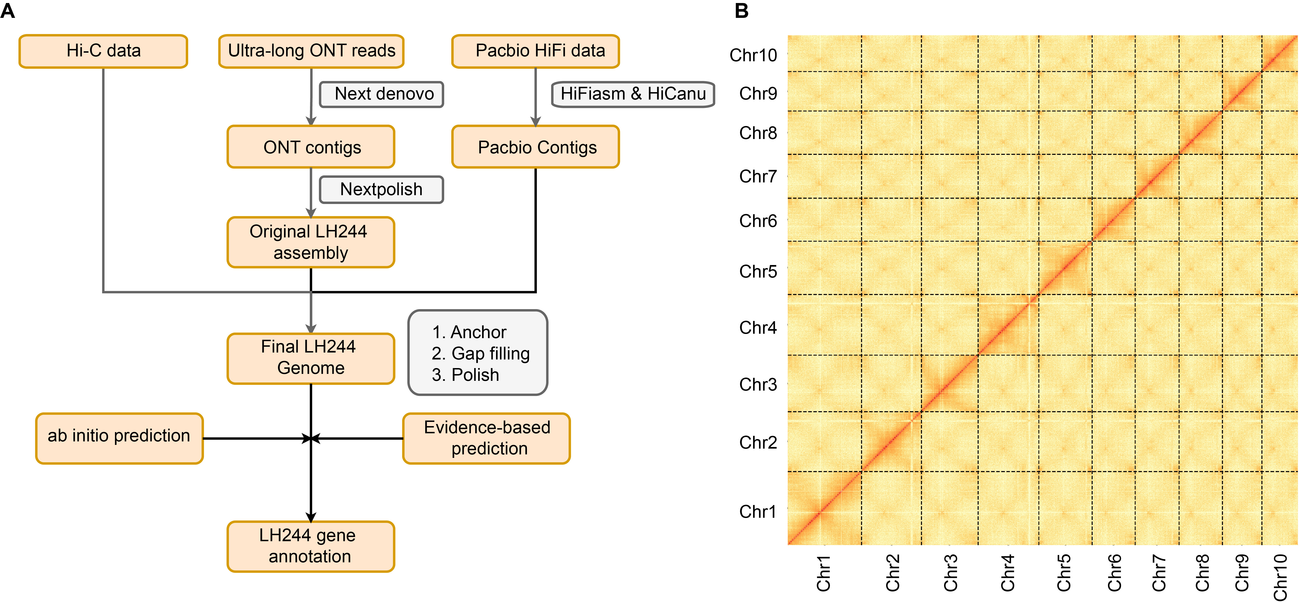
Figure S1. Workflow and Hi-C validation of the LH244 genome assembly.
(A) Flowchart of the LH244 genome assembly process. The basal assembly was generated using ONT reads, contig anchoring was performed using Hi-C data, and gap filling was conducted using PacBio HiFi contigs and ONT reads. Gene annotation was completed through both evidence-based and ab initio prediction methods. See the Methods section for detailed procedures.
(B) Whole genome Hi-C interaction heat map of the basal genome assembly. The absence of obvious anchoring errors indicates the accuracy of the assembly.

Figure S2. Comparison of flanking region assemblies for gaps closed by PacBio contigs in the basal LH244 assembly.

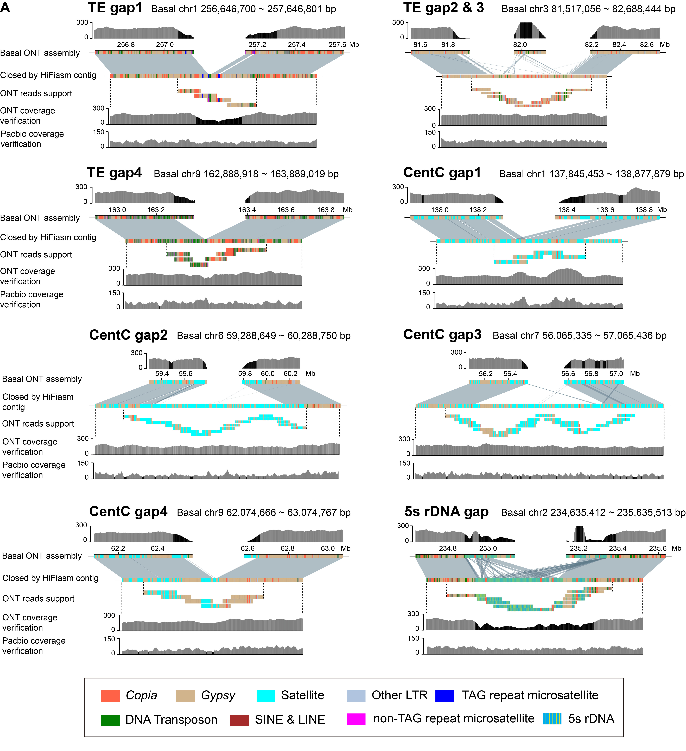

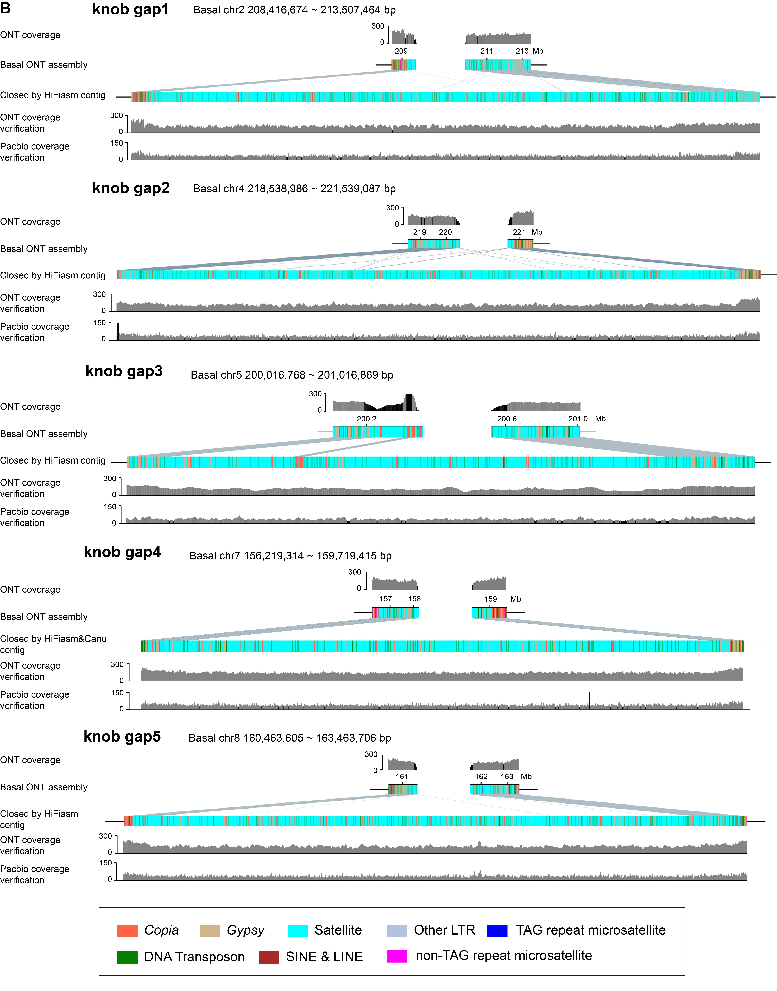
Figure S3. Validation of the assembly of 14 gaps closed using PacBio contigs.
The validity of the non-knob-associated gaps (A) and knob-associated gaps (B) closed by PacBio contigs was confirmed by uniform ONT and/or PacBio read coverage, along with tiling ONT reads. Regions with abnormal depth are shaded in black.

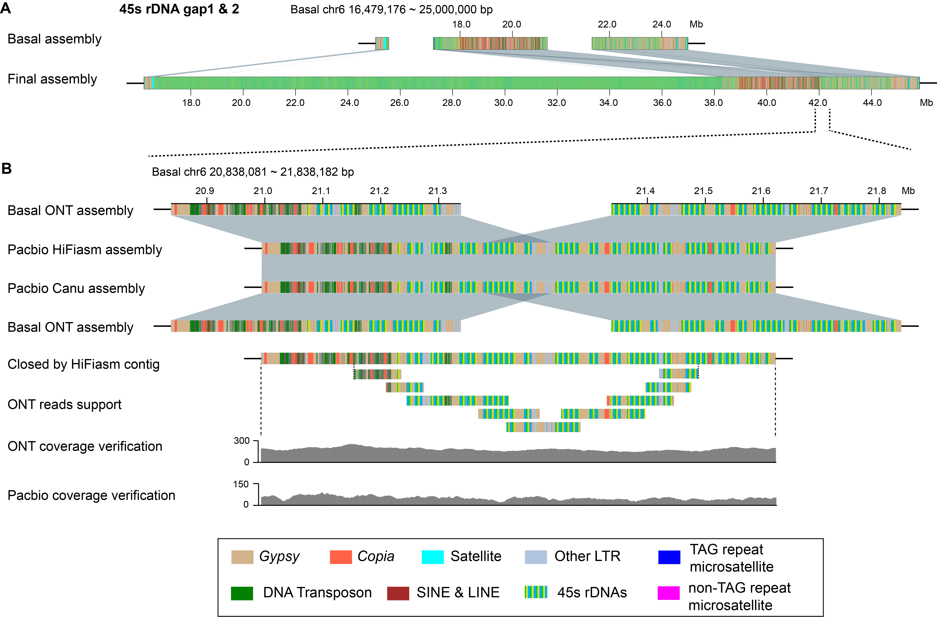
Figure S4. Gap closures and assembly validation in the 45S rDNA-enriched region.
(A) Schematic representation of the gaps and assembly status in the 45S rDNA region.
(B) Validation of the gap related to the 45S rDNA array through consistent ONT and PacBio read coverage, along with the alignment of tiling ONT reads.

Figure S5. Correction of LCRs using contigs from the PacBio assembly.
Alignment with the PacBio assembly showed that PacBio contigs examined eight LCRs on the basal LH244 assembly (LCR4 in Figure 2B). The corrected regions were validated by consistent ONT and PacBio read coverage, along with tiling ONT reads. Regions with abnormal depth are shaded in black.

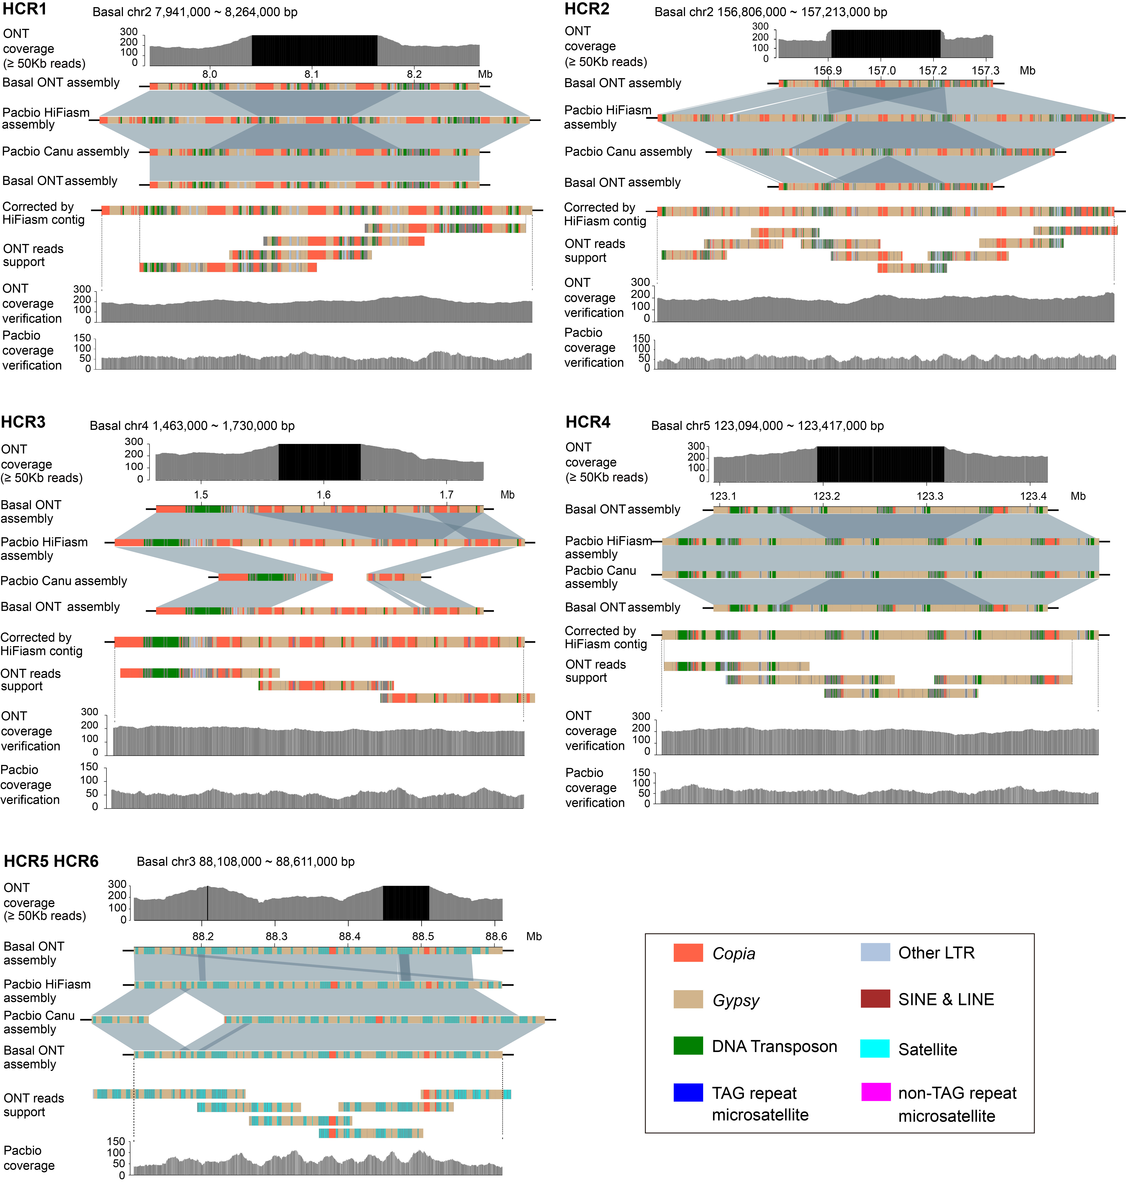
Figure S6. Correction of HCRs using contigs from the PacBio assembly.
Similar to the approach used for LCRs, six HCRs were examined. HCR5 and HCR6 were validated as correctly assembled based on consistent PacBio read coverage, while others were corrected using PacBio contigs.

Figure S7. Validation of the terminal 1 Mb regions of all 10 chromosomes in the basal LH244 assembly.
The terminal 1–2 Mb regions were validated by comparison with the PacBio assembly. To address potential misreading of telomeric repeats in ONT data, telomere-containing reads were specifically used to validate the telomeric regions.

Figure S8. Validation of the assembly of the terminal 1 Mb regions for 10 chromosomes of the final LH244 assembly.
The terminal 1 Mb regions were confirmed by tiling ONT reads. Analysis of ONT read coverage revealed generally uniform depth, except for the 20 telomeres, subtelomeric regions, satellite regions and the long TAG repeat region. Regions with a read depth lower than 100 were marked with black shading. Red pentagrams indicate reads with the longest telomeric repeats at each chromosomal end, which were used to correct the corresponding telomeric regions.

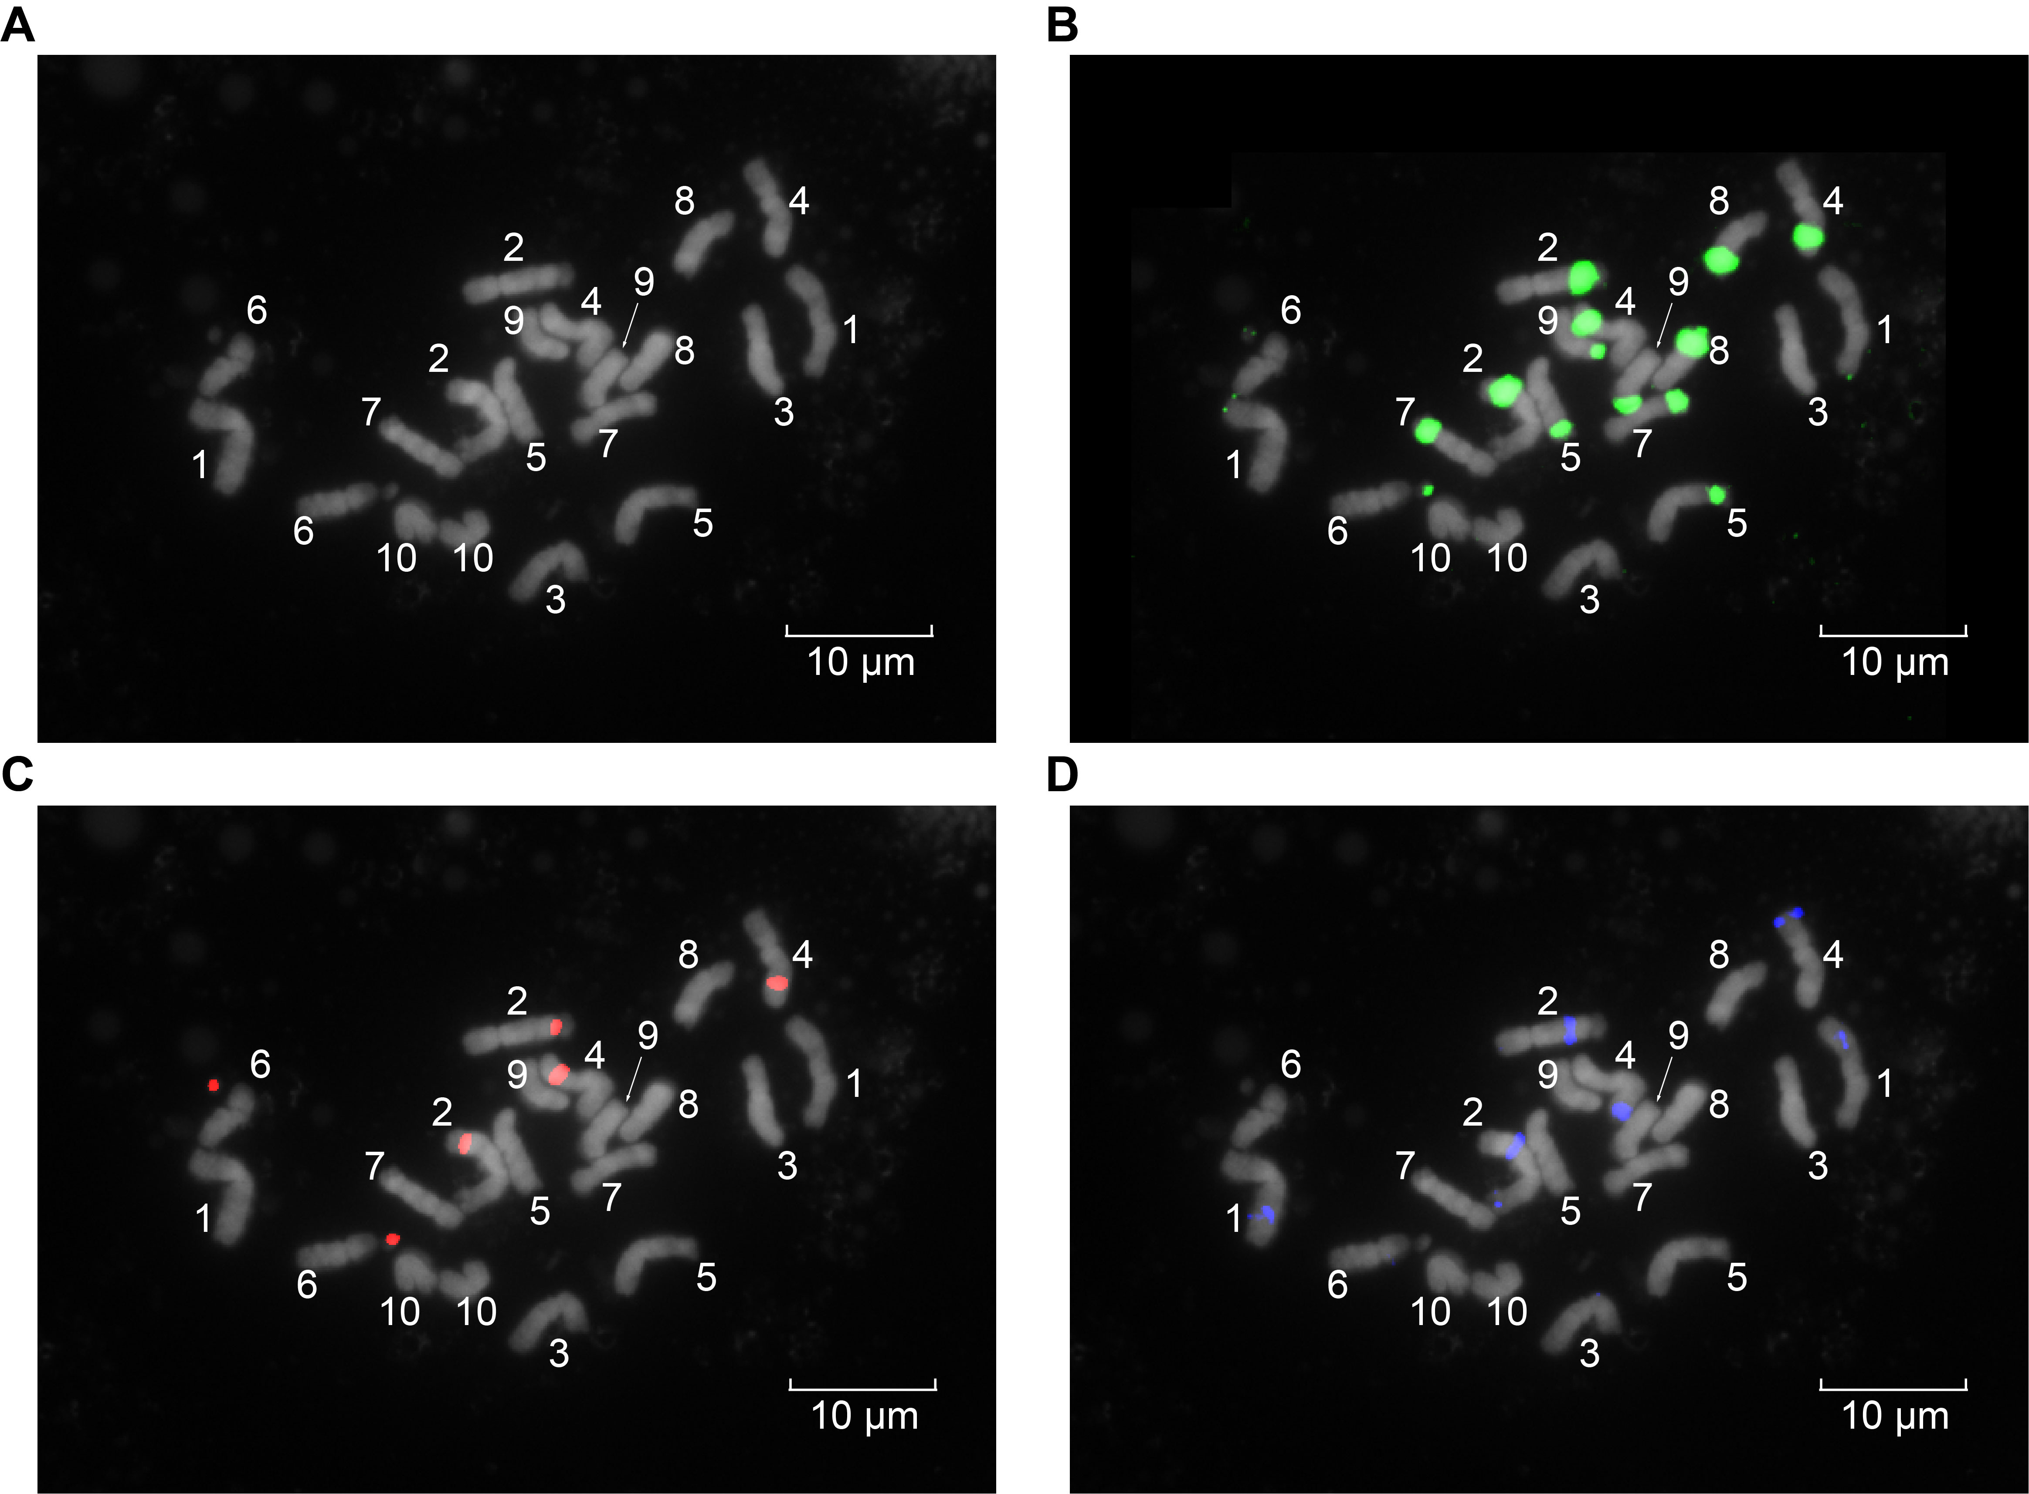
Figure S9. Single-channel FISH images corresponding to Figure 2C.
(A–D) DNA channels of chromosomes (grayscale, (A)), knob180 probe (green, (B)), TR-1 probe (red, (C)), TAG probe (blue, (D)). All panels show the same cell from LH244 root tips. Numbers indicate chromosomes 1 to 10.

Figure S10. Closures of gap related to super-long TAG repeat arrays.
The schematic diagram illustrates the manual resolution and extension of TAG-associated gaps using ONT reads.

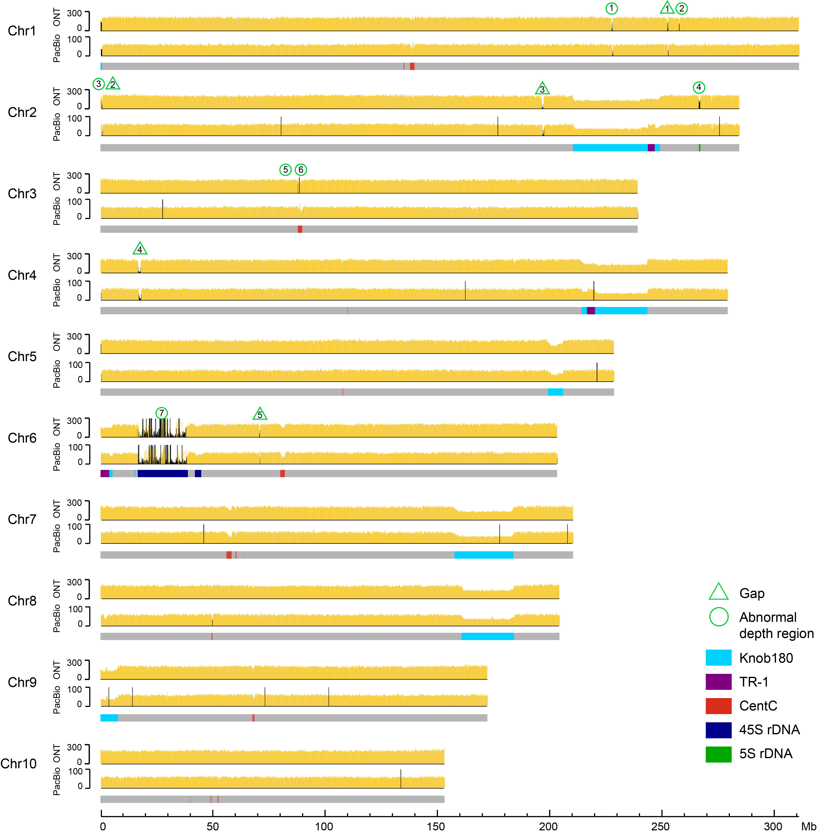
Figure S11. Whole-genome coverage of ONT and PacBio reads across the LH244 genome assembly.
Ultra-long ONT reads longer than 50 kb and PacBio HiFi reads were used for the analysis. Abnormal read depth regions were shown in black shades.

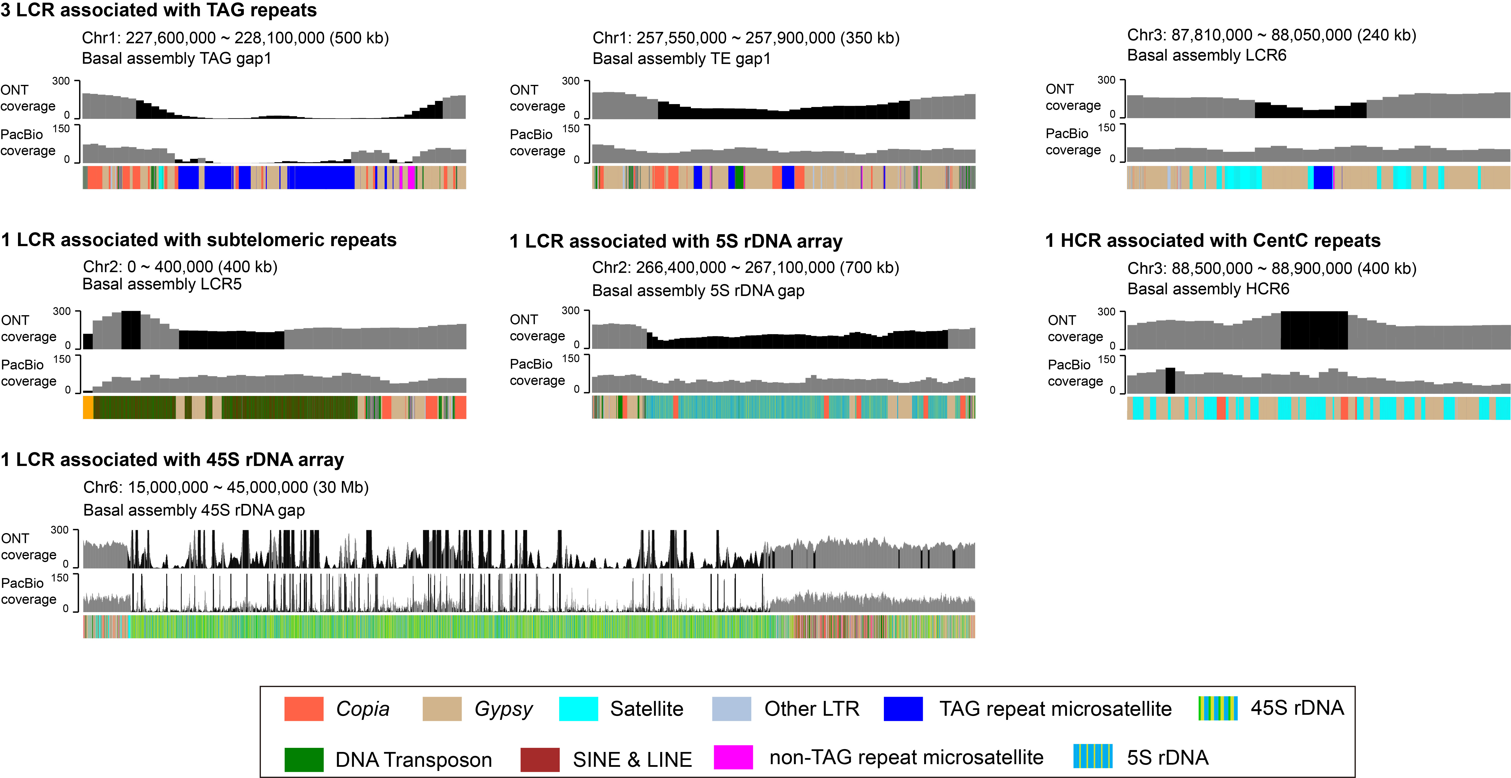
Figure S12. LCRs and HCRs identified in the final LH244 assembly.
The schematic diagram detailed displaying of the LCRs and HCRs of the final LH244 assembly identified based on the ONT read coverage. The coverage of terminal 1 Mb regions of chromosomes was showed in Figure S8.

Figure S13. The gene annotation workflow diagram of LH244.

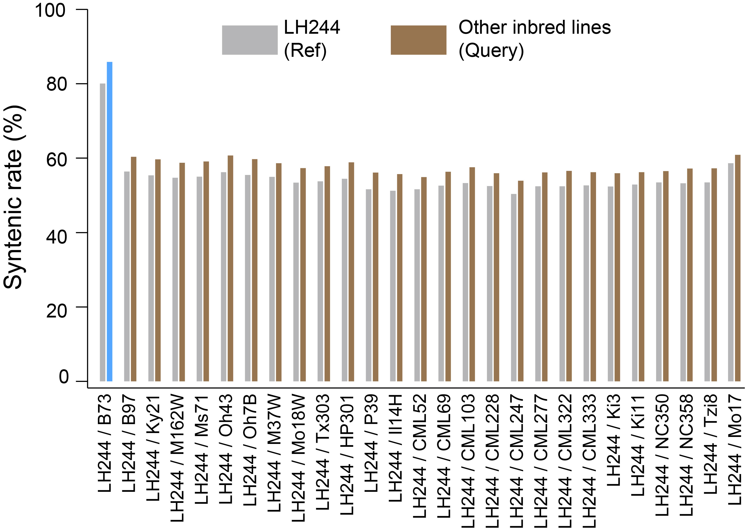
Figure S14. Syntenic rate statistics between LH244 and other inbred lines.

Figure S15. Structural variation at the knob-2L and knob-4L regions between LH244 and B73.

Figure S16. Synteny analysis between centromere regions of LH244 and Mo17 chromosomes.
The schematic illustrates the synteny of 8 Mb regions flanking the centromere midpoint in the LH244 and Mo17 genomes. Centromeres were indicated by dotted boxes. CENH3 enrichment was shown as red lines.

Figure S17. Synteny of pericentromeric TE regions between LH244 and Mo17.

Figure S18. Comparative analysis of repetitive sequences in the centromeric regions of LH244 and Mo17 chromosomes.

Figure S19. Genome structure of the knob-related SV identified on chromosome 2, 4, 5, 7, and 9.

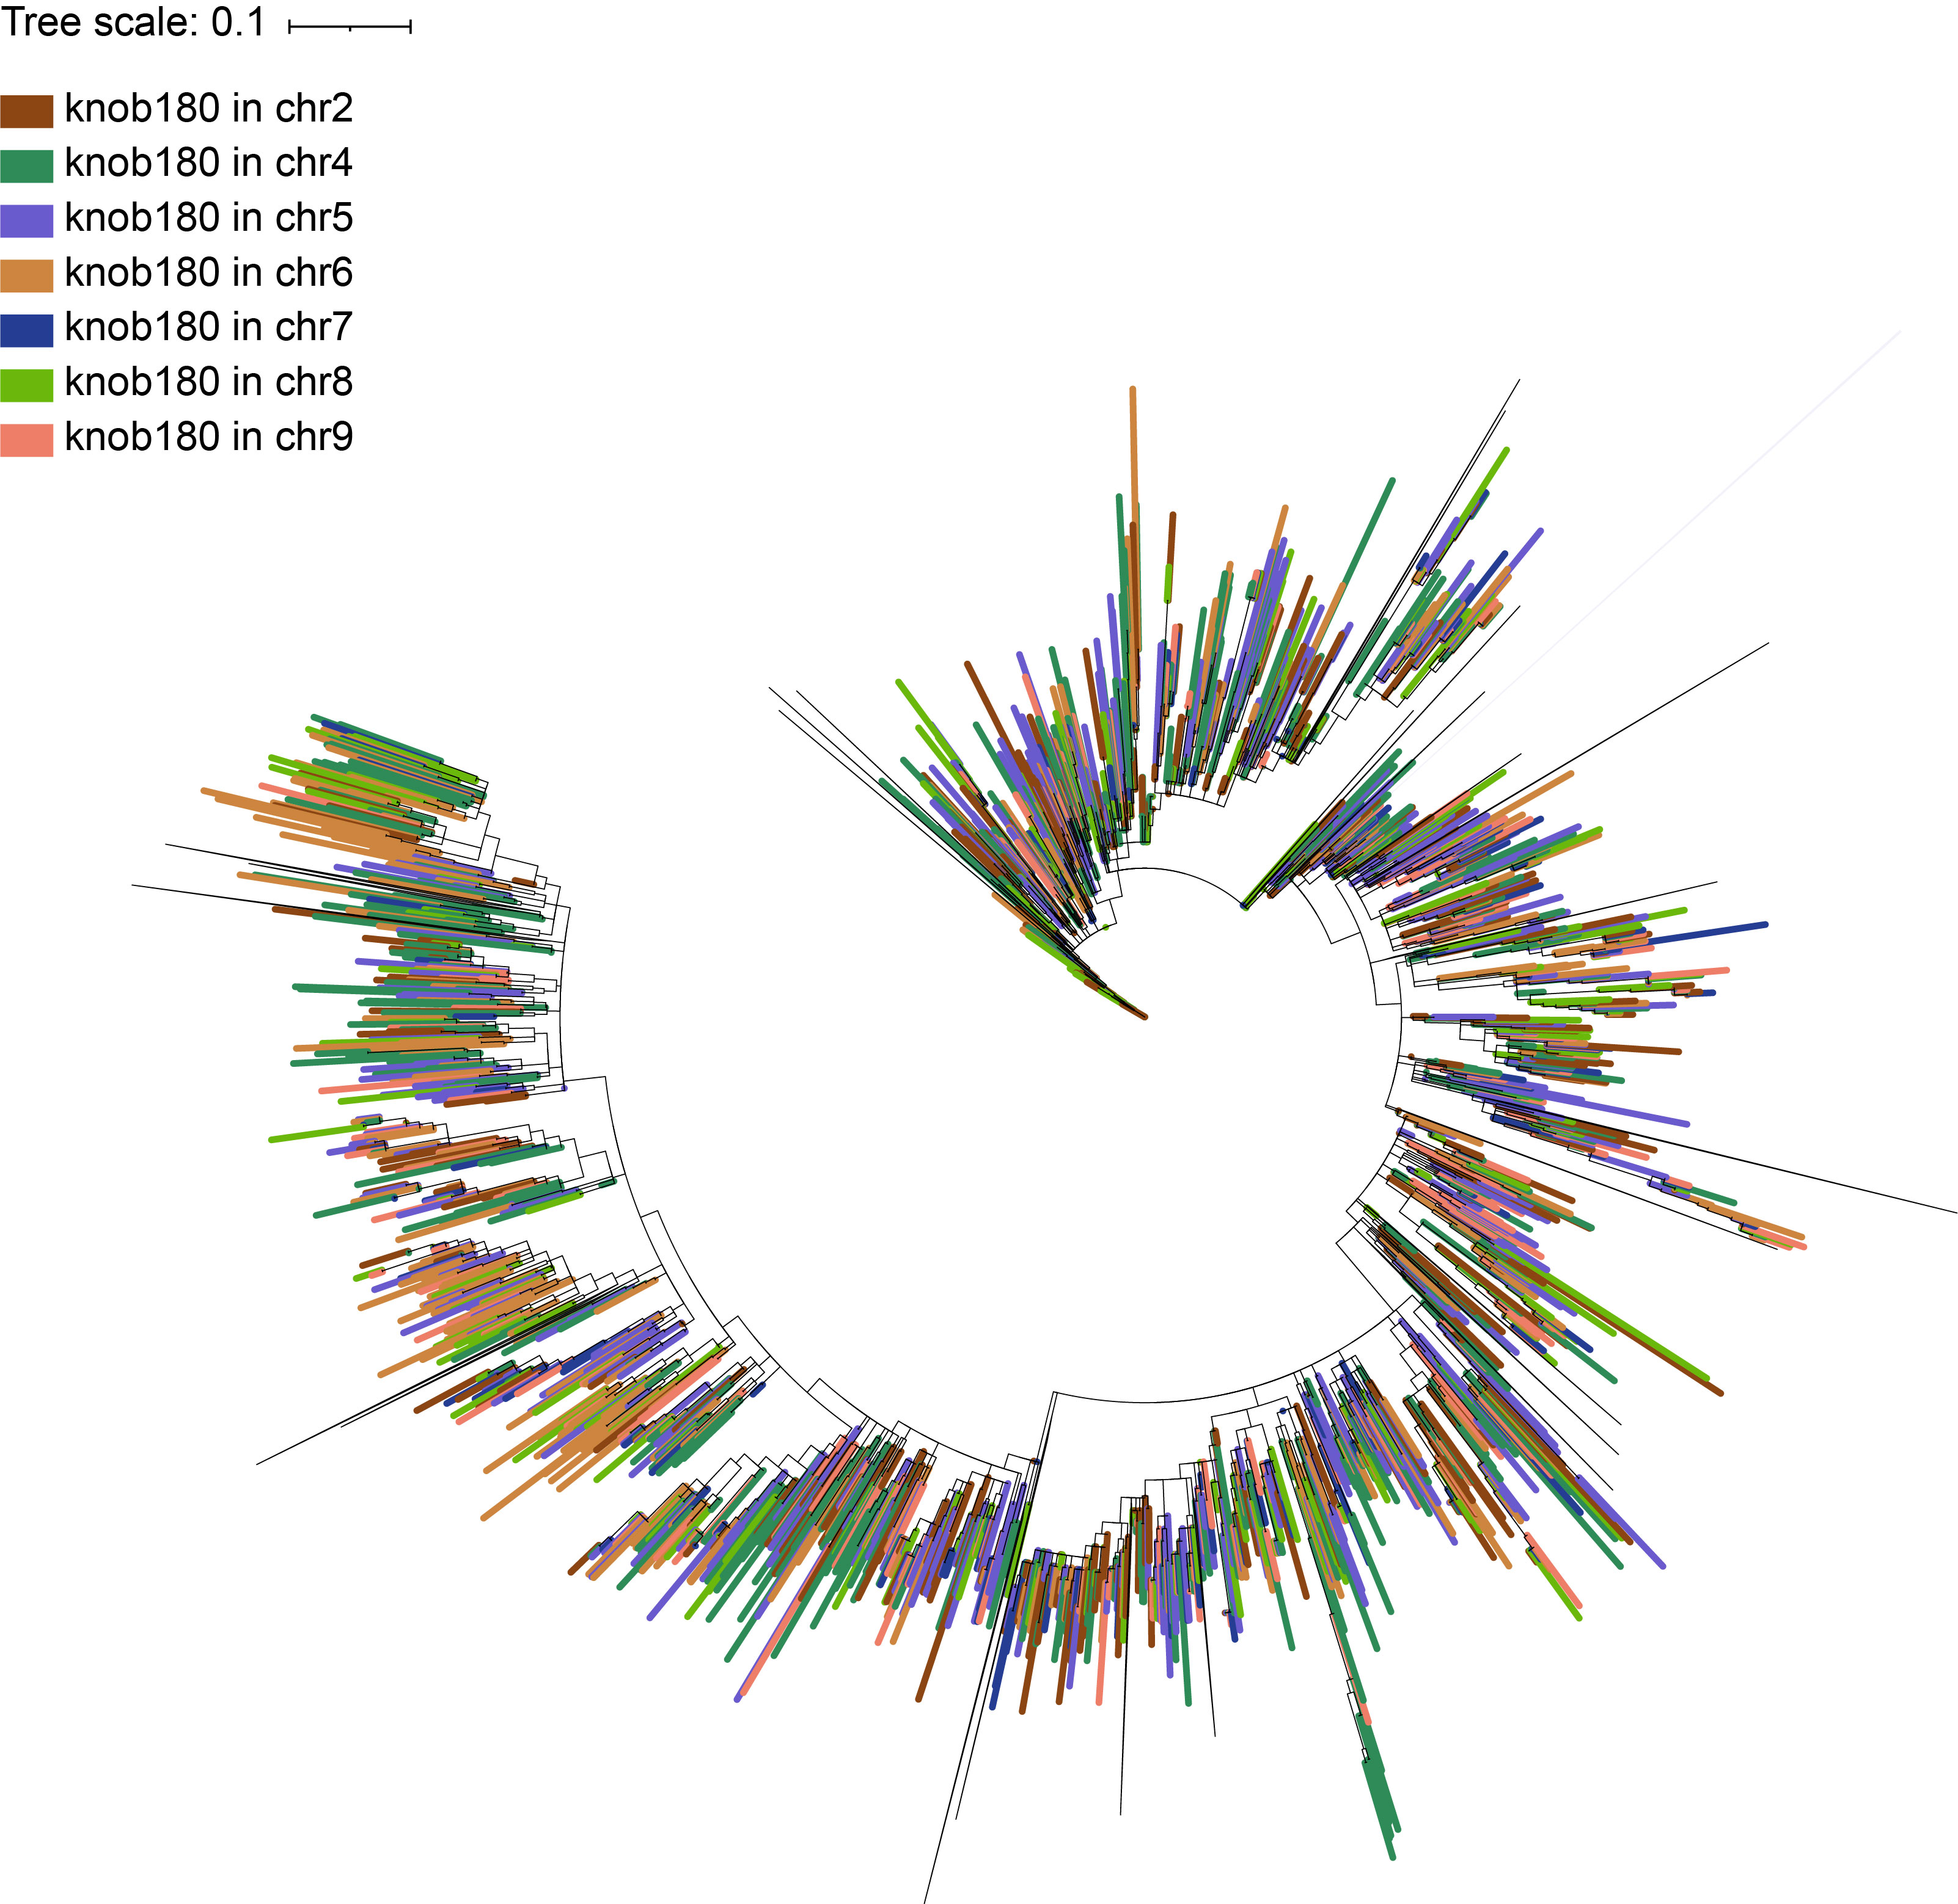
Figure S20. Phylogenetic tree based on knob180 copies in 7 mega-base knob regions of LH244.

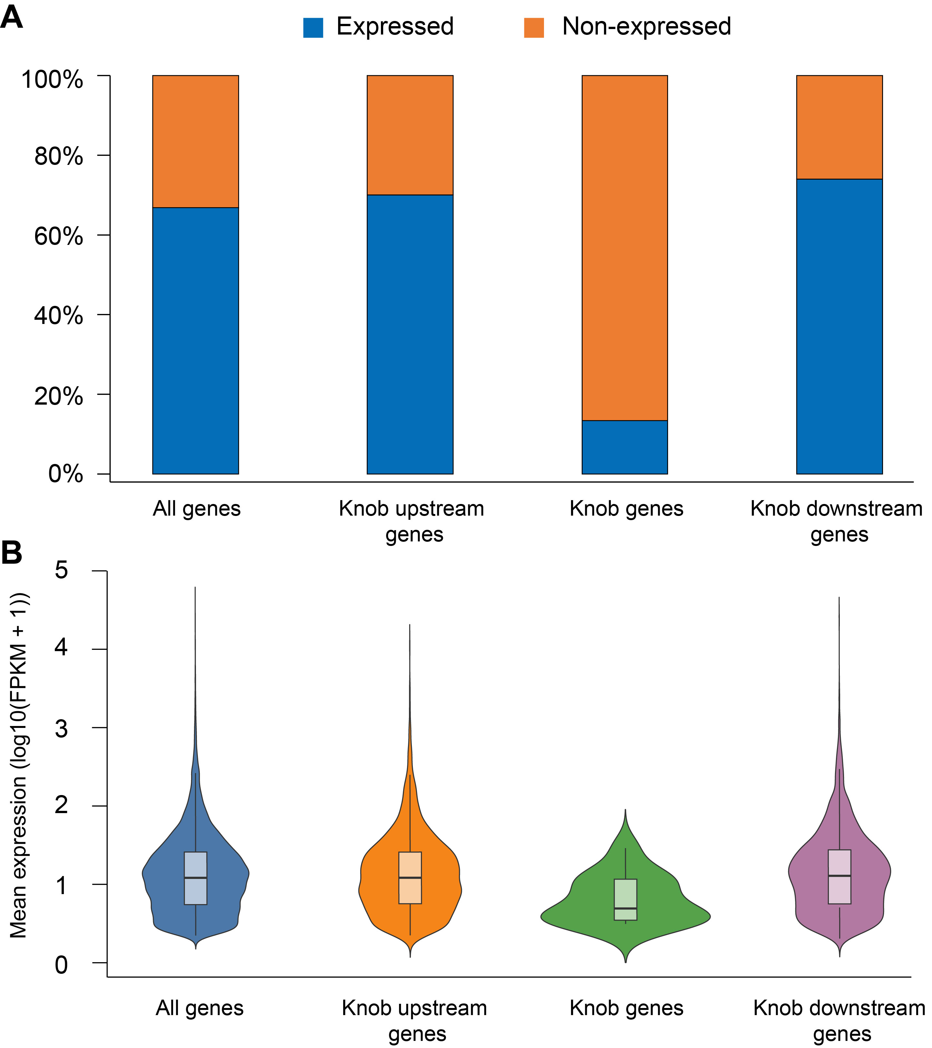
Figure S21. Gene expression in knob regions.
(A) The proportions of expressed and non-expressed genes identified in the knob regions, upstream and downstream regions of knobs, and the whole genome. Upstream and downstream regions were defined by the regions adjacent to knobs and with equal length to corresponding knob.
(B) Comparison of gene expression levels among the knob regions, upstream and downstream regions of knobs, and the whole genome. Only expressed genes were used for analysis. For each gene, its mean expression level was showed, which was calculated as the arithmetic mean of expression values across tissues with detectable expression (FPKM ≥ 1).

Table S1. The genetic transformation frequency of LH244 maize inbred lines mediated by Agrobacterium tumefaciens.
Test number | Number of embryos | Number of bar positive events | Transformation frequency
1 | 500 | 55 | 11.00%
2 | 600 | 58 | 9.67%
3 | 500 | 53 | 10.60%
4 | 300 | 27 | 9.00%
5 | 700 | 68 | 9.71%
6 | 370 | 47 | 12.70%
7 | 390 | 36 | 9.23%
8 | 560 | 55 | 9.82%
9 | 510 | 66 | 11.93%
10 | 600 | 47 | 7.83%

Table S2. Summary of sequencing data of LH244 genome.
 | Flow cell number | Reads Number | Total bases (Gbp) | N50 length of reads (bp)
Raw ultralong ONT data | 32 | 46,649,161 | 1194. 59 | 43,889
Ultralong ONT data used for assembly | 32 | 1,830,561 | 189.40 | 100,102
PacBio HiFi data | 6 | 8,640,115 | 142.48 | 16,543
Hi-C data | - | 1,962,339,942 | 293.42 | -
Illumina data | - | 2,406,766,418 | 361.01 | -

Table S3. Global statistics for the initial and final LH244 genome assembly.
Metrics | Basal assembly contigs | PacBio Hifiasm assembly contigs | PacBio Canu assembly contigs | Final assembly
N50 | 138,329,967 | 153,169,994 | 77,338,880 | 206,109,593
N75 | 89,206,172 | 64,730,687 | 27,451,308 | 172,248,240
L50 | 7 | 6 | 10 | 5
L75 | 11 | 12 | 22 | 8
GC (%) | 46.70 | 46.66 | 46.65 | 46.74
Largest contig | 203,358,878 | 322,957,443 | 193,876,235 | 261,468,704
Total length | 2,215,132,314 | 2,416,491,556 | 2,474,790,603 | 2,286,149,880
Total contigs | 153 | 2,898 | 5,749 | 15

Table S4. Statistics of repetitive elements in LH244 genome.
Classification | LH244 assembly
Classification | Length (bp) | % of genome
Repeat | 2,035,290,175 | 89.03%
Class I: Retrotransposon | 1,664,271,066 | 72.80%
SINE | 223,626 | 0.01%
LINE | 15,383,879 | 0.67%
LTR-Retrotransposon: | 1,648,663,561 | 72.12%
LTR/Copia | 557,213,497 | 24.37%
LTR/Gypsy | 1,000,780,434 | 43.78%
Class II: DNA Transposon | 216,478,403 | 9.47%
hAT | 30,393,739 | 1.33%
MULE | 27,131,343 | 1.19%
CMC-EnSpm | 81,338,462 | 3.56%
Harbinger | 25,975,723 | 1.14%
TcMar-Stowaway | 7,039,472 | 0.31%
Helitron | 44,599,664 | 1.95%
Satellites | 124,423,336 | 5.44%
knob180 | 111,071,057 | 4.86%
TR-1 | 6,883,787 | 0.30%
rDNA | 23,663,749 | 1.04%
Others* | 6,453,621 | 0.28%
Non-repeat | 250,859,705 | 10.97%
Total Content | 2,286,149,880 | 100.00%
*Others contain minisatellites, microsatellites, and unclassified repetitive sequences identified by EDTA.

Table S5. RNA-seq data statistics.
Tissue | Replicate |  | Total reads |  | Mapped reads | Unique mapped reads | Unique mapping rates | Corelation  (R)
2mm_ear |  | 1 | 80,551,133 | 78,318,485 |  | 70,195,446 | 87.14% | 0.99
2mm_ear |  | 2 | 42,438,636 | 41,507,457 |  | 37,483,574 | 88.32% | 0.99
3dap_seed |  | 1 | 61,454,150 | 60,715,583 |  | 54,235,758 | 88.25% | 0.94
3dap_seed |  | 2 | 57,322,471 | 56,607,587 |  | 46,301,450 | 80.77% | 0.94
6dap_seed |  | 1 | 54,921,830 | 54,147,183 |  | 47,408,105 | 86.32% | 0.99
6dap_seed |  | 2 | 39,308,470 | 38,780,229 |  | 33,852,347 | 86.12% | 0.99
9dap_seed |  | 1 | 41,106,129 | 39,970,157 |  | 34,858,678 | 84.80% | 0.98
9dap_seed |  | 2 | 35,112,527 | 34,143,237 |  | 28,921,907 | 82.37% | 0.98
12dap_seed |  | 1 | 37,154,821 | 36,618,567 |  | 32,800,694 | 88.28% | 0.99
12dap_seed |  | 2 | 41,495,055 | 40,815,854 |  | 36,589,340 | 88.18% | 0.99
callus |  | 1 | 26,737,157 | 26,096,253 |  | 22,735,758 | 85.03% | 0.97
callus |  | 2 | 40,273,336 | 39,073,074 |  | 35,351,101 | 87.78% | 0.97
embryo |  | 1 | 42,786,722 | 40,907,284 |  | 37,569,483 | 87.81% | 0.99
embryo |  | 2 | 44,429,658 | 42,773,387 |  | 39,130,232 | 88.07% | 0.99
pollen |  | 1 | 49,158,743 | 48,434,695 |  | 37,926,693 | 77.15% | 0.98
pollen |  | 2 | 50,010,632 | 49,286,764 |  | 39,066,418 | 78.12% | 0.98
root |  | 1 | 48,841,033 | 47,812,152 |  | 41,486,629 | 84.94% | 0.99
root |  | 2 | 46,347,036 | 45,498,277 |  | 41,465,152 | 89.47% | 0.99
seedling |  | 1 | 38,443,732 | 37,930,880 |  | 32,229,702 | 83.84% | 0.93
seedling |  | 2 | 46,423,773 | 45,796,190 |  | 31,807,780 | 68.52% | 0.93
silk |  | 1 | 35,078,687 | 34,321,995 |  | 27,971,795 | 79.74% | 0.92
silk |  | 2 | 36,016,791 | 35,421,045 |  | 30,730,717 | 85.32% | 0.92
tassel |  | 1 | 26,624,475 | 24,051,739 |  | 21,827,246 | 81.98% | 1.00
tassel |  | 2 | 20,995,700 | 19,112,151 |  | 17,341,265 | 82.59% | 1.00
Table S6. Statistics of LH244 gene models.
Types | LH244
Number of gene model Number | 43,854
Number of transcripts | 47,397
Average number of transcripts per gene | 1.08
Mean exons per gene* | 4.66
Expressed genes (FPKM > 1) | 29,316
Supported by Pfam domain | 29,076
Homology of NAM founder genes | 41,989
Homology of 12 FILs genes | 40,789
Median Protein length* | 282
Mean Protein length* | 355
Median CDS length* | 849
Mean CDS length* | 1,068.40
Gene GC | 0.47
Exon GC | 0.54
Single-Exon gene | 10,332
Max Exon num | 65
mRNA with annotated UTR | 8,609
* Analyzed based on the longest transcript.

Table S7. Genome-wide Distribution of IBD blocks between B73 and LH244.
Chr | IBD length (Mb) | Percentage of chromosomes covered by IBD in LH244
chr1 | 170.70 | 54.88%
chr2 | 206.92 | 72.74%
chr3 | 57.85 | 24.19%
chr4 | 193.41 | 69.25%
chr5 | 182.23 | 79.69%
chr6 | 119.21 | 58.63%
chr7 | 120.77 | 57.40%
chr8 | 166.84 | 81.65%
chr9 | 90.70 | 52.65%
chr10 | 100.93 | 65.89%

Table S8. Statistical analysis of megabase-scale SVs between LH244 and Mo17.
No. | Chr | LH244_Start (bp) | LH244_End (bp) | LH244_Size (bp) | Mo17_Start (bp) | Mo17_End (bp) | Mo17_Size (bp) | Type# | Primary components# | Gene number*
1 | chr1 | 190,563,457 | 191,664,418 | 1,100,961 | 189,699,080 | 189,711,056 | 11,976 | Ins | TE | 16
2 | chr2 | 210,481,125 | 249,142,034 | 38,660,909 | 212,278,127 | 212,321,040 | 42,913 | Ins | Knob | 25
3 | chr3 | 101,349,409 | 113,233,127 | 11,883,718 | 99,507,514 | 111,816,212 | 12,308,698 | Inv | TE | 127
4 | chr3 | 168,900,900 | 168,987,685 | 86,785 | 167,449,426 | 170,756,216 | 3,306,790 | Del | TE | 30
5 | chr4 | 153,317,010 | 154,979,186 | 1,662,176 | 154,513,271 | 156,069,394 | 1,556,123 | Inv | TE | 26
6 | chr4 | 214,238,981 | 243,609,306 | 29,370,325 | 216,960,696 | 216,960,697 | 1 | Ins | Knob | 21
7 | chr5 | 200,421,546 | 205,531,198 | 5,109,652 | 196,408,421 | 196,408,422 | 1 | Ins | Knob | 2
8 | chr6 | 38,892,954 | 42,039,326 | 3,146,372 | 44,747,260 | 44,747,261 | 1 | Ins | TE | 95
9 | chr6 | 80,265,686 | 81,946,990 | 1,681,304 | 78,862,263 | 78,862,264 | 1 | Ins | CentC | 0
10 | chr6 | 98,376,151 | 99,101,606 | 725,455 | 95,382,401 | 99,805,241 | 4,422,840 | Del | TE | 25
11 | chr7 | 157,604,208 | 183,887,765 | 26,283,557 | 154,699,310 | 154,699,311 | 1 | Ins | Knob | 14
12 | chr8 | 49,648,383 | 49,648,384 | 1 | 52,526,671 | 53,861,780 | 1,335,109 | Del | CentC | 1
13 | chr9 | 1,038,669 | 7,796,160 | 6,757,491 | 965,989 | 965,990 | 1 | Ins | Knob | 8
14 | chr9 | 68,364,178 | 68,364,179 | 1 | 60,336,092 | 61,868,770 | 1,532,678 | Del | CentC | 0
# The statistics were based on the annotation of LH244 genome.
*The number of genes in the deletions corresponds to the number of genes in the respective regions in the Mo17 genome.

Table S9. GO annotations of genes located within the SV8 region of the LH244 genome.
Gene ID | Description | GO annotation
Zm00116aa315050 | N/A | N/A
Zm00116aa315060 | N/A | N/A
Zm00116aa315070 | N/A | N/A
Zm00116aa315090 | N/A | N/A
Zm00116aa315100 | EGF-like calcium-binding domain | GO:0005509
Zm00116aa315110 | N/A | N/A
Zm00116aa315120 | N/A | N/A
Zm00116aa315130 | N/A | N/A
Zm00116aa315140 | N/A | N/A
Zm00116aa315160 | N/A | N/A
Zm00116aa315170 | N/A | N/A
Zm00116aa315180 | Ulp1 protease family, C-terminal catalytic domain | GO:0006508|GO:0008234
Zm00116aa315190 | N/A | N/A
Zm00116aa315200 | N/A | N/A
Zm00116aa315210 | N/A | N/A
Zm00116aa315220 | N/A | N/A
Zm00116aa315230 | N/A | N/A
Zm00116aa315240 | N/A | N/A
Zm00116aa315250 | N/A | N/A
Zm00116aa315260 | N/A | N/A
Zm00116aa315270 | N/A | N/A
Zm00116aa315280 | N/A | N/A
Zm00116aa315290 | N/A | N/A
Zm00116aa315300 | N/A | N/A
Zm00116aa315310 | N/A | N/A
Zm00116aa315330 | N/A | N/A
Zm00116aa315340 | N/A | N/A
Zm00116aa315350 | N/A | N/A
Zm00116aa315360 | N/A | N/A
Zm00116aa315370 | N/A | N/A
Zm00116aa315380 | N/A | N/A
Zm00116aa315390 | N/A | N/A
Zm00116aa315400 | N/A | N/A
Zm00116aa315410 | N/A | N/A
Zm00116aa315420 | Major facilitator, sugar transporter-like | GO:0016021|GO:0022857|GO:0055085
Zm00116aa315430 | IQ motif, EF-hand binding site | GO:0005515
Zm00116aa315440 | N/A | N/A
Zm00116aa315450 | Leucine-rich repeat | GO:0005515
Zm00116aa315460 | N/A | N/A
Zm00116aa315470 | N/A | N/A
Zm00116aa315480 | Multi antimicrobial extrusion protein | GO:0015297|GO:0016020|GO:0042910|GO:0055085
Zm00116aa315490 | N/A | N/A
Zm00116aa315500 | Ceramide glucosyltransferase | GO:0016757
Zm00116aa315520 | N/A | N/A
Zm00116aa315530 | N/A | N/A
Zm00116aa315540 | Proteinase inhibitor I12, Bowman-Birk | GO:0004867|GO:0005576
Zm00116aa315550 | N/A | N/A
Zm00116aa315560 | N/A | N/A
Zm00116aa315570 | N/A | N/A
Zm00116aa315580 | N/A | N/A
Zm00116aa315590 | N/A | N/A
Zm00116aa315600 | N/A | N/A
Zm00116aa315610 | N/A | N/A
Zm00116aa315620 | N/A | N/A
Zm00116aa315630 | N/A | N/A
Zm00116aa315640 | N/A | N/A
Zm00116aa315670 | N/A | N/A
Zm00116aa315680 | N/A | N/A
Zm00116aa315690 | N/A | N/A
Zm00116aa315700 | Protein kinase, ATP binding site | GO:0005524
Zm00116aa315710 | N/A | N/A
Zm00116aa315720 | Class I-like SAM-dependent O-methyltransferase | GO:0008171
Zm00116aa315730 | N/A | N/A
Zm00116aa315750 | N/A | N/A
Zm00116aa315760 | N/A | N/A
Zm00116aa315770 | N/A | N/A
Zm00116aa315780 | N/A | N/A
Zm00116aa315790 | N/A | N/A
Zm00116aa315800 | N/A | N/A
Zm00116aa315820 | N/A | N/A
Zm00116aa315830 | N/A | N/A
Zm00116aa315840 | N/A | N/A
Zm00116aa315860 | N/A | N/A
Zm00116aa315870 | N/A | N/A
Zm00116aa315880 | N/A | N/A
Zm00116aa315890 | N/A | N/A
Zm00116aa315900 | N/A | N/A
Zm00116aa315910 | N/A | N/A
Zm00116aa315920 | N/A | N/A
Zm00116aa315930 | N/A | N/A
Zm00116aa315940 | N/A | N/A
Zm00116aa315950 | N/A | N/A
Zm00116aa315960 | Autonomous transposable element EN-1 mosaic protein | GO:0032196
Zm00116aa315980 | N/A | N/A
Zm00116aa315990 | N/A | N/A
Zm00116aa316000 | N/A | N/A
Zm00116aa316010 | N/A | N/A
Zm00116aa316020 | N/A | N/A
Zm00116aa316030 | N/A | N/A
Zm00116aa316040 | N/A | N/A
Zm00116aa316050 | N/A | N/A
Zm00116aa316060 | N/A | N/A
Zm00116aa316070 | N/A | N/A
Zm00116aa316080 | N/A | N/A
Zm00116aa316090 | N/A | N/A

Table S10. Coordinates and composition of centromeres defined by CENH3 ChIP-seq in the LH244 genome.
Chr | Start (bp) | End (bp) | long/short arm | Size (bp) | CentC  (%) | CRM  (%) | Copia  opie_ji  (%) | Copia  other  (%) | DNA  TE  (%) | Gypsy  cinful_zeon  (%) | Gypsy  flip  (%) | Gypsy  grande  (%) | Gypsy  gyma  (%) | Gypsy  huck  (%) | Gypsy  other  (%) | Gypsy  prem1  (%) | Other  LTR  (%) | Non  LTR  (%) | Other sequences (%) | Total  (%)
chr1 | 138,100,000 | 139,590,000 | 1.24 | 1,490,000 | 53.76 | 41.02 | 0.63 | 0.00 | 0.07 | 0.49 | 0.00 | 0.00 | 0.00 | 2.19 | 1.61 | 0.07 | 0.00 | 0.00 | 0.17 | 100.00
chr2 | 95,648,463 | 97,738,463 | 1.95 | 2,090,000 | 1.22 | 34.57 | 2.23 | 2.93 | 2.86 | 13.41 | 8.08 | 3.18 | 4.80 | 5.95 | 6.16 | 7.98 | 3.54 | 0.17 | 2.91 | 100.00
chr3 | 87,920,000 | 89,500,000 | 1.70 | 1,580,000 | 44.83 | 41.90 | 1.13 | 1.92 | 0.00 | 0.61 | 0.88 | 0.00 | 0.00 | 0.74 | 4.44 | 1.54 | 1.04 | 0.00 | 0.97 | 100.00
chr4 | 109,260,001 | 110,990,001 | 1.54 | 1,730,000 | 1.01 | 47.48 | 3.90 | 3.89 | 1.97 | 9.97 | 6.11 | 0.46 | 3.41 | 3.43 | 7.69 | 6.28 | 2.73 | 0.00 | 1.69 | 100.00
chr5 | 104,110,000 | 106,180,000 | 1.18 | 2,070,000 | 0.00 | 15.88 | 1.25 | 3.06 | 6.13 | 18.46 | 15.70 | 1.91 | 4.87 | 2.08 | 11.96 | 8.74 | 6.54 | 0.01 | 3.43 | 100.00
chr6 | 80,102,828 | 81,862,828 | 1.52 | 1,760,000 | 61.69 | 33.42 | 0.00 | 0.37 | 0.05 | 0.90 | 0.71 | 0.00 | 0.00 | 1.55 | 1.22 | 0.00 | 0.00 | 0.00 | 0.11 | 100.00
chr7 | 56,250,000 | 57,790,000 | 2.71 | 1,540,000 | 51.75 | 43.25 | 0.59 | 0.71 | 0.00 | 0.14 | 0.91 | 0.91 | 0.00 | 0.00 | 1.60 | 0.00 | 0.06 | 0.00 | 0.09 | 100.00
chr8 | 50,530,000 | 52,320,000 | 3.01 | 1,790,000 | 0.00 | 27.30 | 1.27 | 2.83 | 4.85 | 17.37 | 12.65 | 4.06 | 5.53 | 2.34 | 9.75 | 4.24 | 4.99 | 0.16 | 2.65 | 100.00
chr9 | 69,180,000 | 71,170,000 | 1.46 | 1,990,000 | 0.00 | 3.02 | 3.78 | 5.42 | 3.85 | 17.19 | 18.41 | 4.35 | 6.95 | 5.97 | 11.24 | 11.17 | 4.98 | 0.13 | 3.54 | 100.00
chr10 | 50,820,000 | 52,640,000 | 1.98 | 1,820,000 | 8.54 | 22.89 | 5.43 | 6.23 | 2.85 | 11.56 | 4.63 | 1.91 | 2.02 | 3.93 | 13.46 | 8.31 | 3.91 | 0.37 | 3.96 | 100.00

Table S11. Coordinates and composition of megabase-scale knob regions in the LH244 genome.
No. | Chr | Start (bp) | End (bp) | Size (bp) | knob180  (%) | TR-1  (%) | Gypsy  cinful_zeon  (%) | Gypsy  flip  (%) | Gypsy  prem1  (%) | Gypsy  gyma  (%) | Gypsy  huck  (%) | Gypsy  grande  (%) | Gypsy  other  (%) | Copia  opie_ji  (%) | Copia  other  (%) | Other  LTR  (%) | DNATE  (%) | Other  sequence  (%) | Total  (%)
1 | chr2 | 210,419,225 | 249,121,144 | 38,701,919 | 80.22 | 4.34 | 5.73 | 0.67 | 0.31 | 0.55 | 0.21 | 0.15 | 1.78 | 1.17 | 3.15 | 0.32 | 0.91 | 0.48 | 100
2 | chr4 | 214,237,674 | 243,520,768 | 29,283,094 | 75.00 | 8.24 | 7.48 | 0.19 | 0.16 | 0.86 | 0.16 | 0.28 | 1.34 | 1.41 | 3.11 | 0.40 | 0.58 | 0.78 | 100
3 | chr5 | 199,173,877 | 205,954,555 | 6,780,678 | 79.88 | 1.81 | 6.90 | 0.85 | 0.42 | 1.29 | 0.24 | 0.62 | 2.72 | 0.91 | 1.92 | 0.54 | 1.01 | 0.88 | 100
4 | chr6 | 10,677 | 5,320,848 | 5,310,171 | 20.31 | 38.92 | 18.78 | 4.58 | 0.80 | 1.30 | 1.70 | 1.05 | 5.69 | 0.17 | 2.53 | 1.43 | 1.31 | 1.43 | 100
5 | chr7 | 157,604,207 | 183,887,690 | 26,283,483 | 86.35 | 0.31 | 5.31 | 0.32 | 0.14 | 0.46 | 0.06 | 0.17 | 0.78 | 2.03 | 2.70 | 0.09 | 0.73 | 0.54 | 100
6 | chr8 | 160,774,917 | 184,162,934 | 23,388,017 | 86.24 | 0.31 | 4.19 | 0.38 | 0.25 | 0.48 | 0.06 | 0.18 | 0.76 | 2.65 | 3.20 | 0.14 | 0.69 | 0.49 | 100
7 | chr9 | 3,386 | 7,747,169 | 7,743,783 | 84.81 | 0.51 | 4.39 | 0.41 | 0.27 | 0.78 | 0.58 | 0.19 | 0.72 | 2.69 | 2.42 | 0.19 | 0.59 | 1.45 | 100

Table S12. GO annotations of genes located within knob regions of the LH244 genome.
Gene ID | Knob | Description | GO annotation
Zm00116aa147010 | knob-2L | 3'-5' exonuclease domain | GO:0003676 | GO:0006139 | GO:0008408
Zm00116aa147020 | knob-2L | N/A | N/A
Zm00116aa147030 | knob-2L | Autonomous transposable element EN-1 mosaic protein | GO:0032196
Zm00116aa147040 | knob-2L | UTP--glucose-1-phosphate uridylyltransferase | GO:0003676 | GO:0005524 | GO:0070569
Zm00116aa147050 | knob-2L | WRKY DNA-binding domain | GO:0003700 | GO:0006355 | GO:0043565
Zm00116aa147060 | knob-2L | 3'-5' exonuclease domain | GO:0003676 | GO:0006139 | GO:0008408
Zm00116aa147070 | knob-2L | N/A | N/A
Zm00116aa147080 | knob-2L | N/A | N/A
Zm00116aa147090 | knob-2L | N/A | N/A
Zm00116aa147100 | knob-2L | N/A | N/A
Zm00116aa147110 | knob-2L | E3 ubiquitin ligase RBR family | GO:0004842 | GO:0016567
Zm00116aa147120 | knob-2L | N/A | N/A
Zm00116aa147130 | knob-2L | Autonomous transposable element EN-1 mosaic protein | GO:0032196
Zm00116aa147160 | knob-2L | N/A | N/A
Zm00116aa147170 | knob-2L | N/A | N/A
Zm00116aa147180 | knob-2L | Peptidase M17, leucine aminopeptidase/peptidase B | GO:0003677 | GO:0003899 | GO:0004177 | GO:0005737 | GO:0006351 | GO:0006508 | GO:0008235 | GO:0019538 | GO:0030145
Zm00116aa147190 | knob-2L | N/A | N/A
Zm00116aa147200 | knob-2L | N/A | N/A
Zm00116aa147220 | knob-2L | Triosephosphate isomerase | GO:0004807
Zm00116aa147240 | knob-2L | N/A | N/A
Zm00116aa147250 | knob-2L | Autonomous transposable element EN-1 mosaic protein | GO:0032196
Zm00116aa147260 | knob-2L | N/A | N/A
Zm00116aa147270 | knob-2L | N/A | N/A
Zm00116aa147280 | knob-2L | N/A | N/A
Zm00116aa147290 | knob-2L | SNF2-related, N-terminal domain | GO:0005524
Zm00116aa251240 | knob-4L | N/A | N/A
Zm00116aa251250 | knob-4L | N/A | N/A
Zm00116aa251260 | knob-4L | N/A | N/A
Zm00116aa251270 | knob-4L | N/A | N/A
Zm00116aa251280 | knob-4L | N/A | N/A
Zm00116aa251290 | knob-4L | N/A | N/A
Zm00116aa251300 | knob-4L | CCR4-NOT transcription complex subunit 1 | GO:0006417 | GO:0030015
Zm00116aa251310 | knob-4L | N/A | N/A
Zm00116aa251320 | knob-4L | N/A | N/A
Zm00116aa251330 | knob-4L | N/A | N/A
Zm00116aa251350 | knob-4L | N/A | N/A
Zm00116aa251360 | knob-4L | NADH-quinone oxidoreductase, chain M/4 | GO:0008137 | GO:0042773 | GO:0055114
Zm00116aa251370 | knob-4L | N/A | N/A
Zm00116aa251380 | knob-4L | N/A | N/A
Zm00116aa251390 | knob-4L | Nonaspanin (TM9SF) | GO:0016021
Zm00116aa251400 | knob-4L | CCR4-NOT transcription complex subunit 4 | GO:0004842 | GO:0030014
Zm00116aa251430 | knob-4L | Autonomous transposable element EN-1 mosaic protein | GO:0032196
Zm00116aa251440 | knob-4L | N/A | N/A
Zm00116aa251450 | knob-4L | N/A | N/A
Zm00116aa251470 | knob-4L | N/A | N/A
Zm00116aa251480 | knob-4L | Kinesin motor domain | GO:0003777 | GO:0005524 | GO:0007018 | GO:0008017
Zm00116aa303350 | knob-5L | N/A | N/A
Zm00116aa303360 | knob-5L | N/A | N/A
Zm00116aa303380 | knob-5L | N/A | N/A
Zm00116aa303390 | knob-5L | N/A | N/A
Zm00116aa303400 | knob-5L | N/A | N/A
Zm00116aa303410 | knob-5L | N/A | N/A
Zm00116aa312580 | knob-6S | N/A | N/A
Zm00116aa312590 | knob-6S | N/A | N/A
Zm00116aa312610 | knob-6S | N/A | N/A
Zm00116aa312620 | knob-6S | N/A | N/A
Zm00116aa312630 | knob-6S | N/A | N/A
Zm00116aa312640 | knob-6S | N/A | N/A
Zm00116aa312650 | knob-6S | N/A | N/A
Zm00116aa312660 | knob-6S | N/A | N/A
Zm00116aa312680 | knob-6S | Putative GTPase activating protein for Arf | GO:0005096
Zm00116aa312690 | knob-6S | N/A | N/A
Zm00116aa380240 | knob-7L | N/A | N/A
Zm00116aa380250 | knob-7L | Autonomous transposable element EN-1 mosaic protein | GO:0032196
Zm00116aa380260 | knob-7L | N/A | N/A
Zm00116aa380290 | knob-7L | KNOX2 domain | GO:0003677 | GO:0005634
Zm00116aa380300 | knob-7L | Signal peptidase complex subunit 3 | GO:0005787 | GO:0006281 | GO:0006465 | GO:0006801 | GO:0008233 | GO:0016020 | GO:0016021 | GO:0016757 | GO:0046872
Zm00116aa380310 | knob-7L | DEAD/DEAH box helicase domain | GO:0003676 | GO:0005524
Zm00116aa380320 | knob-7L | N/A | N/A
Zm00116aa380330 | knob-7L | Pyridoxamine 5'-phosphate oxidase | GO:0004733 | GO:0008615 | GO:0010181 | GO:0048037
Zm00116aa380340 | knob-7L | Ribosomal protein L5 | GO:0003735 | GO:0005840 | GO:0006412
Zm00116aa380360 | knob-7L | Ribosomal protein S3, C-terminal domain | GO:0003735 | GO:0006412
Zm00116aa380390 | knob-7L | N/A | N/A
Zm00116aa380400 | knob-7L | KNOX2 domain | GO:0003677 | GO:0005634
Zm00116aa380410 | knob-7L | N/A | N/A
Zm00116aa380420 | knob-7L | N/A | N/A
Zm00116aa422020 | knob-8L | N/A | N/A
Zm00116aa422030 | knob-8L | N/A | N/A
Zm00116aa422040 | knob-8L | N/A | N/A
Zm00116aa422050 | knob-8L | N/A | N/A
Zm00116aa422060 | knob-8L | N/A | N/A
Zm00116aa422070 | knob-8L | N/A | N/A
Zm00116aa422080 | knob-8L | N/A | N/A
Zm00116aa422090 | knob-8L | Autonomous transposable element EN-1 mosaic protein | GO:0032196
Zm00116aa422100 | knob-8L | N/A | N/A
Zm00116aa422110 | knob-8L | N/A | N/A
Zm00116aa422120 | knob-8L | N/A | N/A
Zm00116aa422130 | knob-8L | N/A | N/A
Zm00116aa422140 | knob-8L | DNA polymerase epsilon catalytic subunit | GO:0003676 | GO:0003677 | GO:0003887 | GO:0006260 | GO:0006281 | GO:0008622
Zm00116aa422150 | knob-8L | N/A | N/A
Zm00116aa422160 | knob-8L | N/A | N/A
Zm00116aa431380 | knob-9S | N/A | N/A
Zm00116aa431390 | knob-9S | Ribosomal protein S2, bacteria/mitochondria/plastid | GO:0003735 | GO:0005840 | GO:0006412 | GO:0015935
Zm00116aa431400 | knob-9S | Cytochrome c oxidase, subunit III, 4-helical bundle | GO:0004129 | GO:0015002 | GO:0016020 | GO:0019646 | GO:0022904
Zm00116aa431410 | knob-9S | N/A | N/A
Zm00116aa431430 | knob-9S | N/A | N/A
Zm00116aa431440 | knob-9S | N/A | N/A

