SUPPORTING INFORMATION
Population-scale landscape of TE insertion polymorphisms reveals their roles in gene expression regulation, adaptation, and agronomic traits in Brassica napus
Supplementary Figures
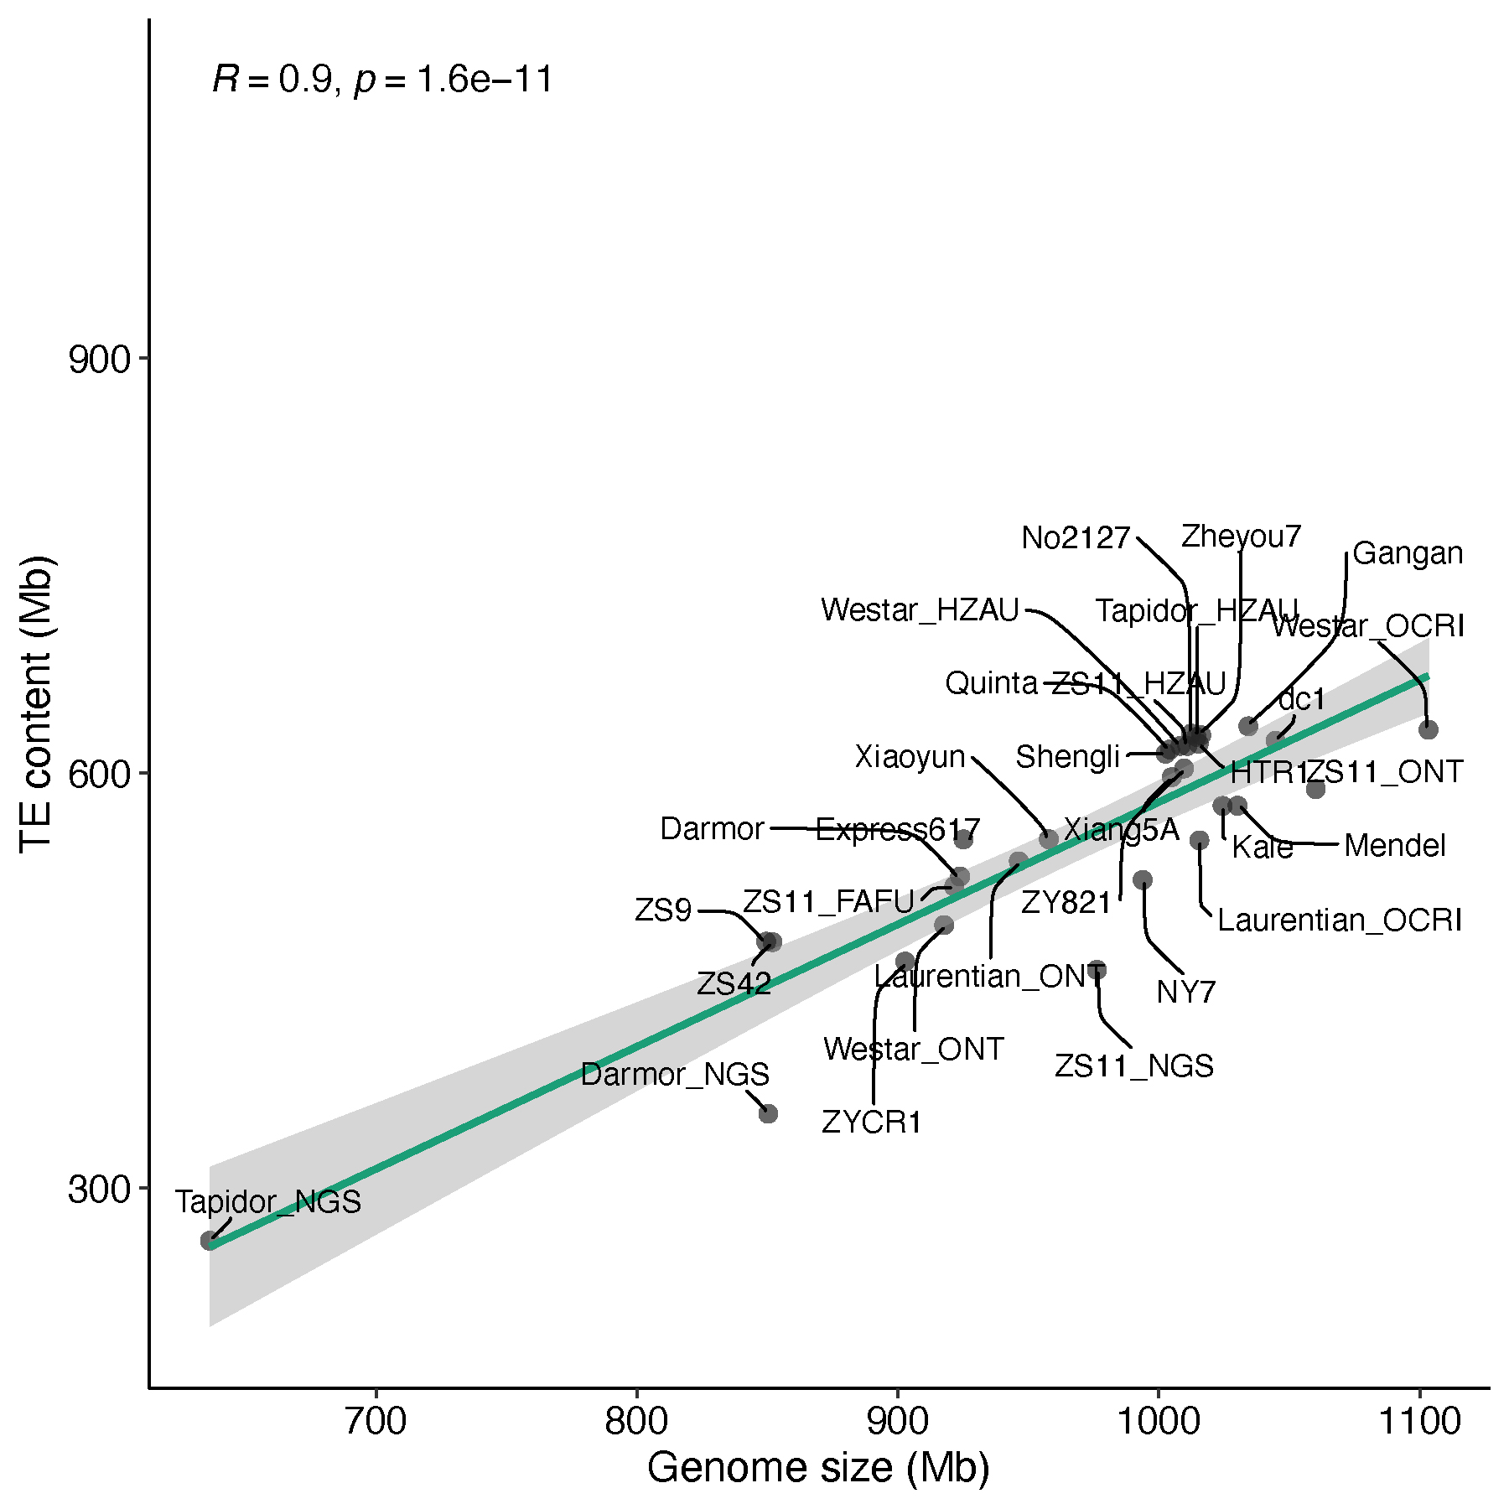
Figure S1. Correlation analysis between TE content and the assembled genome size of each B. napus accession.

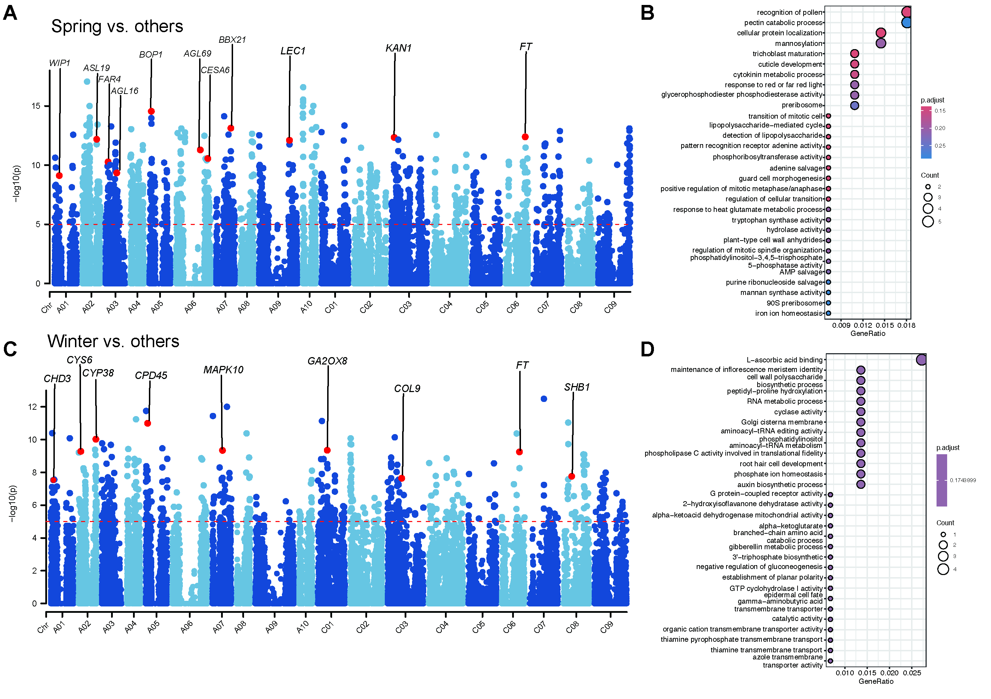
Figure S2. Frequency differences of TIPs between different ecotypes of B. napus.
(A) Frequency differences of TIPs between the spring and other ecotypes assessed by Fisher’s exact test, with P-values transformed as –Log₁₀.(B) GO enrichment analysis of significant genes in (A).
(C) Frequency differences of TIPs between the winter and other ecotypes assessed by Fisher’s exact test, with P-values transformed as –Log10.(D) GO enrichment analysis of significant genes in (C).
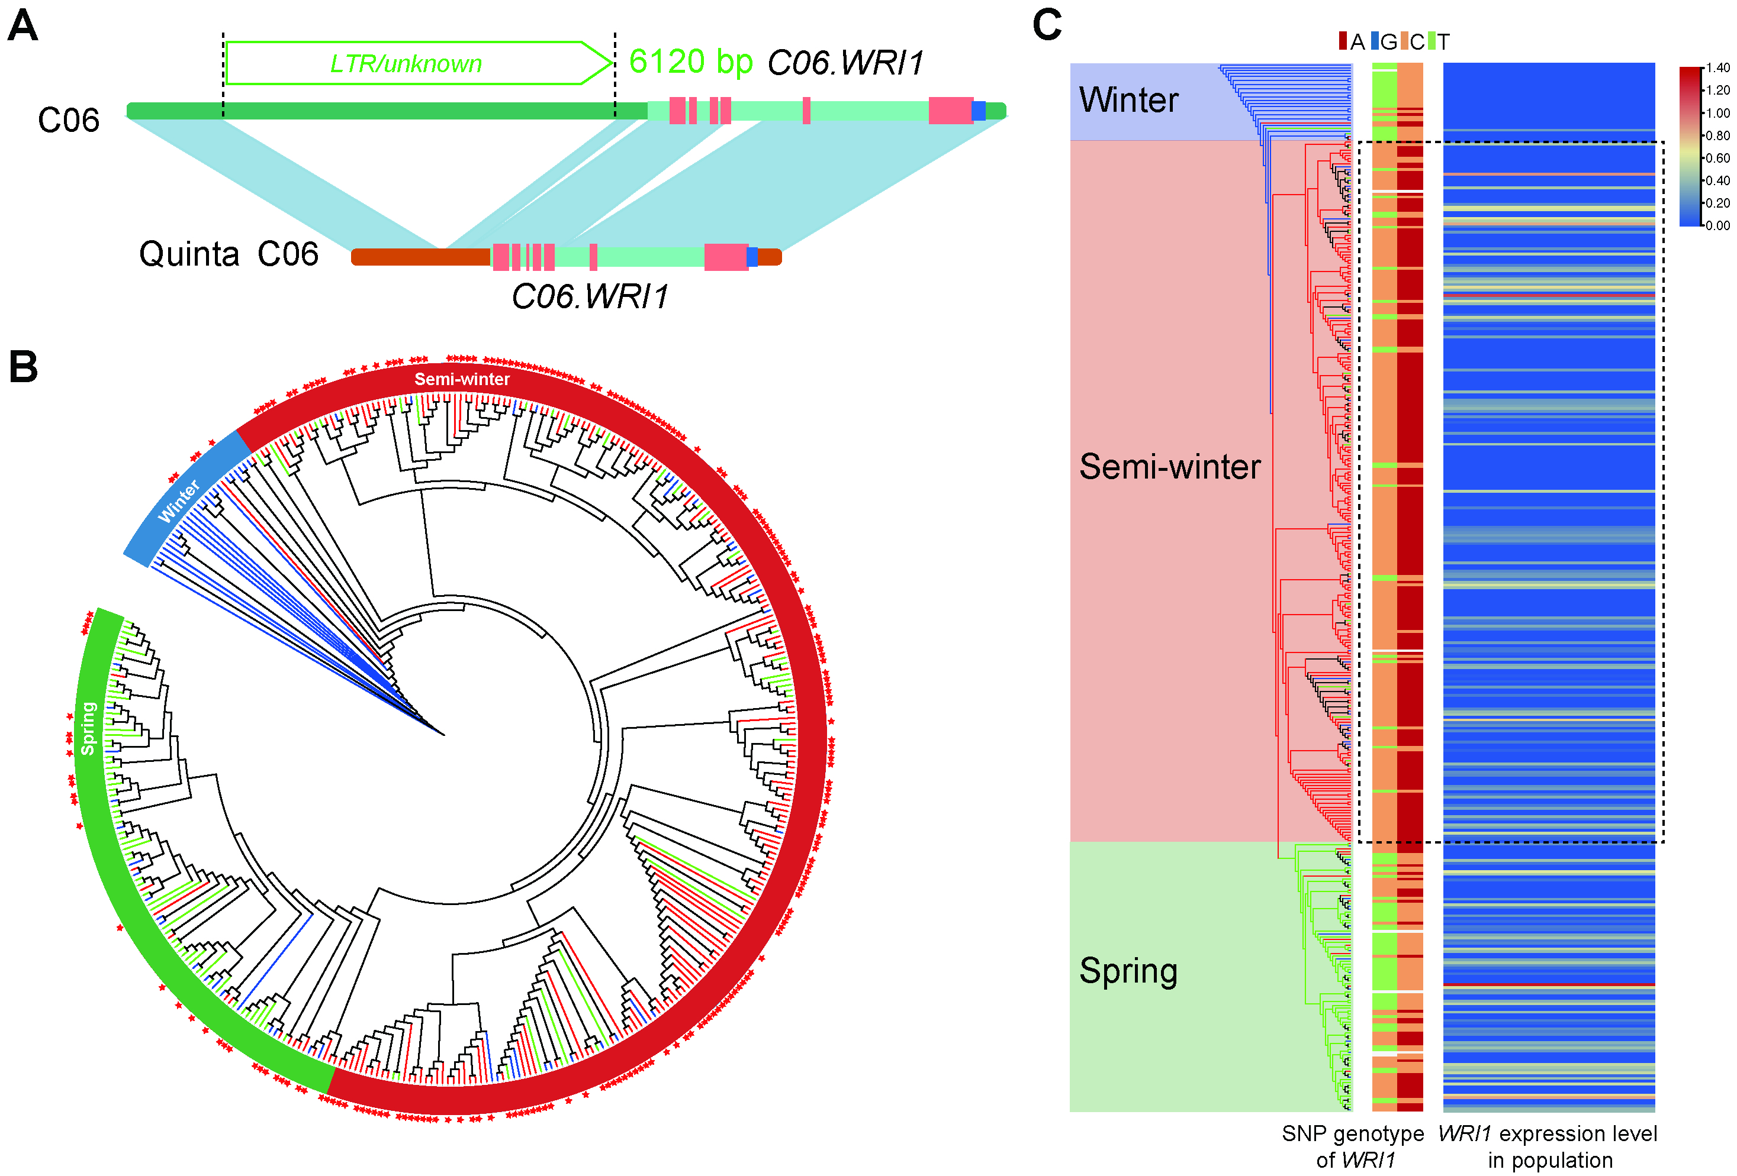
Figure S3. The TIP-containing gene C06.WRI1 was under strong selection during ecotype differentiation in B. napus.
(A) A LTR element inserted in the upstream region of C06.WRI1.(B) Distribution of the LTR insertion among 381 B. napus accessions, with the phylogenetic tree constructed from genome-wide SNPs. Accessions carrying the TE insertion are marked with red stars. (C) SNP haplotype distribution of C06.WRI1 in 381 accessions. Homozygous genotypes (AA, CC, GG, TT) are indicated by distinct colors, while missing (NN) and heterozygous loci remain uncolored.
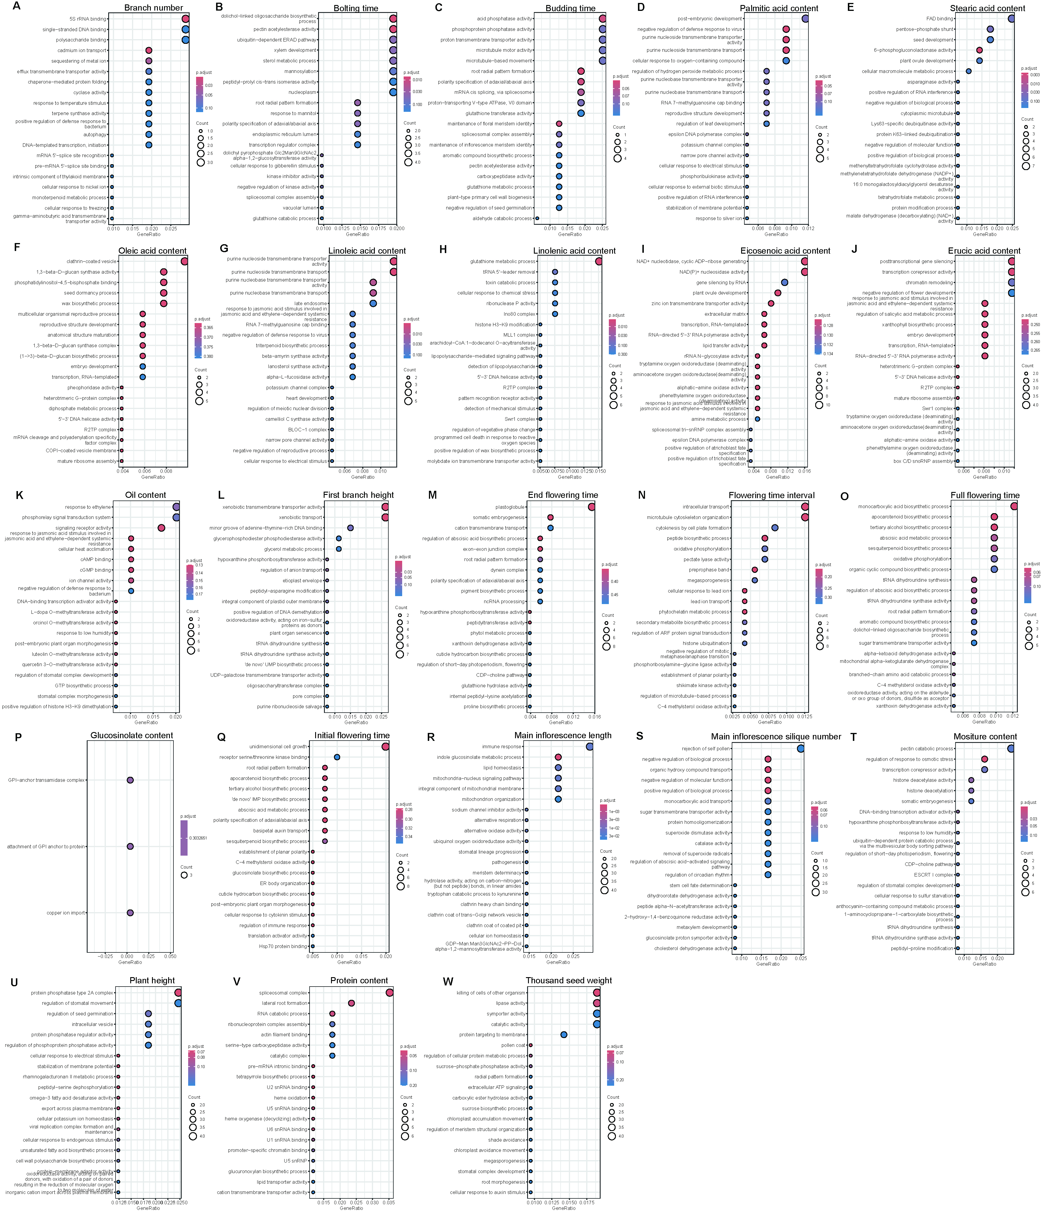
Figure S4. The GO enrichment analysis for the genes nearby the significant TIP loci specifically detected for the TIP-based GWAS.

