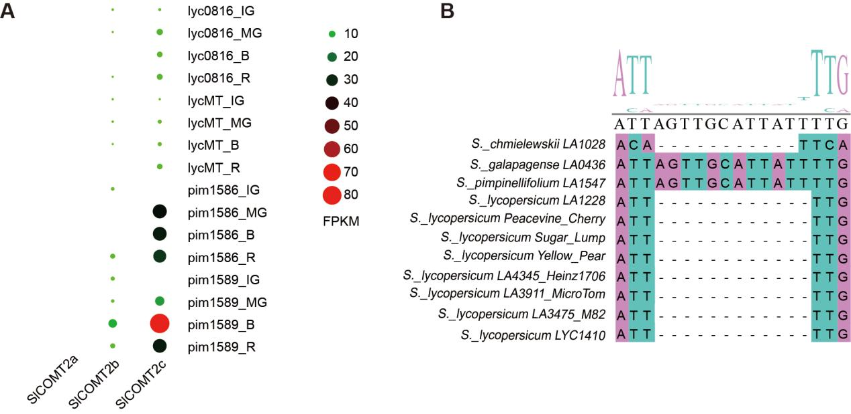
Figure S1. Expression patterns of the tandemly duplicated OMT gene cluster and genetic variation in the SlCOMT2c promoter.
The scale bar represents the level of gene expression (FPKM).

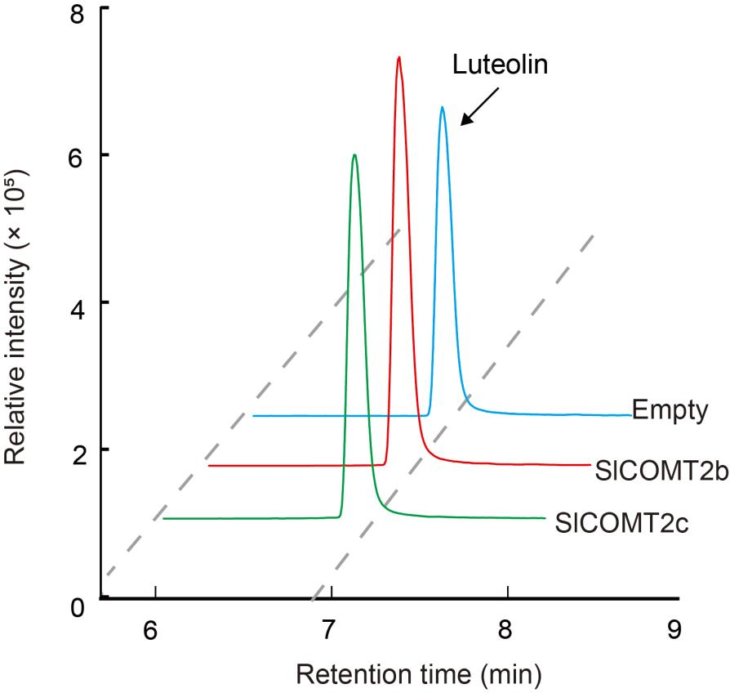
Figure S2. In vitro enzymatic activity assay of SlCOMT2b and SlCOMT2c with luteolin as a substrate including two independent experiments.
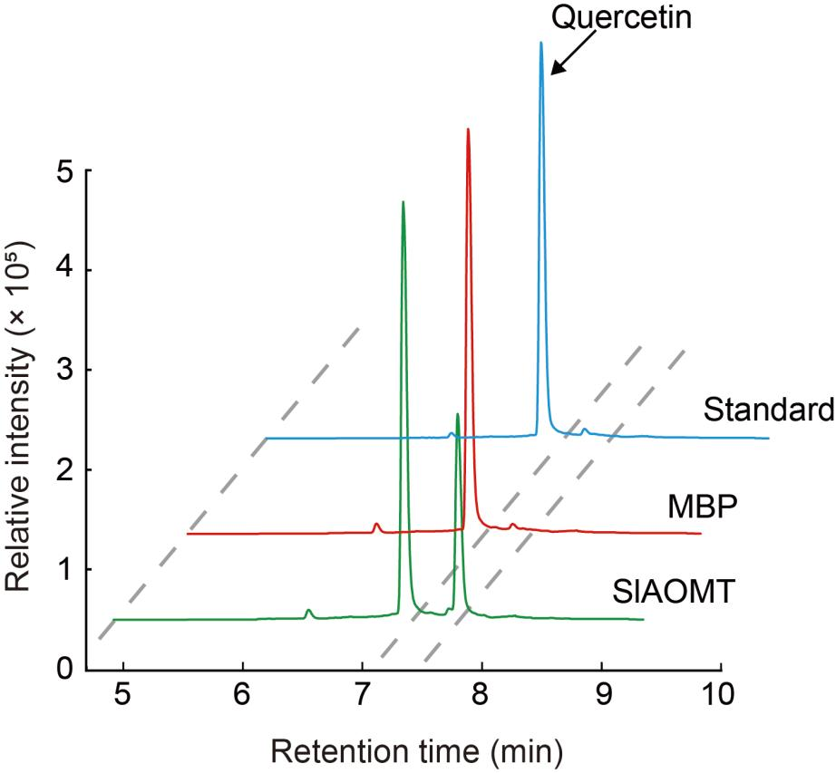
Figure S3. In vitro enzymatic activity assay of SlAOMT with quercetin as a substrate with two independent experiments.

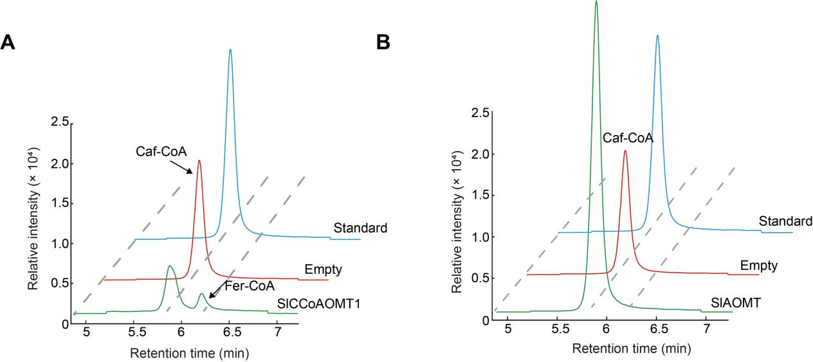
Figure S4. In vitro enzymatic activity assay of SlCCoAOMT1 (A) and SlAOMT (B) with Caf-CoA as a substrate including two independent experiments.
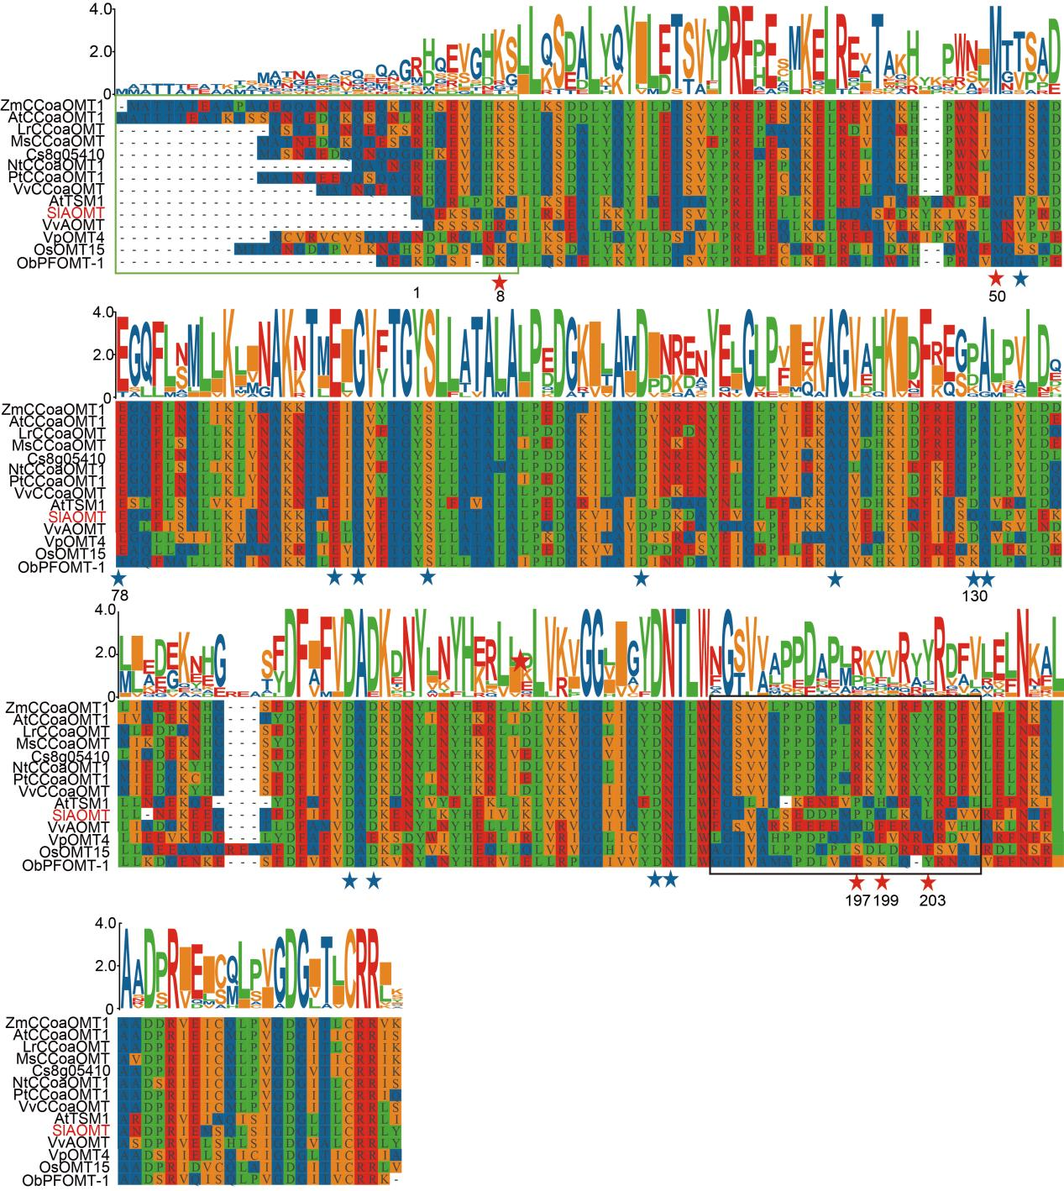
Figure S5. Sequence alignment of SlAOMT with other plant CCoAOMTs.
SlAOMT is shown in red text. Red asterisks indicate amino acid residues involved in caffeoyl-CoA substrate recognition and blue asterisks indicate amino acid residues involved in metal ion and co-factor binding, which are highly conserved.

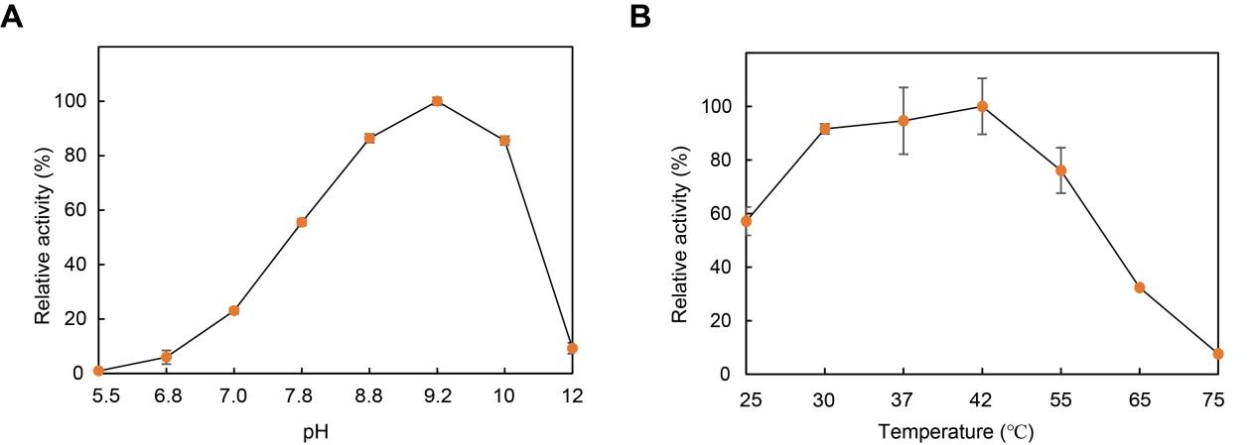
Figure S6. Optimal pH and temperature conditions for SlAOMT enzymatic reaction.
Values represent means ± SE, three independent experiments.

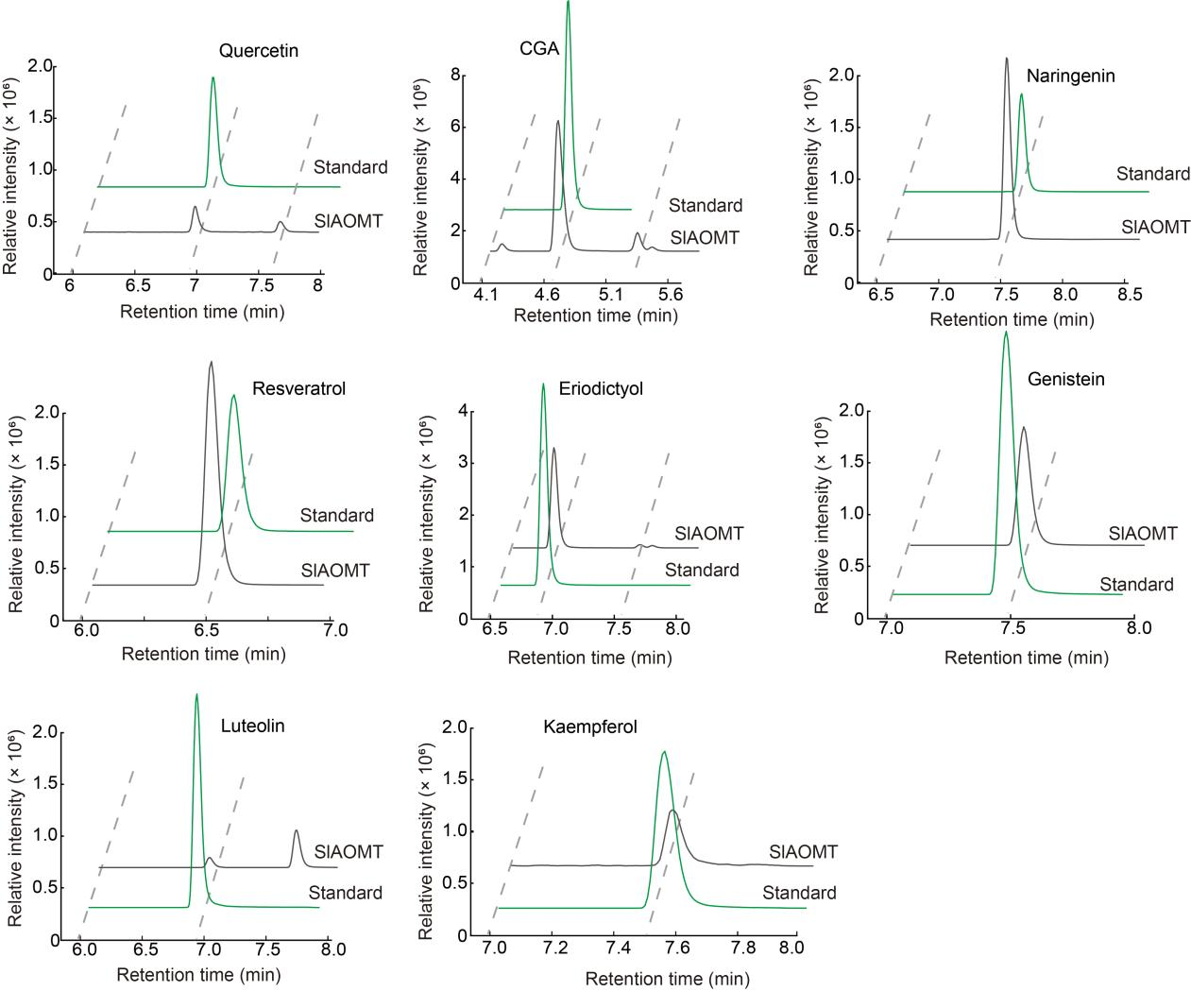
Figure S7. Substrate specificity of SlAOMT in vitro with two independent experiments.

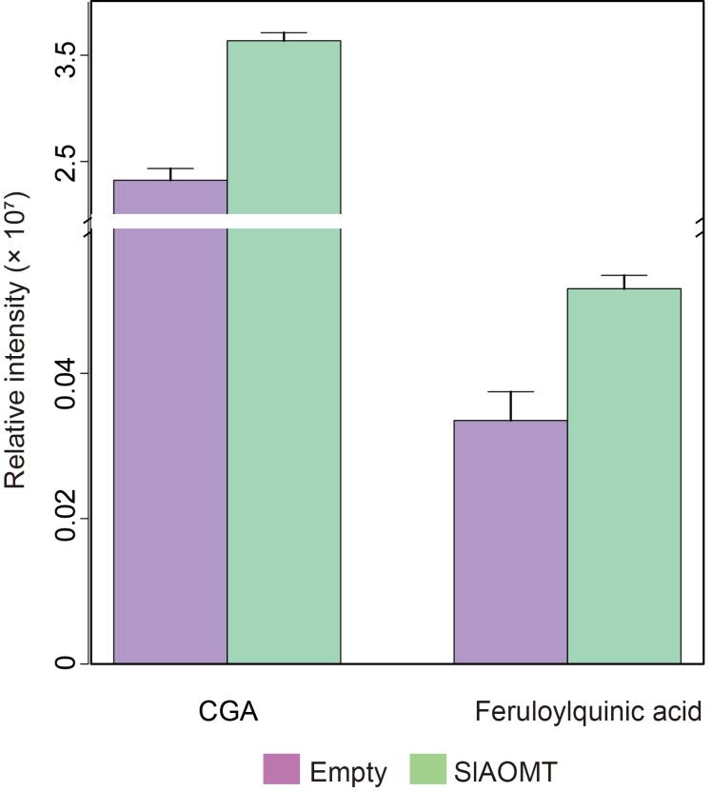
Figure S8. Functional verification of SlAOMT in N. benthamiana.
Values represent means ± SE, three independent experiments.

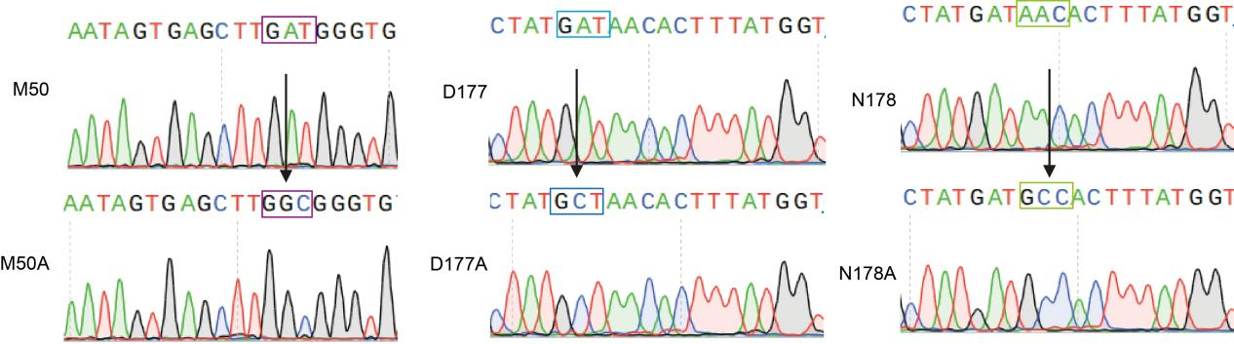
Figure S9. Mutational sites of the SlAOMT gene sequence.

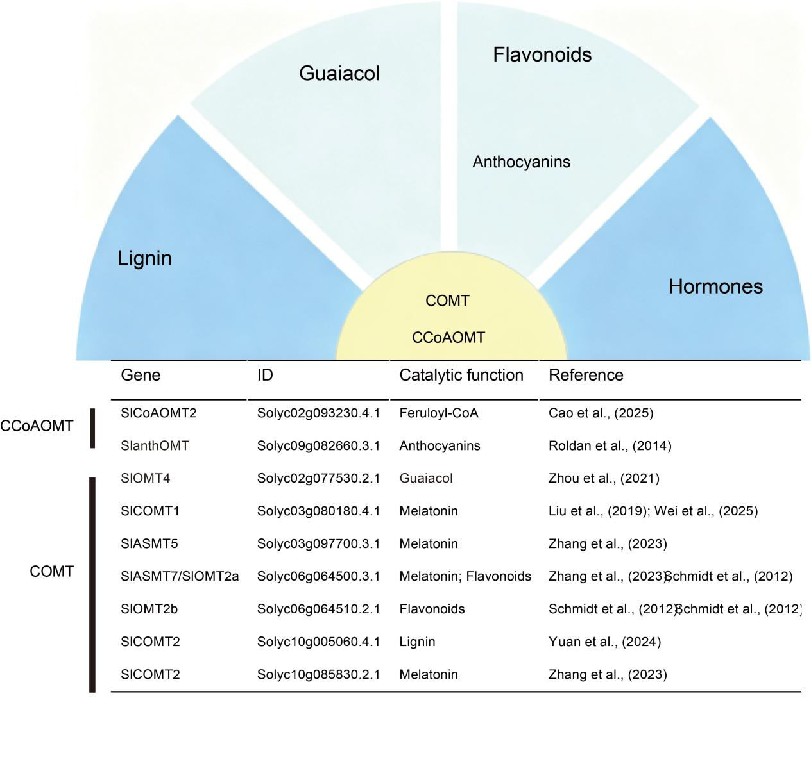
Figure S10. The catalytic functions of OMTs in tomato based on relevant references.

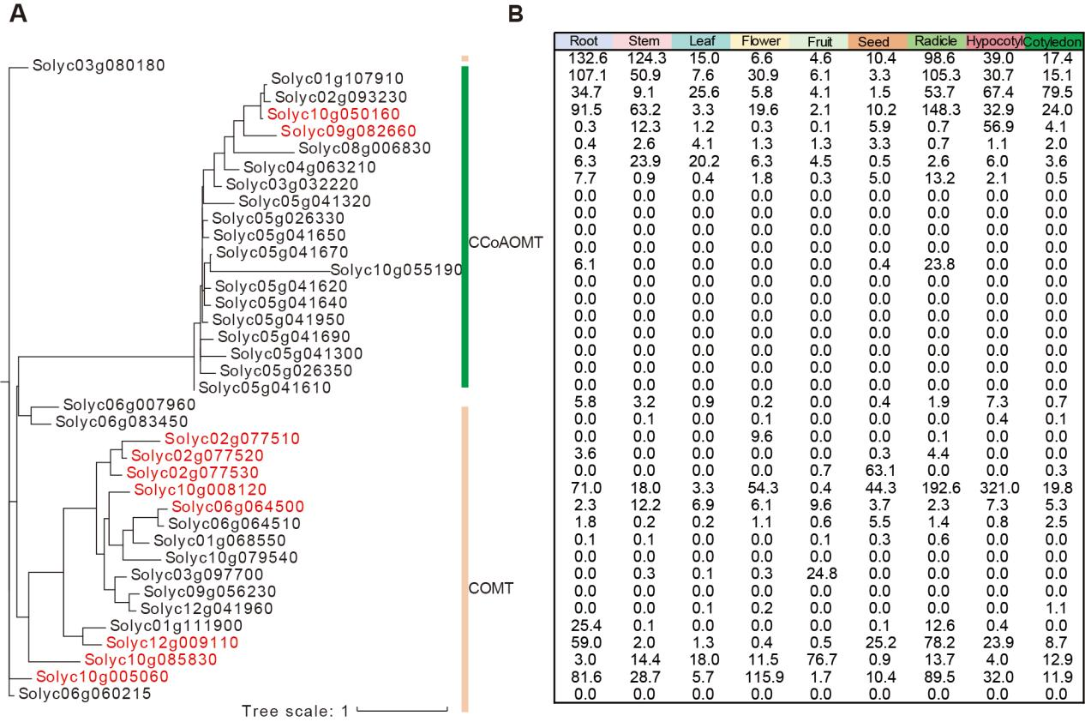
Figure S11. Phylogenetic analysis and expression patterns of OMTs in tomato.
Tree Scale: 1 substitutions per site.

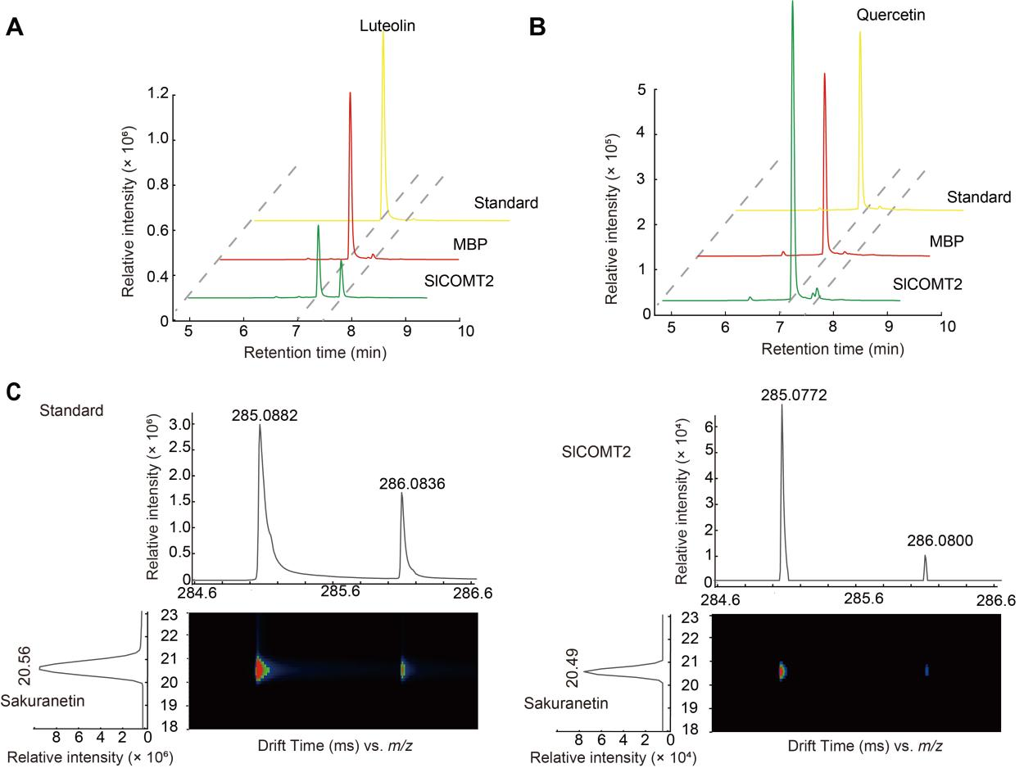
Figure S12. Enzymatic activity assay of SlCOMT2 with luteolin (A), quercetin (B), and naringenin (C) as substrate in vitro with two independent experiments.
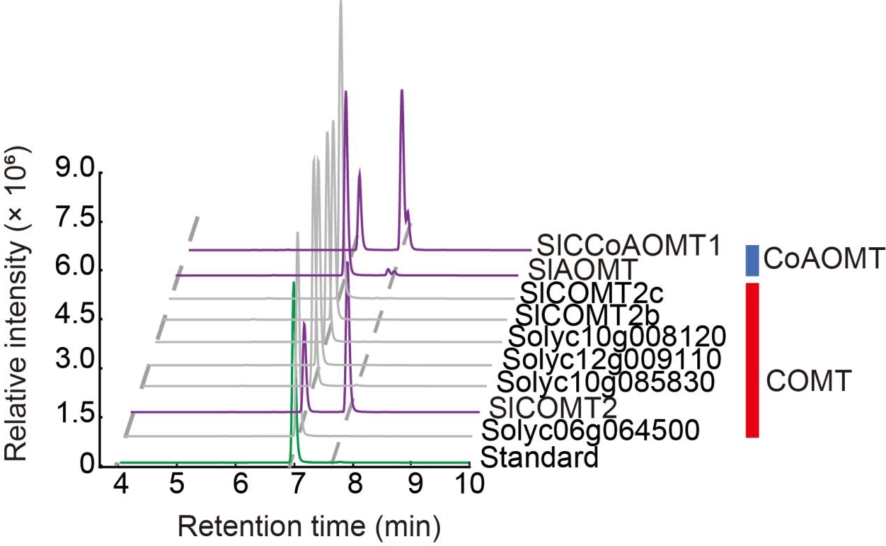
Figure S13. Identification of enzymes that catalyze the methylation of eriodictyol in tomato with two independent experiments.
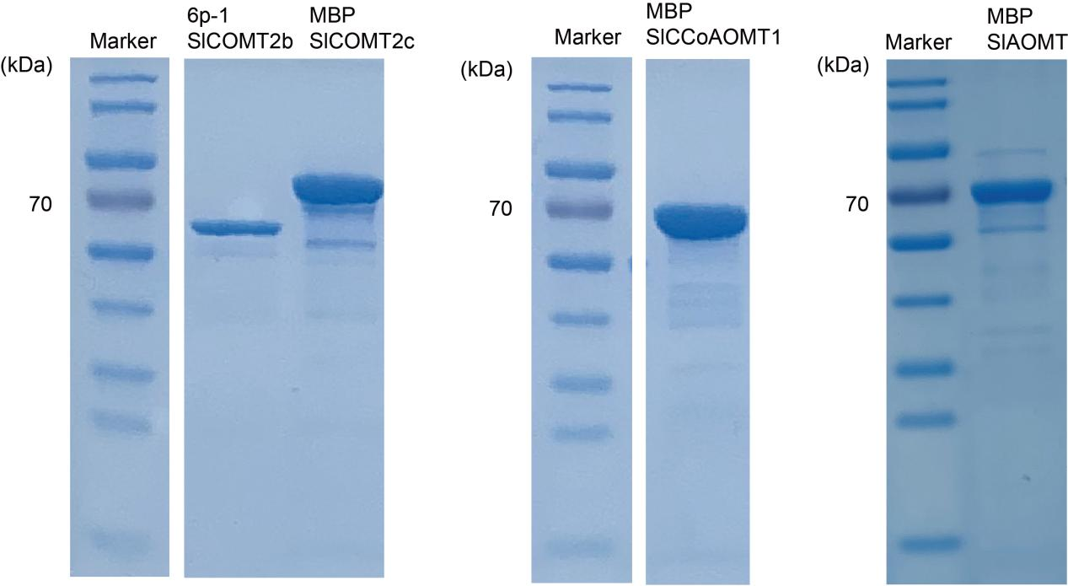
Figure S14. SDS-PAGE of the recombinant proteins expressed in E. coli.

