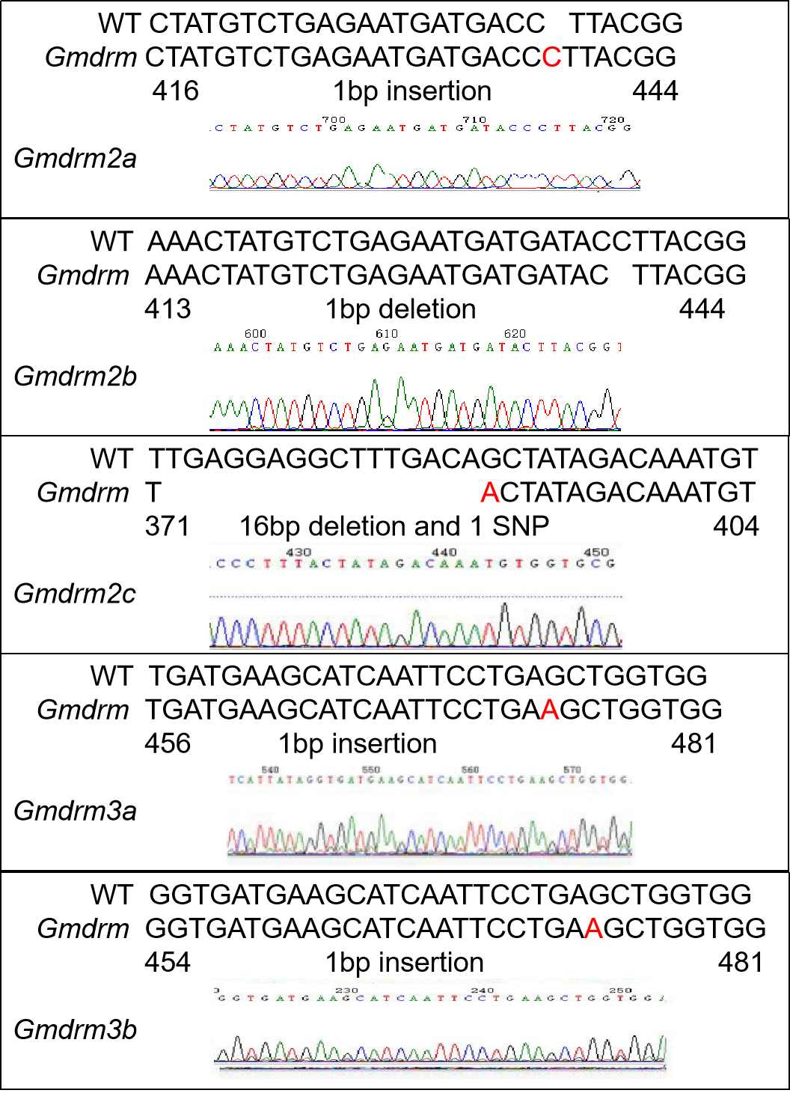

Figure S1. Visualization of Sanger sequencing results for five genes in the Gmdrm mutant.
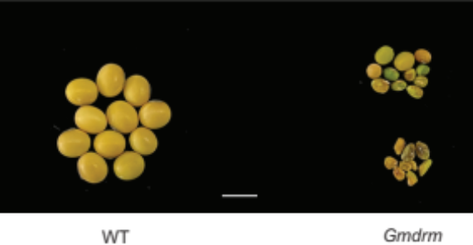

Figure S2. The phenotype of seed size in the Gmdrm mutant and WT (Scale bar = 8 cm).

Figure S3. Comparison of phenotypic, DNA methylation levels, and types of gene editing between different Gmdrm mutants compared to WT plants. (A) Plant phenotypes of mutants (Gmdrm2c^{-/-}3a^{-/-}3b^{-/-}, Gmdrm2a^{-/-}2b^{-/-}2c^{-/-}3a^{-/-}3b^{+/-}, Gmdrm2b^{-/-}2c^{-/-}3a^{-/-}3b^{-/-}2a^{+/-} and Gmdrm) compared to WT plants at the V2 stage in the greenhouse. (B) DNA methylation levels in mutants (Gmdrm2c^{-/-}3a^{-/-}3b^{-/-}, Gmdrm2a^{-/-}2b^{-/-}2c^{-/-}3a^{-/-}3b^{+/-}, Gmdrm2b^{-/-}2c^{-/-}3a^{-/-}3b^{-/-}2a^{+/-} and Gmdrm) compared to WT plants. (C) Visualization of Sanger sequencing results for the given gene in the Gmdrm2c^{-/-}3a^{-/-}3b^{-/-}, Gmdrm2a^{-/-}2b^{-/-}2c^{-/-}3a^{-/-}3b^{+/-}, Gmdrm2b^{-/-}2c^{-/-}3a^{-/-}3b^{-/-}2a^{+/-} and Gmdrm mutants.
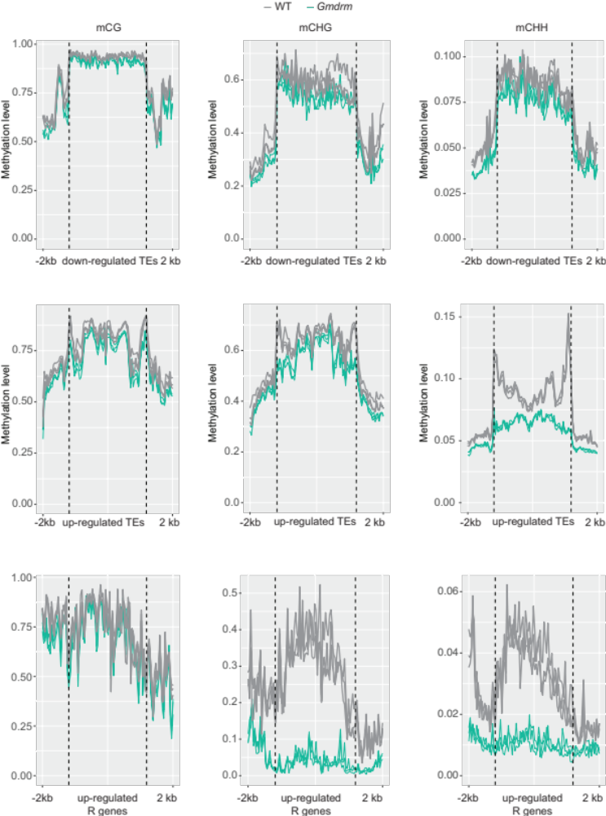
Figure S4. Analysis of methylation landscape surrounding R genes and differentially expressed transposable elements (DETs). This panel illustrates the distribution patterns of CG, CHG, and CHH DNA methylation levels within and adjacent to R genes and DETs.

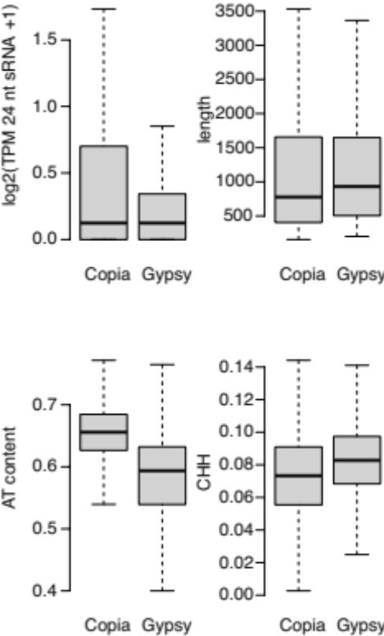

Figure S5. Analysis of sequence pattern between Copia and Gypsy in soybean.

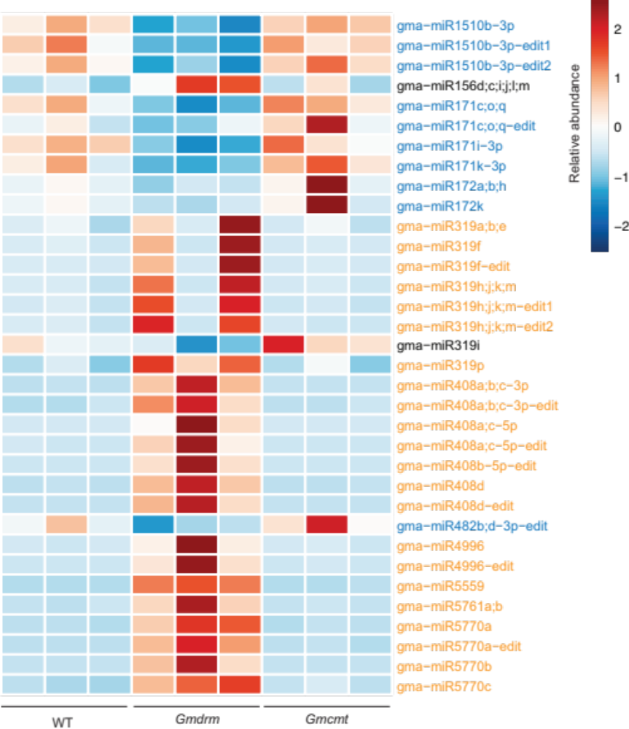

Figure S6. Relative expression levels of miRNAs in WT, Gmdrm, and Gmcmt mutants. The heatmap depicts scaled color intensities for each row.

Figure S7. Relative expression levels of four GLK transcription factors in the Gmdrm mutant compared to WT.

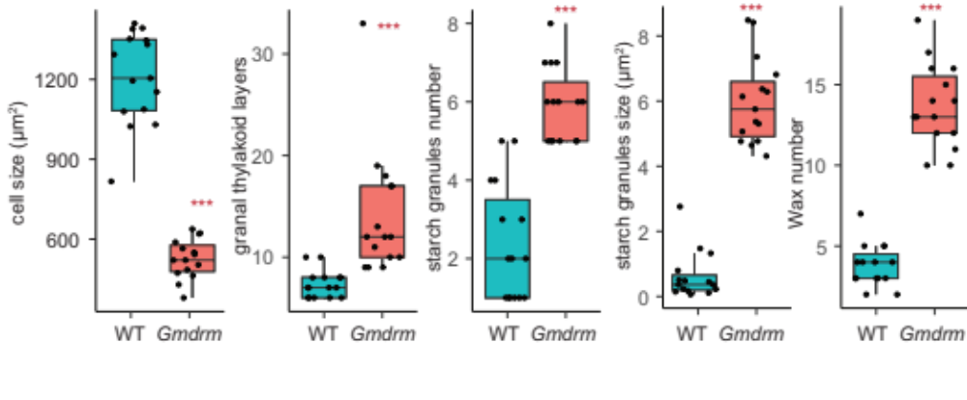

Figure S8. Statistical analysis of cell structures on leaves between Gmdrm mutants and WT. KS test was performed to assess statistical significance (***p value < 0.001).

Figure S9. The Gmdrm2c/3a/3b variants exhibited enhanced resistance to SMV under greenhouse inoculation conditions. (A) Phenotype of plants after SMV inoculation. (B) Sanger sequencing results for three genes in the Gmdrm mutant. (C) Correlation analysis of the expression levels of CP gene of SMV. Student’s t-test was performed to assess statistical significance (***p value < 0.001).

