Supporting Information
Figure S1. Boxplots showing the distribution of sequencing coverage, mapping, and missing rate of the 280 samples.
Figure S2. The coalescent-based phylogenetic tree inferred using SVDquartets.
Figure S3. All possible topologies found in the Twisst analyses.
Figure S4. Marginal likelihood value for different K values.
Figure S5. Population structure of R. sect. Trifida based on Admixture at K = 2 – 3.
Figure S6. Gene flow events identified among genetic groups of R. sect. Trifida by Dtrios of Dsuite.
Figure S7. Gene flow events among genetic groups of R. sect. Trifida revealed by TreeMix and OptM.
Figure S8. The results of the 18-individual demographic histories inferred by PSMC.
Figure S9. Demographic histories of R. sect. Trifida inferred by Stairway Plot 2 and SMC++.
Figure S10. The nine demographic models analyzed with Fastsimcoal2.
Figure S11. Decay of linkage disequilibrium (LD) in different groups quantified by r².
Figure S12. The inbreeding coefficient (F_{IS}) values among the R. sect. Trifida.
Figure S13. Correlation analyses of nucleotide diversity (π), genetic divergence (F_{ST}), absolute divergence (D_{XY}), and Tajima's D between genetic groups of R. sect. Trifida.
Figure S14. Statistical test of genetic indices of highly differentiated regions versus background regions.
Figure S15. GO enrichment results of SNPs in highly differentiated windows between different species and their background genomes.
Figure S16. Correlation between geographical distance and environmental differences and genetic distance analyzed by the Partial Mantel test.
Figure S17. GO annotation results for 13,109 GEA core outliers SNPs.
Figure S18. Inversion analyses for chromosomes 7 on MDS03.
Table S3. Characteristics of datasets used in this study.
Table S5. Parameter revaluation and confidence intervals of the best differentiation scenarios.
Table S14. Frequencies of the ‘1’ arrangement of the assumed inversions in Rhodiola sect. Trifida.
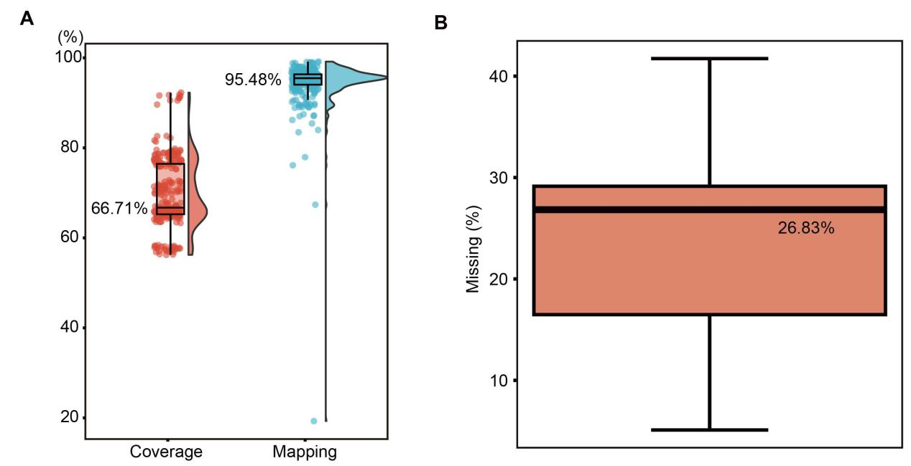

Figure S1. Boxplots showing the distribution of sequencing coverage, mapping, and missing rate of the 280 samples.
(A) Coverage and mapping rates. The average coverage is 69.76% in the left, and the average mapping rate is 94.43% in the right. The numbers to the left of the box plot are their respective median values. (B) Boxplot showing the distribution of missing rate in all individuals. In both figures, the box extends from the first quartile (Q1) to the third quartile (Q3), with the line inside the box denotes the median value (Q2). The whiskers denote 1.5 times the interquartile range (IQR; Q3-Q1) above the third quartile (Q3) and below the first quartile (Q1). Extreme values are represented by dots.
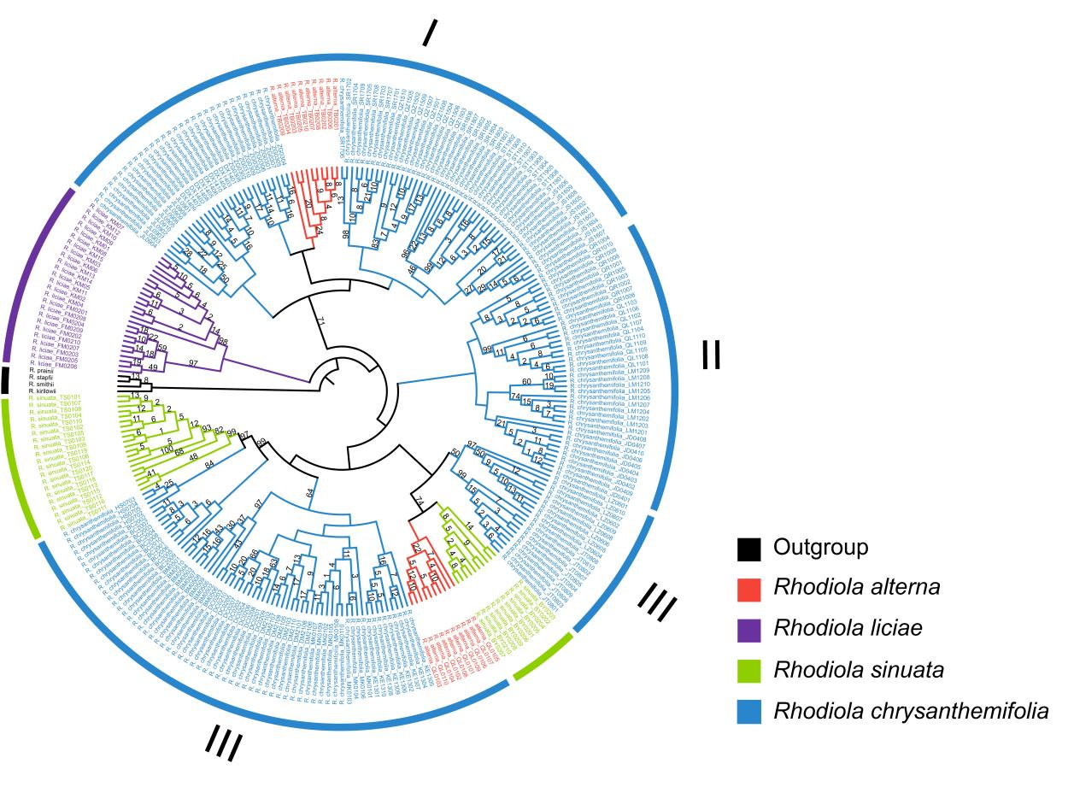

Figure S2. The coalescent-based phylogenetic tree inferred using SVDquartets. The number beside each node represents the bootstrap value, and nodes without bootstrap values were those with 100% bootstrap support.

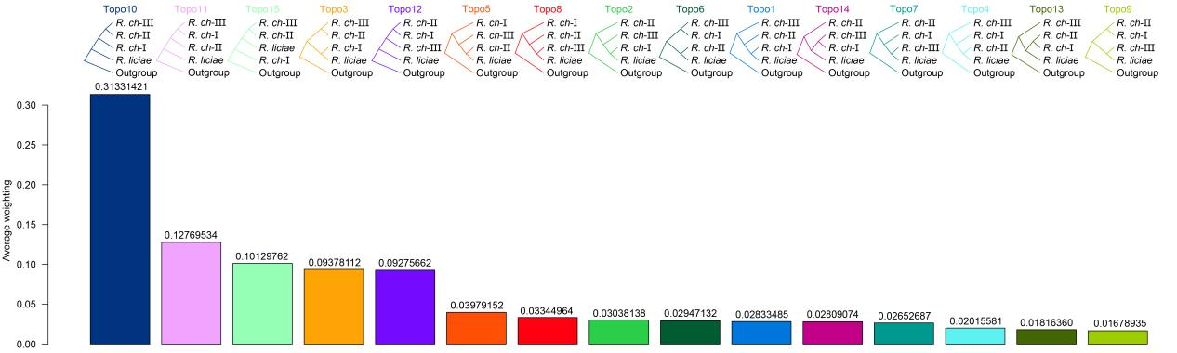

Figure S3. All possible topologies found in the Twisst analyses.
The upper side shows the topology of the NJ tree based on the SNPs, different color represents different topologies, and the bar plot shows the average weighting values for each tree.

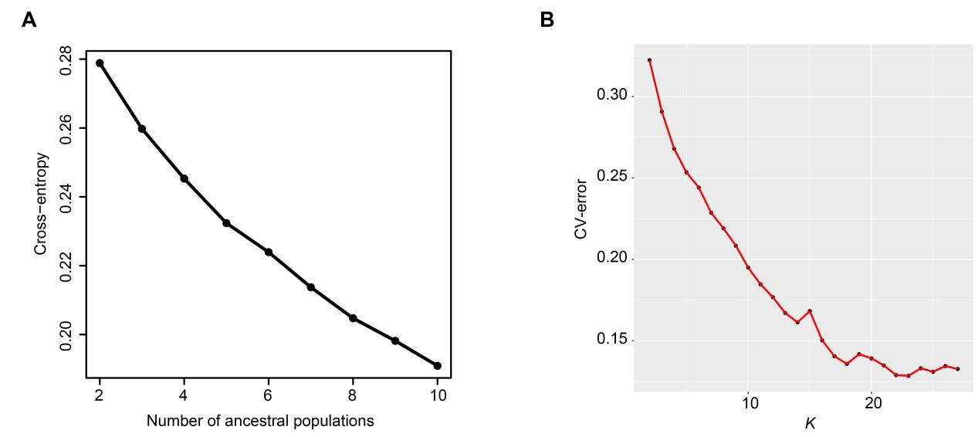

Figure S4. Marginal likelihood value for different K values.
(A) Marginal Likelihood value for different K values in sNMF (K = 2 – 10). (B) Marginal Likelihood value for different K values in Admixture (K = 2 – 27).

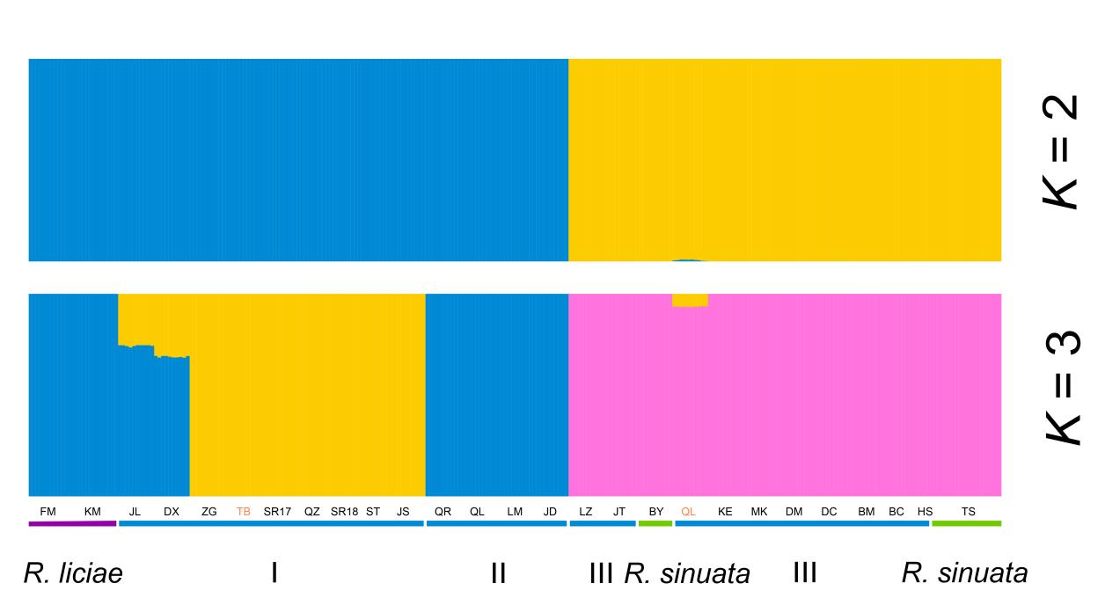

Figure S5. Population structure of R. sect. Trifida based on Admixture at K = 2 – 3.
Colored columns indicate inferred the ancestry proportion of each sample. Different color represents genetic components. The bars at the bottom indicating species status were colored according to ML tree in Figure 1B.

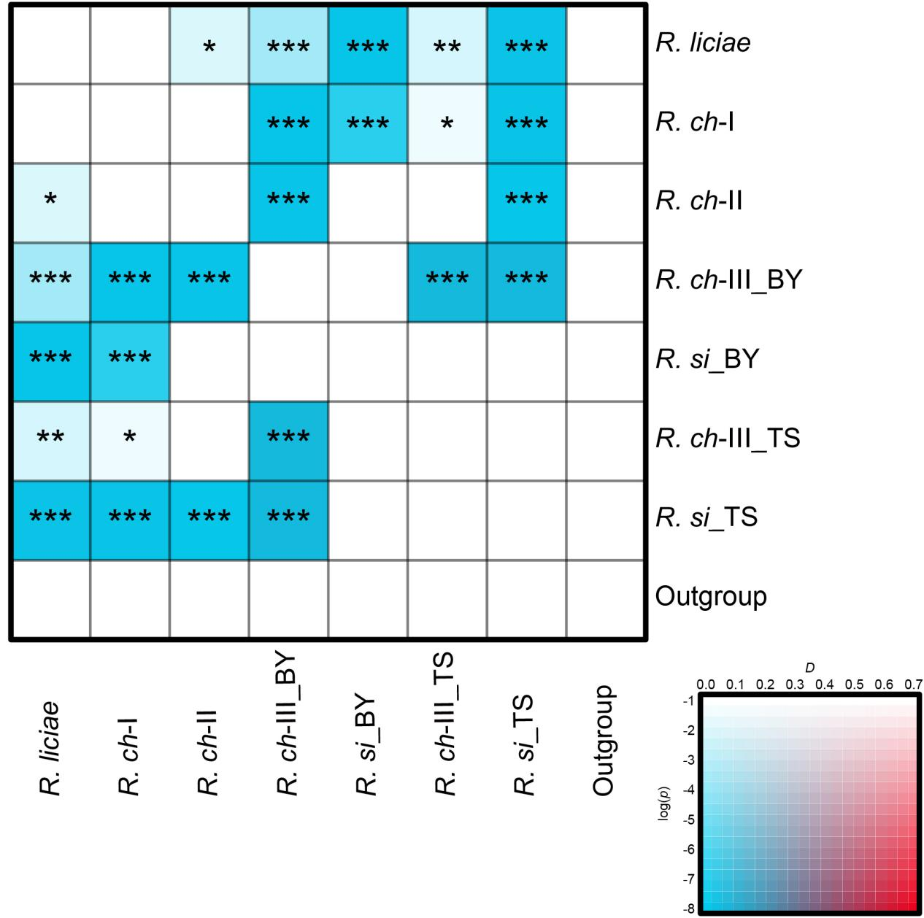

Figure S6. Gene flow events identified among genetic groups of R. sect. Trifida by Dtrios of Dsuite.
The color of each square marks the D-statistic estimate (high saturation in red indicates a high estimate), and the saturation of these colors represents the p-value for that test (see the bottom left inset box). P_{adjust} results were marked with * in boxes. * significant at 0.05; ** significant at 0.01; *** significant at 0.001.

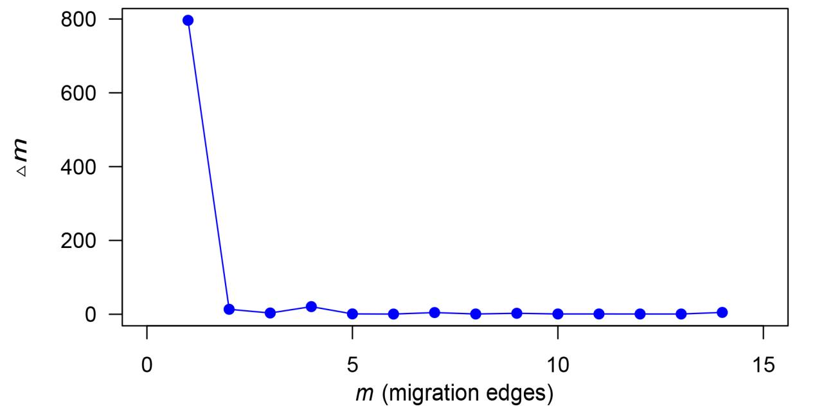

Figure S7. Gene flow events among genetic groups of R. sect. Trifida revealed by TreeMix and OptM.
Distribution of deltaM statistic based on the second order rate of change in the likelihood with standard deviation considered.

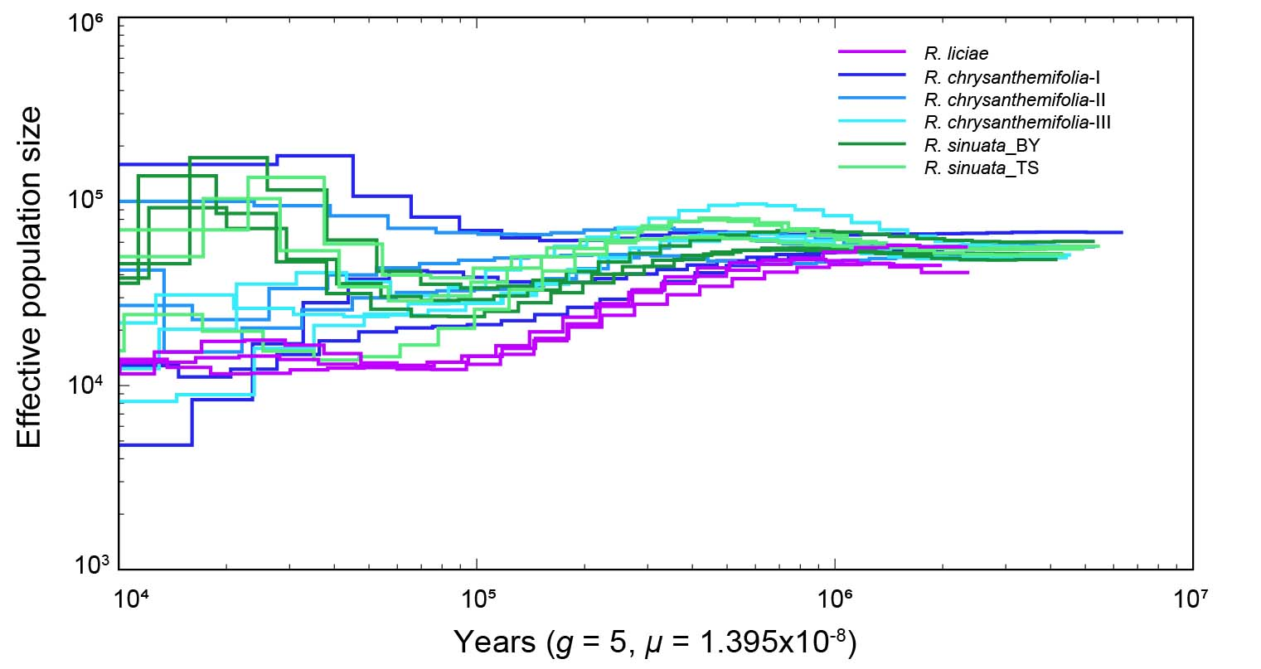

Figure S8. The results of the 18-individual demographic histories inferred by PSMC.
A generation time of 5 years and a mutation rate μ of 1.395 × 10⁻⁸ per site per generation were assumed.

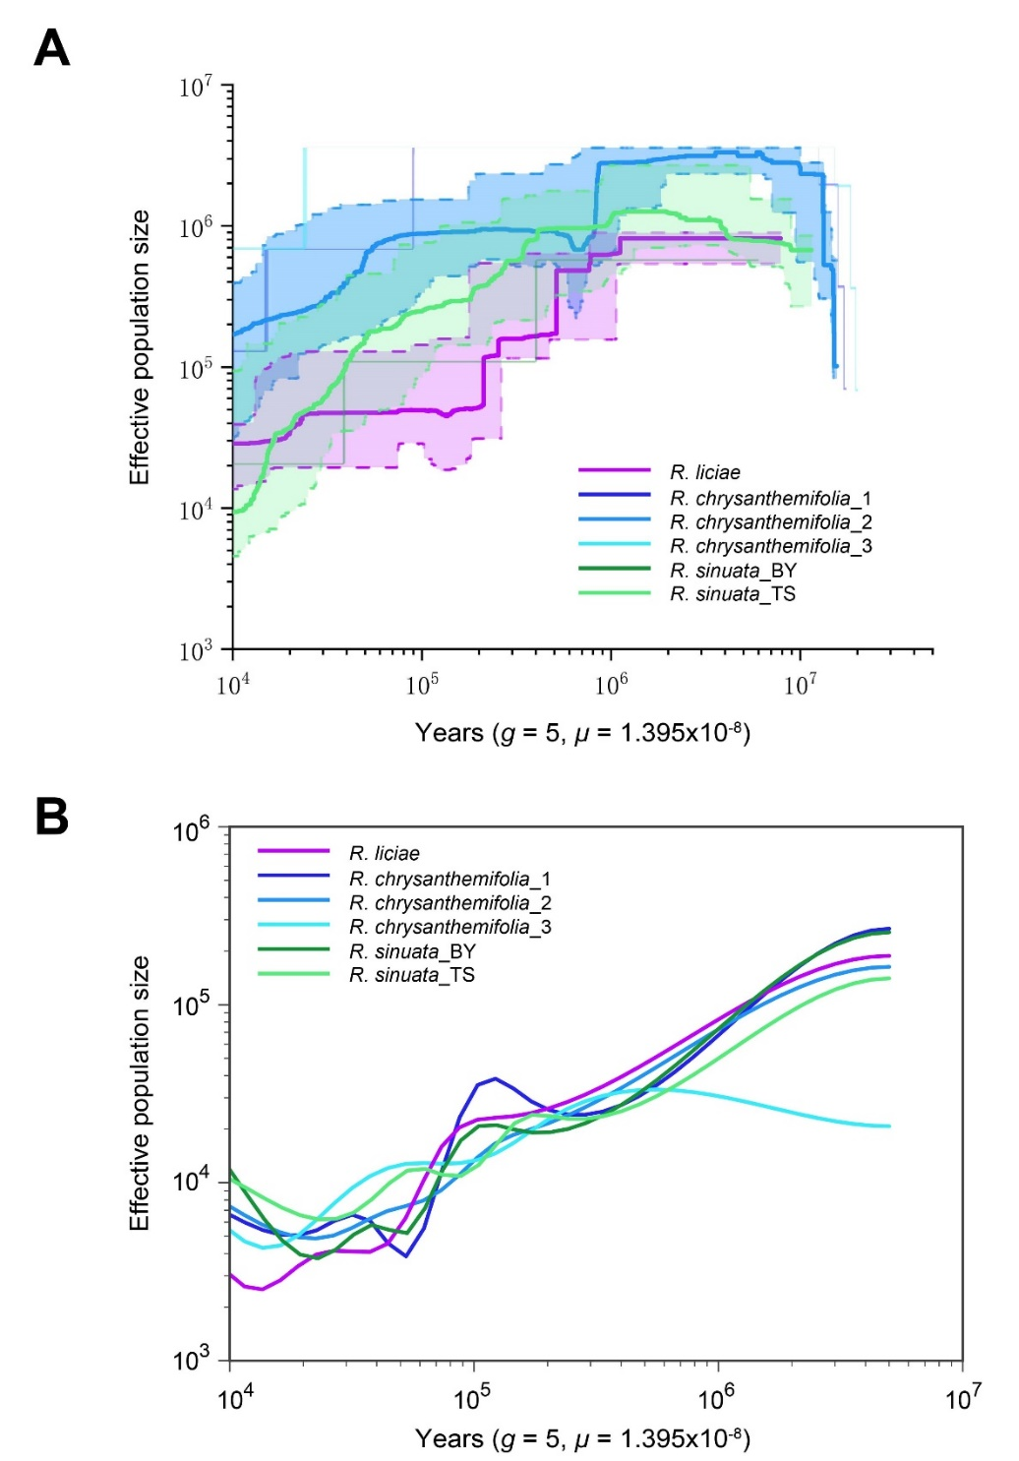

Figure S9. Demographic histories of R. sect. Trifida inferred by Stairway Plot 2 (A) and SMC++ (B).
Lines represent the median effective population size over time, and shaded areas represent 95% confidence intervals. A generation time of 5 years and a mutation rate μ of 1.395 × 10⁻⁸ per site per generation were assumed.

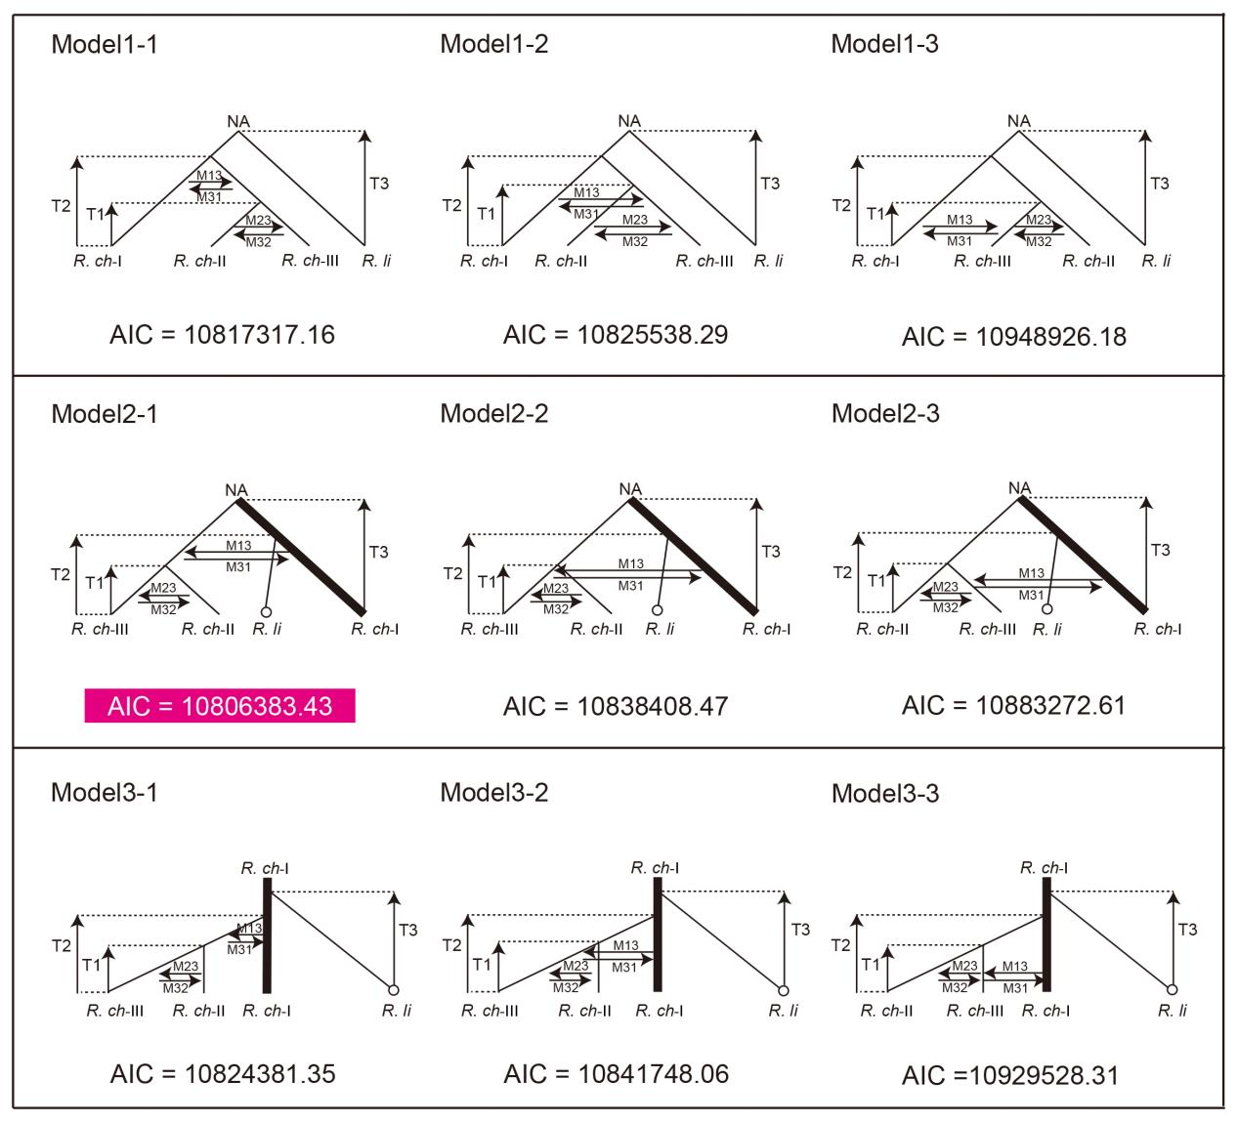

Figure S10. The nine demographic models analyzed with Fastsimcoal2.
Based on the results of TreeMix and ABBA test, we set up nine models to speculate on the optimal differentiation history of R. liciae. Between-population gene flow was indicated by arrows. The AIC for each model was given at the bottom and pink rectangles represent the best model.

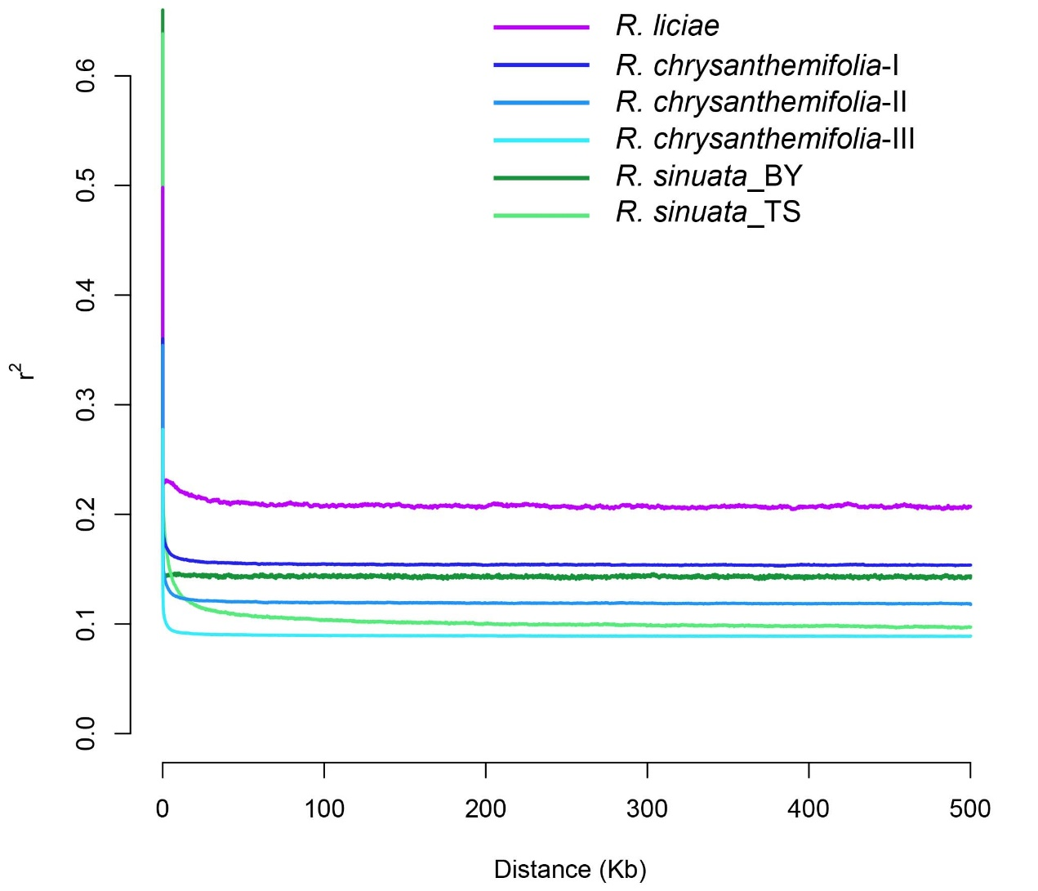

Figure S11. Decay of linkage disequilibrium (LD) in different groups quantified by r².
Different line colors represent different groups. To minimize bias due to sample size variation, we sequentially sampled 10 individuals from each group of the R. sect. Trifida based on the ML tree (Figure 1B).

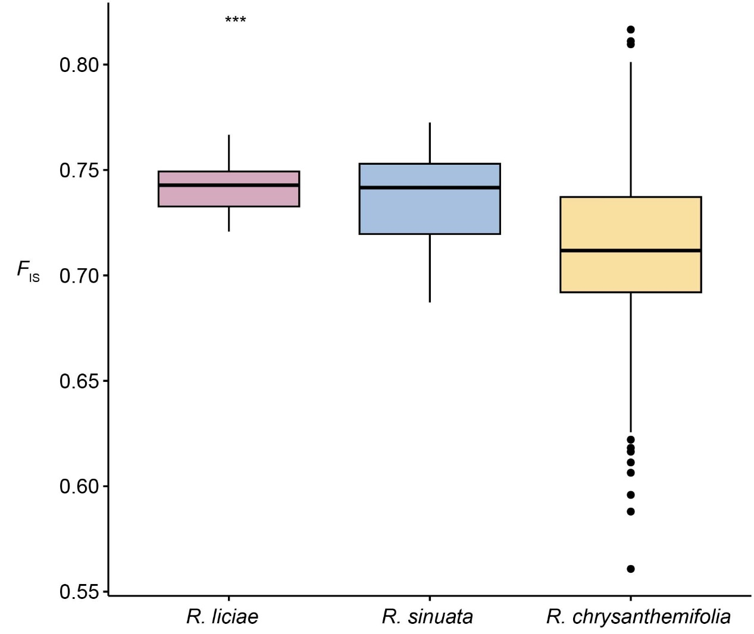

Figure S12. The inbreeding coefficient (F_{IS}) values among the R. sect. Trifida.

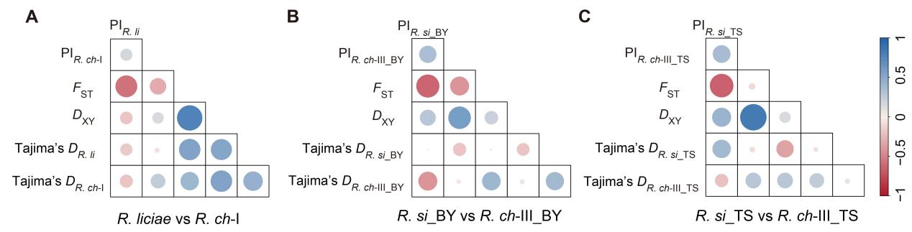

Figure S13. Correlation analyses of nucleotide diversity (π), genetic divergence (F_{ST}), absolute divergence (D_{XY}), and Tajima's D between genetic groups of R. sect. Trifida.
All statistics were calculated in 50 kb sliding windows and a 10 kb step. Red circles indicate a positive correlation, while blue circles indicate a negative correlation. The color intensity and circle size are proportional to Spearman's correlation coefficient.

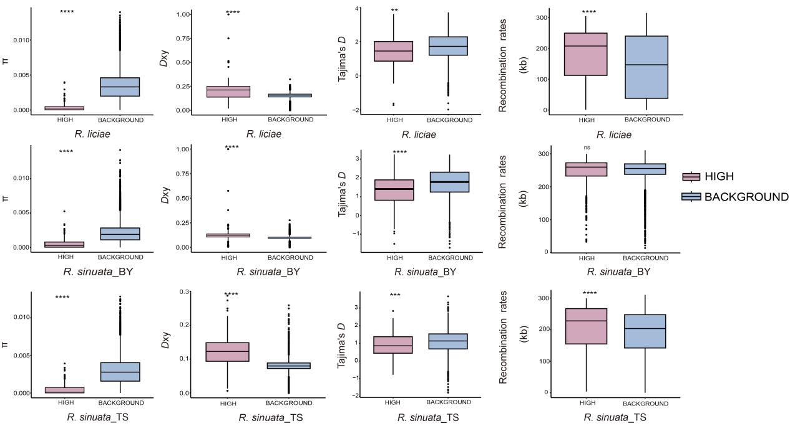

Figure S14. Statistical test of genetic indices of highly differentiated regions versus background regions.
Asterisks designate significant differences between outlier windows and the rest of genomic regions by the Mann–Whitney U test (*P < 0.05; **P < 0.01; ***P < 0.001; ****P < 0.0001).

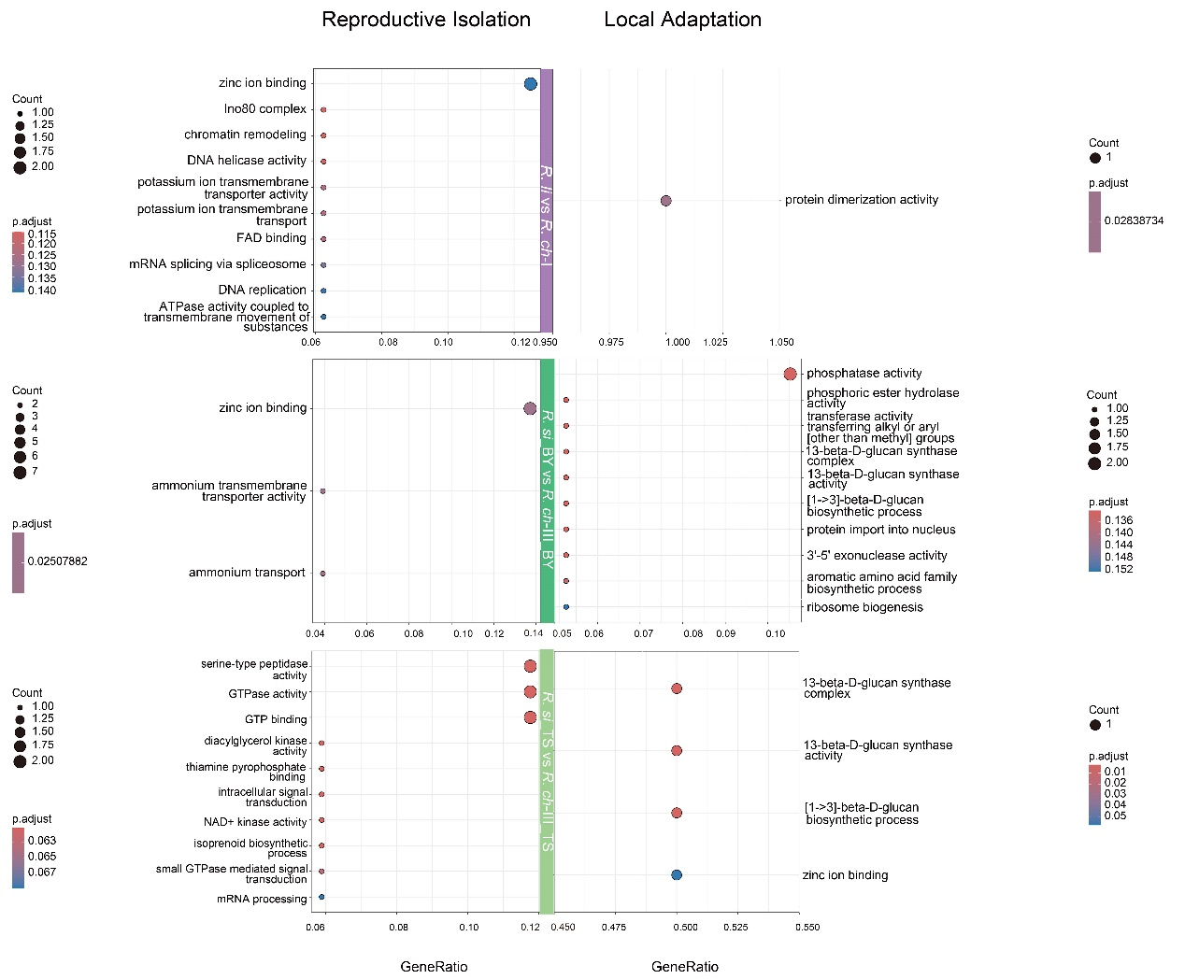

Figure S15. GO enrichment results of SNPs in highly differentiated windows between different species and their background genomes.
Reproductive isolation-associated genes are on the left and local adaptation-associated genes are on the right. X-axis represents GeneRatio, bubble size represents the number of genes enriched, and bubble color represents P.adjust. Only up to 10 GO terms are shown, the rest are shown in Table S8–9.

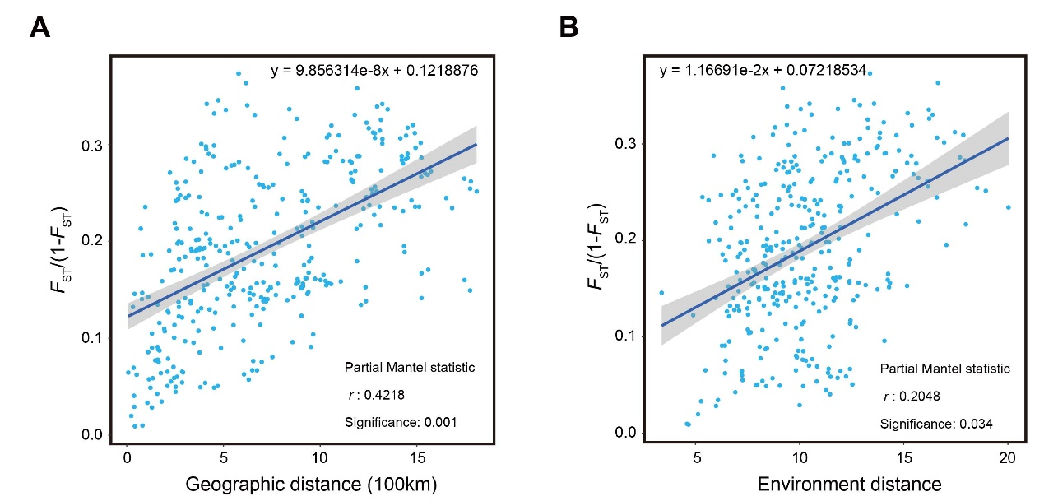

Figure S16. Correlation between geographical distance and environmental differences and genetic distance analyzed by the Partial Mantel test.
The shadow of linear regression denotes the 95% confidence interval. (A) When controlling for the effect of environmental distance, the correlation between genetic distance and geographic distance (r = 0.4218, P = 0.001). (B) When controlling for the effect of geographic distance, the correlation between genetic distance and environmental distance (r = 0.2048, P = 0.034) among the 27 populations in R. sect. Trifida.

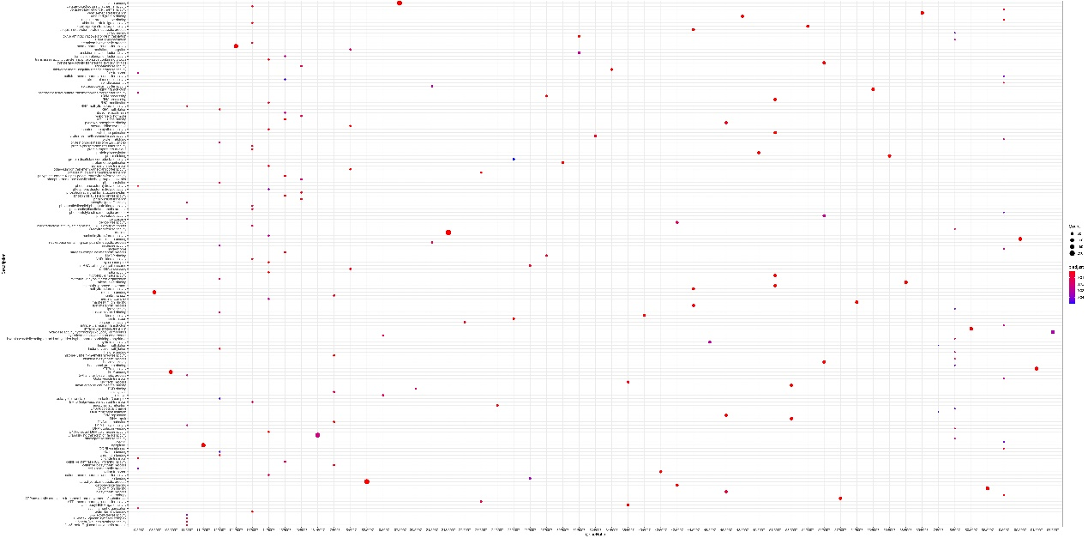

Figure S17. GO annotation results for 13,109 GEA core outliers SNPs.
X-axis represents GeneRatio, bubble size represents the number of genes enriched, and bubble color represents P. adjust.

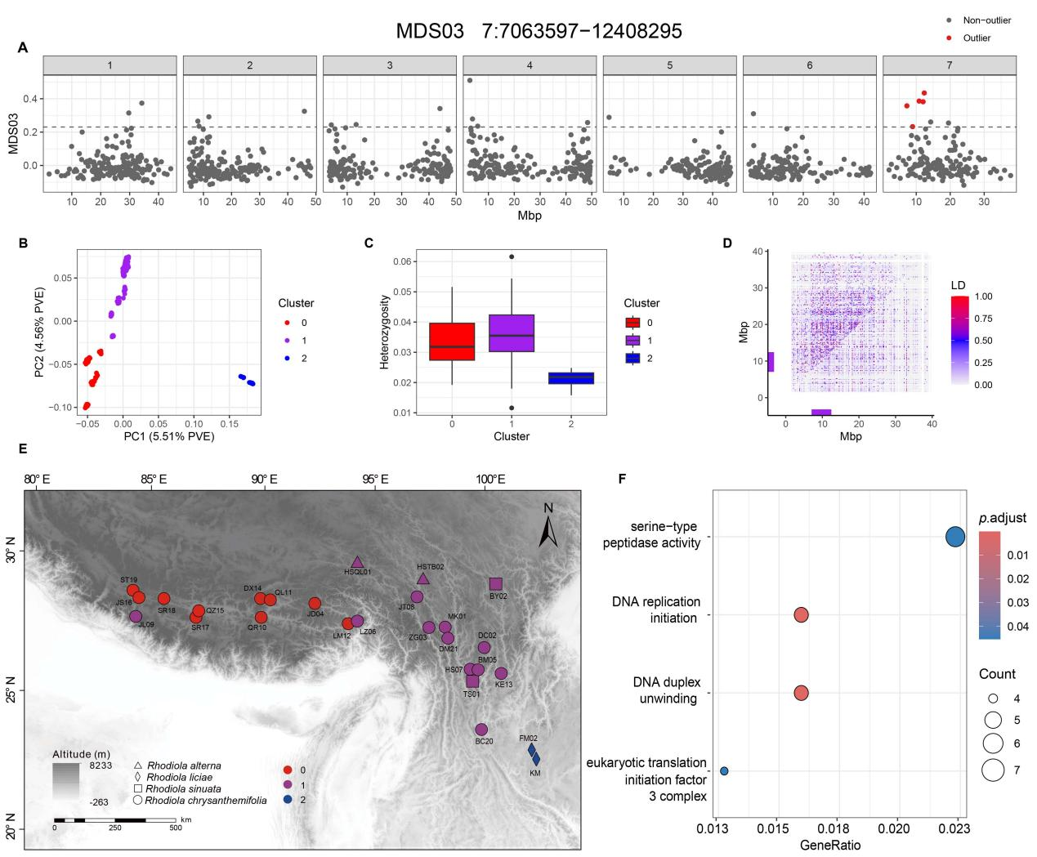

Figure S18. Inversion analyses for chromosomes 7 on MDS03.
(A) Genome plot of MDS values for 7 chromosomes of the reference genome on MDS03. Each dot represents a window of 1000 SNPs, with outlier windows in red. The dashed line indicats the outlier threshold for the positive direction of MDS03 as standard deviation plus three standard deviations. (B) PCA analysis based on SNPs within the identified outlier windows. 272 individuals were genotyped using k-means, with red and blue representing homozygotes and purple representing heterozygotes. (C) Heterozygosity calculation based on PCA genotyping. The one-way ANOVA statistic was F = 157.68 and P < 2.2e-16; the TukeyHSD showed that the cluster ‘1’ was significantly higher than the other two (0-1, P = 0.0143178, and 1-2, P = 0.0000000). (D) linkage disequilibrium (LD) plot for chromosome 7. Genotype R² values for all loci retained at one per 10,000 SNPs. The mapping window size was 200 kb and showed the second largest R². The triangle on the left shows the LD pattern for all individuals, and the triangle on the right shows the individuals that were homozygotes in the more common direction. The purple bar represents the presumed inversion. (E) Distribution of genotype in different populations of the putative inversion. Triangles represent R. alterna, diamonds represent R. liciae, squares represent R. sinuata, and circles represent R. chrysanthemifolia. Different color represents different genotypes, which were based on the k-means clustering in PCA. (F) GO enrichment analysis of genetic variants located on putative inversion.

Table S3. Characteristics of datasets used in this study
Datasets | No. of SNP | Filtration parameters | No. of sample
Dataset 0 | 52,983,624 | QD <2.0 || FS > 60.0 || MQ < 40.0 || SOR > 3.0 || MQRankSum < −12.5 || ReadPosRandSum < −8.0 | 276
Dataset 1 | 42,546,684 | Dataset 0 + mean coverage depth lower than 3 or higher than 150 | 276
Dataset 2 | 29,554,670 | Dataset 1 + --geno 0.75 --maf 0.01 | 276
Dataset 3 | 7,768,862 | Dataset 2 + --indep-pairwise 50 10 0.2 | 276
Dataset 4 | 311,824 | Dataset 3 + --geno 0 | 276
Dataset 5 | 1,093,033 | Dataset 1 + --geno 0 --maf 0.01 | 272

Table S5. Parameter revaluation and confidence intervals of the best differentiation scenarios

Model2_1 parameter | Best parameter | 95%HPD (Lower limit) | 95%HPD (Higher limit)
Ne (NA) | 2.10E+07 | 1.95E+05 | 2.88E+07
Ne (R. ch-Ⅱ) | 2.05E+06 | 1.49E+05 | 1.15E+07
Ne (R. ch-Ⅰ) | 3.60E+06 | 1.37E+06 | 9.52E+06
Ne (R. ch-Ⅲ) | 6.19E+06 | 8.47E+05 | 3.03E+07
Ne (R. li) | 9.09E+05 | 2.40E+05 | 2.62E+06
T3 | 5.37E+06 | 5.11E+05 | 8.59E+06
T2 | 3.41E+05 | 5.09E+04 | 1.14E+06
T1 | 2.95E+05 | 2.8E+04 | 5.19E+05
M31 | 6.96E-07 | 5.63E-12 | 1.09E-4
M32 | 1.46E-08 | 1.58E-12 | 5.67E-7
M13 | 1.56E-05 | 2.96E-10 | 1.23E-4
M23 | 1.71E-09 | 1.34E-12 | 3.04E-6

Table S14. Frequencies of the ‘1’ arrangement of the assumed inversions in Rhodiola sect. Trifida
Mds-coord | Estimated size (Mbp) | R. chr frequency | R. chr Ⅰ frequency | R. chr Ⅱ frequency | R. chr Ⅲ frequency | R. lic frequency | R. sin frequency
mds23-neg | 1.99 | 0.4 | 0.2 | 0.5 | 0.5 | 0.5 | 1
mds03-pos | 5.34 | 0.3 | 0.2 | 0.1 | 0.5 | 0.5 | 1

