SUPPORTING INFORMATION
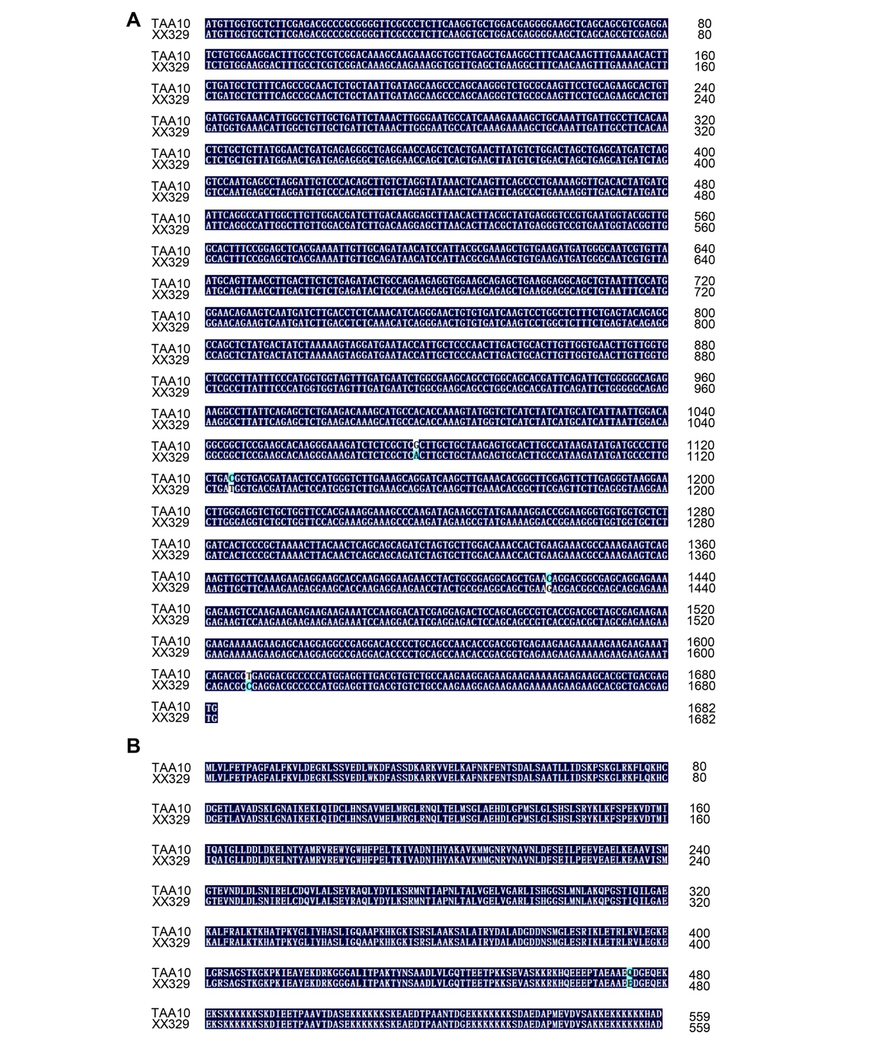
Figure S1 TaSED sequence variation between TAA10 and XX329. (A, B) Differences in the TaSED locus (A) and TaSED (B) between TAA10 and XX329.
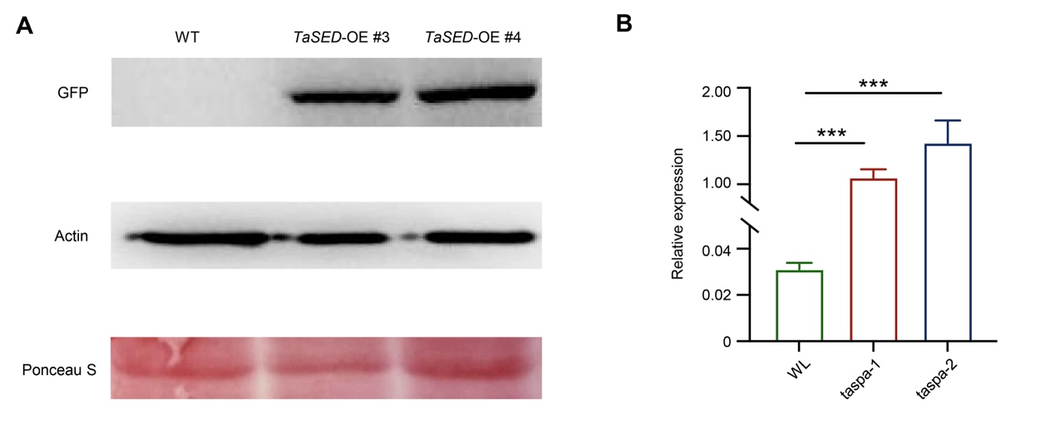
Figure S2 Identification of the TaSED overexpression lines. (A) Immunoblot analysis of TaSED protein expression in TaSED-OE lines. (B) RT-qPCR analysis of TaSED at 20 days after pollination (DAP) in TaSED-OE lines. Values are means ± standard deviation (SD) from three independent biological replicates. P values were determined using Student’s t test, ***P < 0.001.
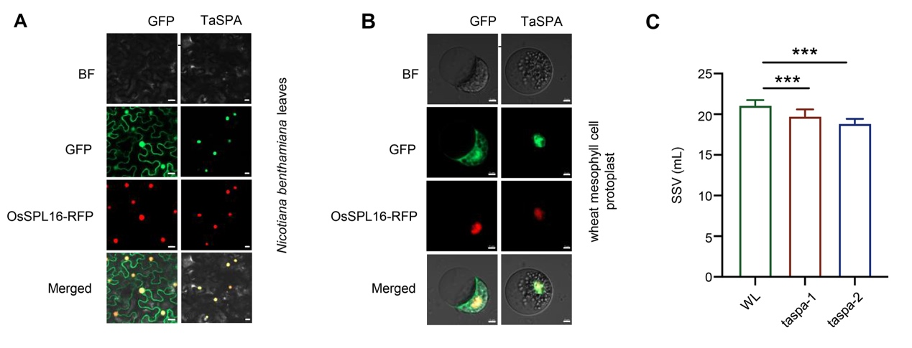
Figure S3 Subcellular localization of TaSPA and SDS-sedimentation volume (SSV) analysis of TaSPA transgenic lines. (A) Subcellular localization of TaSPA in Nicotiana benthamiana leaves. Scale bars, 20 μm. (B) Subcellular localization of the TaSPA in wheat mesophyll cell protoplast. Scale bars, 5 μm. (C) SSV for grains of the wild type (WT) and TaSPA transgenic lines at the mature stage. Values are means ± SD from independent biological replicates. P-values were determined using Student’s t test, ***P < 0.001.
.

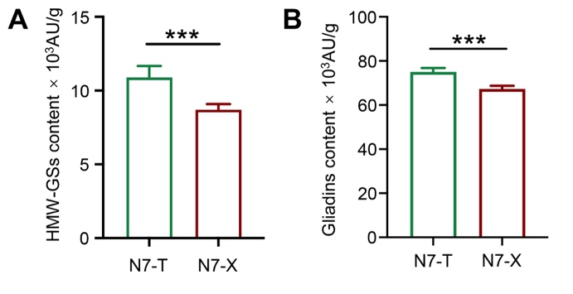
Figure S4 Quantification of high-molecular-weight glutenin subunit (HMW-GS) and gliadin contents in the progeny of N7 homozygous for the TAA10 or XX329 genotype at TaSED. Values are means ± SD from three independent biological replicates. P-values were determined using Student’s t test, *P < 0.05, ***P < 0.001.
Table S1 Information of evaluated environments
Table S2 Primers and sequences used in this study
Table S3 Stable QTLs for SSV identified in the TAA10 × XX329 RIL population
Table S4 Annotated genes in the interval between the molecular markers Xcau-2D497 and Xcau-2D3108
Table S5 The 346 accessions used for association analysis in this study

