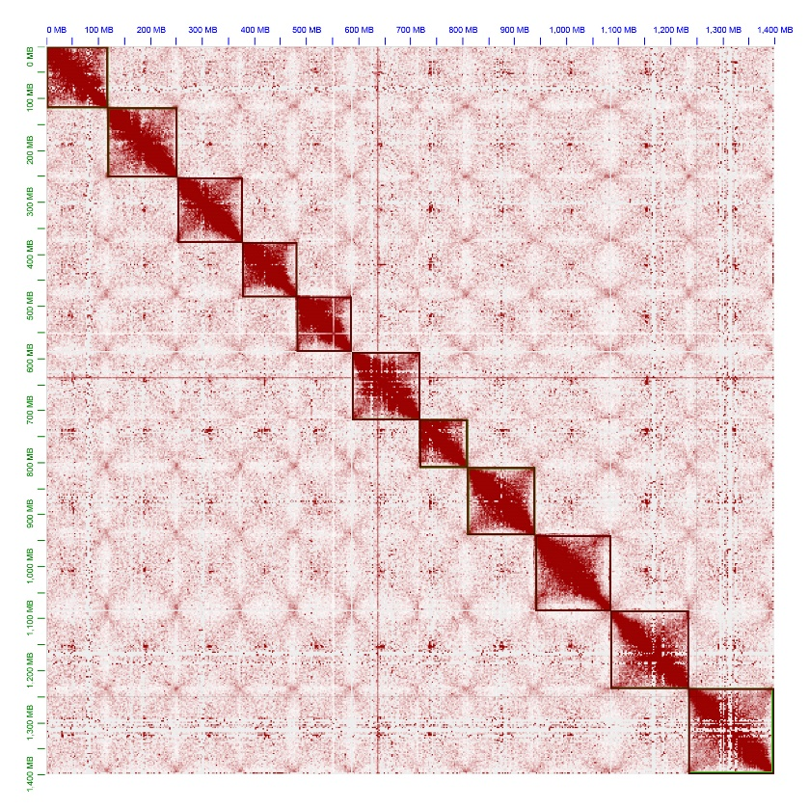
Figure S1. Hi-C chromatin interaction map of H. polyrhizus cv. ‘Dahong’.

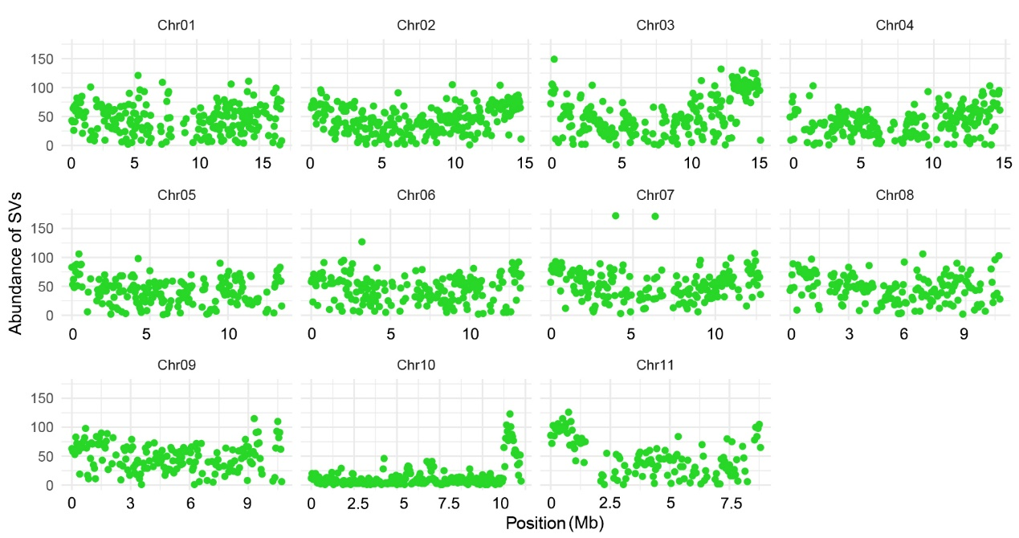
Figure S2. Abundance of structural variations (SVs) in H. stenopterus var. Honghuaqinglong genome.

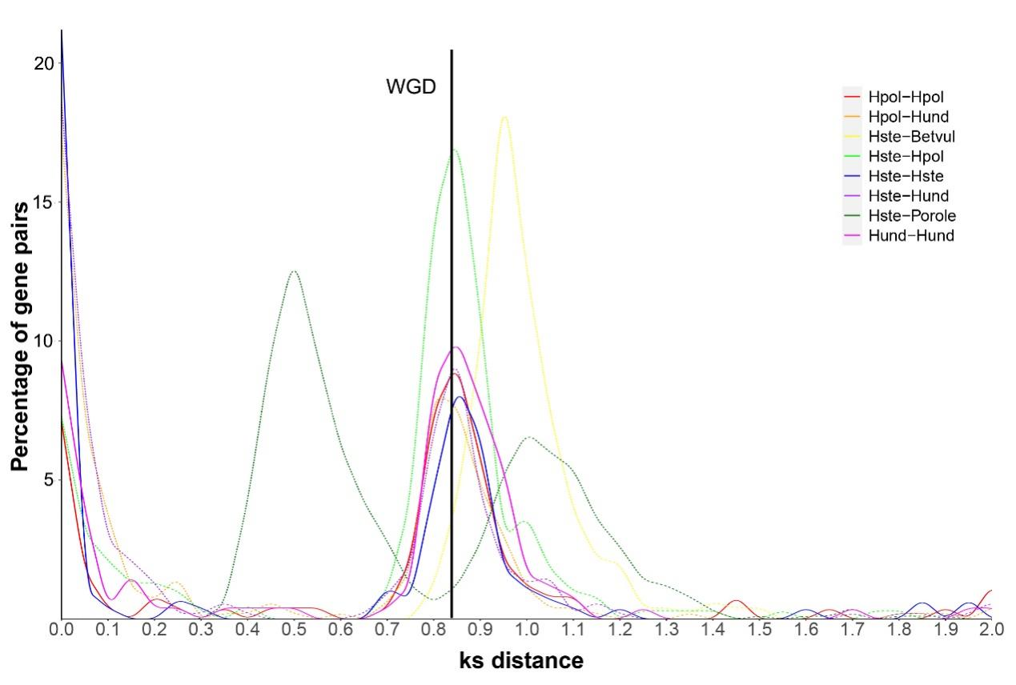
Figure S3. Synonymous substitutions per synonymous site (ks) plot of WGD events detection of Caryophyllales and Hylocereus species.
Hpol (H. polyrhizus), Hund (H. undatus), Betvul (Beta vulgaris), Hste (H. stenopterus) and Porole (Portulaca oleracea) were selected for WGD events detection.

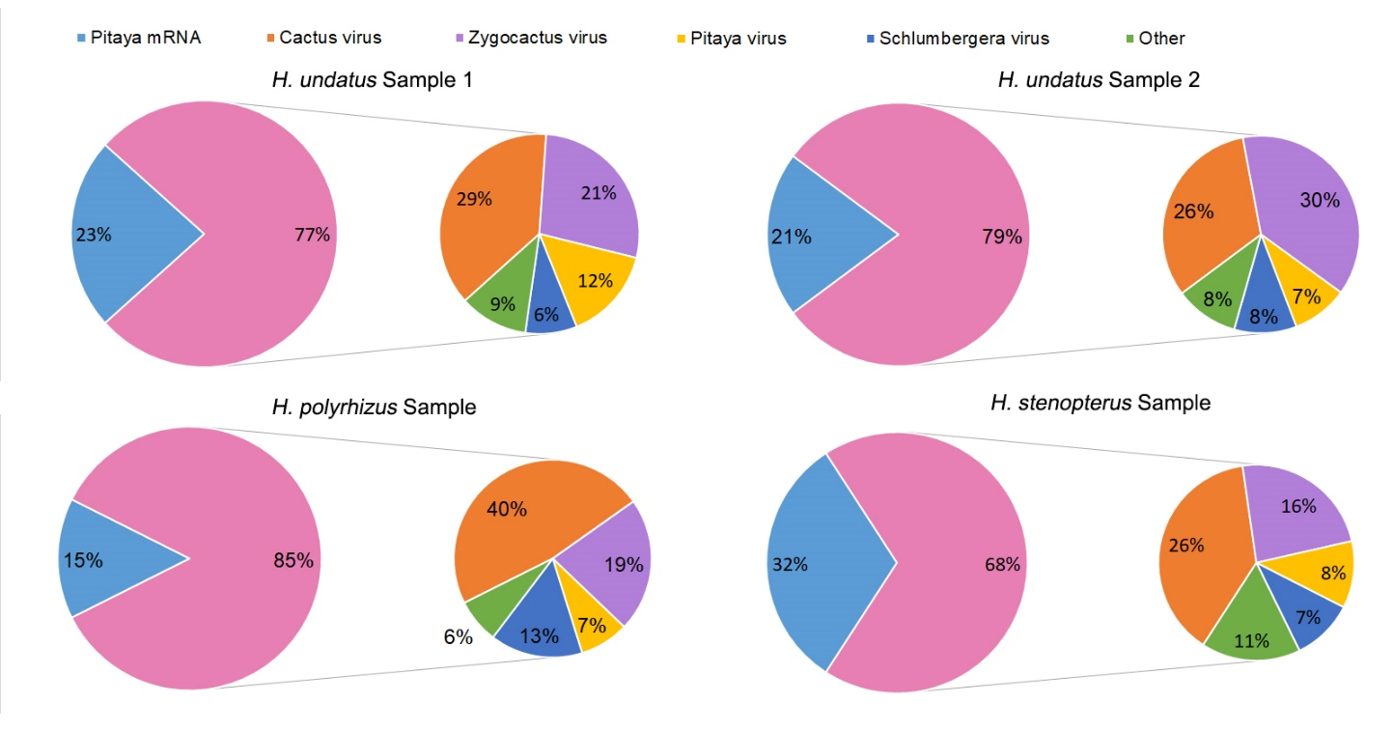
Figure S4. Virus contamination of four different pitaya samples.

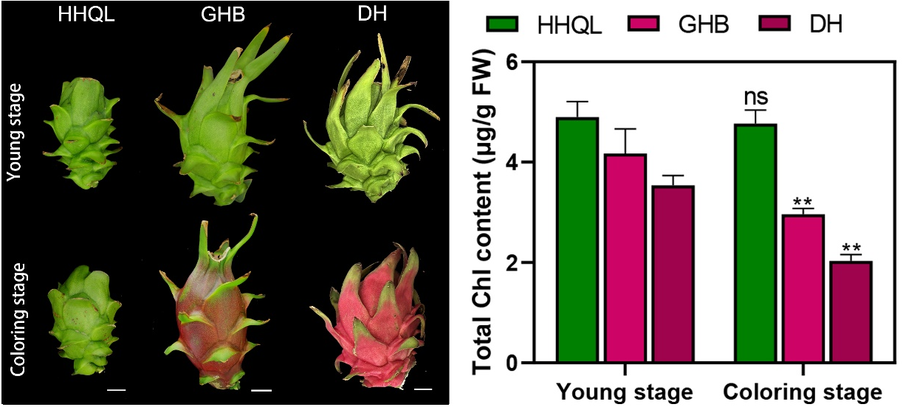
Figure S5. Phenotype and chlorophyll content of young- and coloring-stage peels of wild variety H. stenopterus var. Honghuaqinglong, H. undatus cv. ‘Guanhuabai’ and H. polyrhizus cv. ‘Dahong’ pitaya.

Figure S6. Phylogenetic analyses of HuERF72 with homolog proteins from Arabidopsis and other species.
(A) Phylogenetic analysis of HuERF72 from Arabidopsis. (B) Phylogenetic analyses of HuERF72, AtDREB1A (AT4G25490.1), AtDREB1B (AT4G25480.1), AtDREB1C (AT4G25470.1), AtDREB1D (AT5G51990.1), NtDREB1F (Nicotiana tabacum, XP_016448076.1), SlDREB1F (Solanum lycopersicum, XP_004228864.2), AmrDREB1B (Amaranthus tricolor, XP_057535376.1), SoDERB1F (Spinacia oleracea, XP_021846035.2) and BvDREB1B (Beta vulgaris, XP_010686196.2). (C) Amino acid sequences of 10 ERFs.

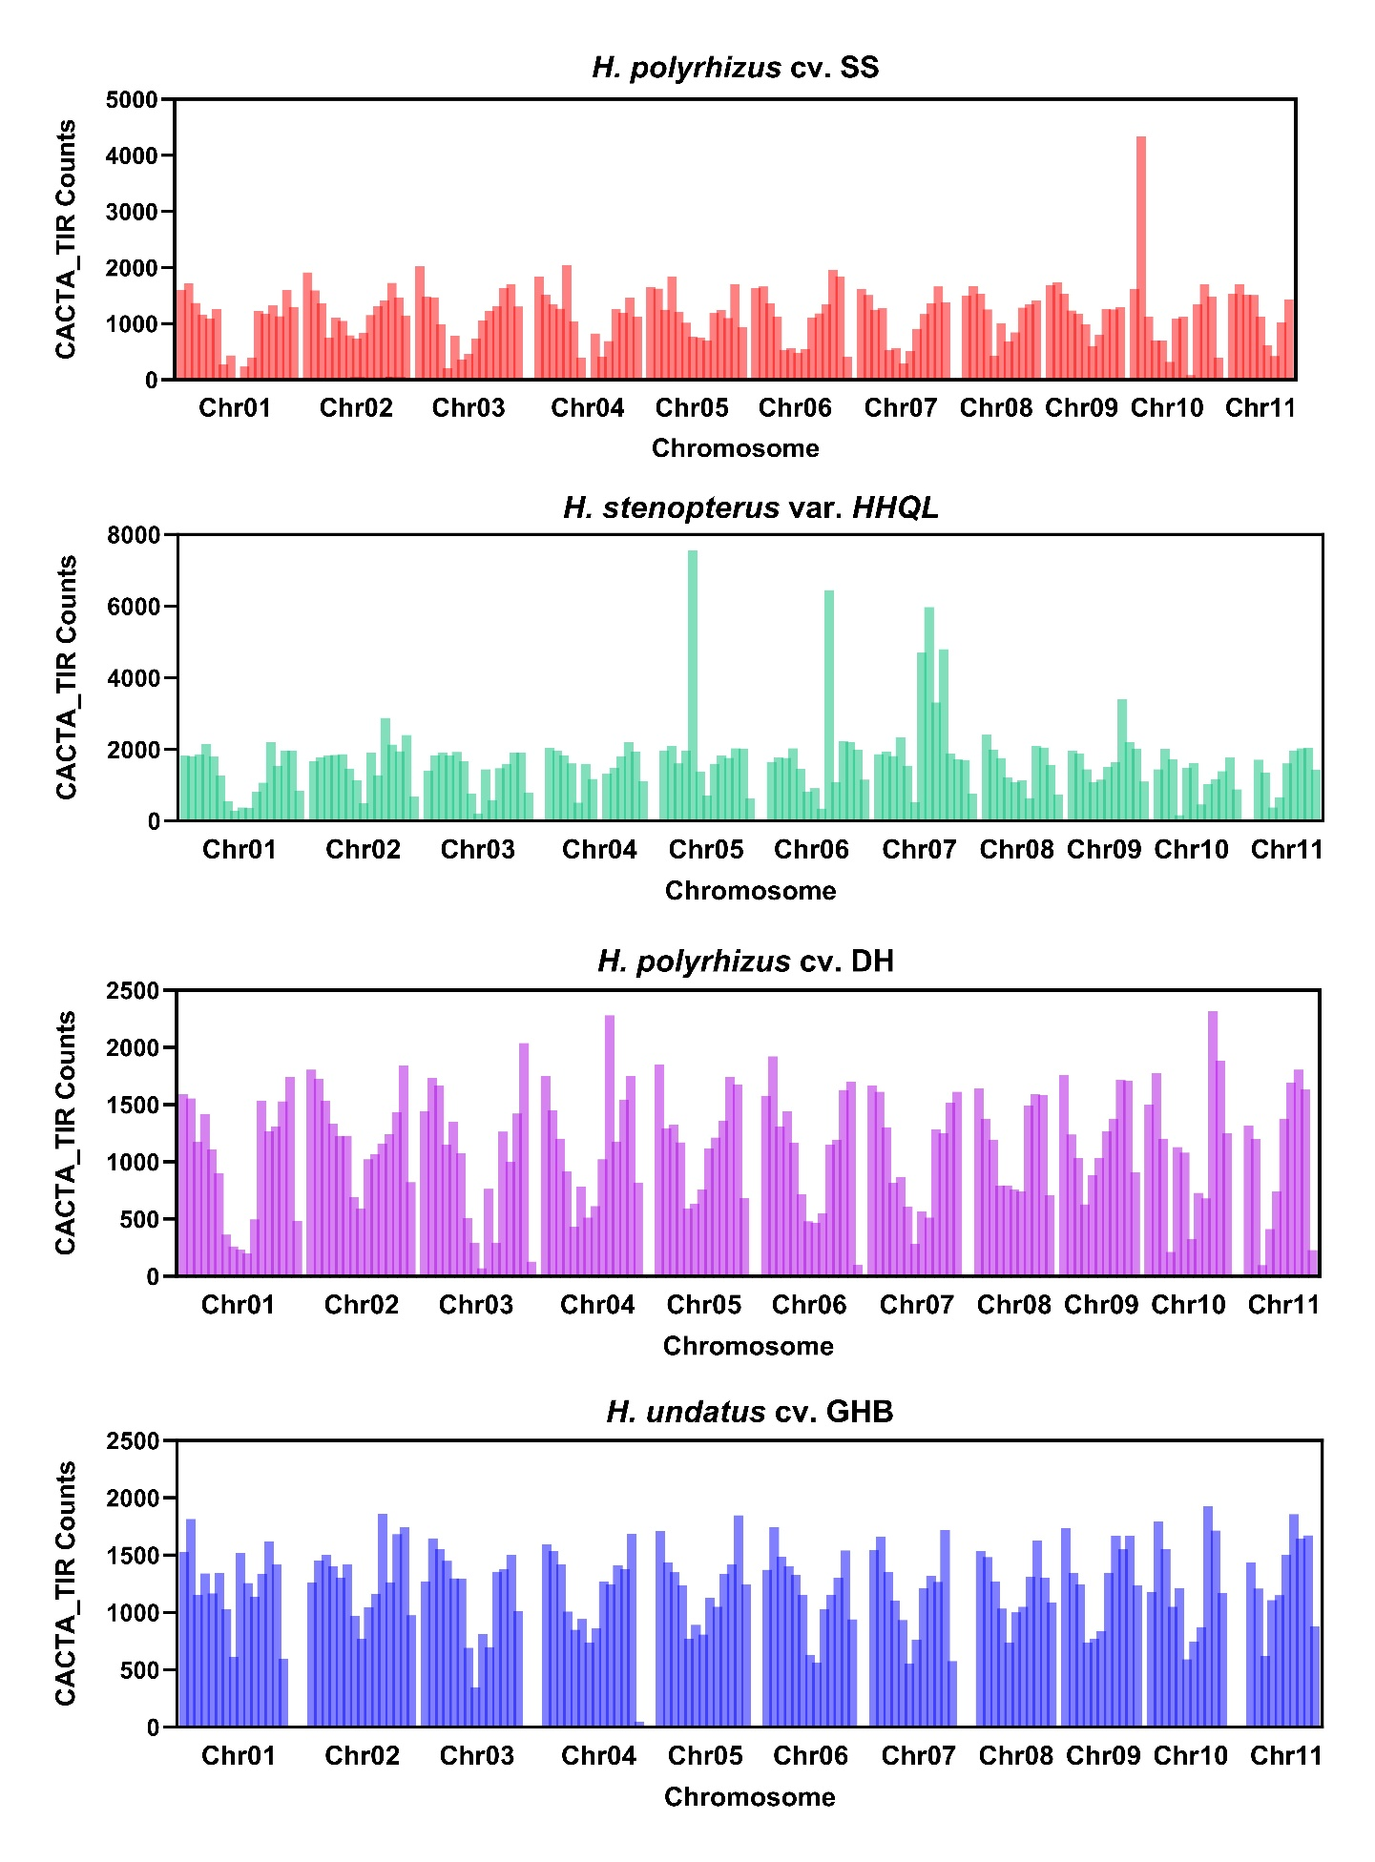
Figure S7. Abundance of CACTA_TIR transposons in four pitaya genomes.

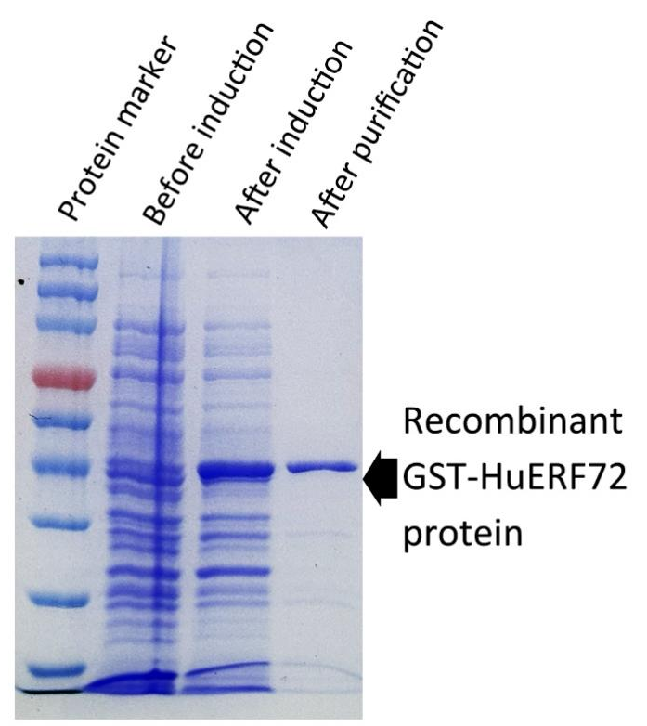
Figure S8. Purification of recombinant GST-HuERF72 protein.

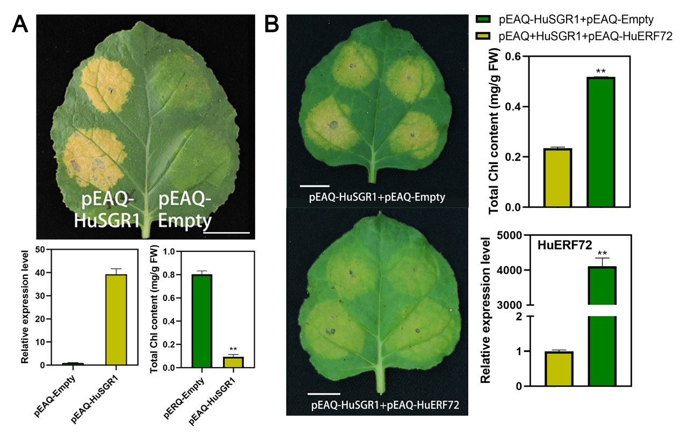
Figure S9. Functional verification of HuSGR1 and HuERF72 by transient expression in N. benthamiana leaves.
(A-B) The phenotype, chlorophyll content and expression levels of N. benthamiana leaves overexpressed pEAQ-HuSGR1 (A) and pEAQ-HuSGR1+pEAQ-HuERF72 (B).

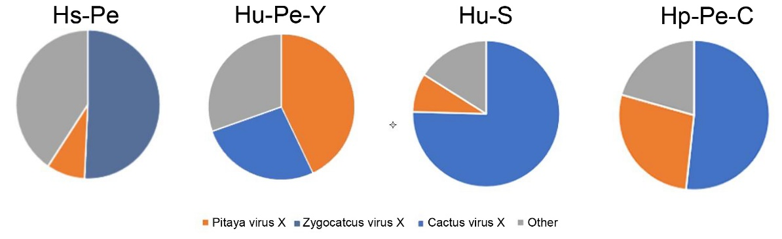
Figure S10. The distribution of unmapped reads in purified pitaya transcriptomes of different tissues and species.
Hs-Pe: H. stenopterus peels at mature stage; Hu-Pe-Y: H. undatus peels at young stage; Hu-S: H. undatus stems; Hp-Pe-C: H. polyrhizus peels at coloring stage.

