Supplemental figures
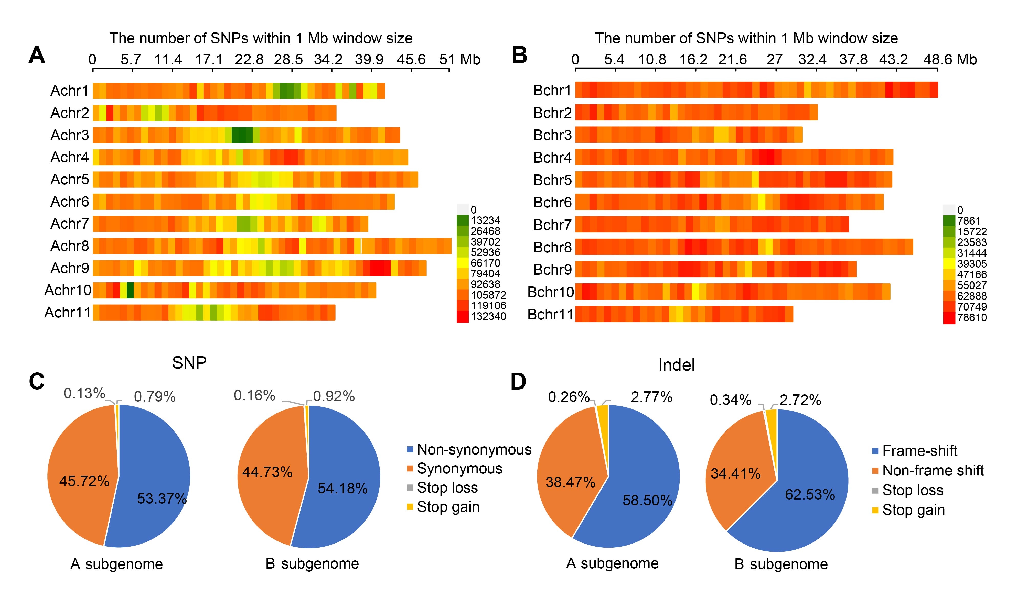 Figure S1. Genome-wide distribution and annotation of SNPs and InDels.
(A, B) SNP density across the 11 chromosomes in the A (A) and B subgenomes (B). (C, D) Functional classification of genome-wide SNPs (C) and InDels (D), showing the proportion of variants in each functional category.

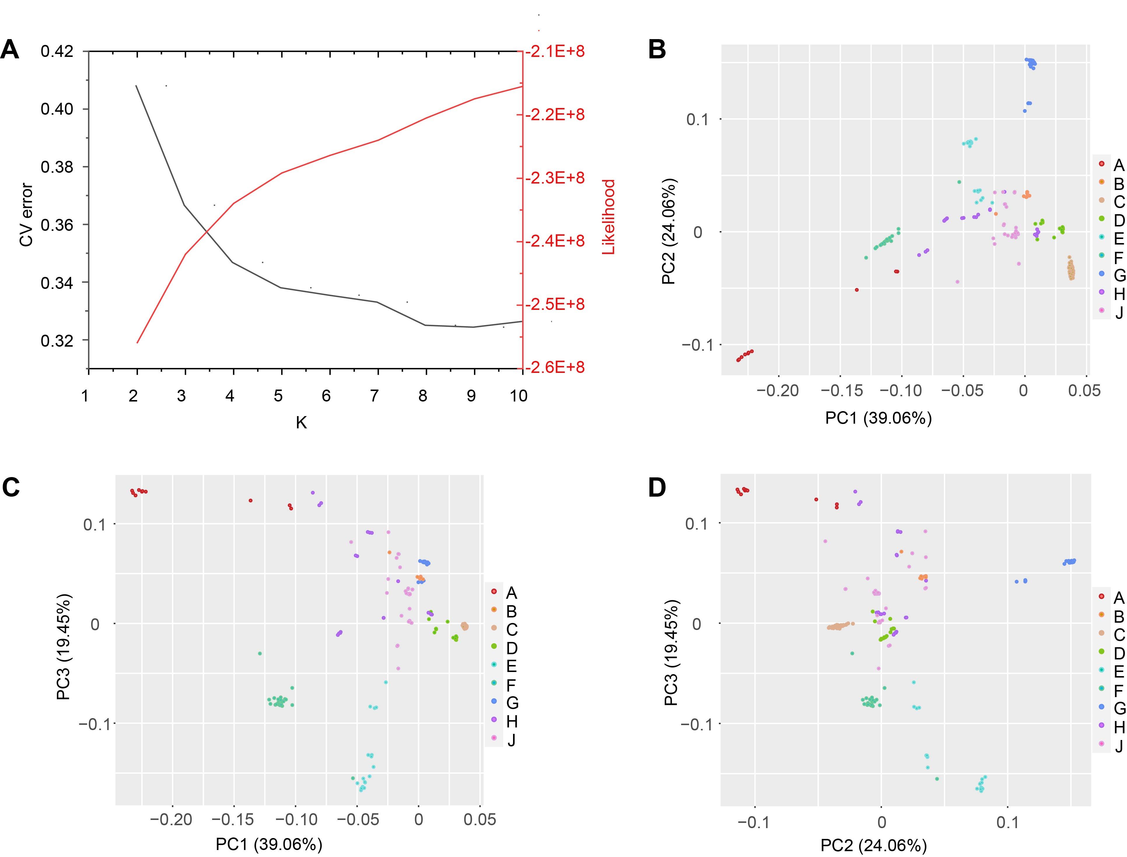
Figure S2. Population structure and principal component analysis (PCA) of banana accessions.
(A) Estimation of optimal ancestral populations based on cross-validation (CV) error and likelihood scores for different K values. (B–D) PCA plots depicting the top three principal components of genetic variation among accessions based on genome-wide SNP data.

Figure S3. Subgroup-specific linkage disequilibrium (LD) decay.
LD decay curves calculated across nine genetic subgroups with a distance threshold of 50 Mb. Colors correspond to subgroup identities.

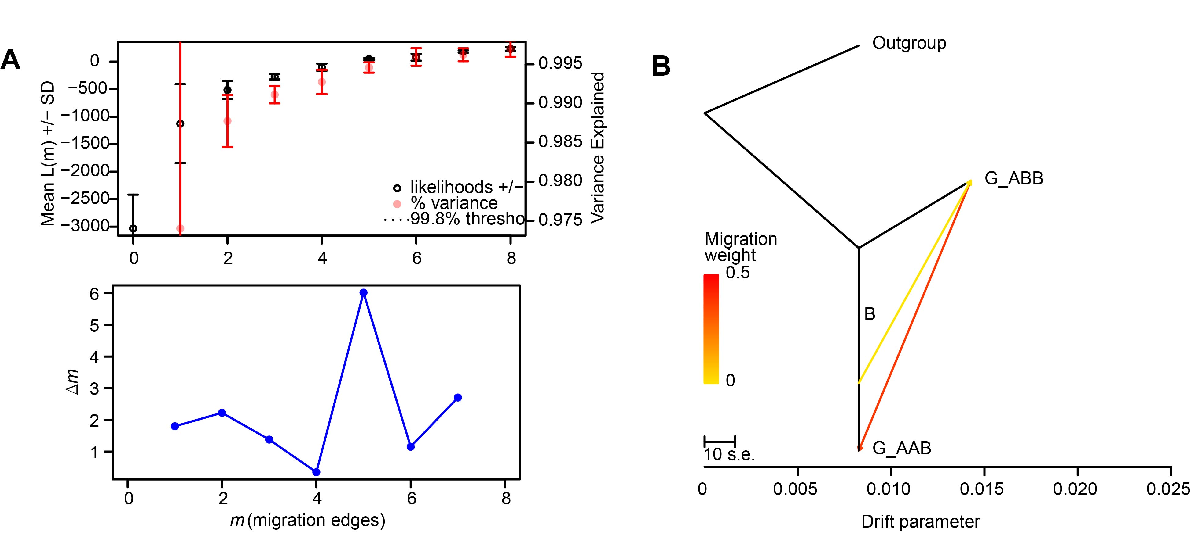
Figure S4. Gene flow analysis among banana population subgroups.
(A) TreeMix analysis showing gene flow among subgroups with five migration edges (m = 5) based on the A subgenome. (B) Directional gene flow detected between subgroup B and ABB/AAB genotypes within subgroup G.

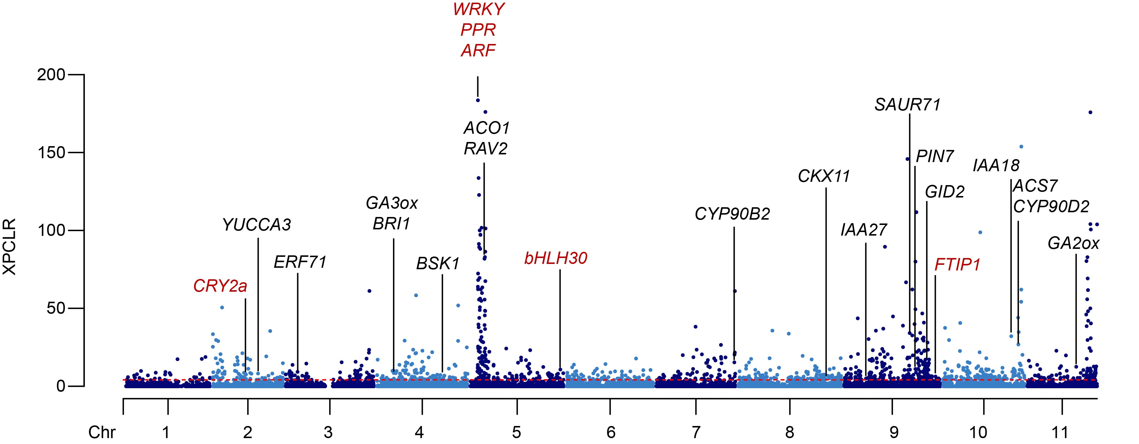
Figure S5. Selective sweep analysis identifying hormone-related candidate genes.
Genome-wide XP-CLR analysis between dwarf and tall banana accessions reveals selective sweeps enriched in hormone biosynthesis and signaling genes.

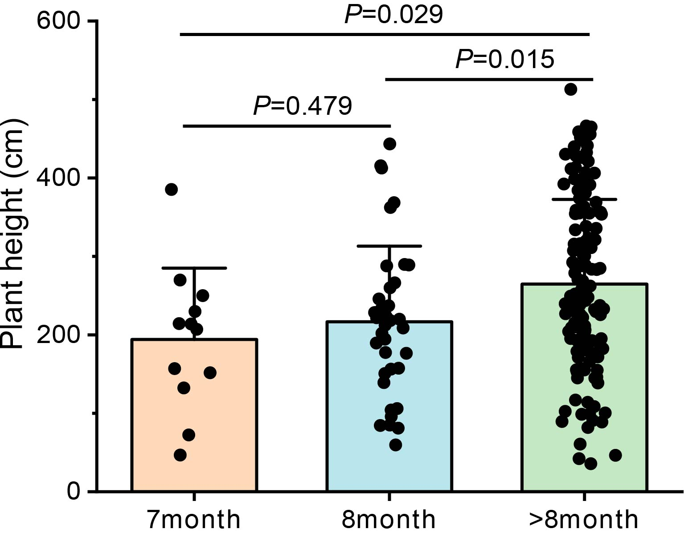
Figure S6. Correlation between plant height and flowering time.
Box plots comparing plant height across accessions grouped by flowering time.

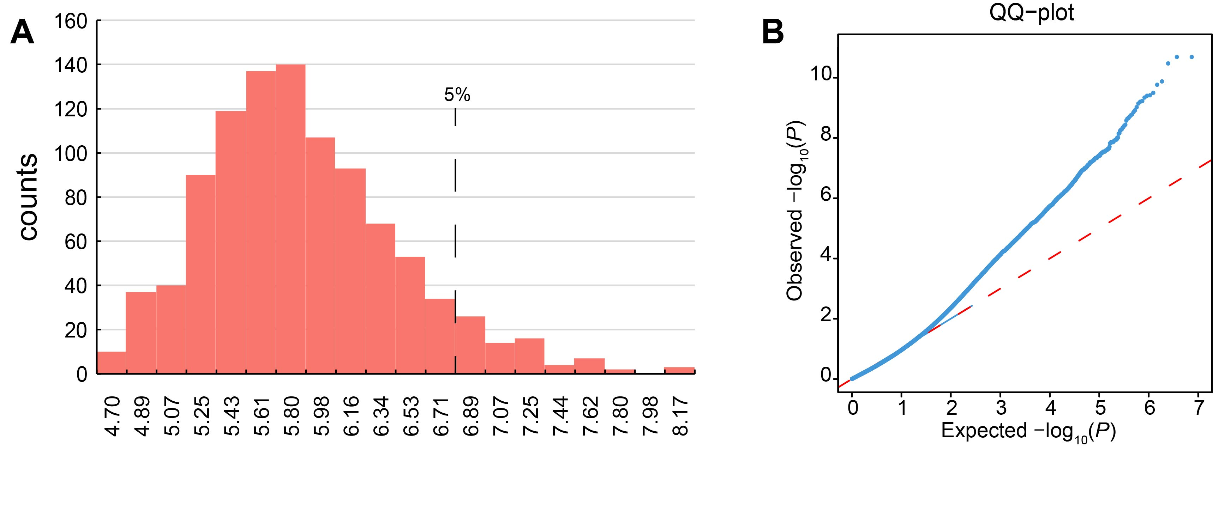
Figure S7. GWAS threshold determination and normality test in GWAS.
(A) Permutation-derived significance threshold distribution. (B) Quantile-Quantile (QQ) plot comparing observed and expected P-values from GWAS.

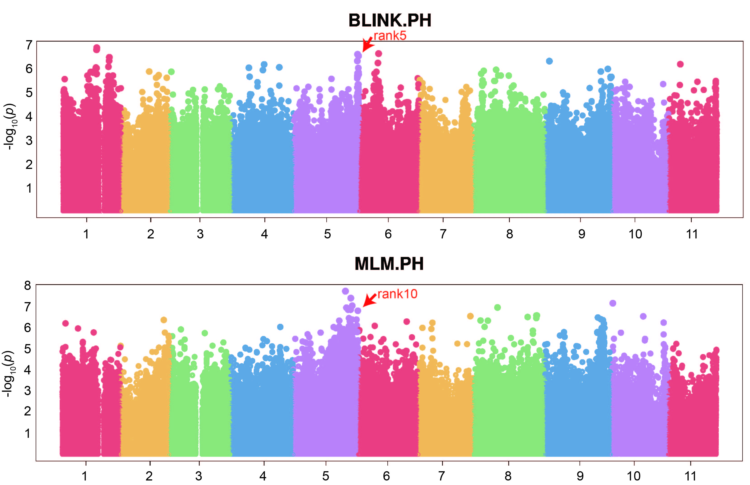
Figure S8. GWAS validation of the MabHLH30 locus using alternative models.
Significant SNP (chr05:46,248,991) identified by both the Bayesian-information and Linkage-disequilibrium Iteratively Nested Keyway (BLINK) model and Mixed Linear Model (MLM), located 59.52 kb upstream of MabHLH30.
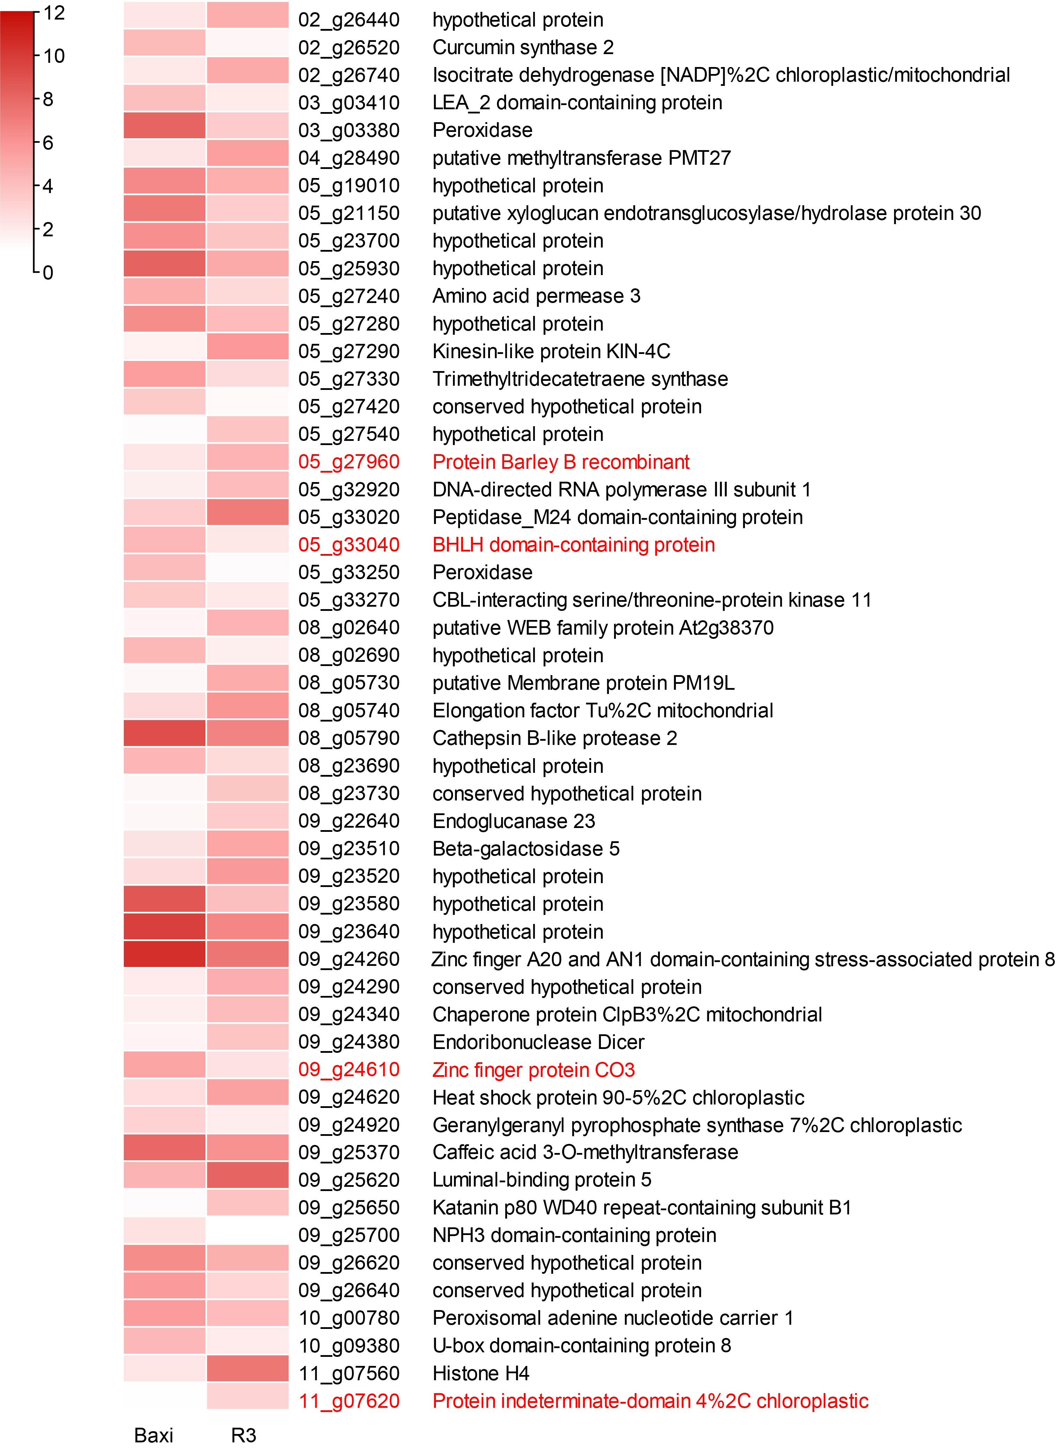
Figure S9. Expression heatmap of 51 genes overlapping GWAS, XP-CLR, and RNA-seq datasets.
Genes are categorized by function and clustered based on expression in ‘Baxi’ vs. ‘R3’, with transcription factors associated with plant growth and development depicted in red.

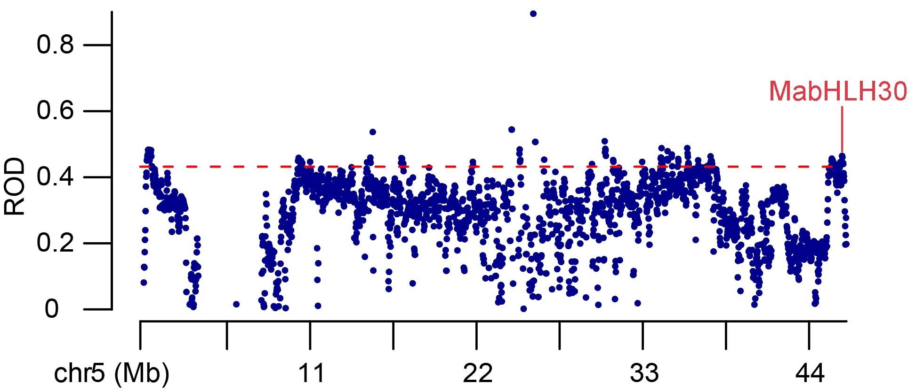
Figure S10. Reduction of diversity (ROD) analysis surrounding MabHLH30.
Selective signal plotted across chr5, with MabHLH30 marked in red. The dashed line indicates the 5% genome-wide threshold.

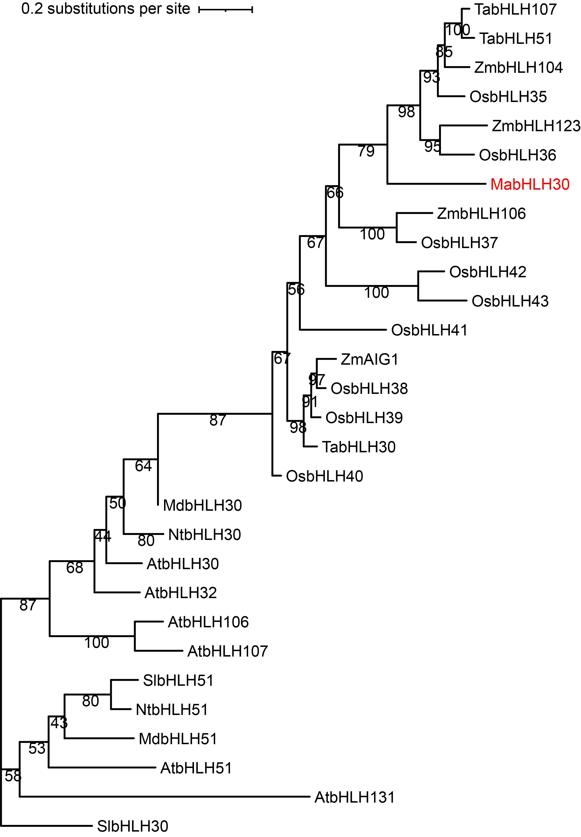
Figure S11. Phylogenetic relationships between MabHLH30 and its homologous genes. The phylogenetic tree was generated using encoding sequences of MabHLH30 and its homologous genes from Malus domestica (Md), Nicotiana tabacum (Nt), Solanum lycopersicum (Sl), Oryza sativa (Os), Triticum aestivum (Ta), and Zea mays (Zm).

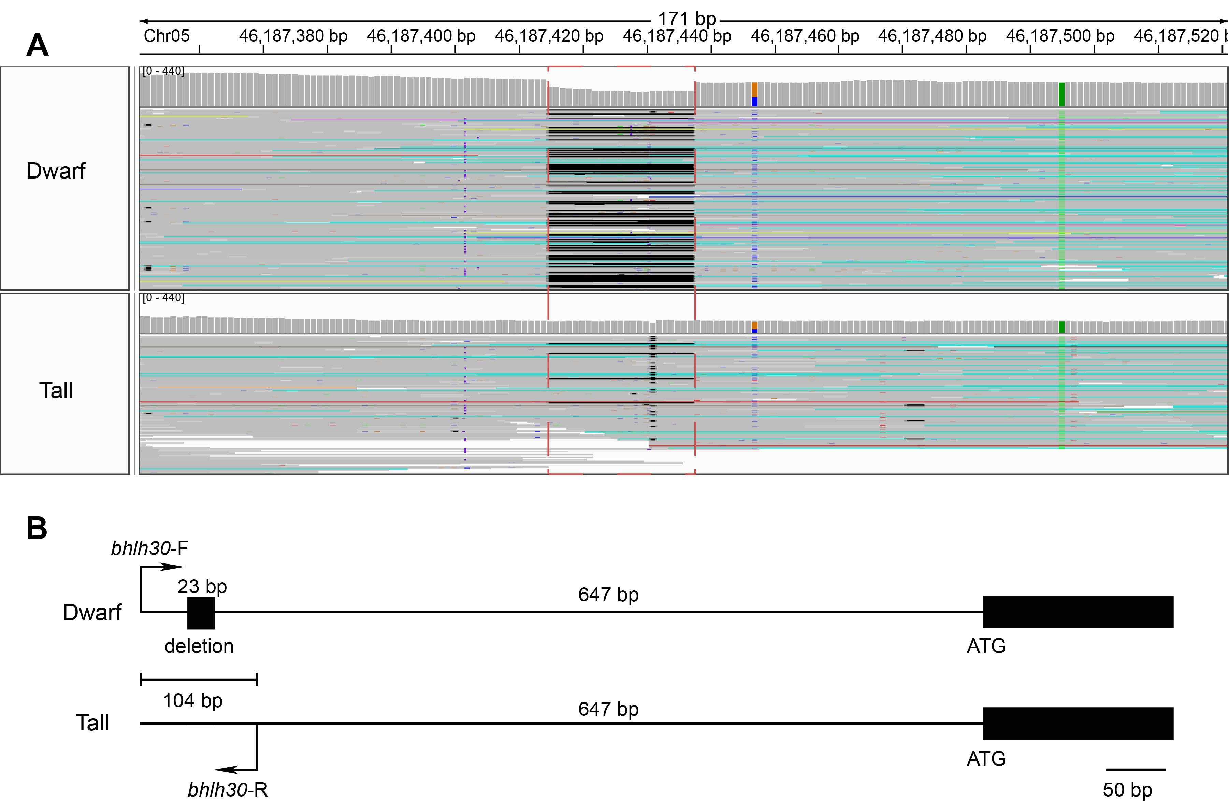
Figure S12. Structural variation in the MabHLH30 promoter region. (A) IGV visualization of a 23-bp deletion upstream of the MabHLH30. (B) PCR validation of the deletion in dwarf vs. tall accessions.

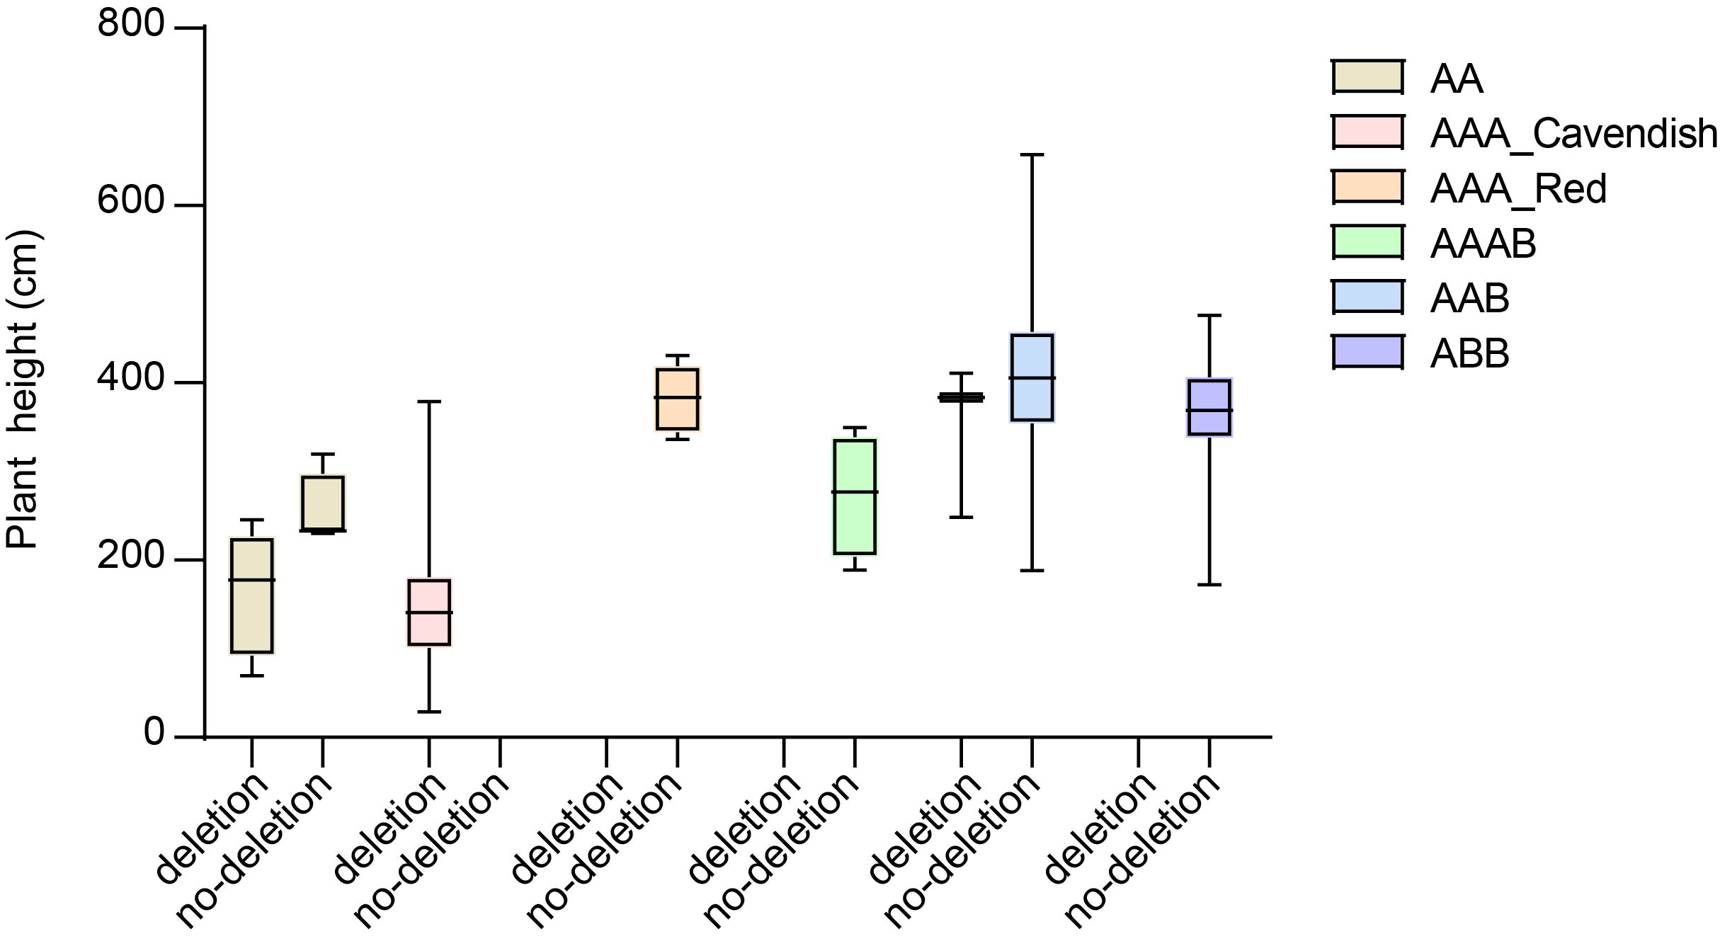
Figure S13. Effect of the 23-bp deletion on plant height across genotypes AA, AAA_Cavendish, AAA_Red, AAAB, AAB, and ABB.

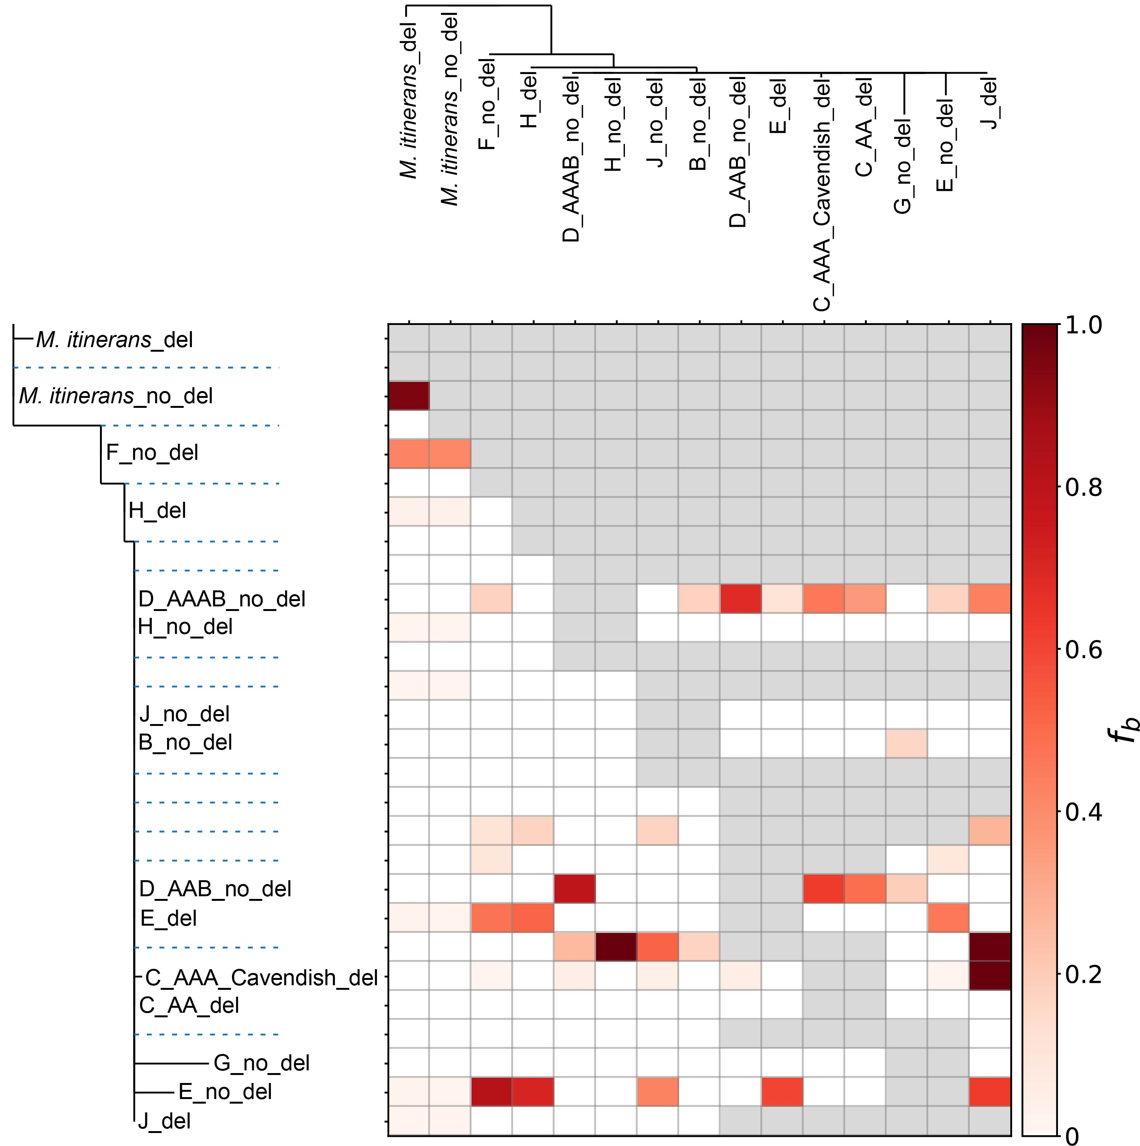
Figure S14. Genome-wide f-branch statistics from Dsuite, used to infer gene infiltration sources for AAA_Cavendish. Darker colors in the heatmap represent stronger gene flow between subgroups.

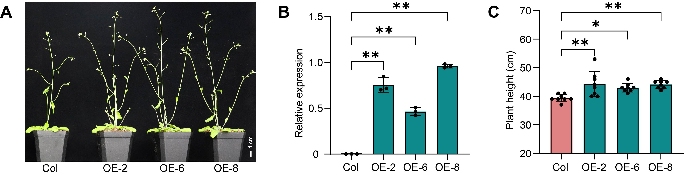
Figure S15. Overexpression of MabHLH30 increases plant height in Arabidopsis.
(A) Growth phenotypes of Col-0 wild type and transgenic lines (OE-2, OE-6, OE-8). Scale bars, 1 cm. (B) Relative expression levels of MabHLH30 in Col and overexpression plants. Data are presented as mean ± SD (n = 3). P values were calculated using a two-tailed Student’s t test. The asterisks indicate significant differences (**p<0.01). (C) Comparison of plant height between Col and overexpression plants. Data are presented as mean ± SD (n = 8). P values were calculated using a two-tailed Student’s t test. The asterisks indicate significant differences (*p<0.1, **p<0.01).

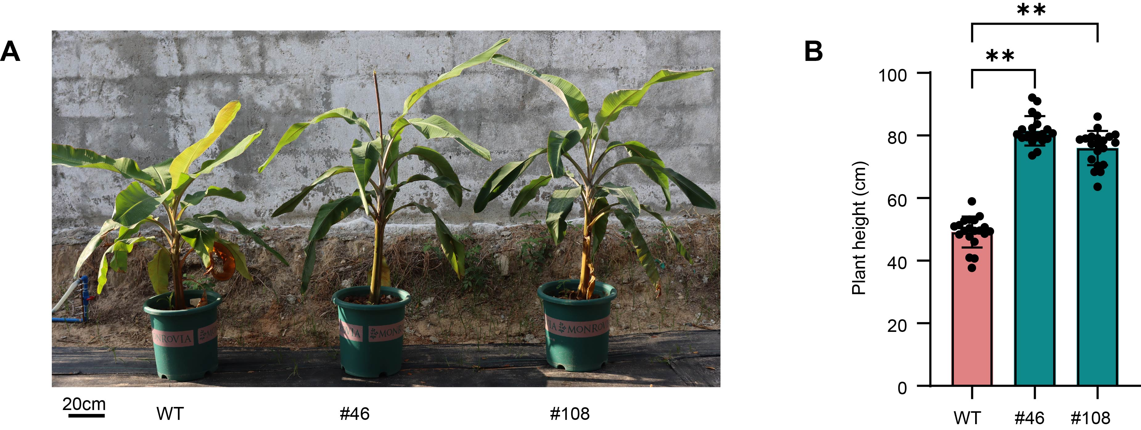
Figure S16. Overexpression of MabHLH30 enhances banana plant height in banana under field conditions in Sanya.
(A) Phenotypes of MabHLH30 overexpression (OE) lines (#46, #108) and wild-type (WT) plants grown in Sanya (n = 20). Scale bar, 20 cm. (B) Quantification of plant height in OE and WT plants. Data are presented as mean ± SD. P values were calculated using a two-tailed Student’s t test. Asterisks indicate significant differences (**P < 0.01).
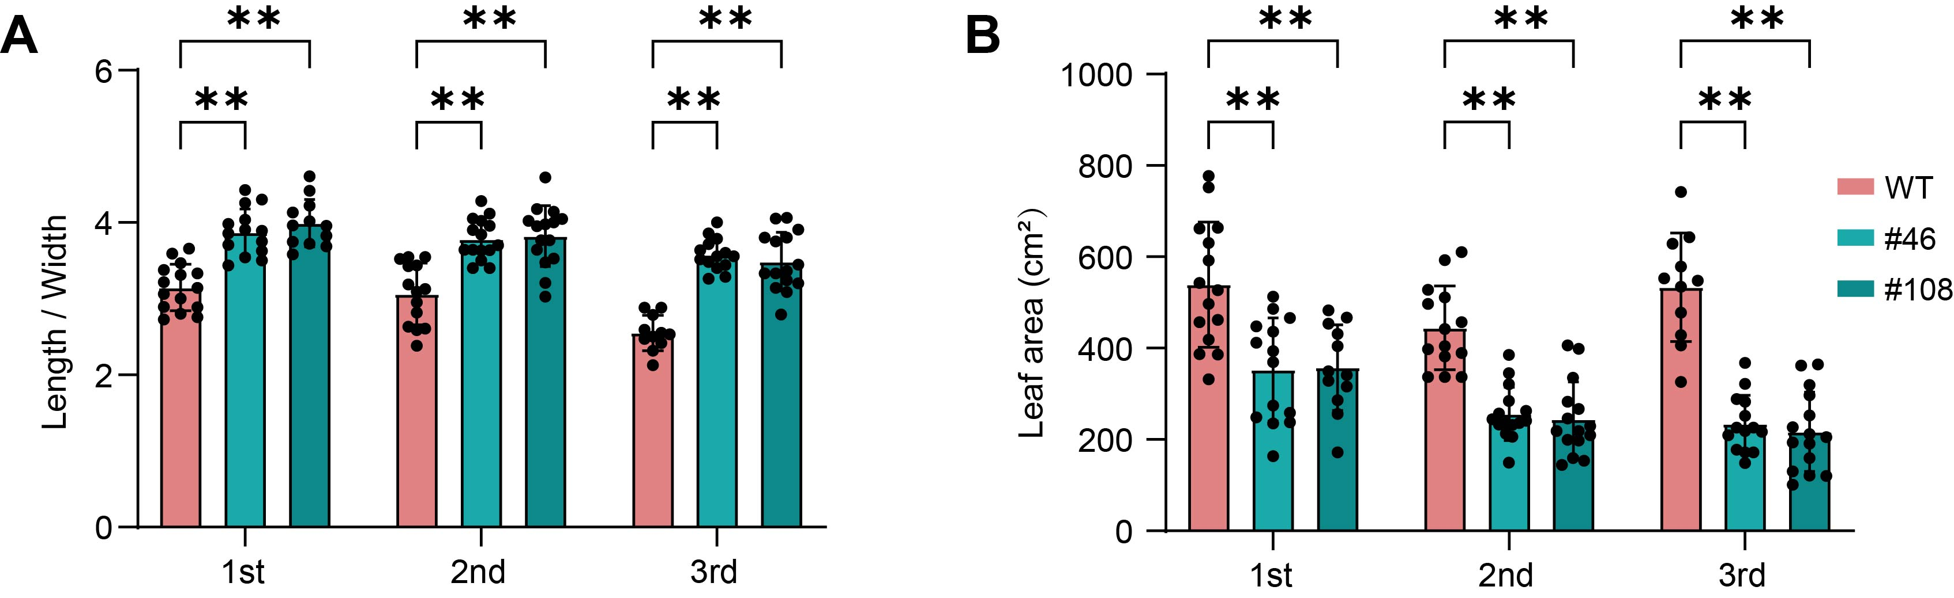
Figure S17. Effects of MabHLH30 on leaf morphology.
Comparison of the leaf length-to-width ratio (A) and leaf area (B) between WT and OE lines (n > 12). Data are presented as mean ± SD. P values were calculated using a two-tailed Student’s t test. The asterisks indicate significant differences (**p<0.01).

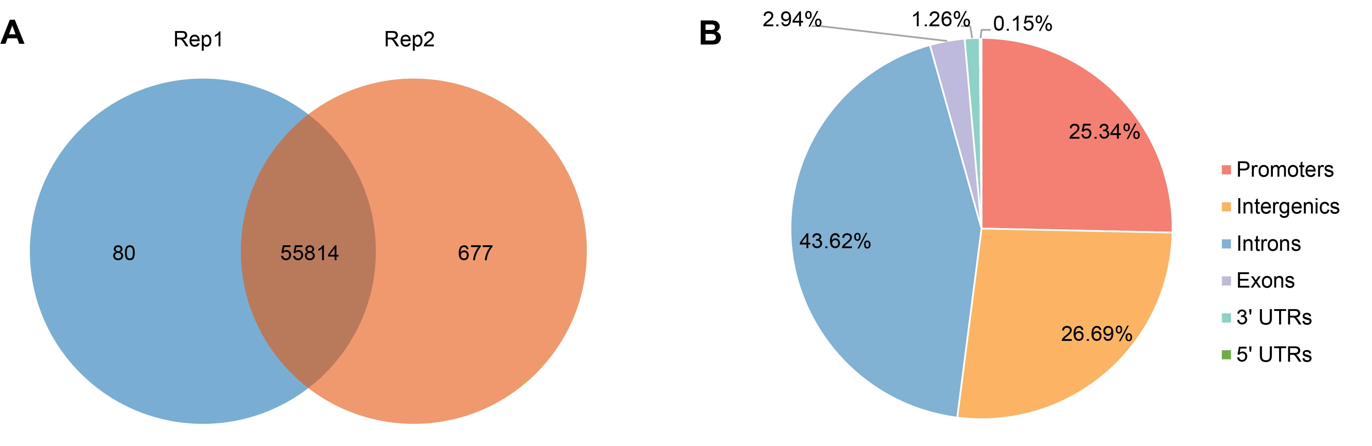
Figure S18. Genome-wide identification of MabHLH30 binding sites using DAP-seq.
(A) Number of binding peaks detected in two biological replicates. (B) Distribution of MabHLH30 binding sites across genomic features.
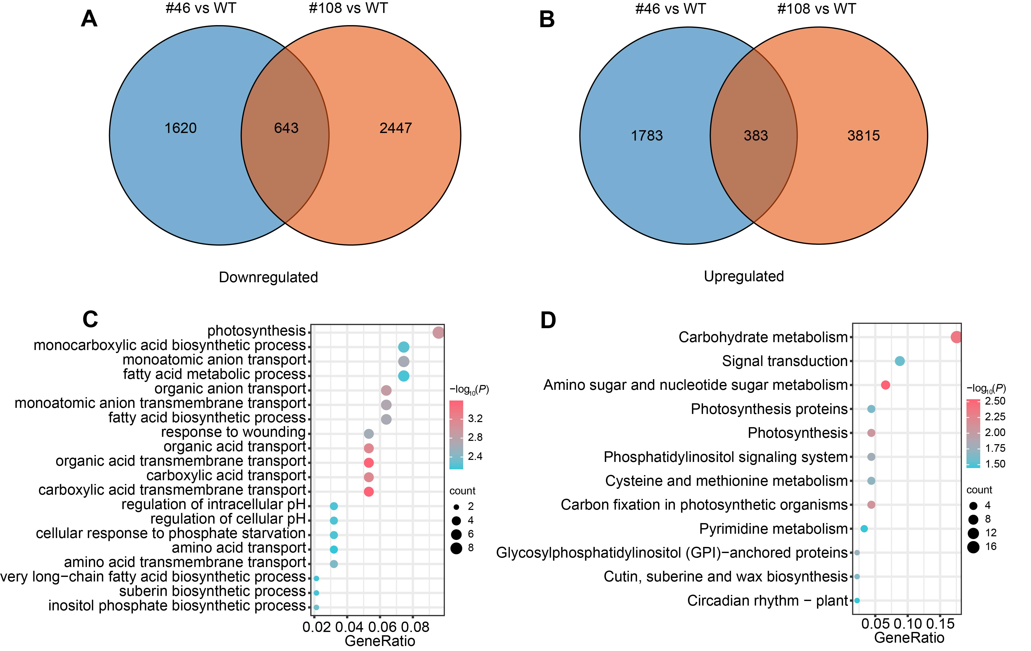
Figure S19. Differentially expressed genes (DEGs) in MabHLH30 overexpression lines compared to wild type.
(A) Venn diagram showing the overlap of significantly downregulated genes in two MabHLH30 overexpression lines (#46 and #108) relative to WT plants. (B) Venn diagram showing the overlap of significantly upregulated genes in lines #46 and #108 relative to WT. (C) Top enriched GO terms of MabHLH30-regulated genes. (D) Top enriched KEGG terms of MabHLH30-regulated genes.
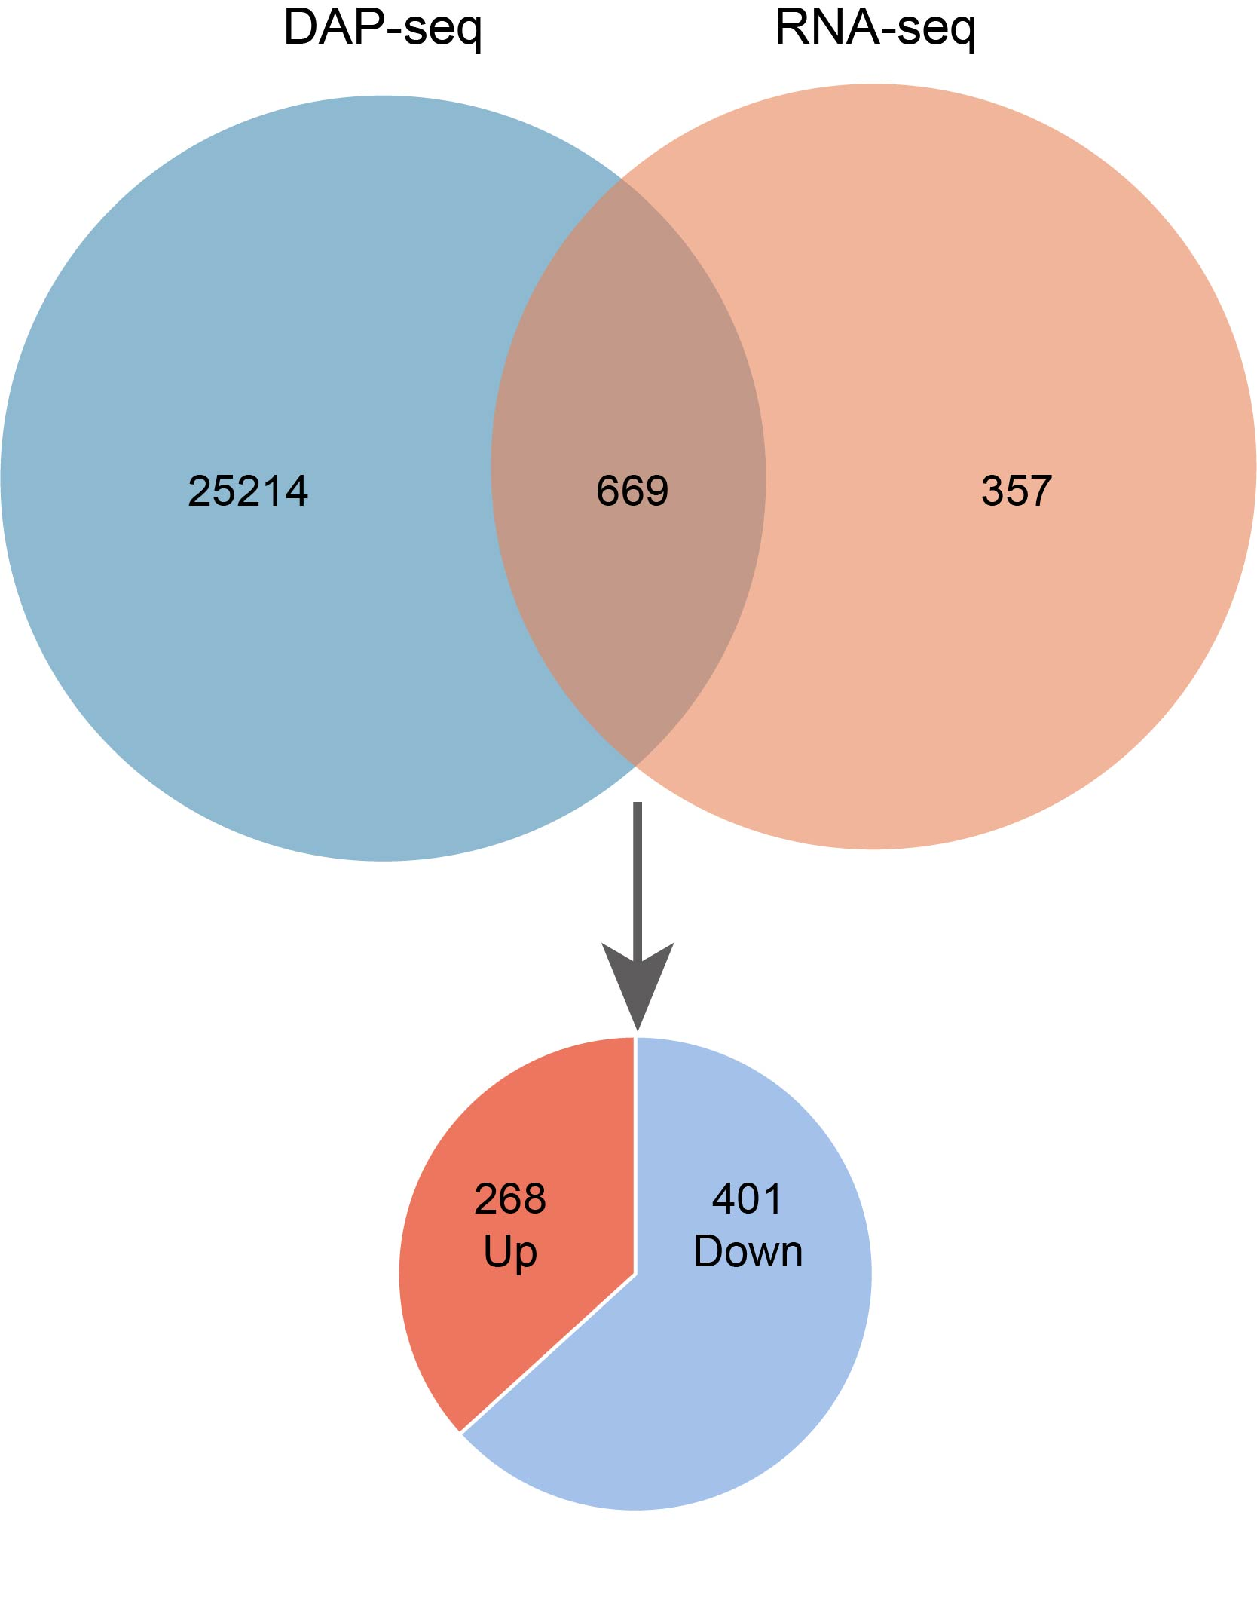
Figure S20. Integration of DAP-seq and RNA-seq identifies direct MabHLH30 targets. Venn diagram illustrating the overlap between MabHLH30-bound genes identified by DAP-seq and DEGs from RNA-seq. The pie chart classifies the direct targets into upregulated and downregulated categories based on RNA-seq results.

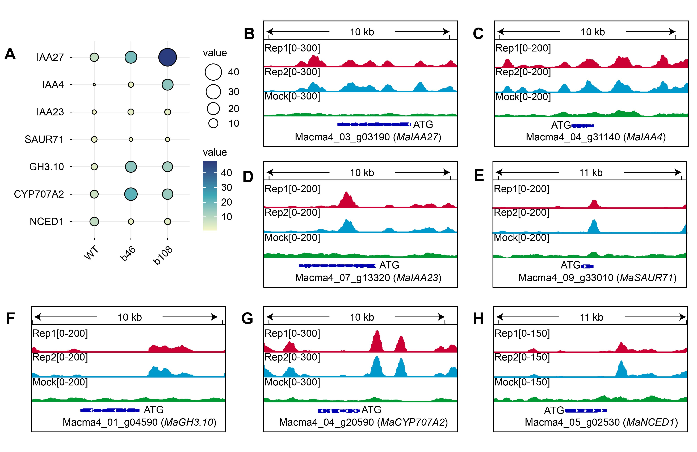
Figure S21. Regulatory effects of MabHLH30 on hormone-related target genes.
(A) Heatmap expression changes in hormone pathway genes. (B–H) DAP-seq signal tracks showing MabHLH30 binding at target loci, including MaIAA27, MaIAA4, MaIAA23, MaSAUR71, MaGH3.10, MaCYP707A2, and MaNCED1.

