Supporting Information
Figure S1. A maximum likelihood phylogeny of Aspidistra inferred from IQ-TREE based on dataset6.
Figure S2. A phylogeny of Aspidistra inferred from ASTRAL-III based on dataset6.
Figure S3. A phylogeny of Aspidistra inferred from SVDQuartets based on dataset6.
Figure S4. Phylogenies of Aspidistra inferred from different datasets and methods.
Figure S5. The Robinson–Foulds (RF) distances among different phylogenies estimated from different methods and datasets.
Figure S6. Chronogram of Aspidistra estimated by Bayesian method using the 100 most clock-like genes selected from dataset6.
Figure S7. 95% credible set of speciation rate shifts in Aspidistra estimated in BAMM.
Figure S8. ClaDS-estimated speciation rates across the phylogeny, alongside mapped morphological and habitat characters for each species.
Figure S9. Results of diversification analysis with episodic birth–death model implemented in CoMET.
Figure S10. The 18 models on individual or multiple direct or indirect effects of abiotic and biotic factors on speciation rates depicted as directed acyclic graphs.
Figure S11. The best-fitting model from phylogenetic path analysis using the tip speciation rates estimated by BAMM.
Figure S12. The best-fitting model from phylogenetic path analysis using the tip speciation rates estimated by ClaDS.
Figure S13. Ancestral state reconstruction of pistil shape, corolla color, stem habit and soil habitat in Aspidistra.
Figure S14. Diagnostic plots for Stacks de novo assembly.
Figure S15. A flow chart of procedures for different datasets assembly.
Figure S16. Scatter plot of the first three principal components derived from 19 bioclimatic variables.

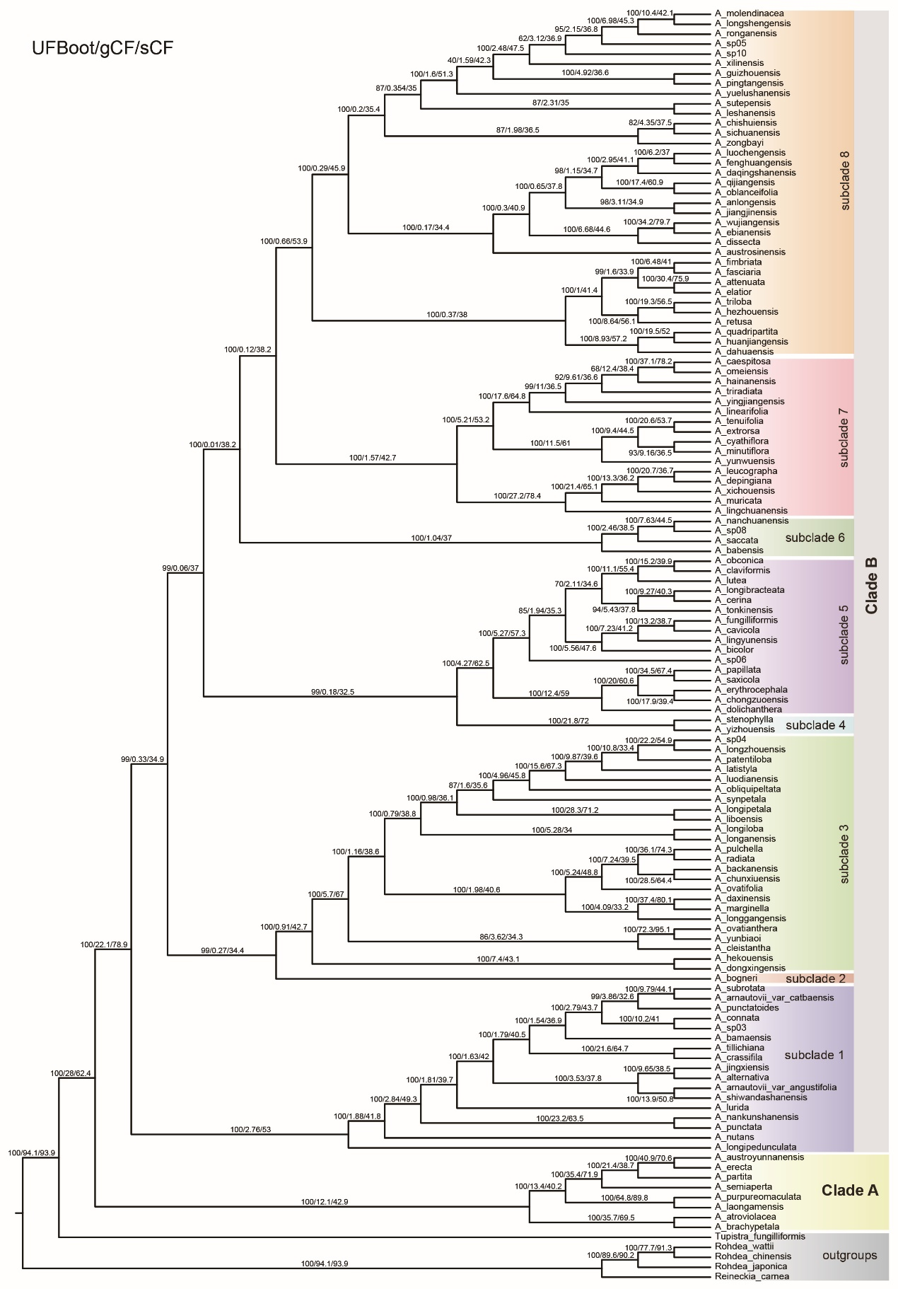
Figure S1. A maximum likelihood phylogeny of Aspidistra inferred from IQ-TREE based on dataset6.
The ultrafast bootstrap (UFBoot), gene concordance factor (gCF) and site concordance factor (sCF) of each node across the tree are shown on the branch in the format of UFBoot/gCF/ sCF. Clade and subclade classiﬁcations are the same as those in Figure 2.
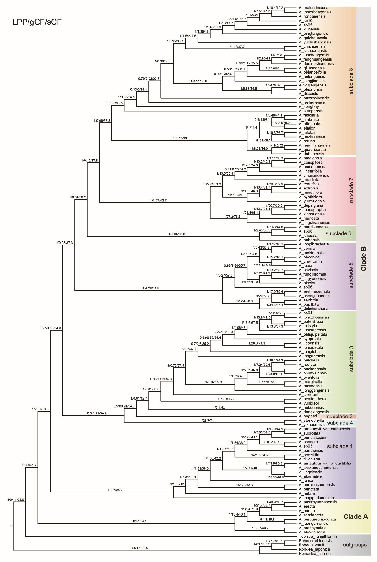
Figure S2. A phylogeny of Aspidistra inferred from ASTRAL-III based on dataset6.
The local posterior probability (LPP), gene concordance factor (gCF) and site concordance factor (sCF) of each node across the tree are shown on the branch in the format of LPP/gCF/ sCF. Clade and subclade classiﬁcations are the same as those in Figure 2.
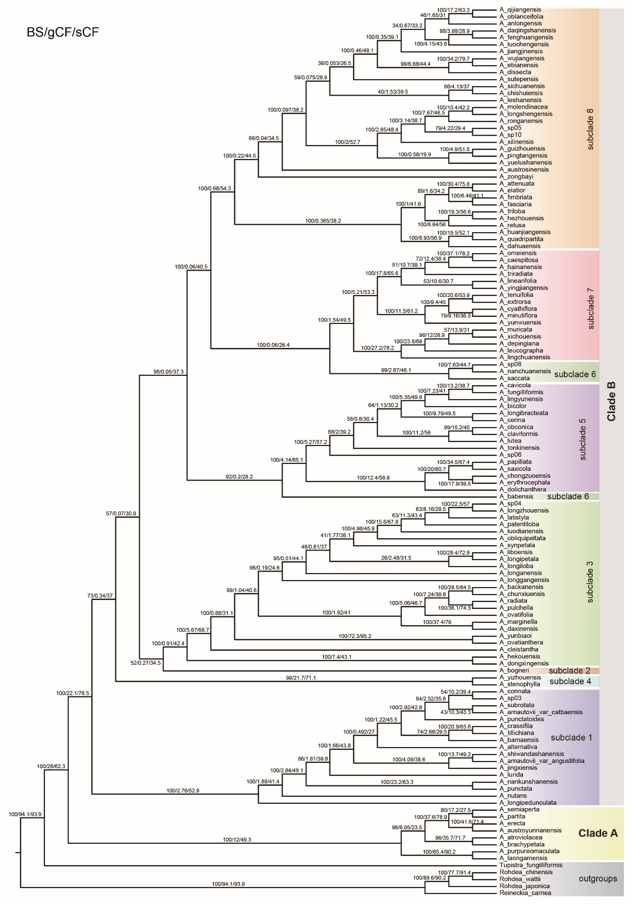
Figure S3. A phylogeny of Aspidistra inferred from SVDQuartets based on dataset6.
The bootstrap (BS) value, gene concordance factor (gCF) and site concordance factor (sCF) of each node across the tree are shown on the branch in the format of BS/gCF/ sCF. Clade and subclade classiﬁcations are the same as those in Figure 2.

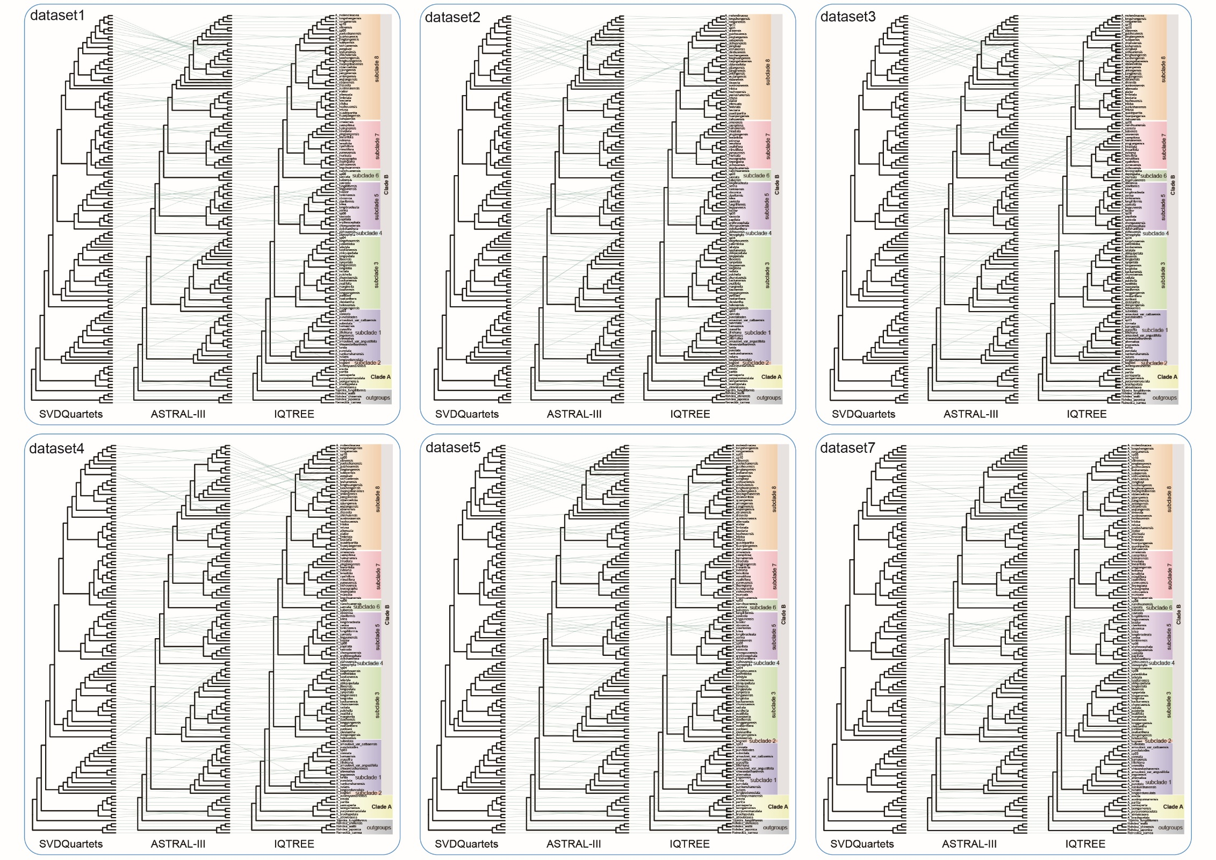
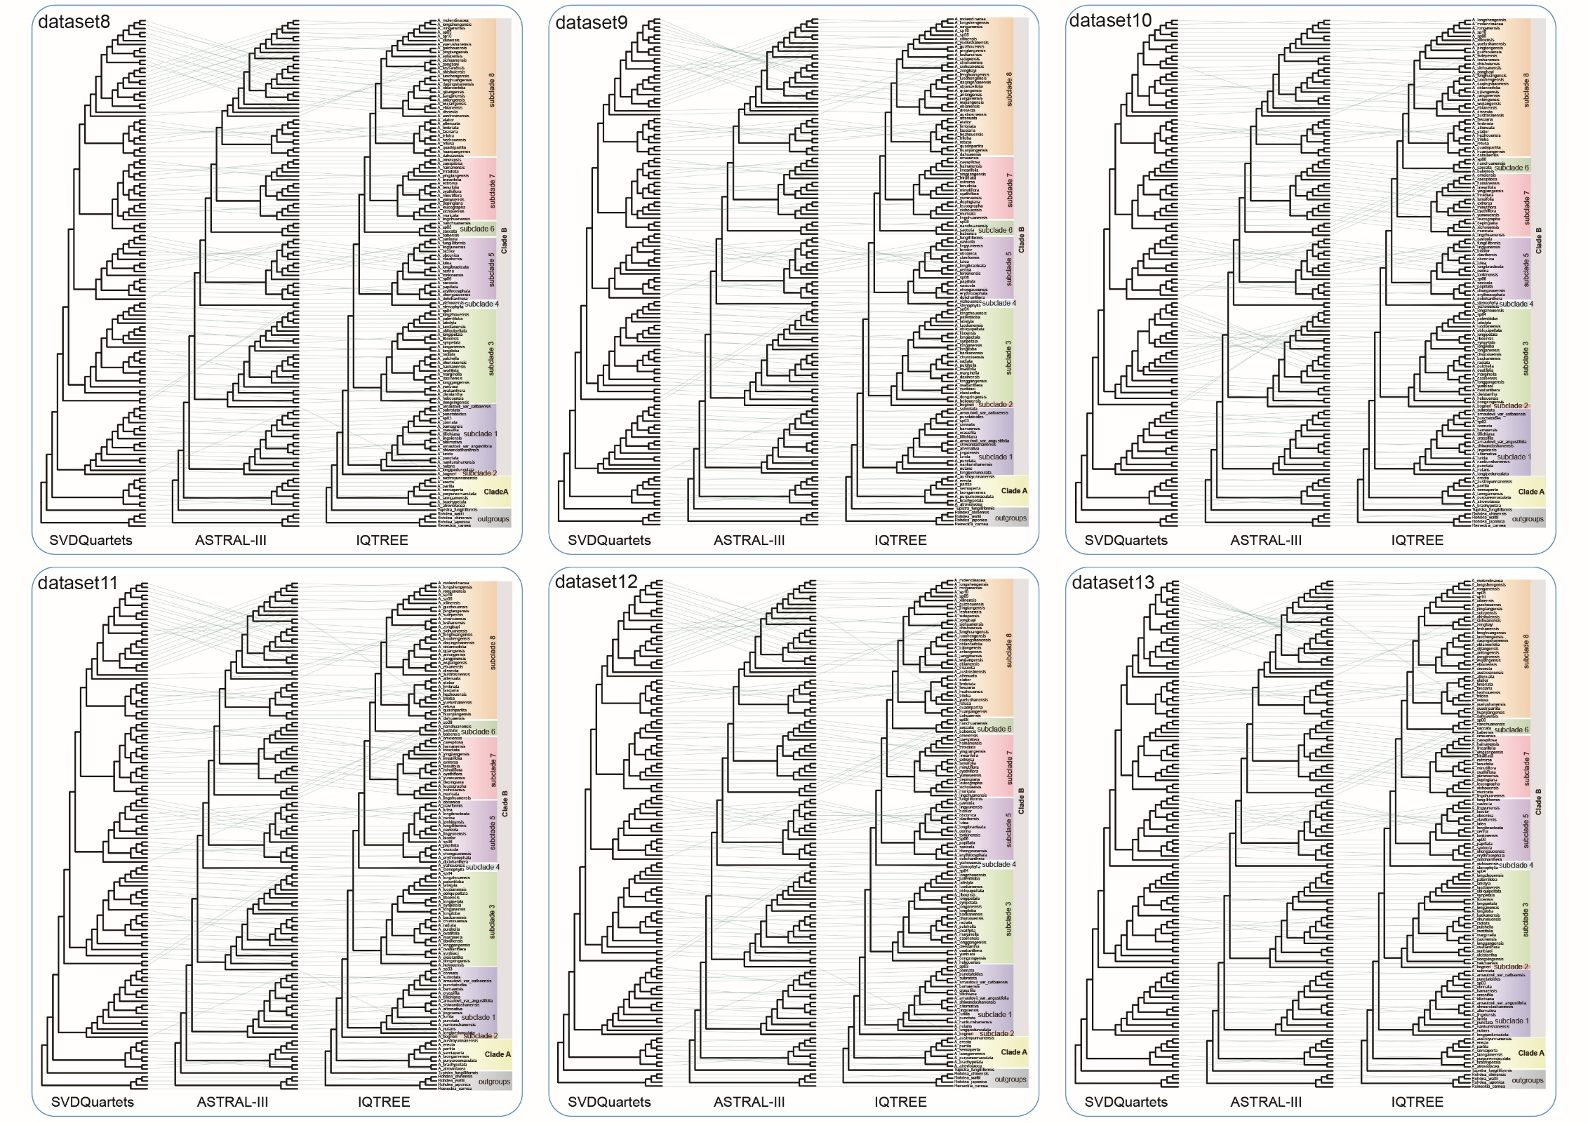
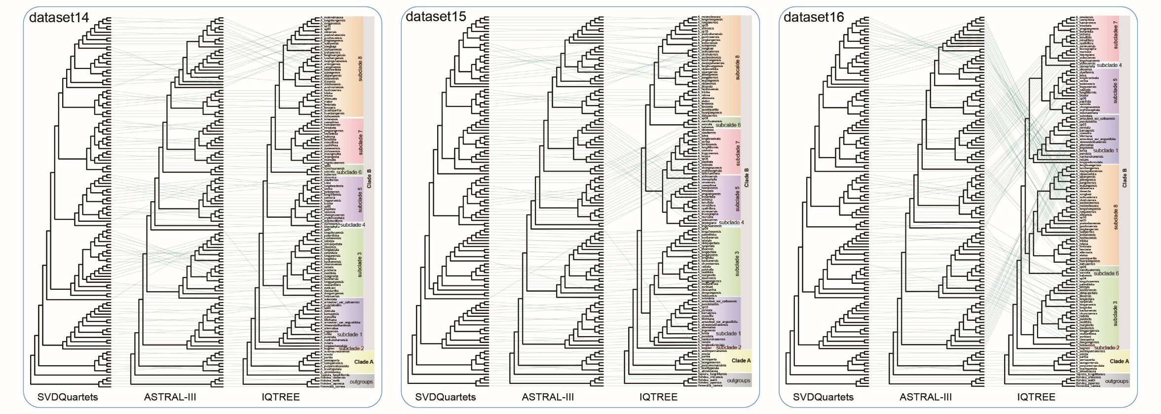
Figure S4. Phylogenies of Aspidistra inferred from different datasets and methods.
For comparison, the three different topologies estimated by different methods (SVDQuartets, ASTRAL-III, and IQ-TREE) are connected by lines. Clade and subclade classiﬁcations are the same as those in Figure 2.

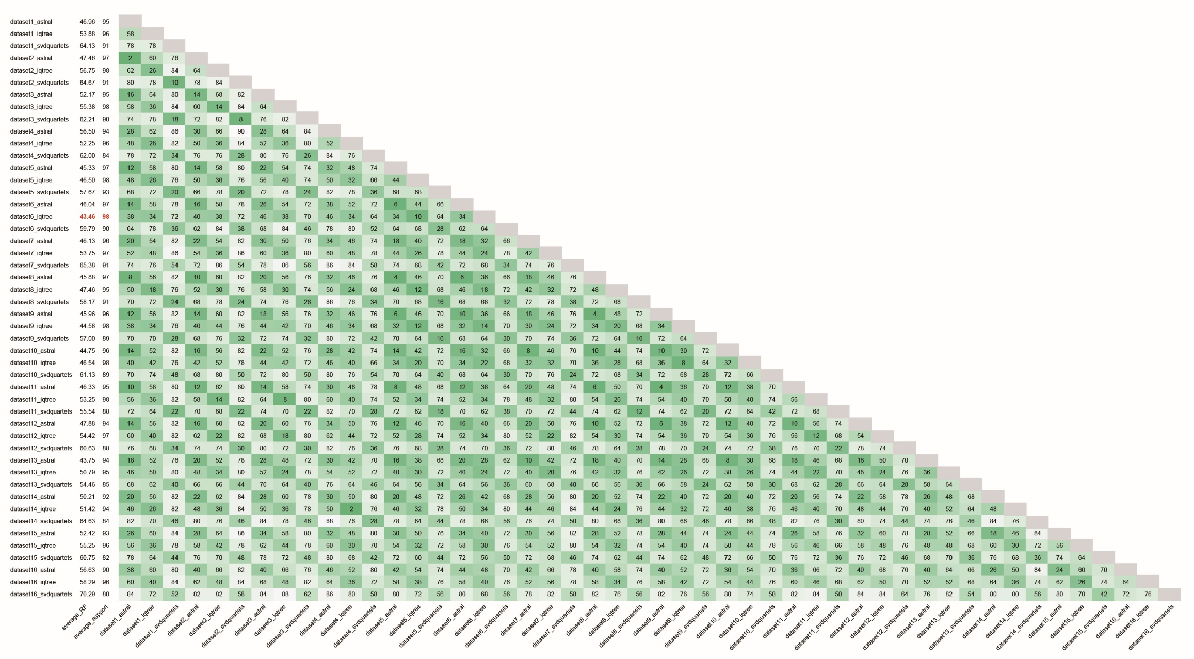
Figure S5. The Robinson–Foulds (RF) distances among different phylogenies estimated from different methods and datasets.

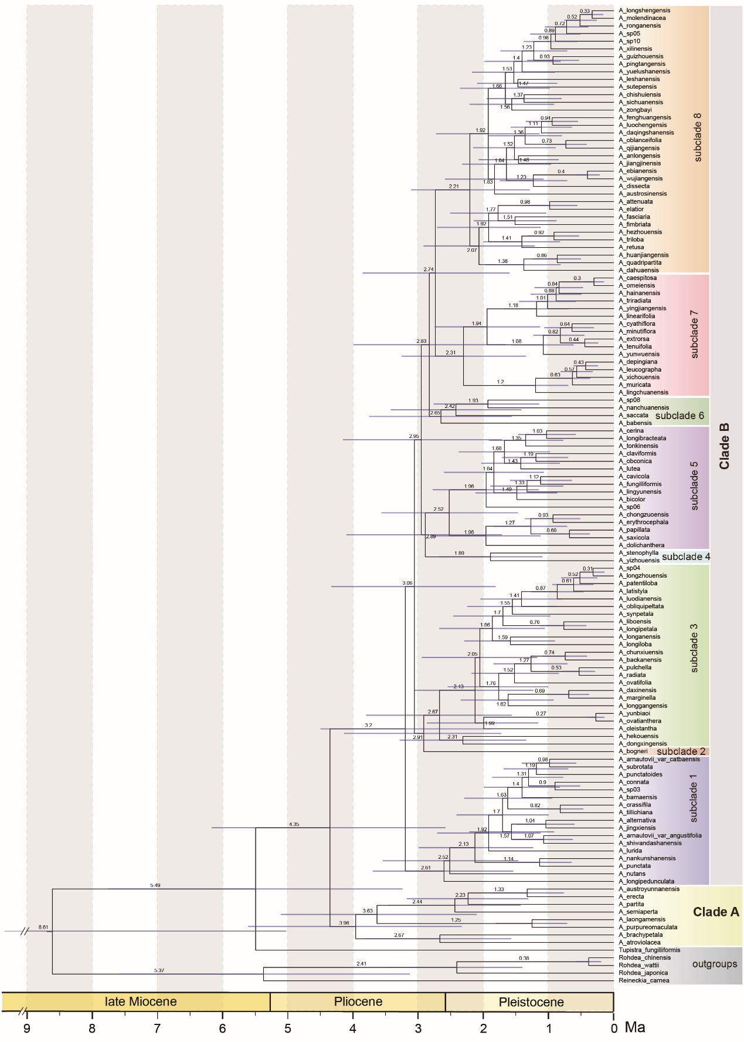
Figure S6. Chronogram of Aspidistra estimated by Bayesian method using the 100 most clock-like genes selected from dataset6.
Number on each branch represents the mean age of the corresponding node, and the blue bar on each node shows the 95% HPD interval. Clade and subclade classiﬁcations are the same as those in Figure 2.
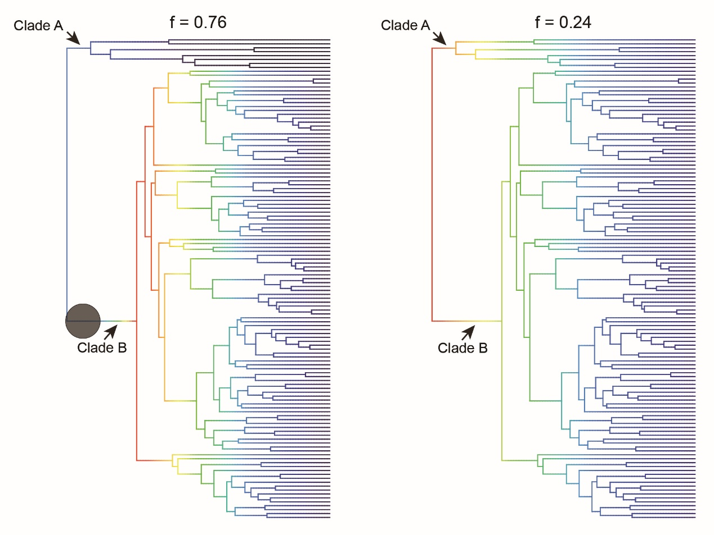
Figure S7. 95% credible set of speciation rate shifts in Aspidistra estimated in BAMM.

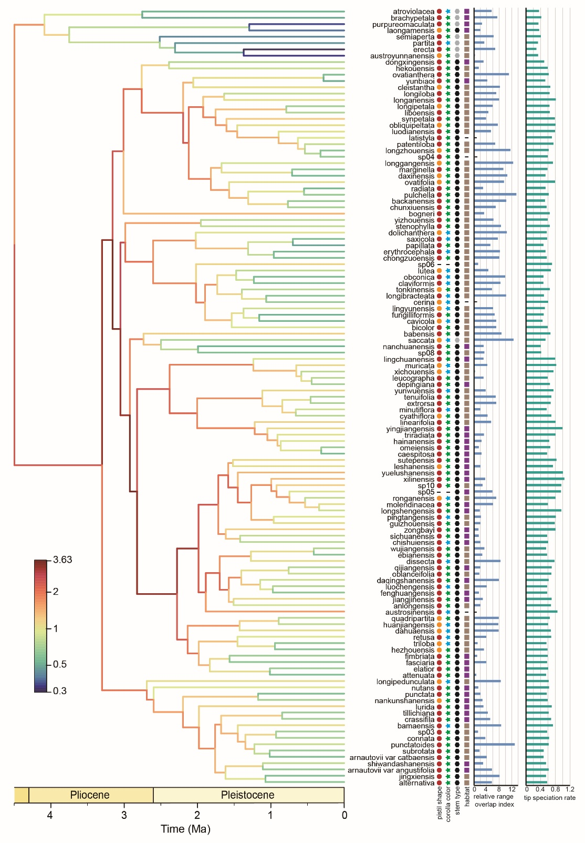
Figure S8. ClaDS-estimated speciation rates across the phylogeny, alongside mapped morphological and habitat characters for each species.
The pistil shape (red dot represents mushroom-shape, yellow dot represents non- mushroom-shape), corolla color (blue star represents non-purple-red, green star represents purple-red), stem habit (black hexagon represents erect stem, gray hexagon represents creeping stem), habitat (purple square represents non-karst, brown square represents karst), relative range overlap index, and speciation rate estimated in ClaDS of each species were mapped at the right part. Short dash represents data missing.
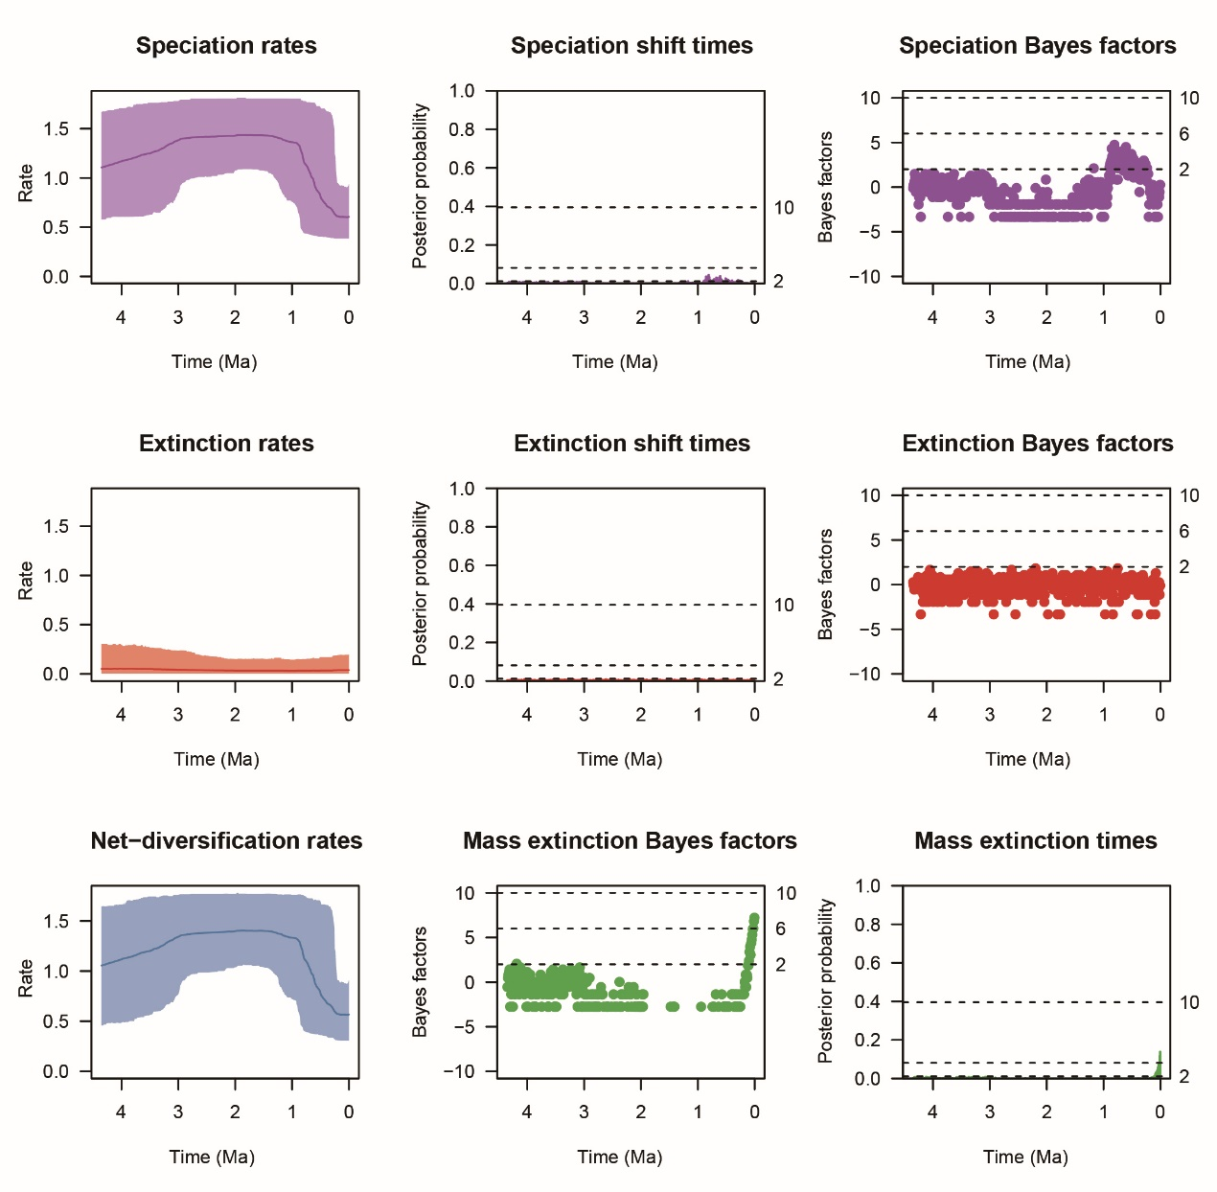
Figure S9. Results of diversification analysis with episodic birth–death model implemented in CoMET.

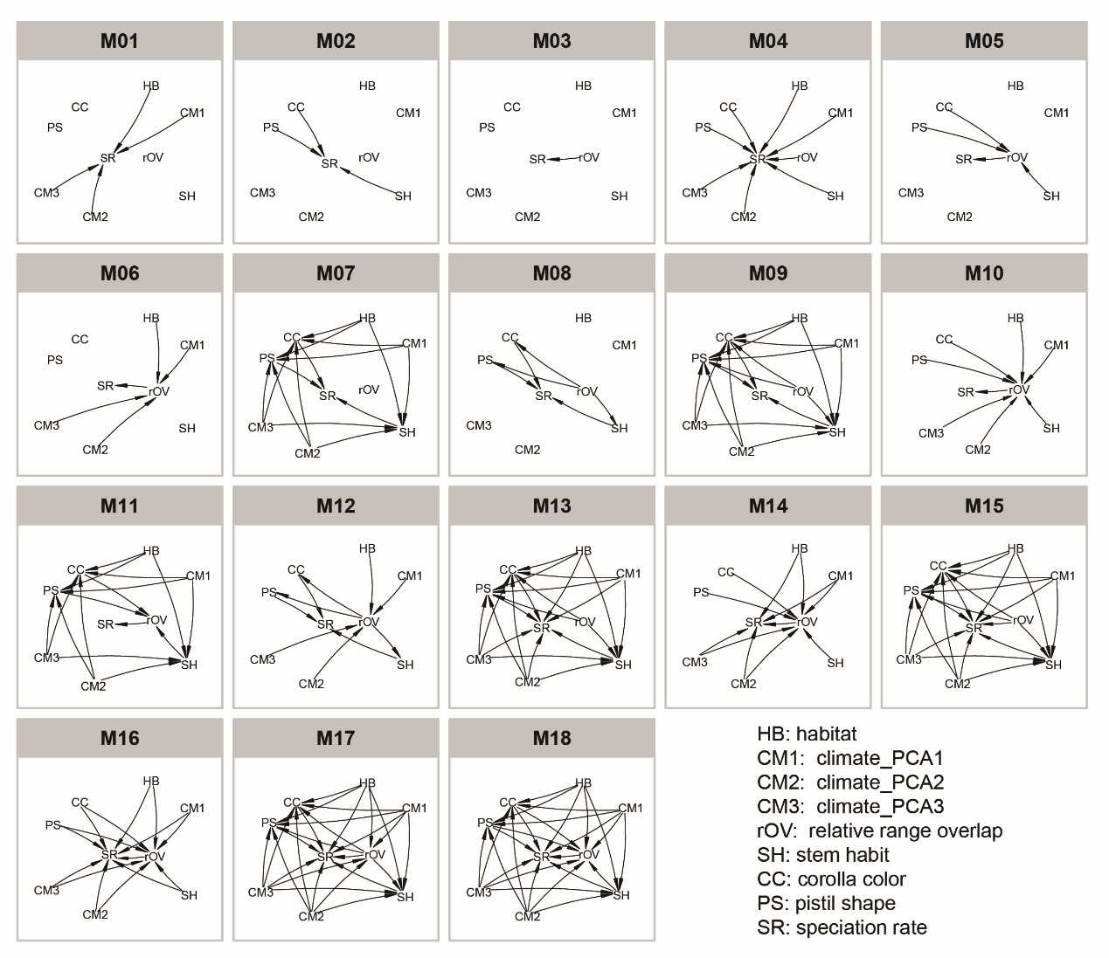
Figure S10. The 18 models on individual or multiple direct or indirect effects of abiotic and biotic factors on speciation rates depicted as directed acyclic graphs.

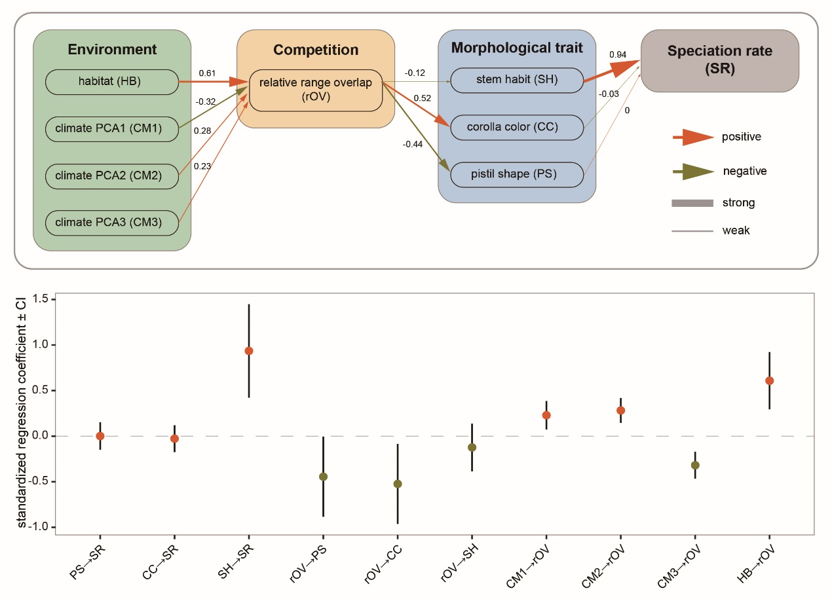
Figure S11. The best-fitting model from phylogenetic path analysis using the tip speciation rates estimated by BAMM.
Numbers associated with the arrows are the standardized correlation coefﬁcients, and the thickness of lines reﬂects the strength of positive (orange-red) or negative (dark-olive-green) interactions between a pair of variables. Panels below show standardized regression coefficients with standard errors for the paths in the above model schematic. Abbreviations on the x-axis refer to variables in the schematic above.

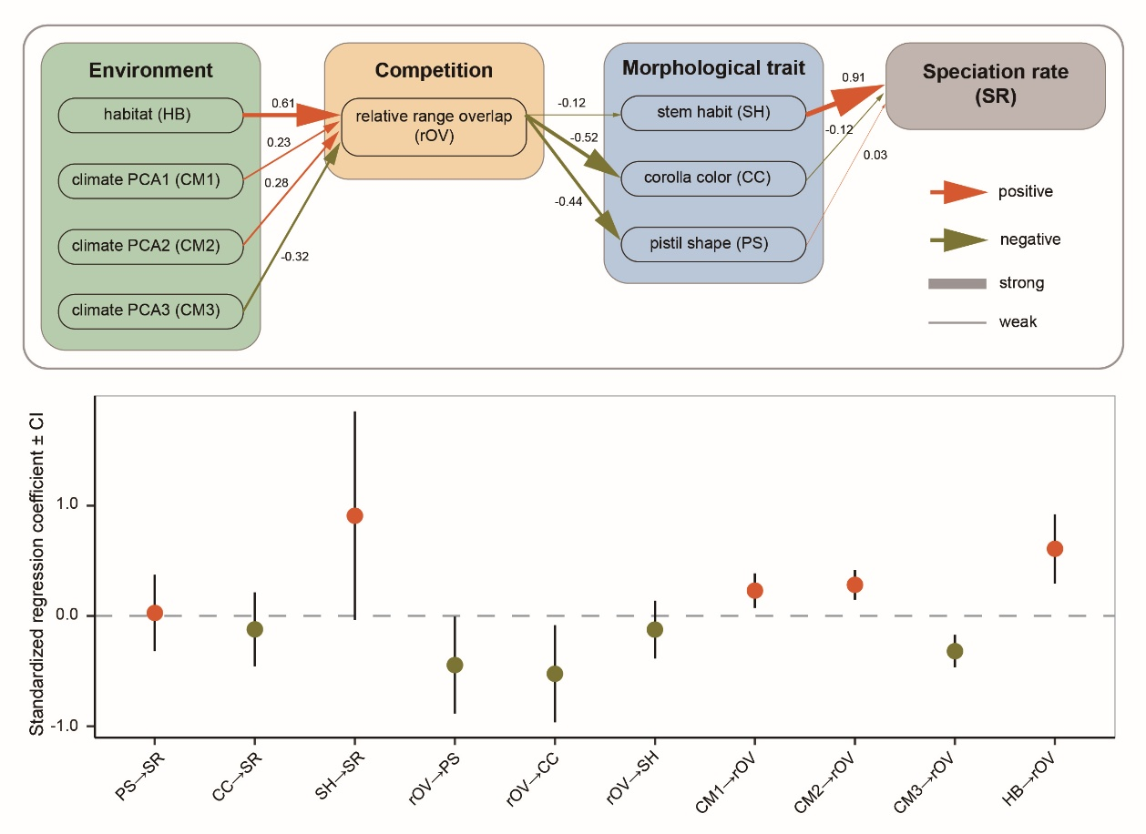

Figure S12. The best-fitting model from phylogenetic path analysis using the tip speciation rates estimated by ClaDS.
Numbers associated with the arrows are the standardized correlation coefﬁcients, and the thickness of lines reﬂects the strength of positive (orange-red) or negative (dark-olive-green) interactions between a pair of variables. Panels below show standardized regression coefficients with standard errors for the paths in the above model schematic. Abbreviations on the x-axis refer to variables in the schematic above.

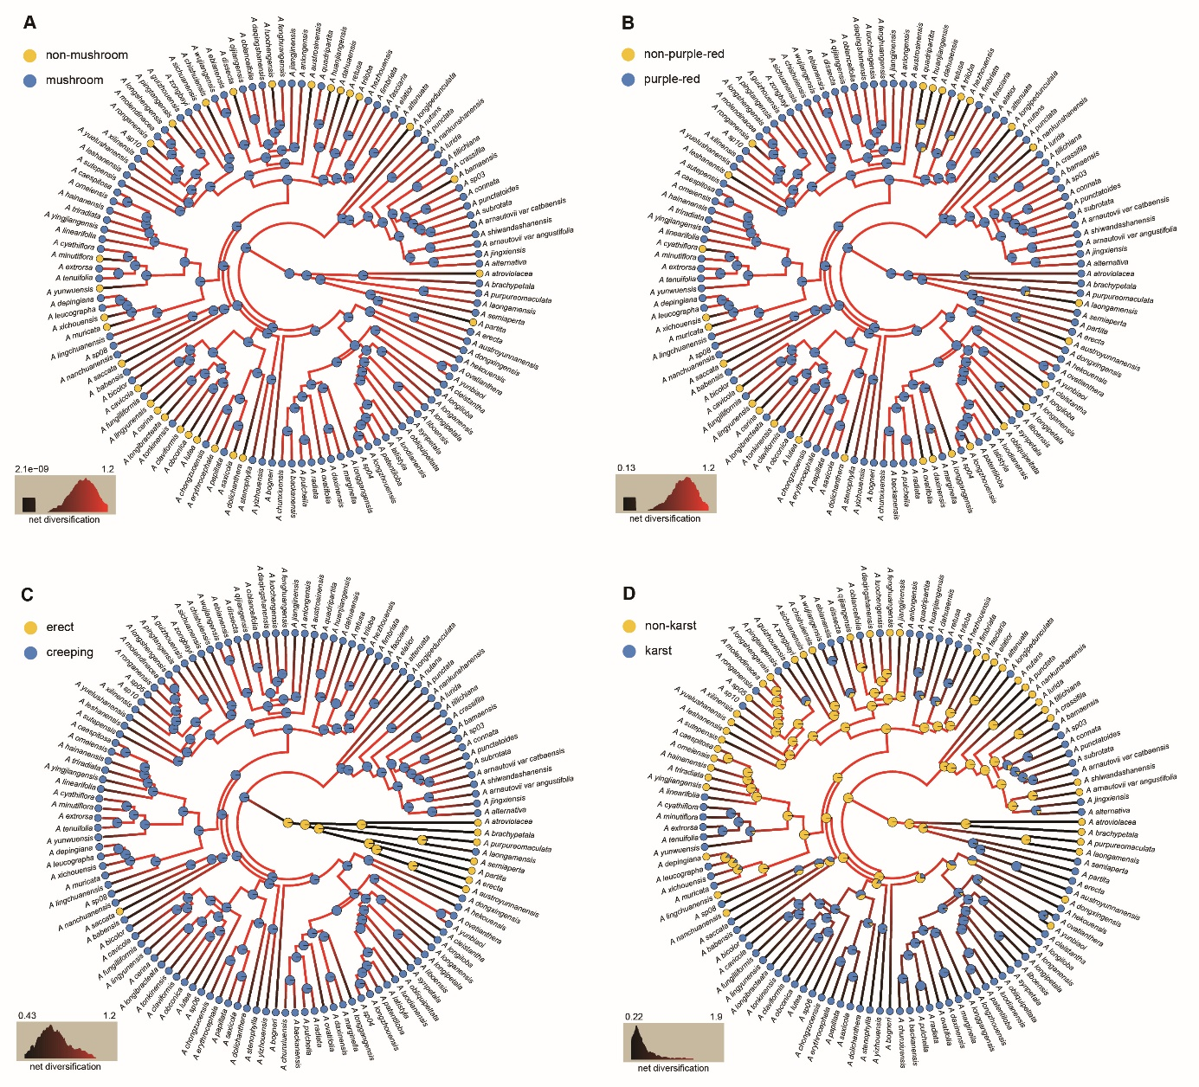
Figure S13. Ancestral state reconstruction of pistil shape, corolla color, stem habit and soil habitat in Aspidistra.
Ancestral state reconstruction of pistil shape (A), corolla color (B), stem habit (C) and soil habitat (D) in Aspidistra. Ancestral state was estimated from HiSSE using model averaging to account for uncertainty in both models and reconstructions. Circles at tips and nodes are colored by state, with node pie charts indicating the probability of a state assignment. Branches are colored using a gradient from the model-averaged net diversiﬁcation rate, with black representing the slowest rate. The legend in the lower left shows the range of rates and the distribution of rates across the tree.
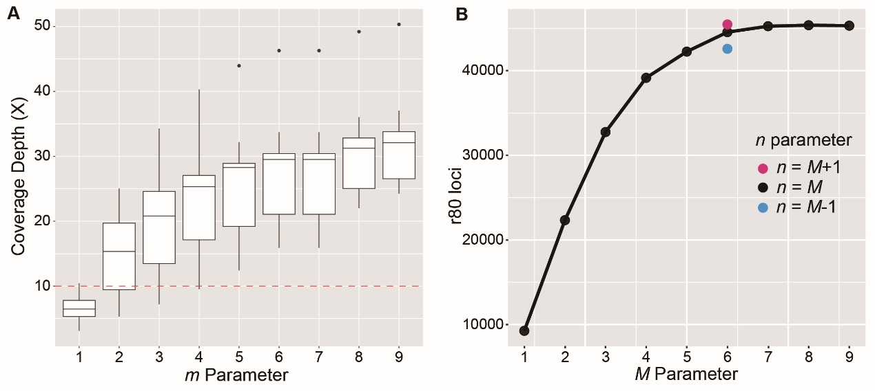
Figure S14. Diagnostic plots for Stacks de novo assembly.
(A) Coverage depth (X) for every iteration of the m parameter, while holding the other core parameters constant (M=n=4). The lowest m value where all samples had X ≥ 10 (horizontal red line) was chosen. (B) Number of loci shared by ≥80% of the samples (i.e., r80 loci) for every iteration of M and n core parameters, while holding m parameter constant (m=5). The value of M was chosen when the number of r80 loci began to plateau. The value of n was iterated among n=M±1, and the value that generated the highest number of r80 loci was selected.

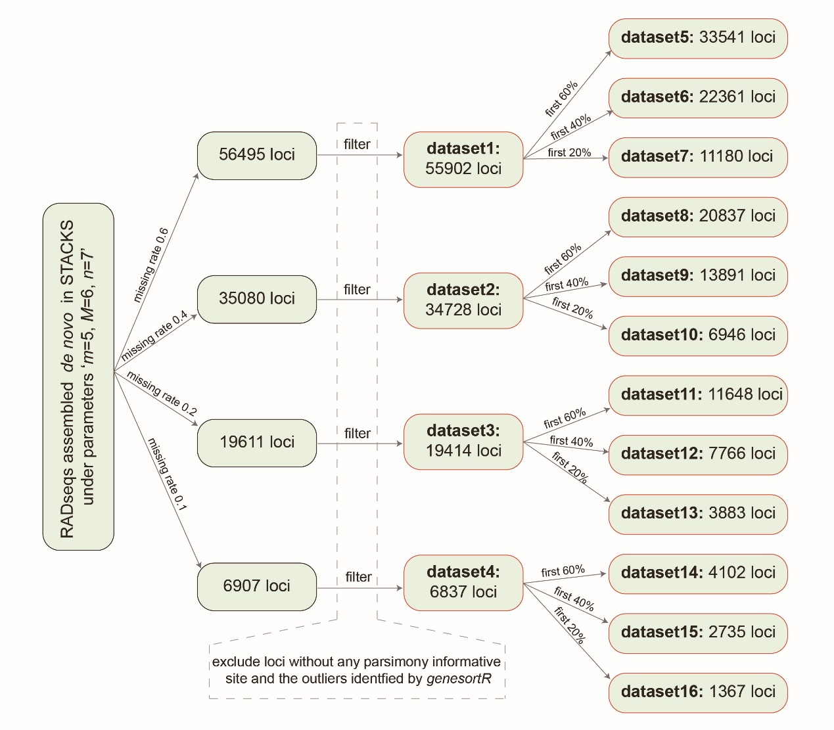
Figure S15. A flow chart of procedures for different datasets assembly.

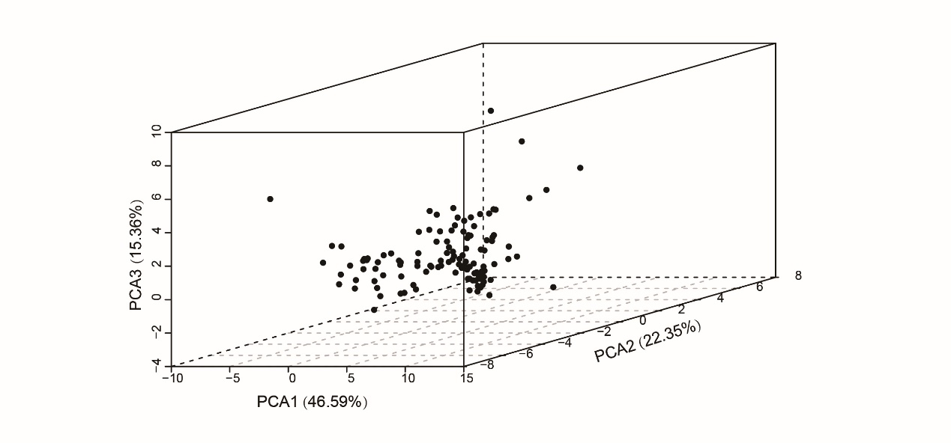
Figure S16. Scatter plot of the first three principal components derived from 19 bioclimatic variables.
The bioclimatic variables were obtained through WorldClim (http://worldclim.org) for each location recorded in Supplementary Dataset S2, and then were averaged for each species. In the principal component analysis (PCA), the first three principal components account for 84.3% variance in total, with the PCA1 represents 46.59%, PCA2 represents 22.35%, and PCA3 represents 15.36%.

