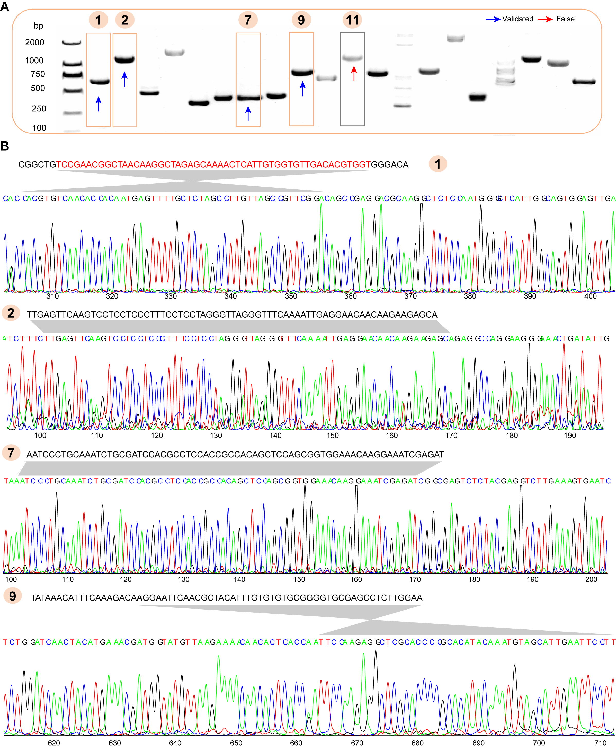
Figure S1. PCR validation of random selected novel genes.
(A) The gel image of 20 random selected novel genes, and five of them were marked in either blue or red arrow. The blue indicates the PCR products were rightly sequenced. (B) Detail predicted gene sequences and the sanger sequencing validation of the 5 random selected novel genes.

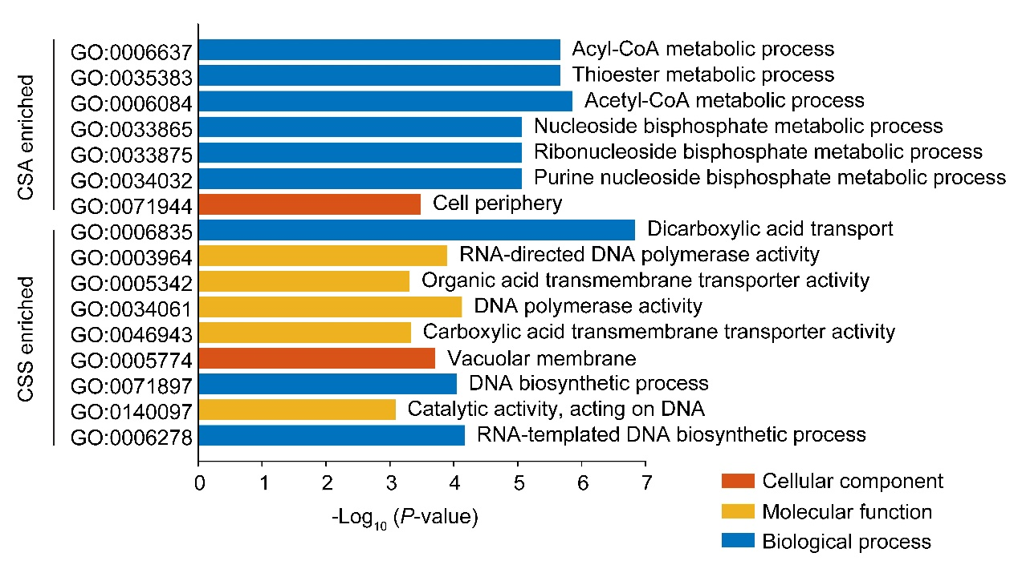
Figure S2. GO enrichment analysis of the accession-specifically enriched genes in CSS and CSA.

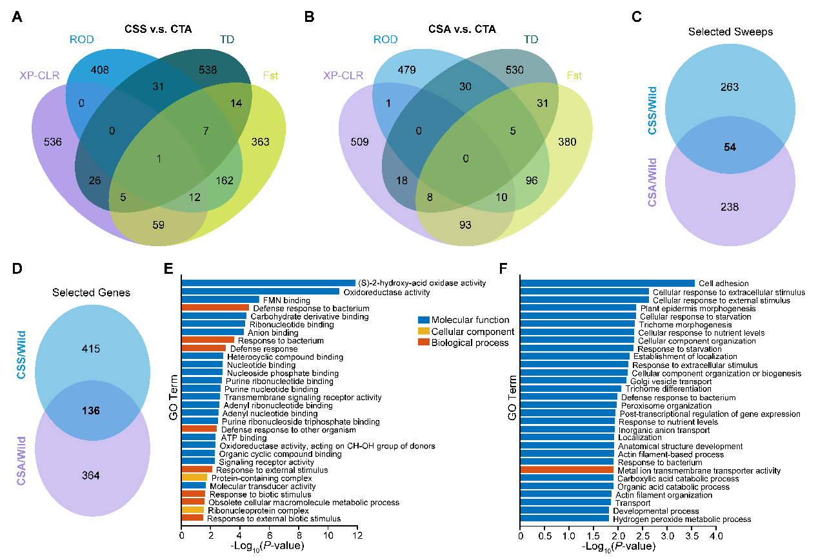
Figure S3. Selective sweeps identification and selective gene enrichments of CSS or CSA against CTA.
(A–C) The selective sweeps identified in CSS and CSA against CTA using different method. (D) Joint analysis of selected genes. (E–F) GO enrichments of the selected genes in CSS and CSA.

