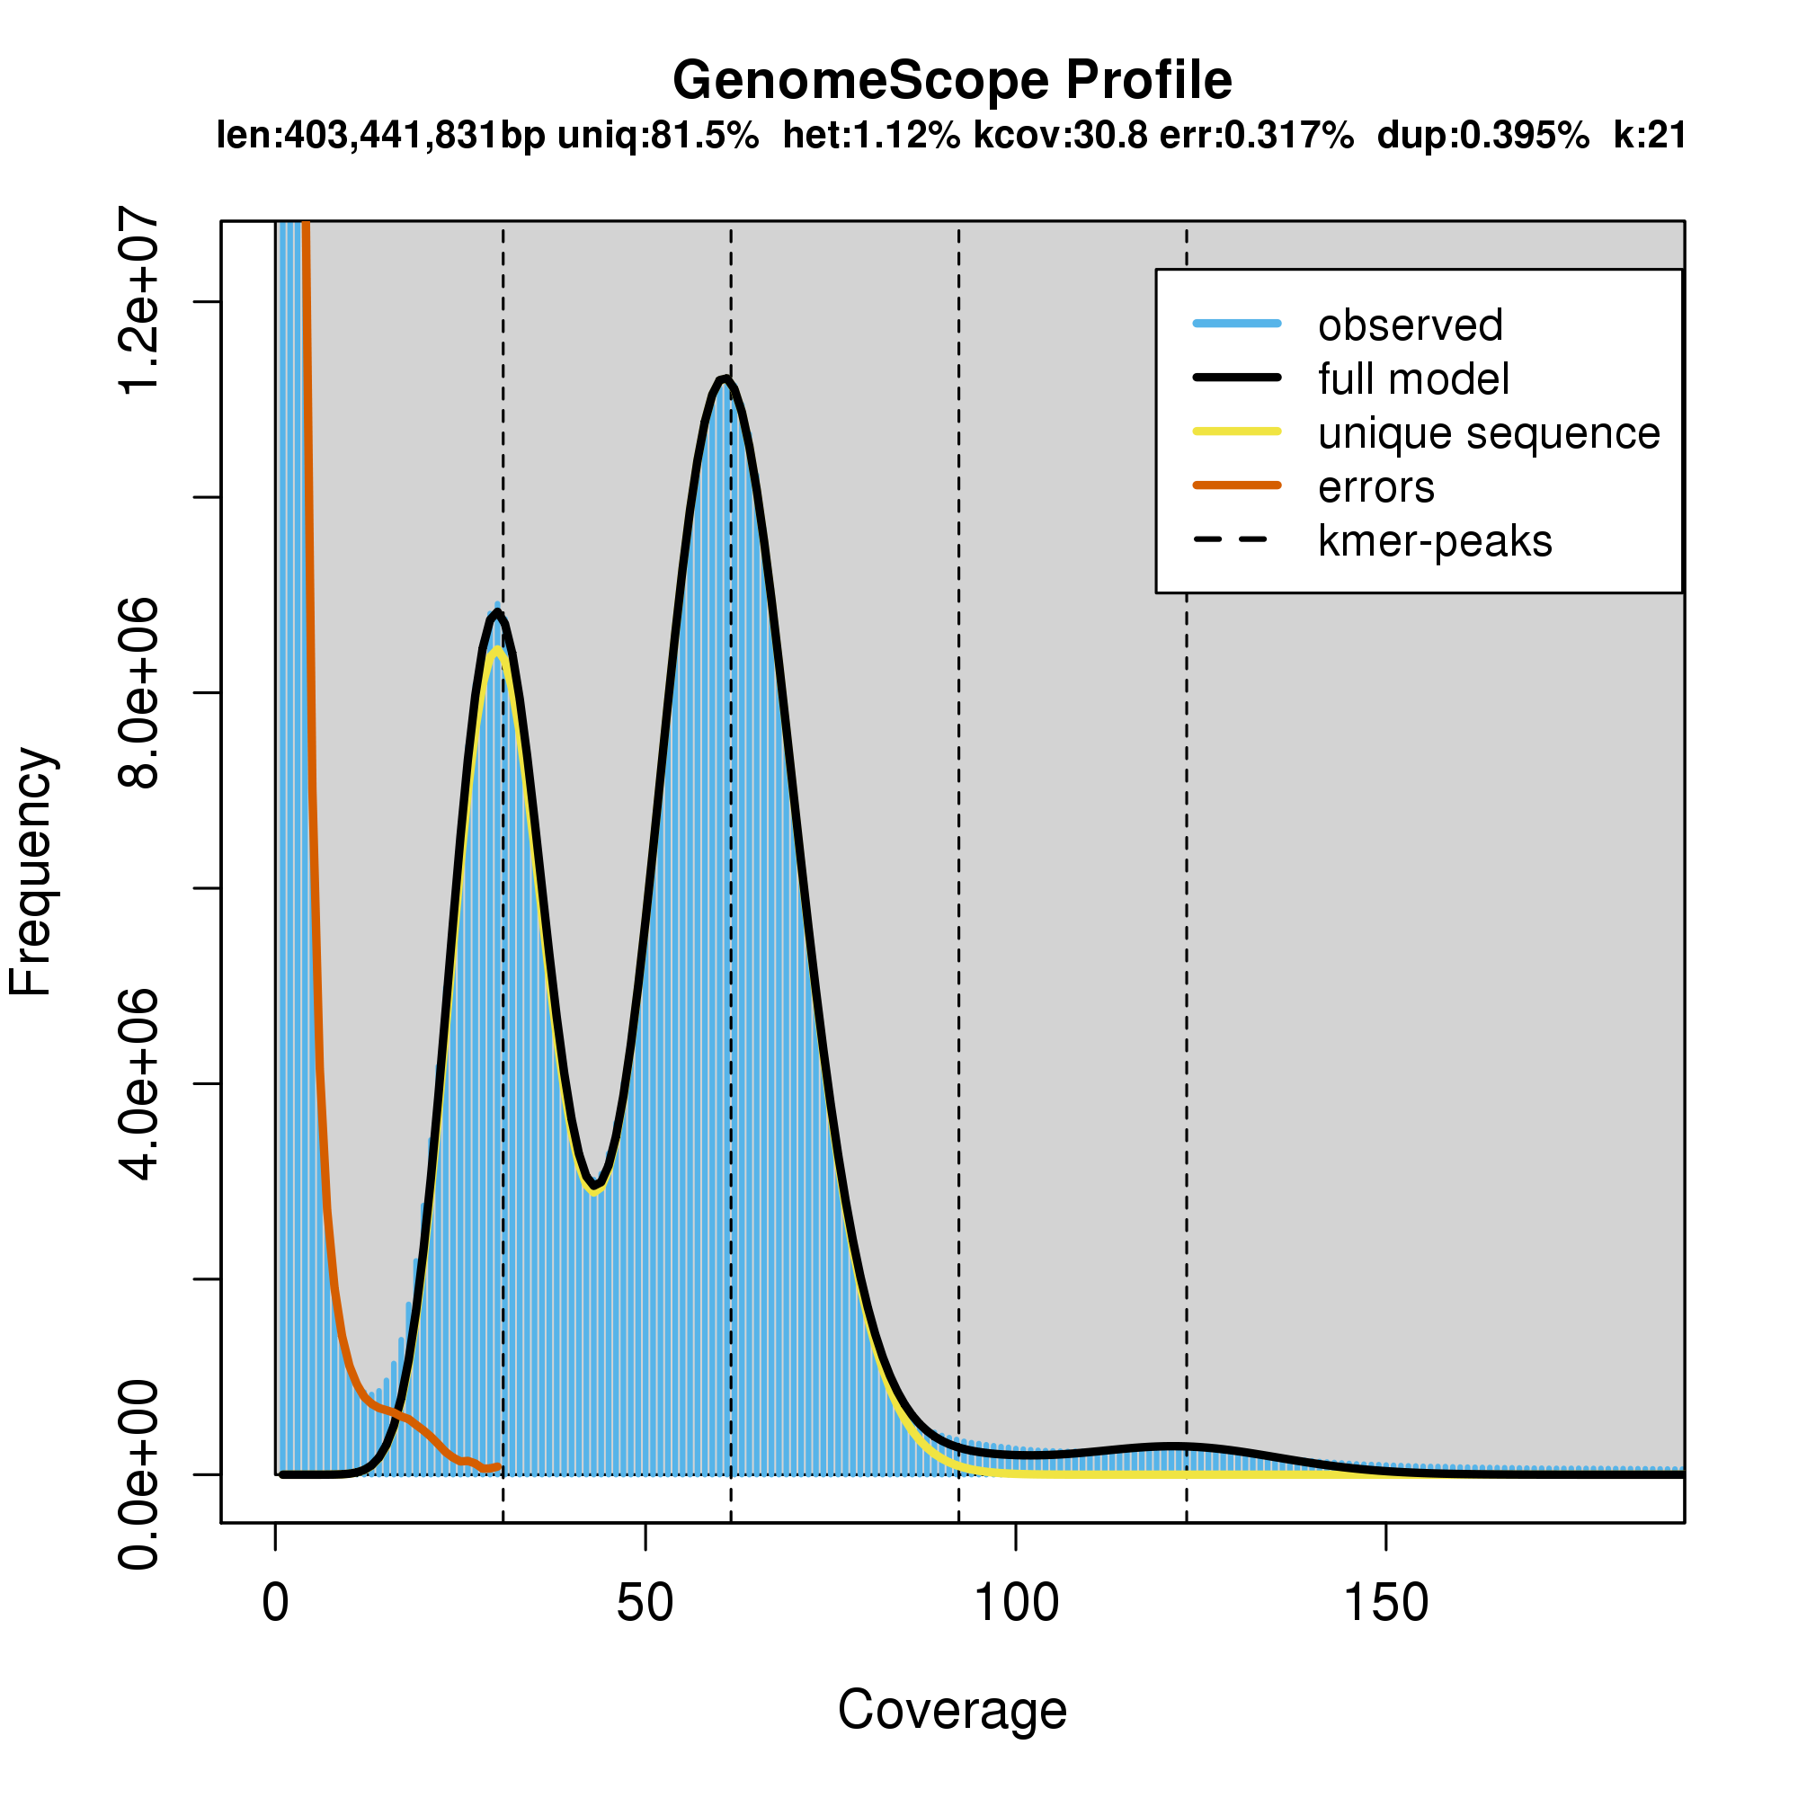
Figure S1. K-mer distribution of ZXST genome (K=21).
Blue bars represent the observed K-mer distribution; black line represents the modeled distribution without the error K-mers (indicated by the red line), up to a maximum K-mer coverage specified in the model (indicated by the yellow line). Len, estimated total genome length; Uniq, unique portion of the genome (not repetitive); Het, heterozygosity rate; Kcov, mean K-mer coverage for heterozygous bases; Err, error rate; Dup, duplication rate.
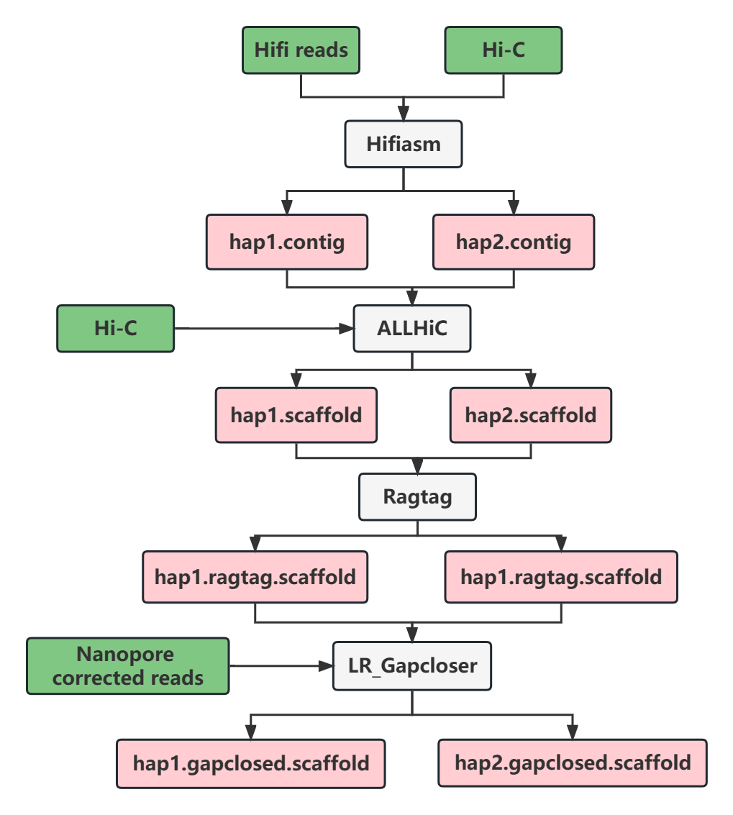
Figure S2. Workflow of the assembly of the haplotype genome of ZXST.
The green boxes show the input data, the white boxes indicate the softwares used, and the pink boxes demonstrate the output results.
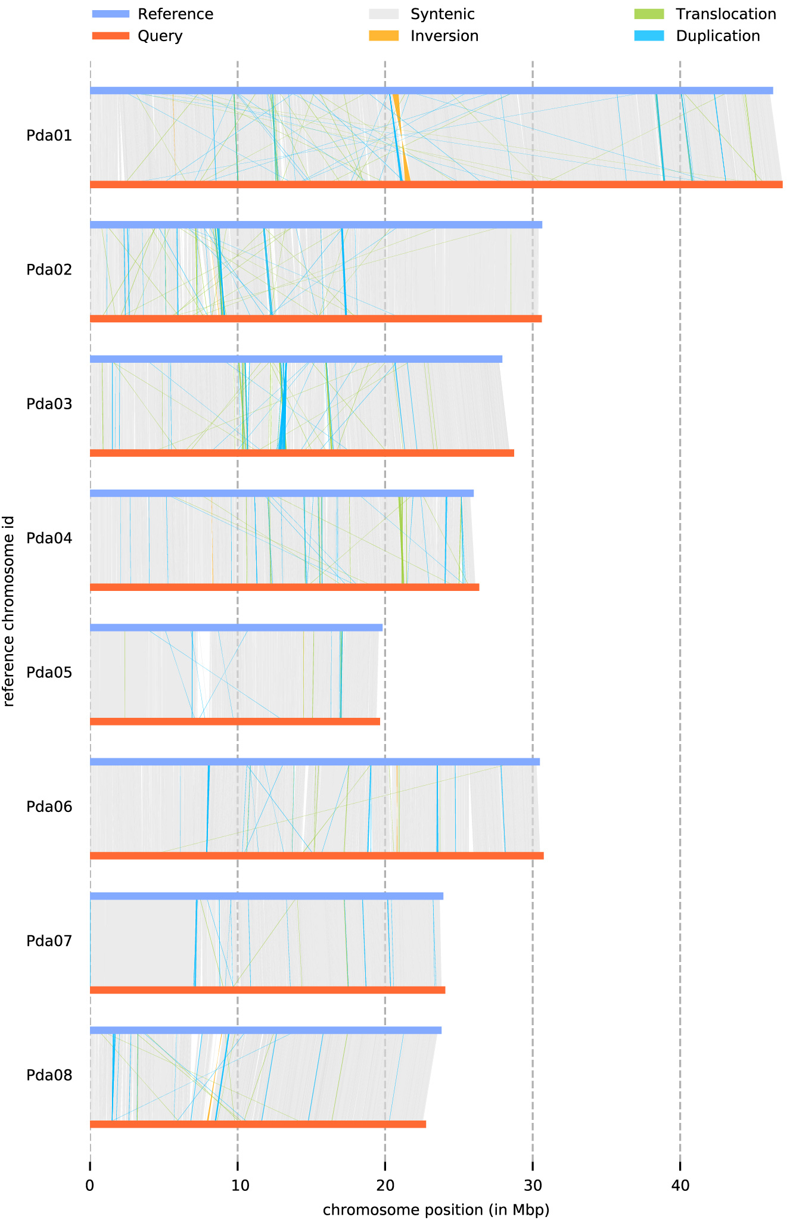
Figure S3. Collinearity between the two haplotypes of ZXST.
Reference is Pda_hap1 and Query is Pda_hap2.
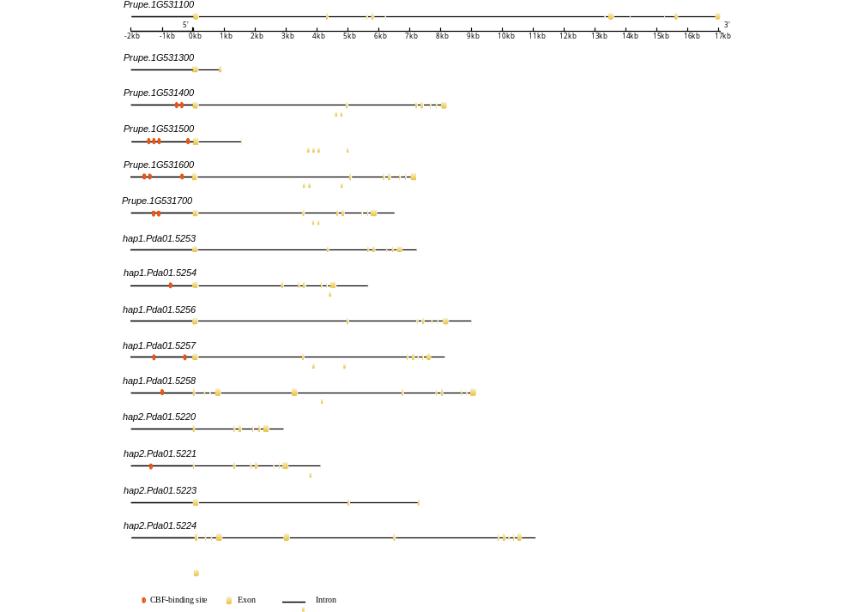
Figure S4. Gene structure of the tandem MADS-box genes on chromosome 1 of Lovell and ZXST.
The Prupe indicate the genes from Lovell v2.0. The hap1 imply the genes from Pda_hap1, and the hap2 shows the genes from Pda_hap2.

Figure S5. CDS sequence of the tandem MADS-box genes on chromosome 1 of Lovell and ZXST.
The Prupe indicate the genes from Lovell v2.0. The hap1 imply the genes from Pda_hap1, and the hap2 shows the genes from Pda_hap2.
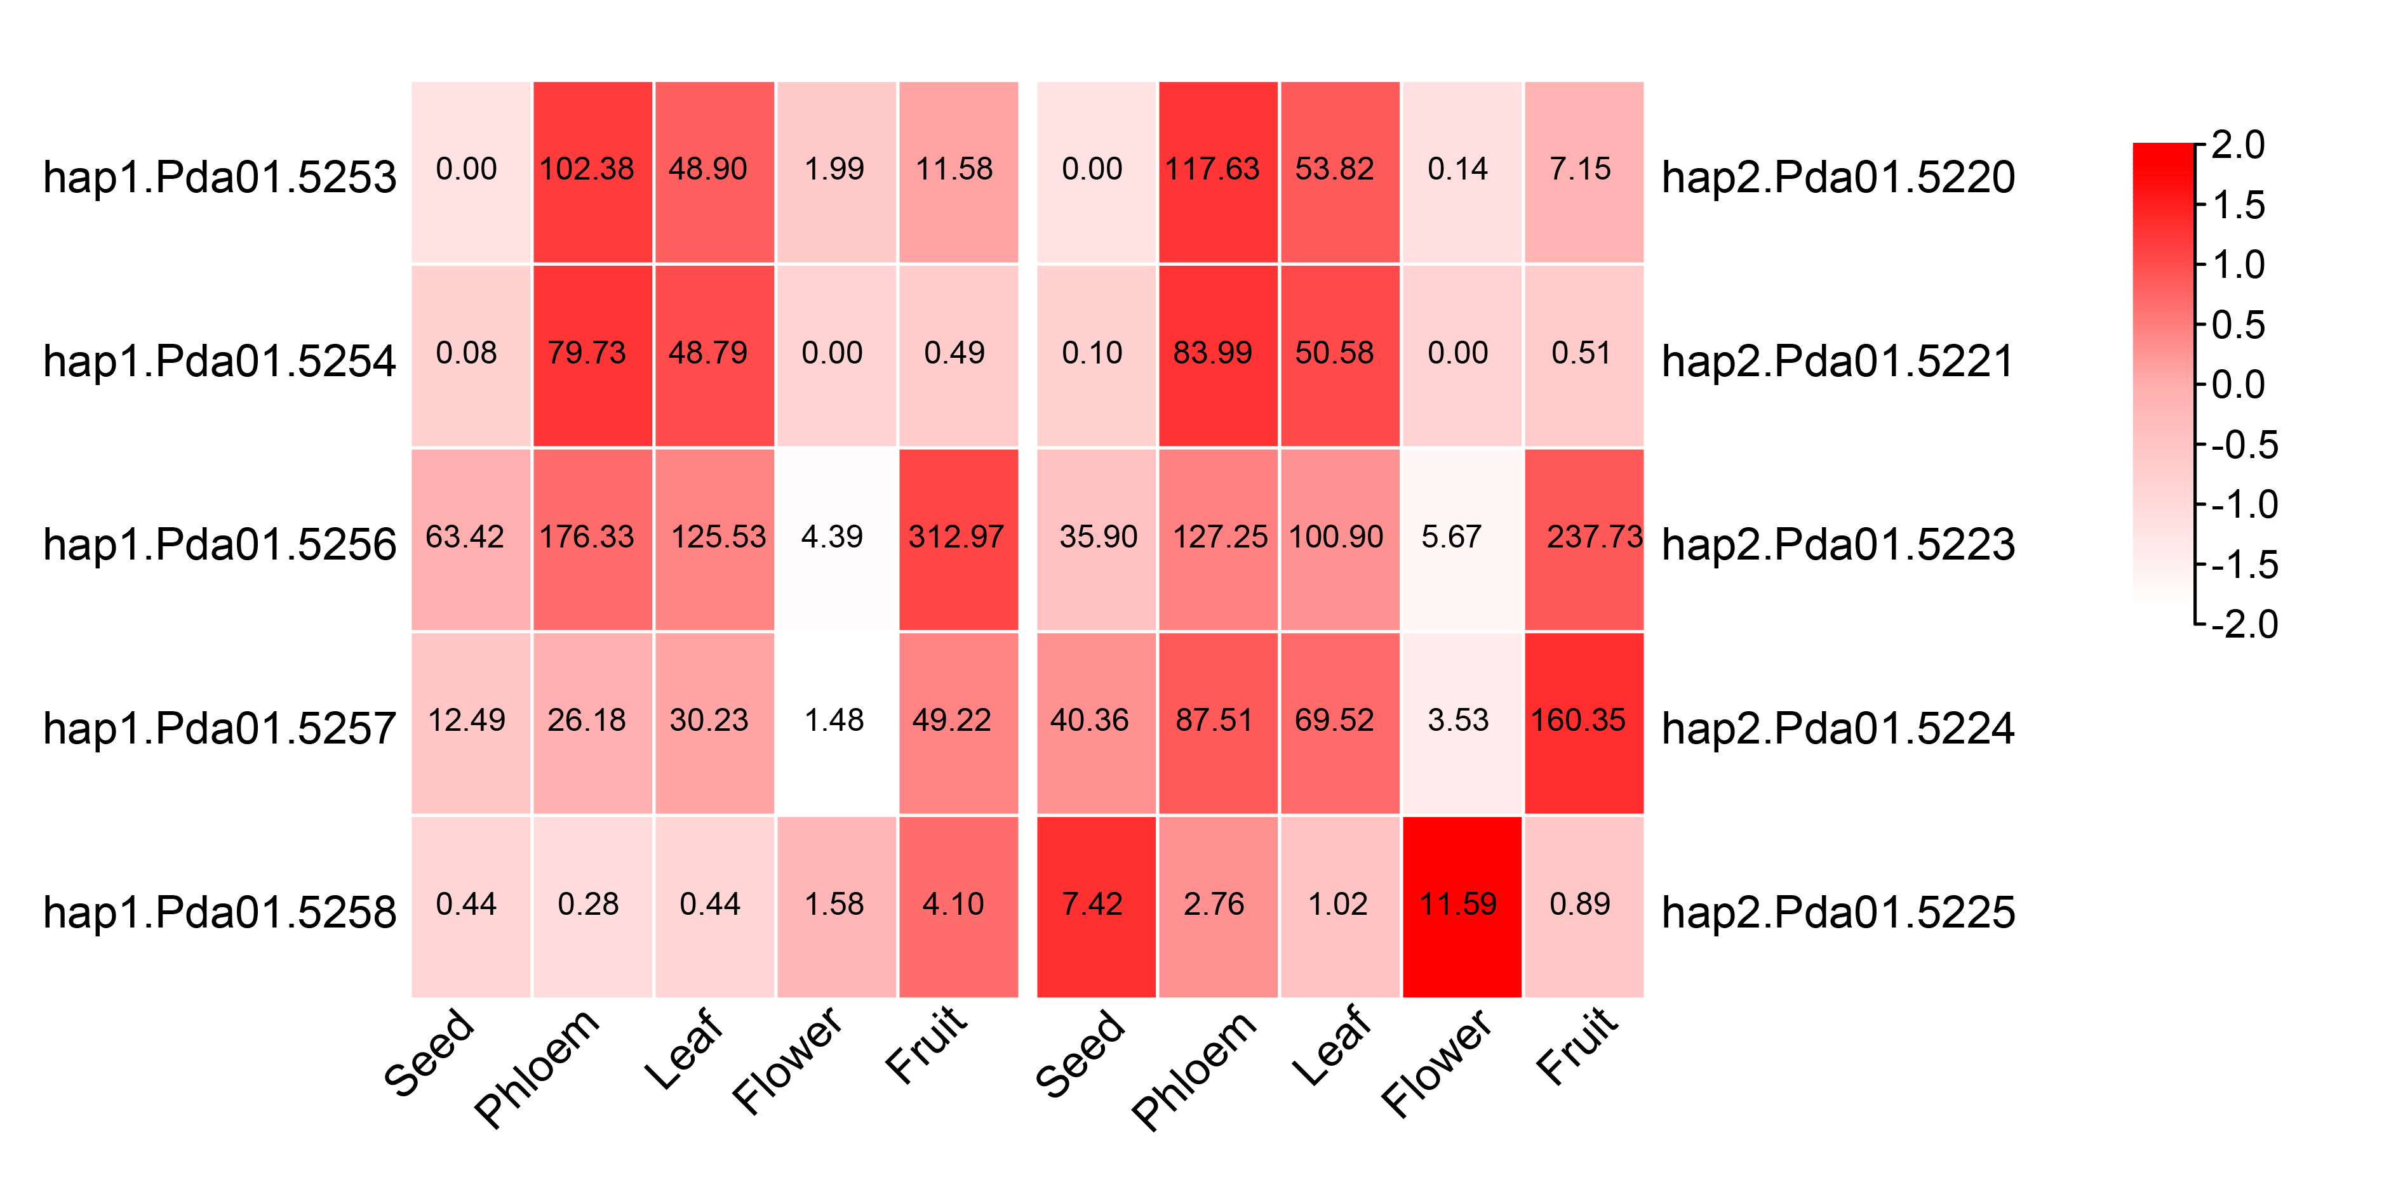
Figure S6. Expression heatmap of the tandem MADS-box genes on chromosome 1 of ZXST.
The left and right columns are the MADS-box alleles in Pda_hap1 and Pda_hap2, respectively.

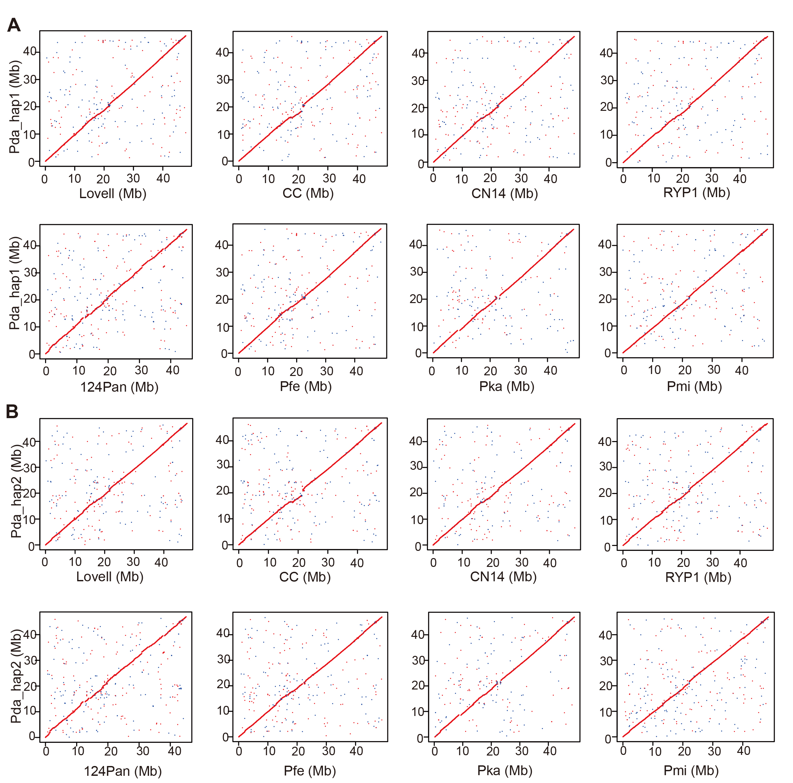

Figure S7. Collinearity of Pda_hap1 (A) and Pda_hap2 (B) versus 8 released peach genomes on chromosomes 1.
Lovell (2.0), Chinese Cling (CC), Zhongyoutao 14 (CN14), Rui You Pan 1 (RYP1), 124Pan, Prunus ferganensis (Pfe), Prunus kansuensis (Pka), Prunus mira (Pmi).

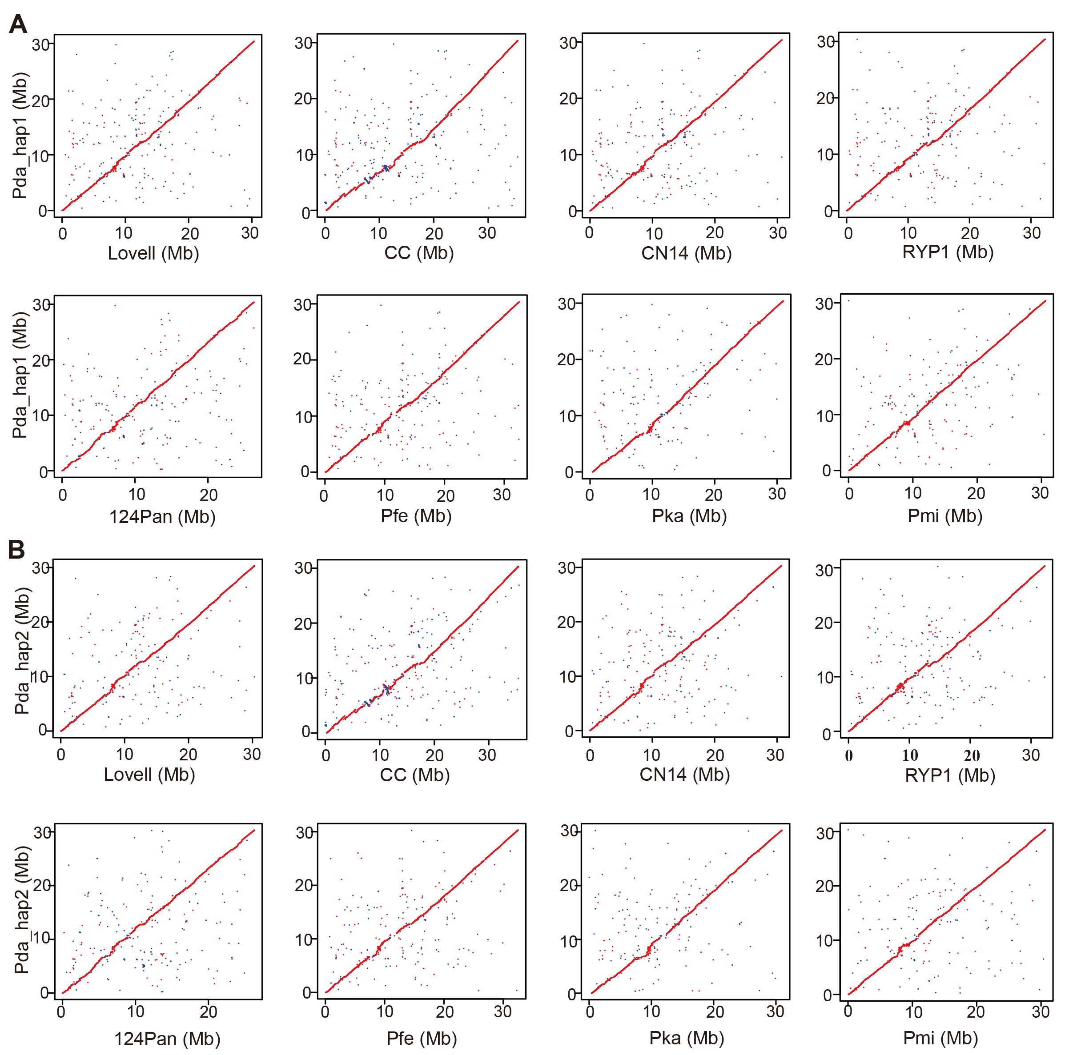
Figure S8. Collinearity of Pda_hap1 (A) and Pda_hap2 (B) versus 8 released peach genomes on chromosomes 2.
Lovell (2.0), Chinese Cling (CC), Zhongyoutao 14 (CN14), Rui You Pan 1 (RYP1), 124Pan, Prunus ferganensis (Pfe), Prunus kansuensis (Pka), Prunus mira (Pmi).

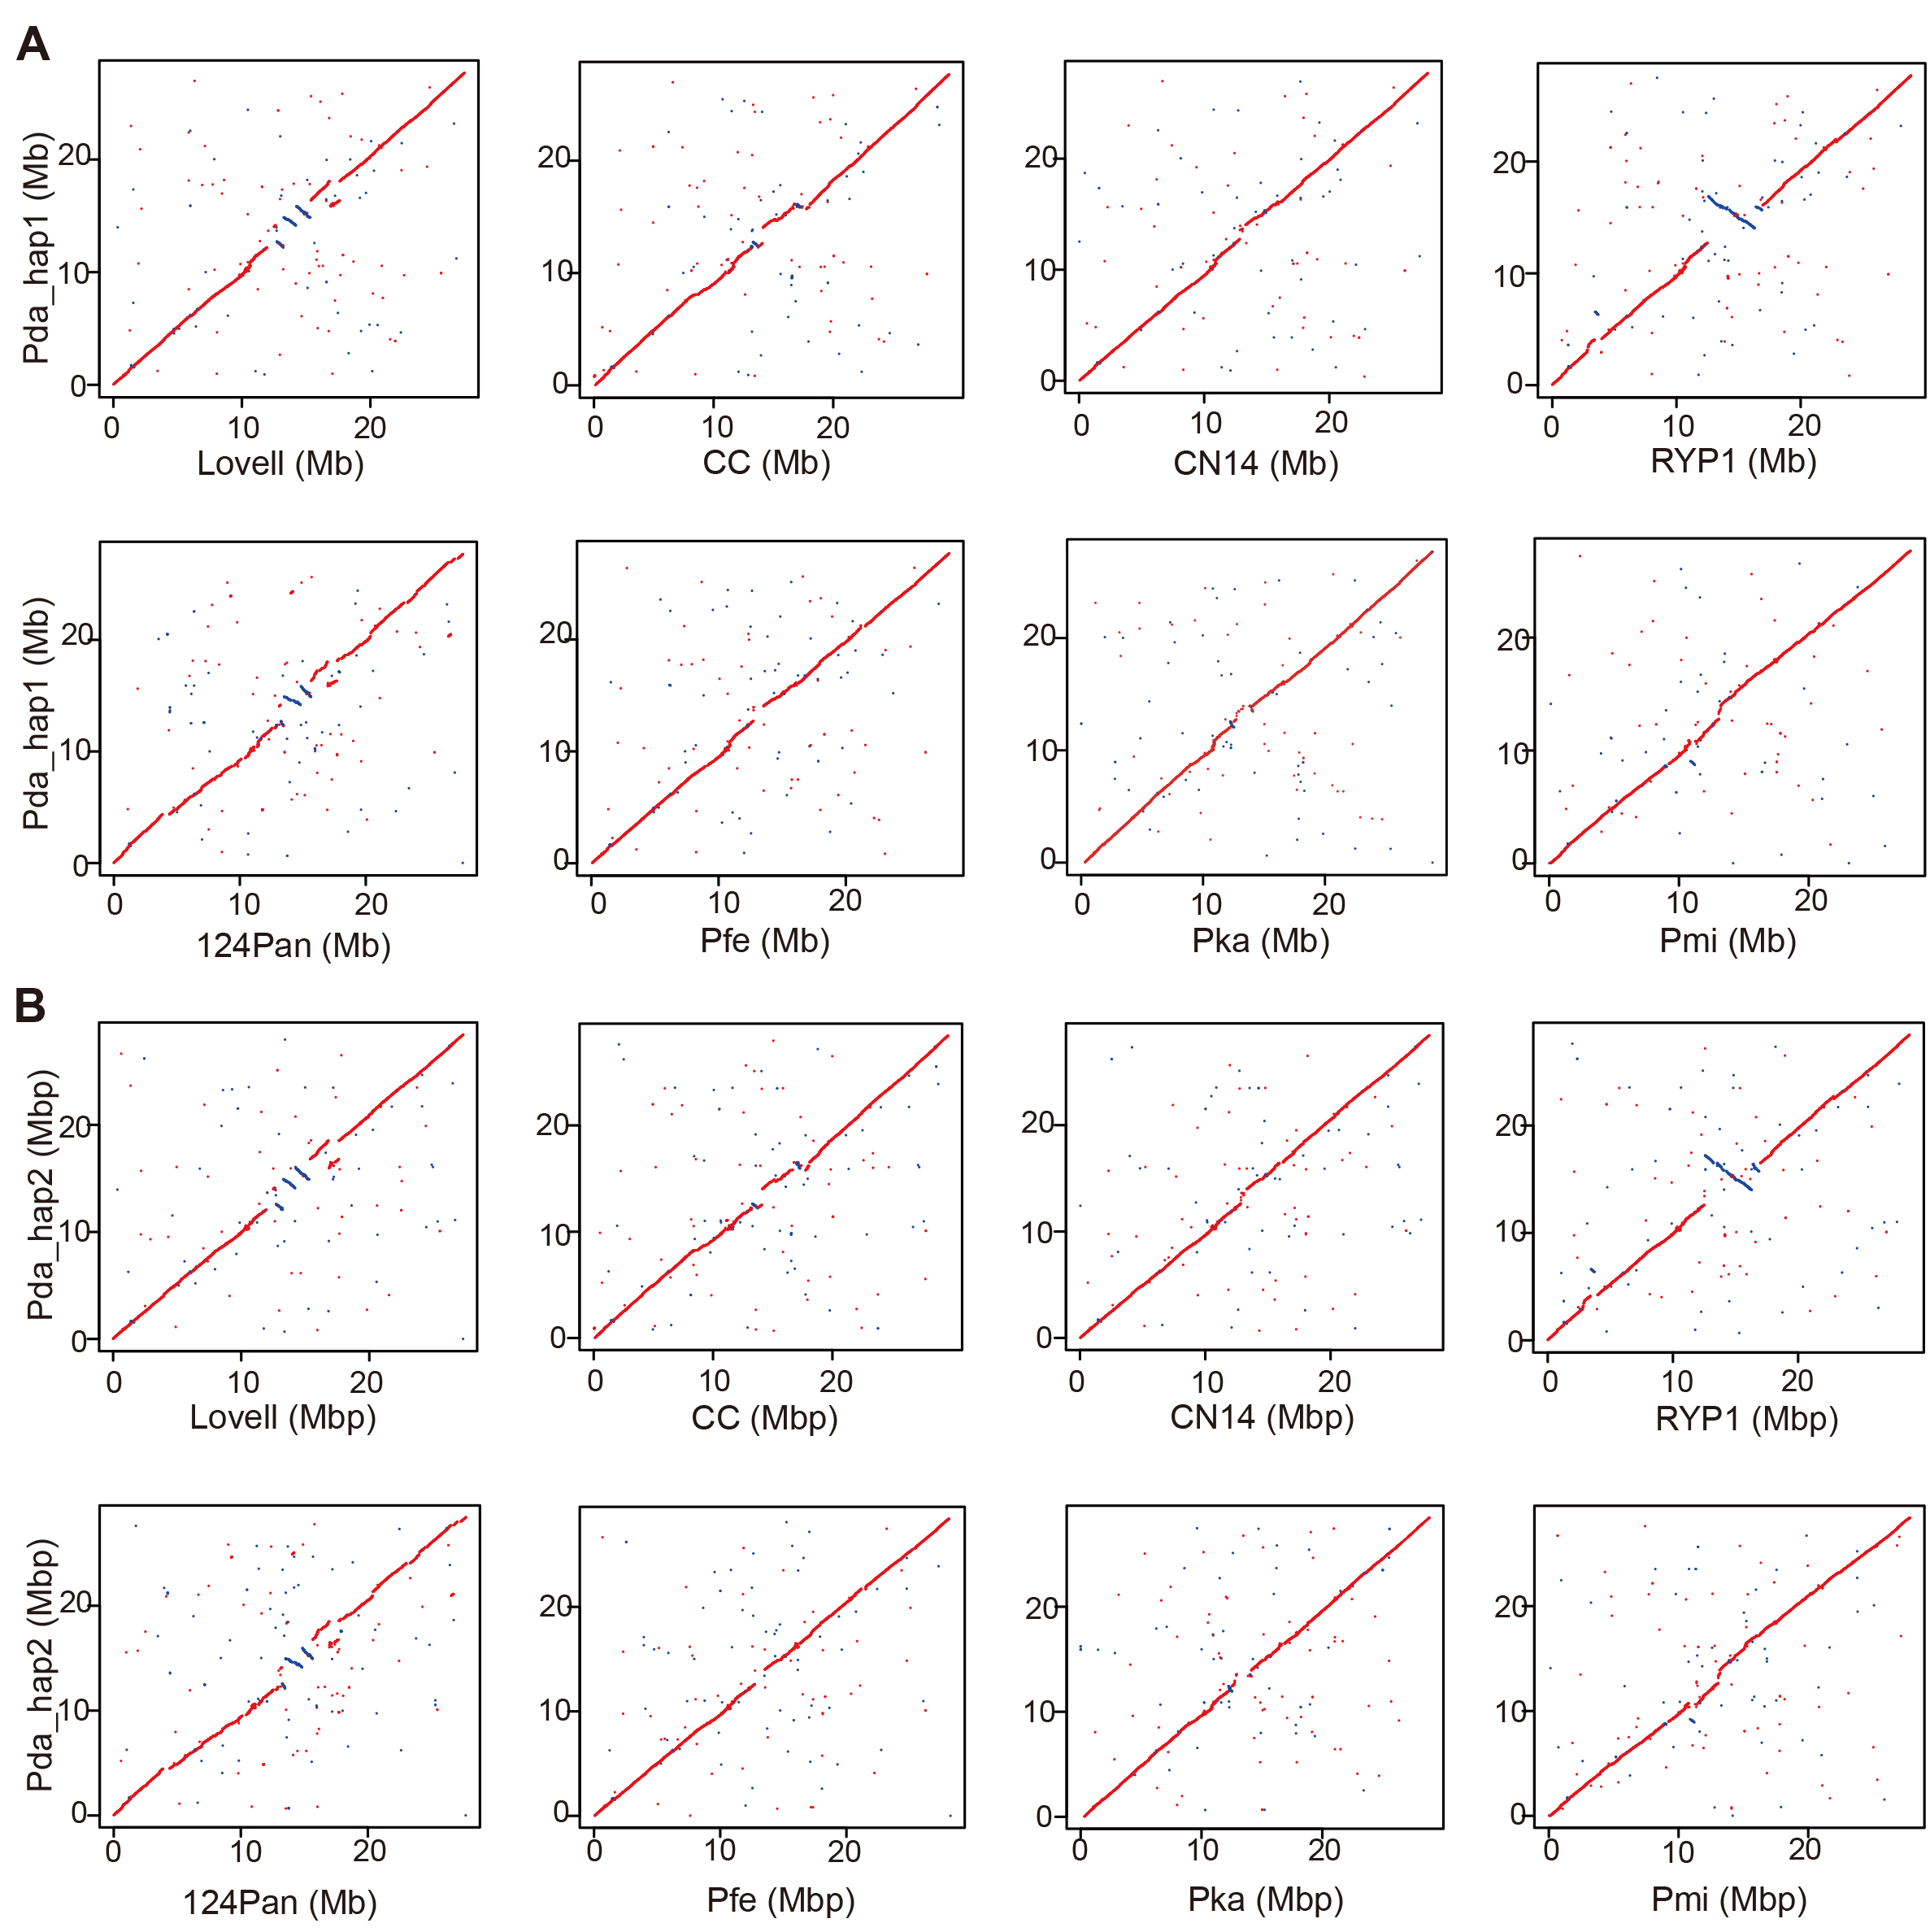
Figure S9. Collinearity of Pda_hap1 (A) and Pda_hap2 (B) versus 8 released peach genomes on chromosomes 3.
Lovell (2.0), Chinese Cling (CC), Zhongyoutao 14 (CN14), Rui You Pan 1 (RYP1), 124Pan, Prunus ferganensis (Pfe), Prunus kansuensis (Pka), Prunus mira (Pmi).

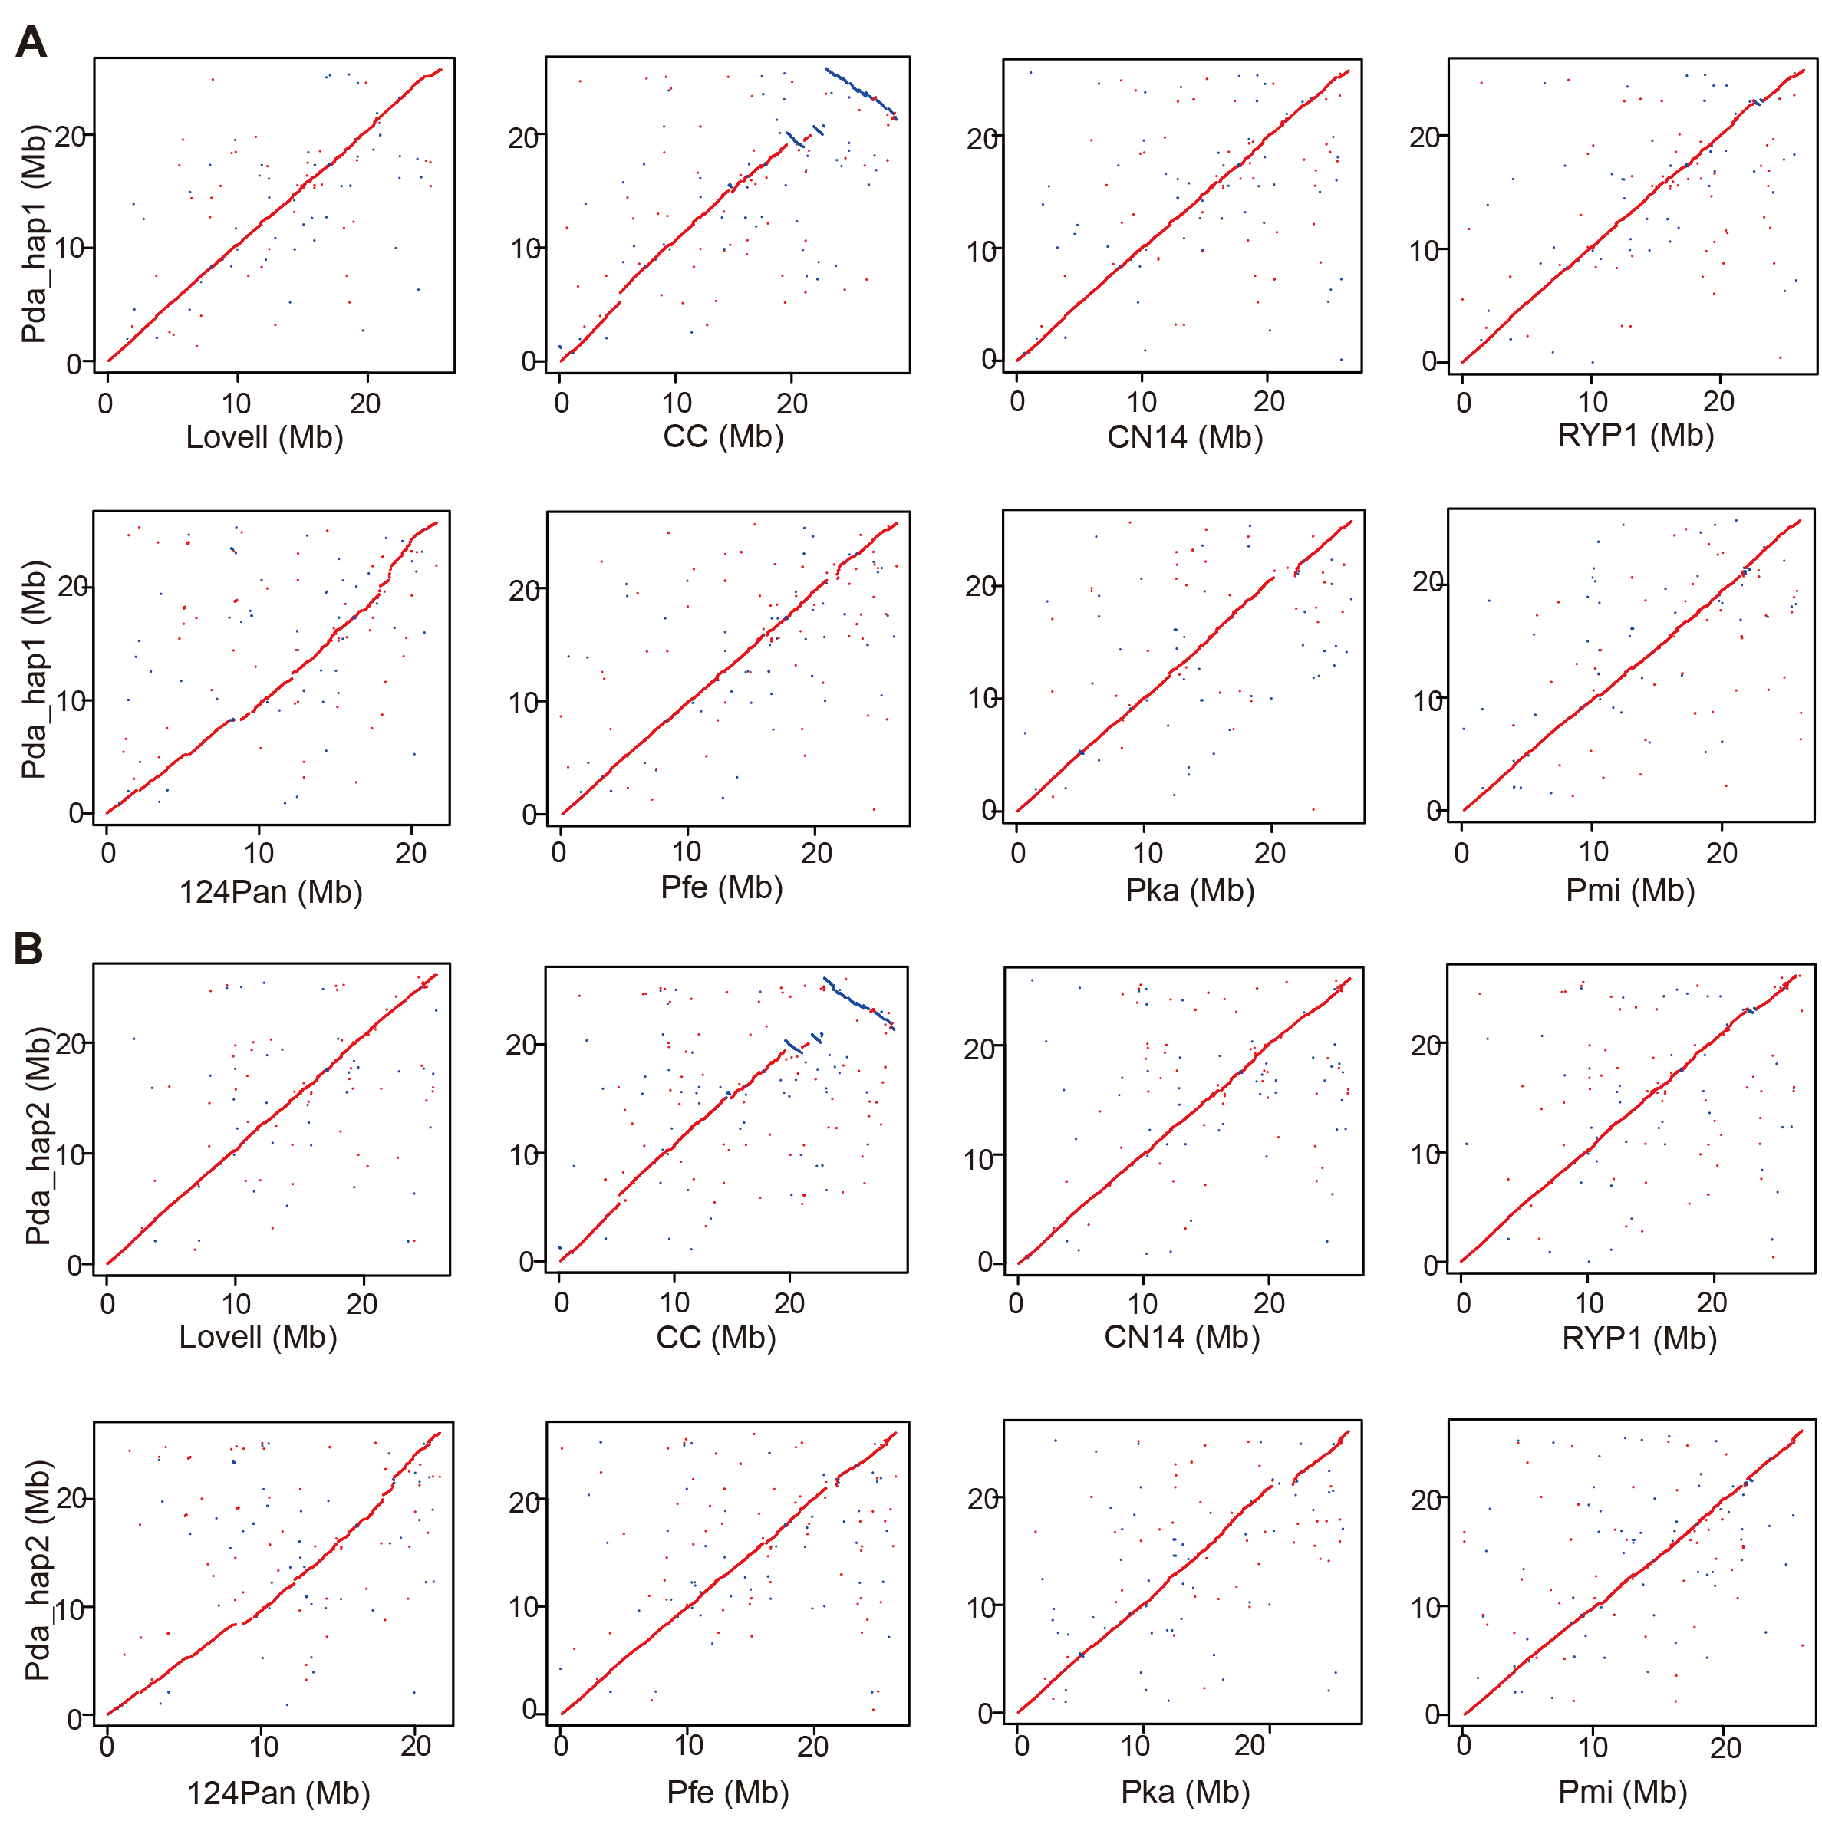
Figure S10. Collinearity of Pda_hap1 (A) and Pda_hap2 (B) versus 8 released peach genomes on chromosomes 4.
Lovell (2.0), Chinese Cling (CC), Zhongyoutao 14 (CN14), Rui You Pan 1 (RYP1), 124Pan, Prunus ferganensis (Pfe), Prunus kansuensis (Pka), Prunus mira (Pmi).

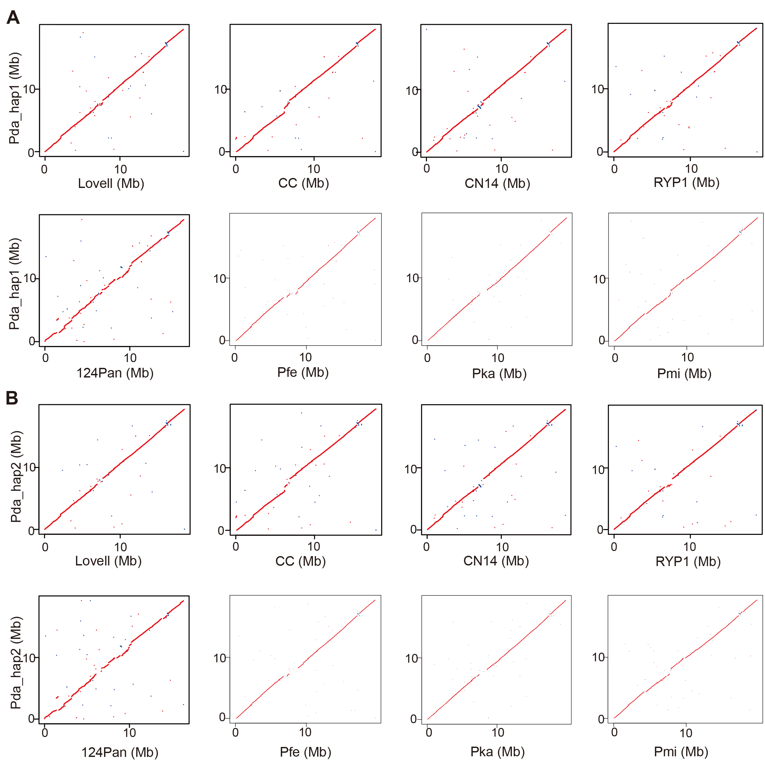
Figure S11. Collinearity of Pda_hap1 (A) and Pda_hap2 (B) versus 8 released peach genomes on chromosomes 5.
Lovell (2.0), Chinese Cling (CC), Zhongyoutao 14 (CN14), Rui You Pan 1 (RYP1), 124Pan, Prunus ferganensis (Pfe), Prunus kansuensis (Pka), Prunus mira (Pmi).

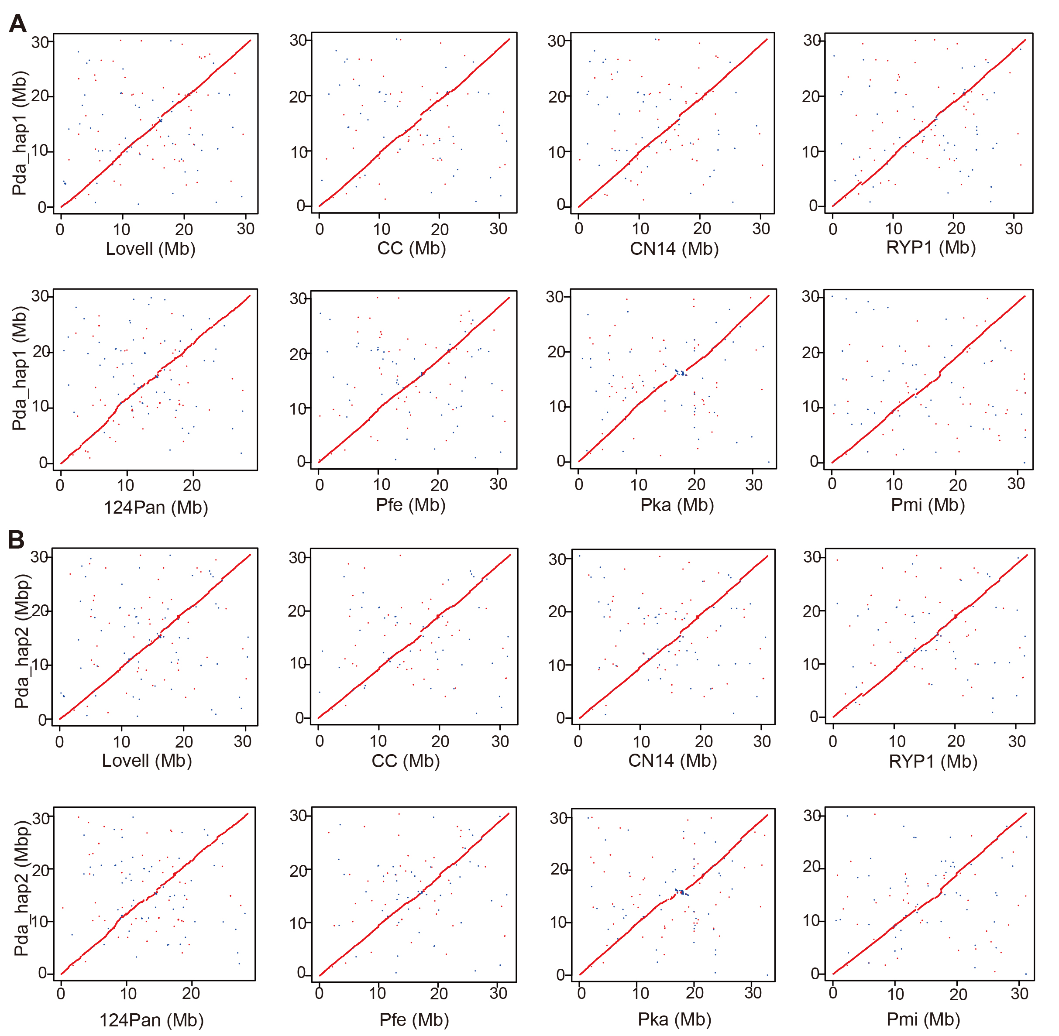
Figure S12. Collinearity of Pda_hap1 (A) and Pda_hap2 (B) versus 8 released peach genomes on chromosomes 6.
Lovell (2.0), Chinese Cling (CC), Zhongyoutao 14 (CN14), Rui You Pan 1 (RYP1), 124Pan, Prunus ferganensis (Pfe), Prunus kansuensis (Pka), Prunus mira (Pmi).

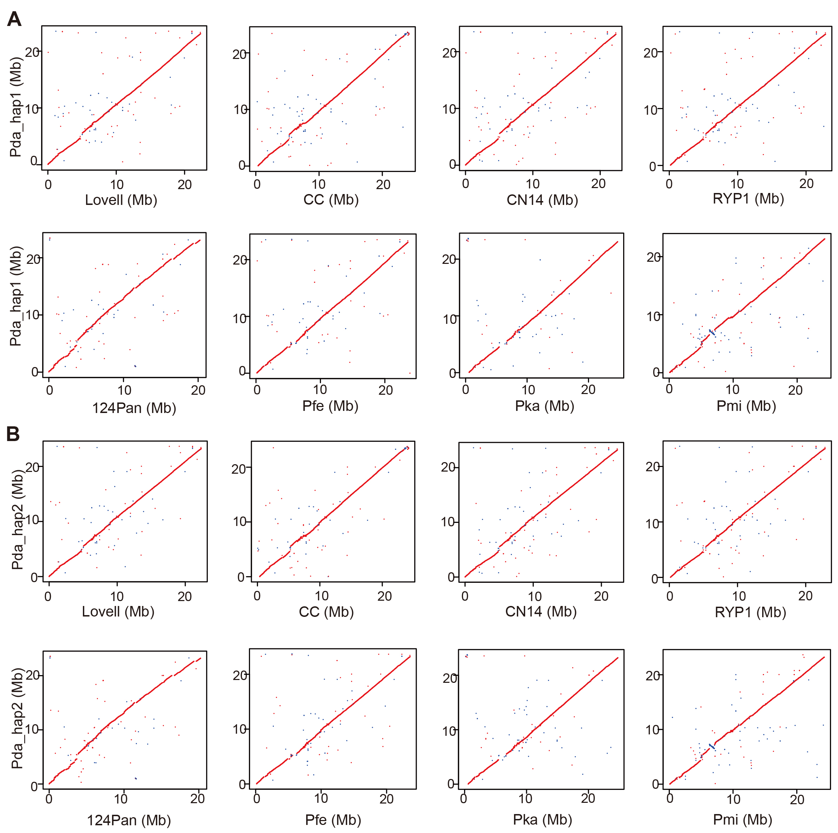
Figure S13. Collinearity of Pda_hap1 (A) and Pda_hap2 (B) versus 8 released peach genomes on chromosomes 7.
Lovell (2.0), Chinese Cling (CC), Zhongyoutao 14 (CN14), Rui You Pan 1 (RYP1), 124Pan, Prunus ferganensis (Pfe), Prunus kansuensis (Pka), Prunus mira (Pmi).

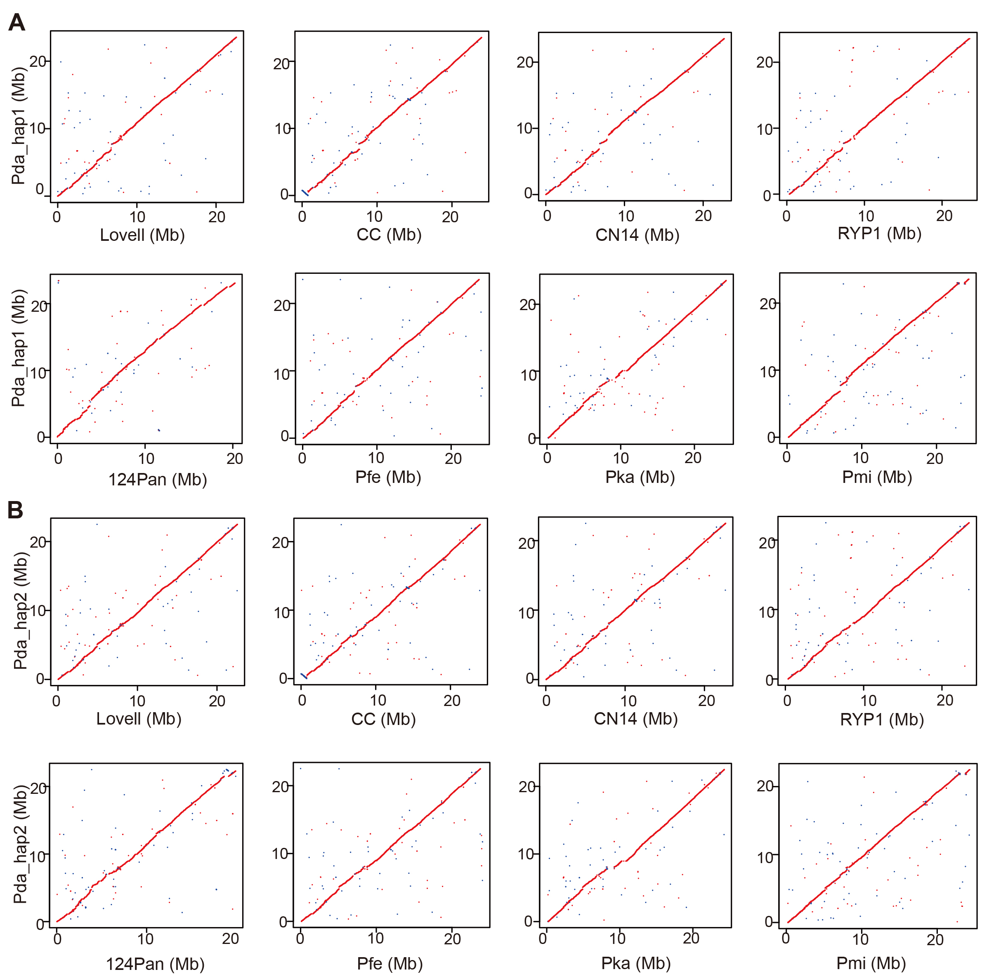
Figure S14. Collinearity of Pda_hap1 (A) and Pda_hap2 (B) versus 8 released peach genomes on chromosomes 8.
Lovell (2.0), Chinese Cling (CC), Zhongyoutao 14 (CN14), Rui You Pan 1 (RYP1), 124Pan, Prunus ferganensis (Pfe), Prunus kansuensis (Pka), Prunus mira (Pmi).

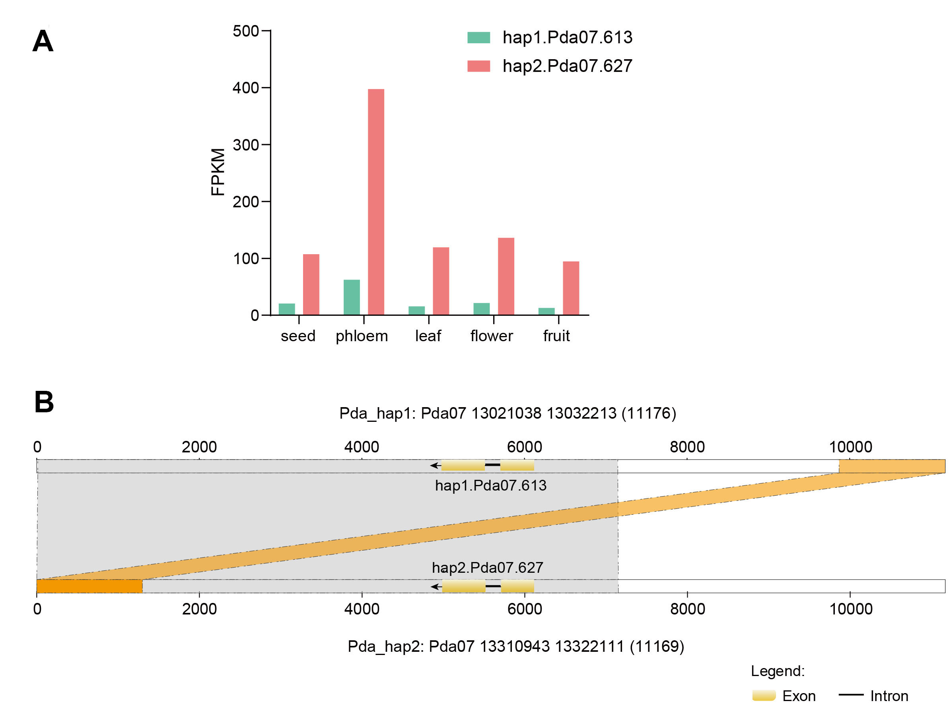
Figure S15. Differences in expression (A) and structure (B) between the two alleles hap1. Pda07.613 and hap2. Pda07.627.
Orange indicates duplication sequence.

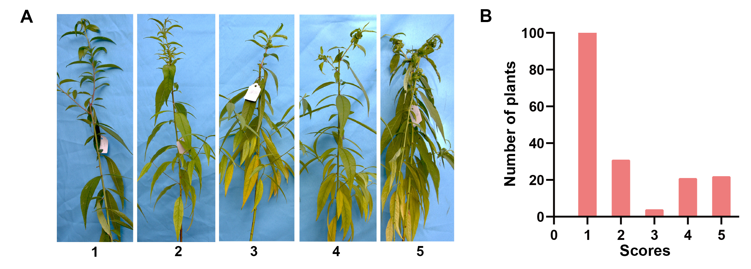
Figure S16. Identification of aphid resistance phenotypes.
(A) Phenotypes with aphid resistance score of 1-5. (B) Number of plants with different aphid resistance levels in F2 population of ZXST.

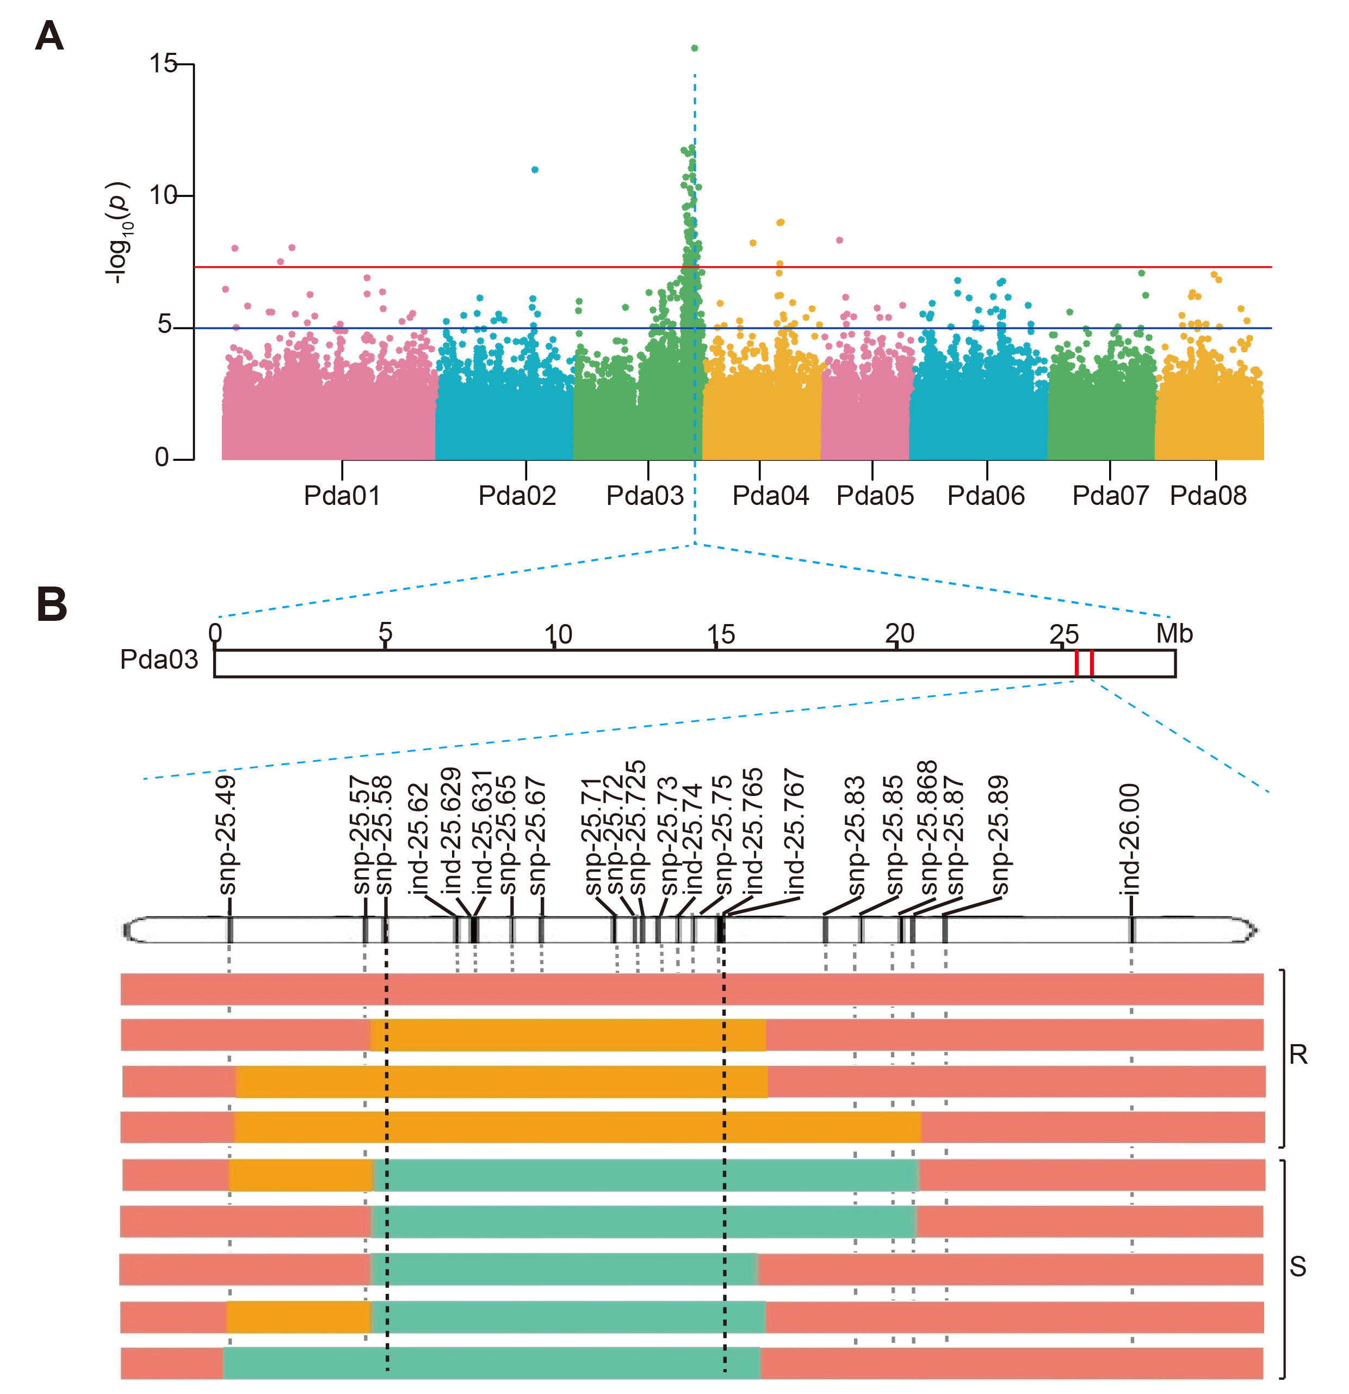
Figure S17. Identification of anti-aphid QTL of ZXST with Pda_hap2 as reference.
(A) Manhattan plot of the FOAM results for aphid-resistance. (B) Flanking marker-assisted selection with 190 offspring plants. Red and green represent chromosome segments corresponding to the resistant and susceptible individuals, respectively. Orange indicates heterozygous.

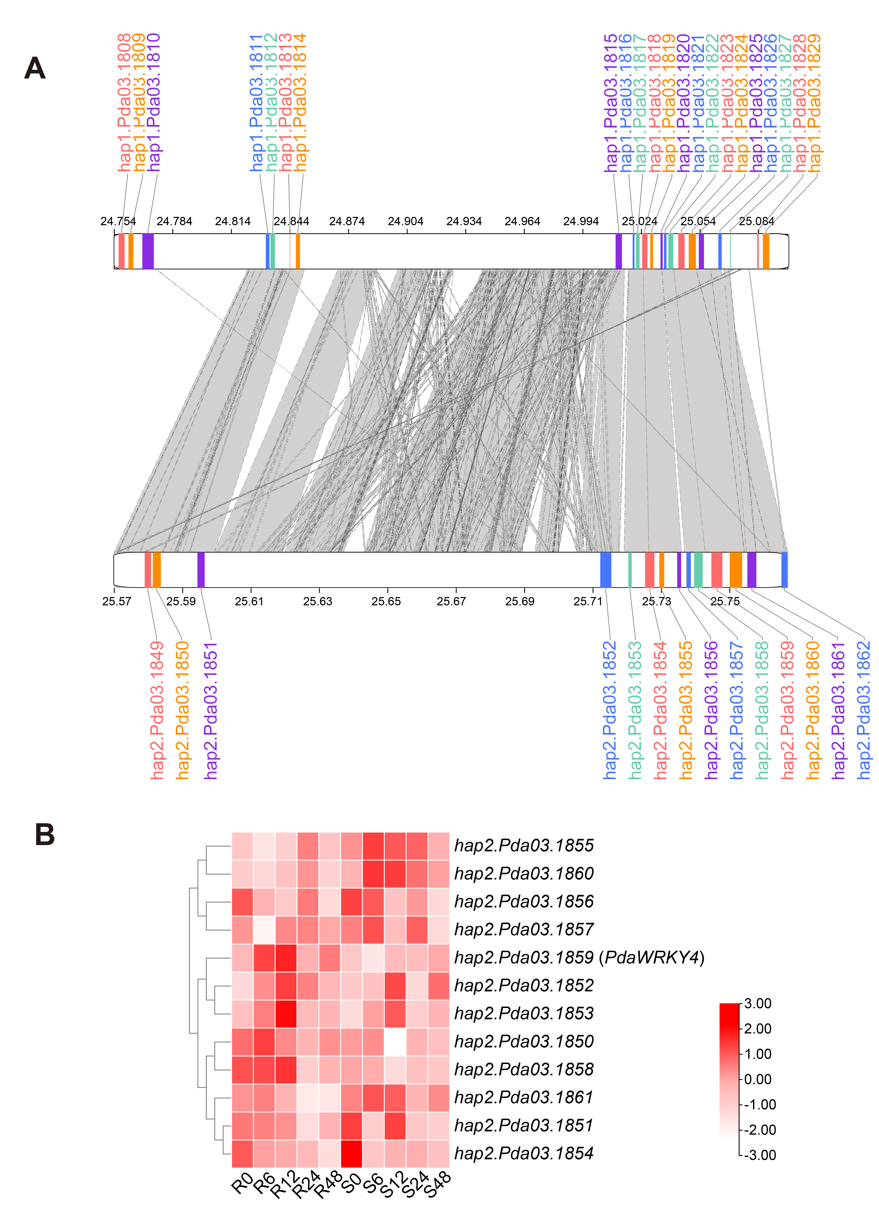
Figure S18. A 9-bp variation in the promoter of PdaWRKY4 highly related to aphid resistance.
(A) The collinearity of two haplotype genomes in the anti-aphid QTL. (B) Taking Pda_hap2 as reference, expression heatmap of genes in the anti-aphid QTL, in R-32 and S-27 at 0, 6, 12, 24 and 48 hours post infestation (hpi).

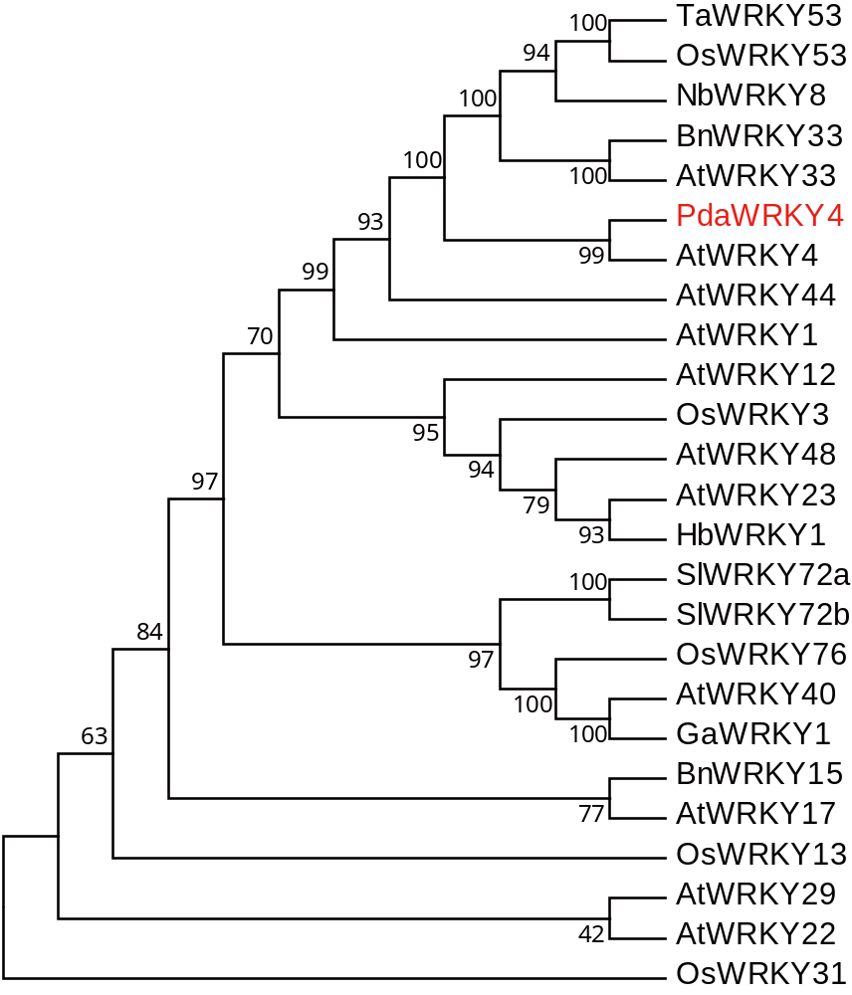
Figure S19. Phylogenetic relationship of PdaWRKY4 with other WRKYs involved in the regulation of secondary metabolism and stress tolerance in plants.
The plant species used for building phylogenetic tree are as follows: Arabidopsis thaliana, Brassica napus, Gossypium arboreum, Hevea brasiliensis, Oryza sativa, Solanum lycopersicum, Triticum aestivum L., and Nicotiana benthamiana.

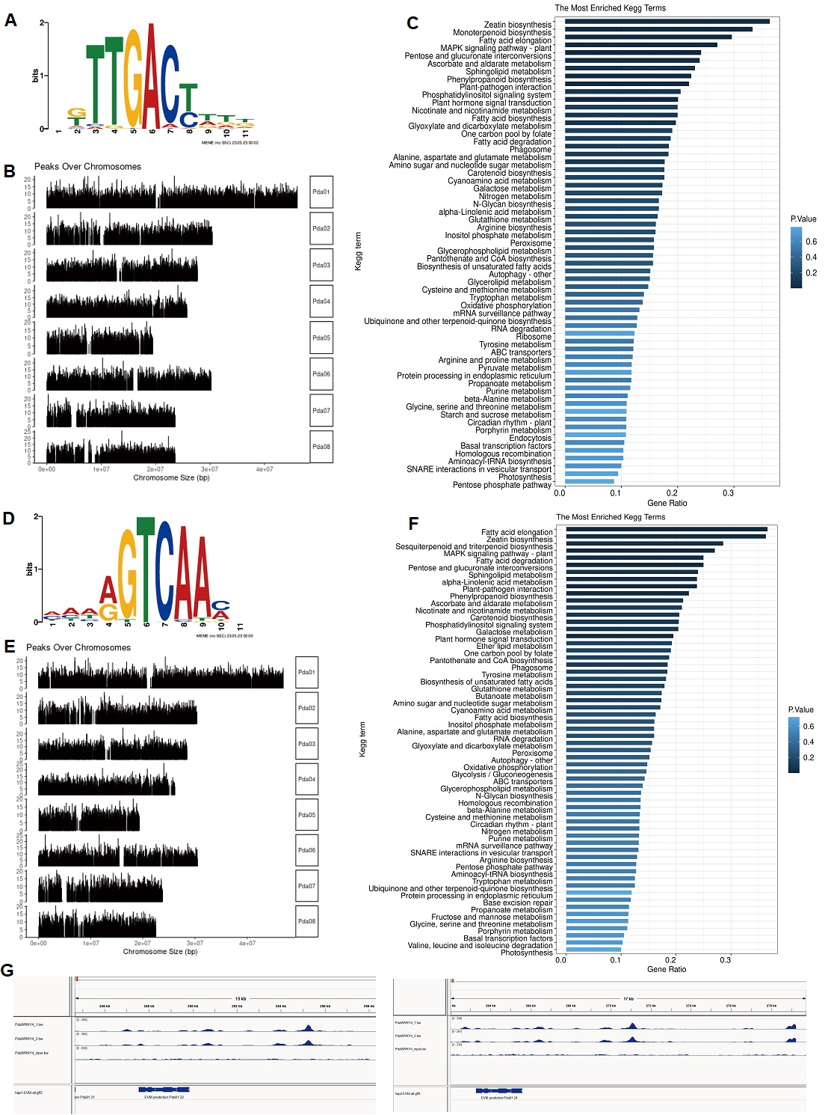
Figure S20. DNA affinity purification sequencing (DAP-seq) of PdaWRKY4.
Position weight matrix of PdaWRKY4 binding motif sequence for Pda_hap1 (A) and Pda_hap2 (D). The distribution of peaks on different chromosomes for Pda_hap1 (B) and Pda_hap2 (E). KEGG enrichment of the peak associated genes for Pda_hap1 (C) and Pda_hap2 (F). (G) Binding peaks on the promoter of the homologue of PpCYP716A1 in Pda_hap1 (left panel) and Pda_hap2 (right panel).

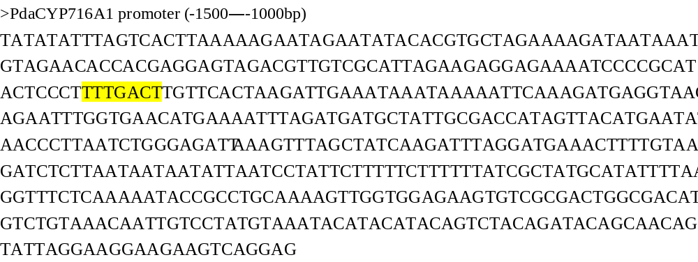
Figure S21. The sequence of PdaCYP716A1 promoter, ranging from 1500 to 1000 bp upstream of the start codon.
The core binding motif is highlighted with yellow color.

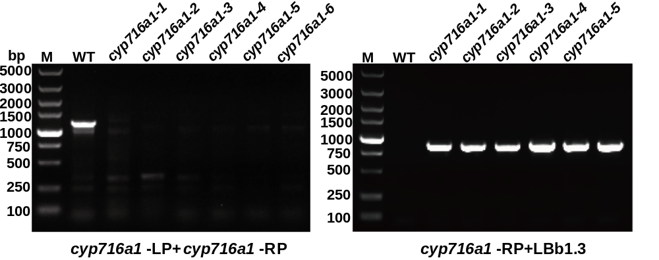

Figure S22 Identification of T-DNA insertion in Arabidopsis mutant cyp716a1 lines by agarose gel electrophoresis.

Table S1. Summary of features of the assembled haplotype genome of ZXST.
Assembly feature | Pda_hap1 | Pda_hap2 | Pda_diploid (Cao et al., 2022)
Genome size (Mb) | 257.1 | 244.6 | 259.3
N50 (Mb) | 27.7 | 28.5 | 28.5
Longest scaffolds (Mb) | 46.1 | 46.9 | 47.2
Number of scaffolds | 375 | 123 | 564
Complete BUSCOs (%) | 98.9 | 99 | 99
Fragmented BUSCOs (%) | 0.6 | 0.5 | 0.5
Missing BUSCOs (%) | 0.5 | 0.5 | 0.5
LTR assembly index (LAI) | 11.81 | 14.71 | 12.8

Table S2. Summary of long terminal repeat sequence in ZXST haplptype genome.
Repeat type | Pda_hap1 |  | Pda_hap2
Repeat type | Total (bp) | Percentage of genome (%) | Total (bp) | Percentage of genome (%)
Copia_LTR_retrotransposon | 11965056 | 4.65 | 13029556 | 5.33
Gypsy_LTR_retrotransposon | 17841476 | 6.94 | 17730828 | 7.25
LTR_retrotransposon | 40131529 | 15.61 | 25325642 | 10.35
long_terminal_repeat | 1334151 | 0.52 | 1292497 | 0.53
repeat_region | 7788581 | 3.03 | 7668965 | 3.14
target_site_duplication | 10742 | 0.00 | 10774 | 0.00
Total content | 79071535 | 30.76 | 65058262 | 26.60

Table S3. Basic statistical results of gene structure prediction of ZXST haplotype genome.
Methods | Software | Number in Pda_hap1 | Number in Pda_hap2
De novo | Augustus | 24966 | 25089
De novo | GlimmerHMM | 9556 | 9639
Homolog | Exonerate | 74759 | 65799
RNA-seq | stringtie | 22174 | 21429
Integration | EVidenceModeler | 22479 | 21784

Table S4. The statistical results of gene function annotation of ZXST haplotype genome.
Database | Gene number in Pda_hap1 | Percent (%) in Pda_hap1 | Gene number in Pda_hap2 | Percent (%) in Pda_hap2
SwissProt | 18621 | 82.84 | 18292 | 83.97
NR | 21591 | 96.05 | 21410 | 98.28
InterProScan | 16674 | 74.18 | 16645 | 76.41
KAAS | 7110 | 31.63 | 7033 | 32.29
EggNOG | 19971 | 88.84 | 19849 | 91.12
Total | 22479 | 100.00 | 21784 | 100.00
Annotated | 21606 | 96.12 | 21420 | 98.33
unannotated | 873 | 3.88 | 364 | 1.67

Table S5. Polymorphic InDel marker sequences.
Primer | Forward | Reverse
IND-1 | GGCCACACTTGTTGAGGTTT | AACCTCCTCAATGCCAAGAA
IND-2 | CCCATATGTTTTCTTCTGTTGG | GGGAAGAGGCAATAGGGAAG
IND-3 | GTATGCCGACCCTTCTTTGA | ACATTTGATTGGTGATGCCC
IND-4 | TGCGTCCATCACCCTATACA | GCTGCCAAGATGAAGAAAGC
IND-5 | ACAGTGCATGGAATGGAACA | CTATTGCAGCGACTGGTTGA
IND-6 | ACAGACCACAAAAGGCCAGT | ATTGAGGGCTTTTCCAATCC
IND-7 | TGCAGCCCACTATAGAAATGG | TGGGTTTGTCATTCTCCACC
IND-8 | CTCCTCCCAATCCTCTCTCC | GTGTCAGTGGGAAAAGCCAT
IND-9 | GCCACGTCTTGTTCGGTAAT | TGATACTGAGGAGAACGCAAA
IND-10 | AGTGGCTGAAAGGCCTACAA | CGGGTTAATGTGATAGCAGGA
IND-11 | ATCGGACCTGAAGATCCTTG | GACGGTTTACCCAAAAGTGG
IND-12 | TGGAGCAGTTGGAGATGATG | AGTCTCCTCCTCCAGCAACA
IND-13 | CGCAAATAGCAACCCACTTT | CTGCTGGGATTACACGGTTT
IND-14 | AAAGGTCTCATTCTGGGCCT | GCTCTTTCATGCACGCTACA
IND-15 | ACGAATTGCCAAGGATTTTG | ATCAGCGGCAGTTTTTCAGT
IND-16 | ATCCCACCACTCTCCAATCA | AGGTGGCCGACAACATAAAG
IND-17 | GAAAATTTCCGATTTTGGCA | CATGTCCAACCATTTGAAGG
IND-18 | TGATATTCCCCCGAGACTTG | CAGGTTGCGCTACAGATGAA
IND-19 | CCCCTTTGCAACACTTCAAT | TTCCATGCATCTCTTTTCCC
IND-20 | TCCTGAGGCTTCCGTTATTG | CAAAGGCTGTTCAGCTGCTA
IND-21 | ATGTACGTGGCATAAACGCA | AGCAGCCTCCTCGATACAAA
IND-22 | CTCCGAGTTGGTCCAGAGAC | CGCTCAACAGCAAACTCTGT
IND-23 | TGTCAGTTAGTTGCCCTCCC | GCATTCCAAACTCCAAGGAA
IND-24 | CAAATGAAGCCCAGAAGCTC | ACCTTCCGAGGTTGTCTCCT
IND-25 | GGGACATGATAGCTGCTGGT | ATCCACATCTCCACTGCACA
IND-26 | GGAGTTGACCTTCCAACGAA | TGGTAGGTGGCCATACATGA
IND-27 | GGGCAGTGCCTTATACCTTG | TGTCTCAGGTTCAAAACCCC
IND-28 | AGGGCTACTGGAAAGGTGGT | CATTGACTTCGAGCCAGAGA
IND-29 | CAATGGCCCTGAACAAAAAC | CGAGCACTTAGTGGAGCACA
IND-30 | AGGTCCTACTCATGGCGTTG | CGTTTGTGTTCTTGACCCCT
IND-31 | TGCTGAAATACCGTCTCGTG | CAATGGGTTGAGCCTTGACT
IND-32 | ACCAGAAACCCAACAGCAAC | ATGTACCTCCCAAATGCTGC
IND-33 | CACAACTGGCACAAAAGGAA | GCTTGAAGGATGGGAAATCA
IND-34 | GACCTCCTCCATTCACAAGG | CAGCTTGAATTCGCAACAAA
IND-35 | ACCTGAAGAGGAGGCTGTGA | AATGGTGGCTGAGAAGGAGA

Table S6. Flanking markers in anti-aphid QTL of Pda_hap1 for assisted selection.
Name | Position | Reference | Alternative
snp-24.74 | 24737948 | C | T
snp-24.75 | 24750981 | T | G
snp-24.754 | 24754324 | G | T
snp-24.761 | 24761294 | A | G
snp-24.766 | 24765848 | C | T
snp-24.772 | 24772079 | T | C
snp-24.829 | 24829094 | T | C
snp-24.838 | 24837835 | A | G
snp-24.84 | 24840758 | G | A
snp-24.85 | 24847847 | T | C
snp-24.869 | 24869272 | A | T
snp-24.877 | 24877083 | A | G
snp-24.881 | 24880725 | C | A
snp-24.909 | 24908647 | A | T
snp-24.912 | 24911606 | G | T
snp-24.956 | 24955905 | C | T
snp-24.964 | 24964224 | T | C
snp-24.98 | 24982817 | C | T
snp-25.00 | 24995320 | A | T
indel-25.04 | 25040603 | T | TTTTCCGGCC
snp-25.10 | 25098201 | T | A
snp-25.12 | 25120812 | T | A
snp-25.14 | 25135260 | T | C
snp-25.155 | 25155398 | T | G
snp-25.165 | 25164830 | A | C

Table S7. Flanking markers in anti-aphid QTL of Pda_hap2 for assisted selection.
Name | Position | Reference | Alternative
snp-25.49 | 25493476 | T | C
snp-25.57 | 25570289 | A | C
snp-25.58 | 25580133 | G | A
indel-25.62 | 25619783 | C | CA
indel-25.629 | 25628756 | T | TGAGTGGTAGC
indel-25.631 | 25630569 | T | TC
snp-25.65 | 25650749 | A | G
snp-25.67 | 25666710 | G | A
snp-25.71 | 25708987 | T | C
snp-25.72 | 25719980 | C | A
snp-25.725 | 25724551 | T | C
snp-25.73 | 25732925 | G | T
indel-25.74 | 25742979 | T | TTTTCCGGCC
snp-25.75 | 25751480 | G | T
indel-25.765 | 25765235 | T | TG
indel-25.767 | 25766923 | A | AT
snp-25.83 | 25825527 | T | A
snp-25.85 | 25845084 | A | C
snp-25.868 | 25867838 | G | A
snp-25.87 | 25872738 | G | T
snp-25.89 | 25891749 | T | C
indel-26.00 | 25995661 | GA | G

Table S8. The alleles within the anti-aphid QTLs of the two haplotypes
Pda_hap1 | Pda_hap2 | Annotation
Pda03.1808 | Pda03.1846 | Cyclic nucleotide-gated ion channel 2
Pda03.1809 | Pda03.1847 | Phosphatidylinositol 3,4,5-trisphosphate 3-phosphatase and protein-tyrosine-phosphatase PTEN1
Pda03.1810 | Pda03.1848 | Probable ubiquitin conjugation factor E4
Pda03.1811 | Pda03.1849 | F-box/FBD/LRR-repeat protein
Pda03.1812 | Pda03.1850 | tRNA (guanosine(18)-2'-O)-methyltransferase
Pda03.1813 |  | UDP-glycosyltransferase 13
Pda03.1814 | Pda03.1851 | Probable mitochondrial saccharopine dehydrogenase-like oxidoreductase
Pda03.1815 | Pda03.1852 | No Hit Found
Pda03.1816 | Pda03.1853 | UPF0301 protein Plut_0637
Pda03.1817 |  | Pentatricopeptide repeat-containing protein
Pda03.1818 | Pda03.1854 | Chorismate mutase 1, chloroplastic
Pda03.1819 | Pda03.1855 | Lamin-like protein
Pda03.1820 | Pda03.1856 | Lamin-like protein
Pda03.1821 | Pda03.1857 | Cell division topological specificity factor homolog, chloroplastic
Pda03.1822 | Pda03.1858 | No Hit Found
Pda03.1823 | Pda03.1859 | Probable WRKY transcription factor 4
Pda03.1824 | Pda03.1860 | Cyclin-dependent kinase C-2 C
Pda03.1825 | Pda03.1861 | No Hit Found
Pda03.1826 | Pda03.1862 | Protein ADP-ribosyltransferase PARP3
Pda03.1827 | Pda03.1863 | No Hit Found
Pda03.1828 | Pda03.1864 | Transmembrane protein 230
Pda03.1829 | Pda03.1865 | SNF1-related protein kinase catalytic subunit alpha KIN10

Table S9. Parameters of dose-response curves from microscale thermophoresis experiments.
Test | Treatments | Kd (nM) | 95% CI a (nM) | HillSlope | R2
Pda01.3808 | R promoter of PdaWRKY4 | 141.5 | - | 12.46 | 0.05
Pda01.3808 | S promoter of PdaWRKY4 | 1.21 | 0.90-1.60 | 0.14 | 0.96
Pda03.257 | R promoter of PdaWRKY4 | 70.98 | - | -14.64 | 0.23
Pda03.257 | S promoter of PdaWRKY4 | 4.53 | 3.36-6.22 | 0.83 | 0.97
PdaWRKY4 | PdaCYP716A1 promoter | 4.71 | 3.23-6.89 | 0.85 | 0.95
CI a, Confidence Interval; R2, coefficient of determination.

Table S10. Genomic loci associated with soluble solid content and fruit weight.
Traits | Chr | Lovell2.0 | Major allele | Minor allele | Pda_hap1 | Pda_hap2 | Reference
SSC | 1 | 11511656 | T | C | 11181386 | 11414833 | Li et al., 2019b
 | 1 | 11597100 | T | A | 11267397 | 11540467 | Li et al., 2019b
 | 1 | 11599686 | A | C | 11270151 | 11543237 | Li et al., 2019b
 | 1 | 11606442 | G | T | 11276932 | 11550024 | Li et al., 2019b
 | 1 | 11613651 | G | C | 11284045 | 11557228 | Li et al., 2019b
 | 1 | 17538855 | A | G | 16879874 | 17301083 | da Silva Linge et al., 2021
 | 1 | 33203045 | T | A | 31681161 | 28874826 | Li et al., 2019b
 | 2 | 14008803 | G | A | 15461226 | 13792490 | Li et al., 2019b
 | 2 | 29042803 | A | G | 29095902 | 29047838 | Li et al., 2019b
 | 3 | 3919221 | G | C | 4144904 | 3971203 | Li et al., 2019b
 | 4 | 694626 | G | A | 6967580 | 6978677 | da Silva Linge et al., 2021
 | 4 | 1851070 | C | T | 1824053 | 1860182 | Li et al., 2019b
 | 4 | 1851100 | A | G | 1824079 | 1860214 | Quilot et al., 2004
 | 4 | 8866627 | T | A | 9172146 | 9240921 | Quilot et al., 2004
 | 4 | 9917371 | G | A | 10213011 | 10213361 | Quilot et al., 2004
 | 4 | 9956708 | A | C | 16640243 | 10192571 | Quilot et al., 2004
 | 4 | 11208348–12107192 | — | — | 11510188–12538247 | 11691696–12685534 | Hernández Mora et al., 2017
 | 5 | 541076 | T | C | 524782 | 533799 | Cao et al., 2016
 | 5 | 1376476–6071714 | — | — | 1356255–6286209 | 1362067–6290813 | Hernández Mora et al., 2017
 | 5 | 1436302 | G | A | 1420779 | 1426589 | Quilot et al., 2004
 | 5 | 15249345–18236498 | — | — | 15974277–19332614 | 15907205–19144788 | Hernández Mora et al., 2017
 | 6 | 21277895 | T | G | 20861455 | 20862643 | da Silva Linge et al., 2021
 | 6 | 29231387–30104758 | — | — | 28682887–29580371 | 28972874–29835766 | Hernández Mora et al., 2017
FW | 1 | 209701 | A | G | 165667 | 206261 | da Silva Linge et al., 2021
 | 1 | 27194373–28053064 | — | — | 25878568–26639868 | 26700949–27458761 | da Silva Linge et al., 2021
 | 2 | 1197660–4172142 | — | — | 1063798–3808051 | 1145505–3899468 | Hernández Mora et al., 2017
 | 3 | 3989094 | G | A | 4114018 | 4189933 | da Silva Linge et al., 2021
 | 4 | 9321093 | T | C | 9612683 | 9636424 | da Silva Linge et al., 2021
 | 4 | 15742278 | A | G | 16199993 | 16123745 | da Silva Linge et al., 2021
 | 5 | 1376476–4224621 | — | — | 1347711–4471526 | 1362067–4465671 | Hernández Mora et al., 2017
 | 5 | 11258684–14161849 | — | — | 11856324–14801271 | 11837110–14720729 | Hernández Mora et al., 2017
 | 5 | 15249345–18236498 | — | — | 15974277–19332614 | 15907205–19144788 | Hernández Mora et al., 2017
 | 6 | 27164548–30104758 | — | — | 26619910–29580371 | 26925360–29835766 | Hernández Mora et al., 2017

Table S11. The length of IBD segments derived from cultivar peaches.
Accessions | Segments derived from cultivar peaches |  |  | Segments derived from JH |  |  | Segments derived from XPYT
Accessions | Total/100kb | SSC/100kb | FW/100kb | Total/100kb | SSC/100kb | FW/100kb | Total/100kb | SSC/100kb | FW/100kb
1704-38 | 54.501 | 22.733 | 49.017 | 7.92 | 3.092 | 7.389 | 46.581 | 19.641 | 41.628
1704-40 | 66.736 | 25.881 | 48.204 | 15.287 | 4.604 | 11.72 | 51.449 | 21.277 | 36.484
1704-41 | 62.643 | 29.557 | 50.658 | 13.012 | 6.098 | 10.089 | 49.959 | 23.459 | 40.569
1704-42 | 42.41 | 19.136 | 31.921 | 7.814 | 4.284 | 4.784 | 34.596 | 14.852 | 27.137
1704-43 | 41.256 | 10.114 | 37.375 | 8.797 | 1.846 | 8.05 | 32.459 | 8.268 | 29.325
1704-47 | 43.741 | 20.275 | 28.893 | 9.798 | 3.527 | 7.072 | 33.943 | 16.748 | 21.821
1704-49 | 50.861 | 30.581 | 27.402 | 10.071 | 5.068 | 6.355 | 40.79 | 25.513 | 21.047
1704-50 | 68.651 | 23.342 | 53.048 | 15.945 | 4.107 | 12.557 | 52.706 | 19.235 | 39.702
1704-52 | 81.197 | 29.252 | 68.775 | 17.44 | 5.149 | 14.967 | 63.757 | 24.103 | 53.808
1704-53 | 88.426 | 52.363 | 52.568 | 19.006 | 10.677 | 10.917 | 69.42 | 41.686 | 41.651
1704-54 | 69.863 | 19.484 | 56.724 | 15.791 | 3.873 | 13.057 | 54.072 | 15.611 | 43.667
1704-55 | 64.888 | 41.472 | 30.151 | 14.393 | 8.863 | 7.045 | 50.495 | 32.609 | 23.106
1704-56 | 104.905 | 53.571 | 68.189 | 19.506 | 9.845 | 12.306 | 85.399 | 43.726 | 55.883
1704-57 | 69.085 | 43.1 | 31.716 | 14.348 | 8.435 | 7.286 | 54.737 | 34.665 | 24.43
1704-60 | 87.915 | 36.183 | 68.408 | 15.498 | 6.874 | 11.237 | 72.417 | 29.309 | 57.171
1704-61 | 87.262 | 39.52 | 66.681 | 13.988 | 7.315 | 10.04 | 73.274 | 32.205 | 56.641
1704-63 | 55.086 | 22.235 | 39.043 | 10.684 | 4.06 | 7.386 | 44.402 | 18.175 | 31.657
1704-65 | 72.766 | 44.336 | 36.6 | 16.899 | 8.999 | 9.158 | 55.867 | 35.337 | 27.442
1704-67 | 61.484 | 21.486 | 46.17 | 14.806 | 4.219 | 10.879 | 47.398 | 17.267 | 35.291
1704-69 | 86.124 | 44.861 | 59.817 | 15.649 | 8.826 | 9.621 | 70.475 | 36.035 | 50.196
1704-70 | 40.202 | 14.46 | 31.716 | 8.851 | 1.834 | 7.904 | 31.351 | 12.626 | 23.812
1704-71 | 73.838 | 39.895 | 42.085 | 14.656 | 7.64 | 8.257 | 59.182 | 32.255 | 33.828
1704-72 | 71.91 | 38.712 | 40.095 | 16.042 | 8.368 | 8.411 | 55.868 | 30.344 | 31.684
1704-73 | 80.803 | 42.443 | 45.546 | 15.227 | 8.172 | 8.178 | 65.576 | 34.271 | 37.368
1704-74 | 66.528 | 29.816 | 52.932 | 12.252 | 6.396 | 8.637 | 54.276 | 23.42 | 44.295
1704-76 | 79.886 | 38.126 | 59.607 | 14.948 | 6.308 | 11.494 | 64.938 | 31.818 | 48.113
1704-77 | 84.314 | 38.921 | 62.759 | 14.038 | 6.763 | 10.135 | 70.276 | 32.158 | 52.624
1704-78 | 60.503 | 26.655 | 41.858 | 13.255 | 4.39 | 10.207 | 47.248 | 22.265 | 31.651
1704-79 | 63.682 | 24.337 | 46.714 | 11.057 | 4.078 | 8.107 | 52.625 | 20.259 | 38.607
1704-80 | 79.922 | 24.749 | 72.606 | 15.985 | 3.988 | 14.937 | 63.937 | 20.761 | 57.669
1704-81 | 99.209 | 46.13 | 70.284 | 18.751 | 8.703 | 12.771 | 80.458 | 37.427 | 57.513
1707-83 | 59.232 | 24.093 | 52.37 | 12.026 | 3.688 | 11.359 | 47.206 | 20.405 | 41.011
1704-84 | 79.945 | 28.626 | 66.52 | 15.508 | 5.519 | 12.246 | 64.437 | 23.107 | 55.004
1707-85 | 76.347 | 40.825 | 41.162 | 19.478 | 9.321 | 11.53 | 56.869 | 31.504 | 29.632
1707-86 | 77.804 | 35.587 | 59.88 | 15.275 | 6.468 | 11.833 | 62.215 | 29.119 | 48.047
1707-87 | 48.782 | 19.096 | 38.397 | 11.889 | 4.355 | 9.032 | 36.893 | 14.741 | 29.365
1707-88 | 92.808 | 52.868 | 56.986 | 18.711 | 9.967 | 11.281 | 74.097 | 42.901 | 45.705
1707-89 | 81.906 | 48.771 | 46.442 | 13.727 | 8.973 | 6.326 | 68.179 | 39.798 | 40.116
1707-91 | 83.758 | 50.986 | 50.715 | 15.101 | 10.47 | 7.983 | 68.657 | 40.516 | 42.732
1707-94 | 82.152 | 42.95 | 47.308 | 16.636 | 8.818 | 8.989 | 65.516 | 34.132 | 38.319
1707-95 | 57.654 | 28.564 | 36.257 | 11.79 | 5.196 | 7.972 | 45.864 | 23.368 | 28.285
1707-96 | 87.283 | 47.157 | 58.668 | 13.871 | 8.212 | 8.262 | 73.412 | 38.945 | 50.406

Table S12. The sequence of qRT-PCR primers.
Gene ID | Forward | Reverse
PpActin | GATTCCGGTGCCCAGAAGT | CCAGCAGCTTCCATTCCAA
PdaWRKY4 | ATTTGATGGTGGCTCGGTCG | TTCCAAATGGACTCGGAGGTG
PdaCYP716A1 | CAGCGCTACCTGCACTTTCA | TCCATTTGCTCCTTGTAGACCT

Table S13. The sequence of specific primers for PCR amplification.
Primers | Sequence
35S::PdaWRKY4-F | gggaattccatatgATGACAGAAAAAGAAAAAAGGTGCT
35S::PdaWRKY4-R | cgcggatccTTACACAAAGATTTGCTCTTCTTTTAGC
35S::PdaCYP716A1-F | tcttcactgttgatacatatgATGGAGCATTTCTATCTCACCCTC
35S::PdaCYP716A1-R | ttcggatccggtacccccgggTTAAGCAGTCTTTTTGTGAGGAAAA
R-pGreen-F | ctatagggcgaattgggtaccTAATAATAAATCTTAAAAAAGCTAAAAAAATTC
R-pGreen-R | tgtttttggcgtcttccatggAAACCCTCTGTTTTATCTATCTCTCTGTA
S-pGreen-F | ctatagggcgaattgggtaccTAATAATAAATCTTTTTCCGGCCA
S-pGreen-R | tgtttttggcgtcttccatggAAACCCTCTGTTTTATCTATCTCTCTGTA
P1-pGreen-F | ctatagggcgaattgggtaccACCCGATGCTCCCAAACAA
P1-pGreen-R | tgtttttggcgtcttccatggGATTGATTAAACTGTTGTGATCAGTGTT
P2-pGreen-F | ctatagggcgaattgggtaccGCAACCAATATCTCGTTCAATTATTT
P2-pGreen-R | tgtttttggcgtcttccatggGATTGATTAAACTGTTGTGATCAGTGTT
P3-pGreen-F | ctatagggcgaattgggtaccTATATATTTAGTCAGTTAAAAAGAATAGAATATACACG
P3-pGreen-R | tgtttttggcgtcttccatggGATTGATTAAACTGTTGTGATCAGTGTT
P4-pGreen-F | ctatagggcgaattgggtaccAGAAACTCTGGCATAGGTATCCCA
P4-pGreen-R | tgtttttggcgtcttccatggGATTGATTAAACTGTTGTGATCAGTGTT
PABAi-PdaCYP716A1-F | aaatgatgaattgaaaagcttTATATATTTAGTCAGTTAAAAAGAATAGAATATACACG
PABAi-PdaCYP716A1-R | cgaggtcgacagatccccgggCTCCTGACTTCTTCCTTCCTAATACC
AD-PdaWRKY4-F | gccatggaggccagtgaattcATGACAGAAAAAGAAAAAAGGTGCT
AD-PdaWRKY4-R | cagctcgagctcgatggatccTTACACAAAGATTTGCTCTTCTTTTAGC
VIGS-PdaWRKY4-F | gtgagtaaggttaccgaattcAGCTACGCGATGGGGAAATT
VIGS-PdaWRKY4-R | cgtgagctcggtaccggatccCACAAAGATTTGCTCTTCTTTTAGCT
VIGS-PdaCYP716A1-F | gtgagtaaggttaccgaattcCATCTTTGACCGCATGACCAA
VIGS-PdaCYP716A1-R | cgtgagctcggtaccggatccGGACGCCTTGATGGCTTTG
LBb1.3 | ATTTTGCCGATTTCGGAAC
wrky4-LP | TACTGCCTCCTGAAAAATTGG
wrky4-RP | TTGCAAAGTTCCTTCCTTGAG
cyp716a1-LP | ACACATTCTTGGTCCTCCTCC
cyp716a1-RP | GAGGTTTCCGCTATCGTAAGG

