Supplementary materials
Figure S1. Genome constitutions of the hybrid F022 showing similar yield performance to Shanyou 63
Yellow, red and grey bar represented the genome region homozygous to Zhenshan 97 and Minghui 63 and heterozygous respectively.

Figure S2. Genome constitutions of the hybrid F135 showing similar yield performance to Shanyou 63
Yellow, red and grey bar represented the genome region homozygous to Zhenshan 97 and Minghui 63 and heterozygous respectively.

Figure S3. Genome constitutions of the hybrid F282 showing similar yield performance to Shanyou 63
Yellow, red and grey bar represented the genome region homozygous to Zhenshan 97 and Minghui 63 and heterozygous respectively.

Figure S4. Genome constitutions of the hybrid F291 showing similar yield performance to Shanyou 63

Yellow, red and grey bar represented the genome region homozygous to Zhenshan 97 and Minghui 63 and heterozygous respectively.
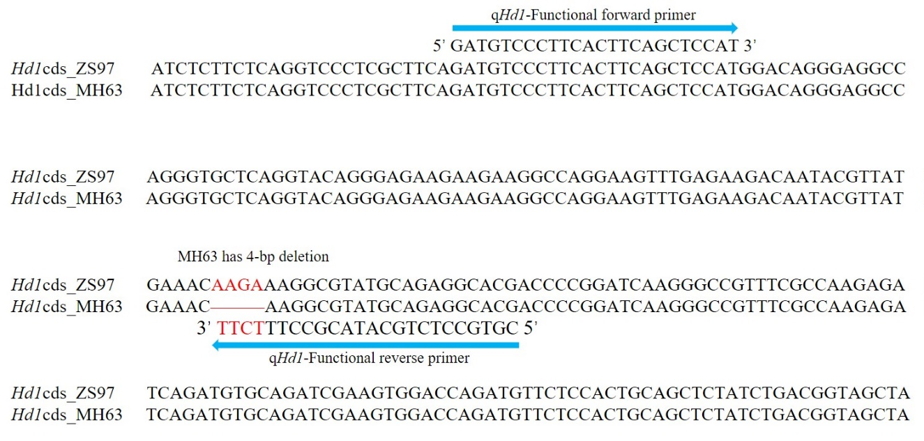
Figure S5. The 4-bp deletion in Hd1 CDS (partial) between ZS97 and MH63
qHd1-Functional reverse primer is allele-specific primer based on the nucleobase difference between ZS97 and MH63.

Table S1. The effects of major QTLs on panicle number and 1,000-grain weight in 2010
Traits | QTL | LOD | A | D | Var％
Panicle number | SPP3.2 | 3.8 | -0.9 | 0.7 | 5.5
Panicle number | SPP4 | 3.3 | 0.9 |  | 4.8
Panicle number | SPP12 | 8.2 | -1.0 | -0.7 | 14.4
1,000-grain weight | SPP1.2 | 2.1 | -0.6 | 0.4 | 3.5
1,000-grain weight | SPP3.2 | 10.3 | 1.9 | -1.3 | 23.7
1,000-grain weight | SPP4 | 2.6 | -0.7 |  | 6.1
1,000-grain weight | SPP5 | 8.4 | 0.9 |  | 11.9
1,000-grain weight | SPP8 | 3.3 | 0.8 |  | 6.5
1,000-grain weight | SPP9 | 4.2 | -1.1 | -0.6 | 7.1

Table S2. Comparison of performance and heterosis of panicle number and 1,000-grain weight between Shanyou 63 and 4-way F₁s and 8-way F₁
Genotype | Panicle number per plant | Middle parent heterosis (%) | 1,000-grain weight (g) | Middle parent heterosis (%)
ZS97 | 9.5 ± 1.4 |  | 23.8 ± 0.6
MH63 | 10.0 ± 1.6 |  | 27.4 ± 0.9
SY63 | 10.8 ± 2.5 | 10.8 | 25.4 ± 0.8 | -2.7
4-way F_{1A} | 11.2 ± 2.1 | 14.9 | 21.8 ± 0.5 | -14.8
HOMO_{4A} | 11.0 ± 1.9 |  | 21.5 ± 0.7
4-way F_{1B} | 10.4 ± 2.7 | NS | 22.1 ± 0.7 | -13.7
HOMO_{4B} | 10.5 ± 2.2 |  | 23.8 ± 0.8
8-way F₁ | 12.5 ± 2.5 | 28.2 | 22.9 ± 0.8 | -10.5

4-way F_{1A} the hybrid carried the heterozygous segments contained YD4, YD6, YD7.1 and YD7.2; 4-way F_{1B} the hybrid carried the heterozygous segments contained YD1, YD3, YD5 and YD8.

Table S3. Real-time PCR primers used in this study
Marker Name | Forward primer sequence (5’-3’) | Reverse primer sequence (5’-3’)
qGhd7 | aggtgctacgagaagcaaatcc | gggcctcatctcggcatag
qHd1 | tcagcaacagcatatctttctcatca | tctggaatttggcatatctatcacc
qGhd7.1 | aatggaagcaatgggcagaatggg | tgatcactgcagccactctatgct
UBQ | gagcctctgttcgtcaagta | actcgatggtccattaaacc
qHd1-Functional primer | gatgtcccttcacttcagctccat | cgtgcctctgcatacgcctttctt
qGhd7.1-Functional primer | acggattctgcttacaacatg | tactaggctttgtcacaacg

