Supporting information

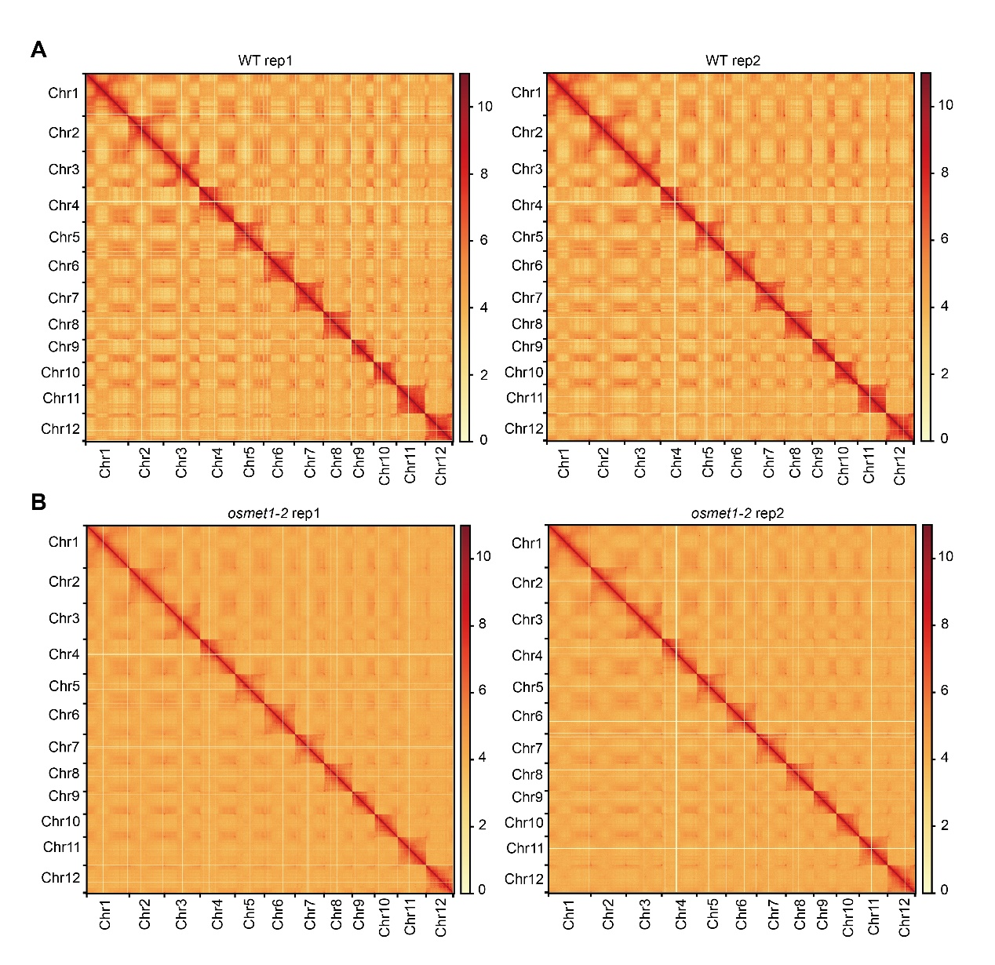
Fig S1. Genome-wide Hi-C contact maps at 100 kb resolution of wild type (WT; panel A) and osmet1-2 mutant (B) based on each independent replicate of Hi-C data.

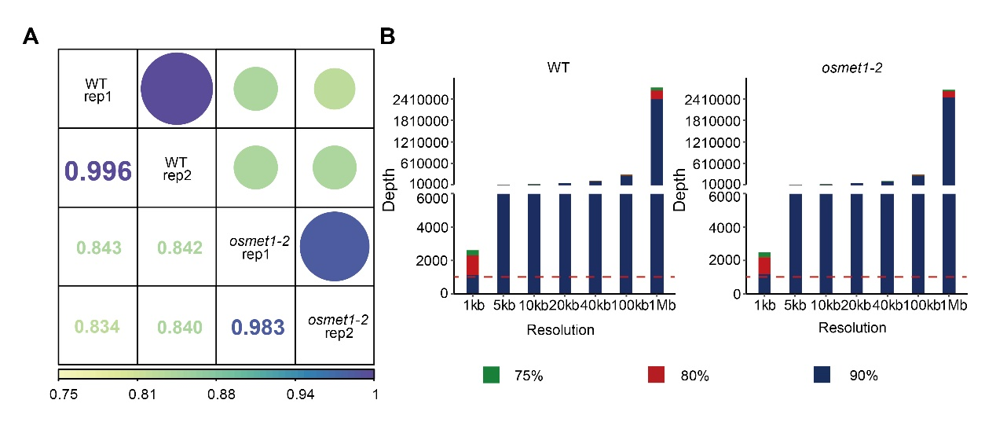
Fig S2. Reproducibility and resolution of Hi-C data.
(A) Pearson correlations among Hi-C replicates of WT and osmet1-2, R, Pearson correlation coefficient; (B) Resolution of WT (left panel) and osmet1-2 (right panel) Hi-C maps.

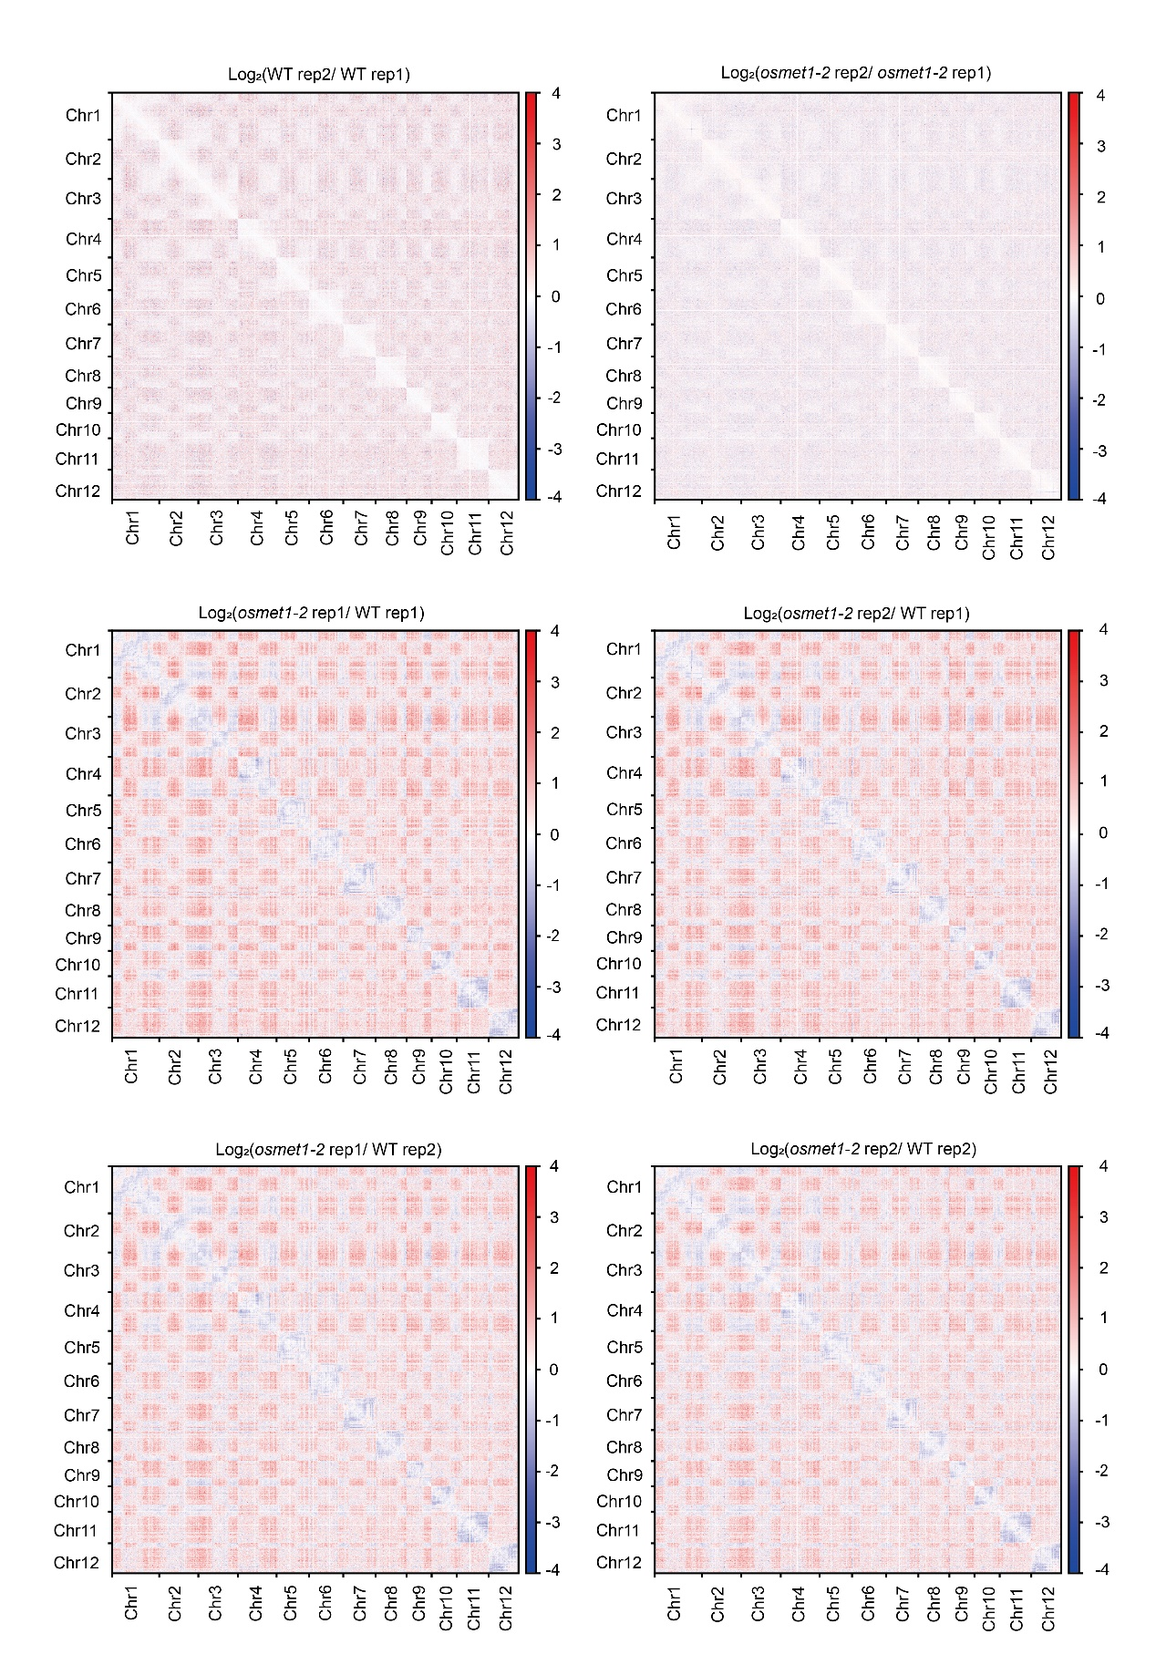
Fig S3. Heatmaps illustrating relative differences (log₂ transformed) of the genome-wide interaction frequencies between different replicates of WT and osmet1-2 at 100 kb resolution. Top two panels illustrate rare differential interaction between replicates of the same genotype (WT and osmet1-2 on the left and right, respectively).
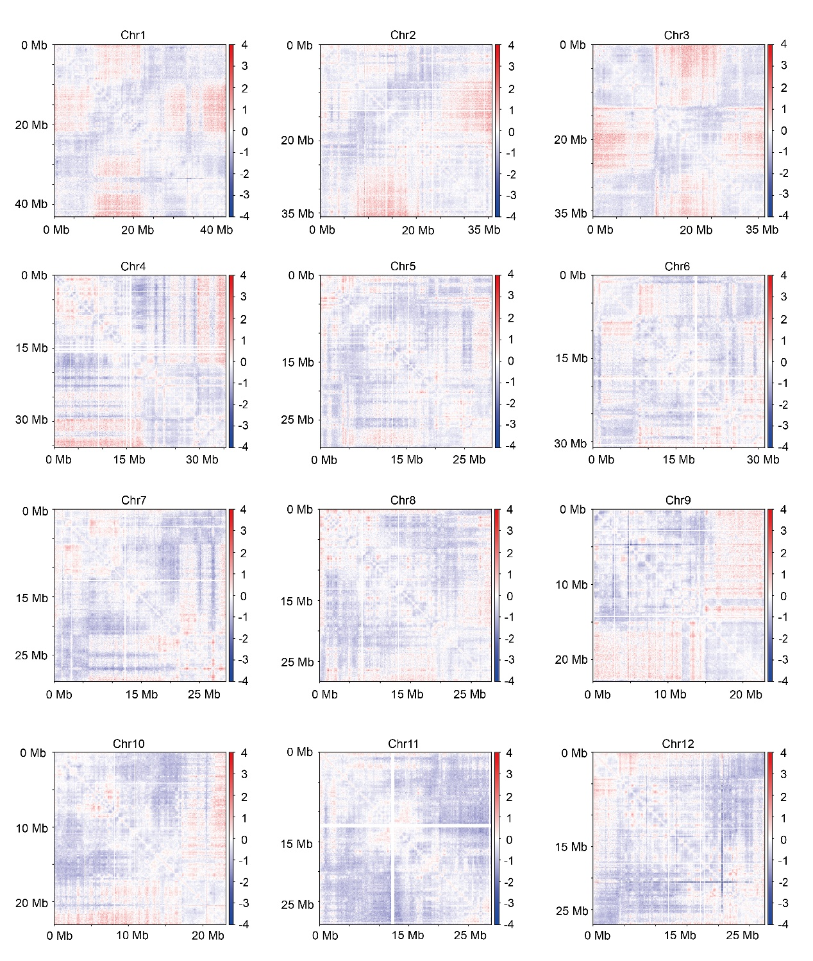
Fig S4. Heatmaps illustrating the quantitative changes of intra-chromosomal interactions between WT and osmet1-2 (based on merged Hi-C data) at 100 kb resolution for each chromosome.

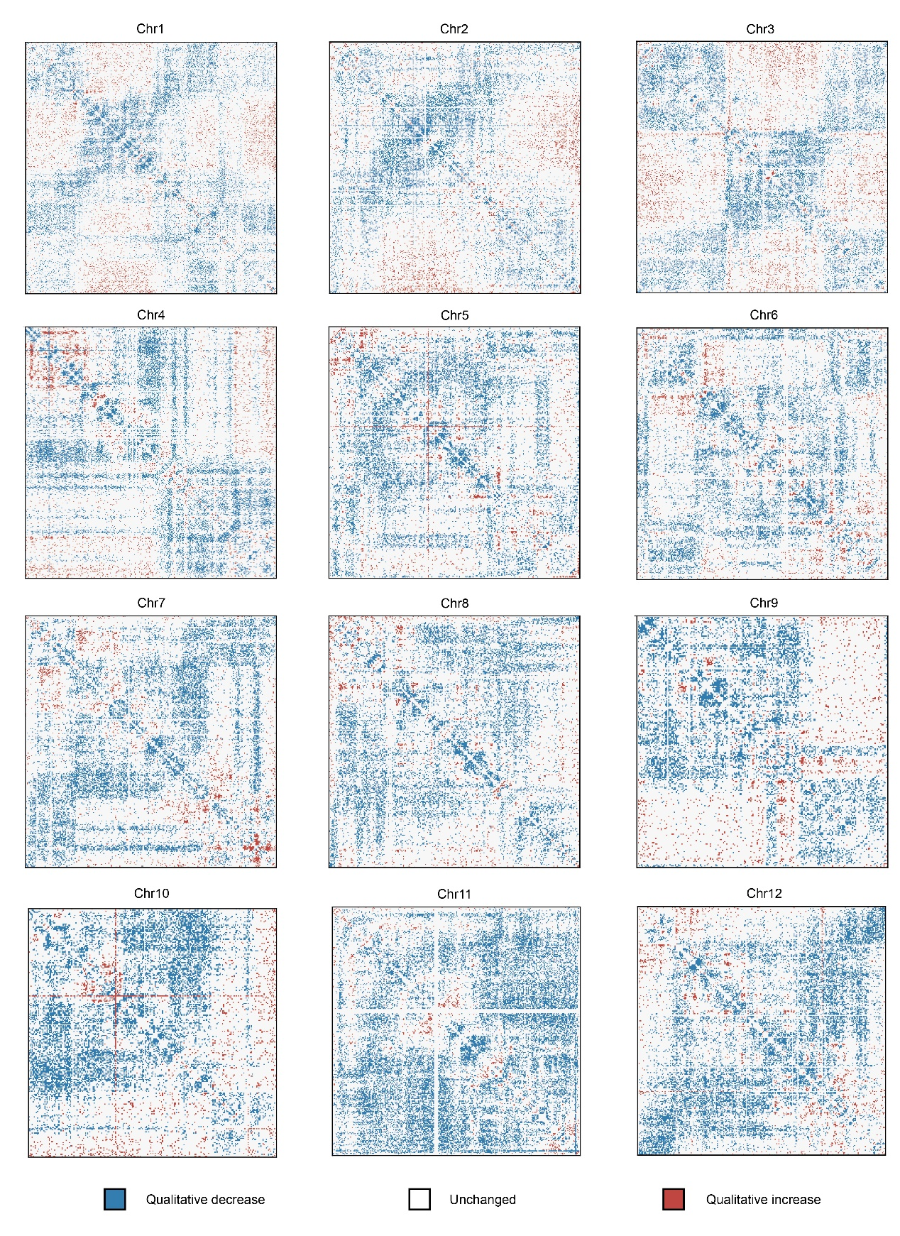
Fig S5. Heatmaps illustrating the qualitative changes of intra-chromosomal interactions between WT and osmet1-2 (based on independent replicates of Hi-C data) at 100 kb resolution for each chromosome.
Replicates of Hi-C interaction values in WT and osmet1-2 mutant are compared by Student’s test. Those bins with statistically significant increased and decreased interactions in osmet1-2 mutant vs. WT (regardless of their absolute variation) are filled in dark red and blue, respectively. 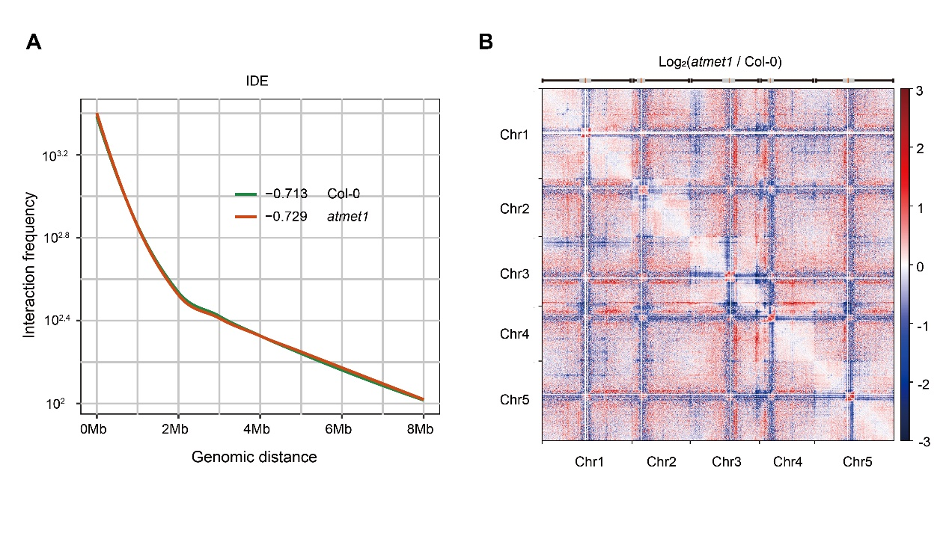
Fig S6. Loss of CG methylation induces changes of global chromatin interactions in Arabidopsis thaliana.
(A) Averaged interaction decay exponents (IDEs) along all chromosomes in Col-0 and atmet1; (B) Heatmap illustrating the genome-wide differential chromatin interaction between atmet1 and Col-0 at 100 kb resolution. The difference of chromatin interaction was evaluated as the log₂ transformed ratio of interaction values in atmet1 versus Col-0. All chromosomes are arranged side-by-side from left to right and from top to bottom. On the top track, the centromeres (red), peri-centromeric regions (grey), sub-telomeric regions (black) are specifically denoted.

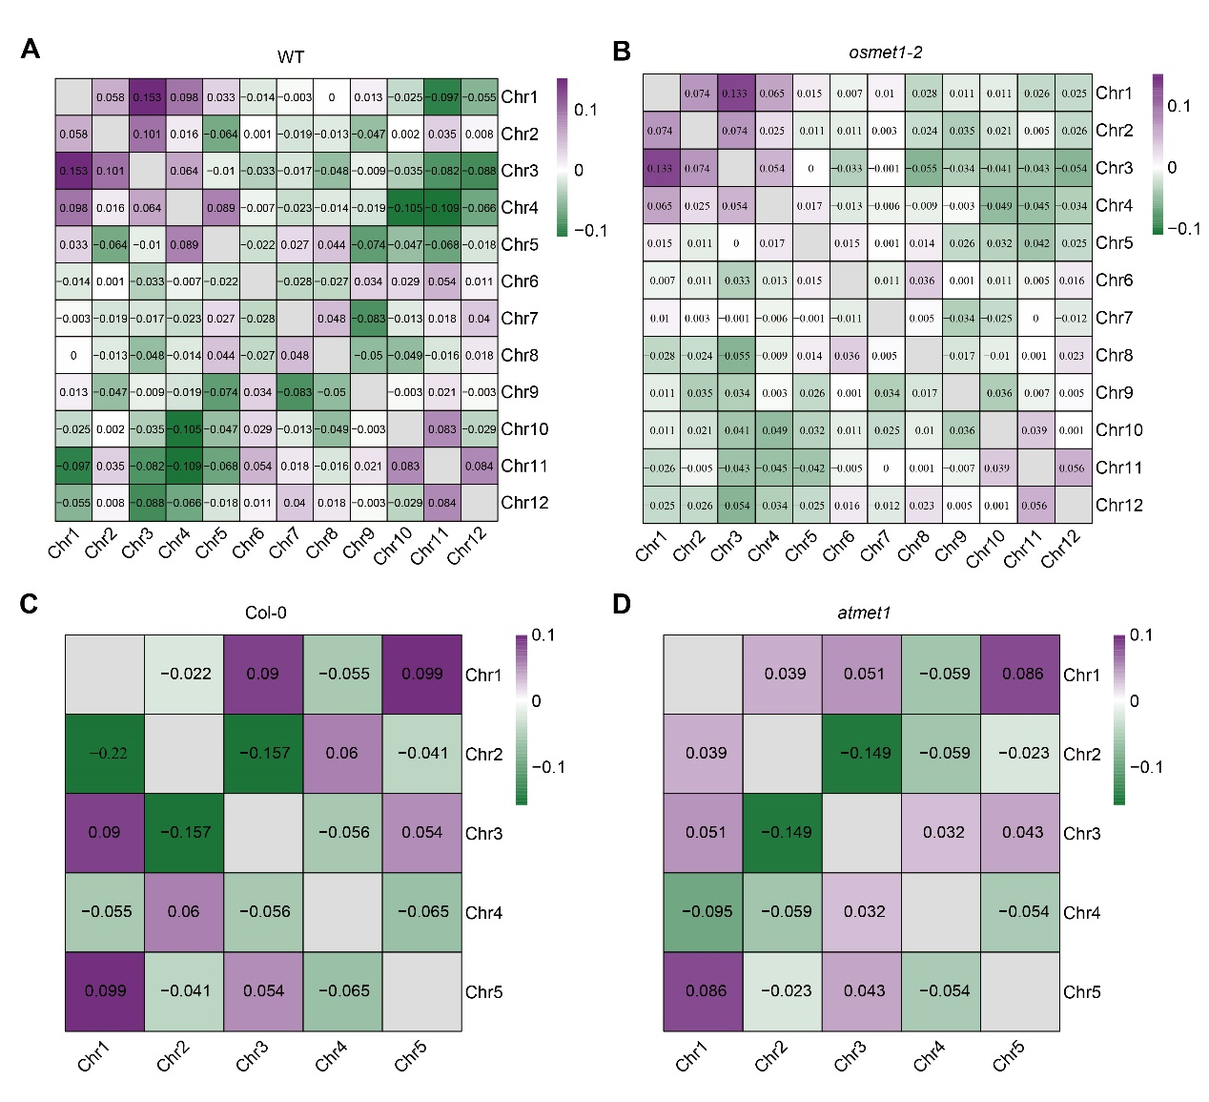
Fig S7. Relative distribution of chromosomes in rice and A. thaliana samples.
For each pair of chromosomes, their relative chromosome distribution (reflecting their occupied chromosome territory) was evaluated as the log₂ transformed ratio of observed versus expected pairwise inter-chromosomal interactions in WT (A), osmet1-2 (B), Col-0 (C), and atmet1 (D) (Materials and Methods).

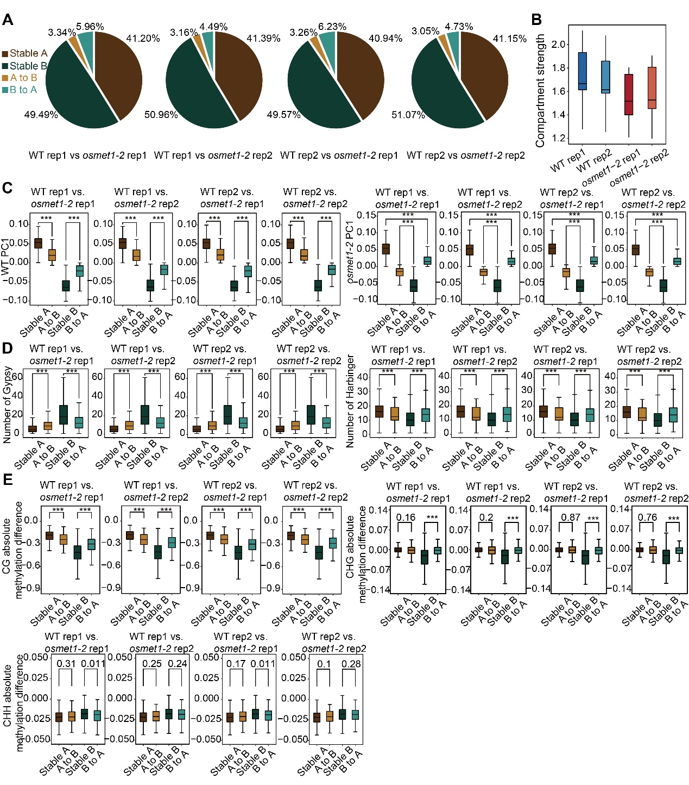
Fig S8. Variations of compartment composition (type switch/transition and TE composition), compartment strength, PC1 values, compartment DNA methylation as revealed by comparisons between WT and osmet1-2 replicates.
(A) Pie chart summarizing the percentages of stable (stable A and B) and switching compartment categories (A to B and B to A) in respective paired replicates (rep1 and rep2) of WT and osmet1-2 mutant; (B) Boxplots summarizing the compartment strengths of all chromosomes in respective biological replicates of WT and osmet1-2 mutant; (C) Boxplots summarizing the PC1 values of genomic regions in different compartment categories in each replicate. Statistical ***p < 0.001 was obtained by Wilcoxon’s rank sum test; (D) Boxplots summarizing the abundance of transposon elements (Gypsy: left, Harbinger: right) in stable and unstable compartments of different paired WT and osmet1-2 replicates. Statistical p values were obtained by Wilcoxon’s rank sum test. (e) Pairwise comparison of absolute differences of CG, CHG, and CHH methylation in different compartment categories in paired replicates of WT and osmet1-2 mutant. All statistical significance p values were calculated using Wilcoxon’s rank sum test.
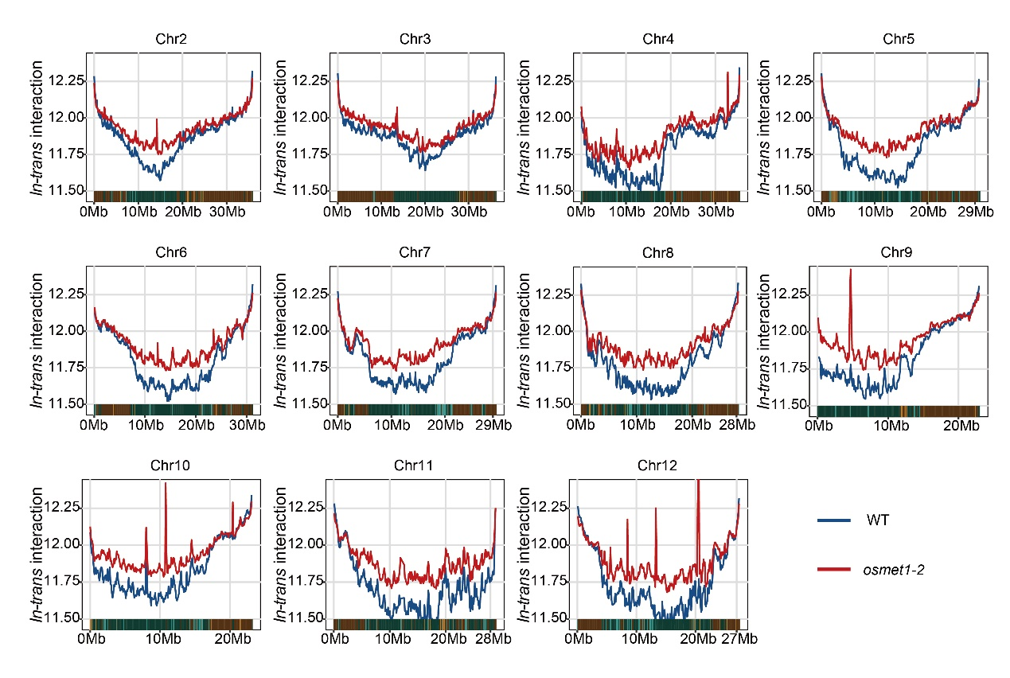
Fig S9. Chromosomal in-trans interaction frequencies of genomic regions in all compartment categories (interaction between genomic regions in certain chromosome and those in other chromosomes) in WT and osmet1-2.
The bottom track denotes the genomic regions in specific compartment category.

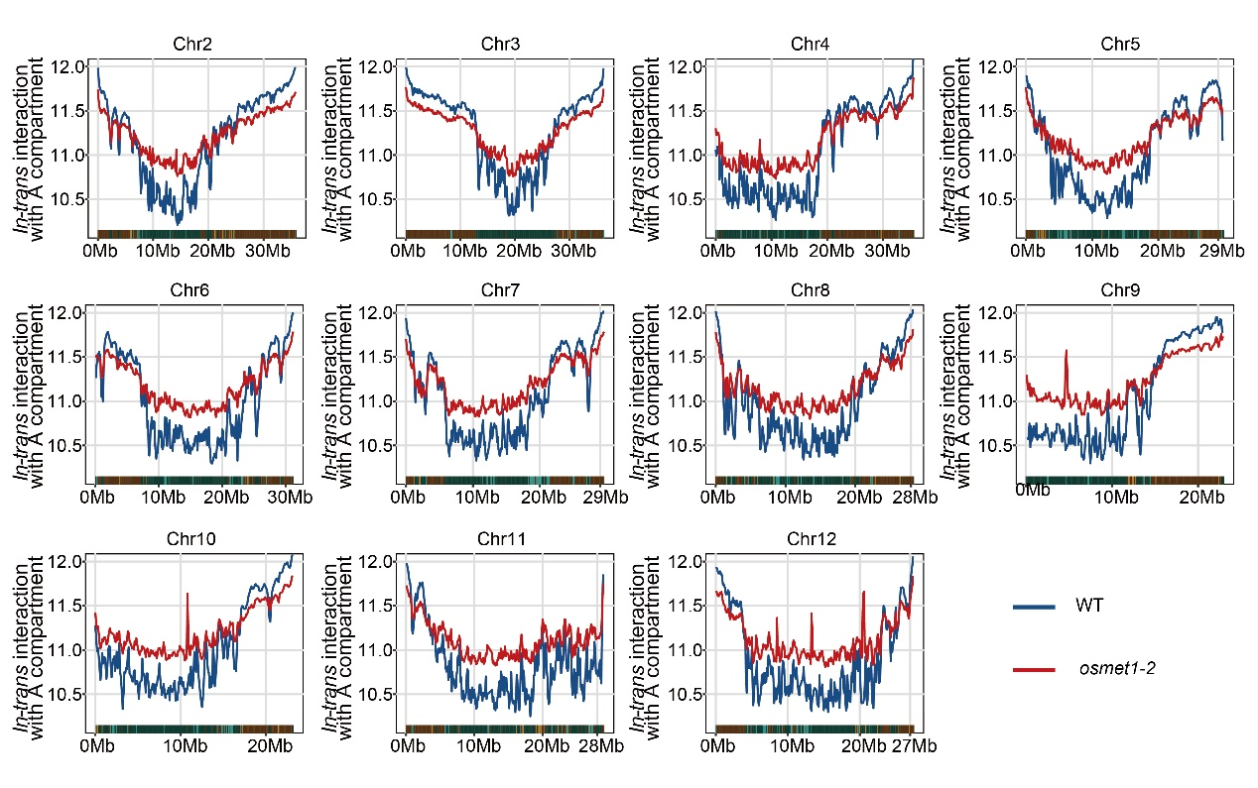
Fig S10. Chromosomal in-trans interaction frequencies of genomic regions in all compartment categories (interaction between genomic regions in certain chromosome and those regions of compartment A in other chromosomes) in WT and osmet1-2.
The bottom track denotes the genomic regions in specific compartment category.

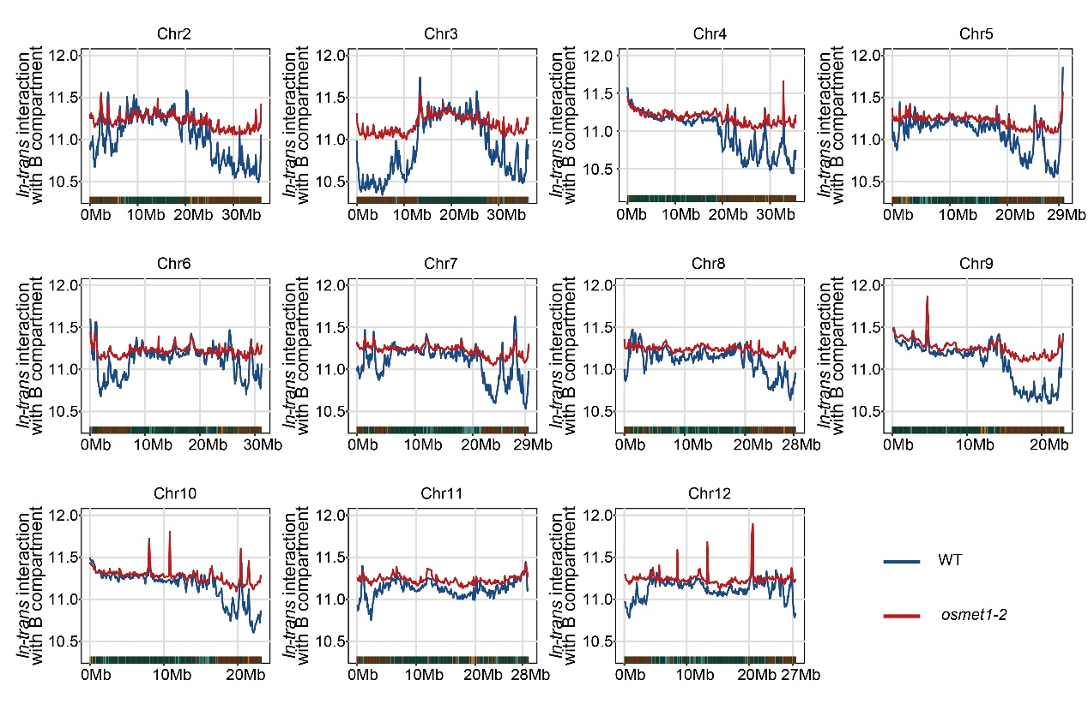
Fig S11. Chromosomal in-trans interaction frequencies of genomic regions in all compartment categories (interaction between genomic regions in certain chromosome and those regions of compartment B in other chromosomes) in WT and osmet1-2.
The bottom track denotes the genomic regions in specific compartment category.

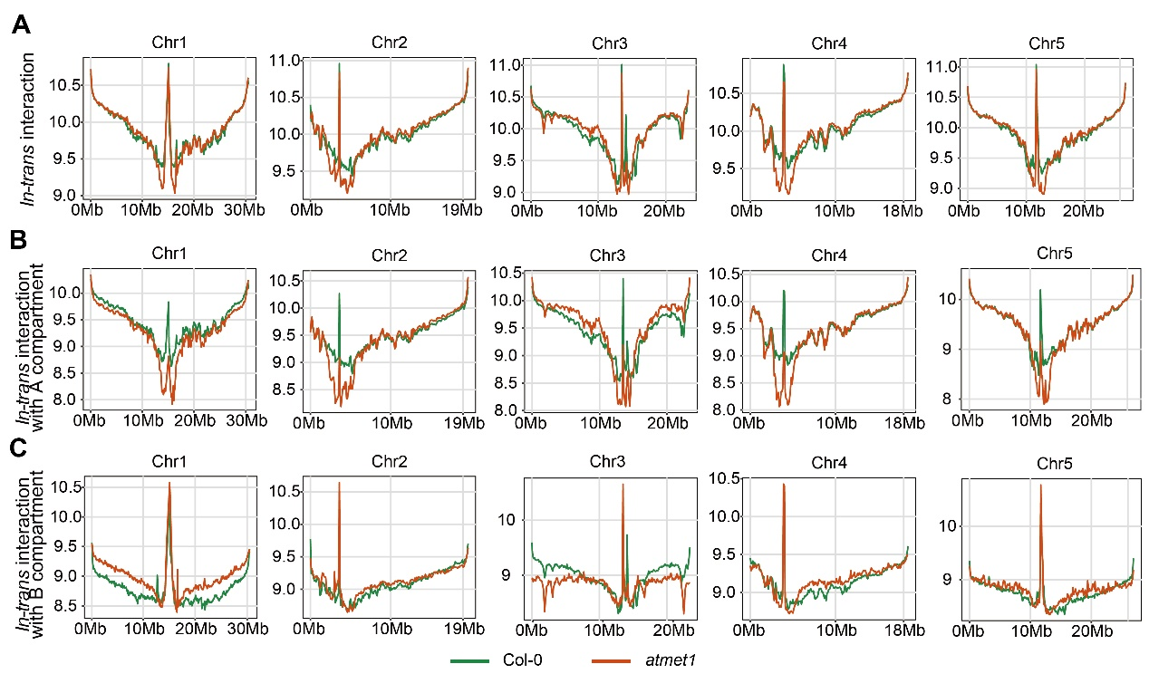
Fig S12. Chromosomal in-trans interaction frequencies of genomic regions in Col-0 and atmet1.
Those interactions between genomic regions in certain chromosome and those regions in other chromosomes are separately considered, which include in-trans interaction with A and B compartments (panel A), with only A compartments (panel B), and with only B compartments (panel C).

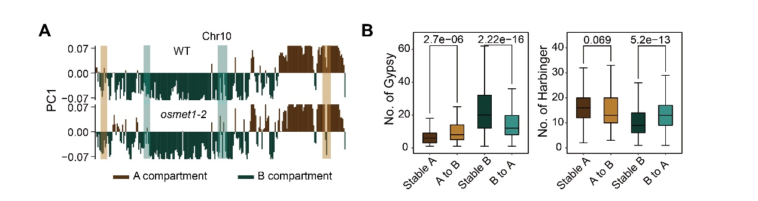
Fig S13. Genomic distribution and TE composition of stable and unstable compartments in WT and osmet1-2.
(A) Distribution of PC1 values along Chr10 in WT and osmet1-2. Shaded regions denote genomic regions with A to B (brown) and B to A (green) compartment switch; (B) Boxplots summarizing the abundance of transposon elements (Gypsy: left, Harbinger: right) in stable and unstable (A to B and B to A) compartments. Statistical p values were obtained by Wilcoxon’s rank sum test.

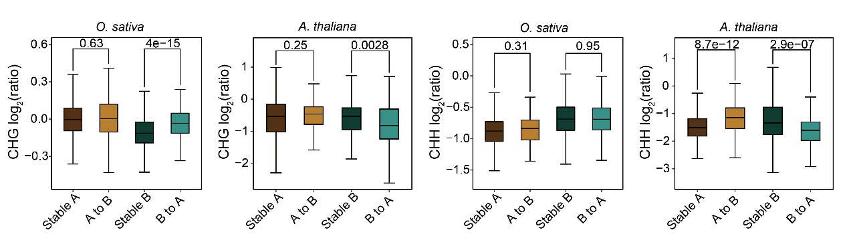
Fig S14. The log₂ transformed CHG and CHH methylation changes in different compartment categories in respective mutant vs. wild type sample of rice (O. sativa) and A. thaliana.

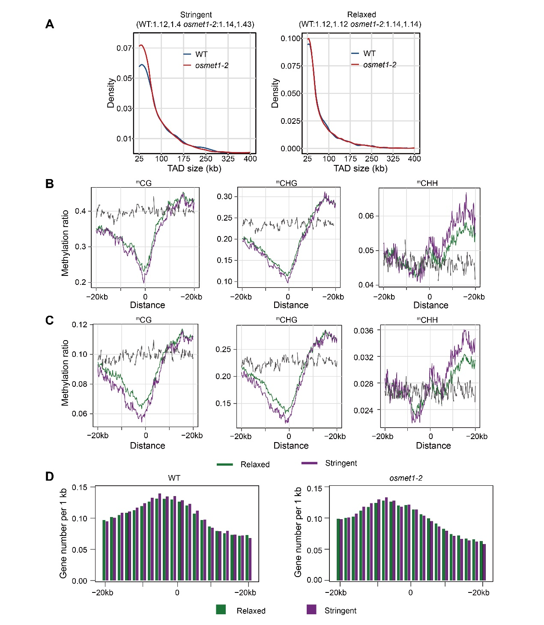
Fig. S15. Comparison of the TAD-like structure boundary features as called with stringent and relaxed parameters.
(A) Size distribution of TAD-like structures; (B) The profiles of CG, CHG, and CHH methylation around TAD-like structure boundaries in WT; (C) The profiles of CG, CHG, and CHH methylation around TAD-like structure boundaries in osmet1-2 mutant; (D) Density of active gene around TAD-like structure boundaries in WT and osmet1-2 mutant.

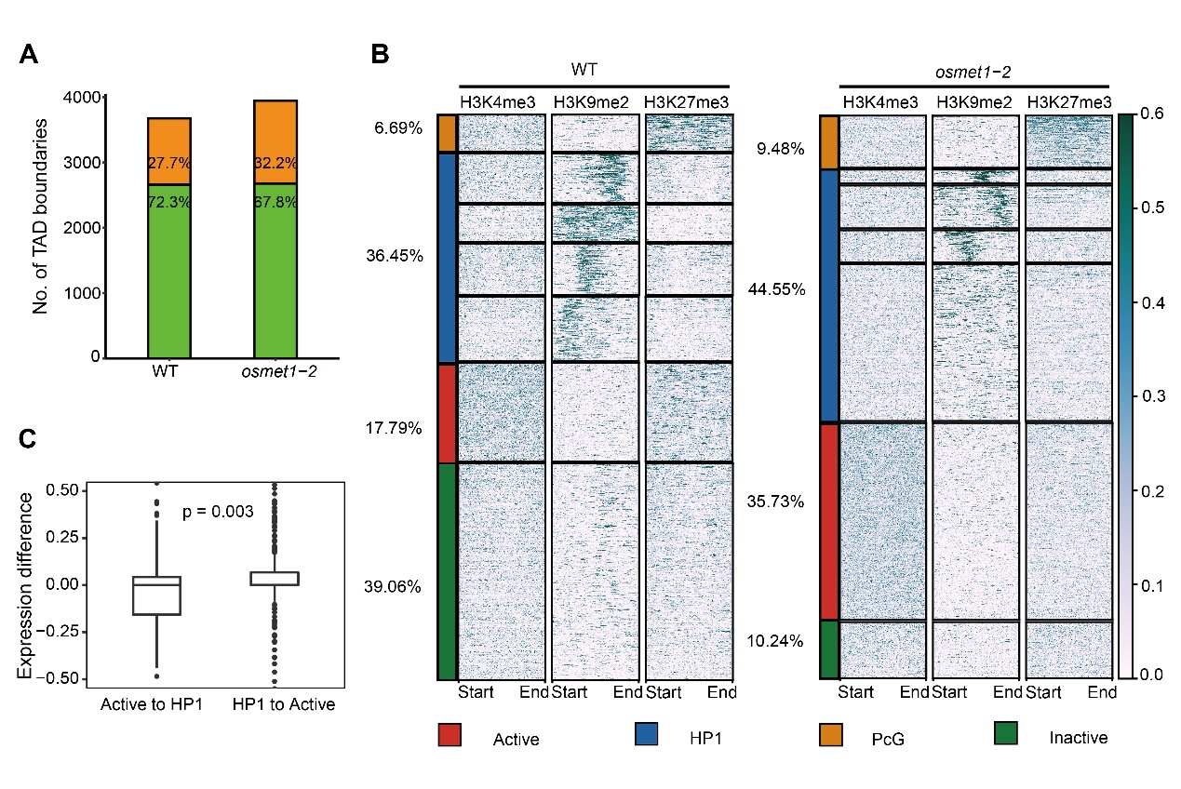
Fig S16. Compositional conservation of TAD boundaries and clustering of TADs based on histone modification in WT and osmet1-2.
(A) Number of conserved TAD boundaries identified in WT and osmet1-2 (conserved TAD boundaries in green columns) and those uniquely identified in WT or osmet1-2 (in orange columns) are summarized, accordingly. (B) Based on the enrichment pattern of different histone modifications in TAD interior regions, TADs are categorized and clustered into groups of active (red column; enriched in H3K4me3), HP1 (blue column; enriched in H4K9me2), PcG (yellow column; enriched in H3K27me3), and inactive TADs (green column; without any enrichment in the above histone modifications) in WT and osmet1-2, the proportions of respective TAD category among all TADs in WT and osmet1-2 are listed on the left; (C) the up- (higher than zero at y-axis) and down-regulated (lower than zero at y-axis) expression of interior genes in active and HP1 TAD-like domains of WT vs. osmet1-2 (from WT to osmet1-2; y axis denotes the difference of expression FPKM in osmet1-2 relative to WT). Significant difference was determined by the Wilcoxon’s rank sum test (p value was specified).

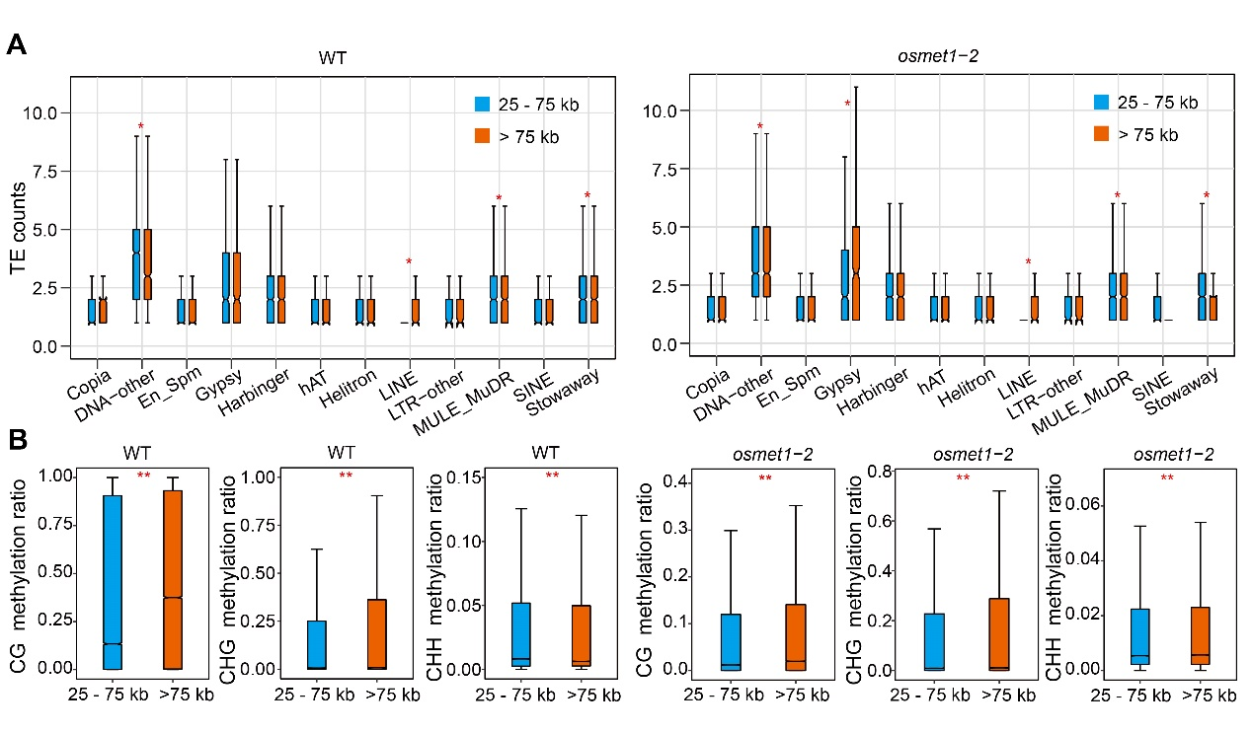
Fig. S17. The compositional and epigenetic differences of TAD-like structure boundaries for those small (25–75kb) and big (> 75kb) TAD-like structures in WT and osmet1-2.
Abundance of TEs (A) and DNA methylation level (B) in respective TAD-like structure boundaries. Statistical *p < 0.05 and **p < 0.01 were obtained by Wilcoxon’s rank sum test.

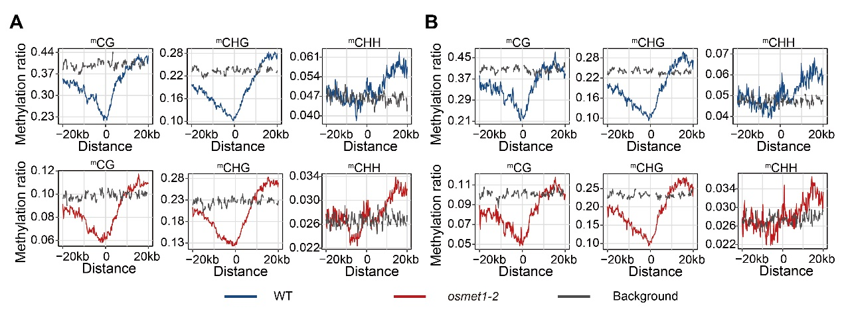
Fig S18. Contextual DNA methylation around all TAD-like structure boundaries and stable/conserved TAD-like structure boundaries in WT and osmet1-2. Distribution of CG, CHG, and CHH methylation levels around all TAD-like structure boundaries (A) and stable/conserved TAD-like structure boundaries (B) in WT and osmet1-2. Borders of all TAD-like structures are aligned at point ‘0’. Grey dash line depicts the distribution of contextual or background DNA methylation level along genomic regions, which were randomly selected from genome.

Table S1. Summary of clean Hi-C reads.
Sample* | osmet1-2
Read Length (bp) | 100
Raw Paired-end Reads | 2,506,514,352
Raw Bases (bp) | 501,302,870,400
Clean Paired-end Reads* | 2,286,368,696
Clean Paired-end Reads Rate (%)* | 91.22
Low-quality Paired-end Reads* | 104,081,311
Low-quality Paired-end Reads Rate (%)* | 4.15
Ns Paired-end Reads | 787,391
Ns Paired-end Reads Rate (%) | 0.03
Adapter Polluted Paired-end Reads | 115,276,954
Adapter Polluted Paired-end Reads Rate (%) | 4.6
Raw Q30 Bases Rate (%) | 92.27
Clean Q30 Bases Rate (%) | 94.06
* Data filtering were completed as followings analysis based on those clean paired-end reads:
(1) Reads pairs with adapter contamination were removed;
(2) Both low quality reads with quality values less than 19 and chimeric reads were filtered. Only reads pairs with mapping quality more than 15 were retained;
(3) reads with N ratios greater than 5% were discarded (either end of reads with N ratios more than 5%).

Table S2. Summary of uniquely mapped Hi-C reads.
Sample | osmet1-2
Clean Paired-end Reads | 2,286,368,696
Unmapped Paired-end Reads | 98,288,715
Unmapped Paired-end Reads Rate (%) | 4.3
Paired-end Reads with Singleton | 798,703,127
Paired-end Reads with Singleton Rate (%) | 34.93
Multi Mapped Paired-end Reads | 499,659,208
Multi Mapped Ratio (%) | 21.85
Unique Mapped Paired-end Reads* | 889,717,646
Unique Mapped Ratio (%) | 38.91
*Aforementioned clean Hi-C reads were aligned to genome assembly of O. sativa L. ssp. japonica using bowtie2. Subsequently, unmapped reads across the ligation junctions were cut into sub-sequences. The sub-sequences were mapped to reference genome again. After combing two output data, only those paired-end reads with both mates uniquely mapped to reference genome (denoted as “Uniquely Mapped Paired-end Reads”) were kept for downstream analysis.

Table S3. Summary of valid Hi-C reads.
Sample | osmet1-2
Unique Mapped Paired-end Reads | 889,717,646
Dangling End Paired-end Reads | 39,062,895
Dangling End Rate (%) | 4.39
Self Circle Paired-end Reads | 41,013,300
Self Circle Rate (%) | 4.61
Dumped Paired-end Reads | 32,841,093
Dumped Rate (%) | 3.69
Interaction Paired-end Reads | 776,800,358
Interaction Rate (%) | 87.31
Valid Paired-end Reads | 630,540,847
Valid Rate (%)* | 70.87
* Invalid uniquely mapped reads as described, such as “Dangling End Paired-end Reads”, “Self Circle Paired-end Reads”, and “Dumped Paired-end Reads” were removed using HiC-Pro. Moreover, we also exclude the invalid reads generated by PCR amplification.

Table S4. Raw in-cis and in-trans interactions of each sample
Rice samples* | in-cis interaction | in-trans interaction | all valid interaction | cis/tans
WT rep1 | 193,618,974 | 133,132,241 | 326,751,215 | 1.454
WT rep2 | 165,622,867 | 124,183,302 | 289,806,169 | 1.334
osmet1-2 rep1 | 197,961,076 | 168,368,555 | 366,329,631 | 1.176
osmet1-2 rep2 | 223,401,633 | 193,542,888 | 416,944,521 | 1.154
Arabidopsis samples† | in-cis interaction | in-trans interaction | all valid interaction | cis/tans
Col-0 | 51,013,157 | 13,543,169 | 64,556,326 | 3.766
atmet1 | 49,709,042 | 13,706,692 | 63,415,734 | 3.627
*Comparisons of raw in-cis and in-trans interaction differences in replicates of WT and osmet1-2 were statistically confirmed by Chi-square test (p < 0.0001).
†There was no replicate of Col-0 and atmet1 in published data (Feng et al., 2014). Respective raw in-cis and in-trans interaction difference in Col-0 and atmet1 was statistically confirmed by Chi-square test (p < 0.0001).

Table S5. Association between reprogrammed TAD-like structures and differential expression genes
 | Non-differentially | Up-regulated | Down-regulated
Conserved boundaries | 290 (0.085) | 2810 (0.825) | 307 (0.09)
Unique boundaries in WT | 314 (0.074) | 3552 (0.835) | 387 (0.091)
Unique boundaries in osmet1-2 | 358 (0.09) | 3303 (0.832) | 308 (0.078)
Conserved boundaries vs. Unique boundaries in WT p = 0.03077
Conserved boundaries vs. Unique boundaries in osmet1-2 p = 0.01531

Table S6. Collected supportive data from public databases.
Types of data | SRA*
Col-0 for Hi-C (HindIII) | SRX627443
atmet1 for Hi-C (HindIII) | SRX627449
WT for Bisulfite-Seq | SRX612561
osmet1-2 for Bisulfite-Seq | SRX612563
WT for RNA-Seq | SRX6803764; SRX6803765
osmet1-2 for RNA-Seq | SRX6803760; SRX6803761
Col-0 replicate 1 for Bisulfite-Seq | SRX174203
Col-0 replicate 2 for Bisulfite-Seq | SRX174204
atmet1 replicate 2 for Bisulfite-Seq | SRX174248
IDS1 input for ChIP-Seq | ERS2180866
IDS1 replicate 1 for ChIP-Seq | ERS2180863
IDS1 replicate 2 for ChIP-Seq | ERS2180864
IDS1 replicate 3 for ChIP-Seq | ERS2180865
*SRA accession number of respective data are tabulated.

Reference

Feng S, Cokus S, Schubert V, Zhai J, Pellegrini M and Jacobsen S (2014) Genome-wide Hi-C analyses in wild-type and mutants reveal high-resolution chromatin interactions in Arabidopsis. Mol. Cell 55: 694-707.

