Supplementary Figures
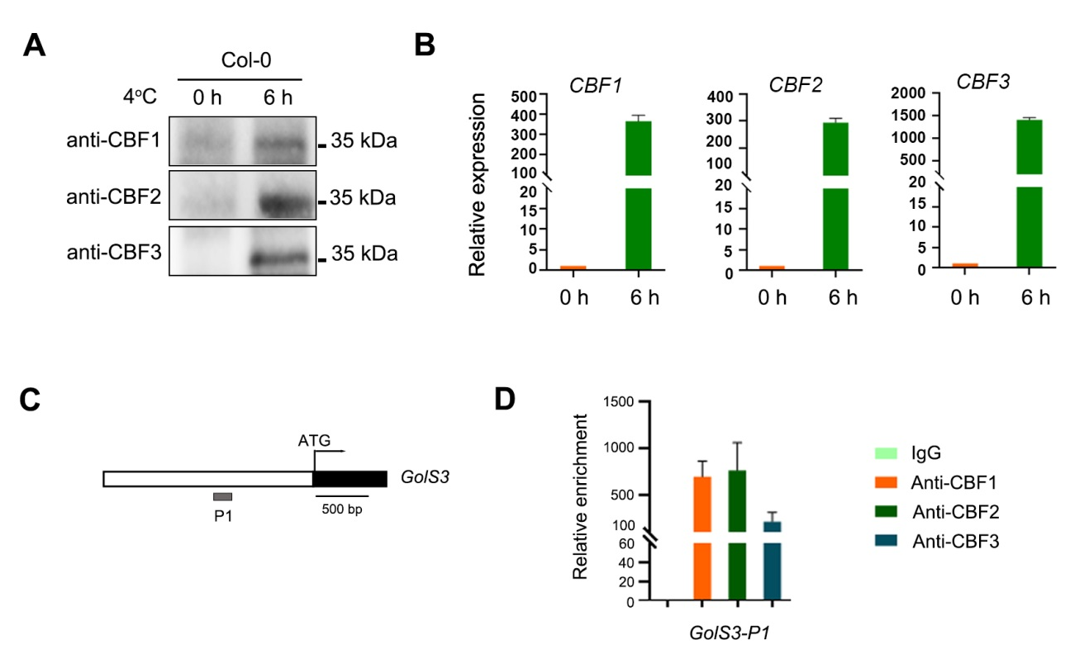
Supplementary Figure 1. Accumulated CBF proteins bind to the promoter of GolS3 under cold treatment.
(A) Col-0 seedlings were treated at 4°C treatment for 0-h and 6-h, and CBF proteins were detected with anti-CBF antibodies. (B) Gene expression of CBFs in Col-0 seedlings at 4°C treatment for 0-h and 6-h. (C-D) qRT-PCR was used to determine the promoter fragments of the GolS3 that were enriched during a ChIP using anti-CBF antibody.
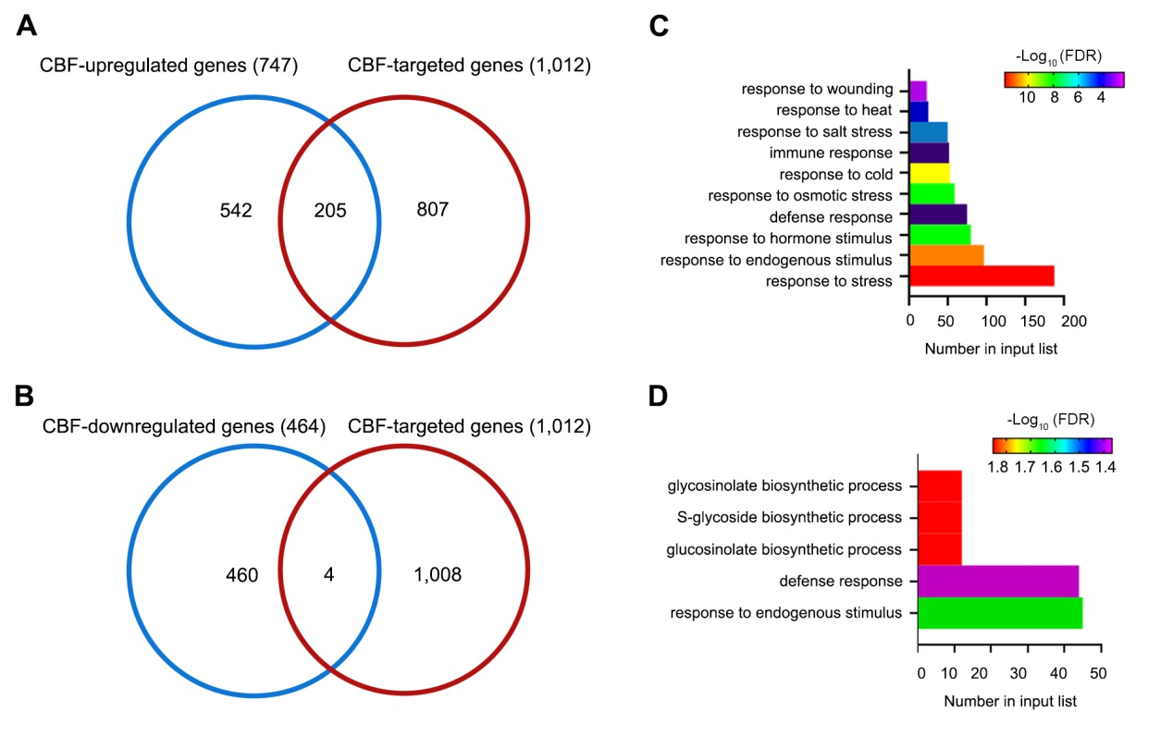
Supplementary Figure 2. GO classification of CBF-regulated genes.
(A) Venn diagram showing the number of the CBF-upregulated target genes. (B) Venn diagram showing the number of the CBF-downregulated target genes. In total, there were 747 CBF-upregulated genes and 464 CBF-downregulated genes have been identified under 0-h, 3-h, and 24-h cold treatments. (C-D) GO classification of 747 CBF-upregulated genes and 464 CBF-downregulated genes from the RNA-seq analysis. The number of genes classified within each GO term is presented. The color scale represents the –log₁₀ adjusted false discovery rate (FDR) values.

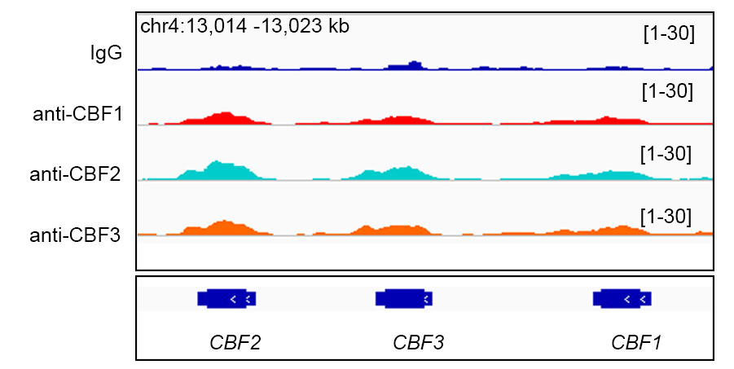
Supplementary Figure 3. Chromatin binding profiles of the CBF proteins at their own gene loci.
Chromatin binding profiles of all three CBFs at their gene loci. ChIP-seq reads were visualized using the IGV. The wild type (WT) is in blue, CBF1 is in red, CBF2 is in green, and CBF3 is in orange.

