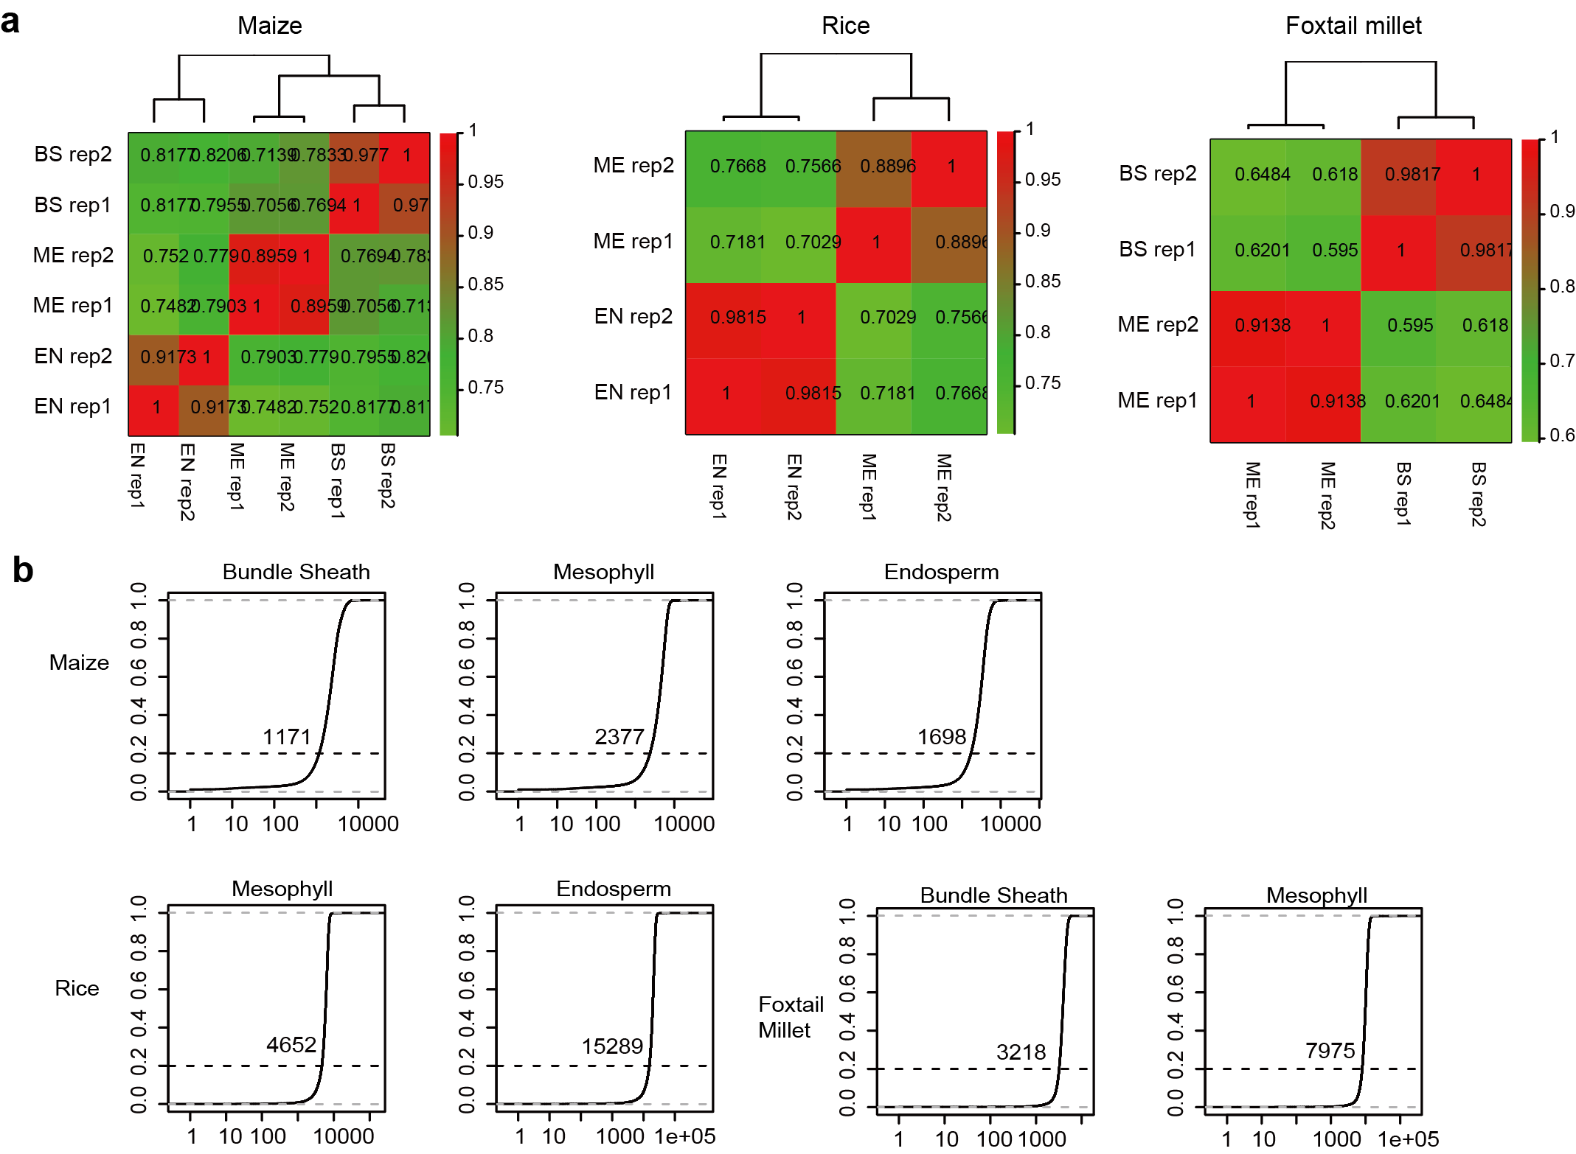

Figure S1 | Reproducibility between Hi-C data biological replicates. A) The correlations were calculated by HiCrep at 100Kb resolution for maize, rice, andfoxtail millet tissue-specific Hi-C data. The correlations are higher between leaf cell types than those between endosperm and leaf cell types. b) For maize domain and loop calling, we used 10 kb bin size. For rice and foxtail millet, 20 kb bin size is used. To confirm that the sequencing depth is sufficient under such resolution, we calculated the cis-interaction for each bin following the method described in Lieberman-aiden et al. (2009), which requires that the top 80% of the bins (indicated by the horizontal dash line) should have no less than 1,000 cis-interaction.
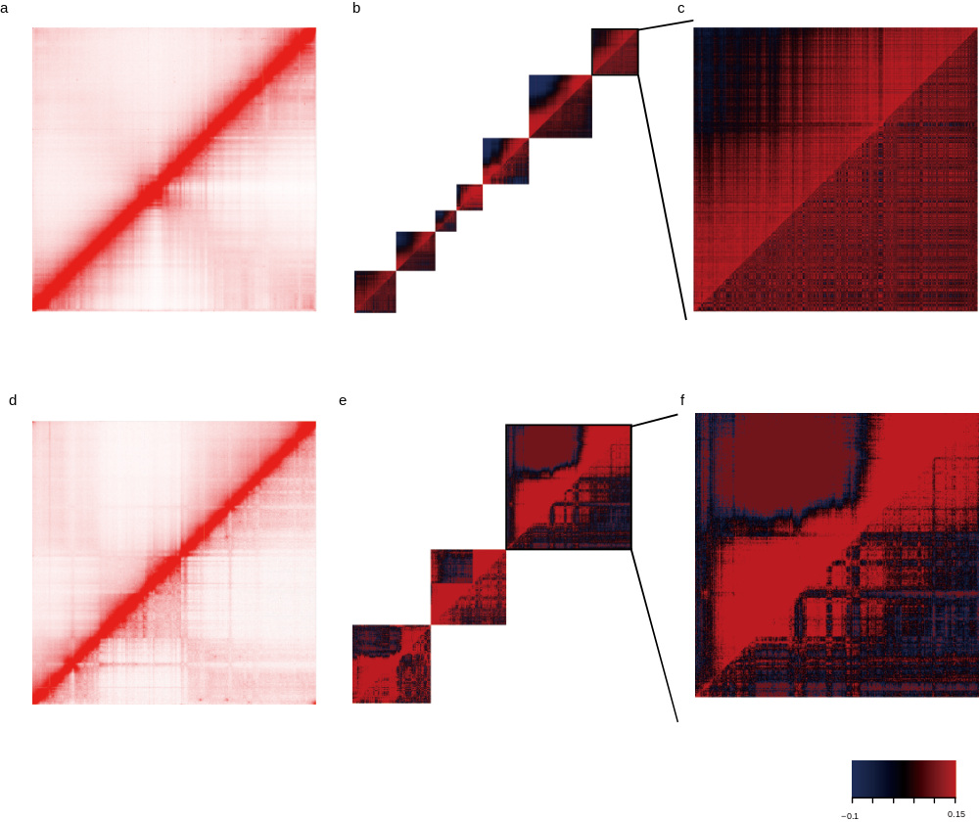
Figure S2 | Reduced local compartment in endosperm.Maize a) and rice d) chromosome 1 interaction heatmap. The lower triangle is mesophyll, while the upper triangle is endosperm. Pearson correlation heatmap of each block of maize b) and rice e) chromosome 1. Theenlarged last block of maize c) and rice f) show the weakened local compartment in endosperm (upper triangle).

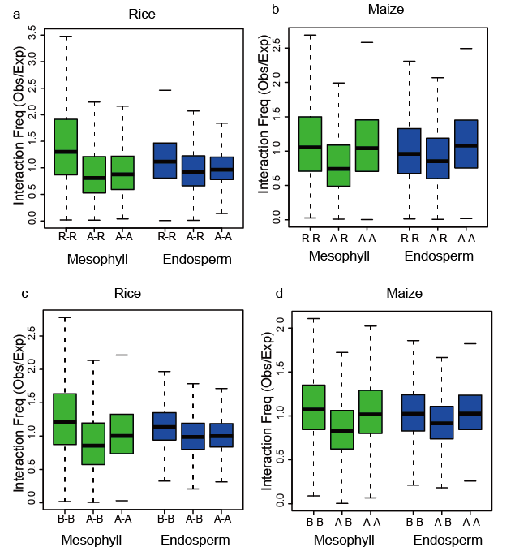
Figure S3 | Reduced interaction between repressive regions in endosperm. Local compartment could not be identified in the rice endosperm. Hence, distance normalized interaction frequency between R regions (repressive region, top 10% high TE content bins), and A regions (active regions, top 10% mRNA read counts bins) were used to infer their repressive and active chromatin, respectively. (a-b) The interaction frequency between R regionsare reduced in both maize and rice endosperm. (c-d) Same pattern could also be observed when comparing theirendosperm interaction between local B compartments called using the from leaf mesophyll cell Hi-C data.

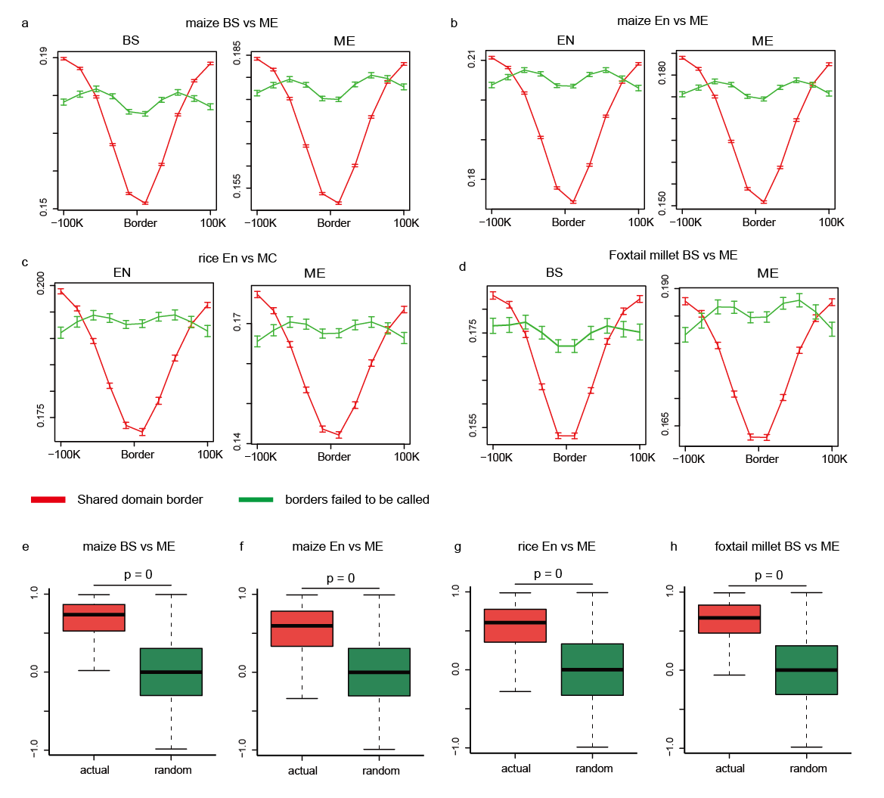

Figure S4 | Non-conserved domain borders still show weak border features. The insulation scores of non-conserved domain borders are still local minima even in the tissue that the region failed to be called as domain border.The maize bundle sheath vs mesophyll comparison a), endosperm vs mesophyll comparison b), rice endosperm vs mesophyll comparison c), and foxtail millet bundle sheath vs mesophyll comparison d). (e-h) The correlation coefficients of the interaction direction index of the region 100 kb upstream and downstream of non-conserved domain borders. Despite they are not called as domain borders, their DI correlation values are still significantly higher than the randomized genome region (KS test). for maize bundle sheath vs mesophyll comparison e), endosperm vs mesophyll comparison f), rice endosperm vs mesophyll comparison g), and foxtail millet bundle sheath vs mesophyll comparison h).

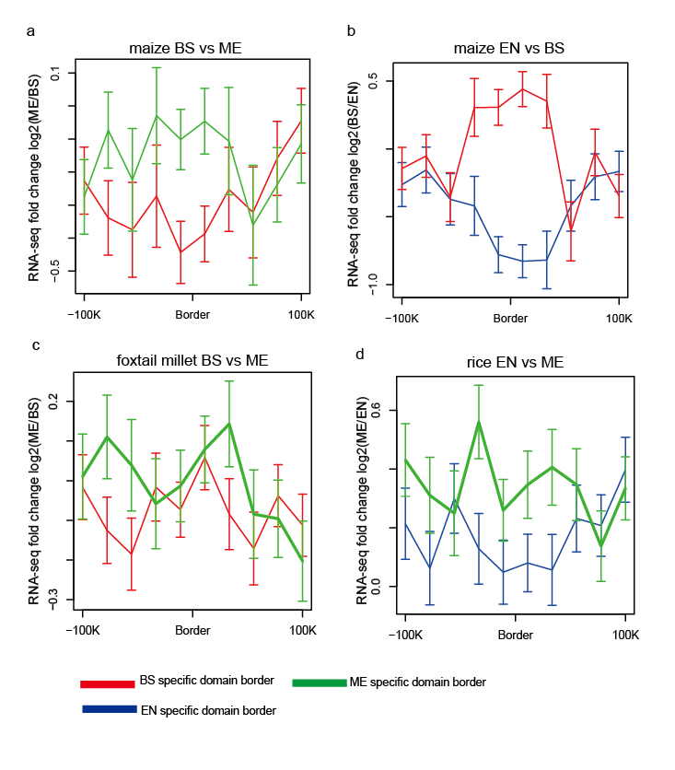
Figure S5 | Tissue-specific domain borders are associated with gene expression changes. The average normalized RNA-Seq signal in tissue-specific domain border regions for maize bundle sheath vs mesophyll comparison a), endosperm vs bundle sheath comparison b), foxtail millet bundle sheath vs mesophyll comparison c), and rice endosperm vs mesophyll comparison d).
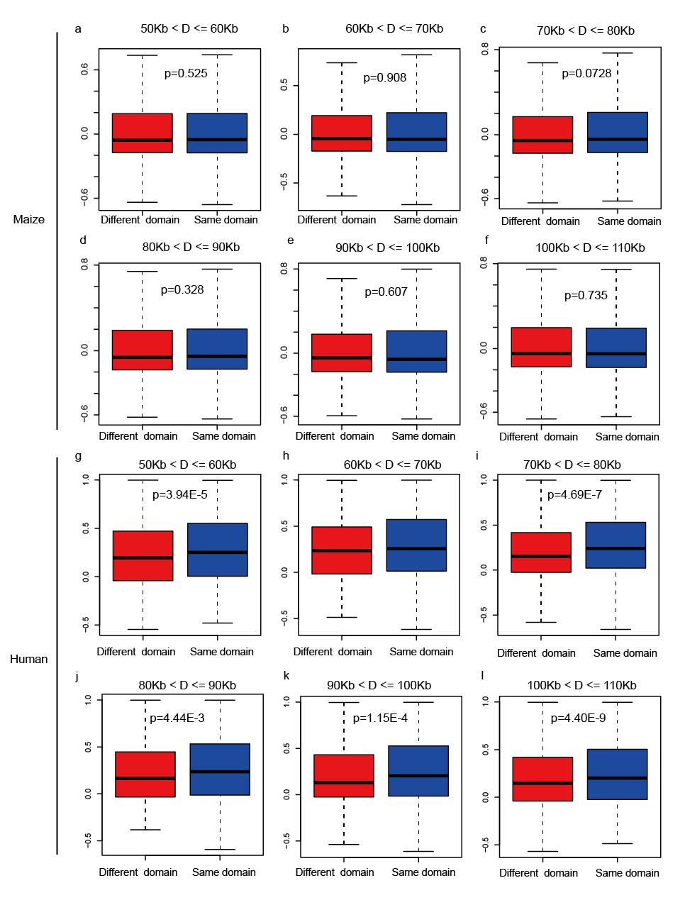
Figure S6 | Expression correlation of gene pairs within the same domain. Pearson correlation of gene expression profile between gene pairs of the similar genomic distance from 50Kb to 100Kb, in a-f) maize, and g-l) human. The human TADs have significant higher gene pair expression correlation than random (KS test).

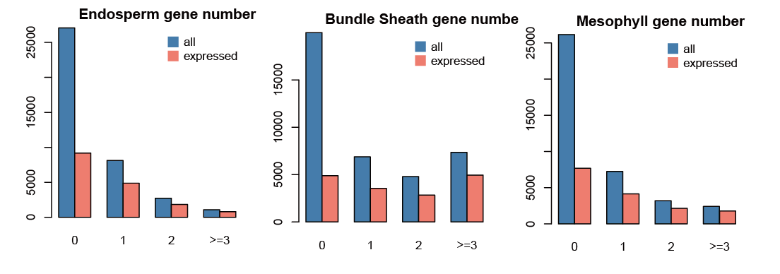
Figure S7 |Expressed genes are more likely to be involved in chromatin loops. The y-axis indicates number of genes associated with 0, 1, 2 or over 3 chromatin loops. We defined the expressed gene (red) as those with FPKM > 1 in their corresponding tissue RNA-Seq dataset.

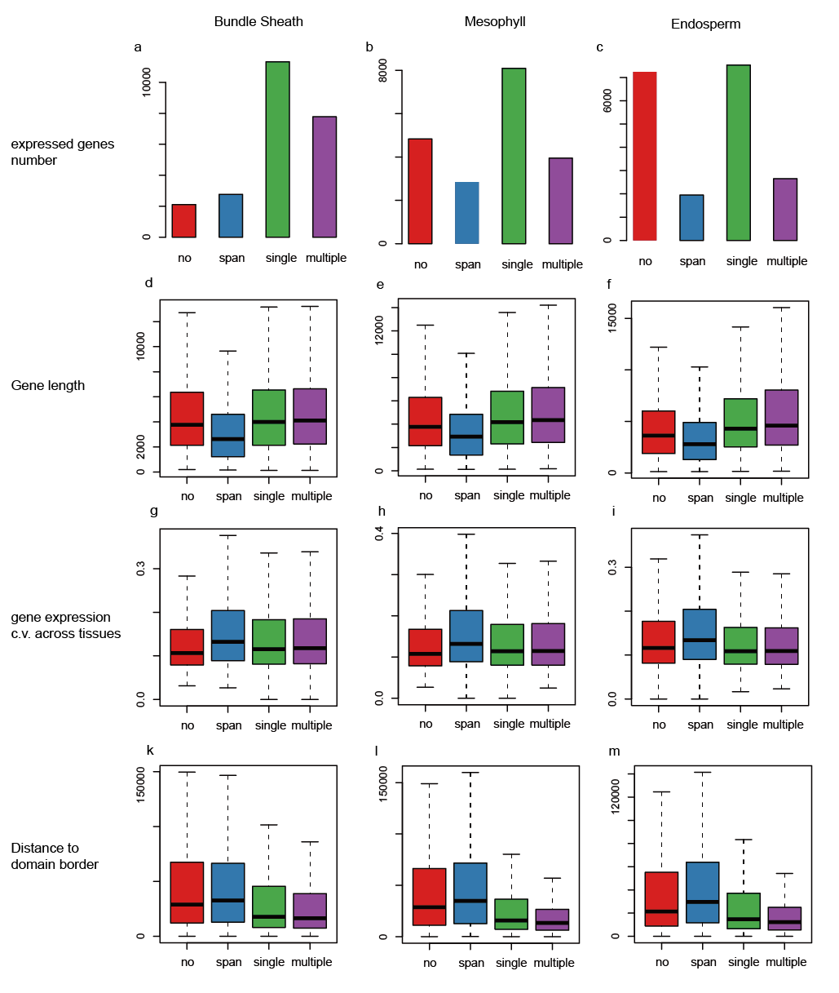
Figure S8 | Characteristics of the loop genes. Red bar indicates genes not involved in loop. Blue color indicate genes spanned by one or multiple loops. Green bar indicates genes involved in a single loop, and those involved in multiple loops are indicated as purple. The number of expressed genes a-c), gene length d-f), gene expression coefficient of variation (c.v.) g-i), and their distance to domain border k-m) are shown. We found that the loop genes are closer to domain borders (p-value in Table S14), and especially for the multiple loop genes, while the genes spanned by loop are shorter (Table S15). The loop-span genes also exhibit significantly higher expression c.v. across different tissues (p-value in Table S16), which suggests that the genes spanned by loop are more tissue-specific.
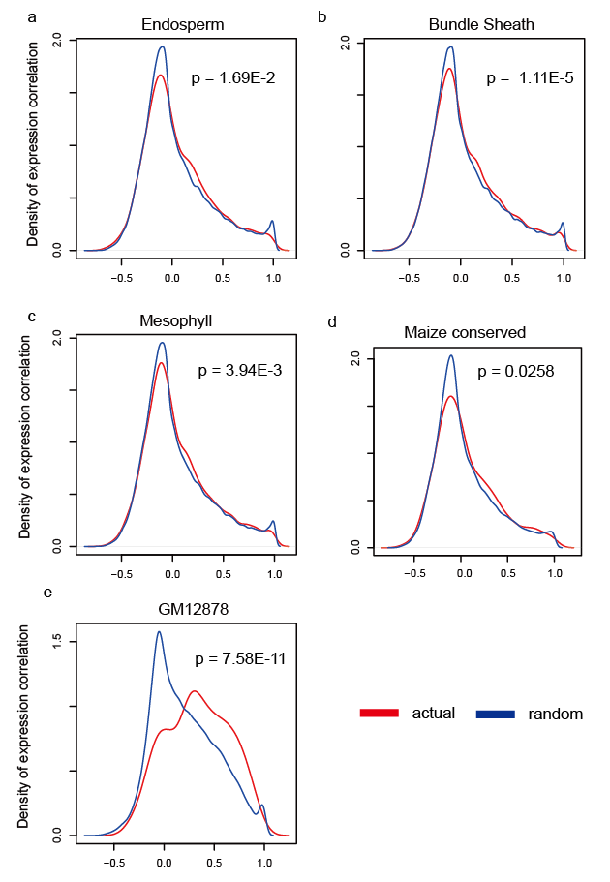
Figure S9 | Maize loop gene pairs lack the strong co-expression pattern when compared to the human loop genes. The distribution of the Pearson correlation of gene expression across three different tissues between loop gene pairs, randomized pairs of the same physical distancesare used as control. The same result is obtained using only the conserved loops called in all three tissues (d). The maize gene-pairs are also possessed significantly higher correlation than the random ones (KS test), but the delta between chromatin loop and random gene pairs are much higher in humans.

A
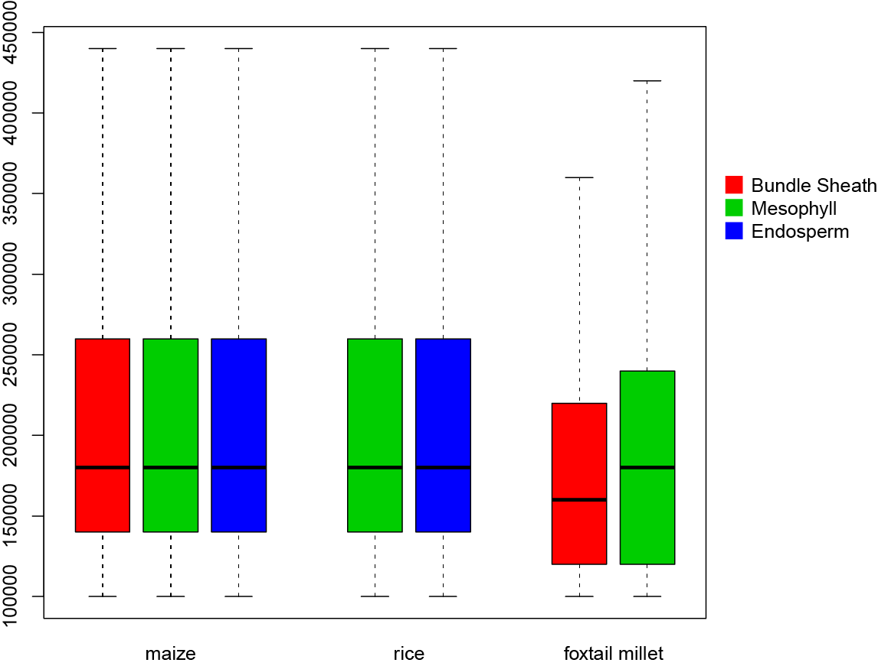
B
 | Domain counts |  |  | Genome domain coverage
 | Maize | rice | foxtail millet | maize | rice | foxtail millet
Bundle sheath | 9336 | - | 2001 | 96.52% | - | 93.34%
Mesophyll | 9028 | 1645 | 1871 | 96.64% | 97.06% | 96.04%
Endosperm | 8997 | 1666 | - | 96.65% | 96.89% | -

Fig S10 | Maize, rice and foxtail millet domain features. A) Domain size distribution. B) Domain number in different tissues and percentage of genome covered by domains. It should be noted that using a different stringency during domain calling will affect the number and genome coverage. We used the same parameter as in Dong et al. 2017.

Table S1| Hi-C data summary
 | total reads | self-circle | dandling ends | PCR duplicate | valid | intra | inter
Maize BS rep1 | 448,399,207 | 506,902 | 22,340,499 | 46,161,842 | 134,703,559 | 84,290,715 | 50,412,844
Maize BS rep2 | 867,566,517 | 216,674 | 14,294,125 | 87,224,372 | 307,806,302 | 203,773,824 | 104,032,478
Maize EN rep1 | 1,655,152,654 | 675,687 | 75,949,074 | 76,357,014 | 431,111,693 | 235,653,898 | 195,457,795
Maize EN rep2 | 528,465,391 | 163,644 | 12,167,501 | 16,614,028 | 128,844,406 | 108,719,746 | 20,124,660
Rice ME rep1 | 222,872,336 | 560,824 | 3,348,575 | 8,164,217 | 97,291,332 | 45,619,118 | 51,672,214
Rice ME rep2 | 74,158,007 | 76,480 | 6,917,210 | 1,817,406 | 24,116,142 | 12,573,249 | 11,542,893
Rice EN rep1 | 260,834,115 | 102,019 | 6,790,942 | 11,313,065 | 108,733,050 | 57,457,345 | 51,275,705
Rice EN rep2 | 633,029,035 | 309,871 | 13,621,543 | 36,660,650 | 246,171,924 | 131,393,086 | 114,778,838
Foxtail Millet BS rep1 | 518,274,243 | 4,405,548 | 92,534,267 | 104,110,668 | 72,472,141 | 40,382,468 | 32,089,673
Foxtail Millet BS rep2 | 118,773,940 | 495,214 | 47,415,402 | 1,921,856 | 18,012,712 | 9,616,516 | 8,396,196

Table S2 | RNA-Seq data summary
 | total reads | rRNA ratio | total mapping ratio
maize BS rep1 | 10,803,806 | 11.22% | 90.80%
maize BS rep2 | 11,520,858 | 14.43% | 92.70%
foxtail millet BS rep1 | 8,501,731 | 23.45% | 91.60%
foxtail millet BS rep2 | 10,053,889 | 21.36% | 93.10%

Table S3 | BS-Seq data summary
 | total reads | mapping ratio | unique map ratio | conversion ratio | cytosine covered | average cytosine  coverage
maize BS rep1 | 667,812,479 | 0.8257 | 0.617 | 0.9899 | 919,598,736 | 14.79
maize BS rep2 | 928,350,674 | 0.8307 | 0.6094 | 0.9911 | 932,792,781 | 20.41
Foxtail millet BS rep1 | 210,080,381 | 0.8728 | 0.7561 | 0.9931 | 175,476,967 | 28.77
Foxtail millet BS rep2 | 78,848,185 | 0.7534 | 0.6596 | 0.9927 | 180,423,206 | 11.24

Table S4| H3K4me3 ChIP-Seq data summary
 | total reads | mapped reads | mapping ratio | unique mapped reads | PCR duplicate rate | peak number
Maize BS | 37,828,758 | 37,082,055 | 98.03% | 25,080,235 | 0.7473 | 23,855
Foxtail millet BS | 21,230,234 | 20,456,667 | 96.36% | 17,312,321 | 0.2084 | 23,708
Rice EN | 7,102,333 | 5,653,932 | 85.70% | 5,109,436 | 0.4375 | 20,807

Table S5| Otherdatasets
Data Set | Accession number
Rice Endosperm/ME RNA-Seq | SRP008821
Rice Endosperm DNA methylation | GSE22591 (Zemach et al. 2010)
Maize Endosperm RNA-Seq, DNA methylation | SRP011991 (Zhang et al. 2014)
Maize leaf developmental gradient RNA-Seq | SRA012297 (Li et al. 2010)
Etiolated and normal maize embryonic leaves (0h and 72h) RNA-Seq | SRA061194 (Liu et al. 2013)
Maize RNA-Seq of different tissues | GSE50191 (Tobergte and Curtis 2013)
Maize Mesophyll H3K4me3,BS-Seq and Hi-C. | PRJNA391551 (Dong et al. 2017)
Foxtail millet mesophyll H3K4me3,  BS-Seq, and Hi-C | PRJNA391551 (Dong et al. 2017)
human GM12878 Hi-C data and loop | GSE63525 (Rao et al. 2014)
human RNA-Seq of different tissues | GTEx portal (Keen et al. 2015)

Table S6 | Global A/B compartment consistency between tissues(500K bin)
 | Consistent between  BS vs ME | Consistent between  ME vs EN | Consistent  Among all | Total bins
Maize | 4101 | 3907 | 3866 | 4217
Rice | - | 674 | 674 | 727
Foxtail millet | 693 | - | 693 | 807

Table S7 | Local A/B compartment dynamicsand gene expressionchanges (also shown in Fig 3C)
 | Foxtail millet |  | Maize |  | Maize
 | BS vs ME |  | BS vs ME |  | EN vs ME
 | A to B | B to A | A to B | B to A | A to B | B to A
Number of bins | 644 | 557 | 397 | 1331 | 974 | 1625
BS/EN specific gene numbers | 64 | 15 | 60 | 1 | 199 | 19
ME specific gene number | 28 | 41 | 10 | 59 | 120 | 345
Fisher exact test P | 5.53E-07 |  | 4.00E-25 |  | 5.98E-43

Table S8 | Active and repressive bins interaction patterns of endosperm and mesophyll (data for Fig S3).The median of distance normalized interaction frequency between R (repressive bins, top 10% TE content bins) and A (active bins, top 10 % mRNA read counts bins). Note the interaction frequency dropped between R-R bins in endosperm.

 | R-R | R-A | A-A | R-R/R-A | A-A/R-A
rice mesophyll | 1.30 | 0.81 | 0.88 | 1.61 | 1.09
rice endosperm | 1.12 | 0.92 | 0.96 | 1.21 | 1.05
maize mesophyll | 1.05 | 0.74 | 1.04 | 1.42 | 1.40
maize endosperm | 0.96 | 0.85 | 1.08 | 1.12 | 1.26

Table S9 | Normalized interaction frequency within and between different local compartments (data for Fig S3).The median of distance normalized interaction frequency between local compartments called using the from leaf mesophyll cell Hi-C data.
 | B-B | B-A | A-A | B-B/B-A | A-A/B-A
rice mesophyll | 1.21 | 0.86 | 1.00 | 1.41 | 1.17
rice endosperm | 1.14 | 0.99 | 1.00 | 1.15 | 1.01
maize mesophyll | 1.07 | 0.83 | 1.02 | 1.30 | 1.23
maize endosperm | 1.02 | 0.91 | 1.03 | 1.12 | 1.12

Table S10| Tissue-specific domain border and gene expression changes. The number of up-/down- regulated gene numbers at the tissue-specific domain borders, tissue-specific domain borders possess more up-regulated gene numbers.
 | Tissue1 | Tissue2 | tissue1 specific border |  | tissue2 specific border |  | tissue1 vs tissue2
 | Tissue1 | Tissue2 | tissue1 specific  gene number | tissue2 specific  gene number | tissue1 specific  gene number | tissue2 specific  gene number
 |  |  |  |  |  |  | Fisherexact test
 |  |  |  |  |  |  | p-value
Maize | BS | ME | 111 | 50 | 71 | 67 | 2.89E-03
Maize | EN | ME | 468 | 229 | 232 | 353 | 6.09E-23
Maize | EN | BS | 338 | 209 | 202 | 344 | 2.30E-16
Foxtail millet | BS | ME | 93 | 100 | 48 | 52 | 1
Rice | EN | ME | 268 | 272 | 189 | 265 | 1.27E-02

Table S11| Maize genes within the samedomain are not co-regulated (Fisher exact test).
 |  | Actual (all tissues domains combined) |  | Control (randomized domains)
 |  | up-/down-coregulated  domain number | total actual  domain number | up-/down-coregulated  domain number | total control  domain number | p value | Actual/random
maize | up | 129 | 2545 | 114,381 | 2,366,066 | 0.58 | 1.05
BS vs ME | down | 160 | 2545 | 153,655 | 2,366,066 | 0.72 | 0.97
maize | up | 292 | 2990 | 265,515 | 2,730,441 | 0.93 | 1.00
EN vs ME | down | 329 | 2990 | 273,075 | 2,730,441 | 0.07 | 1.10
millet | up | 90 | 1466 | 84,828 | 1,341,214 | 0.83 | 0.97
BS vs ME | down | 113 | 1466 | 102,145 | 1,341,214 | 0.88 | 1.01
rice | up | 99 | 1413 | 84,481 | 1,391,978 | 0.15 | 1.15
EN vs ME | down | 86 | 1413 | 91,023 | 1,391,978 | 0.52 | 0.93

 |  | Actual (only using domain conserved in all tissues) |  | Control(randomized domains)
 |  | up-/down-coregulated  domain number | total actual  domain number | up-/down-coregulated  domain number |  | total control  domain number |  | p value | Actual/random
maize | up | 88 | 1651 | 64,137 | 1,351,872 |  | 0.27 |  | 1.12
BS vs ME | down | 99 | 1651 | 84,724 | 1,351,872 |  | 0.68 |  | 0.96
maize | up | 156 | 1634 | 127,303 | 1,261,760 |  | 0.48 |  | 0.95
EN vs ME | down | 168 | 1634 | 131,037 | 1,261,760 |  | 0.94 |  | 0.99
millet | up | 52 | 840 | 46,020 | 738,582 |  | 1.00 |  | 0.99
BS vs ME | down | 66 | 840 | 56,043 | 738,582 |  | 0.74 |  | 1.04
rice | up | 50 | 626 | 37,980 | 609,243 |  | 0.08 |  | 1.28
EN vs ME | down | 29 | 626 | 41,301 | 609,243 |  | 0.03 |  | 0.68

Table S12 | Tissue-specific loops are associated with tissue-specific gene expression
 | Loop type | loop number | BS/EN specific  gene number | ME specific  gene number | Fisher test  p value
BS vs ME | All | 24013 | 1196 | 896 | -
BS vs ME | BS specific | 902 | 138 | 42 | 2.19E-07
BS vs ME | ME specific | 109 | 3 | 5 | 0.3
EN vs ME | All | 12860 | 2228 | 2543 | -
EN vs ME | EN specific | 471 | 160 | 47 | 1.66E-18
EN vs ME | ME specific | 620 | 90 | 260 | 7.76E-15

Table S13 | Weak gene expression correlation between maize gene pairs involved in chromatin loop (data for Figure S9). The median and KS test p-value of gene expression correlation between the loop connected gene pairs as well as between random gene pairs of the same genomic distance.The human loop genes have strong expression correlation, while the maize loops conserved in all three tissues have the weakest expression correlation.
 | median |  | p value
 | actual | random | p value
Maize EN | -0.038 | -0.054 | 3.50E-03
Maize ME | -0.033 | -0.054 | 2.80E-08
Maize BS | -0.037 | -0.055 | 2.80E-08
Maize conserved loops | -0.022 | -0.051 | 0.0258
Human GM12878 | 0.322 | 0.158 | 2.35E-11

Table S14 | Wilcoxon rank sum test p value of maize loop gene distance to domain border (data for Fig S8)
p value | Non-loop vs single loop | span vs single loop | single vs multiple loop
EN | 1.71E-55 | 2.06E-68 | 6.58E-13
BS | 7.39E-46 | 7.16E-66 | 5.14E-07
MC | 1.70E-107 | 2.02E-106 | 1.05E-14

Table S15 | Wilcoxon rank sum test p value of maize loopgene length (data for Fig S8)
p value | Non-loop vs span | span vs single loop | span vs multiple
EN | 1.28E-27 | 1.15E-86 | 1.76E-83
BS | 1.30E-45 | 2.00E-94 | 2.43E-96
MC | 1.78E-41 | 3.79E-78 | 1.23E-75

Table S16 | Wilcoxon rank sum test p value of maize loopgene expression Coefficient of Variation(CV) (data for Fig S8)
p value | Non-loop vs span | span vs single loop | span vs multiple
EN | 1.63E-15 | 5.39E-33 | 1.24E-24
BS | 1.92E-28 | 5.17E-20 | 4.86E-15
MC | 2.63E-37 | 4.13E-26 | 2.83E-19

TableS17 | Tissue-specific borders are often located within domain in another tissue
 |  |  | tissue1 specific border |  | tissue2 specific border
 | tissue1 | tissue2 | no-domain | intra-domain | no-domain | intra-domain
maize | BS | MC | 39 | 1685 | 38 | 1345
maize | EN | BS | 56 | 1800 | 36 | 2124
maize | EN | MC | 54 | 2023 | 32 | 2017
rice | EN | MC | 16 | 477 | 4 | 441
foxtail millet | BS | MC | 8 | 552 | 24 | 320

References

Dong P, Tu X, Chu P-Y, Lü P, Zhu N, Grierson D, Du B, Li P, Zhong S (2017) 3D Chromatin Architecture of Large Plant Genomes Determined by Local A/B Compartments. Mol Plant 10: 1497–1509
Keen J, Moore H, Keen JC, Moore HM (2015) The Genotype-Tissue Expression (GTEx) Project: Linking Clinical Data with Molecular Analysis to Advance Personalized Medicine. J Pers Med 5: 22–29
Li P, Ponnala L, Gandotra N, Wang L, Si Y, Tausta SL, Kebrom TH, Provart N, Patel R, Myers CR, Reidel EJ, Turgeon R, Liu P, Sun Q, Nelson T, Brutnell TP (2010) The developmental dynamics of the maize leaf transcriptome. Nat Genet 42: 1060–1067
Liu W-Y, Chang Y-M, Chen SC-C, Lu C-H, Wu Y-H, Lu M-YJ, Chen D-R, Shih AC-C, Sheue C-R, Huang H-C, Yu C-P, Lin H-H, Shiu S-H, Ku MS-B, Li W-H (2013) Anatomical and transcriptional dynamics of maize embryonic leaves during seed germination. Proc Natl Acad Sci 110: 3979–3984
Rao SSP, Huntley MHH, Durand NCC, Stamenova EKK, Bochkov IDD, Robinson JTT, Sanborn ALL, Machol I, Omer ADD, Lander ESS, Aiden ELL (2014) A 3D Map of the Human Genome at Kilobase Resolution Reveals Principles of Chromatin Looping. Cell 159: 1665–1680
Tobergte DR, Curtis S (2013) Integration of omic networks in a developmental atlas of maize. J Chem Inf Model 53: 1689–1699
Zemach A, Kim MY, Silva P, Rodrigues J a, Dotson B, Brooks MD, Zilberman D (2010) Local DNA hypomethylation activates genes in rice endosperm. Proc Natl Acad Sci U S A 107: 18729–18734
Zhang M, Xie S, Dong X, Zhao X, Zeng B, Chen J, Li H, Yang W, Zhao H, Wang G, Chen Z, Sun S, Hauck A, Jin W, Lai J (2014) Genome-wide high resolution parental-specific DNA and histone methylation maps uncover patterns of imprinting regulation in maize. Genome Res 24: 167–76

