SUPPORTING INFORMATION

Shuai Li^{1†}, Xinyang Tan^{3†}, Lei Yang¹, Xiaolong Deng², Miaomiao Li⁴, Lang Qin², Jing Li¹, Guanghua Luo¹, Meng Yuan², Yang Sun⁴, Chunqing Zhao², Kun Zhang², Jichao Fang^{1,3*}, Zhen He^{2*} and Rui Ji^{1,3}*

Global profiling of lysine-malonylated proteins in rice elucidates the immune-regulatory mechanisms of malonylation under herbivore or viral stresses

SUPPLEMENTARY METHODS
Rice sampling, protein extraction and digestion
Samples were retrieved from −80°C storage and ground with liquid nitrogen in a pre-cooled mortar. The resulting powder was transferred to 5 mL tubes and sonicated for 3 minutes on ice using an ultrasonic processor in lysis buffer containing 1% Triton X-100, 10 mM dithiothreitol, 1% protease inhibitor cocktail, 50 μM PR-619, 3 μM TSA, 50 mM NAM, 2 mM EDTA, and 1% phosphatase inhibitors for phosphorylation (Jadhav et al., 2024). An equal volume of Tris-saturated phenol (pH 8.0) was added, followed by vortexing for 5 minutes. After centrifugation at 4°C for 10 minutes (5,500 g), the phenolic phase was collected into new tubes. Proteins were precipitated by adding excess ammonium sulfate-saturated methanol and incubating at −20°C for at least 6 hours. Following centrifugation at 4°C (5,500 g) for 10 minutes, the supernatant was discarded, and the pellet washed sequentially with ice-cold methanol and acetone three times. The protein was resuspended in 8 M urea, and its concentration determined using a BCA kit (Taunk et al., 2023). Proteins were TCA-precipitated (20%), centrifuged (4,500 g, 5 min), washed thrice with cold acetone, and resuspended in 200 mM TEAB via sonication. Trypsin digestion (1:50) was performed after standard DTT reduction (56°C) and iodoacetamide alkylation steps. Desalting used Strata X SPE columns.
Affinity enrichment of lysine malonylated peptides
To enrich malonylated peptides, tryptic peptides dissolved in NETN buffer (100 mM NaCl, 1 mM EDTA, 50 mM Tris-HCl, 0.5% NP-40, pH 8.0) were incubated with pre-washed antibody beads (PTM-902, PTM Bio, Hangzhou, China) at 4°C overnight with gentle shaking. Then the beads were washed for four times with NETN buffer. The bound peptides were eluted from the beads with 0.1% trifluoroacetic acid. Finally, the eluted fractions were combined and vacuum-dried. For LC-MS/MS analysis, the resulting peptides were desalted with C18 ZipTips (Millipore) according to the manufacturers instructions.
RNA preparation and construction of sequencing library
Total RNA was isolated using the SteadyPure Plant RNA Extraction Kit (ACCURATE BIOTECHNOLOGY(HUNAN)CO.,LTD, ChangSha, China) according to the manufacturer’s instructions. The RNA-seq libraries were prepared using the Illumina TruSeq RNA Sample Preparation Kit and sequenced on Illumina HiSeq 2000 with PE150 method, each library contained 20 μg total RNA. Raw sequence data were filtered by Trimmomatic (version 0.33) to remove contaminations and low-quality reads. Tophat (version 2.0.14) and Cufflinks (version 2.2.1) (Trapnell et al., 2012) were used to map clean reads to rice genome (Oryza sativa. IRGSP-1.0) and calculate differentially expressed genes (DEGs). Genes with adjusted p-value < 0.05 and fold change > 2 or < 0.5 in biotic stress-treated vs. CK comparison groups were considered as DEGs. This work was performed in collaboration with LC-Bio Technologies (Hangzhou) Co., Ltd, China.
Protein-protein interaction (PPI) network
All differentially expressed protein database accession were searched against the STRING database for PPI analysis. We exclusively selected protein interactions within the dataset (excluding external candidates), retaining interactions with STRING confidence scores > 0.7 (high confidence). The network was visualized using the R package visNetwork.
Insect bioassays
In the survival rate test, Nilaparvata lugens nymphs were allowed to feed on rice seedlings, each confined individually within glass cylinders, into which 30 N. lugens nymphs were released (Li et al., 2023). The number of surviving N. lugens nymphs in each cylinder was recorded daily, each experiment was replicated five times. The oviposition test was conducted as follows: a pair of newly emerged female and male N. lugens were released in one cylinder, allowed to mate, and lay eggs for 7 days. The number of eggs laid by each female on the plants was counted using a microscope (Wang et al., 2020). The experiment was replicated five times. For the honeydew and weight gain tests, a brachypterous newly emerged N. lugens female adult was placed into a small parafilm bag (6 × 5 cm), which was then fixed to the leaf sheath of a rice plant. The amount of honeydew excreted by a female adult and weight gain was measured (accurate to 0.1 mg) after 48 hours (Ji et al., 2021). The experiment was replicated eight times with ten N. lugens per test. For the resistance evaluation of rice at the third-leaf stage, ten 3rd-instar N. lugens nymphs were released per seedling. Photographs of the phenotypes were took after 14 days. The experiment was conducted three times with twenty rice plants per test. For the C. suppressalis bioassay, five 2-day-old larvae of C. suppressalis were gently introduced to the middle stem of each rice plant using a soft brush, and the larvae were weighed on a precision balance after 7 days. The mean weight of the two larvae on each plant was considered as one biological replicate, resulting in a total of 25 biological replicates for each treatment. Concurrently, herbivory damage patterns were documented using photography (Yu et al., 2025).
Preparation of RSV-infected rice plants
Wild-type ZH11 and hda711 knockout rice seeds were sown in plastic containers filled with 5 cm of sterilized soil respectively. After 10 days of growth, RSV-carrying Laodelphax striatellus (3rd to 4th instar) were introduced onto the seedlings at a density of 10 insects per seedling. Following a 3-day infection period, the insects were removed. The infested seedlings were then individually transplanted into 650 mL plastic cups for continued cultivation, designated as ZH11-RSV and hda711-RSV plants, respectively. Phenotypic of RSV-infected symptoms were captured 30 days after transplanting. Three independent tests were conducted, each including 30 ZH11 or hda711 rice plants. For symptom imaging, three representative plants displaying the prevalent symptoms from each group were selected.
REFERENCES
Jadhav, H.B., Choudhary, P., Gogate, P., Ramniwas, S., Mugabi, R., Ahmad, Z., Mohammed Basheeruddin Asdaq, S., and Ahmad Nayik, G. (2024). Sonication as a potential tool in the formation of protein-based stable emulsion - Concise review. Ultrason. Sonochem. 107: 106900.
Taunk, K., Paul, D., Dabhi, R., Venkatesh, C., Jajula, S., Naik, V., Tamhankar, A., Naiya, T., Kumar Santra, M., and Rapole, S. (2023). A single step and rapid protein extraction protocol developed for cell lines and tissues: Compatible for gel based and gel free proteomic approaches. Methods. 220: 29-37.
Trapnell, C., Roberts, A., Goff, L., Pertea, G., Kim, D., Kelley, D.R., Pimentel, H., Salzberg, S.L., Rinn, J.L., and Pachter, L. (2012). Differential gene and transcript expression analysis of RNA-seq experiments with TopHat and Cufflinks. Nat. Protoc. 7: 562-578.
Li, J., Li, S., Li, J., Tan, X., Zhao, Z., Jiang, L., Hoffmann, A.A., Fang, J., and Ji, R. (2023). Egg-associated secretions from the brown planthopper (Nilaparvata lugens) activate rice immune responses. Insect Sci. 31: 1135-1149.
Wang, W., Zhou, P., Mo, X., Hu, L., Jin, N., Chen, X., Yu, Z., Meng, J., Erb, M., Shang, Z., et al. (2020). Induction of defense in cereals by 4-fluorophenoxyacetic acid suppresses insect pest populations and increases crop yields in the field. Proc. Natl. Acad. Sci. U.S.A. 117: 12017-12028.
Ji, R., Fu, J., Shi, Y., Li, J., Jing, M., Wang, L., Yang, S., Tian, T., Wang, L., Ju, J., et al. (2021). Vitellogenin from planthopper oral secretion acts as a novel effector to impair plant defenses. New Phytol. 232: 802-817.
Yu, S., Li, S., Li, J., Wang, C.Y., Yang, L., Li, J., Meng, Y., Tan, X.Y., Jing, M.F., Luo, G.H., et al. (2025). Ferritin from striped stem borer (Chilo suppressalis) oral secretion acts as an effector helping to maintain iron homoeostasis and impair defenses in rice. Plant Cell Environ. 48: 3735−3749.
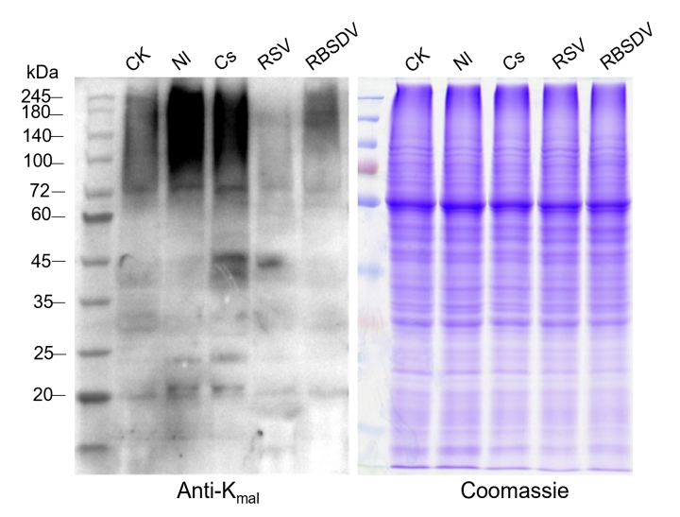
Figure S1. Identification of rice K_{mal} modifications
Detection by immunoblotting of K_{mal} in total proteins isolated from un-treated control rice (CK), N. lugens-infested (Nl), C. suppressalis-infested (Cs), RSV-infected (RSV), and RBSDV-infected (RBSDV) rice plants. Primary antibody: anti-Malonyllysine mouse mAb (PTM-902, PTM Bio, Hangzhou, China) 1:1500 dilution; Secondary: Goat anti-Mouse IgG conjugated antibody 1:10000 dilution. Coomassie blue-stained total proteins are shown as loading controls.
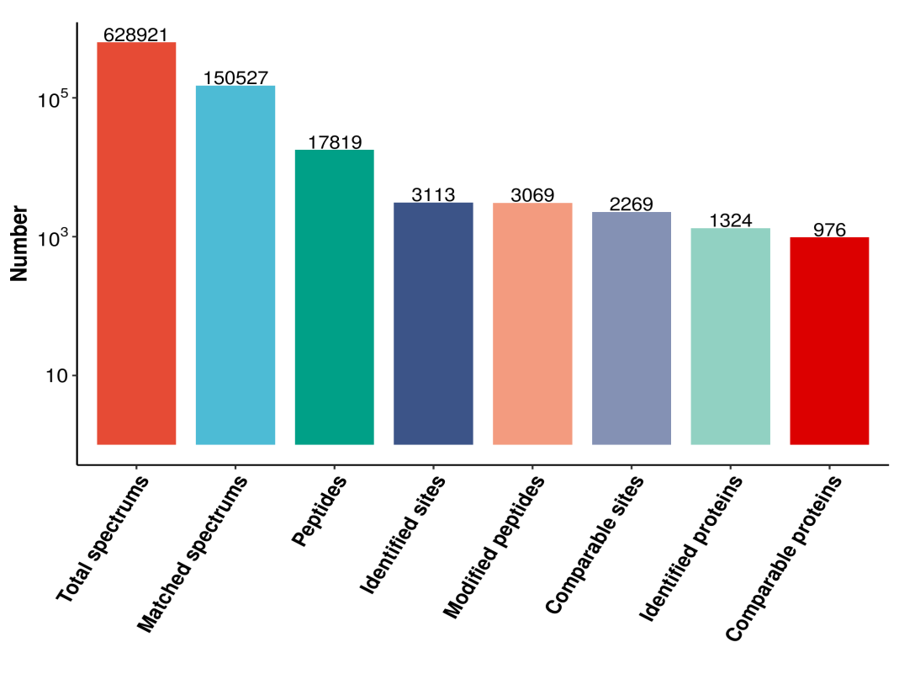
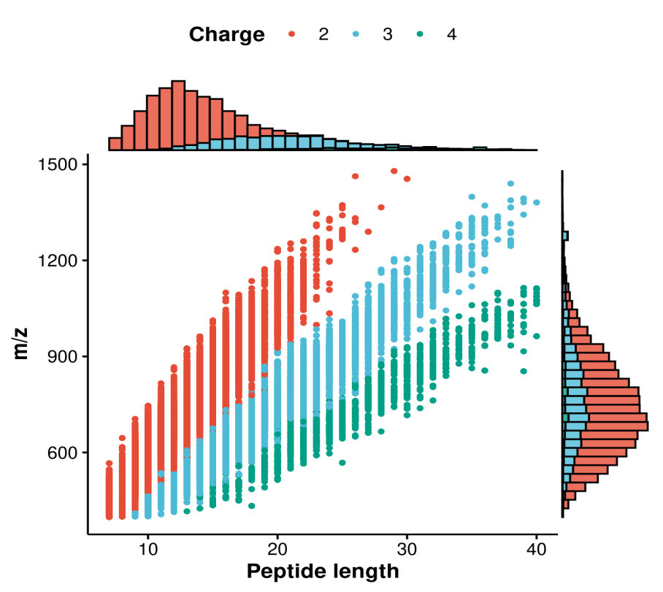
A
B
Figure S2. Characteristics of K_{mal}-modified lysines among proteins
(A) Distribution profile of K_{mal}-modified peptides identified by LC-MS/MS analysis with SEQUEST database searching. (B) Physicochemical properties of K_{mal}-containing peptides. Upper panel: Length distribution of identified peptides. Lower panel: Charge state distribution of modified peptides as indicated by colored symbols: red circles (+2), blue circles (+3), and green circles (+4). m/z values represent recalibrated mass-to-charge ratios derived from high-resolution MS measurements.

A
B
Figure S3. Reproducibility of quantitative K_{mal} proteome analyses
(A) Inter-replicate correlations of K_{mal} abundance profiles across experimental conditions. Pearson correlation coefficients (r) were calculated for normalized malonylation levels (Log₁₀-transformed RPKM values) from three biological replicates in mock-treated control and four biotic stress conditions: RSV infection, RBSDV infection, Nilaparvata lugens infestation, and Chilo suppressalis infestation. (B) Pearson’s correlation coefficients between individual biological replicates of the proteome across all fifteen samples. Protein expression levels were normalized using Log₁₀-transformed RPKM values prior to correlation analysis.

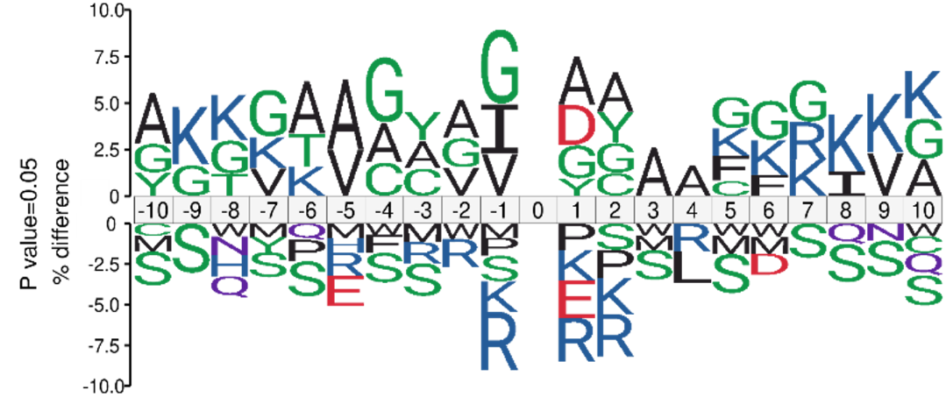
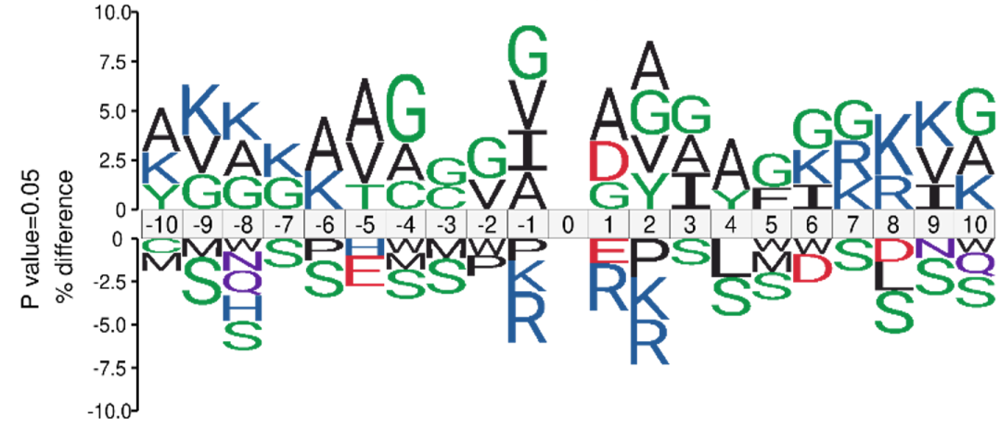
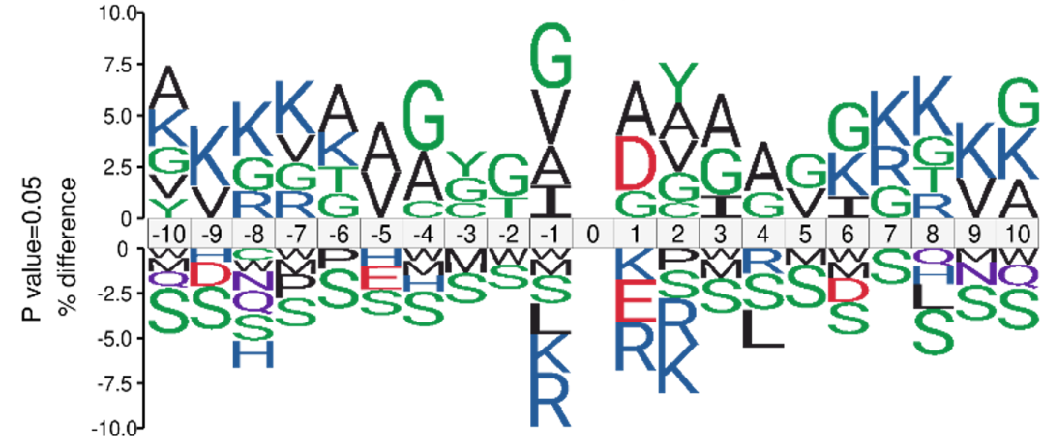
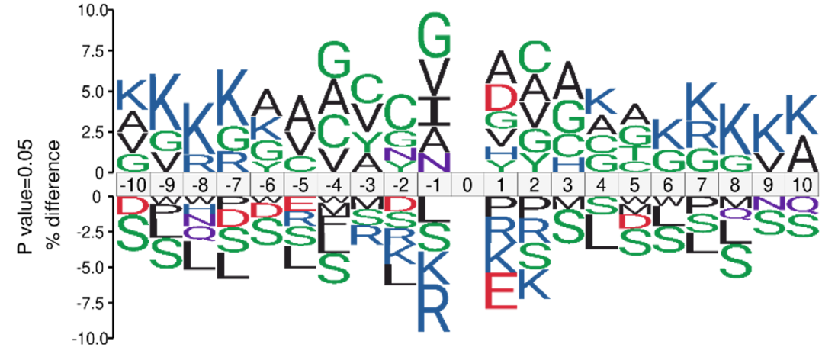
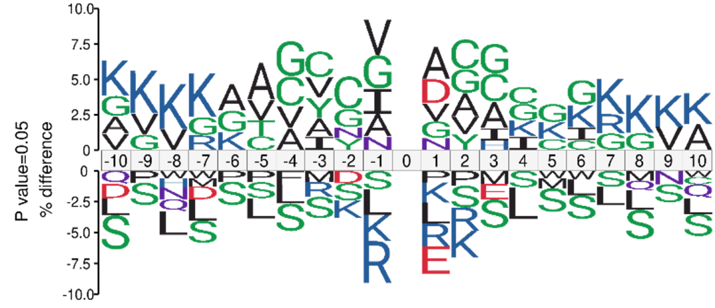
CK
A
RSV
B
RBSDV
C
Nl
D
Cs
E
Figure S4. Motif analysis of conserved amino acids flanking K_{mal} sites
(A-E) Position-specific amino acid preferences flanking malonylated lysine residues. Sequence logos depict residue enrichment patterns in control (A) and stressed conditions: RSV-infected (B), RBSDV-infected (C), Nilaparvata lugens-infested (D), and Chilo suppressalis-infested (E) samples. The size of an amino acid reflects the difference in the frequency of an amino acid in the experiment and its frequency in the reference set. The p‐value of each amino acid at every position was calculated by testing the experimental frequency against the frequency of each amino acid in the reference set with Fisher's exact test. In this logo, only significant amino acids (p < 0.05) are shown.

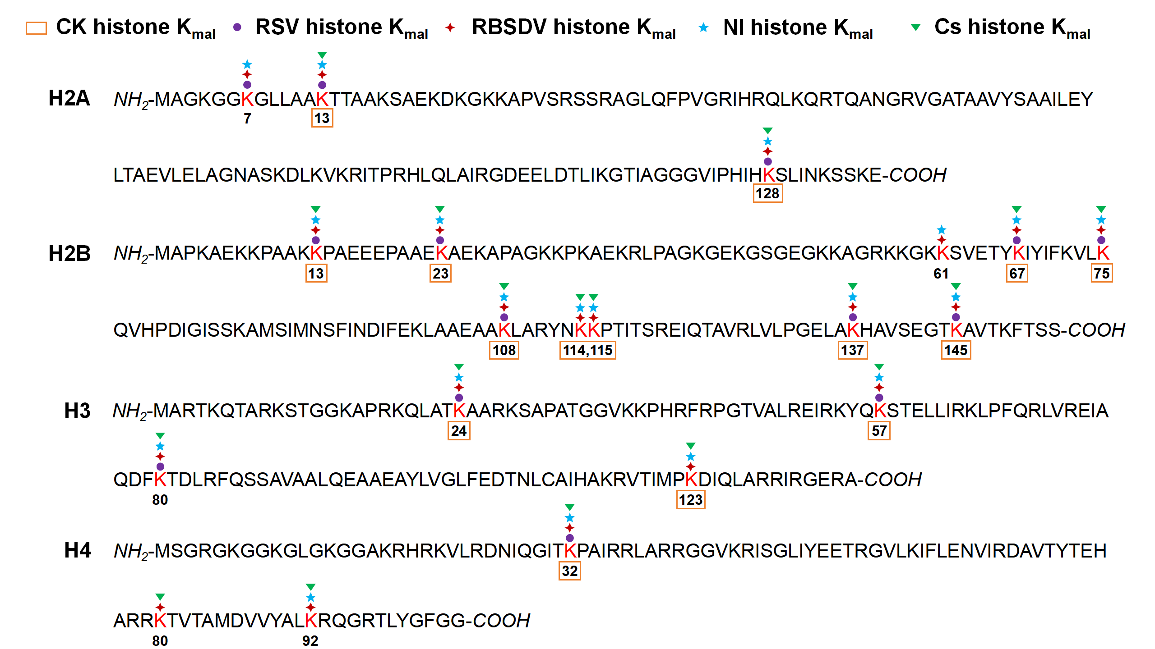
Figure S5. Identification of rice histone K_{mal} sites by mass spectrometry
LC-MS/MS-based profiling of histone malonylation sites in rice under different biotic challenges. Venn diagram illustrates the distribution of identified K_{mal} sites across experimental groups: mock-treated control plants (yellow rectangles), Rice stripe virus (RSV)-infected (purple circles), Rice black-streaked dwarf virus (RBSDV)-infected (red diamonds), Nilaparvata lugens-infested (blue stars), and Chilo suppressalis-infested (green triangles) specimens. Overlapping regions denote conserved modification sites across multiple conditions.

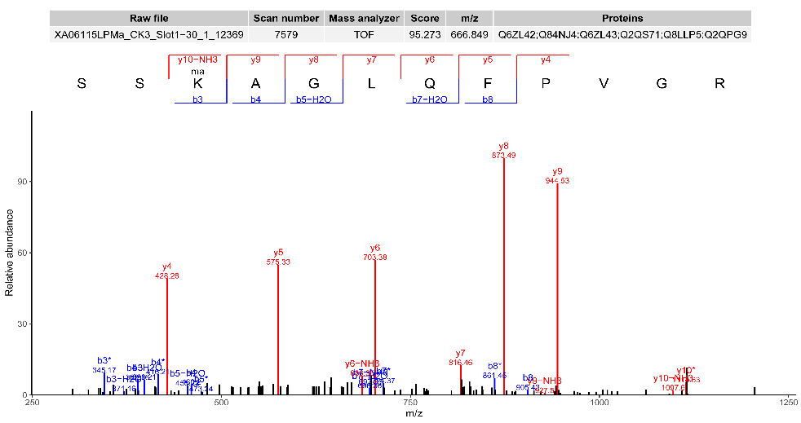
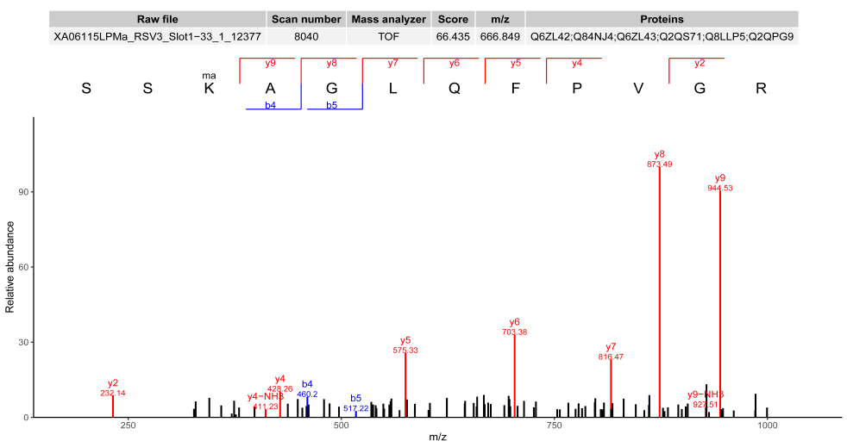
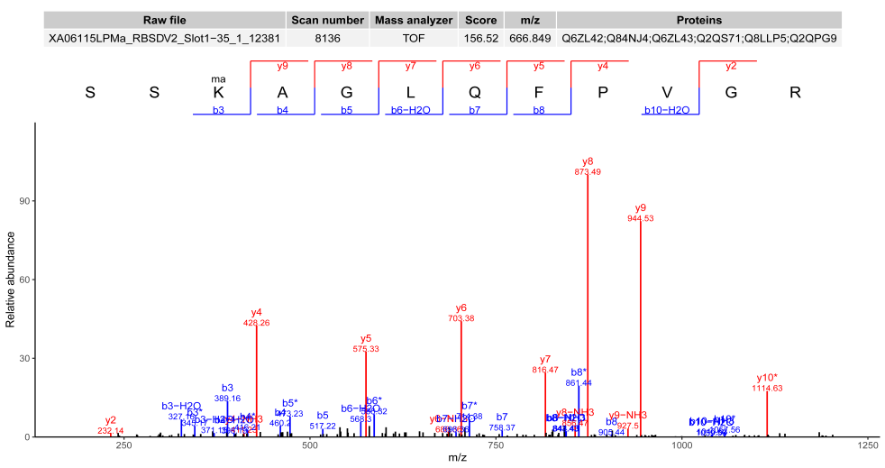
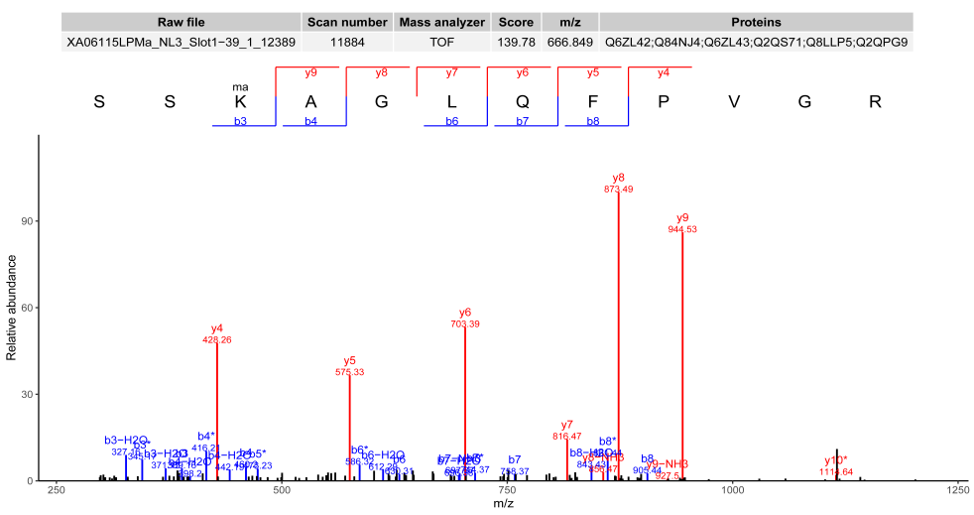
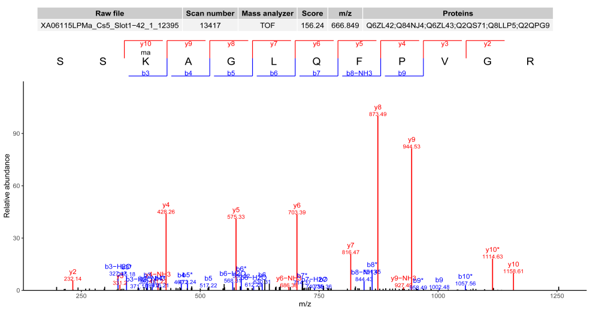
A
B
C
D
E
Figure S6. Representative MS/MS spectrum of K_{mal}-modified peptide from histone H2A.2 in rice plants
The detected b and y fragmention series are shown. Loss of H₂O or NH3 is presented in red color. Asterisks represent the neutral loss of CO₂ (−44 Da) and the precursor m/z. Charge state, peptide score and mass error are shown for each spectrum. The modification site is indicated as (ma) in peptide sequence. (A-E) Diagnostic fragmentation patterns of the malonylated peptide SSK^(mal)AGLQFPVGR (UniProt: Q6ZL42) under different biotic stress conditions: (A) Un-treated control, (B) Rice stripe virus (RSV)-infected, (C) Rice black-streaked dwarf virus (RBSDV)-infected, (D) Nilaparvata lugens-infested, and (E) Chilo suppressalis-infested plants.

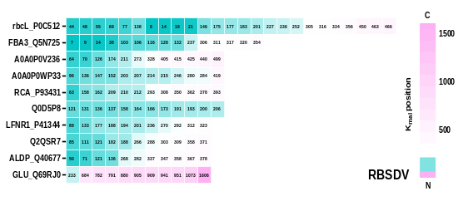
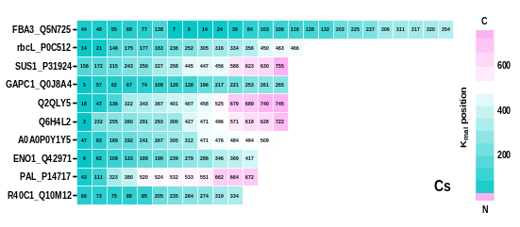
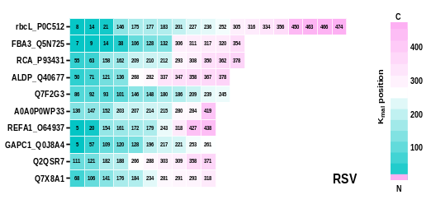
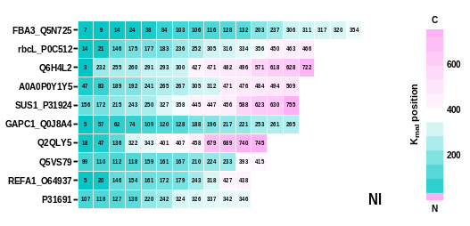
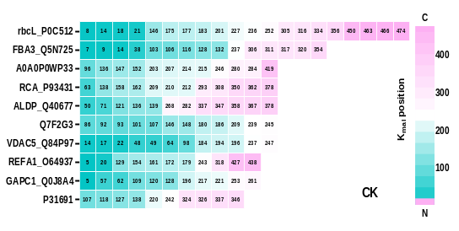
A
B
C
D
E
Figure S7. Graphical summary of proteins with top 10 number of K_{mal} sites in rice plants
(A-E) Comparative analysis of predominant K_{mal}-modified proteins across experimental conditions: (A) Un-treated control, (B) Rice stripe virus (RSV)-infected, (C) Rice black-streaked dwarf virus (RBSDV)-infected, (D) Nilaparvata lugens-infested, and (E) Chilo suppressalis-infested proteomes. Square number represents number of K_{mal} modifification sites while the number in each square shows position of lysine where the protein is K_{mal}‐modifified. K_{mal} positions close to N‐ and C‐terminus of the proteins are marked as blue and pink, respectively.

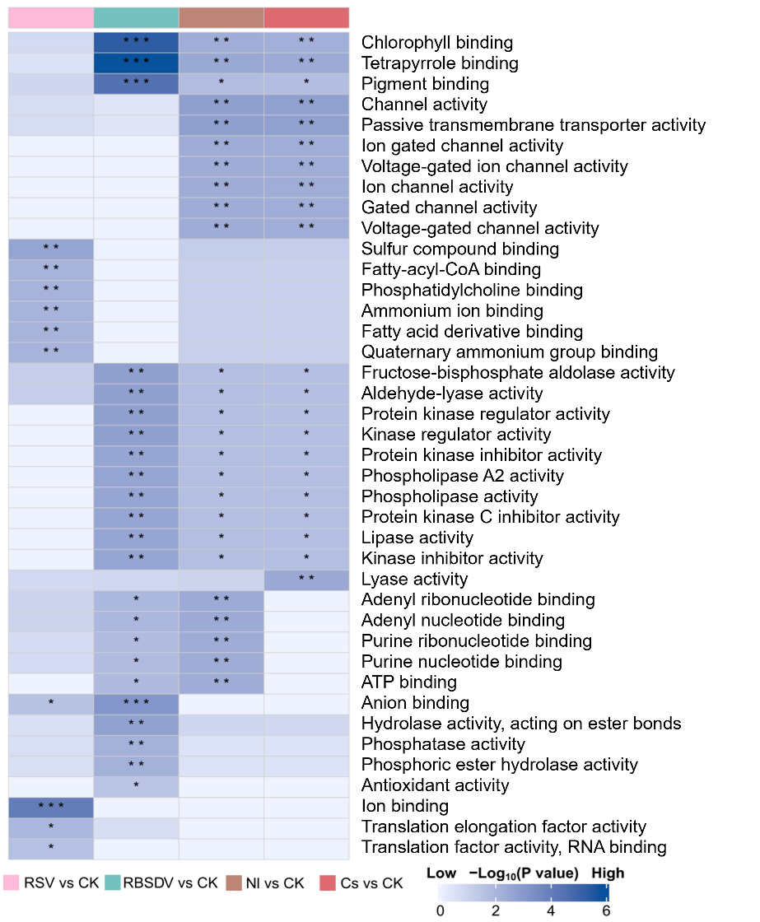
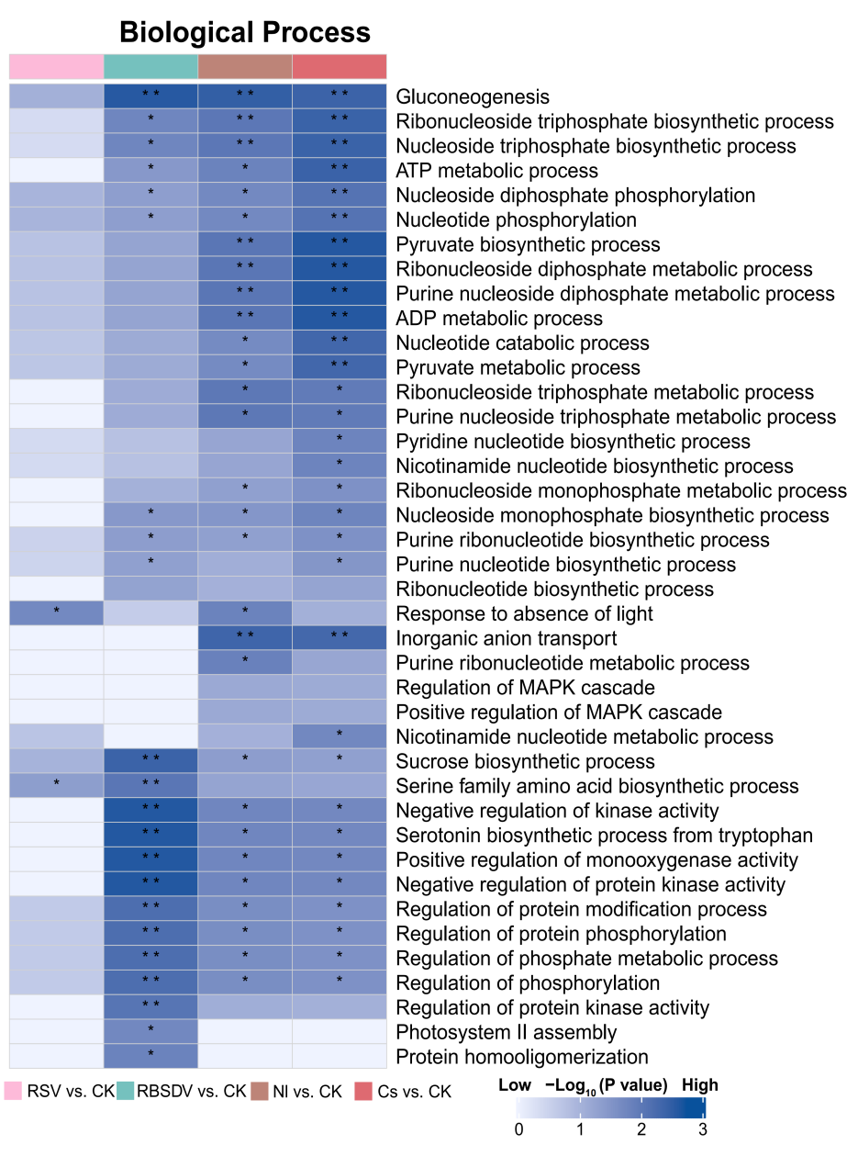
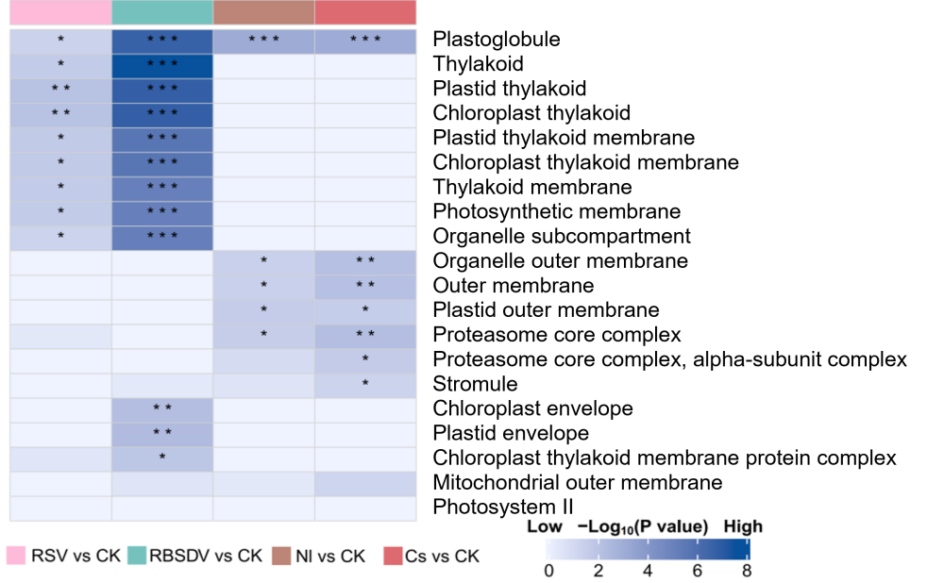
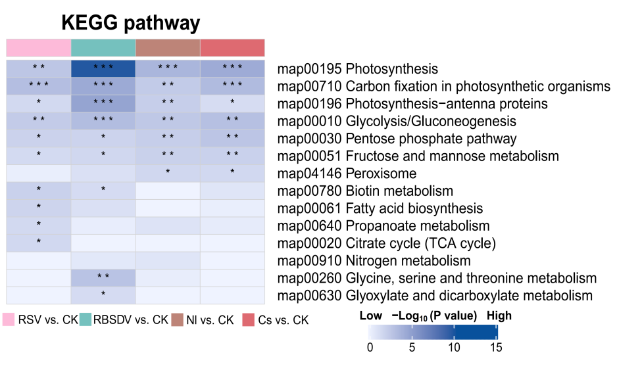
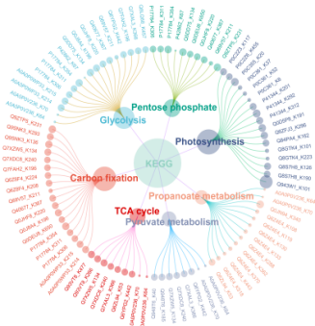
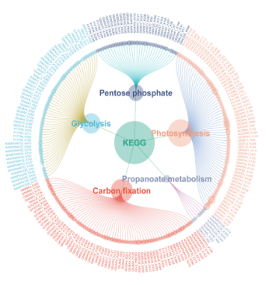
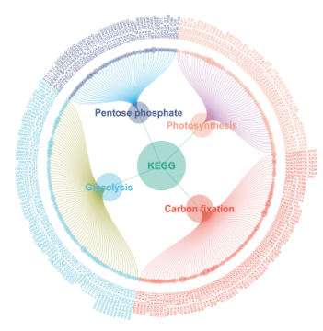
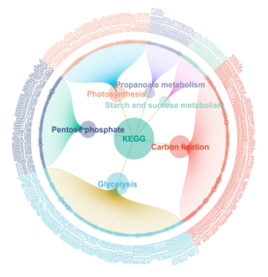
A
D
B
C
RSV vs. CK
RBSDV vs. CK
Nl vs. CK
Cs vs. CK
E
Figure S8. Functional annotation of differential malonylated proteins in infected versus un-treated rice plants
(A-C) Gene Ontology enrichment analysis of differential K_{mal}‐modified proteins for biological processes (A), molecular function (B), and cellular component (C) in the infected rice plants compared with un-treated control plants. (D) Kyoto Encyclopedia of Genes and Genomes (KEGG) pathway enrichment analysis of differential K_{mal}‐modified proteins in the infected rice plants compared with un-treated control plants. Color gradient reflects the statistical significance of enrichment (darker blue = higher significance). Asterisks indicate significant differences (* p < 0.05; ** p < 0.01; *** p < 0.001). (E) KEGG pathway enrichment analysis of differential K_{mal}-modified proteins identified in this study. The differential K_{mal}-modified proteins enriched in the top pathways are highlighted.
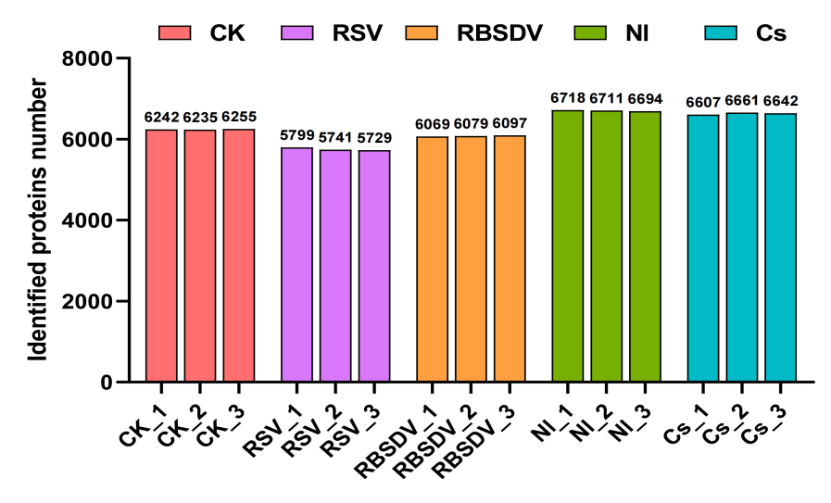
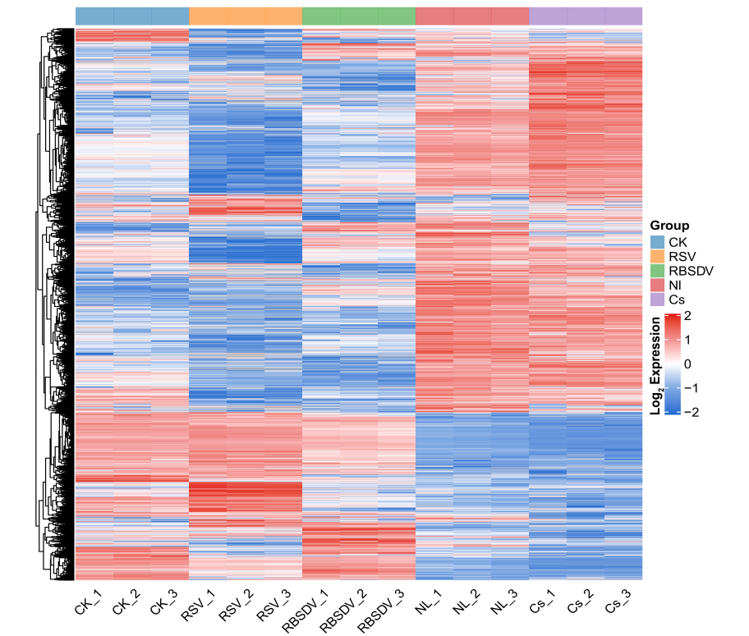
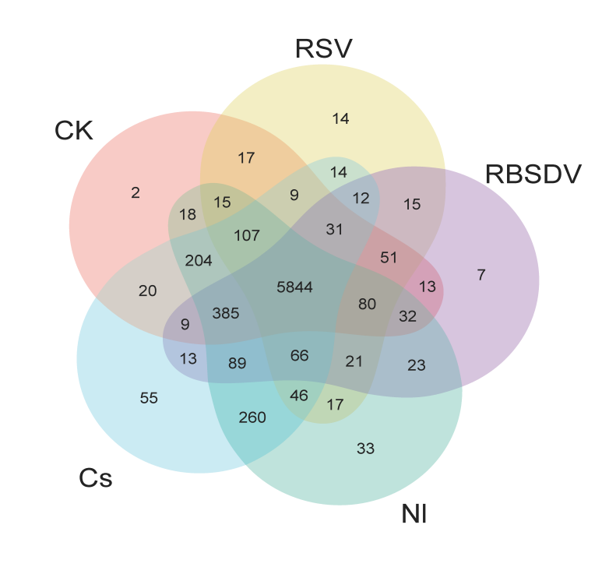
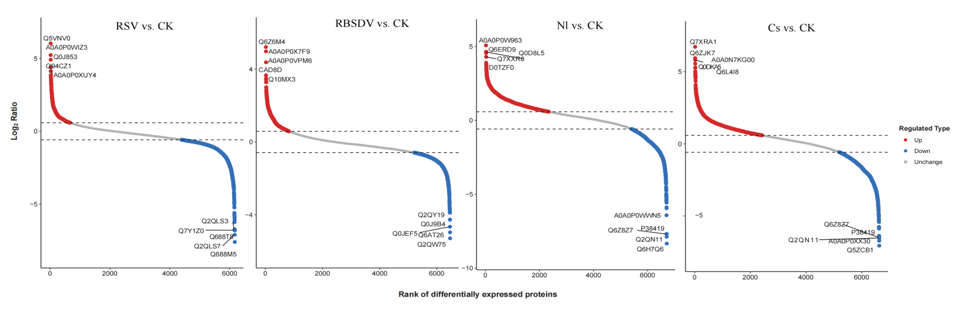
Figure S9. Rice proteome dynamic changes under biotic stresses
A
B
C
D
E
(A) Quantitative proteome profiles across experimental groups: untreated controls (CK) versus Rice stripe virus (RSV)-, Rice black-streaked dwarf virus (RBSDV)-, Nilaparvata lugens (Nl)-, and Chilo suppressalis (Cs)-stressed plants. (B) Number of proteins identified in control and four biostressed rice groups. (C) Venn diagram of identified proteins from control and four biostressed rice groups. (D) Heatmap of protein intensities from control and four biostressed rice groups. (E) Scatterplot analysis of differentially expressed proteins. X-axis: Number of differentially expressed proteins; Y-axis: Log₂-transformed fold-change ratios (stressed vs. CK). Red, upregulation; Blue, downregulation; Gray, non-significant.
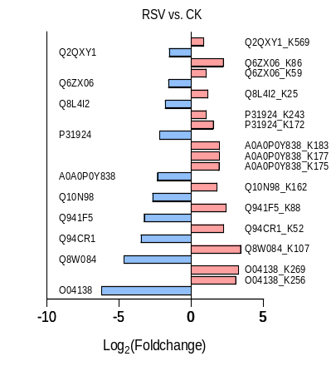
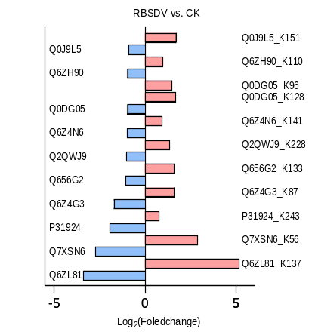
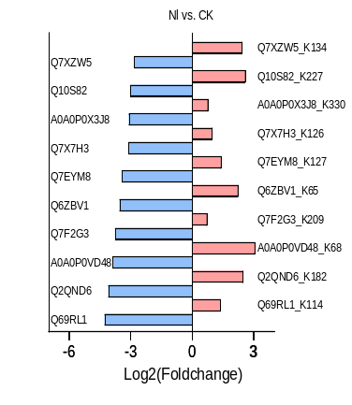
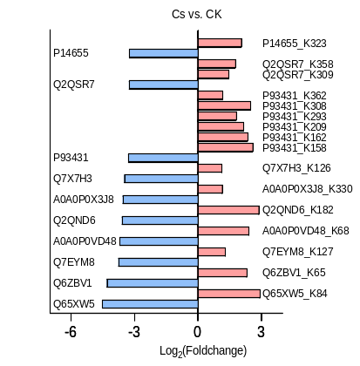
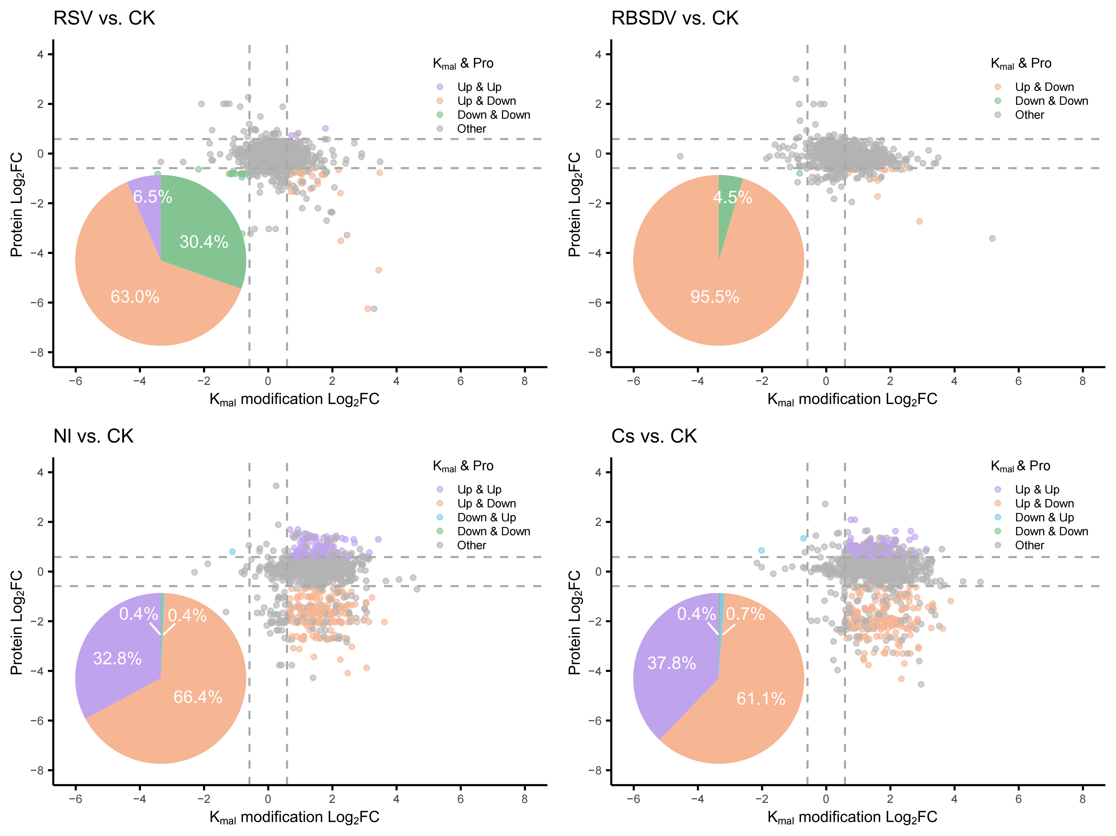
B
A
Figure S10. Biotic stress upregulates K_{mal} modification to drive proteome-wide downregulation
(A) Dual-axis visualization of protein regulation patterns. Scatter plot comparing K_{mal} modification fold change (X-axis) versus protein expression fold change (Y-axis) across four comparison groups, along with pie charts quantifying four color-coded regulatory patterns. Purple: Co-upregulated (K_{mal} modifications and protein expression); Orange: K_{mal} upregulation with concomitant protein downregulation; Blue: K_{mal} downregulation coupled with protein upregulation; Green: Co-downregulated (both K_{mal} and protein expression). (B) Quantitative ranking of the top 10 most abundant proteins demonstrating inversely correlated patterns: upregulated K_{mal} with concomitant protein downregulation in multi-group comparisons.

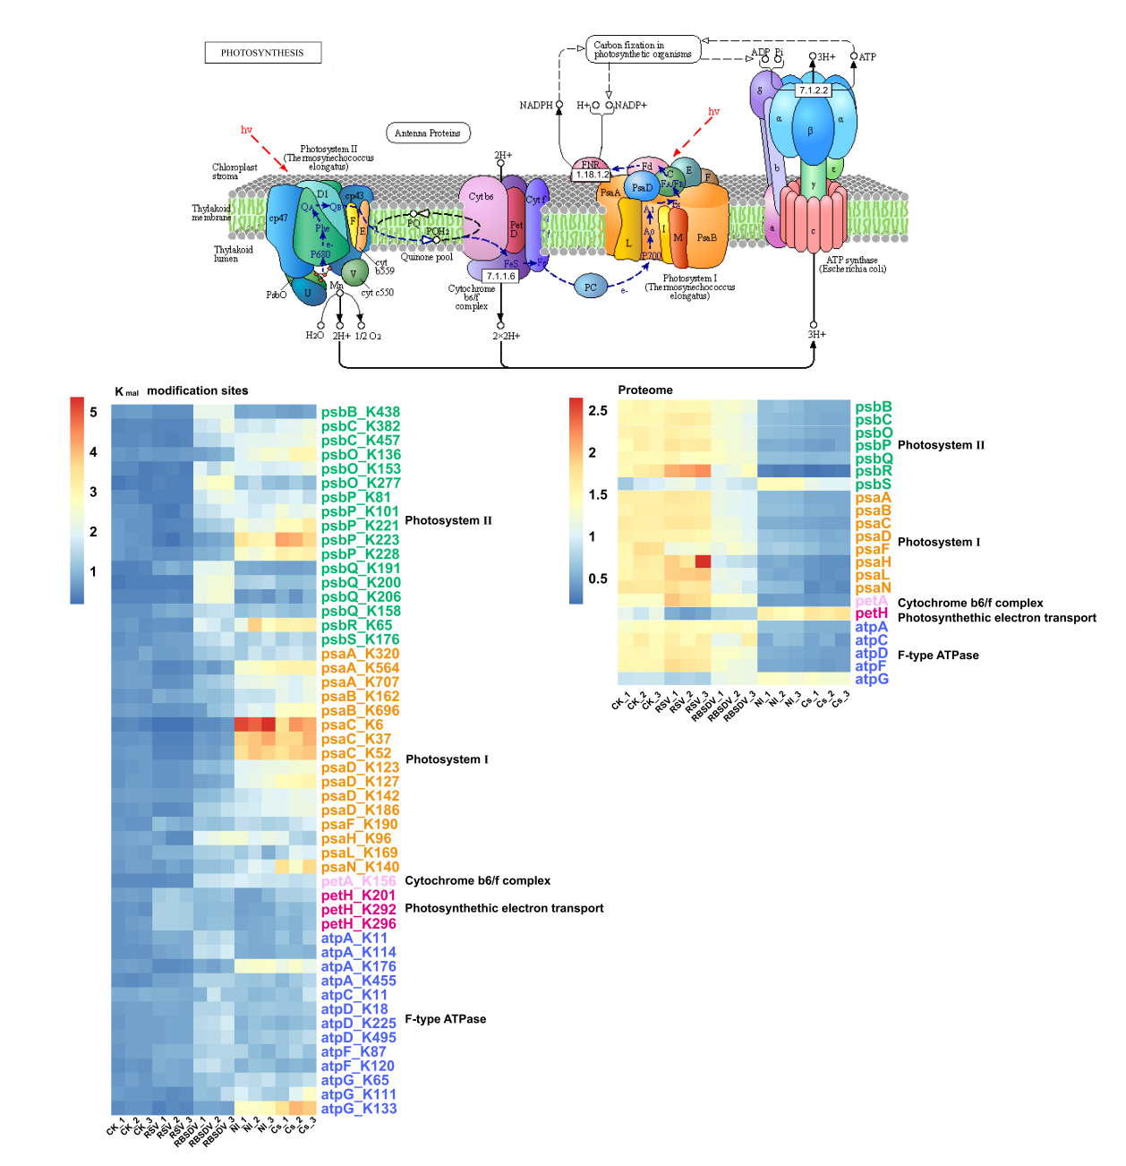
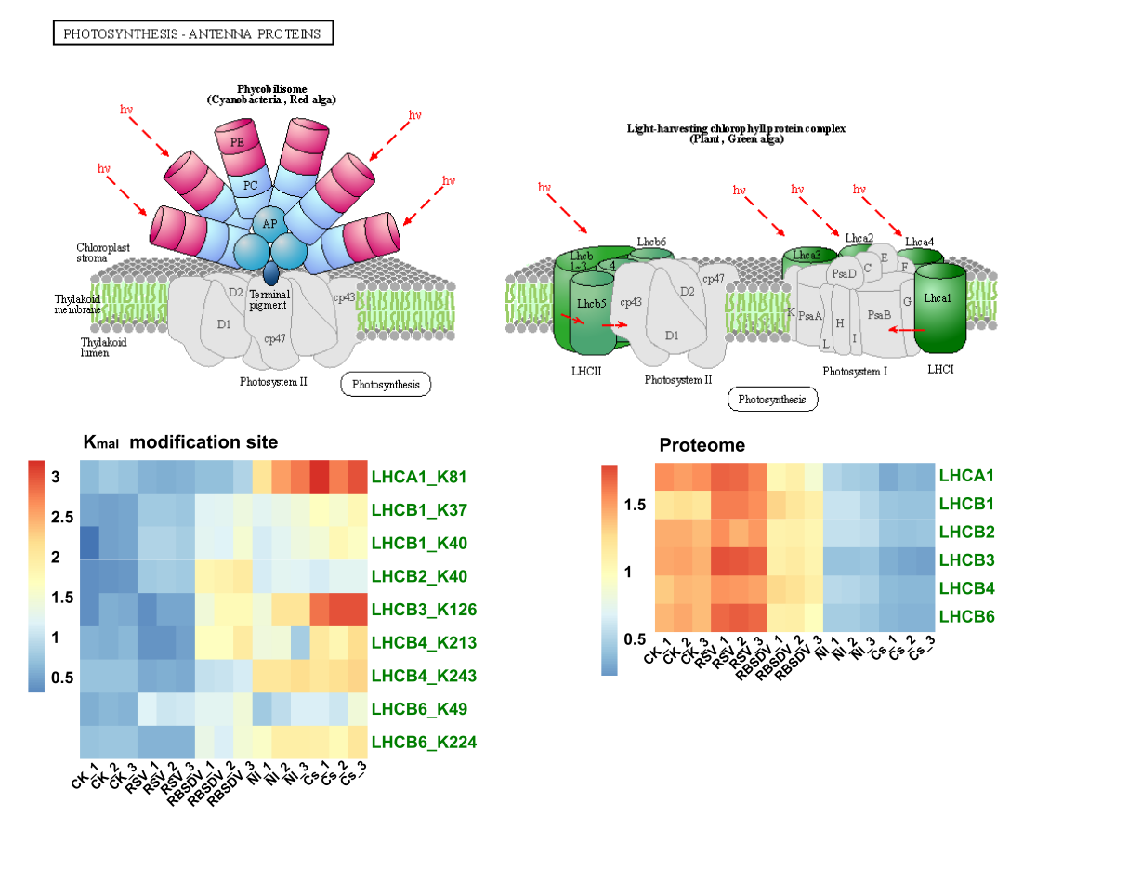
A
B
C
D
E
F

Figure S11. K_{mal} coordinates stress-responsive metabolic and photosynthetic remodeling
(A) Plant photosystem model, containing photosystem I (PSI), photosystem II (PSII), cytochrome b6/f complex, photosynthetic electron transport proteins, and F-type ATPase (upper panel). Heatmaps of both K_{mal} modification levels (left) and protein abundance (right) for photosynthetic components across four treatment groups and control group. (B) Models of plant phycobilisome and light-harvesting chlorophyll protein complex (upper panels), along with heatmaps showing both K_{mal} modification levels (left) and protein abundance (right) across four treatment groups and control group. (C-F) Detailed pathways of glycolysis and carbohydrate metabolism (C), carbon fixation in photosynthetic organisms (D), pentose phosphate (E) and fructose and mannose metabolism (F), along with heatmaps showing both K_{mal} modification levels (left) and protein abundance (right) across treatments.

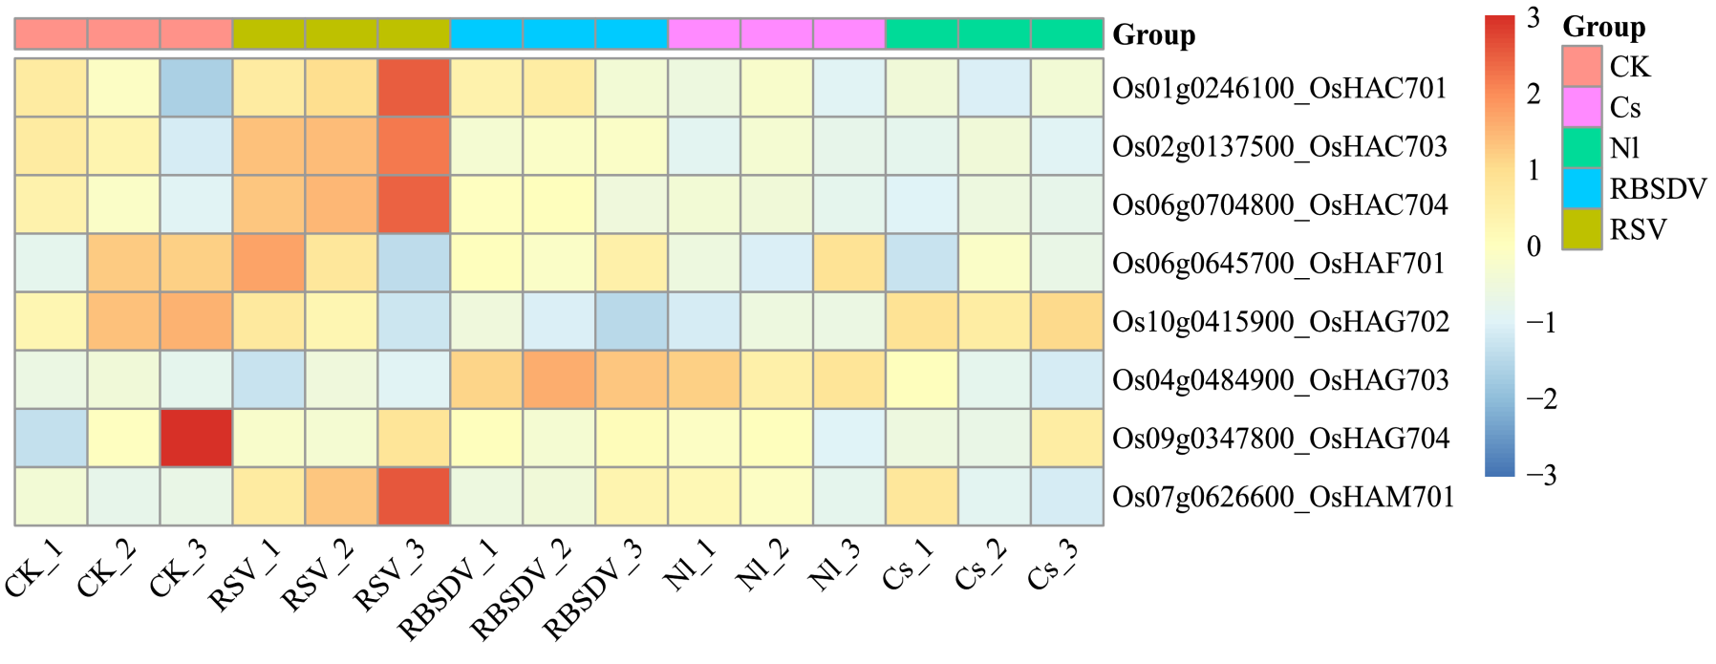
A
B
Figure S12. Heatmap of transcriptome expression of rice acetyl-transferases and deacetylases genes
(A, B) Transcriptome-wide analysis of epigenetic regulator expression patterns under biotic stresses, presented through hierarchically clustered heatmaps (z-score normalized) comparing Rice stripe virus (RSV)-, Rice black-streaked dwarf virus (RBSDV)-, Nilaparvata lugens (Nl)-, and Chilo suppressalis (Cs)-challenged groups versus untreated controls (CK), specifically profiling rice histone deacetylases (Panel A) and histone acetyltransferases (Panel B) with significance thresholds (FDR < 0.05).

A
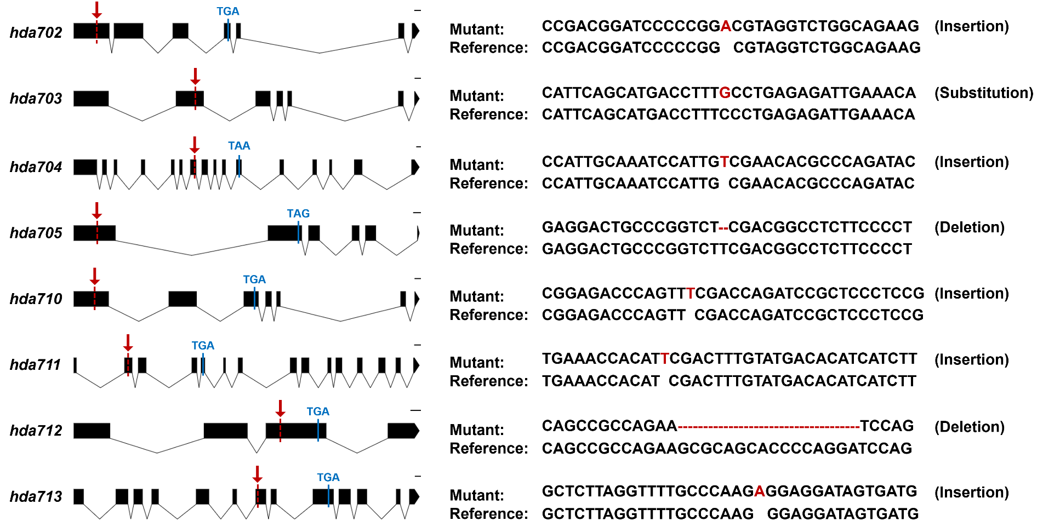
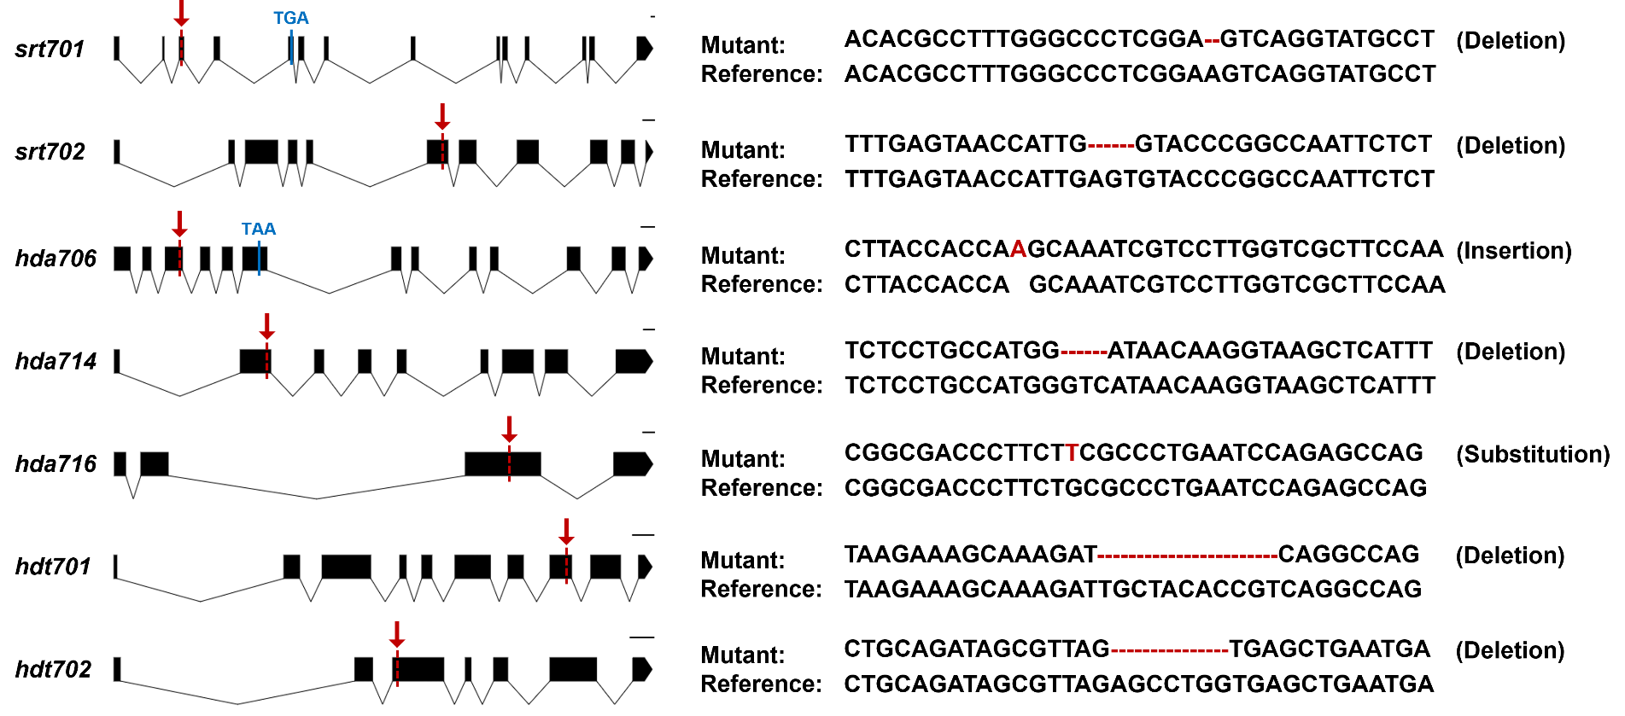
B
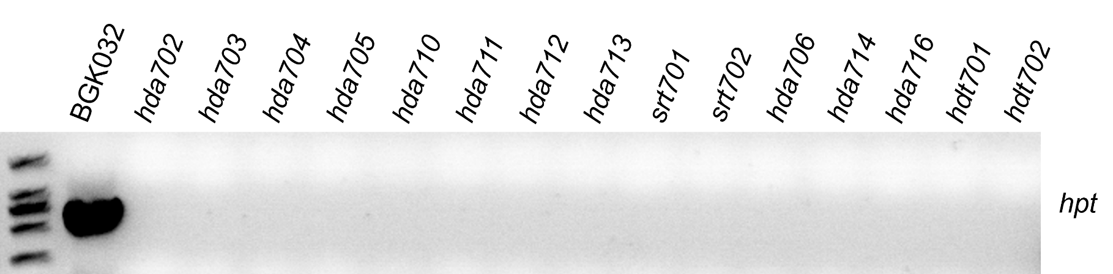

Figure S13. Mutation sites of each rice histone deacetylases mutants and T-DNA detection
(A) Full-length indicates the coding sequence region, solid boxes represent exons, and solid lines denote introns. Red arrowheads point to the editing sites in the mutant gene. The scale bar represents 100 bp. (B) Detection of T-DNA insertion in HDAC mutants. To confirming the complete T-DNA segregation in the mutant lines, PCR analysis was performed by using primers targeting the Hygromycin phosphotransferase (hpt) gene with the Vector-BGK032 plasmid as a positive control. Agarose gel electrophoresis confirmed the absence of the hygromycin resistance marker in all mutant lines used in this study.

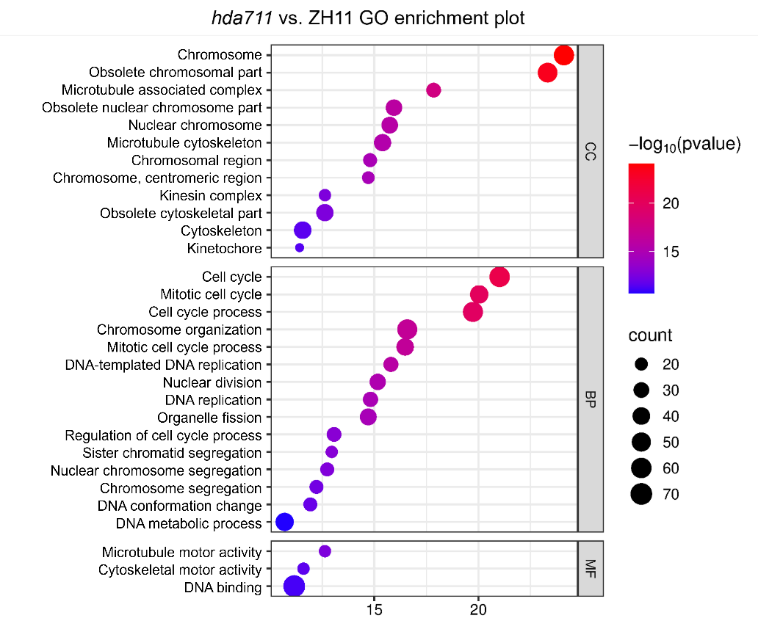
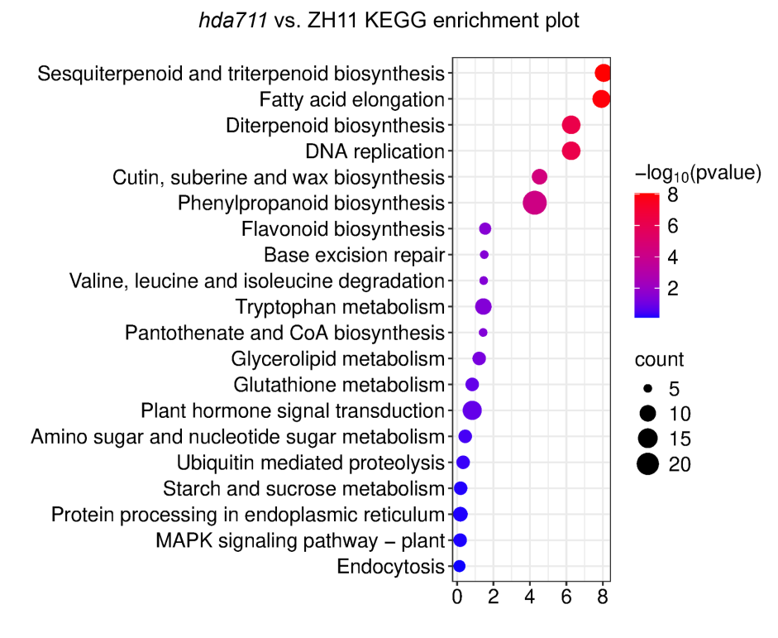
D
C
A
B
Enrich factor
Enrich factor
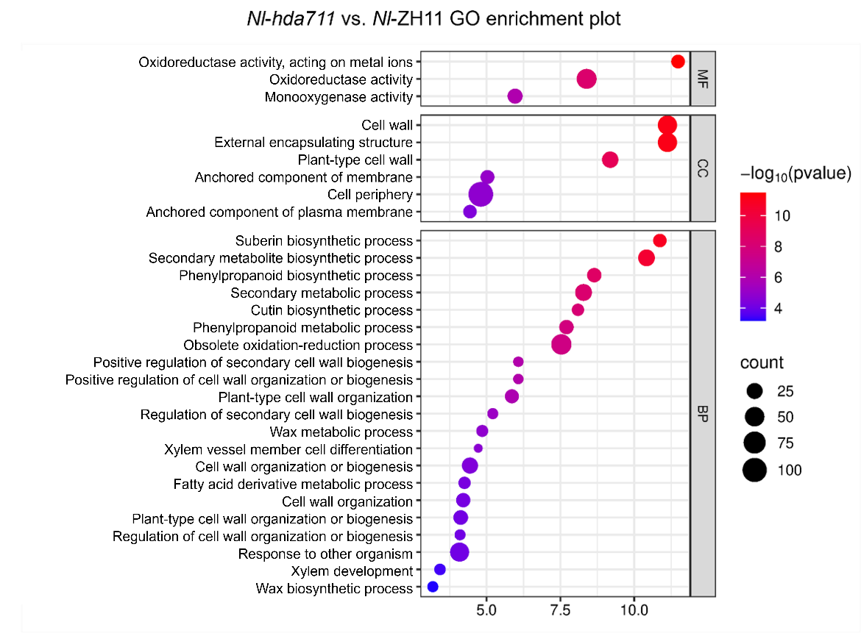
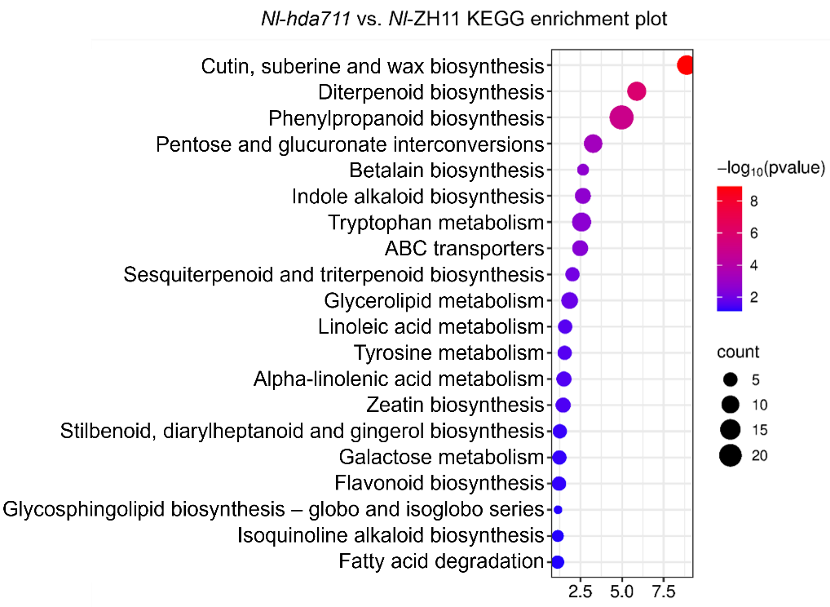

Enrich factor
Enrich factor

Figure S14. Functional enrichment analysis of differentially expressed genes in hda711 vs. ZH11 and Nl-hda711 vs. Nl-ZH11 comparison groups
(A, B) Gene Ontology (GO) (A) and Kyoto Encyclopedia of Genes and Genomes (KEGG) (B) enrichment analysis of differentially expressed genes in hda711 vs. ZH11 comparison groups, respectively. (C, D) GO (C) and KEGG (D) enrichment analysis of differentially expressed genes in Nl-hda711 vs. Nl-ZH11 comparison groups, respectively.

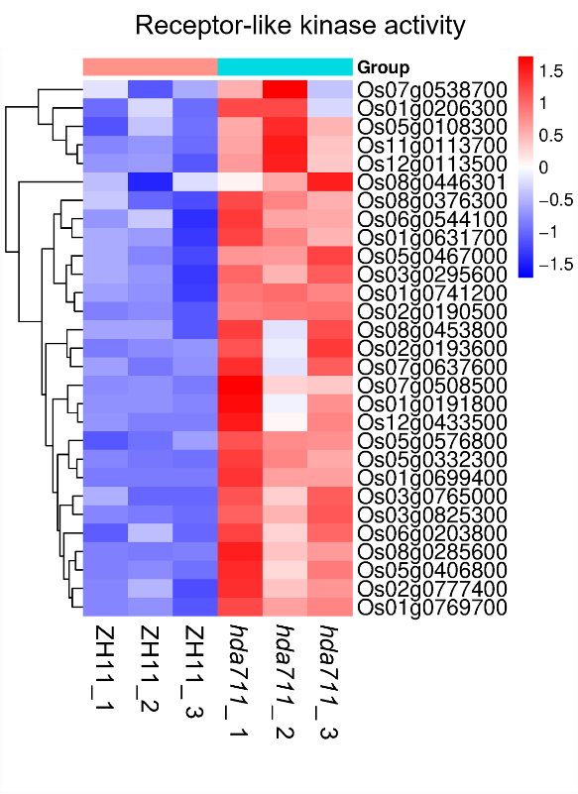
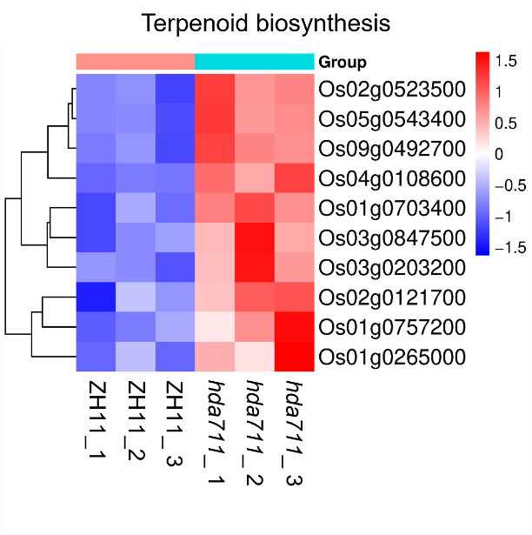
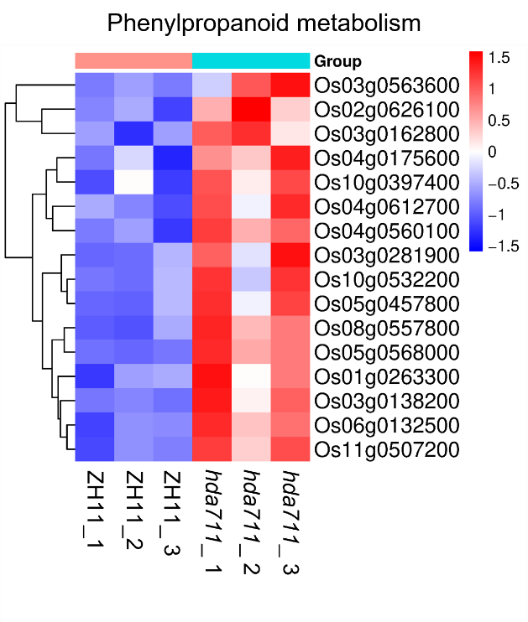
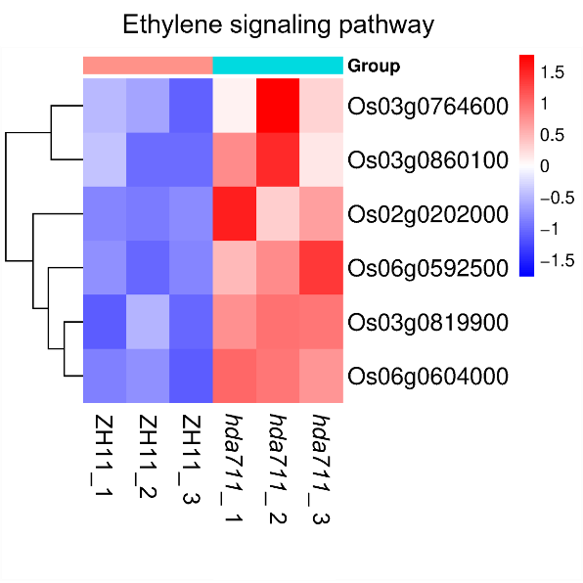
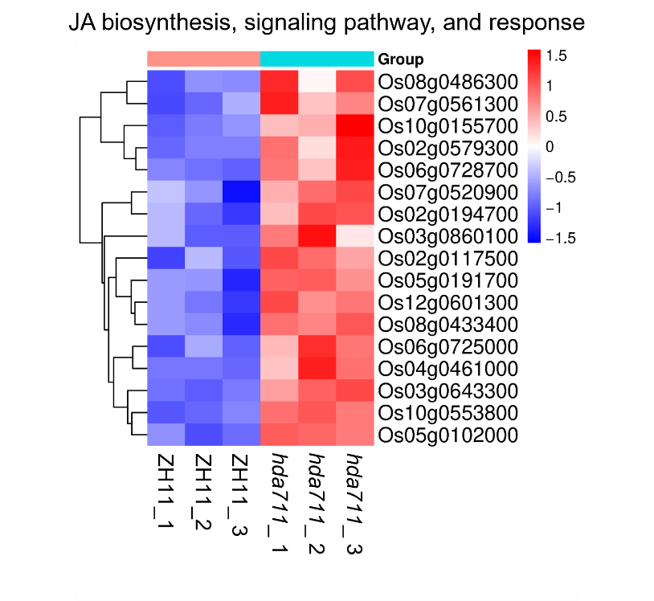
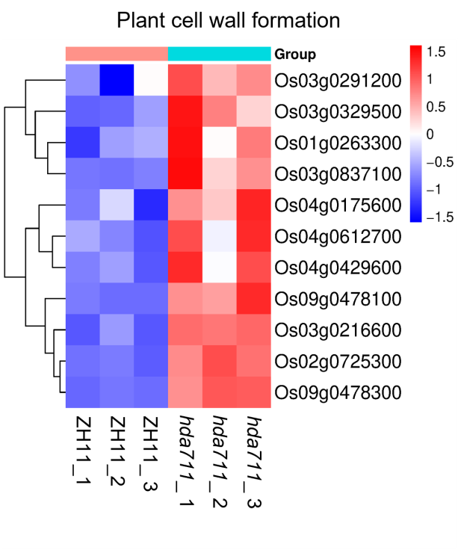
D
E
F
A
B
C

G
I
H
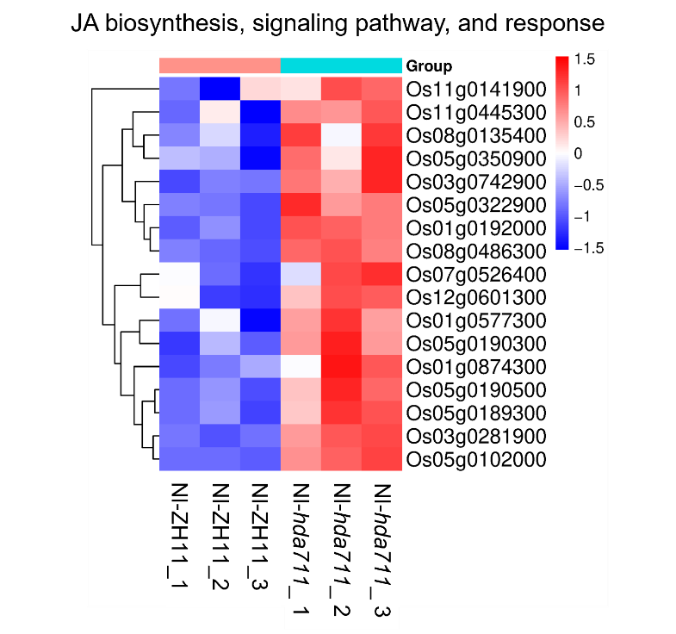
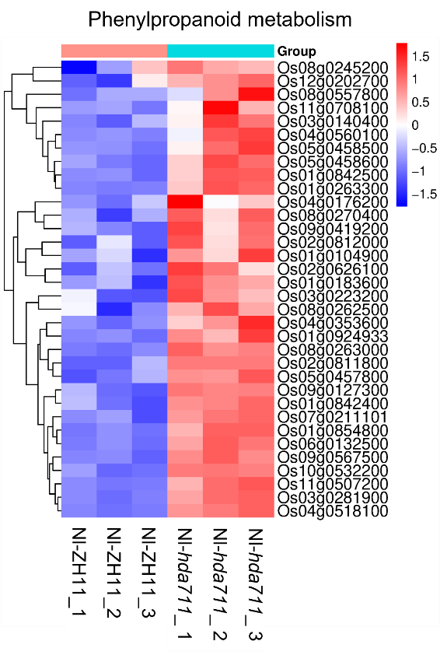
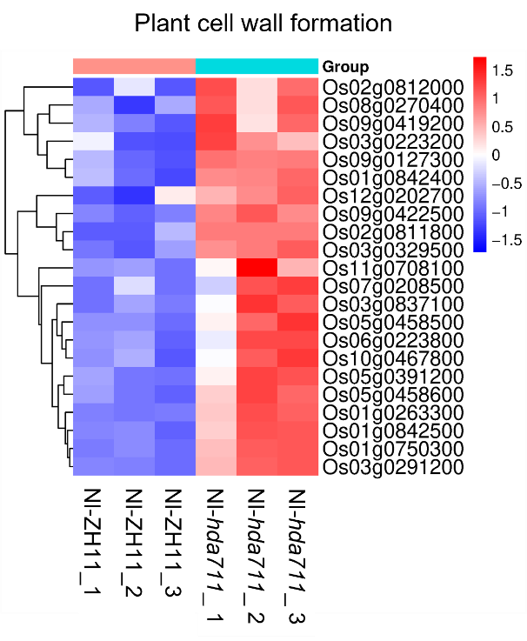

K
J
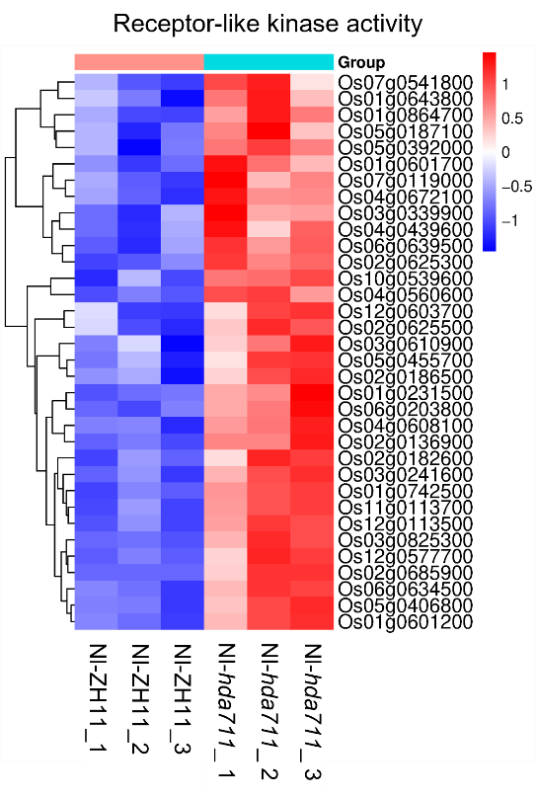
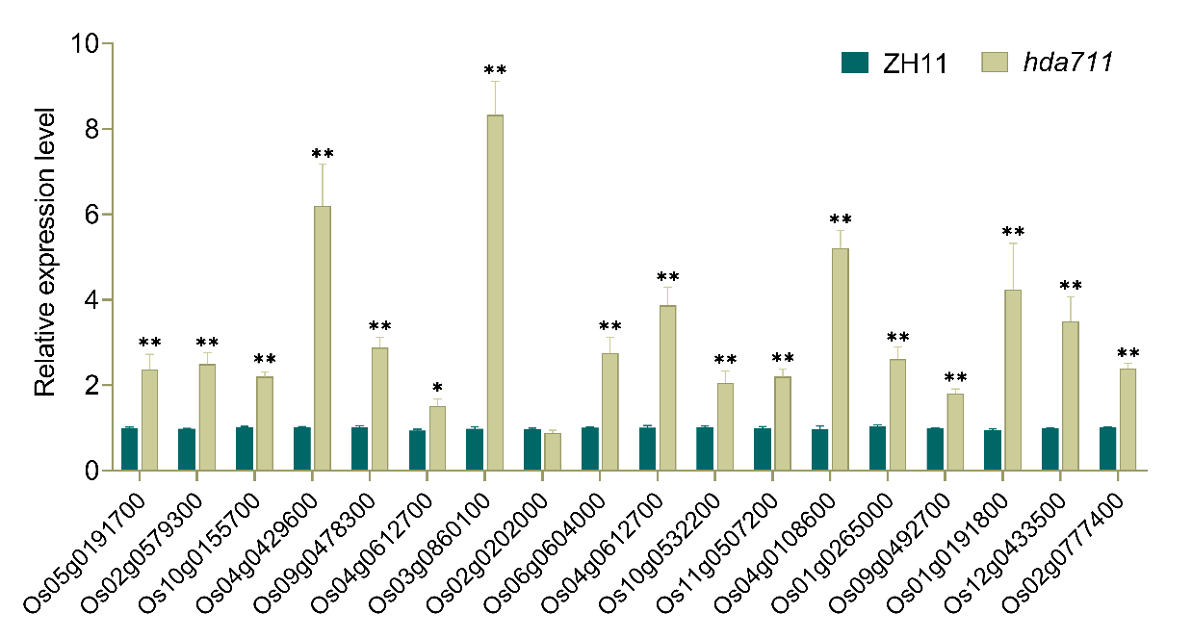

Figure S15. Genes upregulated in plant defense-associated pathways identified through transcriptomic comparative analysis
(A-F) Upregulated genes in jasmonic acid (JA) biosynthesis, signaling pathway, and response (A), plant cell wall formation (B), ethylene signaling pathway (C), phenylpropanoid metabolism (D), receptor-like kinase activity (E), and terpenoid biosynthesis (F) pathways from the hda711 vs. ZH11 transcriptome comparison group. (G-J) Upregulated genes in JA biosynthesis, signaling pathway, and response (G), plant cell wall formation (H), phenylpropanoid metabolism (I), receptor-like kinase activity (J) pathways from the Nl-hda711 vs. Nl-ZH11 transcriptome comparison group. (K) RT-qPCR analyse to quantify the expression levels of defense-related genes in both hda711 mutant and ZH11 wild-type rice plants.

Table S1. RT-PCR primer sequences for viral pathogen detection
Table S2. Alignment statistics of proteomic sequencing data (input vs. K_{mal}-IP enriched)
Table S3. LC-MS/MS-based comprehensive profiling of K_{mal} modification sites in rice
Table S4. Cross-species reference studies on protein malonylation identification
Table S5. Curated database of histone K_{mal} modifications validated by MS
Table S6. Gene Ontology enrichment of differentially malonylated proteins
Table S7. KEGG pathway analysis of differentially malonylated proteins across experimental conditions
Table S8. Detailed information of down-expressed proteins with up-regulated K_{mal} among four comparison groups
Table S9. Profiling of malonylated transcription factors in rice
Table S10. Primers used in this study

