SUPPORTING INFORMATION

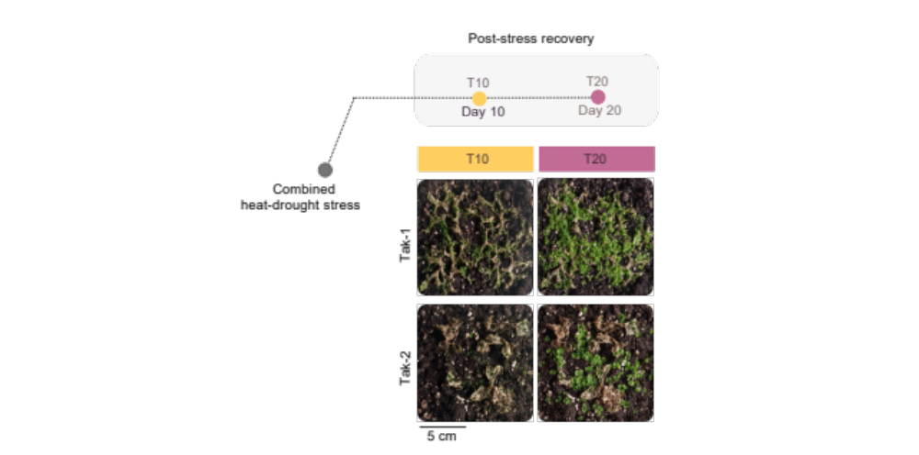
Figure S1. Post-stress phenotypic monitoring in Tak-1 and Tak-2. T10 and T20 corresponding to 7 and 17 days after combined heat and drought stress, respectively.
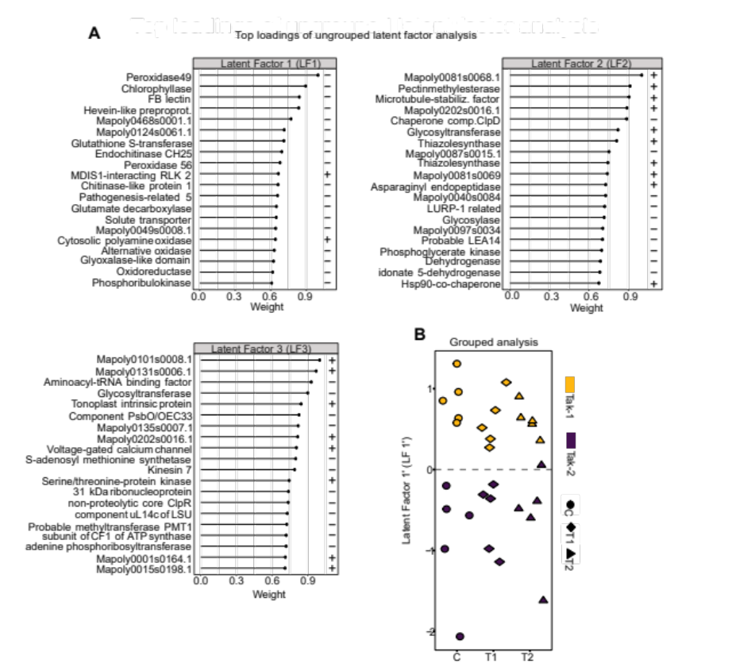
Figure S2. MOFA related information. (A) Top loadings of ungrouped latent factors 1 (LF1), 2 (LF2), and 3 (LF3). (B) Latent factor 1’ (LF1’) differentiation in grouped latent factor analysis.
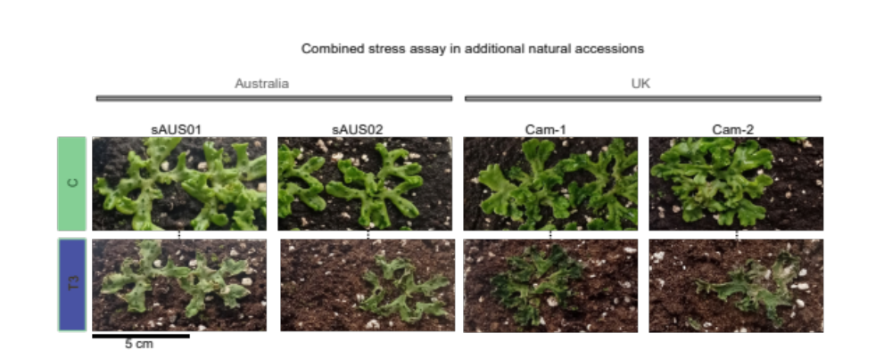
Figure S3. Phenotypical monitoring of stress assay in additional natural accessions. Control (C) and T3 time stress-exposure (T3) changes of Cam-1 and Cam-2 (United Kingdom, UK) and sAUS01 and sAUS02 (Australia) accessions.

Table S1. Photosynthetic measurements and biochemical marker quantification.
Table S2. Protein identification, quantification, annotation, and descriptive analyses.
Table S3. Latent factor analyses from ungrouped and multi-grouped frameworks.
Table S4. Meta-networks and related information.
Table S5. Evolutionary proteomics by protein gene age evaluation.
Table S6. Targeted transcriptomics.

