A high-resolution transcriptomic atlas depicting nitrogen fixation and nodule development in soybean
Baocheng Sun^{1,2†}, Yu Wang^{1,2†}, Qun Yang^{1†}, Han Gao^{1,2}, Haiyu Niu^{1,2}, Yansong Li^{1,2}, Qun Ma^{1,2}, Qing Huan¹, Wenfeng Qian^{1,2}* and Bo Ren^{1,2}*,

1. State Key Laboratory of Plant Genomics, Institute of Genetics and Developmental Biology, Innovation Academy for Seed Design, Chinese Academy of Sciences, Beijing 100101, China
2. University of Chinese Academy of Sciences, Beijing 100049, China
†These authors contributed equally to this work.
*Correspondences: Wenfeng Qian (wfqian@genetics.ac.cn); Bo Ren (bren@genetics.ac.cn，Dr. Ren is fully responsible for the distributions of all materials associated with this article)

Figure S1. DAPI and trypan blue staining of nuclei isolated from soybean roots and nodules
Scale bar: 100 μm.

Figure S2. The correlation of the expression level estimated from snRNA-seq (i.e., pseudobulk) and bulk RNA-seq among genes
Each dot represents a gene, colored according to number of cells expressing it.

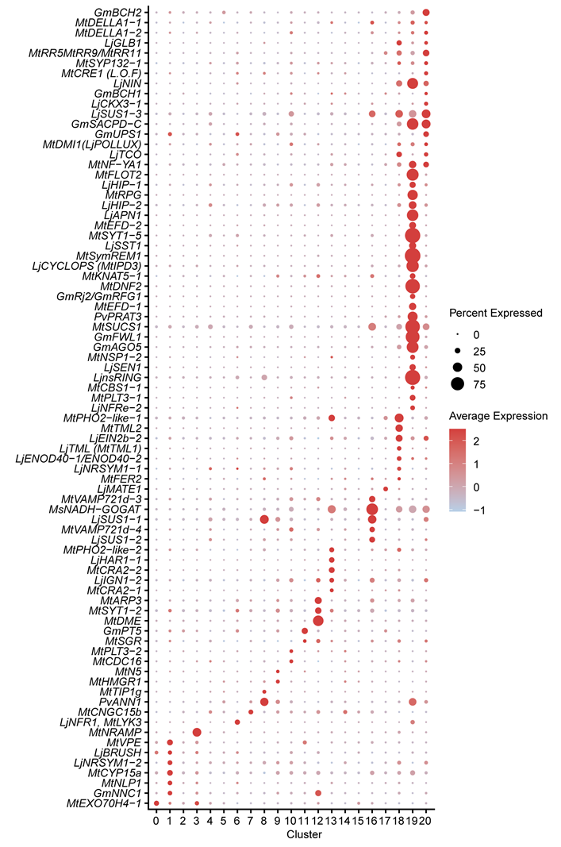

Figure S3. Expression of reported nodulation-related genes (summarized by Roy et al., 2020) in the snRNA-seq soybean data
The figure is otherwise similar to Figure 3D.

Figure S4. Expression of soybean homologs of previously reported marker genes in Arabidopsis roots in the snRNA-seq soybean data
The figure is otherwise similar to Figure 3D.
Figure S5. Expression of cluster-enriched genes in soybean roots and nodules
(A) Subclassification of cluster 20. Left panel, UMAP visualization of seven subclusters for cluster 20 in the N group. Each dot represents an individual cell, colored according to its subcluster classification. Right panel, expression of subcluster-enriched genes in the N group. The panel is otherwise similar to Figure 3D. (B) UMAP visualization for the expression of cluster-enriched genes in soybean roots and nodules. (C) Determination of the expression patterns of eight additional cluster-enriched genes using promoter:GUS staining. Scale bar: 100 μm. (D) Expression of marker genes and cluster-enriched genes in soybean roots and nodules. The homologous genes in soybean of reported marker genes in Arabidopsis are labeled in red.
Figure S6. Comparison of single cell/nucleus transcriptomes between soybean and M. truncatula
(A) UMAP visualization of soybean and M. truncatula root and nodule cells from three datasets. Dots represent cells which were colored according to their sample origins. (B) UMAP visualization of cell types in soybean and M. truncatula. Dots represent cells, colored according to the cell type. (C) Heat map showing the pairwise correlation between cell types of soybean N group and M. truncatula root tips. Spearman’s correlation coefficients are shown. (D) Heat map showing the pairwise correlation between cell types of soybean N group and M. truncatula nodules. Spearman’s correlation coefficients are shown. (E) UMAP visualization of cell types in three nodule-specific cell clusters of soybean and nodule cell types identified in M. truncatula. NF1, 2, Nitrogen Fixation 1, 2; PI, Pre-infection; IF, Infection; NP, Nodule Parenchyma; VA, Vascular tissue; UiC, 1, 2, Un-infected Cell, 1, 2; NA2, Nodule Apex 2; IC, Infected Cell; PP, Pericycle related procambium; InC, Inner Cortex; OuC, Outer Cortex; CO, Cortex; ME, Meristem; EN, Endodermis, EP, Epidermis; PER, Pericycle; PPP, Phloem Pole Pericycle; PH, Phloem; PR, Procambium; XY, Xylem; XPP, Xylem Pole Pericycle; DCC, Developing Cortical Cells; MCC, Mature_CC; SC, Stem Cells; SCN, Stem Cell Niche.

Figure S7. Expression of genes in the cytokinin pathway among cells
(A) Similar to Figure 3D, showing expression of cytokinin related genes among 21 cell clusters. (B) UMAP visualization for the expression of A-type GmRR and GmCKXs genes that specifically expressed in nodules. Cells are colored according to the normalized gene expression levels, log₁₀ (CPM + 1). (C) UMAP visualization for the expression of GmCRE1c and GmCRE1d. (D) Similar to Figure 4G, showing unspliced–spliced phase portraits (cells colored according to individual gene’s velocity), velocity and expression of GmCRE1b.

Figure S8. Characterization of soybean Gmcre1s mutants
(A) Sequencing results of the Gmcre1s mutant. The blue and red colors denote the target sequences and PAM sequence, respectively. In the Gmcre1s mutant, all of the four GmCRE1a/b/c/d genes harbored an identical 40bp-deletion as labeled.
(B) Root phenotype of soybean Gmcre1s mutant. Primary root length and lateral root number were quantified. Data are presented as means ± SD (n > 20). Three independent experiments were repeated with similar results. Asterisks indicate significant differences relative to W82. Two-sided Student’s t-test, **p < 0.01, ****p < 0.0001.
(C) Expression of LBC genes in W82 and Gmcre1s nodules in bulk RNA-seq data. Two-tailed Student’s t-test, **, p < 0.01; ***, p < 0.001; ****, p < 0.001.

Figure S9. The proportion of spliced and unspliced transcripts in soybean roots and nodules
(A) The proportions of spliced and unspliced transcripts in the N group.
(B) Similar to (A), presenting results for individual cell types.

