Supplementary Information for

Multiomics analysis reveals the evolutionary origin of diterpenoid alkaloid biosynthesis pathways in Aconitum

Dake Zhao^{1,†}, Ya Zhang^{3,†}, Huanxing Ren^{2,4}, Yana Shi⁵, Ding Dong¹, Zonghang Li¹, Guanghong Cui⁶, Yong Shen⁷, Zongmin Mou¹, Edward J. Kennelly^{8,9}, Luqi Huang^{5,6}, Jue Ruan³, Suiyun Chen^{1,*}, Diqiu Yu^{10,*}, Yupeng Cun^{2,4,*}

This file includes:

Materials and methods
Supplementary Tables S1 to S19
Supplementary Figures S1 to S19
References

Other Supplementary Material for this manuscript includes the following:
(available at https://cunlab.org/pubs/si4avilmo/)

Supplementary Datasets S1 to S11 (.xlsx)

Materials and methods
- Plant material, DNA, and RNA preparation
In China, Aconitum carmichaeli, A. vilmorinianum, and A. kusnezoffii are used in traditional Chinese medicine (TCM). Among these species, A. vilmorinianum is one of the most important components of the famous medicine “Yunnan Baiyao” (Supplementary Figure S1). The plant is endemic to the central Yunnan Plateau, and A. vilmorinianum is a threatened species due to extensive artificial collection. We, therefore, select A. vilmorinianum for genome sequencing.
Three individuals from each of the four regions were used to extract RNA from four tissues. Apart from Luquan population, where A. vilmorinianum was artificially planted, and the individuals were from field collections. Total RNA was extracted from these tissues using the HiPure Plant RNA Kit (Ambion Trizol). The extracted RNA was reverse transcribed into cDNA using the SMARTer PCR cDNA Synthesis Kit (Clontech), followed by transcriptome sequencing.
- Genome sequencing, assembly, and map integration of A. vilmorinianum

2.1 Estimation of genome size using k-mer analysis
The size of the A. vilmorinianum genome was estimated using a k-mer (k = 19) analysis-based approach together with Illumina paired-end short reads. The sequencing depth was estimated by determining the highest peak value in the frequency curve of the K-mer occurrence distribution (Supplementary Figure S2). The final genome size was estimated to be 5.48 Gb based on the K-mer statistics.

2.2 Quality assessment and validation of assembly.
The results of Nanopore data assembly are evaluated from three perspectives. First, the short sequence of Illumina HiSeq was aligned to the reference genome using BWA software. A total of 2,225 million reads were aligned to the genome, and 1,868 million reads were located to the reference genome, and the distance was consistent with the distribution of sequencing fragments, with an alignment rate of 82.91% (Supplementary Table S7). We employed REDUNDANS (v.013b)³² to identify heterozygous contigs based on at least 85% identity and overlap of binger than 66% of the shorter sequence in the comparison of each pairwise, and only longer of the two redundant contigs was retained.
Secondly, CEGMA V2.5 was used to assess the integrity of the assembly, and 405 conserved core genes were compared, accounting for 88.43%, of which 171 highly conserved CEGs accounted for 68.95% (Supplementary Table S5). This was finally evaluated using the BUSCO software (BUSCO V5) with the following parameters: --E value 1E-05 (e-value cut off for BLAST searches), --SP Generic. Total of 1828 complete BUSCOs were found, accounting for 86.19%, and 1581 complete and single-copy BUSCOs were found (Supplementary Table S6). A complete de novo assembly pipeline was:
a). We employ CANU to correct errors in the raw data of 3rd long Nanopore raw sequencing data and assembled by SMATdenovo;
b). We used Medaka to correct the assembled genome;
c). Pilon was used to applying 2ed generation short sequencing results to polish 3rd generation long sequencing results;
d). Mapping 2ed short and 3rd long sequencing to get the quality of reference genome. and BUSCO was used to evaluate the complete reference genome.
e). Combined with HiC data, scaffold in the reference genome were mapped to chromosome-level genome assembly.
- Genome annotation
Repetitive elements were estimated to comprise 90.39% of the high-quality assembly genome, including long terminal repeat (LTR) retrotransposons (60.39%), DNA transposable elements (5.02%), and long interspersed nuclear elements (5.28%) (Table S10). Gypsy elements were the most abundant LTRs and comprised 39.90% of the entire genome assembly; Copia repeats comprised 19.50% of the genome assembly.
  - Non-coding RNA annotation
According to the structural characteristics of different non-coding RNAs, different strategies were used to predict different non-coding RNAs. Based on the Rfam¹ database, Blastn software was used to identify microRNAs and rRNAs in the whole genome. The tRNAscan-SE ² software was used for tRNA identification.
  - Pseudogene annotation
Using the predicted protein sequences, BLAT³ was used for alignment to identify homologous gene sequences in the genome, and GeneWise ⁴ was used to identify immature stop codons and frameshift mutations in gene sequences.

Evolutionary genomics analyses
Twenty species’ genome assemblies: Chlamydomonas eustigma, Volvox reticuliferus, Physcomitrella patens, Gnetum montanum, Welwitschia mirabilis, Amborella trichopoda, Oryza sativa, A. vilmorinianum, A. coerulea, Artemisa annua, Macleaya cordata, Papaver somniferum, Arabidopsis thaliana, Jatropha curcas, Hevea brasiliensis, Vitis vinifera, Ricinus communis, Coptis chinensis, Kingdonia uniflora, and Thalictrum thalictroides (Table S17)
4.1 Detection of gene duplication events
Analysis of systemic blocks between A. vilmorinianum and Aquilegia coerulea and grape genomes by MCScanX ⁵, based on all homologous proteins of these three species using an all-to-all search in BLAST ⁶. We also found several chromosomal segments duplicated in A. vilmorinianum, for example, chromosomes 1 and 3, chromosomes 1 and 7, and chromosomes 2 and 4 (Supplementary Figure S6). In addition, there is an overall 2:1 syntenic relationship (Figure 1-C) between A. vilmorinianum and Aquilegia coerulea (Figure 1-D). There is a similar 3:4 relationship in the collinearity analysis of grapes and A. vilmorinianum, corresponding to one fragment of the grape corresponding to four fragments in A. vilmorinianum and one fragment of A. vilmorinianum corresponding to three fragments in the grape (Supplementary Figure S5 and Figure S6).
We then used the distribution of synonymous substitution rates per gene (Ks) between collinear paralogous genes to identify WGD events. The distribution of Ks of collinear paralogous genes from A. vilmorinianum and Aquilegia coerulea showed that the peak was around 0.82 (Figure 1-D), suggesting the presence of whole genome duplication. Taken together, our analysis provided strong evidence for a single whole genome duplication event in A. vilmorinianum.

4.2 Estimate of whole genome duplication timing
To time the WGD of A. vilmorinianum, we estimated the average evolutionary rate for Ranunculaceae using A. vilmorinianum and Aquilegia coerulea. The Ks values were then fitted to a Gaussian mixture model to determine the number of components in the Ks distribution ⁷. The divergence time of 65.35 million years ago (MYA) between A. vilmorinianum and Aquilegia coerulea was obtained based on our divergence estimate using MCMCtree (Figure 1-D), we calculated the synonymous substitutions per site per year (r) for Ranunculaceae to be 6.108e-9 (T = Ks / 2r). We dated the WGD (Ks = 0.822) to 67.32 ± 5.52 MYA in A. vilmorinianum, and calculated the WGD timing to 124.10 ±10.18 MYA in Aquilegia coerulea. The estimated timing for the WGD events of A. vilmorinianum and Aquilegia coerulea, as well as previously reported WGD/WGT in three other angiosperm species (Macleaya cordata, Papaver somniferum, Arabidopsis thaliana) were plotted in the phylogenetic tree (Figure 1-B).

Transcriptome analysis

Gene differential expression analysis
The clean reads were mapped to the A. vilmorinianum genome using STAR (v 2.7.1)⁸ software, and then the transcripts were quantified using RSEM (v 1.3.2)⁹ software. Differential gene analysis was performed using DESeq2 in the four tissues according to two conditions, |log2 FoldChange | ≥ 1 and padj < 0.05, and 11475 differentially expressed genes were obtained in A. vilmorinianum.

Co-expression network and the minimum spanning tree of candidate genes for diterpenoid alkaloid synthesis
Differentially expressed candidate genes for diterpenoid alkaloid synthesis, a total of 313 genes, including 4 geranylgeranyl pyrophosphate synthases (GGPPSs), 3 ent-copalyl diphosphate synthases (CPSs), 4 ent-kaurene synthases (KSs), 2 ent-kaurene oxidases (KOXs), 36 aminotransferases (ATFs), 142 CYP450s (P450s), 41 O-methyltransferases (OMTs), 8 BAHD acyltransferases (BAHDs). The WGCNA package was used to construct a weighted gene co-expression network for the genes of these eight gene families. Then, a minimum spanning tree analysis was then performed on the co-expression network to find hub genes. Several hub genes were found in the minimum spanning tree, consisting of 1 GGPPS (EVM0025196), 1 Glutamate--glyoxylate aminotransferase (EVM0007090), 16 P450s (EVM0038628, EVM0046786, EVM0046628, EVM0023781, EVM0026284, EVM0052907, EVM0002806, EVM0050322, EVM0057232, EVM0050789, EVM0019247, EVM0023399, EVM0055500, EVM0035373, EVM0030489, and EVM0014454), 7 OMTs (EVM0008171, EVM0000759, EVM0023968, EVM0046328, EVM0056152, EVM0021046, EVM0034357, and EVM0005923), 3 BAHDs (EVM0000058, EVM0046469, and EVM0051236).

Expression of transposable elements and Construct candidate gene and transcription factor
HMMER software was used to make predictions based on HMM models of transcription factor families. 37 types of transcription factors were predicted in A. vilmorinianum, and 1748 transcription factors (TFs) were obtained after screening. The top 10 most abundant transcription factor types were: GARP (390), MYB (261), AP2/EREBP(160), bHLH (122), C2C2 (116), NAC (108), ABI3/VP1 (89), HB (81), WRKY (62), and bZIP (66) (Figure 2-D and Supplementary Data S2).
To further understand the genes and regulation associated with diterpenoid alkaloid synthesis in A. vilmorinianum, the WGCNA package was used to construct a weighted gene co-expression network for the predicted transcription factors and the genes associated with diterpenoid alkaloid synthesis. Cytoscape software was used to visualize co-expression networks with edge weights greater than 0.24 (Figure 2-D and Supplementary Data S2). We identified 109 transcription factors that may be involved in the regulation of 83 pathway genes. Several transcription factors such as AP2/ERF, bHLH, and WRKY have a high correlation with pathway genes. However, the regulation of diterpenoid alkaloid biosynthesis in A. vilmorinianum may be a relatively complex system, with several unusual TFs also showing strong associations, such as members of the NAC, C3H, and GRAS families. The types and amounts of transcription factors associated with aminotransferase and CYP450 gene families are the largest. In addition, 34 alkaloid synthesis candidate genes were associated with AP2/ERF transcription factors (Supplementary Figure S8 and Figure S9).

Metabolome analysis
  - Sample preparation and UPLC-MS/MS analysis
A. vilmorinianum plant samples were lyophilized using a lyophilizer (Scientz-100F), then the samples were ground into powders using a mixer mill (MM 400, Retsch) for 1.5 min at 30 Hz. 100 g of powder was dissolved in 1.2 ml of 70% methanol, vortexed for 30 sec every 30 min, vortexed 6 times, then the samples were stored in a refrigerator at 4℃ overnight. The solution was centrifuged at 12000 rpm for 10 minutes, the supernatant was filtered through a 0.22μm pore size membrane to perform UPLC-MS/MS analysis.
The sample extracts were analyzed using a UPLC-ESI-MS/MS system (UPLC, SHIMADZU Nexera X2, www.shimadzu.com.cn; MS, Applied Biosystems 4500 Q TRAP, www.appliedbiosystems.com.cn/). The analytical conditions were as follows, UPLC: column, Agilent SB-C18 (1.8 µm, 2.1 mm*100 mm); the mobile phase consisted of solvent A, pure water with 0.1% formic acid, and solvent B, acetonitrile with 0.1% formic acid. Sample measurements were performed with a gradient program using the starting conditions of 95% A, and 5 % B. Within 9 minutes, a linear gradient to 5% A, 95% B was programmed, and a composition of 5% A, 95% B was maintained for 1 minute. Then, within 1.10 min, a composition of 95% A, and 5.0% B was set and maintained for 2.9 min. The flow rate was set to 0.35 ml per minute; the column oven was set to 40°C; the injection volume was 4 µl. The effluent was alternatively connected to an ESI-triple quadrupole-linear ion trap (QTRAP)-MS. The operating parameters of the ESI source: one ion source, Turbo Spray; source temperature 550°C; ion spray voltage (IS) 5500 V (positive ion mode)/-4500 V (negative ion mode); ion source gas I (GSI), gas II(GSII), curtain gas (CUR) were set to 50, 60, and 25.0 psi, respectively; the collision-activated dissociation(CAD) was high. Instrument tuning and mass calibration were performed with 10 and 100 μmol/L polypropylene glycol solutions in QQQ and LIT modes, respectively. QQQ scans were acquired as MRM experiments with collision gas (nitrogen) set to medium. DP and CE for individual MRM transitions were performed with further DP and CE optimization. A specific set of MRM transitions was monitored for each period according to the metabolites eluted within this period.
  - Data analysis of metabolic profile
Analyst software (v1.6.3) was used to process the mass spectrometry data. Chromatographic peak integration and calibration were performed using MultiaQuant software. Unsupervised principal component analysis (PCA) was performed by the prcomp statistics function in R. Hierarchical cluster analysis (HCA) results of samples and metabolites were presented as heatmaps with dendrograms, while Pearson correlation coefficients (PCC) between samples were calculated with the cor function in R and presented as heatmaps (Supplementary Figure S17 and Figure S18). Significantly regulated metabolites between groups were determined by VIP ≥ 1 and absolute Log₂FC (fold change) ≥ 1. VIP values were extracted from the OPLS-DA result, which also contains score plots and permutation plots, and were generated using R package MetaboAnalystR. The data was log transform (log₂) and mean centered before OPLS-DA. A permutation test (200 permutations) was performed to avoid overfitting.
  - KEGG annotation and enrichment analysis
Identified metabolites were annotated using KEGG Compound database (http://www.kegg.jp/kegg/compound/), and annotated metabolites were then mapped to KEGG Pathway database (http://www.kegg.jp/kegg/pathway.html). Pathways with significantly regulated metabolites mapped were then fed into MSEA (metabolite sets enrichment analysis); their significance was determined by hypergeometric test’s p-values.
  - Integrating transcriptome and metabolome data analysis
Based on UPLC-MS/MS technology and metabolite database, alkaloids in four tissues of A. vilmorinianum were investigated and 59 diterpene alkaloid metabolites were identified (Supplementary Data S6 and Figure S10). According to the general DA accumulation law, most of the DAs were enriched in the underground part (primary and lateral roots). After normalizing the levels of these compounds accumulated in different tissues and the gene expression of GGPPSs, CPSs, KSs, KOXs, P450s, ATFs, OMTs, and BAHDs gene families, the Pearson correlation coefficient (PCC) was used to calculate the correlation between these compounds and the expression of these genes to construct the gene-metabolite regulatory network. The integrated network demonstrated that the 103 pathway genes contained 12 hub genes (EVM0030489, EVM0052907, EVM0046628, EVM0035373, EVM0046786, EVM0052195, EVM0056152, EVM0021046, EVM0008171, EVM0000058, and EVM0051236) from the minimum spanning tree highly correlated (p<0.01) (Supplementary Figure S11 and Data S7). Notably, we also found that two GGPPSs (EVM0025196 and EVM0016299) and one KS (EVM0024293) were highly associated with diterpene alkaloids. In particular, we also found that three CPSs (EVM0013250, EVM0040922, and EVM0029892) and three KOXs genes (EVM0050182, EVM0047597, and EVM0025963) were slightly correlated (p<0.05) with diterpenoid alkaloids (Supplementary Figure S11 and Data S7).
- Skeleton formation of diterpenoid alkaloid biosynthesis
  - Identification of diterpenoid alkaloid biosynthesis genes
The putrescine biosynthetic pathway for diterpenoid alkaloid biosynthesis could have three steps: 1) The synthesis of diterpene alkaloids is initiated by the formation of GGPP by three IPPs, followed by the synthesis of diterpenoid skeletons by GGPPSs, CPSs, and KSs; 2) The skeletons of diterpene alkaloids are synthesized by KOXs and ATFs, which in turn lead to two key steps; 3) Finally, the diterpene alkaloid skeleton is modified by a series of modifying enzymes, such as BAHDs and OMTs, after the oxidation by P450s. According to the above information, several key gene family members involved in the synthesis of diterpene alkaloids were retrieved based on the protein annotation of A. vilmorinianum genome in NR, KOG, GO, KEGG, and other functional databases. For TPSs involved in diterpenoid alkaloid synthesis, homologous sequences were searched in A. vilmorinianum using BLAST-based on several TPS candidate genes identified in A. carmichaelii.
  - Phylogenetic analysis of key gene families
Amino acid sequence alignment of five diterpenoid alkaloid biosynthesis gene families (TPSs, P450s, ATFs, BAHD acyltransferases, and OMTs) was performed by MAFFT (1000 bootstrap) ¹⁰, and the alignment data were used to construct phylogenetic trees using RAxML¹¹ with the maximum likelihood method. The phylogenetic trees were visualized using iTOL (https://itol.embl.de/).
We used the terpene synthase genes retrieved in A. vilmorinianum genome and various terpene synthases identified in A. carmichaelii, Arabidopsis thaliana, Oryza sativa, Salvia miltiorrhiza, Tripterygium wilfordii, and tomato for phylogenetic analysis (Supplementary Data S8). Phylogenetic analysis of terpene synthase (TPS) showed that the TPS family members were mainly distributed in the TPS-A, TPS-B, TPS-C, and TPS-E/F branches in A. vilmorinianum. According to the results of phylogenetic tree analysis, we can speculate that the seven genes distributed in TPS-C (pink color) play the function of CPS in the metabolic pathway, catalyzing GGPP to generate ent-CPP. Ten genes distributed in the TPS-E/F branch (blue color) were considered candidate genes for ent-Kaurenes synthesis, catalyzing ent-CPP to produce ent-kaurenes (Supplementary Figure S15).
P450 sequences used to construct phylogenetic trees, including p450 genes annotated in A. vilmorinianum genome and a plant p450 database (Plant cytochrome P450 database, PCPD) contains 181 kinds of functions of known plant p450 sequence¹². In the P450 phylogenetic tree, it can be roughly divided into four branches, the annotated 18 KOX genes forming an independent small branch with CYP701 (Figure 4-A and Supplementary Figure S13). The aminotransferases identified in Arabidopsis thaliana and the genes annotated as aminotransferases in A. vilmorinianum were used to construct a phylogenetic tree of aminotransferases (Supplementary Data S9 and Figure S14). The annotated BAHD genes in A. vilmorinianum and the BAHD acyltransferases identified in other species were used to construct the phylogenetic tree of BAHD acyltransferases (Figure 4-D and Supplementary Data S10). Plant methyltransferases are divided into C-, N-, S-, and O-methyltransferases. The identified methyltransferases were selected respectively, and the annotated O-methyltransferase gene sequence from A. vilmorinianum genome was used to construct a methyltransferase phylogenetic tree (Supplementary Data S11 and Figure S16).

7.3 Evolution of diterpenoid alkaloid biosynthesis genes
In the gene family expansion and contraction analysis, some orthologous genes involved in diterpene alkaloid synthesis were found to be expanded. Surprisingly, the KOX gene family was significantly expanded in A. vilmorinianum. Meanwhile, GO enrichment analysis (p < 0.05, FDR < 0.05) of the expanded and unique genes revealed that these genes were enriched for terpene synthase activity, serine-type peptidase activity, oxidoreductase activity, and O-methyltransferase activity (Supplementary Date S1 and S2), suggesting that the genes involved in diterpene alkaloids may have duplicated and evolved to produce a variety of DAs in A. vilmorinianum (Supplementary Figure S19).

Supplementary Tables
Table S1 Survey statistic results of A. vilmorinianum.
Table S2 Length distribution of nanopore long reads produced from the A. vilmorinianum samples.
Table S3 Sequencing data statistics of A. vilmorinianum.
Table S4 Summary of the final genome assembly of A. vilmorinianum.
Table S5 Assessment of the gene coverage rate using CEGMA.
Table S6 Assessment of the gene coverage rate using BUSCO.
Table S7 The integrity of the assembled genome was assessed using Illumina sequencing data.
Table S8 Statistics of A. vilmorinianum genome after assembly by Hi-C data.
Table S9 Genome statistics after Hi-C assembly
Table S10 Summary of Repeat elements in A. vilmorinianum genome.
Table S11 Summary of predicted protein-coding genes of A. vilmorinianum genome.
Table S12 Summary of functional annotation of predicted genes of A. vilmorinianum genome.
Table S13 Basic statistical results of predicted protein-coding genes of A. vilmorinianum genome.
Table S14 The statistical results of non-coding RNA of A. vilmorinianum genome.
Table S15 Summary of RNA sequencing data of 24 samples from 3 regions of A. vilmorinianum.
Table S16 The statistical results of pseudogene annotation of A. vilmorinianum genome.
Table S17 Genomes of 12 plant species used for comparative genomic analysis.
Table S18 The distribution of A. vilmorinianum genes among the syntenic regions.
Table S19 Comparison of the gene families among A. vilmorinianum and other species.

Table S1. Survey statistic results of A. vilmorinianum.
K-mer | K-mer  number | K-mer  depth | Genome size  (Gb) | Revised genome size (Gb) | Heterozygous  Ratio  (%) |  |  | Repeat ratio  (%)
19 | 277,326,647,402 | 50 | 5.48 | 5.76 |  | 0.31 | 80.52

Table S2. Length distribution of nanopore long reads produced from the A. vilmorinianum samples.
Length | Reads Number | Total Length | Percentage | Average Length
2000-5000 | 1,485,735 | 5,104,567,874 | 0.86% | 3,435.71
5000-10000 | 2,146,285 | 16,008,051,522 | 2.71% | 7,458.49
10000-20000 | 3,883,206 | 58,486,153,040 | 9.91% | 15,061.30
20000-30000 | 6,122,731 | 155,054,822,924 | 26.28% | 25,324.45
30000-40000 | 4,652,326 | 160,130,654,962 | 27.14% | 34,419.48
40000-50000 | 2,214,890 | 98,278,308,199 | 16.66% | 44,371.64
50000-60000 | 971,126 | 52,680,392,820 | 8.93% | 54,246.71
60000-70000 | 376,393 | 24,167,957,348 | 4.09% | 64,209.36
70000-80000 | 145,622 | 10,809,194,549 | 1.83% | 74,227.75
>=80000 | 98,891 | 9,104,024,442 | 1.54% | 92,061.20

Table S3. Sequencing data statistics of A. vilmorinianum.
Read type | Insert size | Total data  (Gb) | Reads length  (bp) | Sequence  coverage (X)
Illumina pair-end reads | 350 bp | 330.72 | 150 | 57.42
Nanopore subreads | 33.31Kb | 589.82 | - | 102.42
Hi-Cpair-end reads | 300 bp | 324.19 | 150 | 56.28

Table S4. Summary of the final genome assembly of A. vilmorinianum.
Contig number | Contig length  (bp) | Contig N50  (bp) | Contig N90  (bp) | GC content  (%)
26,965 | 5,758,762,916 | 311,288 | 91,698 |  | 39.24

Table S5. Assessment of the gene coverage rate using CEGMA.
Number of  458 CEG* | % of 458  CEGs | Number of 248 highly  conserved CEGs | % of 248 highly  conserved CEGs
405 | 88.43 | 171 | 68.95

Table S6. Assessment of the gene coverage rate using BUSCO.
Complete BUSCOs | Complete and single-copy BUSCOs | Complete and duplicated BUSCOs | Fragmented BUSCOs | Missing BUSCOs | Total Lineage BUSCOs
2,144 | 1,733 | 411 | 36 | 146 | 2,326

Table S7. The integrity of the assembled genome was assessed using Illumina sequencing data.
Total  reads | Mapped reads | Mapped  (%) | Properly mapped reads | Properly mapped  (%)
2253863785 | 2225834300 | 98.76 | 1868608322 | 82.91
Note: Properly mapped (%) means that the paired-end sequencing sequences are all mapped to the reference genome and the distance is consistent with the length distribution of the sequenced fragments.

Table S8. Statistics of A. vilmorinianum genome after assembly by Hi-C data.
Group | Cluster Num | Cluster Len  (bp) | Order Num | Order Len  (bp)
LG01 | 6098 | 1297465597 | 4632 | 1144532470
LG02 | 5634 | 1129901442 | 4430 | 1015800089
LG03 | 2461 | 586563584 | 1961 | 530433242
LG04 | 2466 | 512929125 | 1798 | 435539651
LG05 | 2439 | 546252636 | 1894 | 492221476
LG06 | 2265 | 482350638 | 1755 | 427219531
LG07 | 1923 | 591290056 | 1501 | 538186255
LG08 | 1677 | 355638921 | 1138 | 301771692
Total  (Ratio %) | 24963  (92.34) | 5502391999  (95.55) | 19109  (76.55) | 4885704406  (88.79)

Table S9. Genome statistics after Hi-C assembly
Scaffold Number | Scaffold N50  (bp) | Scaffold N90  (bp) | Contig number | Contig N50  (bp) | Contig N90  (bp) | GC  content  (%)
7,934 | 530,629,242 | 181,968 | 27,035 | 311,288 | 91,698 |  | 39.24

Table S10. Summary of Repeat elements in A. vilmorinianum genome.
Type | Length (bp) | Percent (%)
Simple Sequence Repeat  ClassI | 882,857  4,818,240,662 | 0.02  83.64
DIRS | 316,149,476 | 5.49
LARD | 1,376,213,554 | 23.89
LINE | 303,918,642 | 5.28
PLE | 24,411,826 | 0.42
TRIM | 10,291,147 | 0.18
SINE | 567 | 0.00
LTR/Copia | 1,123,565,291 | 19.50
LTR/Gypsy | 2,298,478,150 | 39.90
LTR /Unknown | 56,960,187 | 0.99
Unknown | 388,617 | 0.01
ClassII | 2,890,73,856 | 5.02
PotentialHostGene | 12,111,436 | 0.21
Unknown | 428,118,014 | 7.43
Total | 5,207,179,061 | 90.39

Table S11. Summary of predicted protein-coding genes of A. vilmorinianum genome.
Method |  | Gene number
Ab initio | Augustus | 56061
Ab initio | GlimmerHMM | 184098
Ab initio | GeneID | 162055
Ab initio | SNAP | 107761
Ab initio | Genscan | 73867
Homolog | Arabidopsis thaliana | 32680
Homolog | Macleaya cordata | 37722
Homolog | Aquilegia coerulea | 37424
Homolog | Chinese Lotus | 36786
RNAseq | TransDecoder | 139790
RNAseq | GeneMarkS-T | 71126
RNAseq | PASA | 41544
Integration | EVM | 60351

Table S12. Summary of functional annotation of predicted genes of A. vilmorinianum genome.
Database | Annotated number | Percentage(%)
COG | 27111 | 44.92
GO | 23863 | 39.54
KEGG | 16293 | 27.00
KOG | 26824 | 44.45
Pfam | 44221 | 73.27
Swissprot | 32588 | 54.00
TrEMB | 46840 | 77.61
NR | 48002 | 79.54
NT | 41234 | 68.32
Total | 52611 | 87.18

Table S13. Basic statistical results of predicted protein-coding genes of A. vilmorinianum genome.
Gene  Num | Gene Length | Average  Gene  length (bp) |  | Exon  Number | Average  exon  length (bp) |  | Intron  Number | Average  intron  length (bp)
60351 | 354731451 | 5877.81 | 240351 |  |  | 303.87 | 240350 |  | 1172.03

Table S14. The statistical results of non-coding RNA of A. vilmorinianum genome.
RNA classification | Number | Family
miRNA  rRNA  tRNA | 135  1045  1576 | 19  4  25

Table S15. Summary of RNA sequencing data of 24 samples from 3 regions of A. vilmorinianum.
Sample | Reads number | Q20(%) | Q30(%) | GC(%)
GJ_1_Y | 36,741,142 | 97.35 | 92.93 | 47.57
GJ_1_J | 28,204,173 | 97.64 | 93.49 | 45.98
GJ_1_Z | 30,339,819 | 97.25 | 92.58 | 45.67
GJ_1_C | 33,636,292 | 97.91 | 94 | 45.51
GJ_2_Y | 29,354,366 | 97.54 | 93.2 | 45.15
GJ_2_J | 32,567,134 | 97.65 | 93.49 | 45.1
GJ_2_Z | 29,650,688 | 97.29 | 92.82 | 45.1
GJ_2_C | 26,519,157 | 97.76 | 93.7 | 45.61
GJ_3_Y | 30,089,707 | 97.41 | 92.95 | 45.38
GJ_3_J | 26,834,444 | 97.18 | 92.75 | 46.78
GJ_3_Z | 31,994,460 | 97.47 | 93.24 | 45.47
GJ_3_C | 31,558,880 | 97.4 | 93.07 | 45.59
LQ_2_Y | 27,006,274 | 97.48 | 93.16 | 45.77
LQ_2_J | 28,865,777 | 97.36 | 93 | 46.17
LQ_2_Z | 33,604,163 | 97.32 | 92.91 | 45.37
LQ_2_C | 38,675,220 | 97.67 | 93.42 | 45.55
QJ_1_Y | 35,414,845 | 97.51 | 93.2 | 46.12
QJ_1_J | 32,651,022 | 97.33 | 92.94 | 45.29
QJ_1_Z | 34,148,937 | 97.47 | 93.15 | 45.65
QJ_1_C | 28,473,825 | 97.43 | 93.11 | 45.99
QJ_3_Y | 33,423,530 | 97.66 | 93.53 | 46.03
QJ_3_J | 29,778,213 | 97.46 | 93.14 | 45.17
QJ_3_Z | 33,412,717 | 97.38 | 92.94 | 45.15
QJ_3_C | 36,187,575 | 97.48 | 93.05 | 46.31

Table S16. The statistical results of pseudogene annotation of A. vilmorinianum genome.
Number | Total_len | Average_len
8444 | 24044163 | 2847.48

Table S17. Genomes of 21 plant species used for comparative genomic analysis.
Species | NCBI/Phytozome | Reference
A. vilmorinianum | PRJCA014109 |  | This study
Aquilegia coerulea | GCA002738505.1 |  | Zhai et al. 2019 ¹³
Artemisa annua | GCA003112345.1 |  | Shen et al. 2018 ¹⁴
Macleaya cordata | GCA002174775.1 |  | Liu et al. 2017 ¹⁵
Papaver somniferum | GCA003573695.1 |  | Guo et al. 2018 ¹⁶
Arabidopsis thaliana | https://genome.jgi.doe.gov/arabidopsis |  | Lamesch et al. 2014 ¹⁷
Jatropha curcas | GCA000696525.1 |  | Zhang et al. 2014 ¹⁸
Hevea brasiliensis | GCF001654055.1 |  | Tang et al. 2016 ¹⁹
Vitis vinifera | https://genome.jgi.doe.gov/grape |  | Jaillon et al. 2007 ²⁰
Ricinus communis | https://genome.jgi.doe.gov/Rcommunis |  | Chan et al. 2010 ²¹
Oryza sativa | https://genome.jgi.doe.gov/rice |  | Sun et al. 2007 ²²
Amborella trichopoda | https://genome.jgi.doe.gov/Atrichopoda |  | Albert et al. 2014 ²³
Coptis chinensis | GCA_015680905.1 |  | Liu et al. 2021 ²⁴
Gnetum montanum | GCA_015680685.1 |  | Wan et al. 2018 ²⁵
Kingdonia uniflora | GCA_014058105.1 |  | Sun et al. 2020 ²⁶
Physcomitrium patens | GCA_000002425.2 |  | Lang et al. 2018 ²⁷
Thalictrum thalictroides | GCA_013358455.1 |  | Arias et al. 2021 ²⁸
Welwitschia mirabilis | https://datadryad.org/stash/dataset/doi:10.5061/dryad.ht76hdrdr |  | Wan et al. 2021 ²⁹
Chlamydomonas eustigma | GCA_002335675.1 |  | Hirooka et al. 2017 ³⁰
Volvox reticuliferus | GCA_019650235.1 |  | Yamamoto et al.2021³¹
Selaginella moellendorffii | GCA_000143415.2 |  | Banks et al. 2011³³

Table S18. The distribution of A. vilmorinianum genes among the syntenic regions.
Types of gene duplication | Genes numbers | Percentage
Singleton | 313 | 9.42
Dispersed | 453 | 13.62
Proximal | 127 | 3.82
Tandem | 88 | 2.65
WGD/segmental | 2344 | 70.5
Note: Singleton: no duplication; Tandem: consecutive duplication; Proximal: duplications in nearby chromosomal region but not adjacent; Dispersed: duplications of modes other than tandem, proximal or WGD/segmental.

Table S19. Comparison of the gene families among A. vilmorinianum and other species.
Plant species | Genes  number | Genes number  in families | Unclustered  genes | Family  number | Unique  Gene number | Unique families  number
A. vilmorinianum | 60351 | 52917 | 7434 | 15682 | 15267 | 3419
Macleaya cordata | 21911 | 21231 | 680 | 10720 | 416 | 117
Papaver somniferum | 84177 | 61160 | 1773 | 12662 | 13873 | 1771
Artemisa annua | 63226 | 59777 | 3449 | 14093 | 16929 | 2500
Arabidopsis thaliana | 27416 | 25585 | 1831 | 10637 | 2714 | 549
Vitis vinifera | 26346 | 23130 | 3216 | 10891 | 1405 | 437
Ricinus communis | 31221 | 25091 | 6130 | 12828 | 1729 | 552
Jatropha curcas | 21804 | 21668 | 136 | 10811 | 310 | 71
Hevea brasiliensis | 35267 | 34792 | 475 | 11329 | 983 | 195
Oryza sativa | 42189 | 35137 | 5494 | 12039 | 11263 | 2038
Amborella trichopoda | 26846 | 22925 | 3921 | 11341 | 4163 | 823
Coptis chinensis | 40011 | 38509 | 1502 | 12938 | 4856 | 1062
Gnetum montanum | 27491 | 25295 | 2059 | 10782 | 3347 | 716
Kingdonia uniflora | 43300 | 41373 | 1927 | 12372 | 9015 | 1195
Physcomitrium patens | 48022 | 46653 | 1369 | 10026 | 13349 | 2270
Thalictrum thalictroides | 33624 | 30600 | 3024 | 13024 | 2704 | 750
Aquilegia coerulea | 30023 | 27178 | 2845 | 12166 | 1313 | 433
Welwitschia mirabilis | 26990 | 24917 | 2073 | 11261 | 3342 | 1219
Chlamydomonas eustigma | 14161 | 11947 | 2214 | 8015 | 2268 | 637
Volvox reticuliferus | 22374 | 19270 | 3104 | 8898 | 6769 | 1885

Supporting information
Figure S1 A plant of A. vilmorinianum.
Figure S2 K-mer analysis for estimating the genome size of A. vilmorinianum.
Figure S3 The Hi-C map of A. vilmorinianum genome assembly.
Figure S4 The distribution of genes in different species.
Figure S5 Synteny analysis of A. vilmorinianum, A. coerulea, and V. vinifera.
Figure S6 A Dot plot of the synteny block of the A. vilmorinianum genomes.
Figure S7 Dot plot of the comparative analysis of the A. vilmorinianum and V. vinifera by MCScanX.
Figure S8 Heatmap of transcription factors (TF) highly associated with pathway genes in the diterpenoid alkaloid regulatory network in A. vilmorinianum.
Figure S9 Heatmap of AP2/ERF transcription factors highly associated with pathway genes in the diterpenoid alkaloid regulatory network in A. vilmorinianum.
Figure S10 Chemical structural formulas of diterpenoid alkaloids.
Figure S11 Minimum spanning tree of the integration of gene-metabolite correlation networks with minimum spanning trees in Fig 3-A.
Figure S12 A: A correlation network analysis of pathway genes and diterpenoid alkaloids in A. vilmorinianum (p<0.01).B: A correlation network analysis of KOXs and diterpenoid alkaloids in A. vilmorinianum (p<0.05).
Figure S13 Maximum likelihood phylogenetic tree of Cytochrome P450 genes.
Figure S14 Maximum likelihood phylogenetic tree of ATF genes.
Figure S15 Phylogenetic tree of TPS involved in diterpene alkaloid synthesis.
Figure S16 Phylogenetic tree of O-methyltransferase involved in diterpene alkaloid synthesis.
Figure S17 Principal component analysis of metabolic profiles in four tissues of A. vilmorinianum.
Figure S18 Heatmap of all metabolic compounds in different tissues of A. vilmorinianum.
Figure S19 Expansion and contraction of orthologrous involving diterpene alkaloids in A. vilmorinianum.

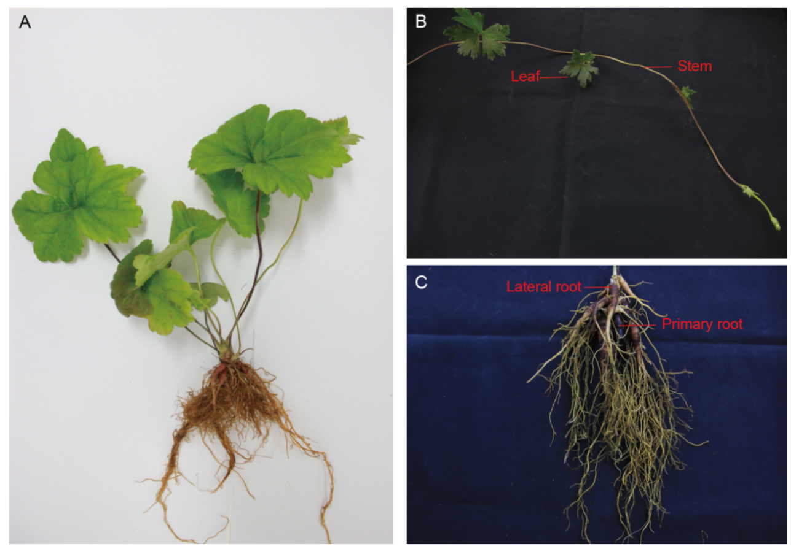

Figure S1. A plant of A. vilmorinianum. A) The young plant. B) The leaves and stem of the adult plant. C) Primary and lateral roots in adult plants.

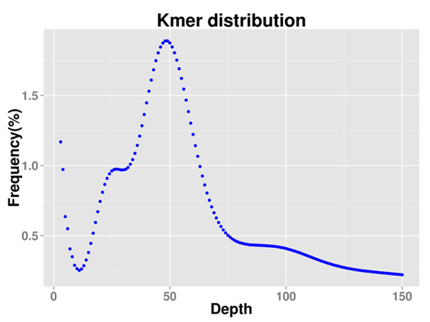

Figure S2. K-mer analysis for estimating the genome size of A. vilmorinianum

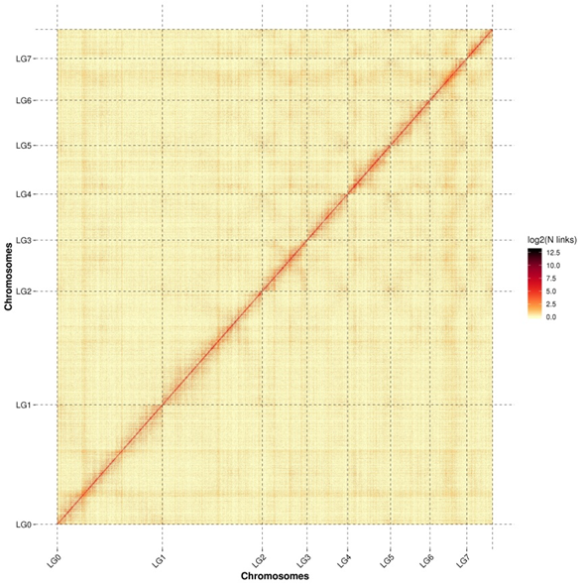

Figure S3. The Hi-C map of A. vilmorinianum genome assembly. Hi-C map of the A. vilmorinianum genome showing genome-wide all by all interactions. The map shows a high resolution of individual chromosomes that are scaffolded and assembled independently.

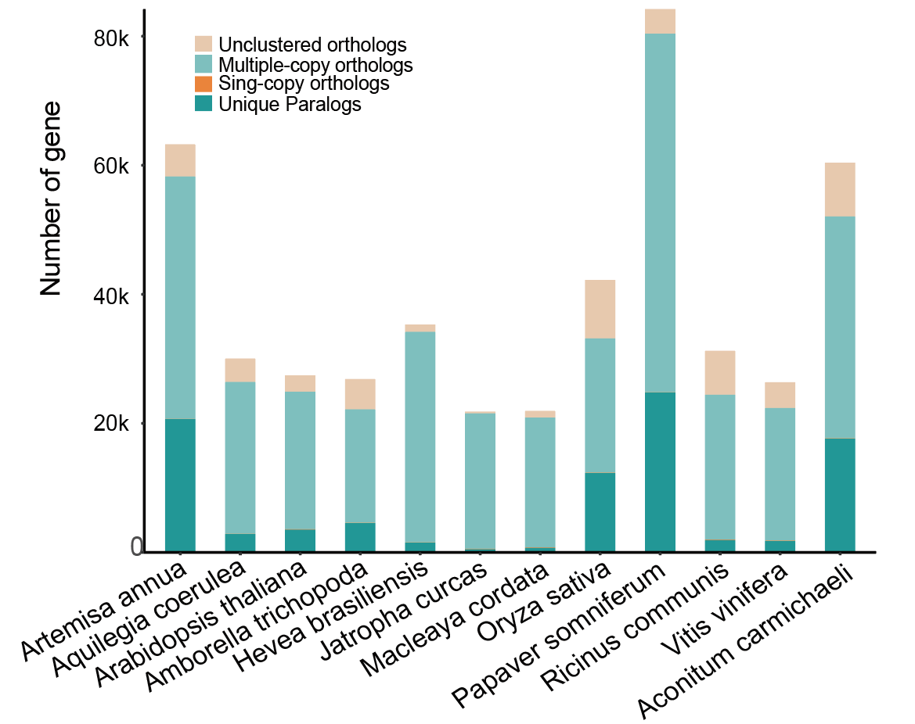

Figure S4. The distribution of genes in different species.

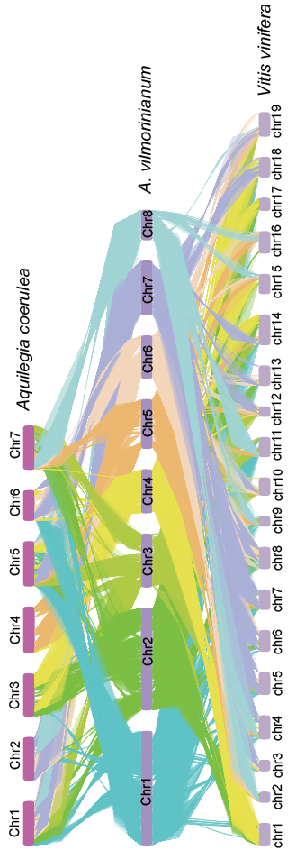

Figure S5. Synteny analysis of A. vilmorinianum, A. coerulea, and V. vinifera.

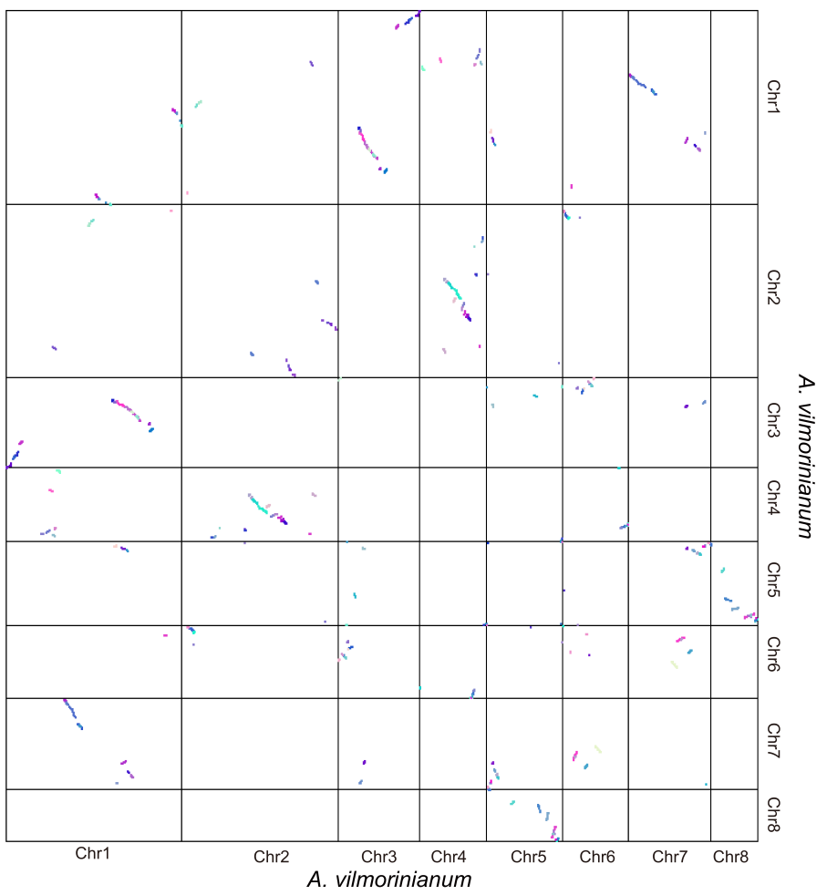

Figure S6. A Dot plot of the synteny block of the A. vilmorinianum genomes.

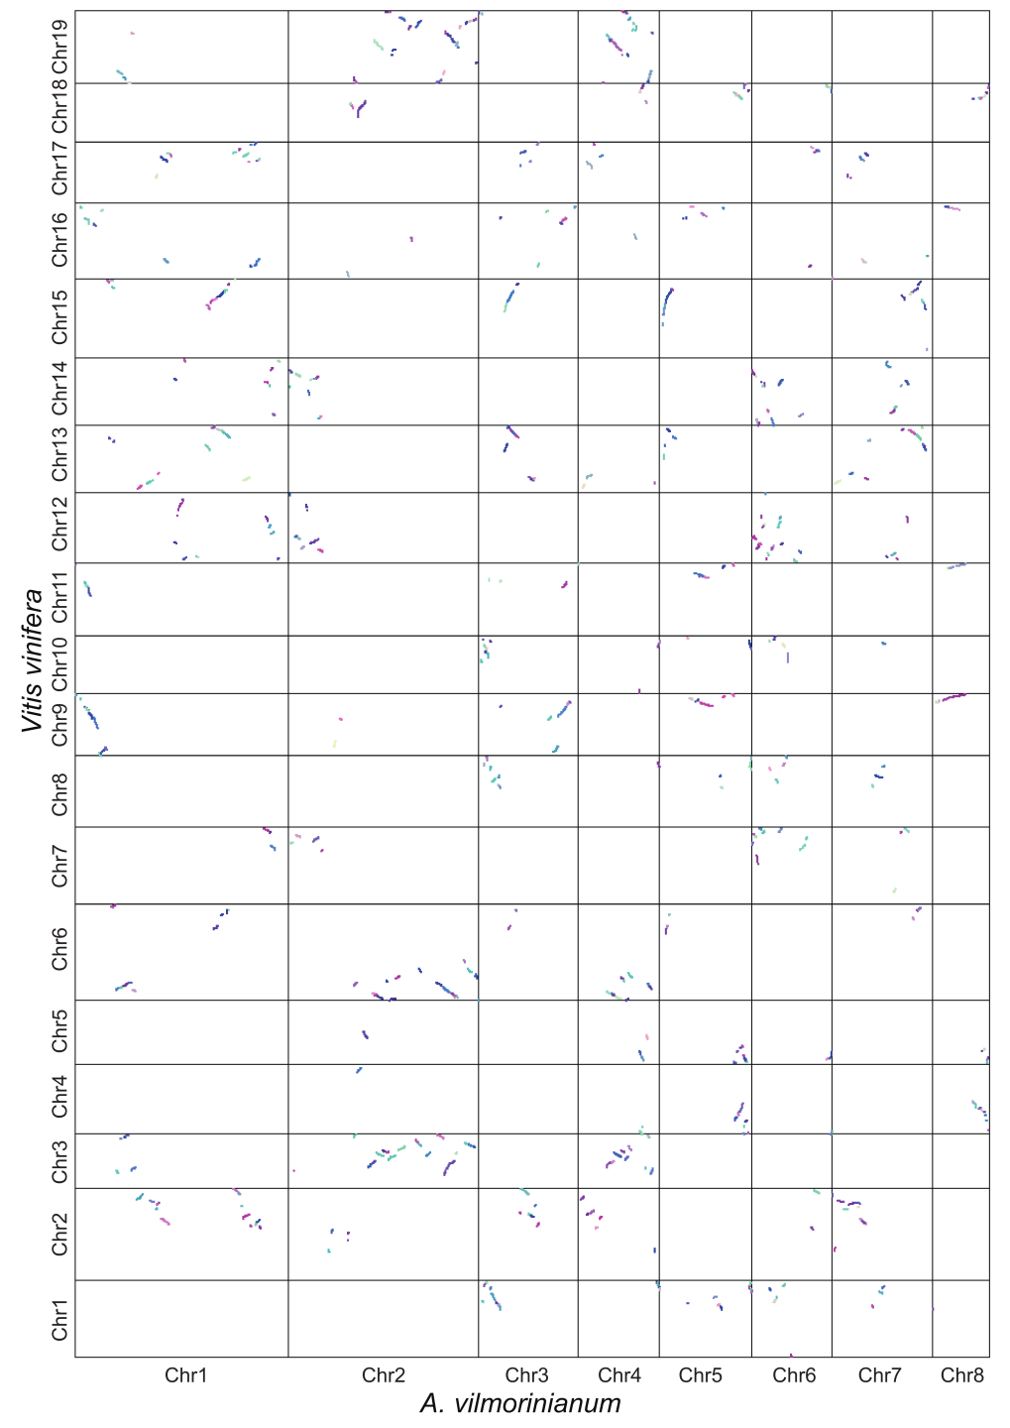

Figure S7. Dot plot of the comparative analysis of the A. vilmorinianum and V. vinifera by MCScanX.

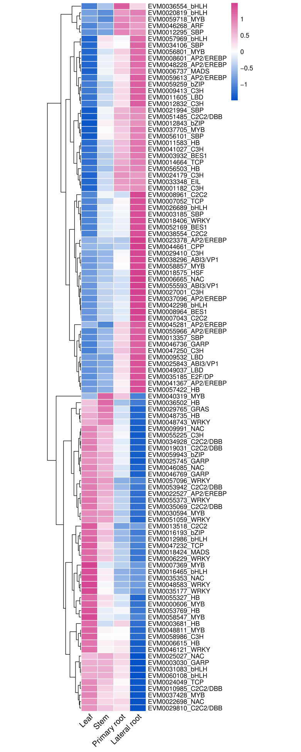

Figure S8. Heatmap of transcription factors (TF) highly associated with pathway genes in the diterpenoid alkaloid regulatory network in A. vilmorinianum.

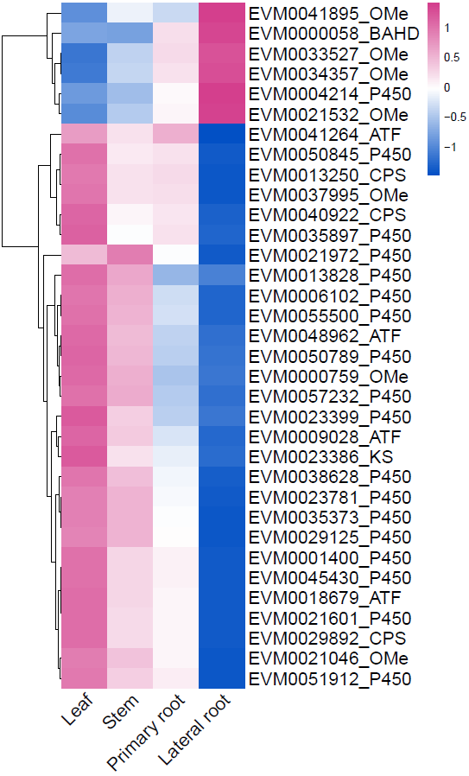

Figure S9. Heatmap of AP2/ERF transcription factors highly associated with pathway genes in the diterpenoid alkaloid regulatory network in A. vilmorinianum.

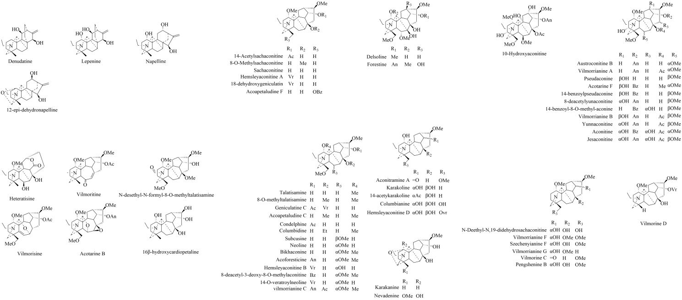

Figure S10. Chemical structural formulas of diterpenoid alkaloids.

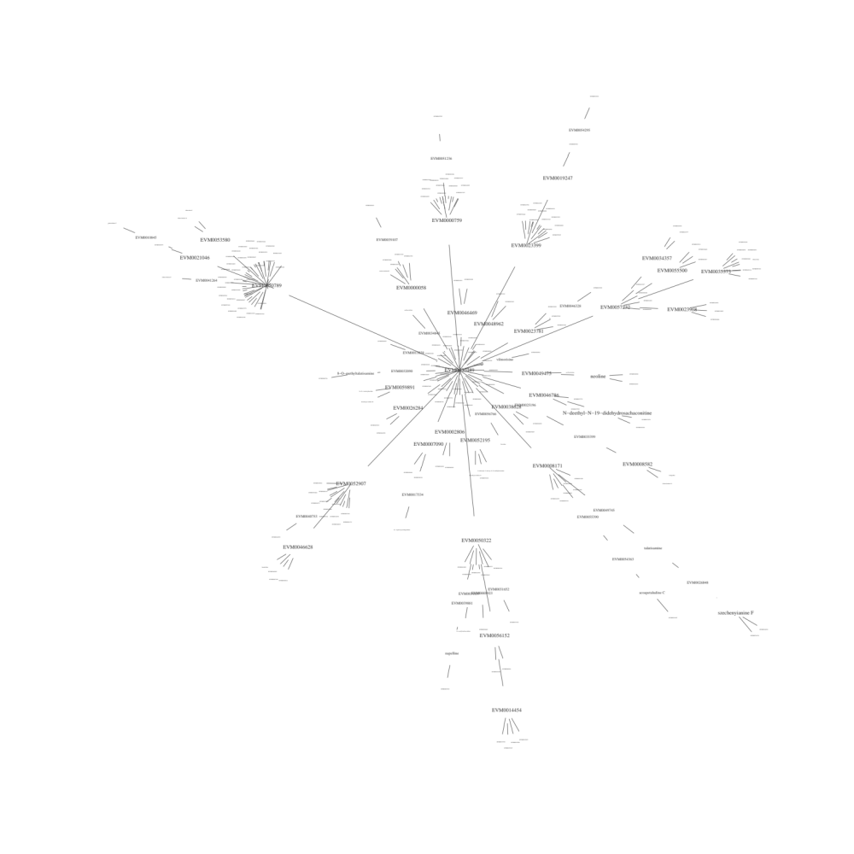

Figure S11. Minimum spanning tree of the integration of gene-metabolite correlation networks with minimum spanning trees in Fig 3-A.

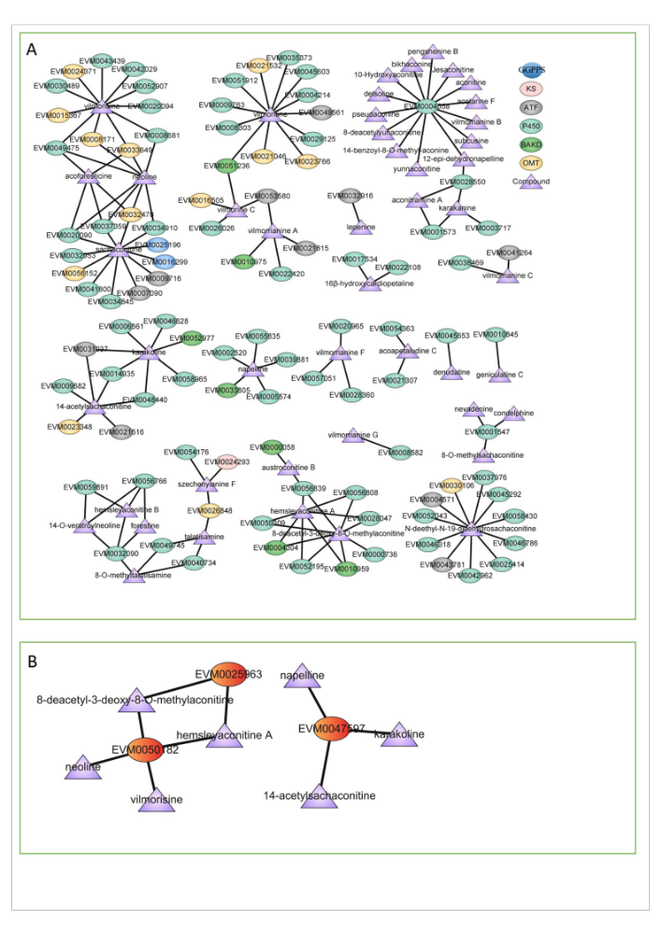

Figure S12. A: Correlation network analysis of pathway genes and diterpenoid alkaloids in A. vilmorinianum (p<0.01). B: Correlation network analysis of KOXs and diterpenoid alkaloids in A. vilmorinianum (p<0.05).

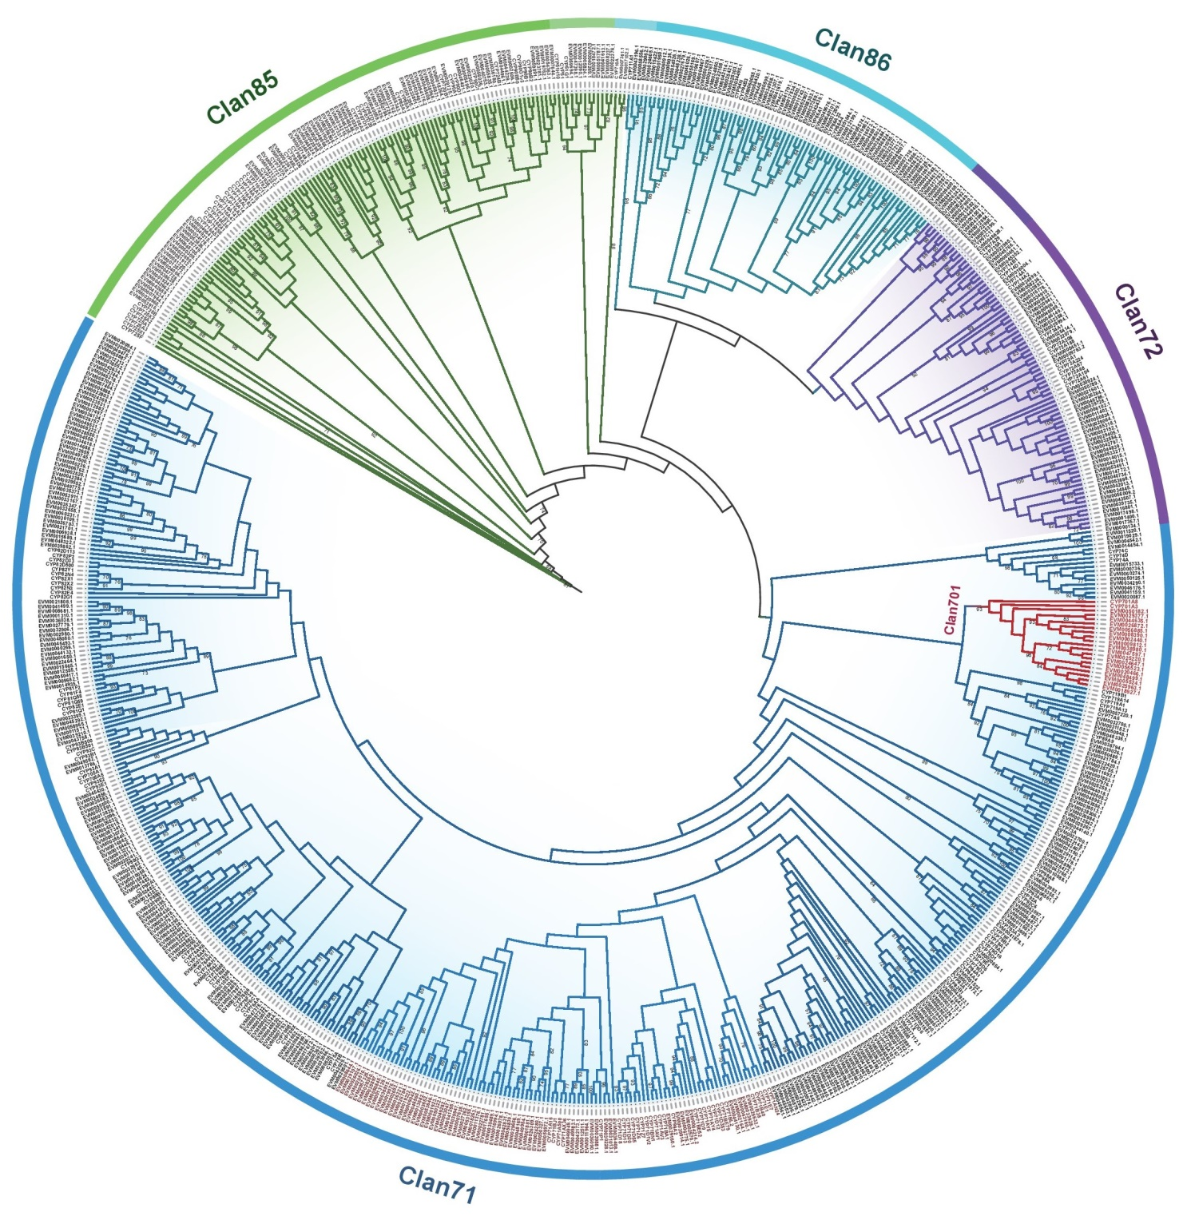

Figure S13. Maximum likelihood phylogenetic tree of Cytochrome P450 genes. The ML tree was constructed using RaxML(v 8.2.12) with the PROTGAMMAJTT and 1000 bootstrap replicates. In summary, the phylogenetic tree of Cytochrome P450 can be roughly divided into four branches, including Clan85, Clan86, Clan71, and Clan72.

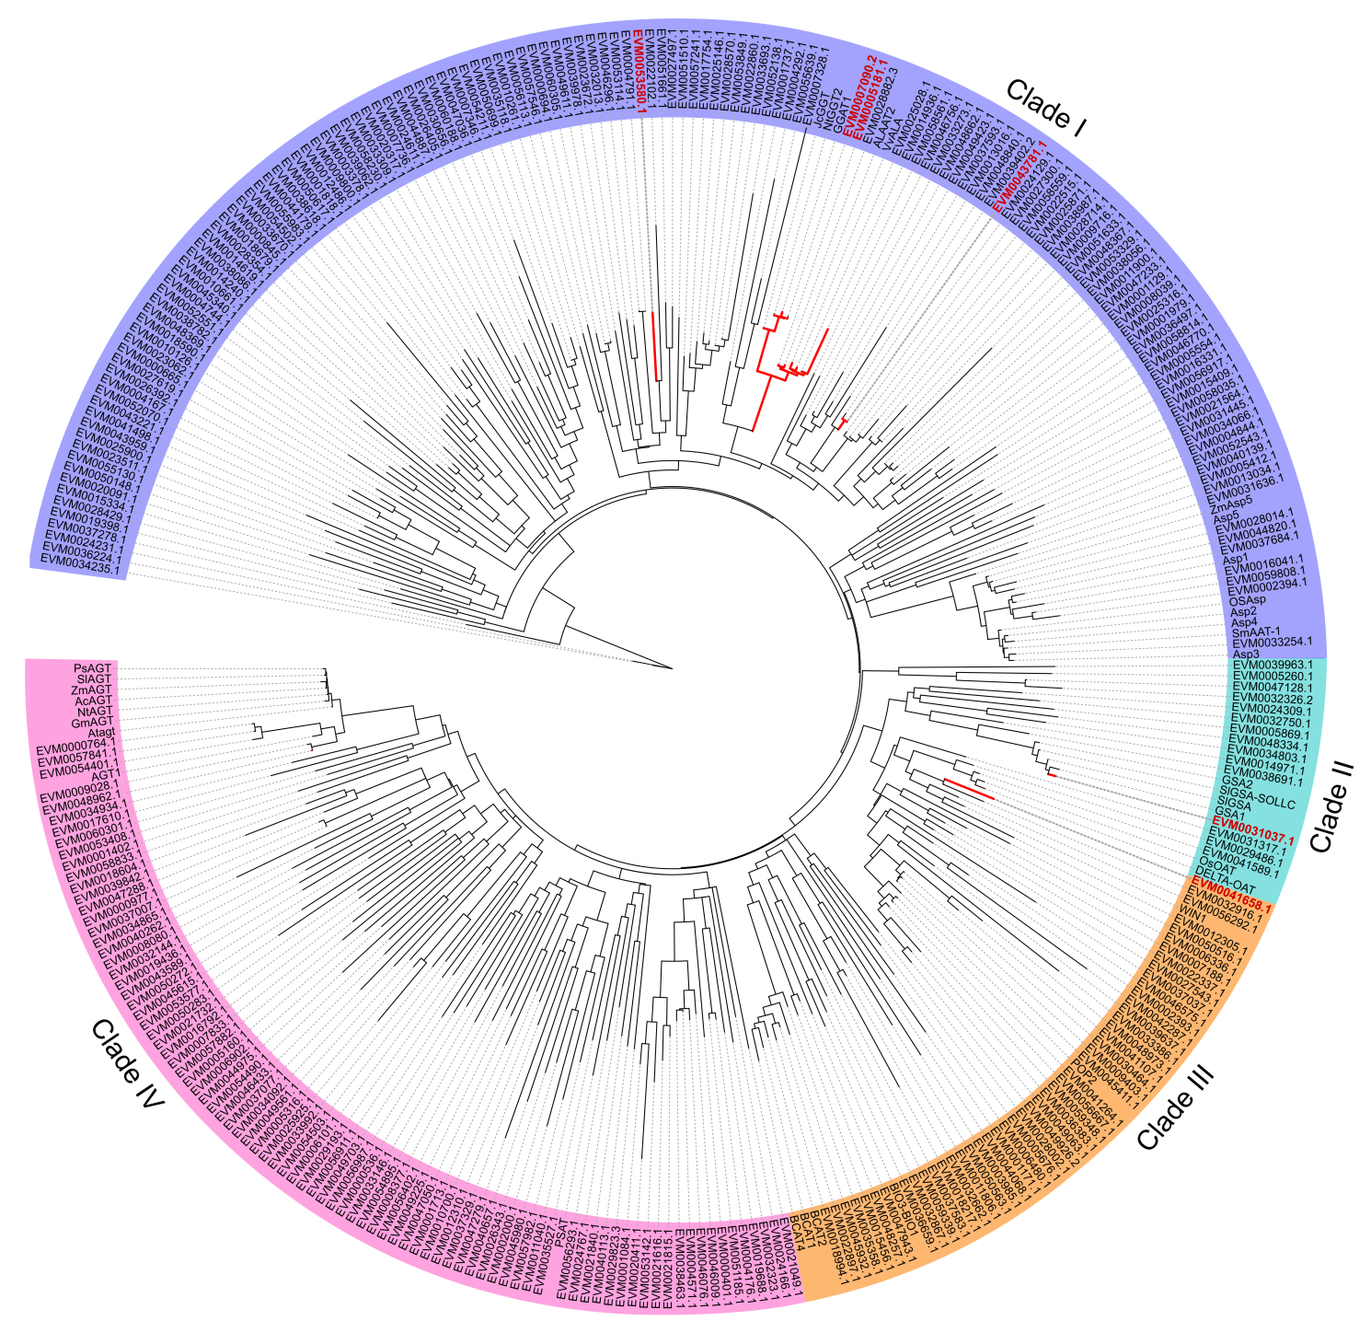

Figure S14. Maximum likelihood phylogenetic tree of ATF genes. The ML tree was constructed using RaxML(v 8.2.12) with the PROTGAMMAJTT and 1000 bootstrap replicates. In summary, the phylogenetic tree of ATF can be roughly divided into four branches, including Clade I, Clade II, Clade III, and Clade IⅤ.

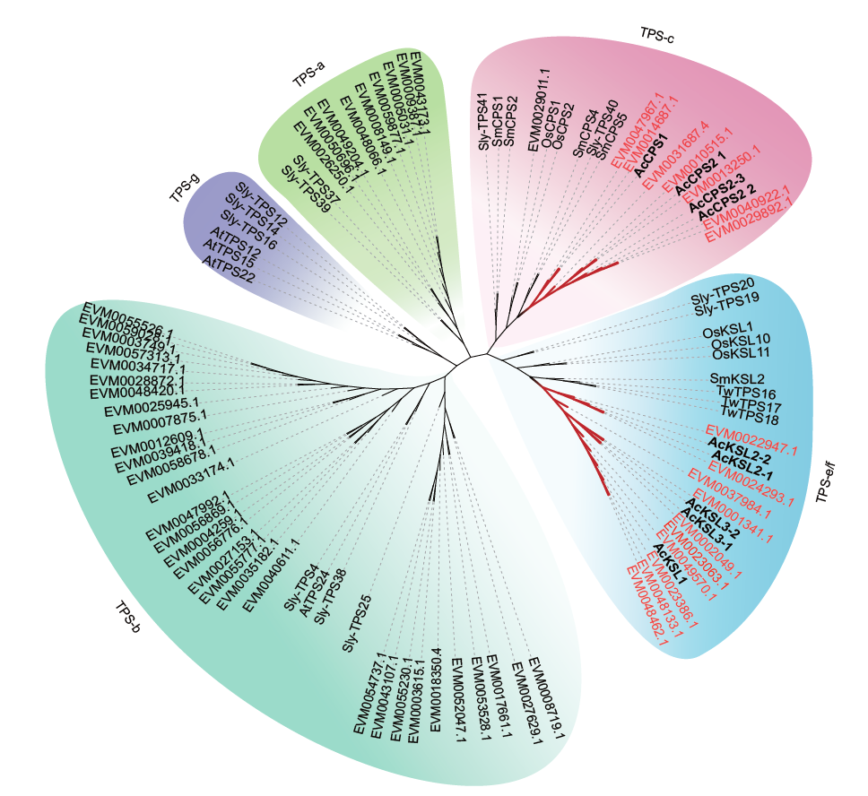

Figure S15. Phylogenetic tree of TPS involved in diterpene alkaloid synthesis. The maximum likelihood tree was reconstructed using RAxML. Numbers on branches indicate the bootstrap percentage values calculated from 1000 bootstrap replicates. TPSs from representative characterized subfamily genes are shown in Data S6. Copalyl diphosphate synthase/ ent-kaurene synthase in Arabidopsis and tomato were used as outgroups.

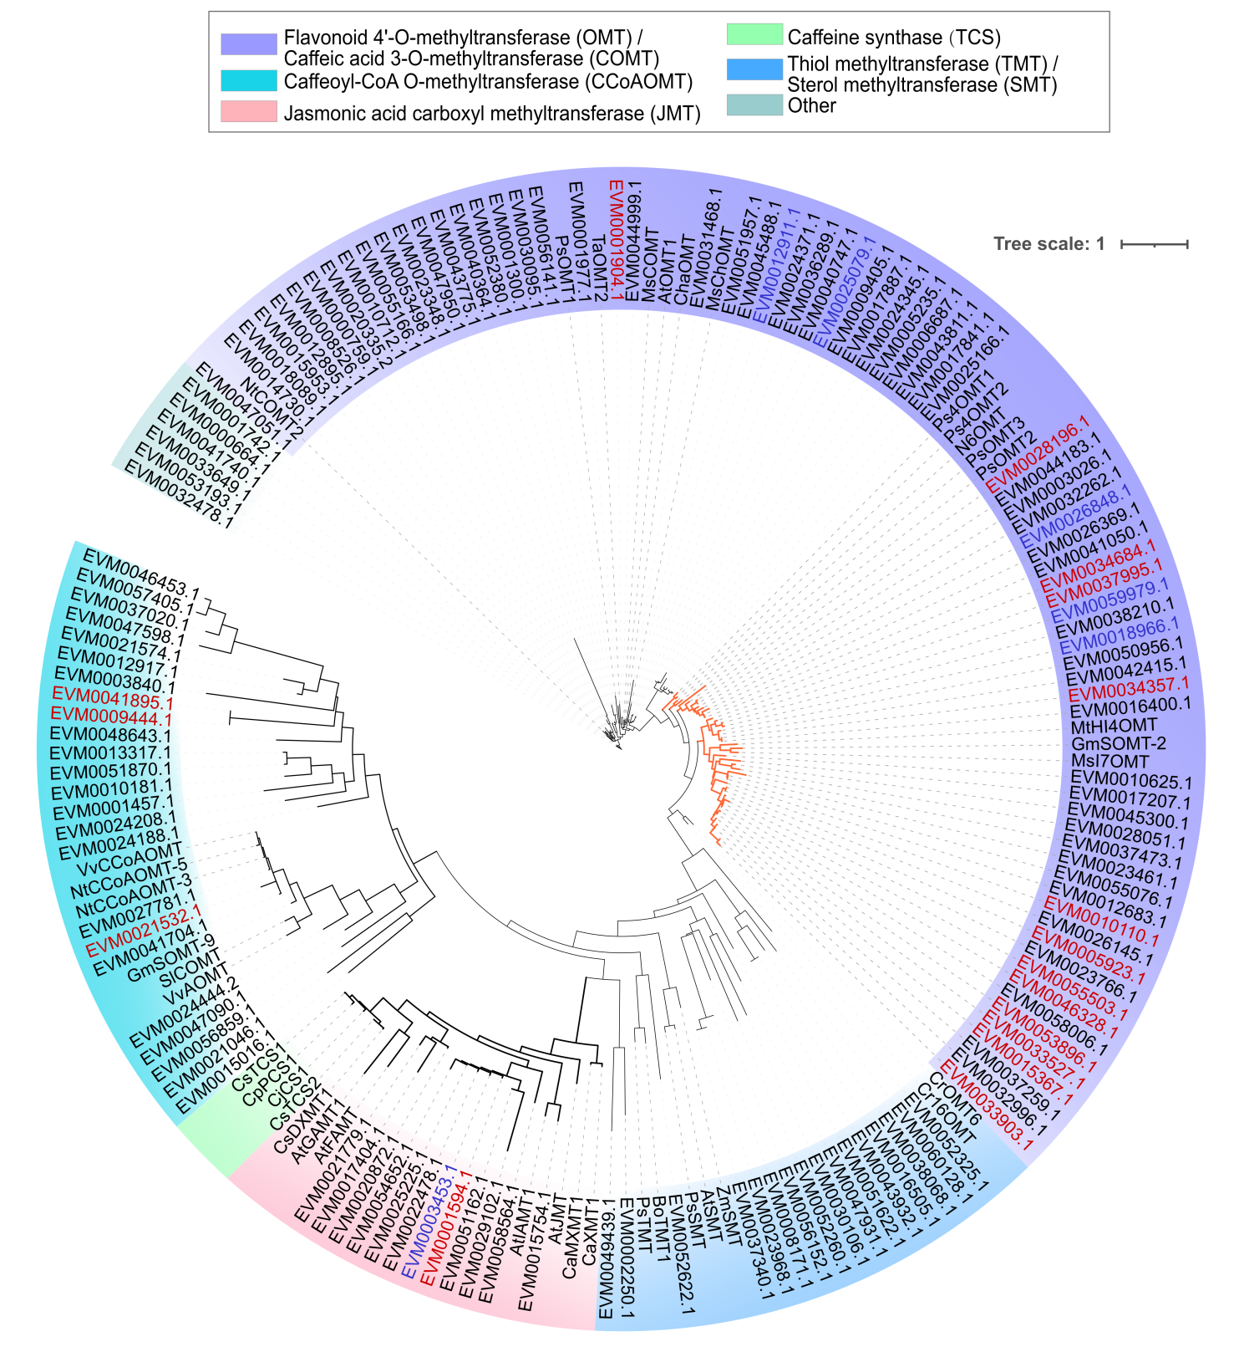

Figure S16. Phylogenetic tree of O-methyltransferase involved in diterpene alkaloid synthesis. The maximum likelihood tree was reconstructed using RAxML(1000 bootstrap). The 19 OMT genes (red) identified in the gene-metabolite correlation analysis were distributed in different branches of the OMT phylogenetic tree.

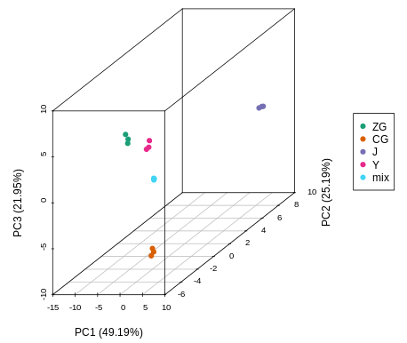

Figure S17. Principal component analysis of metabolic profiles in four tissues of A. vilmorinianum. Y: Leaf, J: Stem, ZG: Primary root, CG: Lateral root.

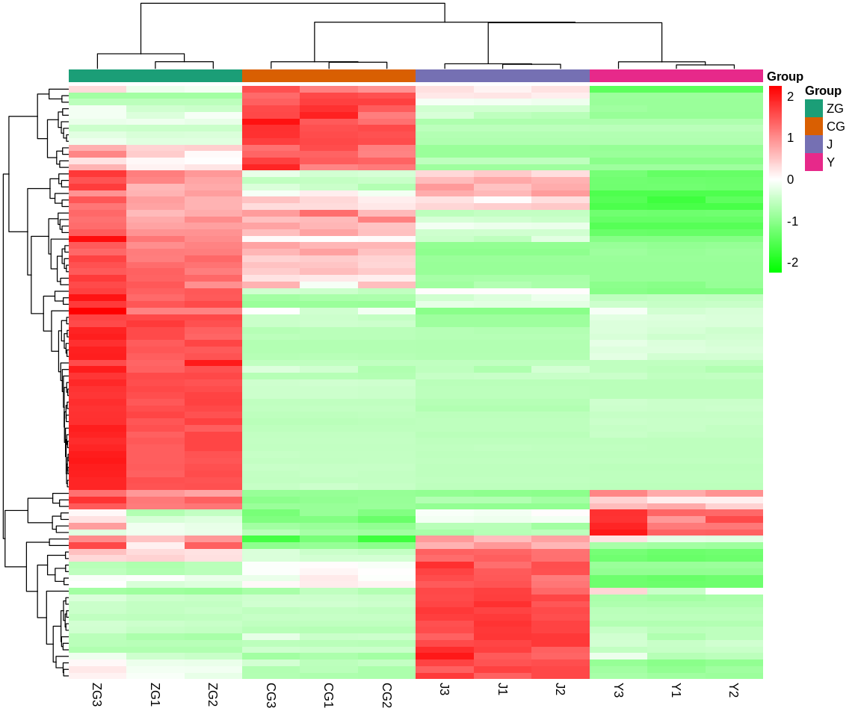

Figure S18. Heatmap of all metabolic compounds in different tissues of A. vilmorinianum. Y: Leaf, J: Stem, ZG: Primary root, CG: Lateral root.

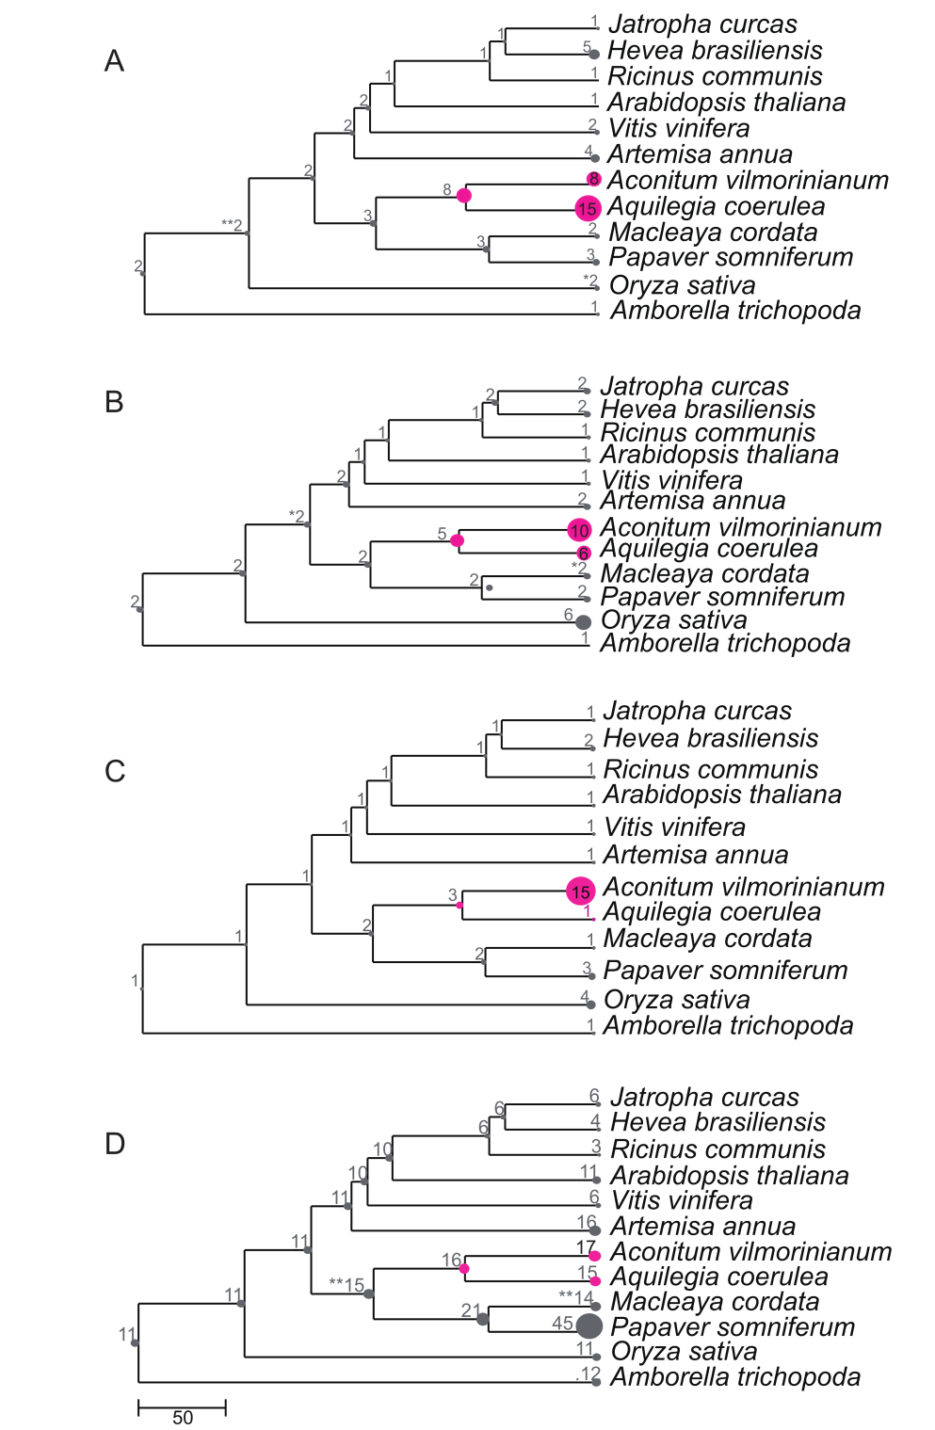

Figure S19. Expansion and contraction of orthologous involving diterpene alkaloids in A. vilmorinianum. A: CPSs in the OG0000968 homology. B: KSs in the OG0001660 homologrou. C: The KOXs in the OG0002270 homology. D: BAHD gene family in the OG0000043 homology.

Supporting data:
Data S1 GO functional enrichment analysis of specific expanded gene families in A. vilmorinianum.
Data S2 GO function enrichment analysis of clade-specific gene families.
Data S3 Summary of pathway gene annotation and expression in A. vilmorinianum.
Data S4 Summary of the candidate genes of 38 transcription factor families in A. vilmorinianum.
Data S5 Correlation analysis of transcription factors that are highly associated with diterpenoid alkaloid biosynthetic genes.
Data S6 The yield of diterpenoids in different tissues of A. vilmorinianum.
Data S7 Correlation analysis of genes and metabolites involved in diterpenoid alkaloid biosynthetic pathway in tissues.
Data S8 Summary of the other plant TPS genes involved in the TPS phylogenetic tree.
Data S9 Biochemically characterized aminotransferase genes in phylogenetic analysis.
Data S10 Biochemically characterized BAHD acyltransferases included in phylogenetic analysis.
Data S11 Summary of the other plant methyltransferases involved in the phylogenetic tree.

References
1 Griffiths-Jones, S. et al. Rfam: annotating non-coding RNAs in complete genomes. Nucleic Acids Res. 33, D121-124 (2005).
2 Chan, P. P. & Lowe, T. M. tRNAscan-SE: Searching for tRNA genes in genomic sequences. Methods Mol. Biol. 1962, 1-14 (2019).
3 Kent, W. J. BLAT--the BLAST-like alignment tool. Genome Res. 12, 656-664 (2002).
4 Birney, E., Clamp, M. & Durbin, R. GeneWise and Genomewise. Genome Res. 14, 988-995 (2004).
5 Wang, Y. et al. MCScanX: a toolkit for detection and evolutionary analysis of gene synteny and collinearity. Nucleic Acids Res. 40, e49 (2012).
6 Camacho, C. et al. BLAST+: architecture and applications. BMC Bioinform. 10, 421 (2009).
7 Benaglia, T., Chauveau, D., Hunter, D. R. & Young, D. S. Mixtools: An R package for analyzing finite mixture models. J. Stat. Softw. 32, 1-29 (2009).
8 Dobin, A. et al. STAR: ultrafast universal RNA-seq aligner. Bioinformatics 29, 15-21 (2013).
9 Li, B. & Dewey, C. N. RSEM: accurate transcript quantification from RNA-Seq data with or without a reference genome. BMC Bioinform. 12, 323 (2011).
10 Rozewicki, J., Li, S., Amada, K. M., Standley, D. M. & Katoh, K. MAFFT-DASH: integrated protein sequence and structural alignment. Nucleic Acids Res. 47, W5-W10 (2019).
11 Stamatakis, A. RAxML version 8: a tool for phylogenetic analysis and post-analysis of large phylogenies. Bioinformatics 30, 1312-1313 (2014).
12 Wang, H. et al. PCPD: Plant cytochrome P450 database and web-based tools for structural construction and ligand docking. Synth. Syst. Biotechnol. 6, 102-109 (2021).
13 Zhai, W. et al. Chloroplast genomic data provide new and robust insights into the phylogeny and evolution of the Ranunculaceae. Mol. Phylogenet. Evol. 135, 12-21 (2019).
14 Shen, Q. et al. The genome of Artemisia annua provides insight into the evolution of Asteraceae family and artemisinin biosynthesis. Mol. Plant 11, 776-788 (2018).
15 Liu, X. et al. The genome of medicinal plant Macleaya cordata provides new insights into benzylisoquinoline alkaloids metabolism. Mol. Plant 10, 975-989 (2017).
16 Guo, L. et al. The opium poppy genome and morphinan production. Science 362, 343-347 (2018).
17 Lamesch, P. et al. The Arabidopsis Information Resource (TAIR): improved gene annotation and new tools. Nucleic Acids Res. 40, D1202-1210 (2012).
18 Zhang, L. et al. Global analysis of gene expression profiles in physic nut (Jatropha curcas L.) seedlings exposed to salt stress. PloS one 9, e97878 (2014).
19 Tang, C. et al. The rubber tree genome reveals new insights into rubber production and species adaptation. Nat. Plants 2, 16073 (2016).
20 Jaillon, O. et al. The grapevine genome sequence suggests ancestral hexaploidization in major angiosperm phyla. Nature 449, 463-467 (2007).
21 Chan, A. P. et al. Draft genome sequence of the oilseed species Ricinus communis. Nat. Biotechnol. 28, 951-956 (2010).
22 Ouyang, S. et al. The TIGR Rice Genome Annotation Resource: improvements and new features. Nucleic Acids Res. 35, D883-887 (2007).
23 Albert, V. A. et al. The Amborella genome and the evolution of flowering plants. Science 342, 1241089 (2013).
- Liu, Y. et al. Analysis of the Coptis chinensis genome reveals the diversification of protoberberine-type alkaloids. Nat Commun. 12, 3276 (2021).
- Wan, T. et al. A genome for gnetophytes and early evolution of seed plants. Nat Plants 4, 82–89 (2018).
- Sun, Y. et al. Genome sequencing of the endangered Kingdonia uniflora (Circaeasteraceae, Ranunculales) reveals potential mechanisms of evolutionary specialization. iScience. 23(5):101124 (2020).
- Lang, D. et al. The Physcomitrella patens chromosome-scale assembly reveals moss genome structure and evolution. Plant J. 93(3):515-533 (2018).
- Arias, T. et al. Genomic and transcriptomic resources for candidate gene discovery in the Ranunculids. Appl Plant Sci. 9(1):e11407 (2021).
- Wan, T. et al. The Welwitschia genome reveals a unique biology underpinning extreme longevity in deserts. Nat Commun. 12: 4247 (2021).
- Hirooka, S. et al. Acidophilic green algal genome provides insights into adaptation to an acidic environment. Proc Natl Acad Sci USA. 114(39): E8304-E8313 (2017).
- Yamamoto, K. et al. Three genomes in the algal genus Volvox reveal the fate of a haploid sex-determining region after a transition to homothallism. Proc Natl Acad Sci USA, 118(21): e2100712118(2021).
- Pryszcz, L. P. et al. Redundans: an assembly pipeline for highly heterozygous genomes. Nucleic Acids Res, 44:e113(2016).
- Banks, J.A. et al.The Selaginella genome identifies genetic changes associated with the evolution of vascular plants. Science 332(6032):960-963 (2011).

