Supplemental information
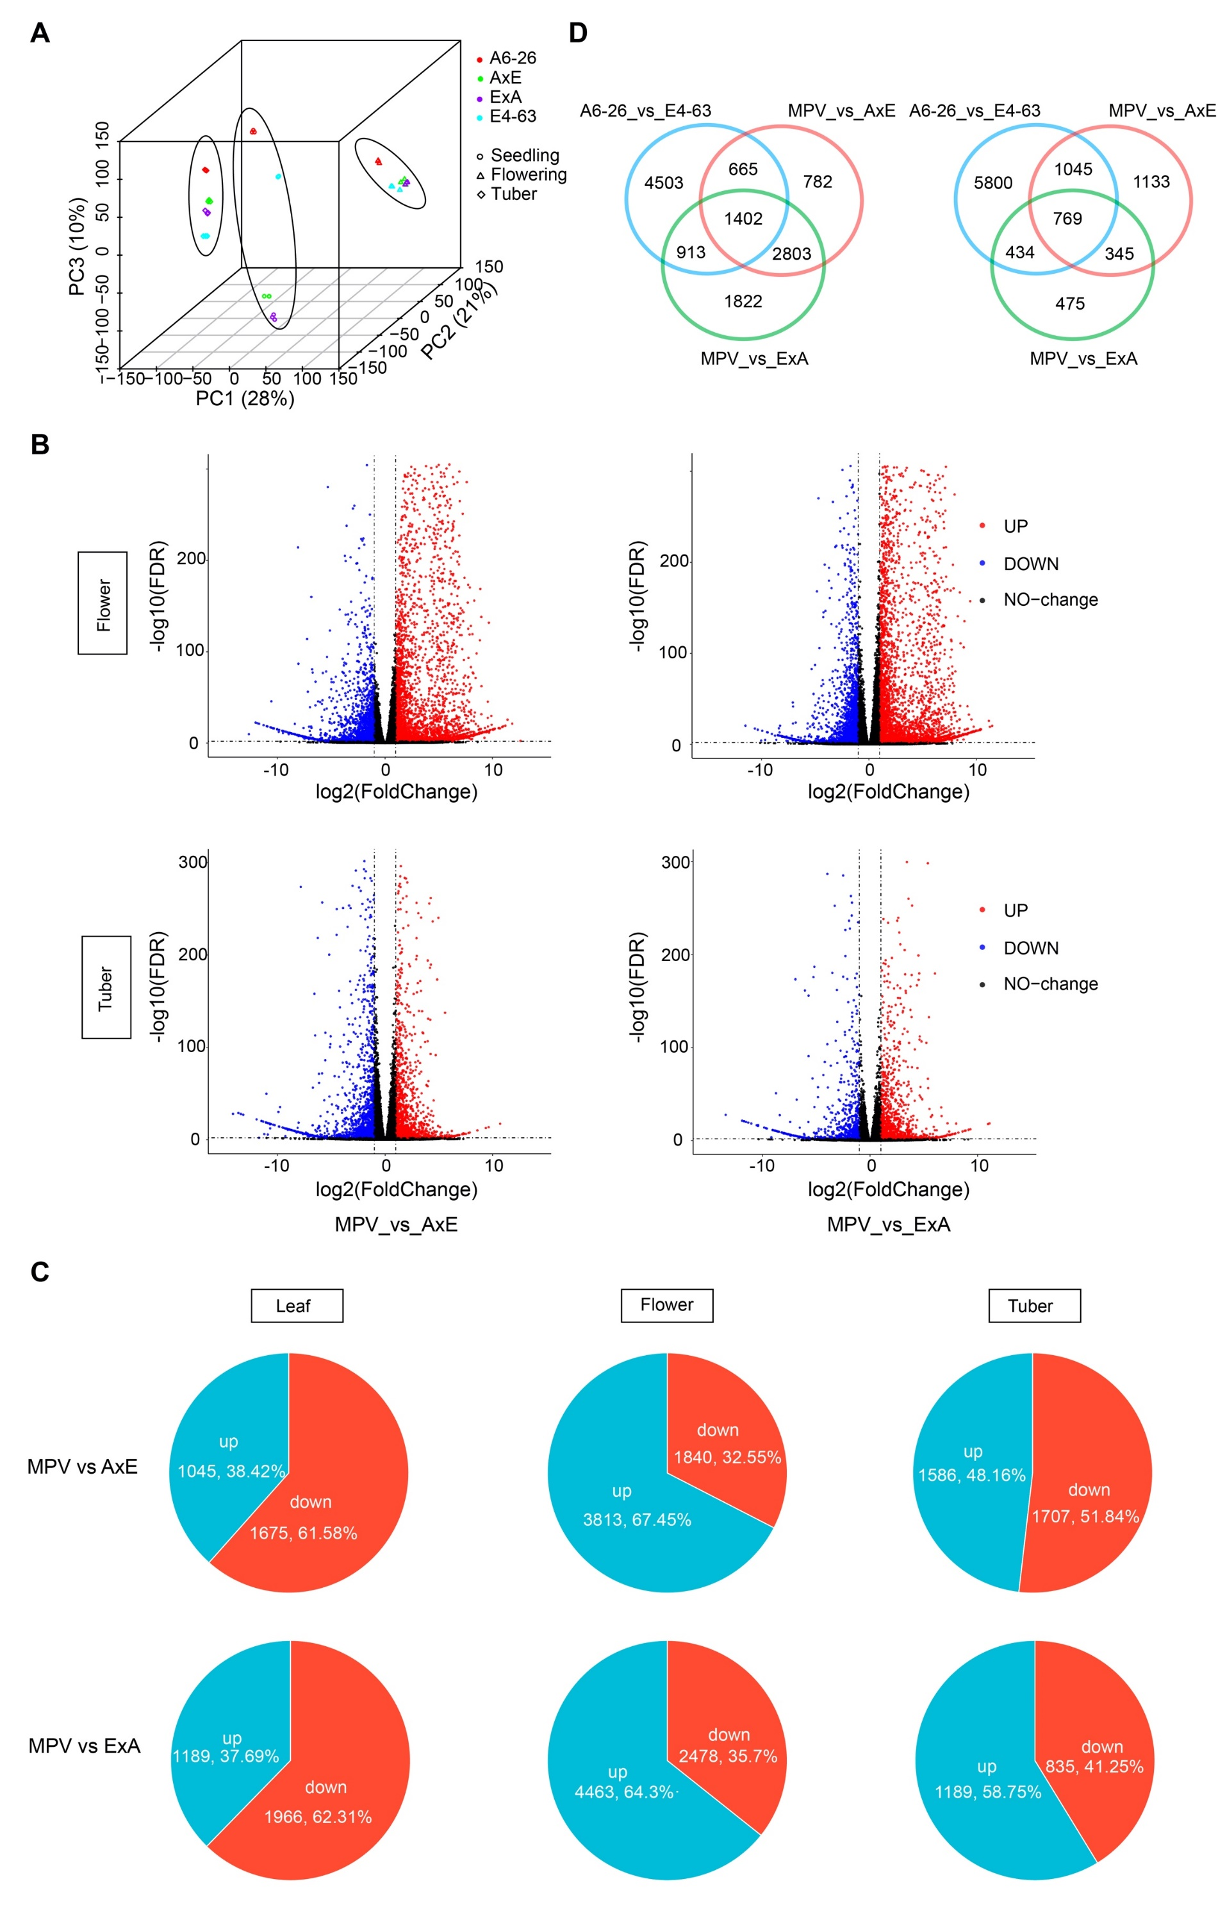
Figure S1. Global transcriptional changes between the F₁ hybrids and their parents in flowers and tubers. (A) PCA for transcriptome data of the three stages. (B) Volcano map of DEGs between the MPV and the F₁ hybrids at the flowering and tuber stages. (C) Pie map showing up- and down-regulated DEGs at the three stages. (D) Venn diagram showing overlap of DEGs between the MPV and the F₁ hybrids and between A6-26 and E4-63 at the flowering and tuber stages.

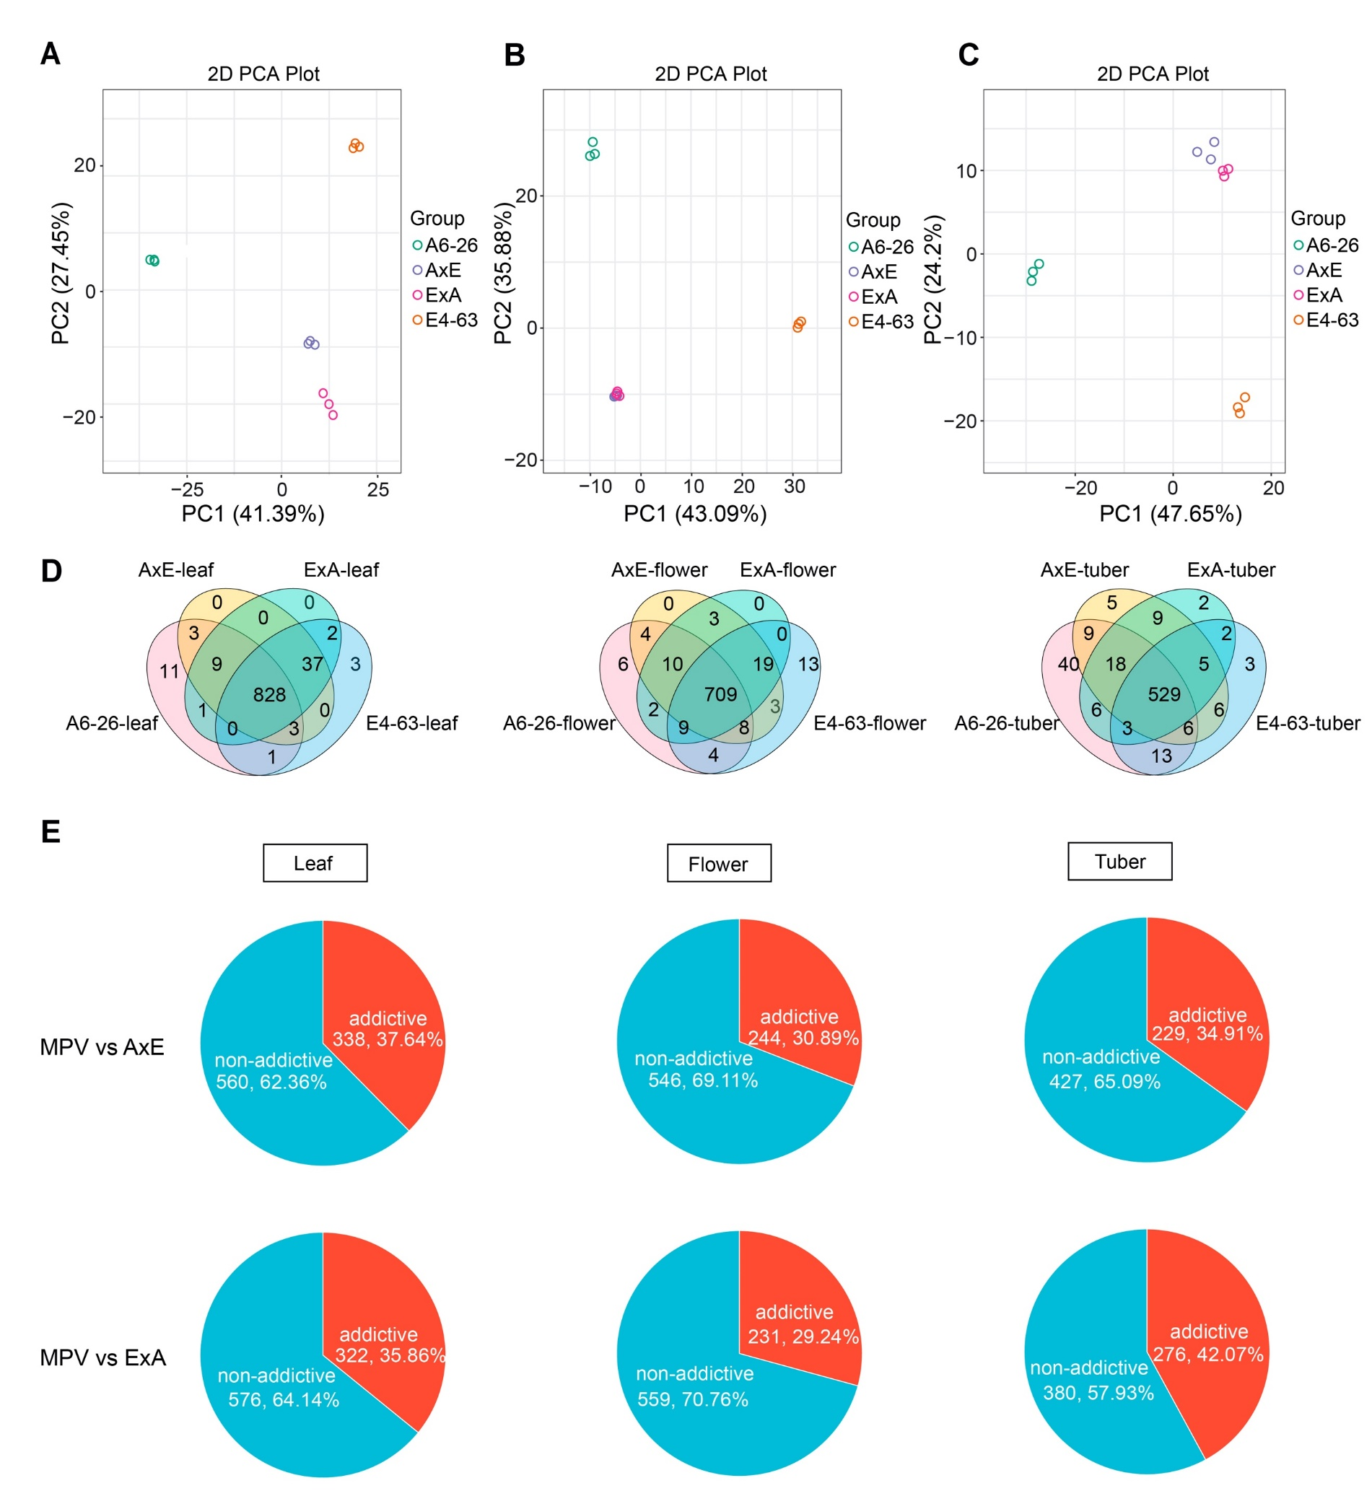
Figure S2. Global metabolic changes between the F₁ hybrids and their parents in flowers and tubers. (A-C) PCA of metabolites at the seedling (A), flowering (B), and tuber stages, respectively. (C) Biological replicates are shown as individuals. (D) Venn diagram showing overlap of metabolites between the F₁ hybrids and their parents at the seedling, flowering and tuber stages. (E) Identification of non-additive metabolites at the three stages for the MPV vs. AxE and the MPV vs. ExA (P < 0.05).
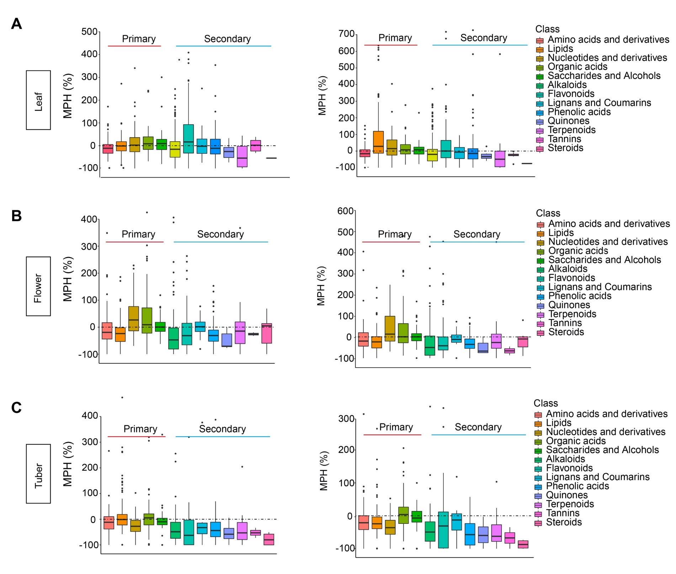
Figure S3. The distribution of MPH (MPV vs. F₁ hybrids) for different kinds of metabolites at the seedling (A), flowering (B) and tuber stages (C). The first five boxes represent primary metabolism, and the rest represent secondary metabolism.

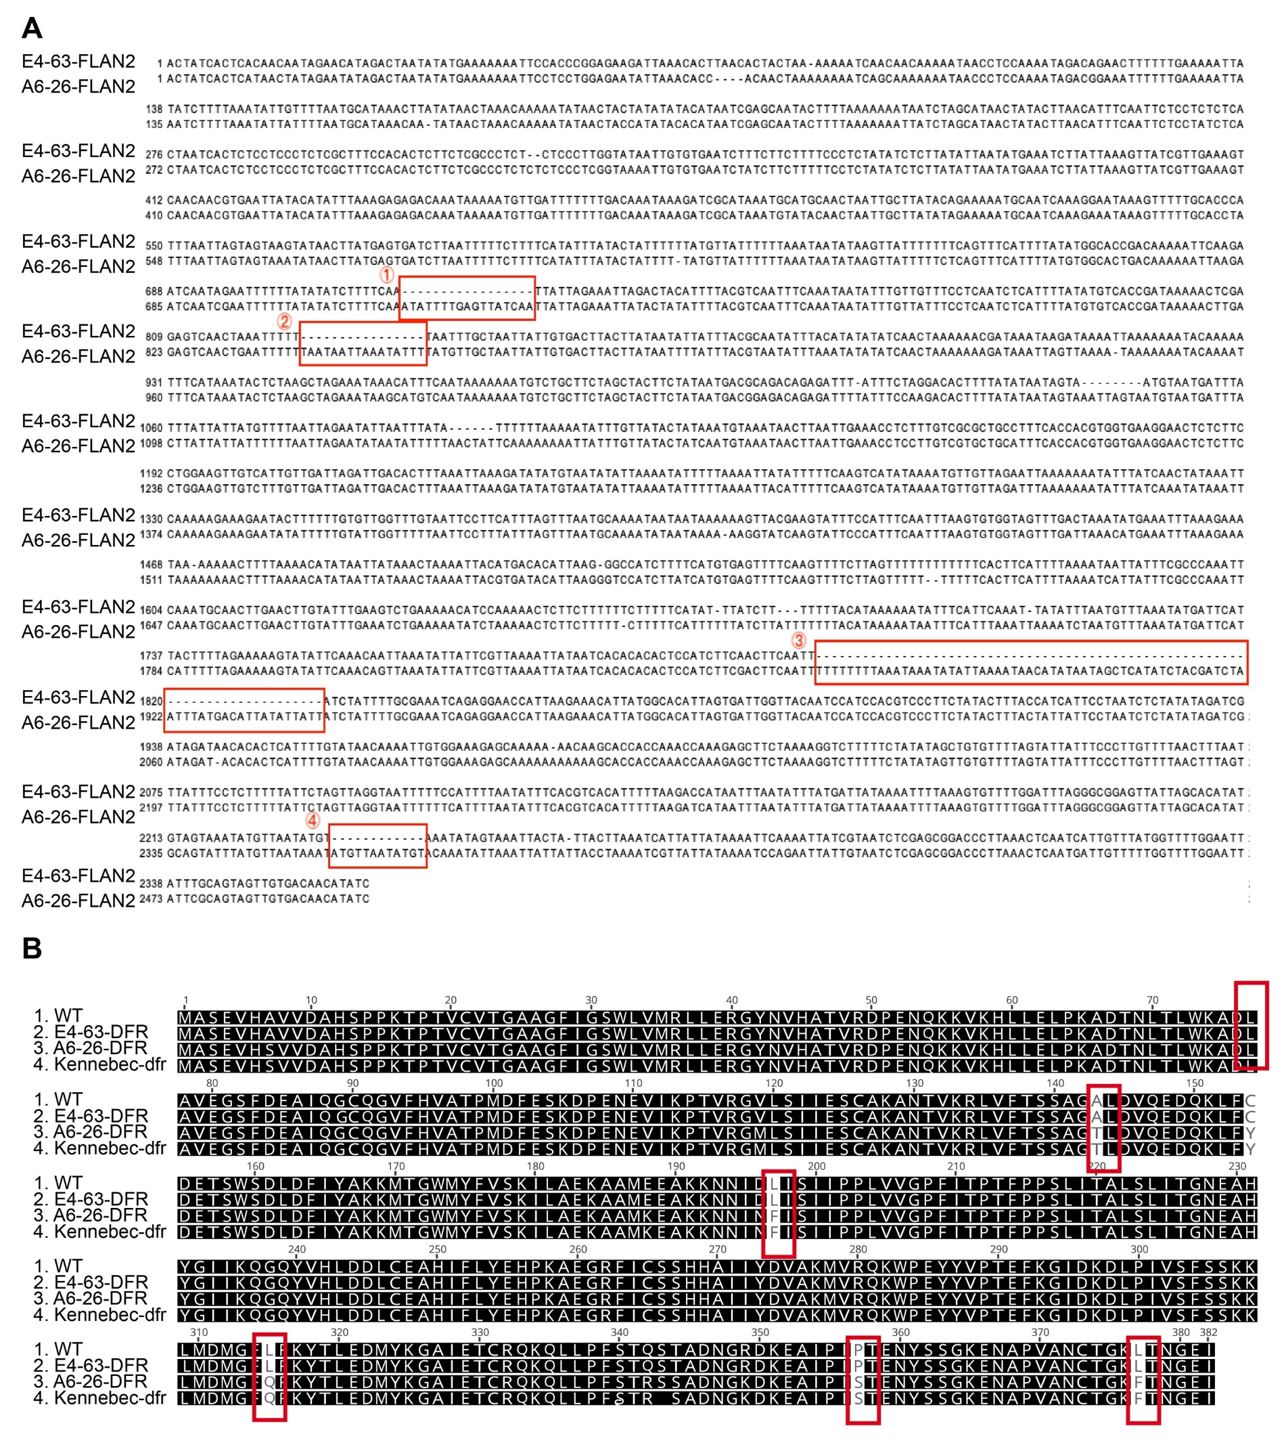
Figure S4. Alignment of promoter sequence of FLAN2 and amino acid sequence of DFR in the two parental lines. (A) Alignment of promoter sequence of FLAN2 in the two parental lines. (B) Alignment of amino acid sequences using DFR of the wild type, E4-63, A6-26, and Kennebec (which contains the dfr mutation).

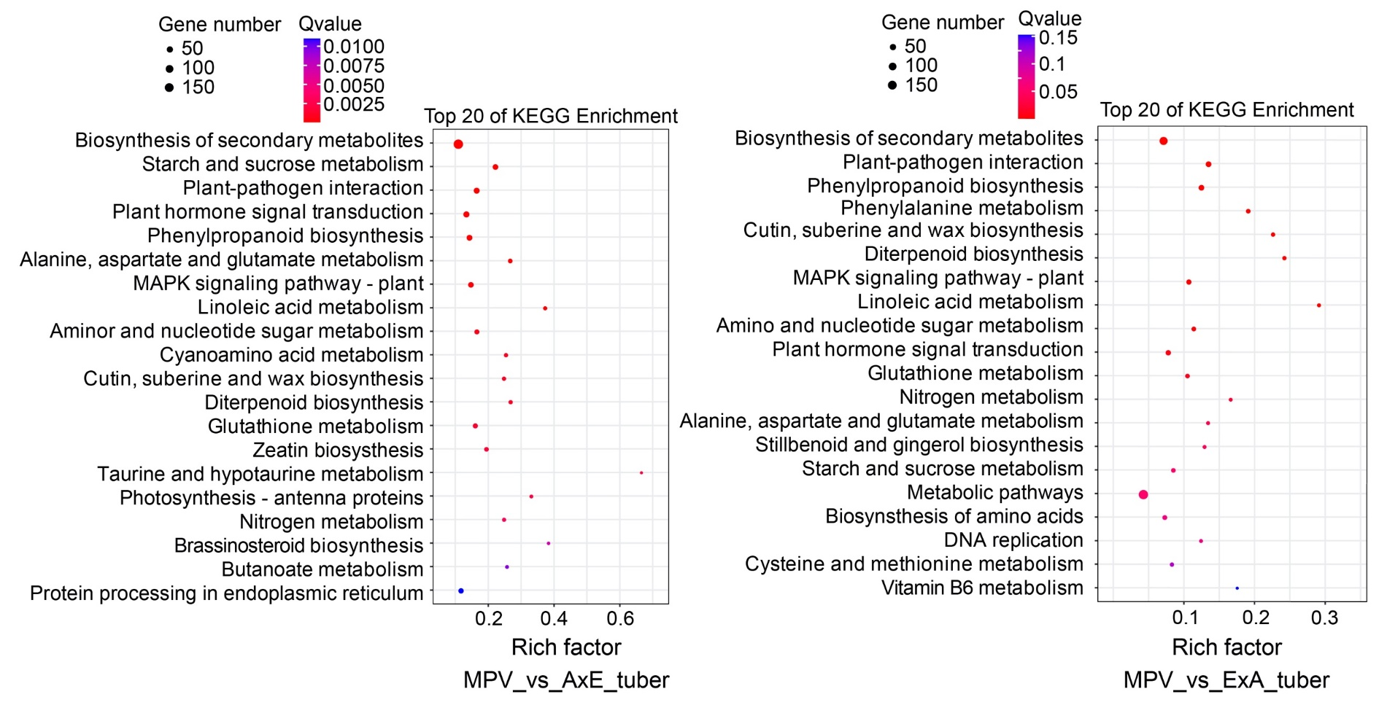
Figure S5. KEGG enrichment analyses of MPV-hybrid DEGs in tubers. The x-axis shows the number of genes belonging to this term in the gene list of interest divided by the number of background genes enriched in this term.

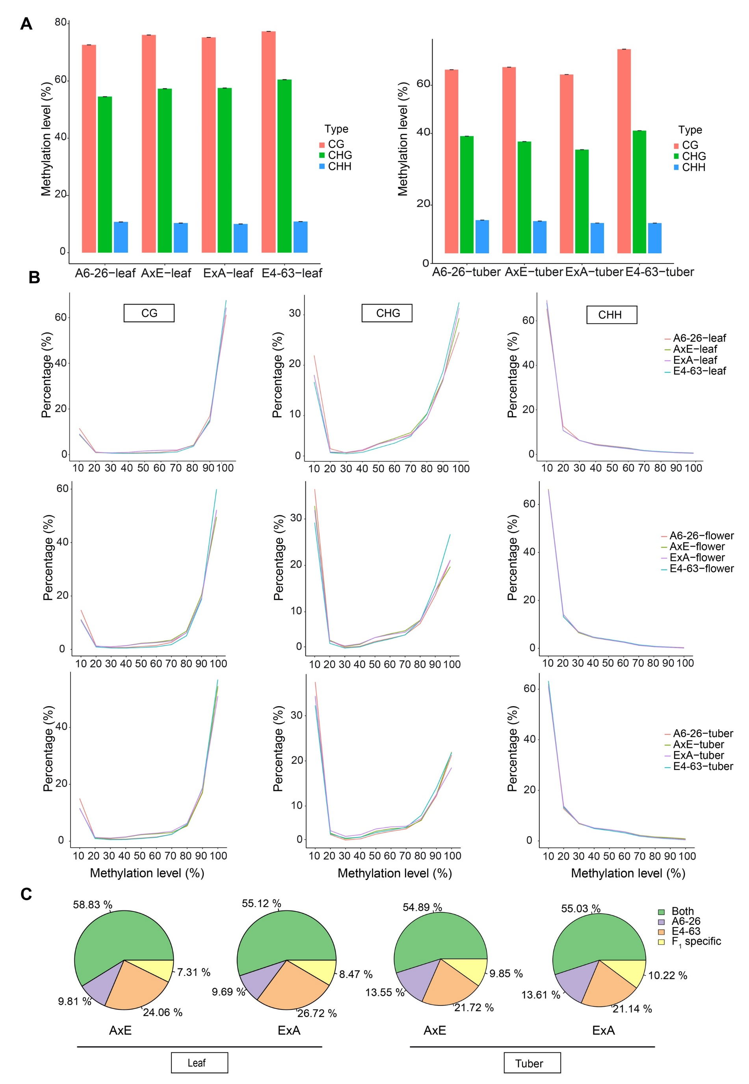
Figure S6. Global methylation levels and the source of methylation sites. (A) Global methylation levels (at CG, CHG, and CHH contexts) of the F₁ hybrids and their parents at the seedling and tuber stages. Data are represented as mean ± SD (n = 3). (B) Distribution of the percentage of methylation at each cytosine context in the F₁ hybrids and their parents at the three stages. The x-axis shows the percentage of methylation in bins of 10%; The y-axis shows the percentage of total methylcytosines present in each bin. (C) Source of methylation sites in the two F₁ hybrids at the seedling and tuber stages. “Both” indicates A6-26 and E4-63.

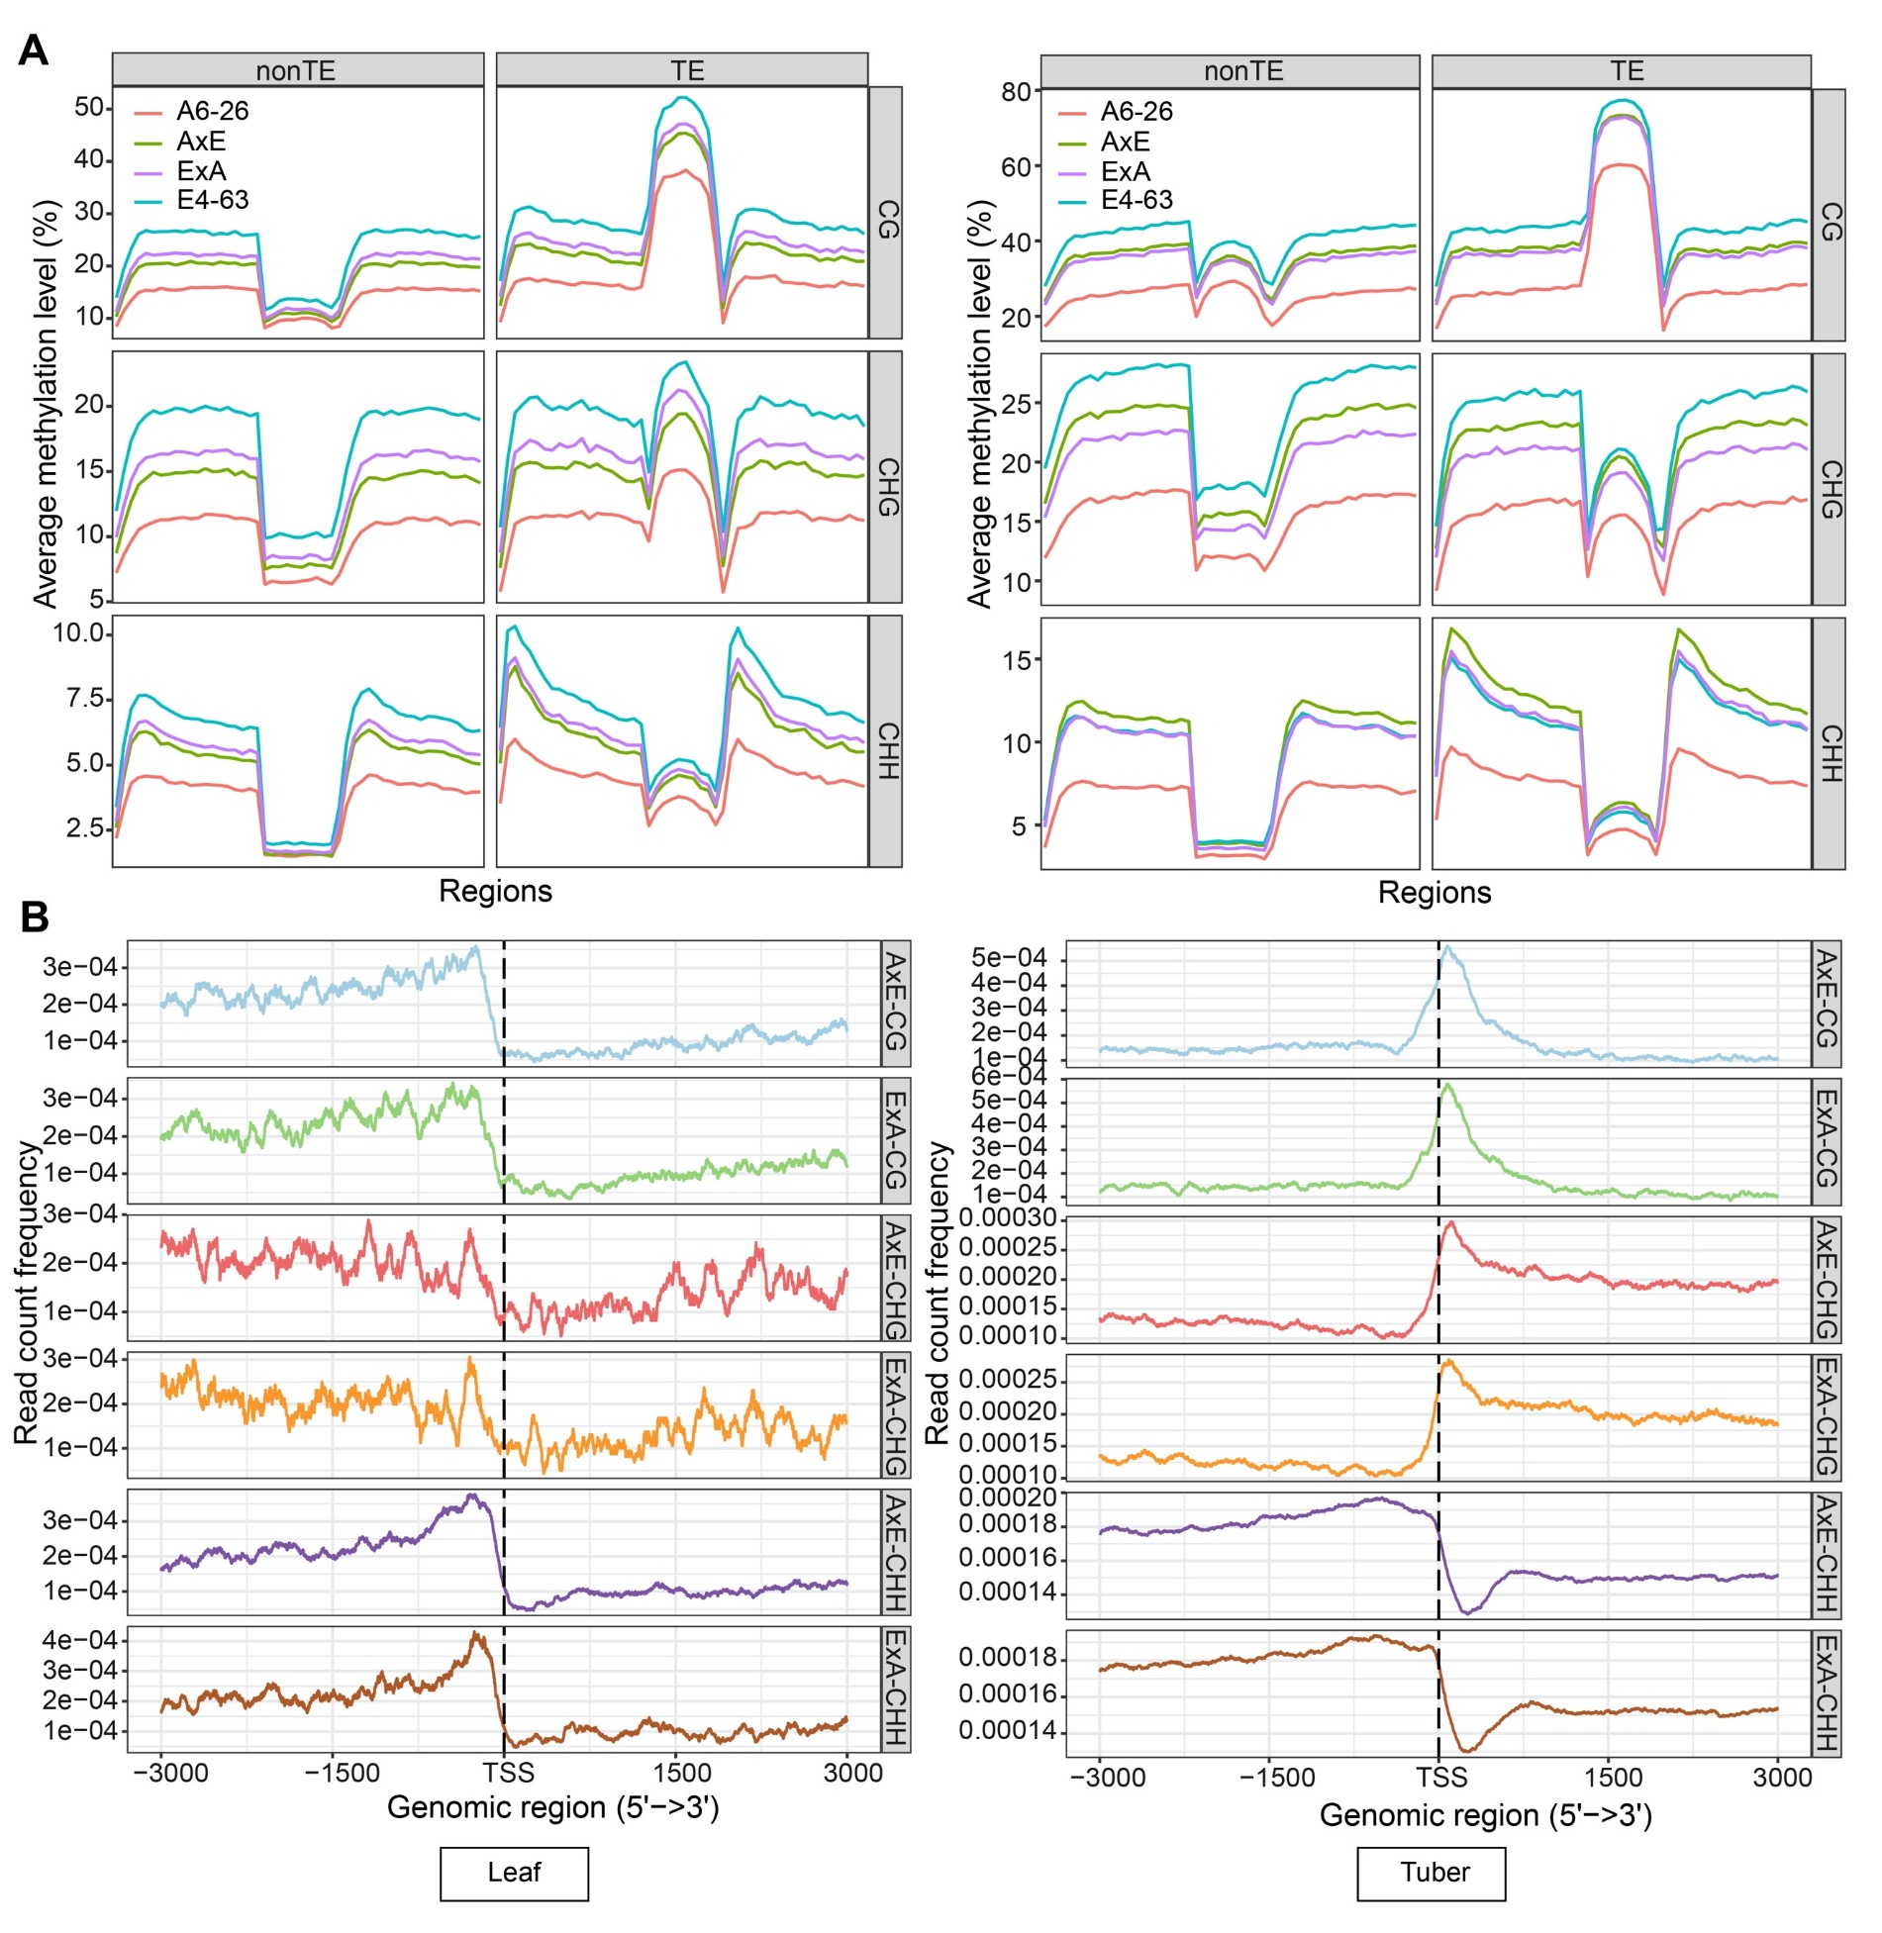
Figure S7. Methylation distribution in non-TE and TE genes at each cytosine context and annotation of DMRs. (A) Average methylation levels of TE and non-TE genes at the seedling and tuber stages. Each bin of 2 kb upstream and 2 kb downstream is 100 bp. The gene body region is evenly divided into 10 bins. (B) Distribution of MPV-hybrid DMRs (at CG, CHG, and CHH contexts).

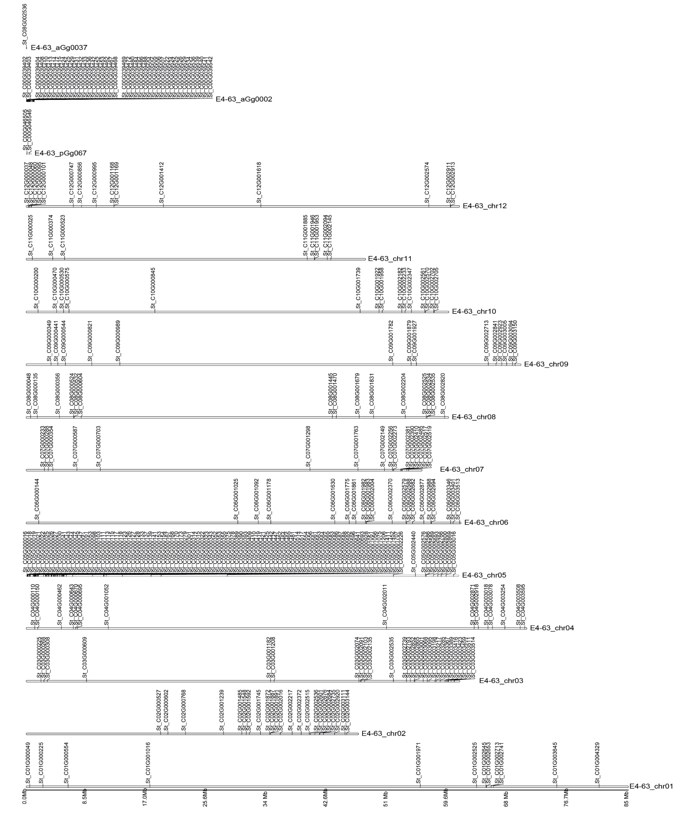
Figure S8. The distribution of all imprinted genes on the chromosomes.

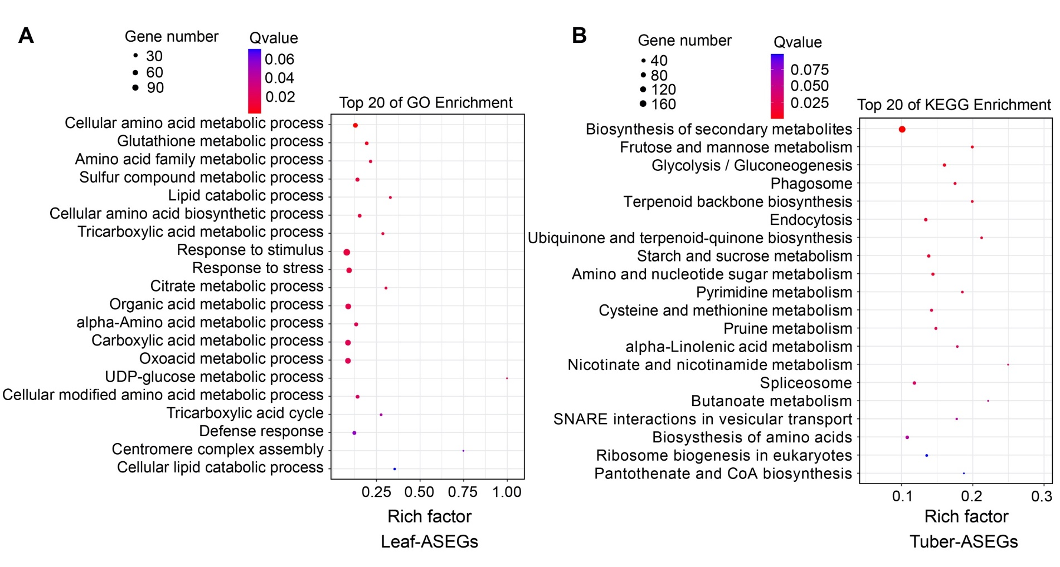
Figure S9. KEGG analyses of ASEGs at the seedling (A) and tuber stages (B). All ASEGs (A6-26-bias and E4-63-bias) were merged together for KEGG analysis at each stage.

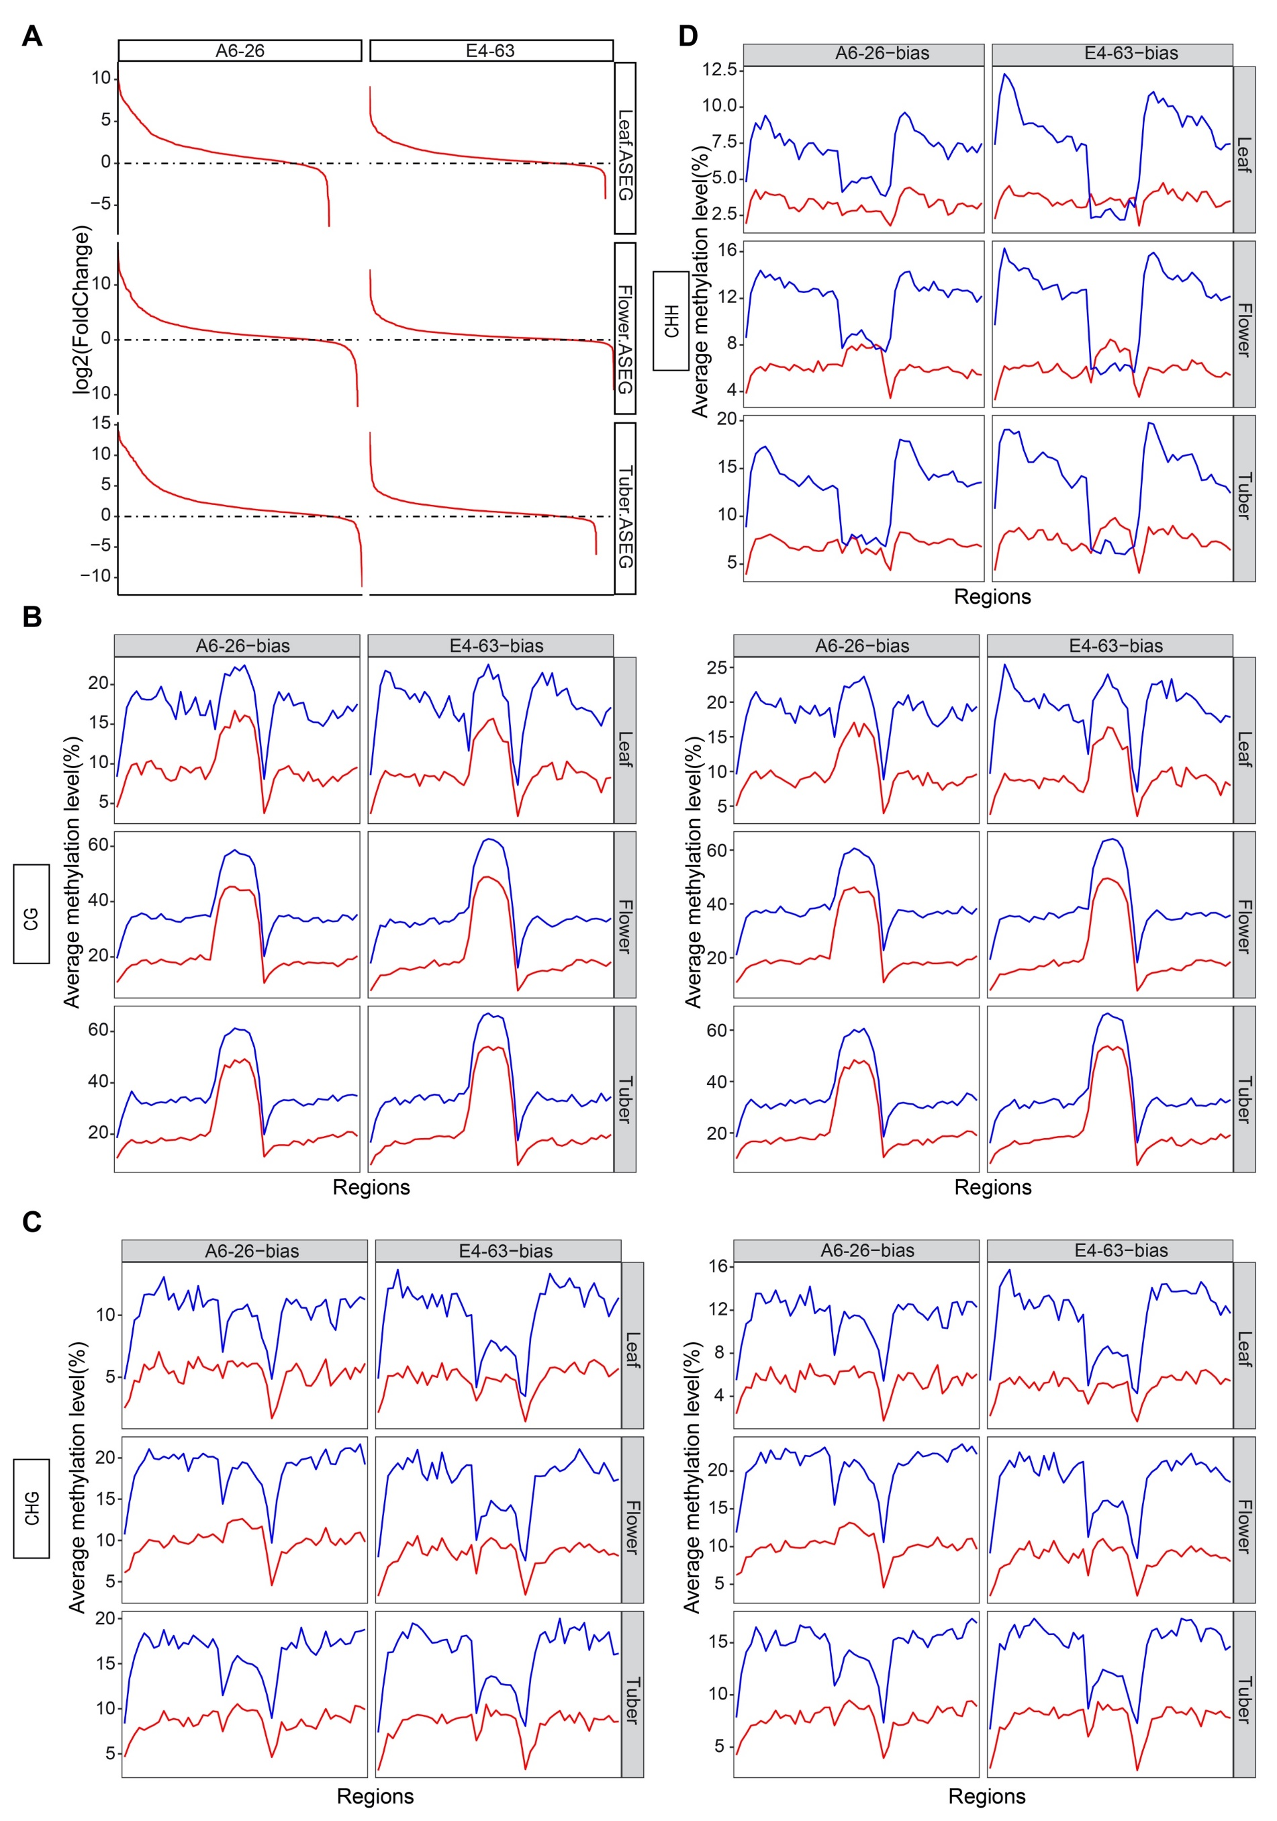
Figure S10. The potential mechanism of ASE. (A) Expression levels of ASEGs in A6-26 and E4-63. The x-axis shows ASEGs. The y-axis represents the log2 (FoldChange) of A6-26 vs. E4-63. (B-C) Average allele-specific CHH methylation level of A6-26- and E4-63-bias ASEGs in AxE and ExA at CG (B), CHG (C), and CHH (D) contexts. Each bin of 2 kb upstream and 2 kb downstream is 100 bp. The gene body region is evenly divided into 10 bins.

Table S1. Number of DEGs, ASEGs, and imprinted genes at the three stages.
Stage | MPV vs AxE | MPV vs AxE | A6-26-biased | E4-63-biased | Maternal | Paternal
Seedling | 2,720 (5.74%) | 3,155 (6.66%) | 1,281 | 1,373 | 58 | 87
Flowering | 5,653 (11.93%) | 6,941 (14.64%) | 1,438 | 1,393 | 60 | 87
Tuber | 3,293 (6.95%) | 2,024 (4.27%) | 1,435 | 1,279 | 60 | 73

Table S2. Annotation of 28 common imprinted genes.
Gene ID | Allele expressed | Potential function
St_C05G000322 | Maternal | Glutamyl/glutaminyl-tRNA synthetase
St_C05G000410 | Maternal | NAC domain superfamily
St_C05G000447 | Maternal | P-type ATPase
St_C05G000563 | Maternal | Reversibly glycosylated polypeptide family
St_C05G000583 | Maternal | Consensus disorder prediction
St_C05G000592 | Maternal | Ureide permease
St_C05G000596 | Maternal | Pentatricopeptide repeat (PPR)
St_C05G002536 | Maternal | F-BOX protein
St_C00G039402 | Paternal | Pentatricopeptide repeat (PPR)
St_C00G039408 | Paternal | Root UVB sensitive family
St_C00G039414 | Paternal | Mg²⁺ transporter
St_C00G039425 | Paternal | Pentatricopeptide repeat (PPR)
St_C00G039429 | Paternal | 6-Phosphogluconolactonase
St_C00G039433 | Paternal | Reversibly glycosylated polypeptide
St_C00G039452 | Paternal | Consensus disorder prediction
St_C00G039469 | Paternal | Basic helix-loop-helix (bHLH) domain
St_C00G039484 | Paternal | Histidine kinase/HSP90-like ATPase
St_C00G039506 | Paternal | Adenosylmethionine decarboxylase
St_C00G039522 | Paternal | Sphingosine N-acyltransferase Lag1/Lac1-like
St_C00G039524 | Paternal | 6-phosphogluconate dehydrogenase
St_C05G000021 | Paternal | Aspartic peptidase A1 family
St_C05G000045 | Paternal | Aspartic peptidase domain superfamily
St_C05G000113 | Paternal | Unknown function
St_C05G000117 | Paternal | Consensus disorder prediction
St_C05G000118 | Paternal | Myosin-like protein
St_C05G000133 | Paternal | Ring finger domain-containing protein 1-like
St_C05G000167 | Paternal | Isopropylmalate dehydrogenase
St_C12G000856 | Paternal | Unknown function

