Supplemental Figures
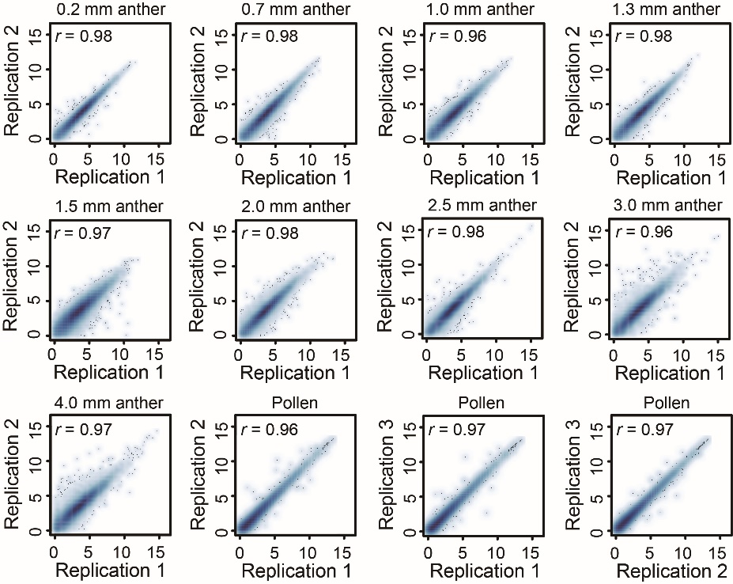
Figure S1. Correlation analysis of gene expression levels between replicates. Samples at each anther stage have two or three biological replicates. We calculated the expression levels (FPKM) for each gene in each replicate, separately and then analyzed the correlation coefficient between every two replicates by using Log₂ (FPKM+0.01) strategy.
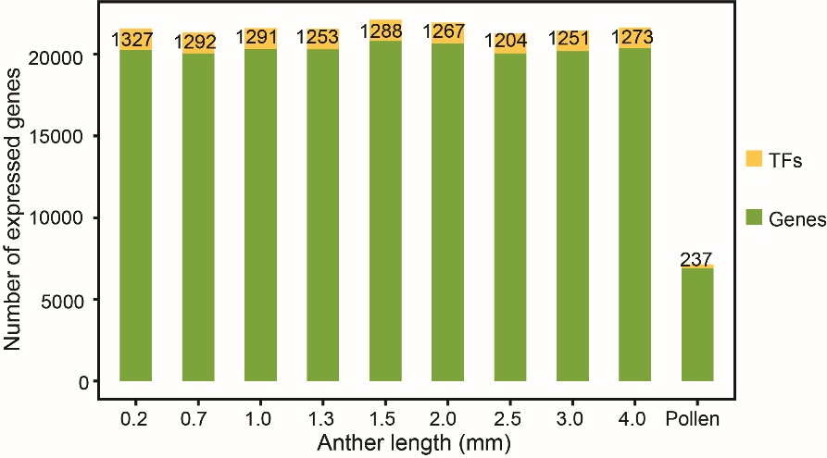
Figure S2. The number of genes expressed among different samples. The histogram exhibits the number of TFs (yellow) and non-TF genes (green), and the number of TFs were marked. Only genes with FPKM ≥ 1 were considered.
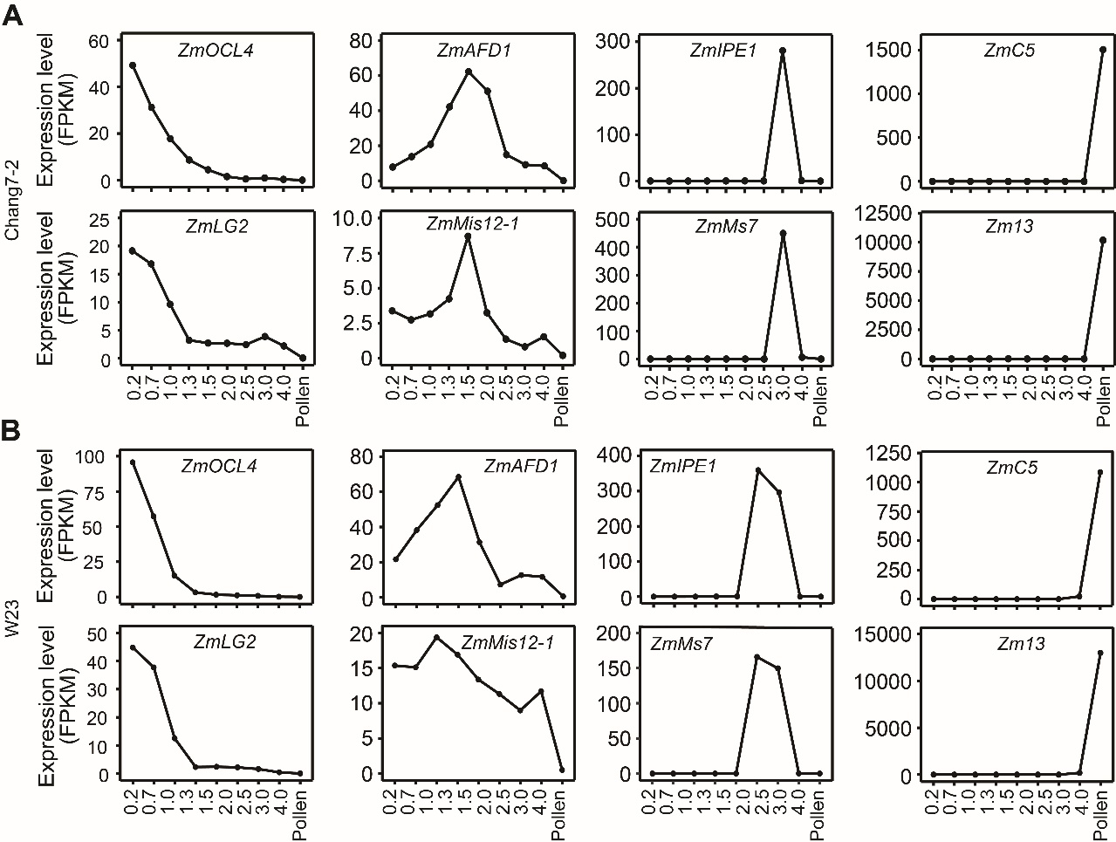
Figure S3. Validation of RNA-seq data with known genes. The expression patterns of known genes preferentially expressed at certain specific stage in both Chang7-2 (A) and W23 (B) during anther development.
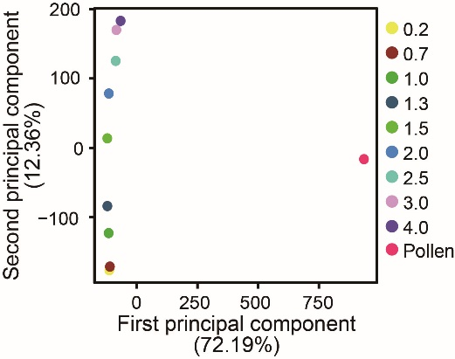
Figure S4. PCA analysis of the transcriptomes of anther and pollen samples. Log₂ (FPKM+0.01) of genes expressed in at least one sample (FPKM ≥ 1) were used for PCA analysis.
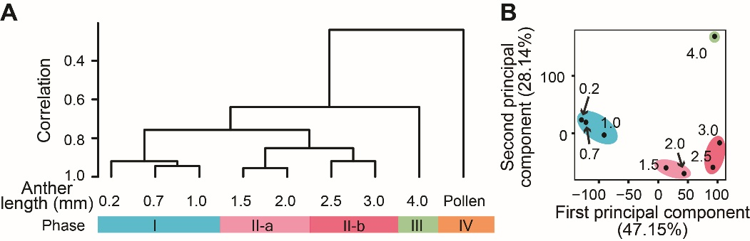
Figure S5. Transcriptome relationships among anther samples from maize W23 inbred line. The hierarchical clustering (A) and PCA (B) analysis graphically display the developmental phases: cell division and expansion (I: blue), meiosis (II-a: pink; II-b: deep pink), pollen maturation (III: light green), and mature pollen (IV: orange) during anther development in W23, using the same strategy as in Chang7-2.
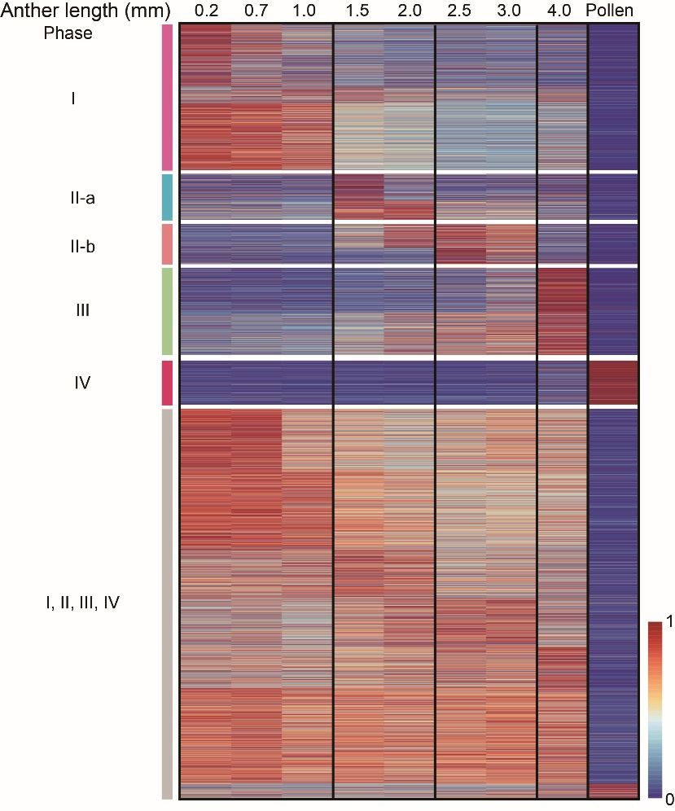
Figure S6. Expression patterns of genes in W23 corresponding to the module genes in Chang7-2. The expressed genes in Chang7-2 anthers displayed pretty similar expression pattern in W23 line as well. The FPKM values of each gene was normalized by the maximum value of all FPKM values of the gene over ten development stages, and genes were displayed in the same order of Chang7-2.

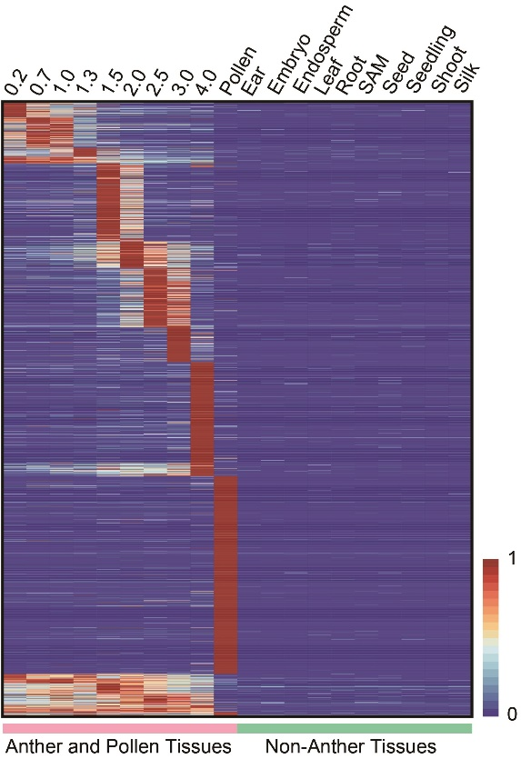
Figure S7. Expression patterns of anther-specific genes in different staged anthers and non-anther tissues. Expression levels of anther samples and non-anther samples were normalized using Log₂ (FPKM+1), and then were converted into z-score values. Only genes, with z-score > 3 in at least one anther sample, were regarded as anther-specific-expressed genes. The FPKM values of each gene displayed was normalized by the maximum value of all FPKM values of the gene over 10 development stages.
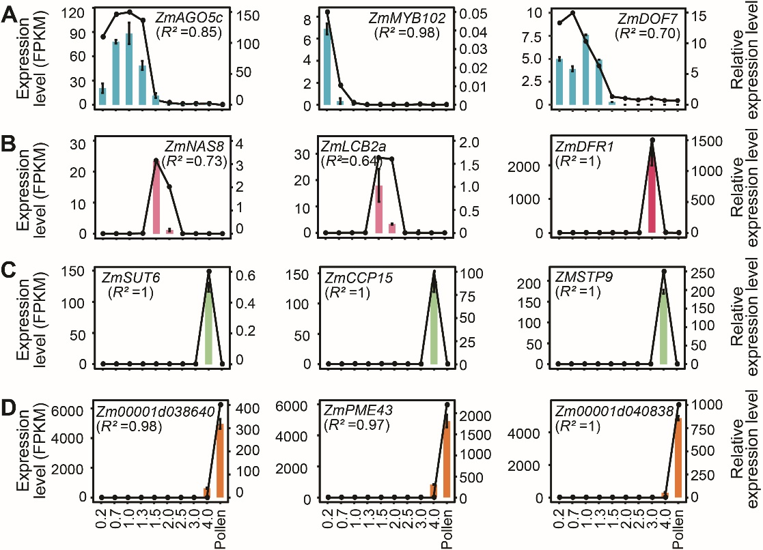
Figure S8. Expression patterns for genes randomly selected from the following phases: cell division and expansion (A), meiosis (B), pollen maturation (C), and mature pollen (D). Expression level assessed with RT-qPCR (histograms) and RNA-seq (line charts). Relative expression levels based on RT-qPCR were the average value for three replicates, and error bars represent SD. The FPKM values from RNA-seq data represent the expression levels for marker genes.

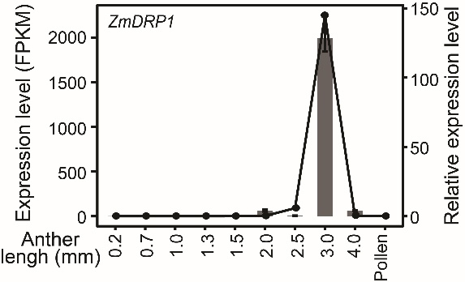
Figure S9. Expression patterns of ZmDRP1 across anther development based on RNA-seq data (FPKM) and RT-qPCR. Expression patterns for specific-expressed genes randomly selected from different development phases. Expression patterns for genes are assessed with RT-qPCR (histograms) and RNA-seq (line charts). Relative expression levels based on RT-qPCR were the average value for three replicates, and error bars represent SD.
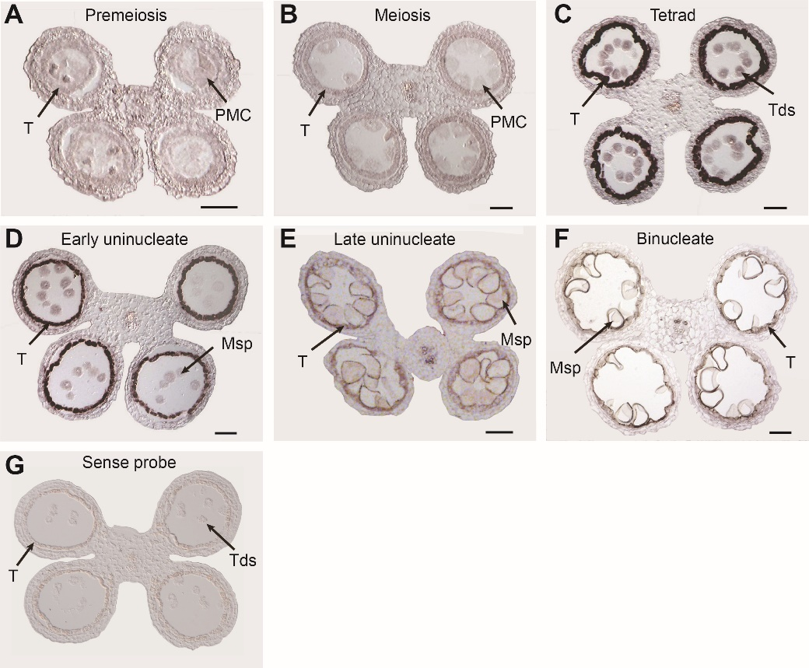
Figure S10. RNA in situ hybridization of ZmDRP1 in maize anthers across different developmental stages. A strong hybridization signal was detected in the tapetum at the tetrad stage (C) as well as the early (D) and late (E) uninucleate microspore stages. The signal was not observed during the premeiotic stage (A), meiosis (B) and binucleate microspore (F) stages. Sense probe was utilized as negative controls for ZmDRP1 at the tetrad stage (G). T, tapetum; PMC, pollen mother cell; Tds, tetrads; Msp, microspore. Bars = 100 µm.
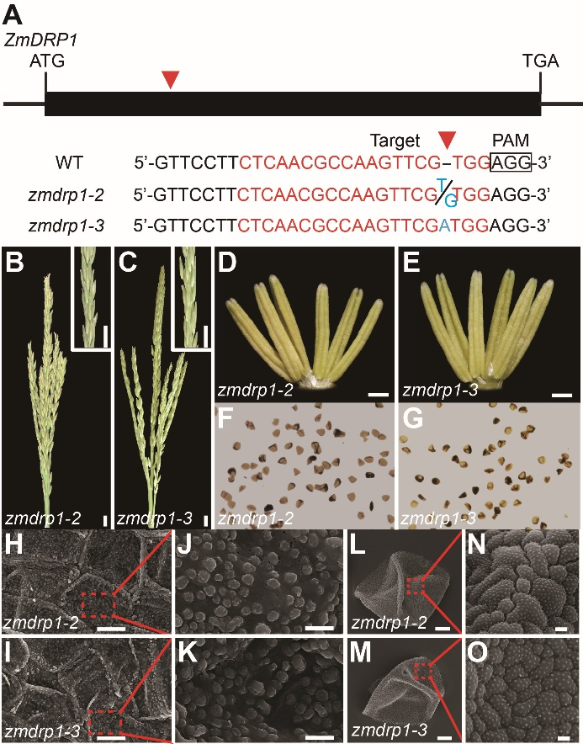
Figure S11. Characterization of zmdrp1-2 and zmdrp1-3 mutants. (A) Schematic diagram of the ZmDRP1 gene and the sequences of the two CRISPR-Cas9-generated mutant alleles. Exons is depicted as black rectangles. The red arrowhead indicates the position of the mutation. A single-base insertion caused frame-shift mutations and resulted in loss of function of ZmDRP1 gene. The 20 bp CRISPR/Cas9 target sequence adjacent to the protospacer adjacent motifs (PAMs) are indicated in red. The zmdrp1-2 and zmdrp1-3 mutants contain a 1bp insertion of G or A (blue), respectively. (B-G). The tassels (B, C), anthers (D, E), and pollen grains (F, G) stained with I₂-KI of zmdrp1-2 (B, D, F) and zmdrp1-3 (C, E, G). The phenotypes in b to g were observed at least three times independently with similar results. Scale bars, 1 cm (B, C), 1 mm (D, E) and 0.1 mm (F, G). (H-O). Scanning electron micrograph analysis of zmdrp1-2 (H, J, L, N) and zmdrp1-3 (I, K, M, O) inner surfaces of anther (H, I), their enlargement (J, K), mature pollen grains (L, M) and outer surfaces of pollen grains (N, O), Scale bars, 10 µm (H, I, L, M), 2 µm (J, K) and 1 µm (N, O).
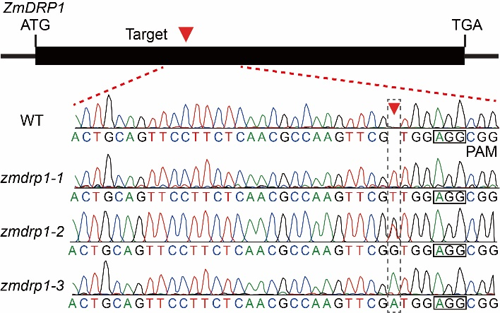
Figure S12. The Sanger sequencing chromatograms of ZmDRP1 gene in wide-type and three zmdrp1 mutant lines at the target sites. Exons is depicted as black rectangles. The red arrowhead and black dotted box indicate the position of the mutation. The protospacer adjacent motifs (PAMs) are indicated in black boxes.
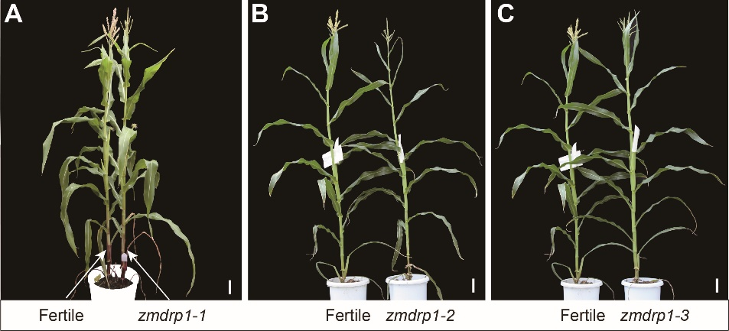
Figure S13. Morphological comparisons between the wild-type and zmdrp1 mutants. No significant difference was observed between the wild-type, zmdrp1-1(A), zmdrp1-2 (B) and zmdrp1-3 (C) at the tasseling stage. Bars=10 cm.
Supplemental Tables
Table S1. Summary of newly generated RNA-Seq data in this study.
Table S2. The FPKM and raw read counts of every gene in different anther sample replicates.
Table S3. Gene expression values (FPKM) in different anther samples.
Table S4. List of transcription factors expressed in different anther samples.
Table S5. Expression patterns of genes in maize related to anther development.
Table S6. The list of anther-specific genes identified in this study.
Table S7. The phase-specific genes identified during maize anther development.
Table S8. The number of co-expressed TFs and phase-specific TFs detected in different development phases of maize anther.
Table S9. List of primers used in this study.
Table S10. Gene names and their corresponding gene IDs.

