Supporting Information
Single-cell RNA sequencing reveals a high-resolution cell atlas of xylem in Populus

Hui Li^{1†}, Xinren Dai^{1†}, Xiong Huang^{1,2}, Mengxuan Xu¹, Qiao Wang^{1,2}, Xiaojing Yan¹, Ronald R. Sederoff³, Quanzi Li¹
- State Key Laboratory of Tree Genetics and Breeding, Chinese Academy of Forestry, Beijing 100091, China
- Research Institute of Forestry, Chinese Academy of Forestry, Beijing 100091, China
- Forest Biotechnology Group, Department of Forestry and Environmental Resources, North Carolina State University, Raleigh, NC 27695, USA
† These authors contributed equally to this work.
Correspondence: Quanzi Li (liqz@caf.ac.cn)

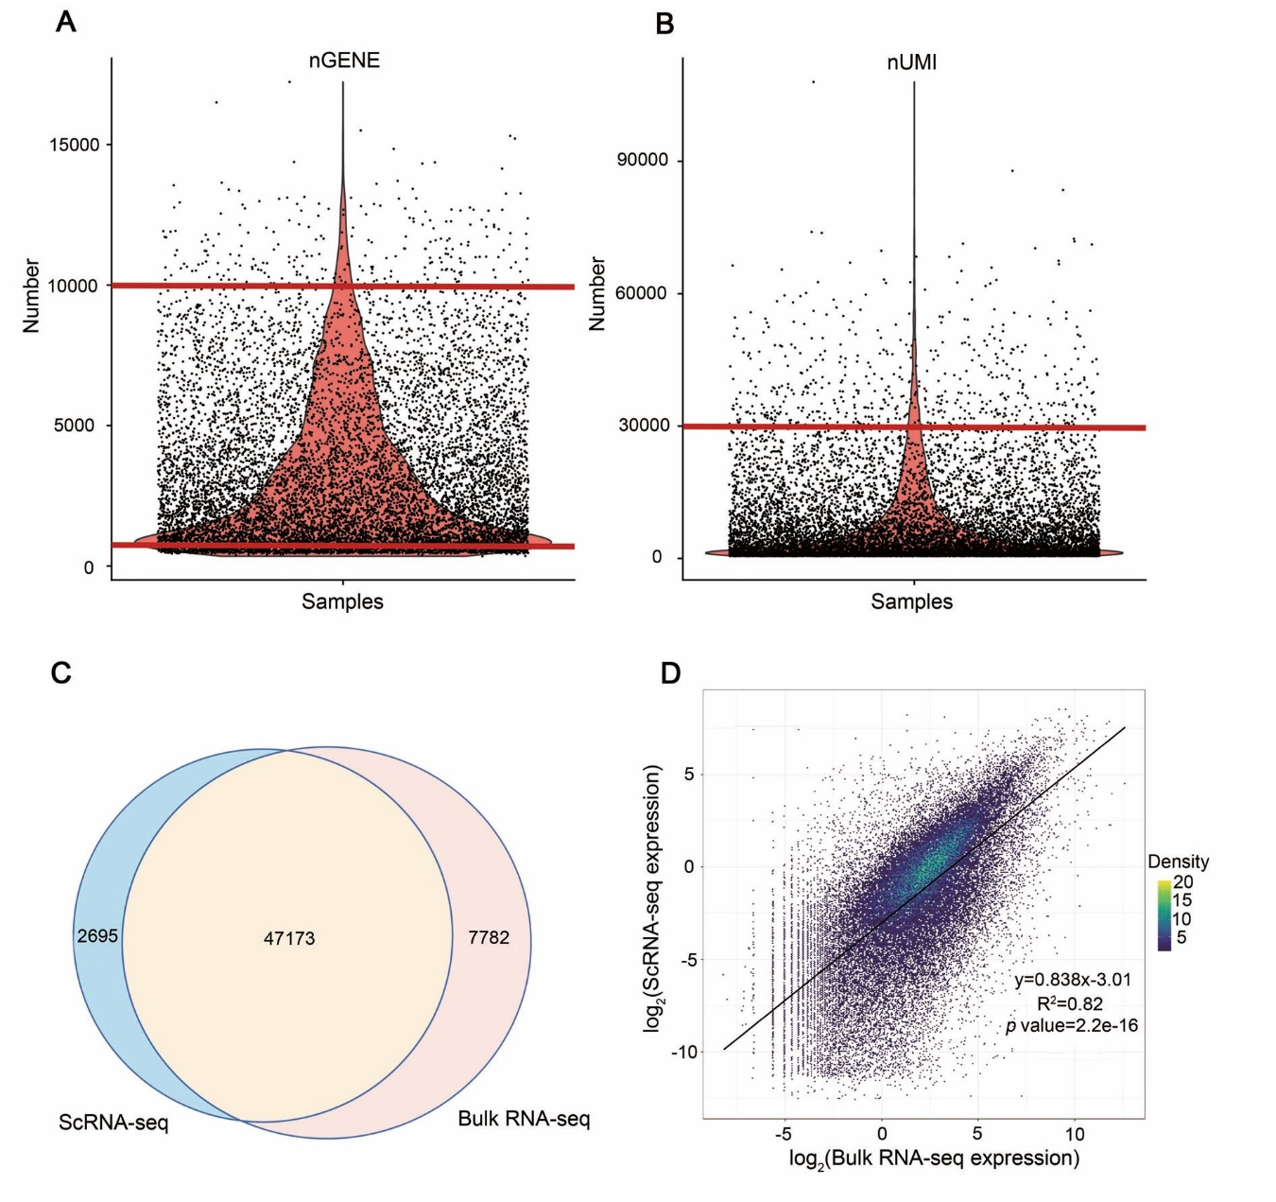
Figure S1. Quality control of scRNA-seq
(A) Cells with gene numbers from 500 to 10,000 were retained. The cells with fewer than 500 genes are considered low quality, and the cells with more than 10,000 genes are likely to be two or more cells in one drop. (B) Cells with 30,000 UMIs were retained. The cells with UMI numbers more than 30,000 are likely two or more cells in one drop. (C) Venn diagram of gene comparison between scRNA-seq and RNA-seq. 83.5% of the transcripts obtained from single cell sequencing are found in unfractionated differentiating xylem. (D) Pearson correlation analysis. Each point represents a unique gene. The bulk xylem RNA-seq was from three biological replicates.

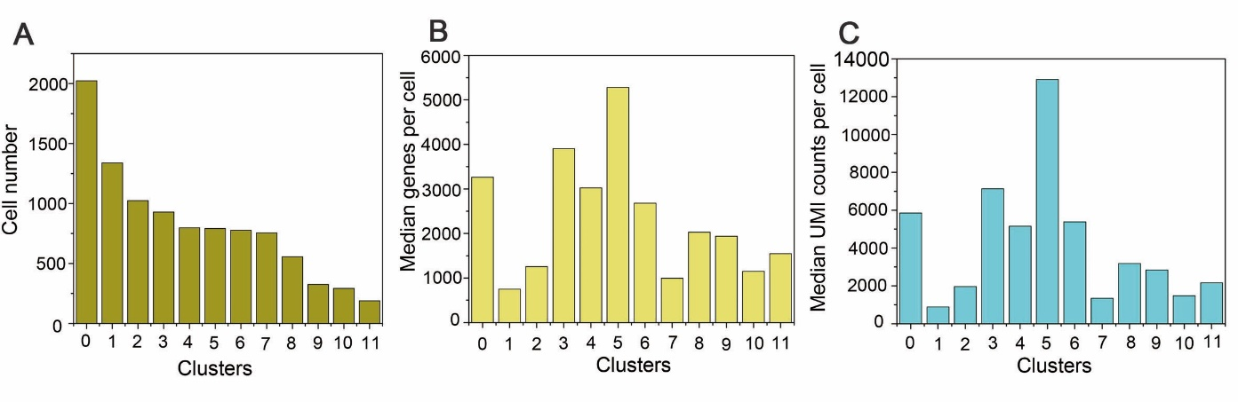
Figure S2. Distribution of related index in each cluster
(A) Cell numbers. (B) Median genes per cell. (C) Median UMI counts per cell.

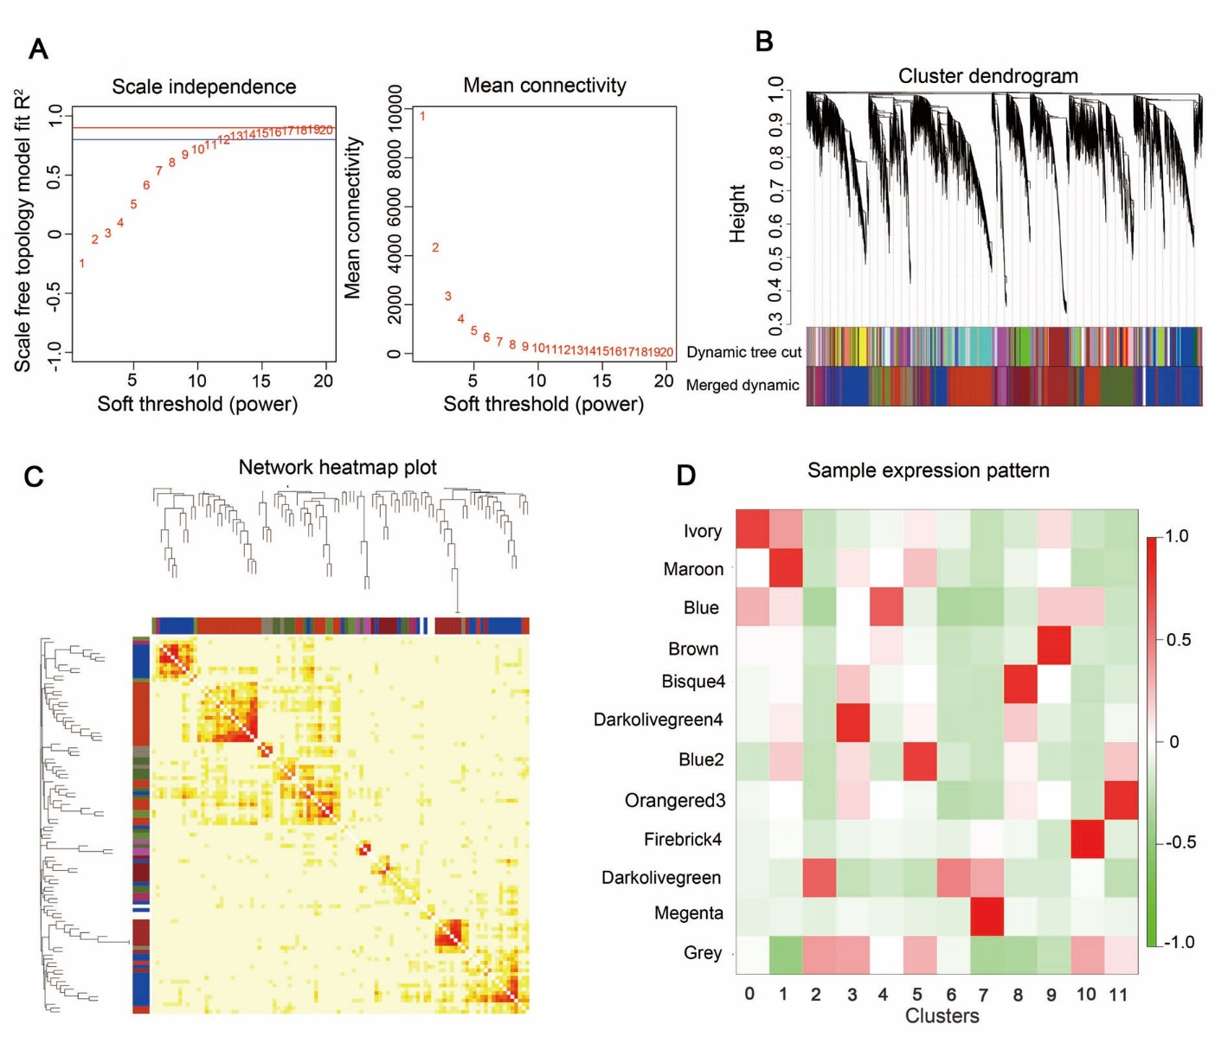
Figure S3. WGCNA analysis of 12 clusters
(A) Selection process of a soft threshold. (B) Classification process of modules. (C) Gene expression heatmap in different modules. (D) Correlation heat map between different modules and clusters. Green color means low correlations, and red color means high correlations.

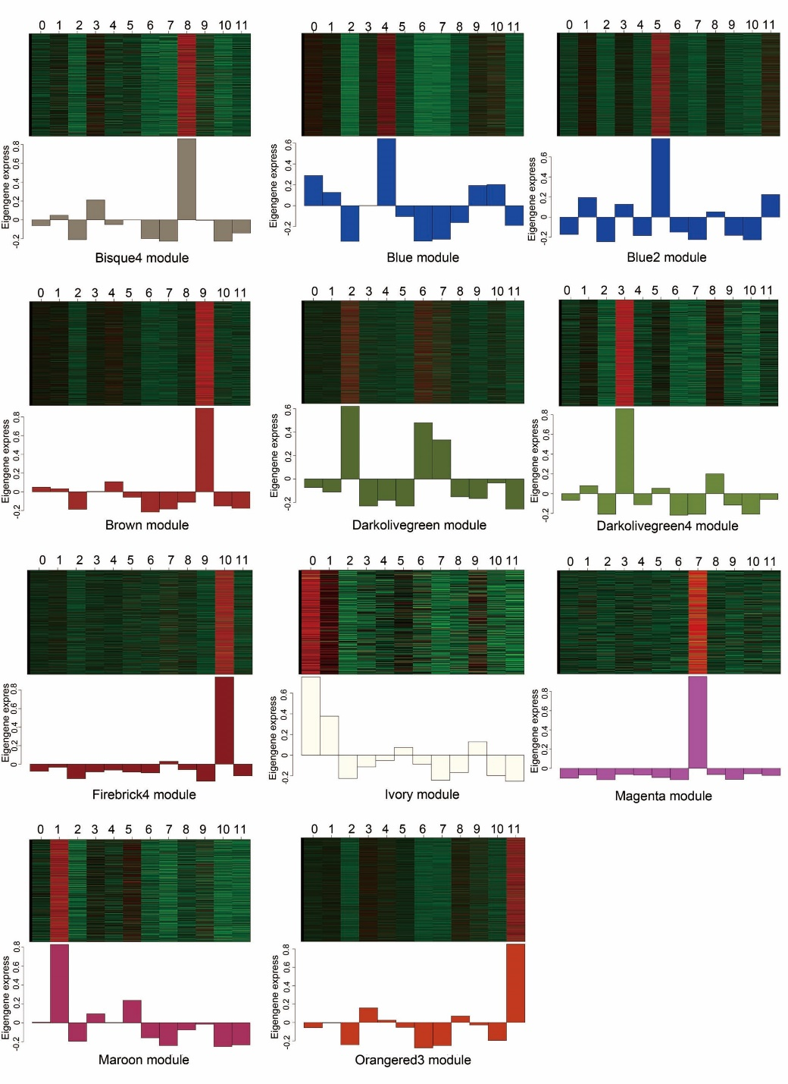
Figure S4. Gene expression heatmap in different modules
The heatmaps show gene expression patterns in different clusters. Green color in heatmaps means downregulation, and red color in heatmaps means upregulation. Histograms represent eigenvalue of modules in different clusters.

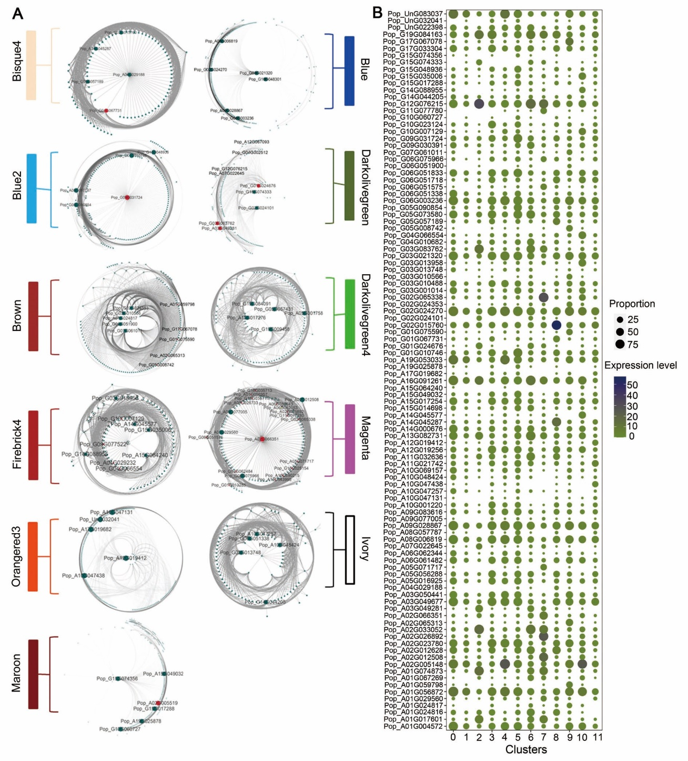
Figure S5. Gene co-expression network within 12 clusters
(A) Rectangles with different colors represent different modules. Big points represent hub genes in the network. Red color means wood formation related-genes. (B) OliveDrab and MidnightBlue color represent low expression level and high expression level of corresponding genes respectively; Point size represent expressed proportion of corresponding gene in all of cells. The top 1,000 coexpression relationships are shown in each module.

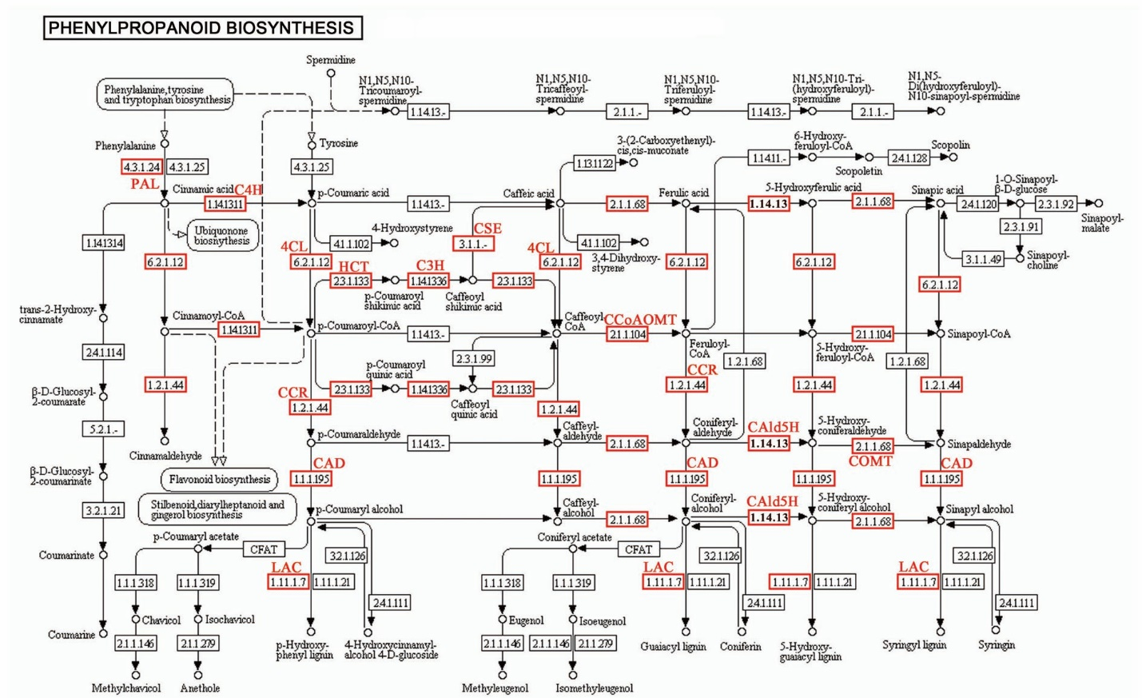
Figure S6. Enriched lignin biosynthesis by KEGG analysis
In the phenylpropanoid biosynthetic pathway (ko00940), the enriched genes (highlighted in red) encode all the enzymes necessary for lignin biosynthesis.

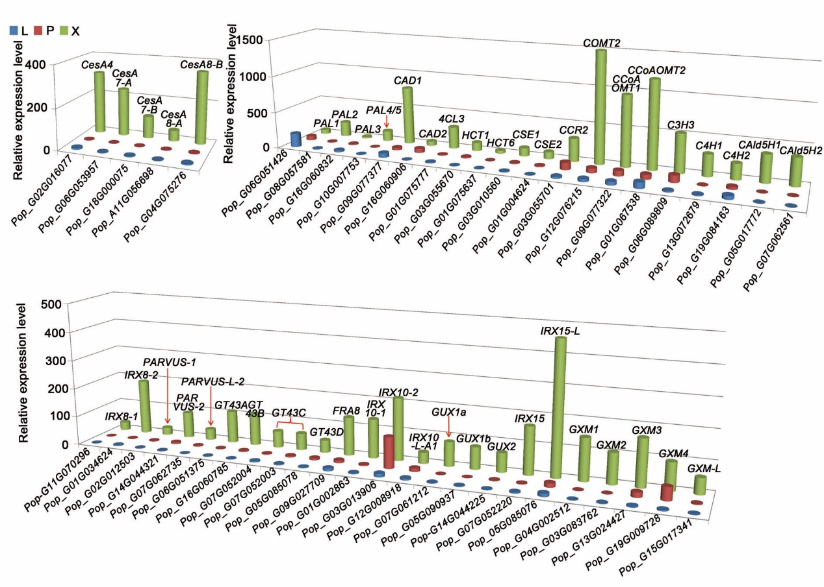
Figure S7. Transcript abundances of SCW pathway genes in differentiating xylem of P. alba × P. glandulosa
(A) Five cellulose synthase A (CesA) genes for cellulose biosynthesis. (B) Seven genes in xylan biosynthesis, including IRX8-1, -2, PARVUS-1, -2, -L-2, GT43A, B, C, D, FRA8, IRX10-1, -2, -L-A1, GUX1a, 1b, and GUX2. (C) Twenty genes for monolignol biosynthesis, including phenylalanine ammonia-lyase genes PAL1, PAL2, PAL3 and PAL4/5, cinnamyl alcohol dehydrogenase genes CAD1 and CAD2, p-coumarate CoA ligase gene 4CL3, hydroxyl cinnamoyl transferase genes HCT1 and HCT6, caffeoyl shikimate esterase genes CSE1 and CSE2, cinnamoyl-CoA reductase gene CCR2, caffeic acid O -methyltransferase gene COMT2, caffeoyl-CoA O-methyl transferase genes CCoAOMT1 and CCoAOMT2, p-coumaroyl-CoA 3-hydroxylase gene C3H3, cinnamate 4-hydroxylase genes C4H1 and C4H2, ferulate/coniferaldehyde 5-hydroxylase genes CAld5H1 and CAld5H2.

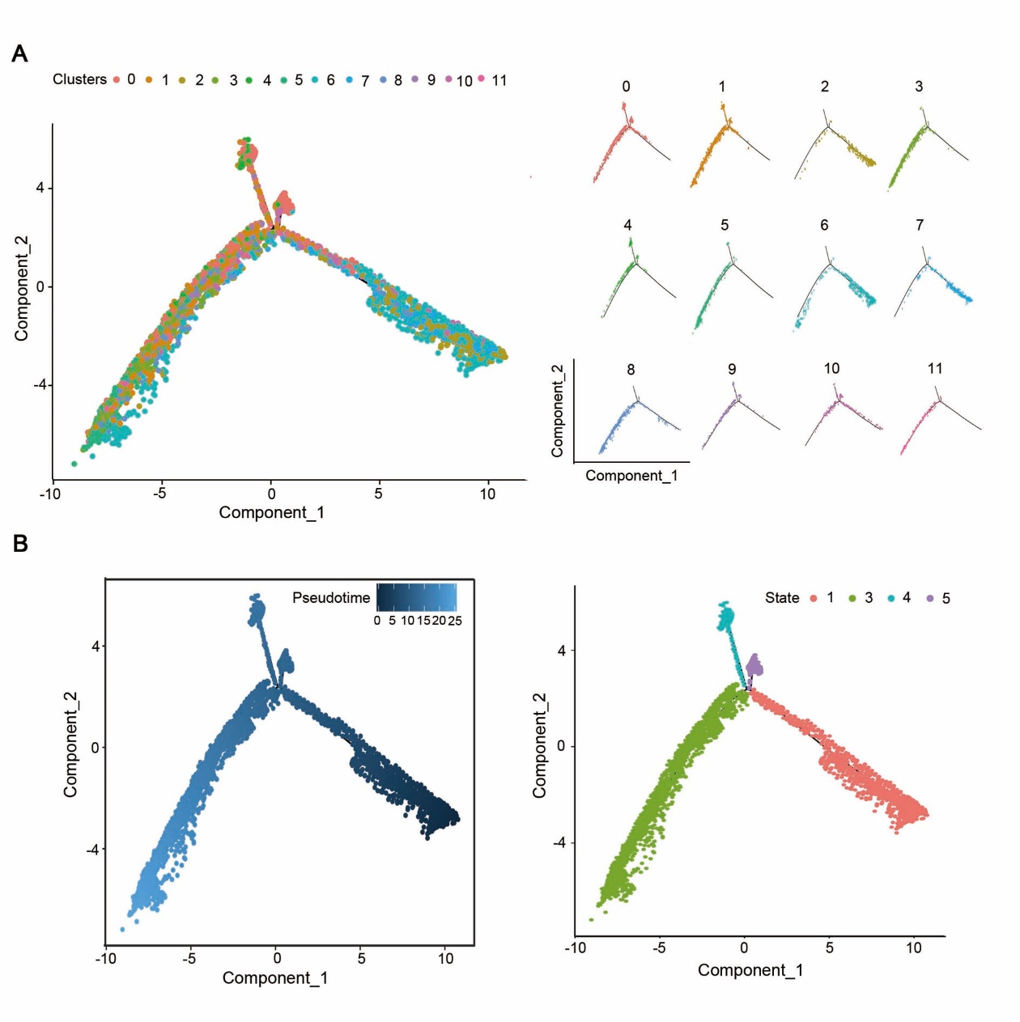
Figure S8. Pseudotime trajectory analysis for 12 clusters
(A) Distribution of 12 clusters along differential trajectory. Each dot represents a single cell, and different color depicts different clusters. (B) Trajectory was divided in 4 states. Each dot represents a single cell, and different color depicts different states.

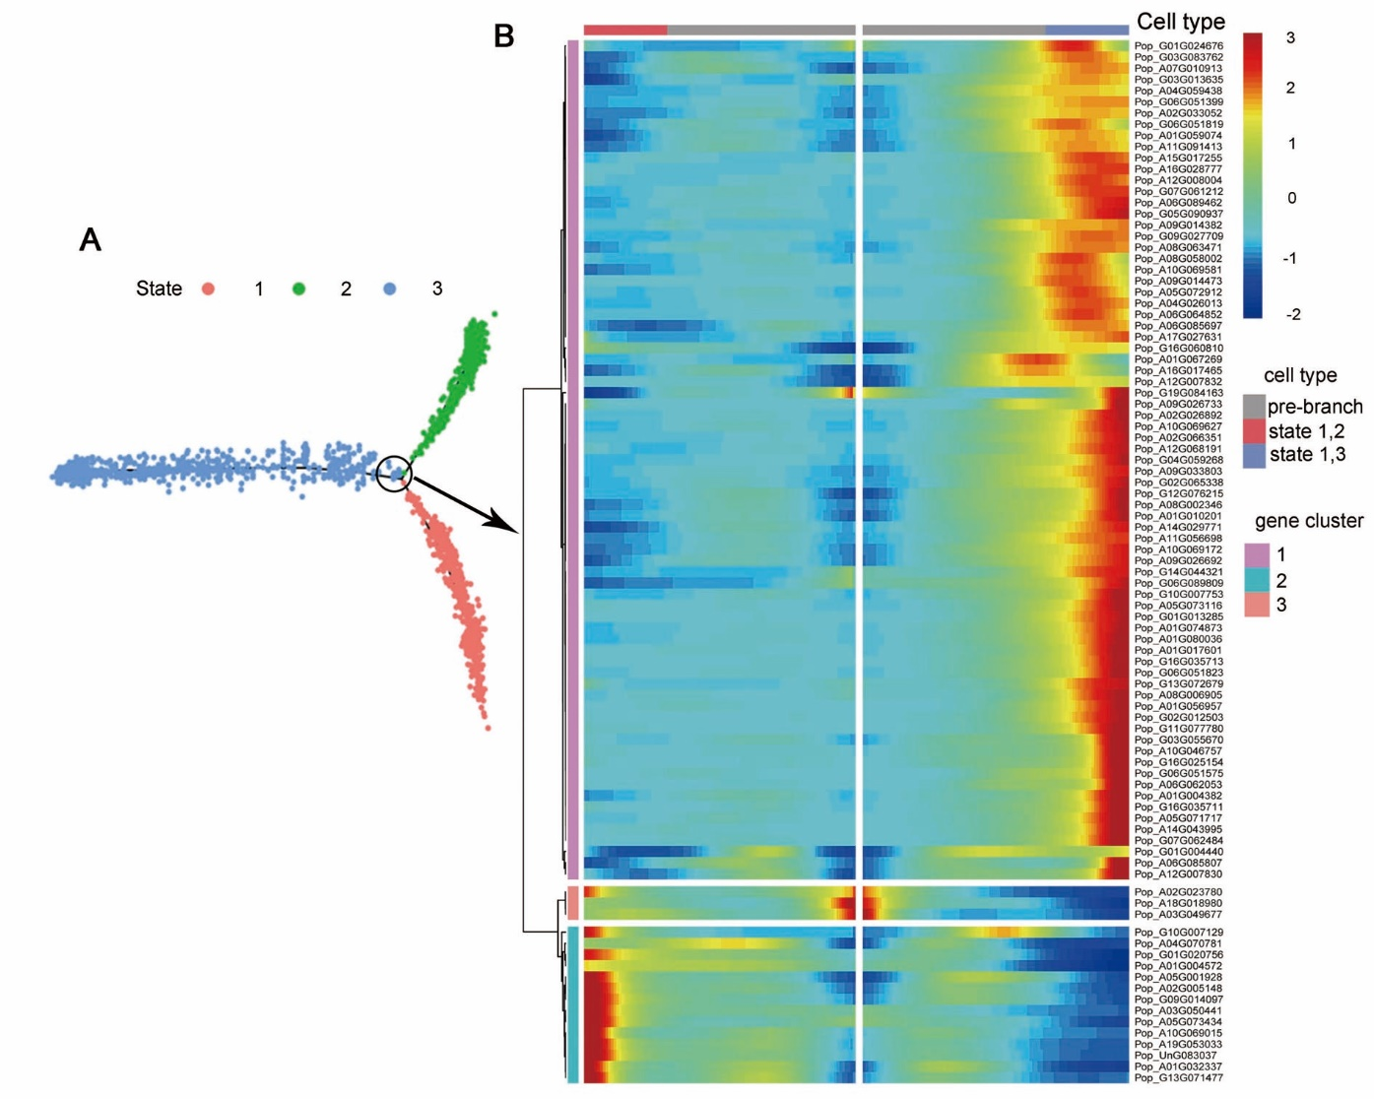
Figure S9. DEGs at branch point along vessel differentiation trajectory
(A) Three states were generated along the trajectory using the cells from Xpc, VeI and VeII. Different colors represent different differentiation states of the cells. (B) Branch heatmap for wood formation-related genes along trajectory. Pseudotime increases from middle to two sides along X-axis. Blue and red colors represent low and high gene expression levels, respectively.

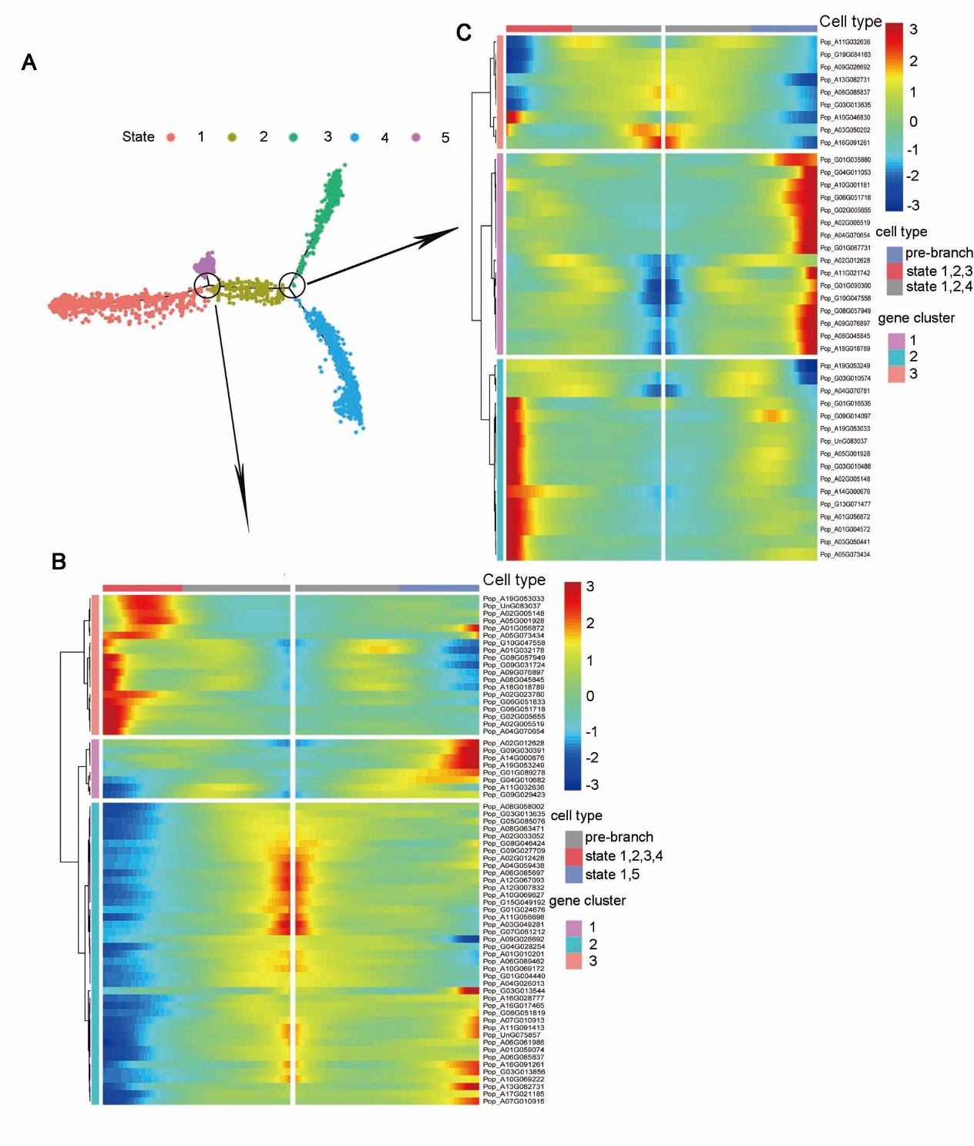
Figure S10. DEGs at branch point along fiber cell differentiation trajectory
(A) Five states were generated along trajectory using the cells of Xpc, FRpc, FcI and FcII. Different colors represent different differentiation states of the cells. (B, C) Branch heatmaps for wood formation-related genes along trajectory. Pseudotime increases from middle to two sides along X-axis. Blue and red colors represent low and high gene expression levels, respectively.

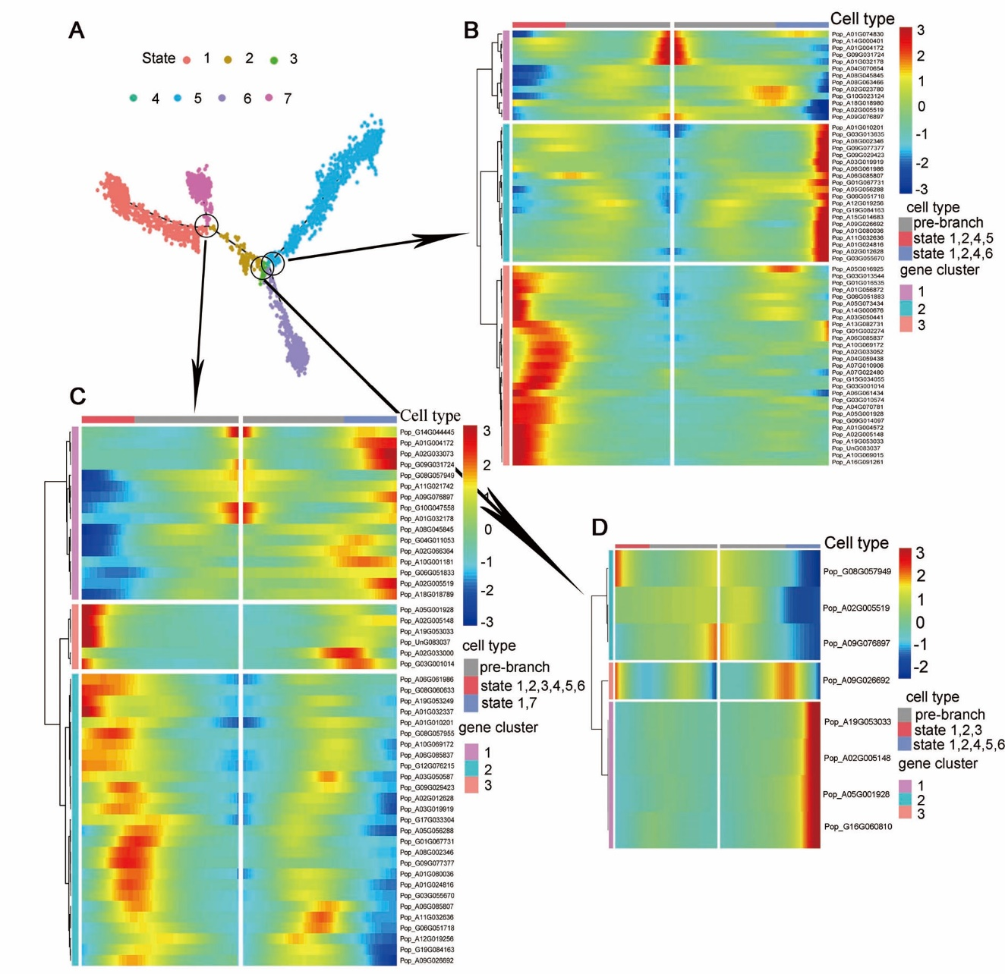
Figure S11. DEGs at branch point along ray cell differentiation trajectory.
(A) Seven states were generated along the trajectory using the cells from Xpc, FRpc, RcI, RcII and RcIII. Different colors represent different differentiation states of the cells. (B-D) Branch heatmaps for wood formation-related genes along trajectory. Pseudotime increases from middle to two sides along X-axis. Blue and red colors represent low and high gene expression levels, respectively.

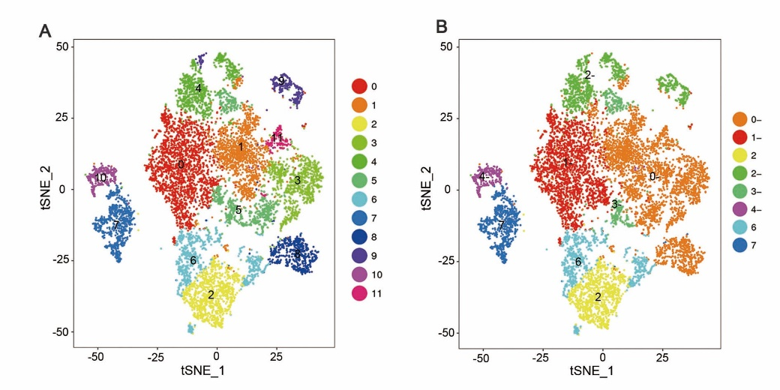
Figure S12. Cluster analysis using the cells from the 9 clusters that do not have SCW thickening (A) t-SNE plot of all cells, generating 12 clusters 0-11 (also shown in Figure 1). (B) t-SNE plot of the cells from 9 clusters 0, 1, 3, 4, 5, 8, 9, 10 and 11, generating 5 clusters 0’-4’. Cluster 2, 6 and 7 are also included in the figure. Clusters are shown in different colors, and each dot represents a single cell. Comparison A and B shows that cluster 0’ is the sum of clusters 1, 3, 8, 11 and partial 5 (38.43%), cluster 1’ is matching cluster 0, cluster 2’ is sum of clusters 4 and 9, cluster 4’ is matching cluster 10, cluster 3’ matching half of cluster 5 (Dataset S10).

Table S1. Basic statistics information of scRNA-seq results

Index | Number
Number of Reads | 400,645,657
Number of cells | 9,798
Median UMI Counts per Cell | 3,673
Number of identified genes | 50,762
Median Genes per Cell | 2,190
Valid Barcodes | 97.0%
Q30 Bases in Barcode | 95.8%
Q30 Bases in RNA Read | 90.2%
Q30 Bases in UMI | 95.3%
Reads Mapped Confidently to Genome | 83.3%

