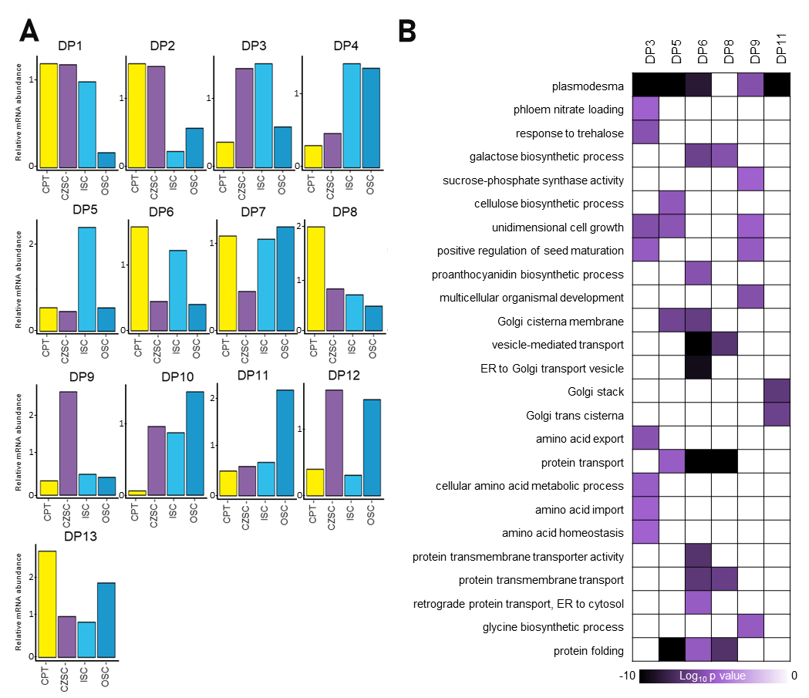

Figure S1.Gene expression and GO term analysis of maternal subregions in the B. napus globular seed. (A)Fuzzy K means clustering analysis of maternal subregions (data from the Fuzzy K means clustering areantilog₂ transformed). (B)GO term enrichmentof selected fuzzy K means clustering patterns (DPs).

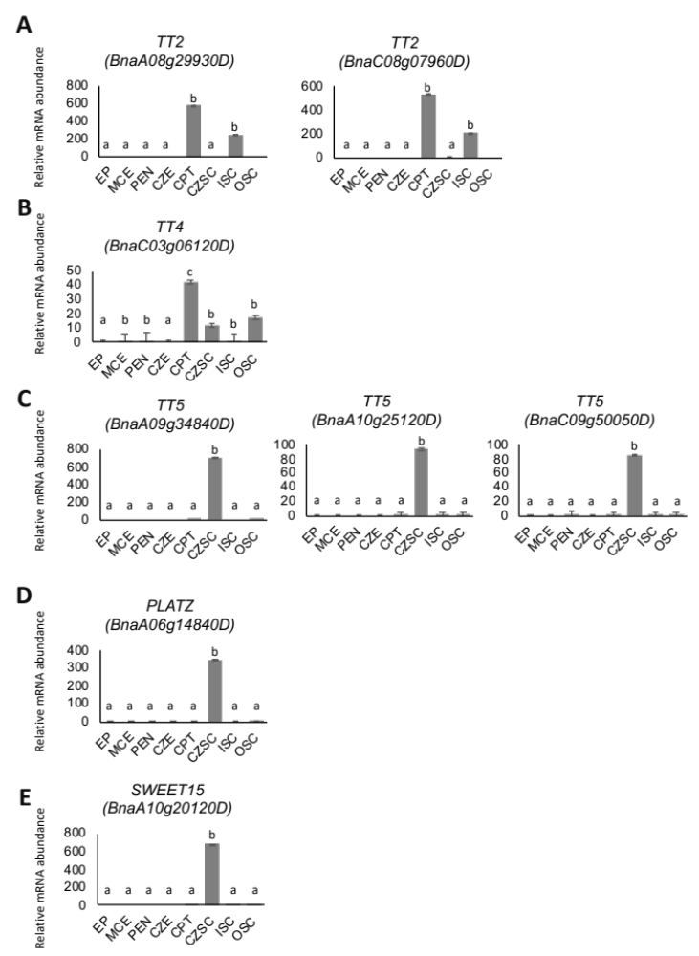
Figure S2. Relative abundance of transcripts found in the globular stage B. napusseed. Key transcription factors and target genes were selected from the networks presented in Figure 4. TRNASPARENT TESTA 2(A) and its putative targets TRANSPARENT TESTA 4(B)and TRANSPARENT TESTA 5(C)were selected from Figure 4A, which represents a regulatory network predicted in maternal subregion-enriched transcripts. PLATZ(D)and its putative target SWEET15(E)were chosen from Figure 4B, which represents a regulatory network predicted in the CZSC.Letters indicate significant differences as determined by ANOVA and Student’s t-test (p<0.05).

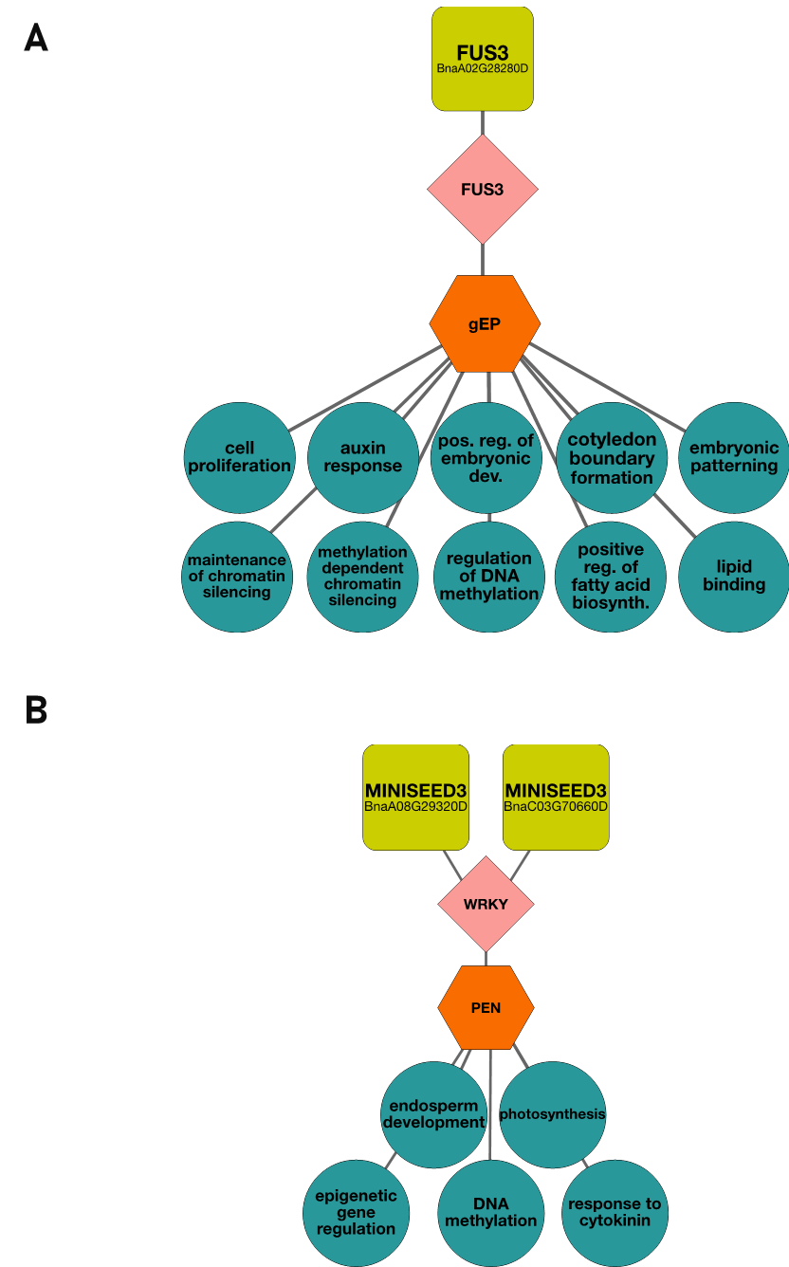

Figure S3. Predictive transcription factor networksof filialsubregions of the B. napus seed. (A) a predicted EP-specificFUS3network. (B) a predicted PEN-specific WRKY transcription factor network.

