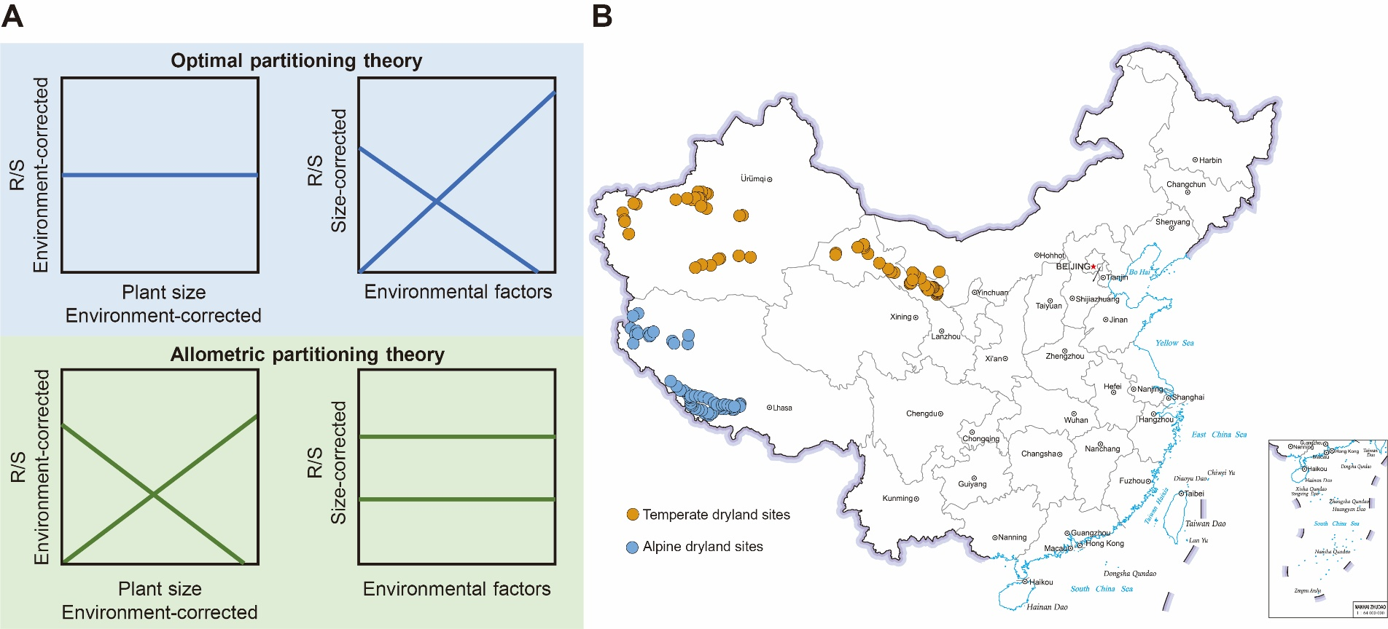
Figure S1. Conceptual framework and study site distribution
(A) A conceptual diagram illustrating the contrasting predictions of the optimal partitioning theory (OPT) and the allometric partitioning theory (APT) for biomass allocation patterns. The diagram shows the expected relationships after statistically controlling for confounding effects. OPT is supported if two conditions are met: the environment-corrected R/S is independent of environment-corrected plant community size, and concurrently, the size-corrected R/S shows a significant relationship with environmental factors. APT is supported if the environment-corrected R/S shows a significant relationship with environment-corrected plant community size, and concurrently, the size-corrected R/S is independent of environmental factors. (B) Geographic location of the 120 sampling sites across temperate and alpine drylands in northern China. The approval number of the map: GS(2019)1676.
Figure S2. Initial conceptual structural equation model.
MAT, mean annual temperature; MAP, mean annual precipitation; SNC, soil nitrogen content; Sand, soil sand content; R/S, root: shoot ratio.

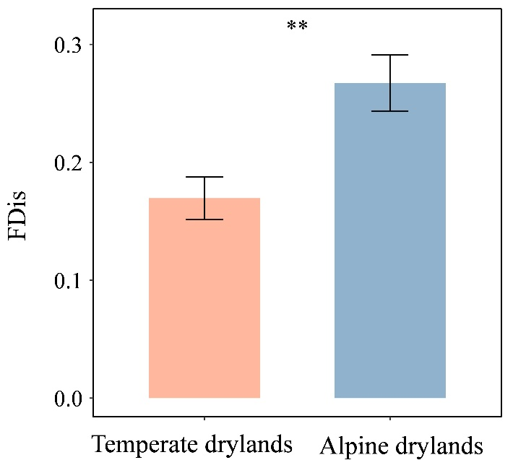
Figure S3. Functional dispersion comparison across dryland types.
Orange represents temperate drylands and blue represents alpine drylands. Significance level: **P < 0.01. Functional trait measurements: following vegetation surveys, we sampled and measured leaf functional traits for dominant species (representing > 90% of total plot biomass) using standardized protocols (Perez-Harguindeguy et al., 2013). We focused on four key traits: Height, specific leaf area, leaf dry matter content, leaf thickness, leaf carbon content and leaf nitrogen content (Reich, 2014; Zuo, et al., 2018). FDis was calculated as the mean distance of individual species to the centroid of the community in multidimensional trait space.

Table S1. Theoretical rationale and supporting evidence for the hypothesized pathways included in the initial structural equation model
NO. | Associations | Rationale
01 | MAT → SNC | Warming enhances microbial activity, accelerating nitrogen mineralization and increasing soil inorganic nitrogen availability, while simultaneously promoting nitrogen losses through leaching and gaseous emissions (Bai, et al., 2013; Yang, et al., 2011).
02 | MAT → Sand | Climate change has a destabilizing effect on soils, affecting the stability of soil aggregate structure, which in turn alters the particle composition of soil aggregates (Joseph & Henry, 2008).
03 | MAT → Plant community size | Climate warming significantly alters plant community size through temperature-mediated shifts in species composition and dominance patterns, with the direction of change depending on ecosystems (Shao, et al., 2022; Wangchuk, , et al., 2021).
04 | MAT → R/S | Elevated temperatures tend to reduce R/S across diverse plant species and ecosystems, with this negative relationship being particularly evident under warmer climatic conditions (Mokany, et al., 2006).
05 | MAP → SNC | Increased precipitation enhanced soil nitrogen turnover by elevating soil moisture and altering plant traits (Song, et al., 2024).
06 | MAP → Sand | Precipitation directly alters soil texture by modifying moisture dynamics and driving physical processes (e.g., raindrop impact, leaching, and clay dispersion), which collectively influence the relative proportions of sand, silt, and clay particles in soils (Engelhardt, et al., 2018).
07 | MAP → Plant community size | Increased precipitation significantly enhances plant community size in desert grasslands by improving soil moisture availability and promoting plant species richness (Li, et al., 2024).
08 | MAP → R/S | Mean annual precipitation exhibited a significant negative relationship with root: shoot ratios across terrestrial biomes, suggesting increased water availability promotes greater biomass allocation to shoots relative to roots (Mokany, et al., 2005).
09 | SNC → Plant community size | Along the aridity gradient, SNC showed a strong positive correlation with aboveground plant biomass, where increasing aridity reduced SNC primarily through its negative impact on plant productivity, establishing a critical plant-mediated feedback loop in the nitrogen cycle (Yang, et al., 2011)
10 | SNC→ R/S | Plants optimize growth under elevated nitrogen by reducing R/S, as increased nitrogen availability favors aboveground biomass investment over root maintenance due to improved nitrogen uptake efficiency (Hilbert, 1990)
11 | Sand → Plant community size | Meta-analysis revealed that soil texture critically mediates N-fixers’ facilitation of neighbor plant biomass, with stronger positive effects in fine-textured (clay-rich) soils versus coarse-textured (sandy) soils, likely due to enhanced nitrogen retention and availability in finer substrates (Ortiz & Wolf, 2024).
12 | Sand→ R/S | Both experimental and meta-analytical evidence confirmed that soil texture significantly affects R/S in grassland plants, likely through altered root-soil hydraulic properties (Jia, et al., 2023).
13 | Plant community size →R/S | R/S is primarily regulated by total plant size, independent of environmental conditions (Liu, et al., 2021).

Table S2. Linear mixed model for analyses of R/S and environmental factors
Factor | R/S  (Temperate drylands) |  |  | R/S  (Alpine drylands)
Fixed effects | β | t-value | P | β | t-value | P
MAT | -0.02 | -0.15 | 0.88 | 0.32 | 2.01 | 0.05
MAP | 0.02 | 0.13 | 0.90 | -0.14 | -0.76 | 0.45
Soil pH | -0.16 | -1.21 | 0.23 | 0.05 | 0.30 | 0.77
Sand content | -0.05 | -0.34 | 0.73 | 0.13 | 0.92 | 0.36
Clay content | 0.06 | 0.36 | 0.72 | -0.52 | -0.35 | 0.73
SCC | -0.27 | -1.93 | 0.06 | -0.13 | -0.64 | 0.52
SNC | -0.36 | 2.28 | * | 0.20 | 0.91 | 0.37
Note: MAT, mean annual temperature; MAP, mean annual precipitation; SCC, soil carbon content; SNC, soil nitrogen content. Significance levels: *P < 0.05.

Table S3. Importance values of dominant species in temperate and alpine drylands
Temperate drylands |  | Alpine drylands
Species | Importance value | Species | Importance value
Halogeton glomeratus | 0.40 | Stipa capillata |  | 0.47
Suaeda glauca | 0.35 | Orinus thoroldii |  | 0.33
Phragmites australis | 0.34 | Oxytropis coerulea |  | 0.28
Salsola collina | 0.19 | Stipa orientalis |  | 0.23
Grubovia dasyphylla | 0.13 | Carex moorcroftii |  | 0.22
Stipa capillata | 0.12 | Stellera chamaejasme |  | 0.13
Artemisia gmelinii | 0.06 | Cyperus compressus |  | 0.12
Agriophyllum pungens | 0.06 | Chamaerhodos erecta |  | 0.11
Corispermum hyssopifolium | 0.05 | Potentilla chinensis |  | 0.11
Zygophyllum mucronatum | 0.04 | Leymus secalinus |  | 0.11

References
Bai, E., Li, S., Xu, W., Li, W., Dai, W., & Jiang, P. (2013). A meta-analysis of experimental warming effects on terrestrial nitrogen pools and dynamics. New Phytologist, 199 (2), 441-451. https://doi.org/10.1111/nph.12252
Engelhardt, I. C., Welty, A., Blazewicz, S. J., Gallegos-Graves, L., Simmons, B., & Banfield, J. F. (2018). Depth matters: Effects of precipitation regime on soil microbial activity upon rewetting of a plant-soil system. ISME Journal, 12(4), 1061–1071. https://doi.org/10.1038/s41396-018-0079-z
Hilbert, D. W. (1990). Optimization of plant root: Shoot ratios and internal nitrogen concentration. Annals of Botany, 66(1), 91-99. https://doi.org/10.1093/oxfordjournals.aob.a088005
Jia, J., Li, C., & Chang, Z. (2023). Soil texture rather than water potential determines the root:shoot ratio in ryegrass and alfalfa. Journal of Soil Science and Plant Nutrition, 23(3), 1297-1305. https://doi.org/10.1007/s42729-022-01121-2
Joseph, G., & Henry, H. A. L. (2008). Soil nitrogen leaching losses in response to freeze–thaw cycles and pulsed warming in a temperate old field. Soil Biology & Biochemistry, 40(7), 1947-1953. https://doi.org/ 10.1016/j.soilbio.2008.04.007
Li, X., Hu, Y., Song, Z., Cong, P., Cheng, H., Zheng, X., Song, W., Yue, P., Wang, S., & Zuo, X. (2024). Precipitation-induced biomass enhancement and differential allocation in Inner Mongolia's herbaceous and shrub communities. Science of the Total Environment, 176483. https://doi.org/10.1016/j.scitotenv.2024.176483
Liu, R., Yang, X., Gao, R., Hou, X., Huo, L., Huang, Z., & Cornelissen, J. H. C. (2021). Allometry rather than abiotic drivers explains biomass allocation among leaves, stems and roots of Artemisia across a large environmental gradient in China. Journal of Ecology, 109(3), 1026-1040. https://doi.org/10.1111/1365-2745.13532
Mokany, K., Raison, R. J., & Prokushkin, A. S. (2005). Critical analysis of root:shoot ratios in terrestrial biomes. Global Change Biology, 12(1), 84-96. https://doi.org/10.1111/j.1365-2486.2005.001043.x
Mokany, K., Raison, R. J., & Prokushkin, A. S. (2006). Critical analysis of root: shoot ratios in terrestrial biomes. Global Change Biology, 12(1), 13-22. https://doi.org/10.1111/j.1365-2486.2005.001043.x
Ortiz, S. K., & Wolf, A. A. (2024). Nitrogen-fixing plants increase soil nitrogen and neighbouring-plant biomass, but decrease community diversity: A meta-analysis reveals the mediating role of soil texture. Journal of Ecology. https://doi.org/10.1111/1365-2745.14402
Perez-Harguindeguy, N., Diaz, S., Garnier, E., Lavorel, S., Poorter, H., Jaureguiberry, P., Bret-Harte, M.S., Cornwell, W.K., Craine, J.M., Gurvich, D.E., Urcelay, C., Veneklaas, E.J., Reich, P.B., Poorter, L., Wright, I.J., Ray, P., Enrico, L., Pausas, J.G., de Vos, A.C., Buchmann, N., Funes, G., Quetier, F., Hodgson, J.G., Thompson, K., Morgan, H.D., ter Steege, H., van der Heijden, M.G.A., Sack, L., Blonder, B., Poschlod, P., Vaieretti, M.V., Conti, G., Staver, A.C., Aquino, S., Cornelissen, J.H.C., 2013. New handbook for standardised measurement of plant functional traits worldwide. Aust J Bot 61, 167–234. https://doi.org/10.1071/BT12225
Shao, J., Zhou, X., van Groenigen, K. J., Zhou, G., Zhou, H., Zhou, L., Lu, M., Xia, J., Jiang, L., Hungate, B. A., Luo, Y., He, F., & Thakur, M. P. (2022). Warming effects on grassland productivity depend on plant diversity. Global Ecology and Biogeography, 31(2), 225-236. https://doi.org/10.1111/geb.13441
Song, Z., Zuo, X., Hu, Y., Wang, H., Zhang, X., Wang, Z., Qiao, J., Liu, L., & Medina-Roldán, E. (2024). Plant functional traits predict soil multifunctionality under increased precipitation and nitrogen addition in a desert steppe. Catena, 108486. https://doi.org/10.1016/j.catena.2024.108486
Wangchuk, K., Darabant, A., Nirola, H., Wangdi, J., & Gratzer, G. (2021). Climate warming decreases plant diversity but increases community biomass in high-altitude grasslands. Rangeland Ecology & Management, 74(1), 1-10. https://doi.org/10.1016/j.rama.2020.11.008
Yang, H., Yuan, Y., Zhang, Q., Tang, J., Liu, Y., & Chen, X. (2011). Changes in soil organic carbon, total nitrogen, and abundance of arbuscular mycorrhizal fungi along a large-scale aridity gradient. Catena, 87(3), 326-330. https://doi.org/10.1016/j.catena.2011.05.009
Zuo, X., Zhang, J., Lv, P., Wang, S., Yang, Y., Yue, X., Zhou, X., Li, Y., Chen, M., Lian, J., Qu, H., Liu, L., Ma, X., 2018. Effects of plant functional diversity induced by grazing and soil properties on above- and belowground biomass in a semiarid grassland. Ecological Indicators 93, 555–561. https://doi.org/10.1016/J.ECOLIND.2018.05.032

