SUPPORTING INFORMATION

Xin Li, Jiahui Zhang, Kathrin Rousk, Yi Jiao, Pu Yan, and Nianpeng He
Key Laboratory of Ecosystem Network Observation and Modeling, Institute of Geographic Sciences and Natural Resources Research, Chinese Academy of Sciences, Beijing, 100101, China
Leaf Multi-dimensional Stoichiometry as a Robust Predictor of Productivity on the Tibetan Plateau

Text S1 Ecosystem Productivity and the Engine Analogy
According to classical physics theory, the power of an engine is primarily determined by the fuel input per unit of time and the engine's performance within that time frame. Additionally, within a given time frame, the total work performed by the engine is also contingent upon its operational duration.

$$\begin{aligned}W=P×T=F_{input}×E_{performance }×T×a\#1\end{aligned}$$
The work done by an engine (W) refers to the conversion of the thermal energy of fuel into mechanical energy, typically determined by the actual power (P) and the operational time of the engine (T). Power (P) represents the speed of the engine's operation and is a crucial metric for assessing engine performance, reflecting how much mechanical work the engine can accomplish in a unit of time. In an abstract sense, both $F_{input}$ (fuel input per unit time) and $E_{performance }$(performance of the engine, the performance of the engine affects the rate of resource release) collectively influence the engine's power.

By leveraging the core principles of engine operation, an analogous three-dimensional framework has been developed based on the formalization of the ecological productivity equation.
$$\begin{aligned}GPP=a×the input of resoources×the rate of resource relese×working time\#2\end{aligned}$$
In the context of a community, $the input of resoources$ is often determined by external factors such as radiation, precipitation, temperature or soil properties. Environmental factors, through their direct and indirect effects on the structure, composition, and functional traits of the entire plant community, play a crucial role in influencing GPP. $the rate of resource relese$ can be effectively characterized using Trait_{density} and Trait_{efficiency.} Trait_{density}, a quantitative trait, reflects the amount of functional traits invested by the standardized community per unit land area to synthesize photosynthetic products. Trait_{efficiency}, an efficiency trait, represents the efficiency with which the community can synthesize photosynthetic products per unit investment of functional traits. Together, they form a muti-dimensional characteristic of functional traits. The concept of $working time$ can be understood as the effective growth period for plants within a specific timeframe. Since plant growth typically occurs during the growing season, the length of the growing season can effectively represent the working time of plants. To improve the overall model, it is essential to introduce a constant ($a$) for calibration and statistical normalization.

In summary, drawing inspiration from the operational principles of an engine, we can analogously conceptualize GPP (GPP).
$$\begin{aligned}GPP=a×E_{i}×{Trait}_{density}×{Trait}_{efficiency}×L_{gs}\#3\end{aligned}$$
refers to the input of energy, often quantified using environmental data such as radiation, temperature, precipitation, or soil properties. In this study, $E_{i}$ can be input in two distinct ways. The first approach involves E_{i} after dimensionality reduction of all environmental factors, including soil parameters (soil N content, soil organic matter content, soil pH), temperature (annual mean temperature, MAT), precipitation (annual total precipitation, MAP), radiation (solar radiation, photosynthetically active radiation, ultraviolet radiation), oxygen partial pressure (PO₂) and so on. The second approach inputs a separate value for the climate factor, MAT or MAP. These two input models are compared to assess how different energy input factors influence the predictive performance of the entire "engine" framework. ${Trait}_{density}$ and ${Trait}_{efficiency}$ signify the quantity and efficiency of functional traits invested per unit area in synthesizing photosynthetic products. In this paper, the ${Trait}_{density}$ and ${Trait}_{efficiency}$of nitrogen and phosphorus are mainly represented (Fig. S5). $L_{gs}$ denotes the length of the growing season. $a$ is a constant for calibration and statistical normalization.

Text S2 Biomass calculation methods
The biomass of herb is obtained by actual field sampling and weighing.
The biomass of trees and shrubs is obtained by biomass equation modeling ((based on species name, diameter at breast height and height data obtained from the field survey), the supplementary Table S8 in (Wang et al., 2015) provided references for calculating the biomass of each plant organ of different species. Moreover, we appealed to another two handbooks (in Chinese) named “Comprehensive Database of Biomass Regressions for China’s Tree Species” (2015) and “Carbon Stocks in Forest Ecosystems in China: Biomass Equations” (2018). They introduced biomass equation modeling in detail and provided biomass equations of plant organs (leaf, branch, trunk, and root) of different species. Especially, for one species with different range of DBH, different parameters were used in equations to ensure the reliability of estimation. Furthermore, the biomass of species without specific equations was calculated using equations of species from the same genera or mixed-species equations, which can also be extracted from the above two handbooks. After obtaining the biomass information of each tree and shrub species, we calculated the community biomass per unit area by the following equation
$$\begin{aligned}B_{i}=\sum_{i=1}^{n}{\sum_{j=1}^{m}{\frac{a_{i,j}D^{b_{i,j}}}{A}}} \#4\end{aligned}$$

$$\begin{aligned}B_{leaf}=\sum_{j=1}^{m}{\frac{a_{leaf,j}D^{b_{leaf,j}}}{A}} \#5\end{aligned}$$
Where $B_{i}$ is the community biomass density in organ (i.e., leaf, branch, and trunk), $B_{leaf}$is the community biomass density in leaf (kg m⁻²). $a_{i,j}$ and $b_{i,j}$ are constants for the organ i of a specific tree or shrub species $j$; and $a_{leaf,j}$and $b_{leaf,j}$ are constants for the above-ground organ (leaf) of a specific tree or shrub species $j$. $A$ is the area (m²) of the sampling plot. $n$ is the number of organs and $m$ is the number of plant species. We calculated the average biomass density of the three plots as the average biomass density of the sampling site.
Text S3 Methods to get GPP from MODIS
1. MODIS GPP Download & Pre-processing
- Software & Tools:
NASA Earthdata Login & AppEEARS web interface (or Reverb)
ArcMap “Multidimension Tools” toolbox
- Detailed Steps:
- Data Retrieval
Log into Earthdata, query MOD17A2H.061 for years 2019–2021, select 8-day composites.
Download HDF files to <###>/MODIS/HDF/.
- Subdataset Extraction
In ArcMap: ArcToolbox → Multidimension Tools → Make NetCDF Raster Layer
Input File: MOD17A2H.A2019001.hdf
Variable: Gpp_500m → outputs a temporary raster layer.
Repeat for Psn_QC_500m.
- Scale‐Factor Application
ArcToolbox → Raster Calculator:
GPP_float = "Gpp_500m" * 0.0001
Output Type: Floating point, saved to <###>/MODIS/Processed/GPP_8day_2019.gdb/GPP_8day_001.
2. Projection Definition & Reprojection
- Software & Tools: ArcMap “Data Management Tools → Projections and Transformations”
- Detailed Steps:
- Define Native Sinusoidal
ArcToolbox → Define Projection
Input Dataset: each raw 8-day GPP raster
Coordinate System: Import from Sinusoidal (SR-ORG:6974) prj file.
- Reproject to WGS84
ArcToolbox → Project Raster
    - Input Raster: defined GPP layer
    - Output Raster: <###>/MODIS/Processed/GPP_8day_2019_WGS84.tif
    - Output Coordinate System: GCS WGS 1984
    - Resampling Technique: Bilinear
    - Cell Size: 500 m
    - Processing Extent & Snap Raster: set to a reference DEM to maintain grid alignment
3. Quality‐Control & Final Scaling
- Software & Tools: ArcMap Spatial Analyst, Raster Calculator
- Detailed Steps:
- Mask Low‐Quality Pixels
Raster Calculator:
QC_mask = Con("Psn_QC_500m" == 0, "GPP_float", None)
This keeps only pixels with MODLAND QC = 0.
- Apply Scale Factor
Already applied in Step 1; confirm that QC_mask remains in units kg C m⁻² per 8 days.
- Batch Automate (optional)
In ModelBuilder, iterate over all 46 HDF files per year feeding through Define Projection → Project Raster → Raster Calculator.
4. Annual Aggregation
- Software & Tools: ArcMap Spatial Analyst “Cell Statistics”
- Detailed Steps:
- Load All 46 GPP_8day rasters for a given year into a new ArcMap session.
- Cell Statistics
ArcToolbox → Spatial Analyst Tools → Local → Cell Statistics
Input rasters: select all 46 8-day layers
Statistics type: SUM
Output raster: <###>/MODIS/Annual/GPP_annual_2019.tif (units: kg C m⁻² a⁻¹)
- Repeat for 2020, 2021 either manually or via ModelBuilder batch iterator.
5. Site-Level Extraction & Validation
- Software & Tools:
ArcMap Spatial Analyst “Extract Multi Values to Points”
Microsoft Excel
- Detailed Steps:
- Prepare Sampling Points
Load <###>/FieldData/TP_Sites.shp (2,040 points).
- Extract Multi Values
ArcToolbox → Spatial Analyst → Extraction → Extract Multi Values to Points
    - Input point features: TP_Sites.shp
    - Input rasters & field names:
      - GPP_annual_2019.tif → GPP2019
      - GPP_annual_2020.tif → GPP2020
      - GPP_annual_2021.tif → GPP2021
Click OK to append three new fields in the attribute table.
Right-click TP_Sites layer → Data → Export Table → CSV.
6. Calculate the mean value: the GPP data of 2040 sample points on the Tibetan Plateau for 2019-2021 obtained from the above steps will be averaged in Excel.

Table S1Assessment of the accuracy of the SEM model-based ‘engine’ framework for predicting total primary productivity in different community types
Community types | R^{2✝} | Chi-square | df | P | GFI | RMSEA | AIC
Forest | 0.45 | 4.281 | 5 | 0.437 | ＞0.999 | 0.691 | 64.831
Shrubland | 0.61 | 11.739 | 6 | 0.068 | 0.97 | 0.224 | 69.739
Grassland | 0.43 | 1.5 | 2 | 0.463 | ＞0.999 | 0.232 | 67.538
Desert | 0.94 | 3,753 | 3 | 0.289 | 0.98 | 0.429 | 67.753
*This study incorporates the annual mean temperature (MAT), growing season length (L_{gs}), nitrogen content (N_{content}), nitrogen density (N_{density}), phosphorus content (P_{content}), and phosphorus density (P_{density}) into the structural equation model (SEM) to evaluate the impact of these factors on the prediction accuracy of Gross Primary Productivity (GPP) across different community types.
✝R² represents the overall explanatory power of the model; Chi-square refers to the goodness-of-fit statistic; df indicates the degrees of freedom; P denotes the significance level. The Goodness-of-Fit Index (GFI) assesses the model’s fit, while the Root Mean Square Error of Approximation (RMSEA) measures the discrepancy between the observed and estimated covariance matrices. The Akaike Information Criterion (AIC) is used to compare the relative fit of different models

Table S2. Information on the impact factor data used in this paper
Category | Impact Factor | Data Source | Time scale | Spatial resolution
GPP |  | Calculated from MODIS images (8 d) | 500m | 2019–2022
Vegetation physiology factors | Quantity traits (N or P density) | Calculated from N or P content | 0.5° | 2019–2022
Vegetation physiology factors | Efficiency traits (N or P content) | Field Testing | 0.5° | 2019–2022
Vegetation physiology factors | N: P | Calculated from N or P content | 0.5° | 2019–2022
The length of growth season |  | Global Change Research Data Publishing & Repository Database | 500 m | 2001–2016
Environment factors data | Soil data (Soil N, SOC, Soil pH) | Field Testing | 0.5° | 2019–2022
Environment factors data | Temperature | Climatologies at high resolution for the earth’s land surface areas | 1000m | 1979–2013
Environment factors data | Precipitation | Climatologies at high resolution for the earth’s land surface areas | 1000m | 1979–2013
Environment factors data | Radiation (SR, PAR, UR) | Science Data Bank | 10km | 1981–2010 (SR and PAR), 2005–2015 (UR)
Environment factors data | PCO2 | Calculated from altitude | 0.5° | 2019–2022

Table S3 The key parameters of nitrogen (N) and phosphorus (P) among different vegetation types on the Tibetan Plateau
 | Vegetation types | GPP  ( gC m^{–2} a^{–1}) | N content  (g kg^{–1}) | P content  (g kg^{–1}) | N density  (g m^{–2}) | P density  (g m^{–2}) | N: P
Forest | EBF† | 268.37 ± 24.57 | 16.31 ± 1.33 | 0.89 ± 0.05 | 12.73 ± 3.04 | 0.68 ± 0.14 | 19.28 ± 1.86
Forest | ECF | 214.12 ± 12.44 | 19.76 ± 0.91 | 0.94 ± 0.05 | 29.51 ± 3.31 | 1.4 ± 0.18 | 21.72 ± 1.05
Forest | DBF | 220.99 ± 14.06 | 18.88 ± 0.89 | 0.86 ± 0.04 | 18.5 ± 2.73 | 0.8 ± 0.11 | 23.47 ± 1.31
Forest | MF | 261.63 ± 28.99 | 15.89 ± 1.83 | 0.78 ± 0.15 | 10.12 ± 1.31 | 0.44 ± 0.08 | 21.93 ± 3.68
Forest | Total | 241.28 ± 10.18 | 17.71^{b} ± 0.59 | 0.87ª ± 0.05 | 17.72 ± 1.83 | 0.83 ± 0.09 | 21.60 ± 0.81
Shrubland | EBS | 136.44 ± 23.19 | 21.02 ± 1.39 | 1.27 ± 0.26 | 15.25 ± 4.01 | 0.97 ± 0.36 | 18.45 ± 1.89
Shrubland | ECS | 127.19 ± 17.83 | 19.87 ± 0.78 | 1.3 ± 0.15 | 13.88 ± 4.02 | 0.84 ± 0.26 | 17.04 ± 2.21
Shrubland | DBS | 100.26 ± 30.28 | 19.81 ± 3.90 | 2.14 ± 0.59 | 9.24 ± 3.46 | 0.96 ± 0.46 | 12.63 ± 5.71
Shrubland | Total | 121.30 ± 16.32 | 20.23^{b} ± 1.05 | 1.57^{c} ± 0.13 | 12.79 ± 3.03 | 0.92 ± 0.15 | 16.04 ± 1.83
Grassland | AMG | 83.23 ± 2.98 | 14.49 ± 0.21 | 1.63 ± 0.04 | 0.65 ± 0.2 | 0.10 ± 0.03 | 13.15 ± 0.35
Grassland | ATG | 41.76 ± 2.93 | 13.99 ± 0.28 | 1.54 ± 0.05 | 0.02 ± 0 | 0.02 ± 0.01 | 13.26 ± 0.38
Grassland | ADG | 30.95 ± 11.57 | 11.2 ± 0.83 | 1.08 ± 0.31 | 0.003 ± 0 | 0.11 ± 0.07 | 16.63 ± 2.82
Grassland | Total | 51.98 ± 3.31 | 13.23ª ± 0.19 | 1.42^{bc} ± 0.03 | 0.22 ± 0.29 | 0.08 ± 0.02 | 14.35 ± 0.27
Desert | Desert | 48.04 ± 5.97 | 14.74ª ± 1.28 | 1.15^{ab} ± 0.13 | 2.67 ± 1.08 | 0.2 ± 0.07 | 18.71 ± 1.70
Total | Total | 115.65 ± 4.15 | 16.48± 0.21 | 1.25 ± 0.03 | 8.35 ± 0.59 | 0.51 ± 0.03 | 17.67 ± 0.32
† EBF, evergreen broad-leaved forest; ECF, evergreen coniferous forest; DBF, deciduous broad-leaved forest; MF, coniferous and broad-leavedmixed forest; EBS, evergreen broad-leaved shrubs; ECS, evergreen coniferous shrubs; DBS, deciduous broad-leaved shrubs; AMG, alpine meadow grassland; ATG, alpine typical grassland; ADG, alpine desert grassland
‡ Different lowercase letters indicate significant differences between the organs in each column at P < 0.05

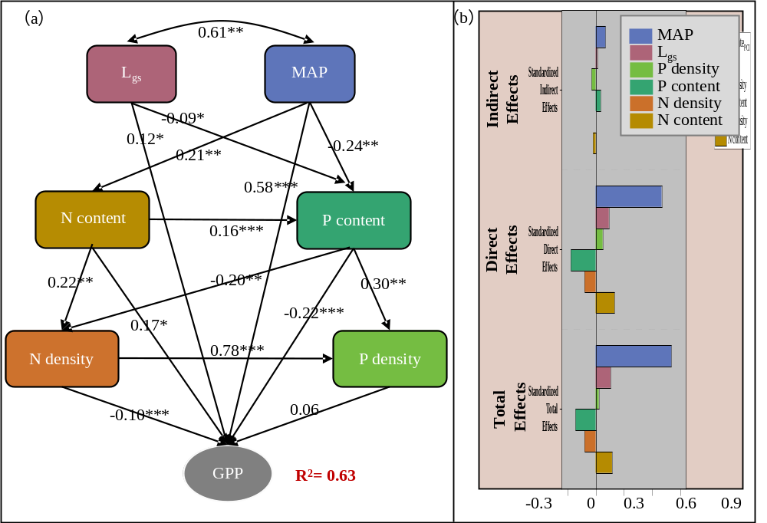
Fig. S1 Structural equation model (SEM) of the direct and indirect effects of gross primary productivity (GPP; gC m^{–2} a^{–1}). In (a), double-headed arrows represent covariance between related variables and single-headed arrows indicate the hypothesized direction of causation. Numbers adjacent to the arrows are standardized path coefficients. The proportion of variance explained (R²) appears alongside each response variable in the model. *P < 0.05; **P < 0.01; ***P < 0.001. (b) Standardized total effects, standardized direct effects, and standardized indirect effects of different variables on GPP. MAP: annual precipitation. L_{gs,} length of plant-growing season.P_{density}, leaf phosphorus density. P_{content}, leaf phosphorus content. N_{density}, leaf nitrogen density.N_{content,} leaf nitrogen content. The model fit statistics are as follows: χ² = 0.94, p = 0.053, GFI = 0.994, RMSEA < 0.0001, AIC = 56.00.

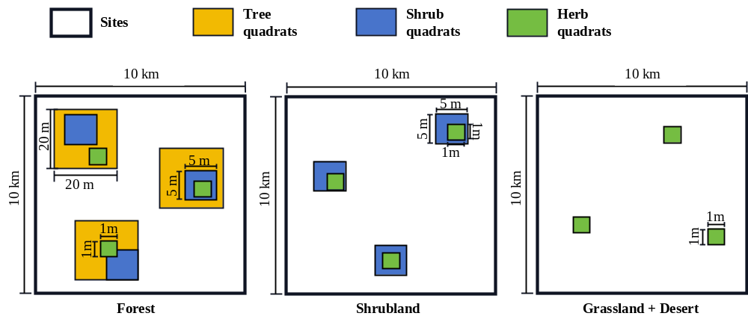
Fig. S2 Sampling area and survey sample of plant community. The plot sizes were determined based on vegetation structure and spatial distribution to ensure representative sampling of different plant functional groups. Trees sample of 20 m × 20 m, shrubs samples of 5 m × 5 m, and herbs samples of 1 m × 1 m.

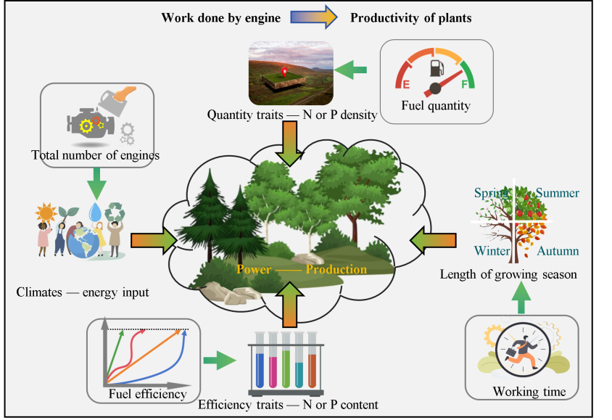
Fig. S3 Using the classic framework of “engine” on leaf functional traits (leaf N, P，or N:P）to predict the productivity of natural communities on the Tibetan Plateau.

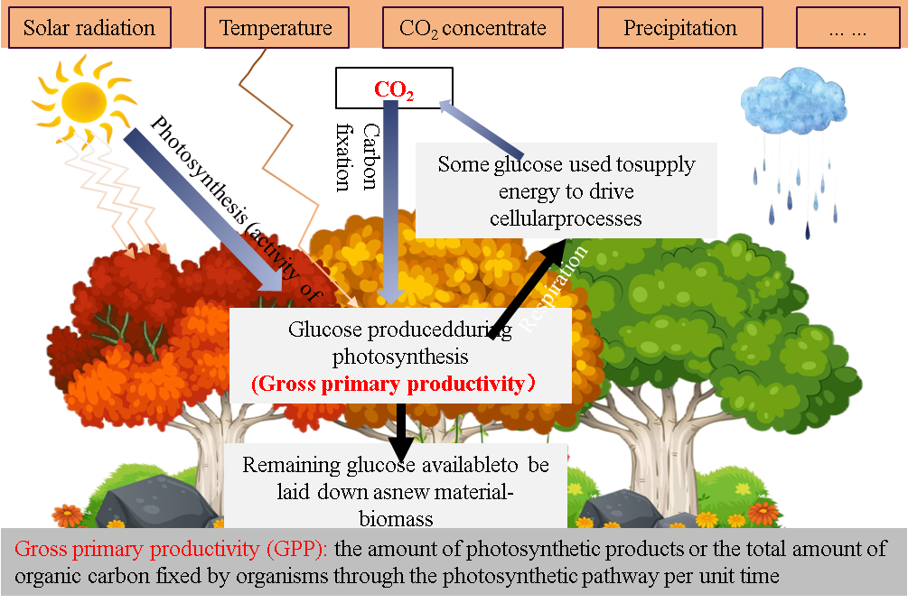
Fig. S4 The impact of environmental factors on plant productivity.

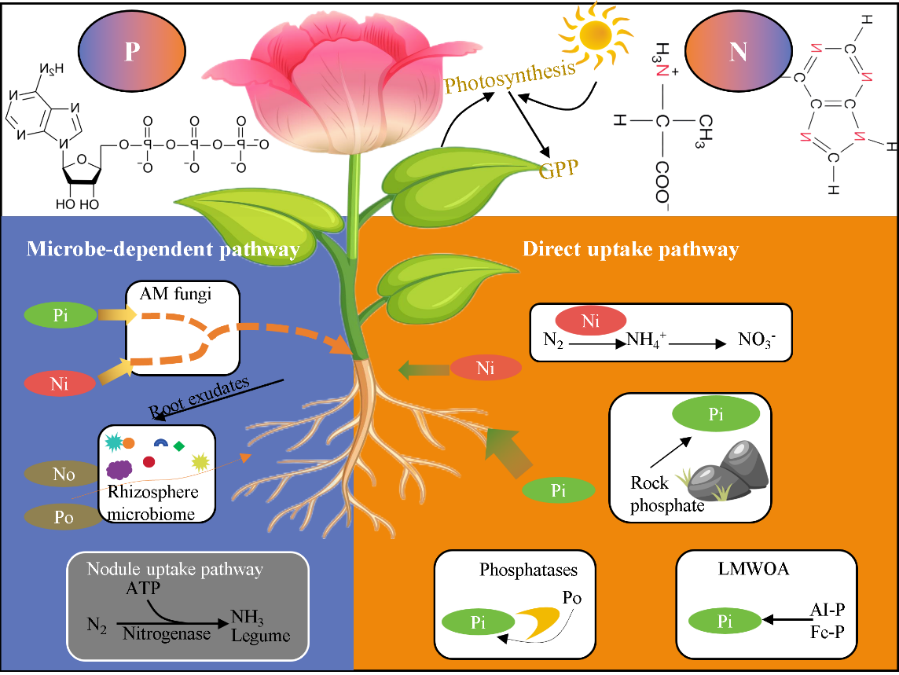
Fig. S5 Nitrogen and phosphorus should be the pivotal limiting nutrients in most of terrestrial ecosystems, exerting substantial influence on plant productivity. Nitrogen and phosphorus in plants are mainly absorbed from the soil through the root system and eventually become important components of plant nucleic acids, amino acids, etc., Plants acquire essential nutrients through both direct and indirect pathways. In the direct uptake mechanism, root epidermal cells absorb nitrogen (N) and phosphorus (P) directly from the soil. Conversely, the microbe-dependent pathway comprises several mechanisms. For instance, many plants form symbiotic associations with arbuscular mycorrhizal (AM) fungi, which extend their nutrient foraging range via the mycorrhizal/symbiotic pathway. Additionally, a portion of the carbon (C) fixed through photosynthesis is exuded by roots into the rhizosphere, serving to attract specialized microbial communities that collaboratively facilitate the mobilization and uptake of N and P. Moreover, legumes develop nodule symbioses with rhizobia, enabling them to fix atmospheric nitrogen (N₂) directly.
Abbreviations: C, carbon; LMWOA, low-molecular-weight organic acid; Ni, inorganic nitrogen; No, organic nitrogen; Pi, inorganic phosphorus; Po, organic phosphorus. Figure adapted from Zhao et al., (2023).

