Supporting Materials for
Long-term climate warming and nitrogen deposition increase leaf epiphytic and endophytic bacterial diversity

*Author for correspondence: Haiyan Ren; Email: renhy@imau.edu.cn; ORCID ID: 0000-0002-2008-9626.

This word files includes:
Appendix S1: Tables S1 to S7
Figs. S1 to S14

Supporting materials
Table S1 Results from linear mixed-effect models on the effects of warming, N addition, year, species and their interactions on host leaf traits.
 | DF1 | DF2 | SPAD | LT | LTR | LNPR | Ci | LSC | LA | LNC | LCC | LPC | SLA | LDW
Warming(W) | 1 | 15 | 0.05 | 72.1** | 4.9* | 0.7 | 0.03 | 0.2 | 0.08 | 0.02 | 4.4 | 1.2 | 0.05 | 0.2
N addition (N) | 1 | 15 | 6.4* | 41.3** | 5.3* | 0.01 | 0.7 | 0.3 | 0.2 | 0.2 | 0.3 | 0.3 | 1.5 | 0.9
Year (Y) | 1 | 60 | 12.3** | 11.7** | 15.9** | 50.1** | 3.4 | 20.4** | 50.1** | 40.3** | 0.06 | 20.4** | 48.1** | 21.5**
Species (S) | 1 | 60 | 16.6** | 2.8 | 0.5 | 7.7 | 14.2** | 30.4** | 2.4 | 52.5** | 13.2** | 3.8 | 4.9* | 47.4**
W*N | 1 | 15 | 0.2 | 1.1 | 1.7 | 0.8 | 0.6 | 0.3 | 0.2 | 1.1 | 2.1 | 0.01 | 0.3 | 0.3
W*Y | 1 | 60 | 0.005 | 4.4* | 6.6* | 6.4* | 6.5* | 0.05 | 1.5 | 1.8 | 0.2 | 0.09 | 1.6 | 0.2
N*Y | 1 | 60 | 0.01 | 48.1** | 1.5 | 0.4 | 2.1 | 0.3 | 0.009 | 0.9 | 4.1* | 0.7 | 0.002 | 0.9
W*S | 1 | 60 | 1.1 | 10.2** | 0.3 | 0.004 | 0.7 | 0.6 | 0.2 | 1.1 | 0.009 | 0.2 | 0.2 | 0.2
N*S | 1 | 60 | 0.9 | 18.7** | 3.1 | 0.02 | 3.4 | 3.3 | 1.1 | 0.091 | 0.1 | 0.2 | 1.3 | 0.8
Y*S | 1 | 60 | 21.8** | 22.1** | 18.7** | 8.2** | 14.8** | 37.9** | 18.3** | 25.33** | 0.05 | 4.7* | 17.1** | 80.6**
W*N*Y | 1 | 60 | 0.001 | 0 | 1.2 | 0.01 | 0 | 0.4 | 0.1 | 1.1 | 0.8 | 1.9 | 0.1 | 0.3
W*N*S | 1 | 60 | 0.2 | 12.7** | 0.01 | 1.1 | 0.08 | 0.07 | 0.6 | 3.6 | 0.3 | 0.3 | 0.04 | 0.2
W*Y*S | 1 | 60 | 0.8 | 23.1** | 0.08 | 0.02 | 2.1 | 1.3 | 1.3 | 0.001 | 0.8 | 0.9 | 1.3 | 0.2
N*Y*S | 1 | 60 | 0.7 | 13.3** | 0.001 | 0.2 | 0.9 | 1.4 | 0.009 | 2.3 | 0.7 | 0.08 | 0.0004 | 0.8
W*N*Y*S | 1 | 60 | 2.6 | 7.14* | 0.4 | 1.3 | 0.04 | 0.001 | 0.5 | 1.1 | 0.04 | 0.1 | 0.5 | 0.3
Note: The F ratios are together with their significance levels. DF1 and DF2 denote the numerator and denominator degrees of freedom, respectively. ** P < 0.01; * P < 0.05. SPAD value (SPAD), Leaf temperature (LT), Leaf transpiration rate (LTR), Leaf net photosynthetic rate (LNPR), intercellular carbon dioxide concentration (Ci), Leaf stomatal conductance (LSC), Leaf area (LA), Leaf nitrogen concentration (LNC), Leaf carbon concentration (LCC), Leaf phosphorus concentration (LPC), Specific leaf area (SLA) and leaf dry weight (LDW).

Table S2 Results from linear mixed-effect models on the effects of warming, N addition, Year and their interactions on epiphytic and endophytic bacterial diversity and abundance of two species (include the Stipa breviflora (Sb) and Cleistogenes songorica (Cs).
 |  |  |  |  | Epi-α diversity |  | Endo-α diversity |  | Epi-abundance |  | Endo-abundance
 | DF1 |  | DF2 |  | Sb | Cs | Sb | Cs | Sb | Cs | Sb | Cs
Warming (W) |  | 1 | 6 |  | 20.34** | 47.43** | 60.52** | 54.3** | 10.25* | 10.20* | 4.97 | 57.22**
N addition (N) |  | 1 | 6 |  | 20.34** | 32.61** | 48.54** | 60.3** | 14.53* | 10.15* | 4.57 | 59.75**
Year (Y) |  | 1 | 8 |  | 0.42 | 4.01 | 3.04 | 0.6 | 93.96** | 58.08** | 0.43 | 69.71**
W*N |  | 1 | 6 |  | 20.07** | 45.91** | 59.81** | 53.1** | 1.62 | 0.15 | 0.11 | 57.51**
W*Y |  | 1 | 8 |  | 0.57 | 5.86 | 0.01 | 1.7 | 8.27* | 3.13 | 4.54 | 0.0081
N*Y |  | 1 | 8 |  | 3.22 | 4.32 | 0.02 | 0.1 | 19.63** | 4.73 | 3.11 | 4.97
W*N*Y |  | 1 | 8 |  | 5.21* | 2.28 | 0.71 | 0.9 | 5.65* | 1.35 | 2.01 | 0.028

Note: Determinants of leaf bacterial α diversity were quantified using the Shannon diversity index, DF1 and DF2 denote the numerator and denominator degrees of freedom, respectively. ** P < 0.01; * P < 0.05. The F ratios are together with their significance levels.

Table S3 Effects of leaf habitat, species identity, treatment, and year on bacterial community structure.
Variables | DF | F value | R² | P
Treatment(T) | 3 | 2.60 | 0.027 | 0.077
Year(Y) | 1 | 4.45 | 0.038 | 0.051
Leaf habitat(L) | 1 | 16.58 | 0.26 | 0.001
Host species identity (H) | 1 | 2.59 | 0.026 | 0.085
T*H | 3 | 2.12 | 0.018 | 0.10
T*Y | 3 | 4.12 | 0.028 | 0.055
L*T | 3 | 6.34 | 0.052 | 0.046
L*H | 1 | 5.15 | 0.040 | 0.050
Y*L | 1 | 9.73 | 0.078 | 0.036
Y*H | 1 | 4.03 | 0.015 | 0.10
L*T*H | 3 | 4.19 | 0.031 | 0.050
T*L*Y | 3 | 5.58 | 0.045 | 0.050
H*L*Y | 1 | 2.20 | 0.018 | 0.092
T*H*Y | 3 | 2.59 | 0.027 | 0.093
T*L*H*Y | 3 | 2.61 | 0.029 | 0.093

Note: PERMANOVA analysis tested the influence of leaf habitat (indicate the leaf epiphytic and endophytic bacteria community), treatment (includes control, warming, nitrogen addition and both of those treatments), host species identity (Stipa breviflora and Cleistogenes songorica), and year (2022 and 2023) on the variation in bacterial community structure. The full model as well as the interaction of each of these variables. P values determined by PERMANOVA. DF, degrees of freedom.

Table S4 The redundancy analysis (RDA) results of the plant traits factors on the epiphytic and
endophytic bacterial community structure.
 | Epiphytic bacteria |  |  |  |  |  | Endophytic bacteria
 | Sb |  | Cs |  |  |  | Sb |  | Cs
 | Explanation%% | P |  | Explanation% | P |  | Explanation% | P | Explanation% | P
Total | 88.3 | - |  | 77.5 | - |  | 88 | - | 89.2 | -
Leaf temperature | 55 | 0.008 |  | 30 | 0.039 |  | 2 | 0.57 | 5.8 | 0.47
Leaf stomatal conductance | 0 | 1 |  | 24 | 0.041 |  | 0 | 1 | 1.3 | 0.86
Intercellular CO₂ concentration | 1.7 | 0.20 |  | 4.7 | 0.22 |  | 0 | 1 | 2 | 0.78
Leaf area | 0.9 | 0.28 |  | 2.8 | 0.35 |  | 3 | 0.34 | 0 | 1
Leaf total nitrogen concentration | 0.8 | 0.22 |  | 0.5 | 0.74 |  | 20.8 | 0.044 | 6.5 | 0.41
Leaf transpiration rate | 22.7 | 0.04 |  | 1.9 | 0.46 |  | 3 | 0.38 | 1.3 | 0.86
Leaf net photosynthetic rate | 1.1 | 0.31 |  | 2.6 | 0.38 |  | 3.4 | 0.3 | 0.8 | 0.88
Leaf total phosphorus concentration | 2.1 | 0.16 |  | 0 | 1 |  | 2.6 | 0.11 | 42.1 | 0.007
Specific leaf area | 2.2 | 0.13 |  | 0 | 1 |  | 3.9 | 0.30 | 4 | 0.63
Leaf total carbon concentration | 0 | 1 |  | 6 | 0.17 |  | 44.5 | 0.012 | 22 | 0.042
Leaf dry weight | 1.8 | 0.19 |  | 1.5 | 0.48 |  | 4.8 | 0.17 | 1 | 0.86
Leaf Chlorophyll content | 0 | 1 |  | 3.5 | 0.33 |  | 0 | 1 | 2.4 | 0.75

Table S5 Pearson correlation analysis of leaf epiphytic diversity and abundance and plant traits. LTR stands for leaf transpiration rate (LTR), LT stand for leaf temperature (LT), SLA stands for specific leaf area, α-diversity stands for leaf epiphytic bacterial α diversity, abundance stands for leaf epiphytic bacterial content. * and ** are P < 0.05 and P < 0.01, respectively.

 | LTR | LT | SLA | α-diversity | biomass
LTR
LT | -0.034
SLA | 0.28 | 0.23
α-diversity | -0.54** | 0.60** | 0.24
abundance | 0.43** | 0.37 | 0.23 | 0.21
plant diversity | -0.12 | -0.19 | 0.050 | 0.48** | -0.46**

Table S6 Pearson correlation analysis of leaf endophytic diversity and abundance and plant traits. Leaf C, N and P stands for leaf total carbon content (C), total nitrogen content (N) and total phosphorus content (P). α-diversity stands for leaf epiphytic bacterial α diversity, abundance stands for leaf epiphytic bacterial content. * and ** are P < 0.05 and P < 0.01, respectively.

 | Leaf C | Leaf N | Leaf P | α-diversity | abundance
Leaf C
Leaf N | -0.064
Leaf P | -0.038 | 0.41**
α-diversity | 0.56** | 0.45** | -0.16
abundance | 0.60** | -0.43** | -0.29* | 0.18
plant diversity | 0.035 | 0.28 | 0.27 | 0.30* | 0.41**

Table S7 Results from linear mixed-effect models on the effects of warming, N addition, year and their interactions on plant diversity (plant Shannon index).
 |  |  | plant diversity
 | DF1 | DF2 | F ratio | P
Warming (W) | 1 | 6 | 26.91 | 0.002
N addition (N) | 1 | 6 | 6.03 | 0.033
Year (Y) | 1 | 32 | 0.82 | 0.37
W*N | 1 | 6 | 18.87 | 0.016
W*Y | 1 | 32 | 7.04 | 0.02
N*Y | 1 | 32 | 0.94 | 0.35
W*N*Y | 1 | 32 | 0.98 | 0.33

Note: DF1 and DF2 denote the numerator and denominator degrees of freedom, respectively. ** P < 0.01; * P < 0.05. The F ratios and P values are showed.

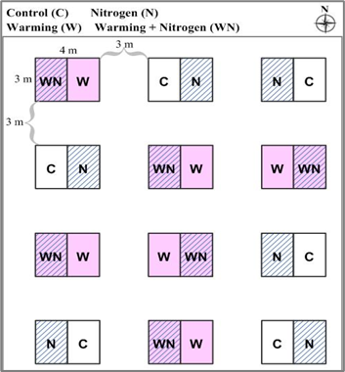
Figure S1 Experimental plot design. Each main plot was 3 m × 4 m, separated by a 3 m buffer. Treatments included controls (C), warming (W), nitrogen addition (N), and combined warming and nitrogen addition (WN), each with six replicates.

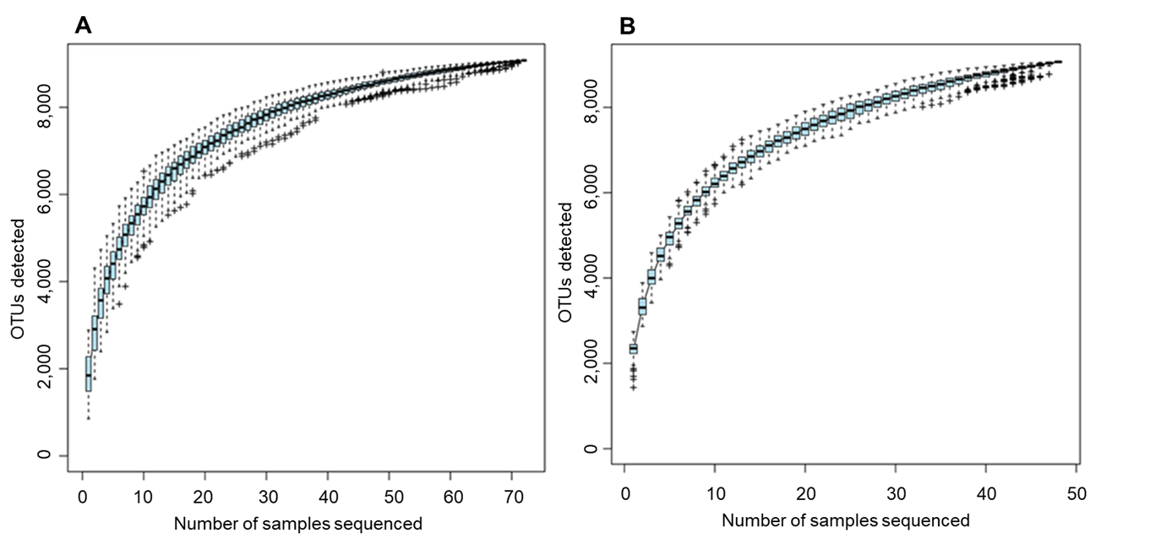
Figure S2 Species accumulation curves for 2022 and 2023. Species accumulation curves for sample sizes in 2022 (A) and 2023 (B). The x-axis represents sample size (or sequencing depth), while the y-axis represents the number of observed OTUs after subsampling. The curve reflects the detection rate of new OTUs (or novel species) with increasing sampling effort.

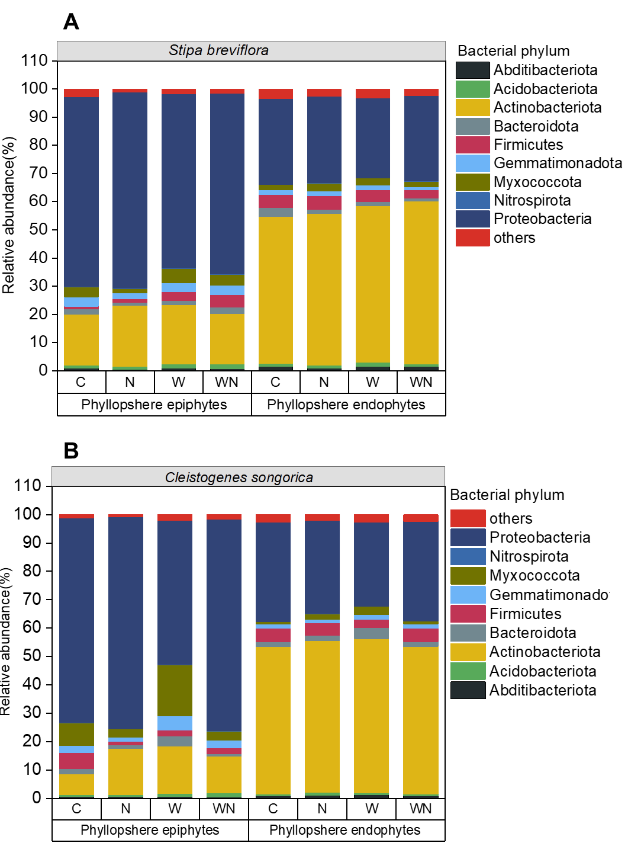
Figure S3 Relative abundance of the top 10 bacterial phyla in the phyllosphere epiphytes and endophytes of Stipa breviflora and Cleistogenes songorica. Relative abundance of the top 10 bacterial phyla in the bacterial communities of phyllosphere epiphytes and endophytes for Stipa breviflora (A) and Cleistogenes songorica (B). Treatments include controls (C), warming (W), nitrogen addition (N), and combined warming and nitrogen addition (WN).

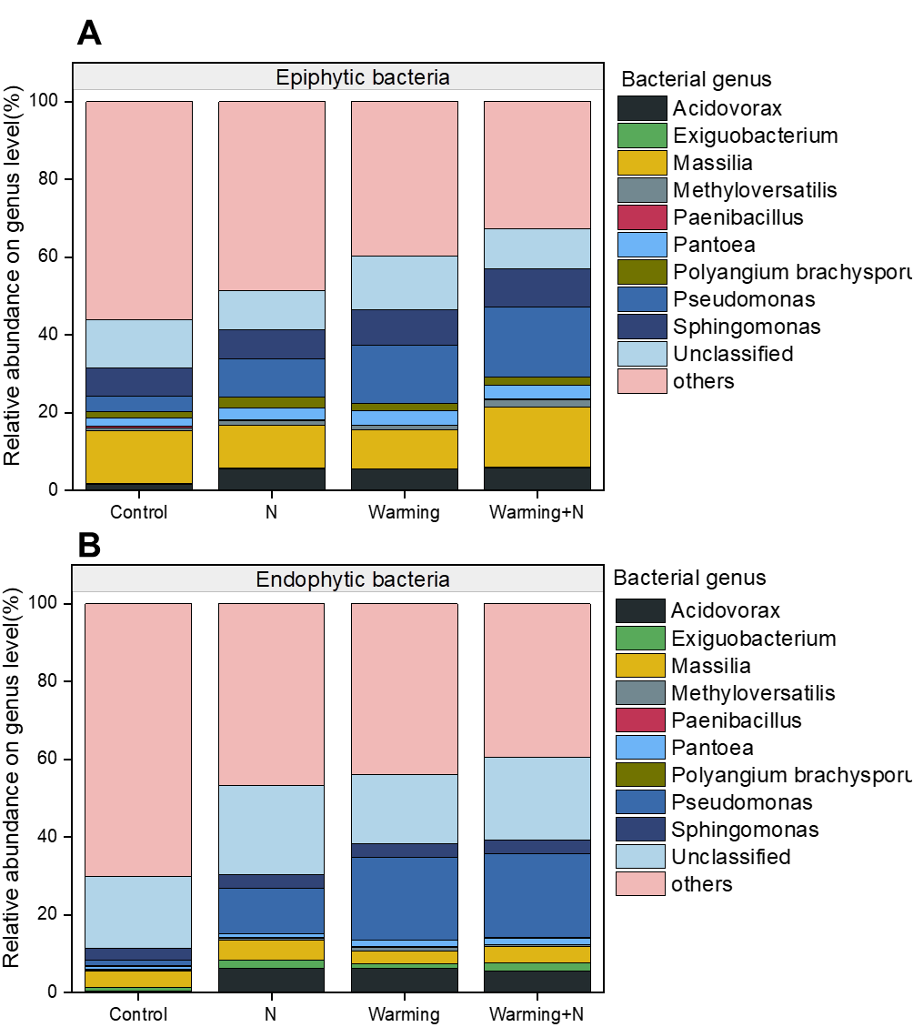
Figure S4 Relative abundance of the top 10 bacterial genera in epiphytic and endophytic bacterial communities. Relative abundance of the top 10 bacterial genera in the bacterial communities of epiphytic bacteria (A) and endophytic bacteria (B). Treatments include controls, warming, nitrogen addition, and combined warming and nitrogen addition.

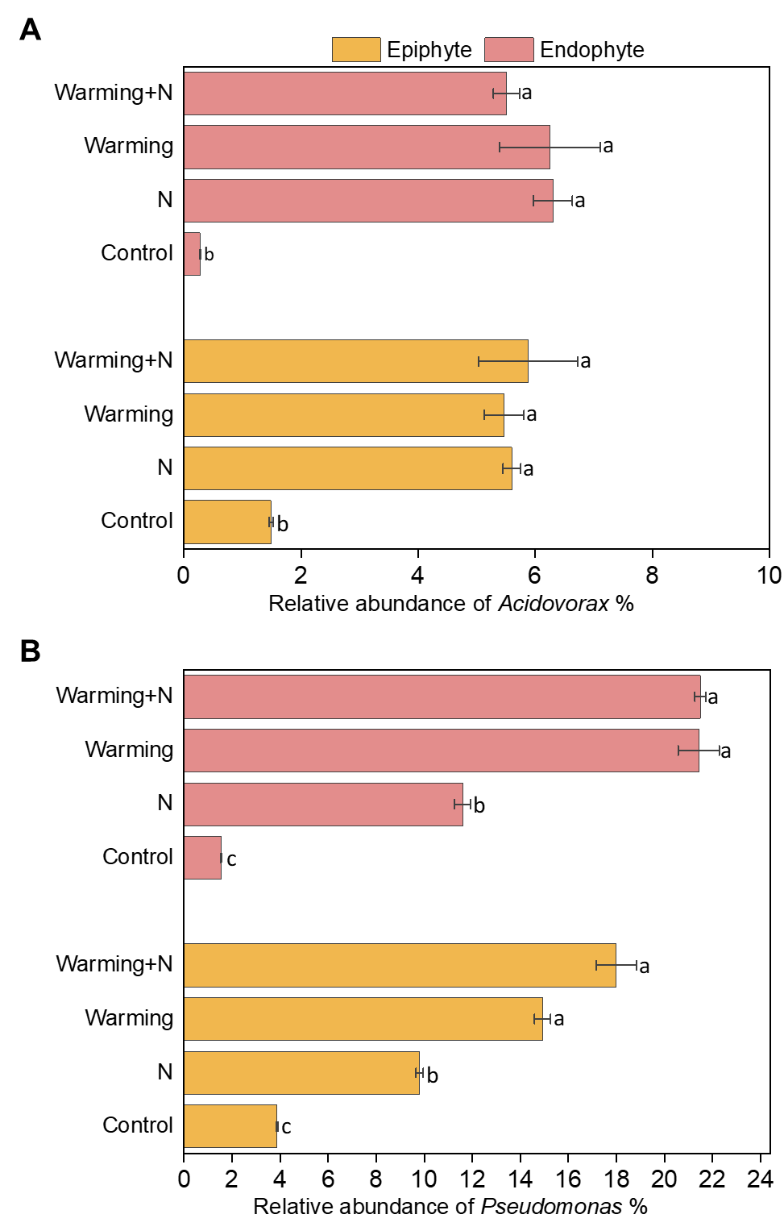
Figure S5 Effects of warming, nitrogen addition, and their interactions on the relative abundance of Acidovorax and Pseudomonas in leaf epiphytic and endophytic bacteria. Effects of warming (W), nitrogen addition (N), and their interactions on the relative abundance of Acidovorax (A) and Pseudomonas (B) in leaf epiphytic and endophytic bacteria, based on a repeated-measures analysis of variance. Lowercase letters indicate significant differences among treatments determined by Tukey’s HSD test at P < 0.05.

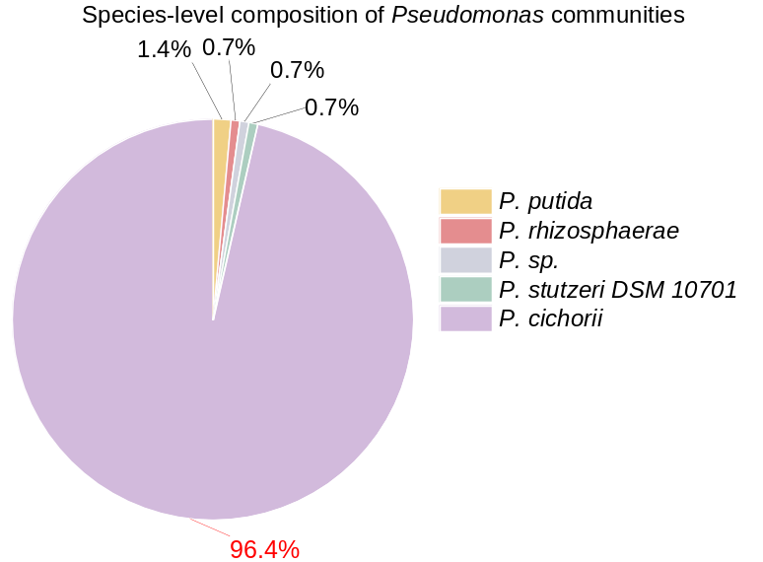
Figure S6 Pie chart showing species-level composition of Pseudomonas communities. Red sector: Pseudomonas cichorii (PHI:1183; 96.4%), the only pathogen validated by PHI-base knockout experiments. Grey sectors: Non-pathogenic species (Pseudomonas. putida, Pseudomonas. rhizosphaerae, etc. cumulatively 3.6%), their abundances remain negligible (all <0.01% of total community).

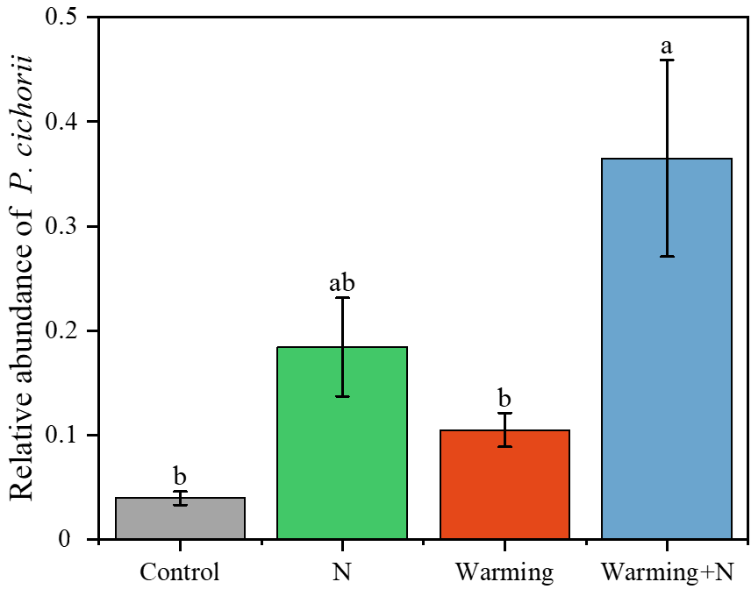
Figure S7 Effects of warming (W), nitrogen addition (N) and their interactions on the relative abundance of Pseudomonas cichorii. Lowercase letter indicate significant difference among treatments determined by Tukey’s HSD test at P < 0.05.

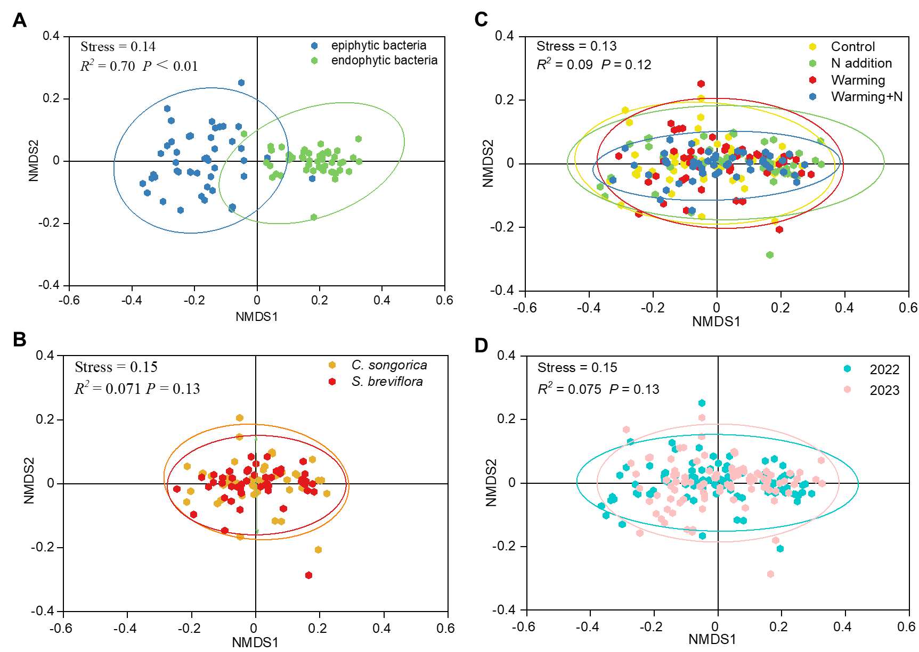
Figure S8 NMDS analysis of bacterial community distribution patterns. NMDS analysis based on Bray-Curtis distances showing distinct distribution patterns with ellipses representing: (A) leaf samples between leaf epiphytic and endophytic bacteria; (B) phyllosphere samples between Stipa breviflora and Cleistogenes songorica species; (C) phyllosphere samples among control, warming, nitrogen addition, and combined warming and nitrogen addition treatments; (D) phyllosphere samples between years 2022 and 2023. R² and P values were determined by PERMANOVA.
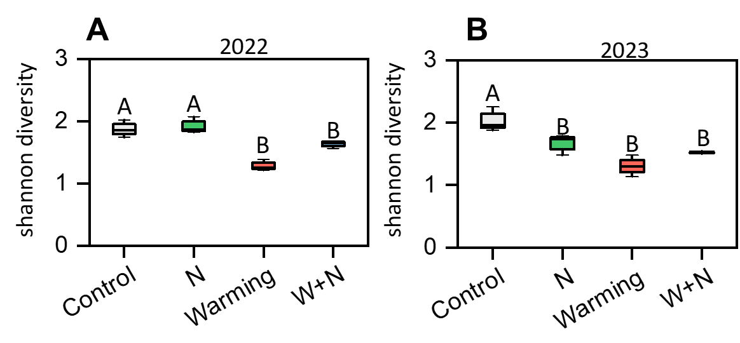
Figure S9 Responses of plant diversity (Shannon index) to warming and N addition during 2022 and 2023. Uppercase letters indicate significant difference among treatments determined by Tukey’s HSD test at P < 0.05.

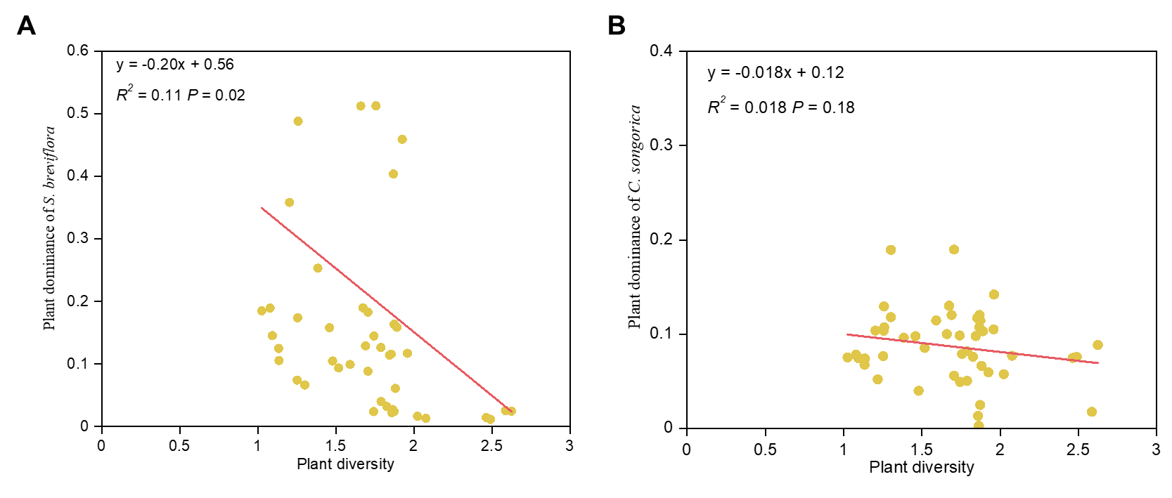
Figure S10 Relationship between plant diversity and plant dominance in Stipa breviflora and Cleistogenes songorica. Point plots showing the relationships between plant diversity and plant dominance in Stipa breviflora (figure A) and Cleistogenes songorica (B). Solid red lines represent regression curves for the data. Species' dominance was quantified as the mean of relative density, relative coverage, and relative height of plants.

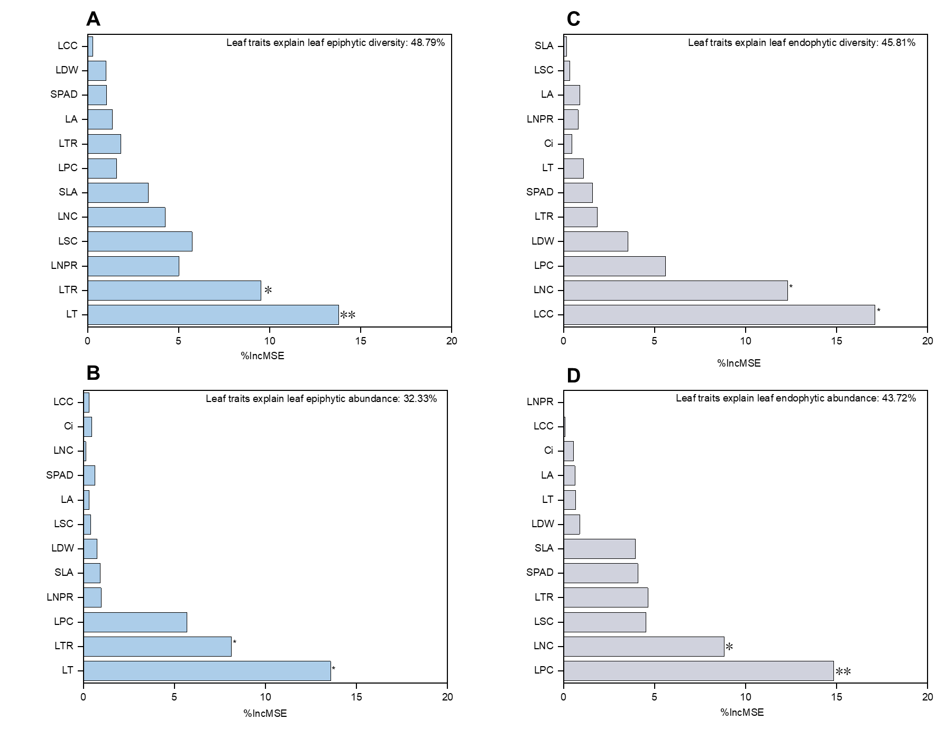
Figure S11 Random Forest regression models predicting leaf epiphytic and endophytic bacterial diversity and abundance. Random Forest regression models predicting leaf epiphytic and endophytic bacterial diversity (A, B) and abundance (C, D) using leaf trait predictors such as SPAD value, leaf temperature, leaf transpiration rate, leaf net photosynthetic rate, intercellular CO₂ concentration, leaf stomatal conductance, leaf area, leaf nitrogen concentration, leaf carbon concentration, leaf phosphorus concentration, specific leaf area, and leaf dry weight. The percentage of variance explained (R²) is reported for each model. The importance of predictors is ranked and visualized, with **P < 0.01 and *P < 0.05.
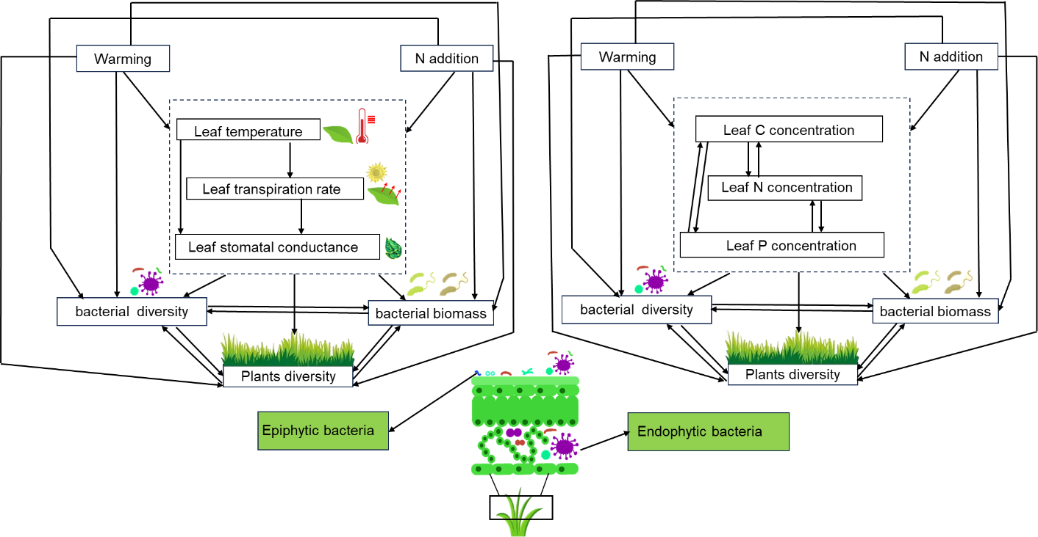
Figure S12 Conceptual model of the pathways through which bacterial and plant diversity respond to warming and nitrogen addition via leaf traits. Conceptual model examining the different pathways through which leaf epiphytic and endophytic bacterial diversity, as well as plant diversity, respond to warming and nitrogen addition via leaf traits.

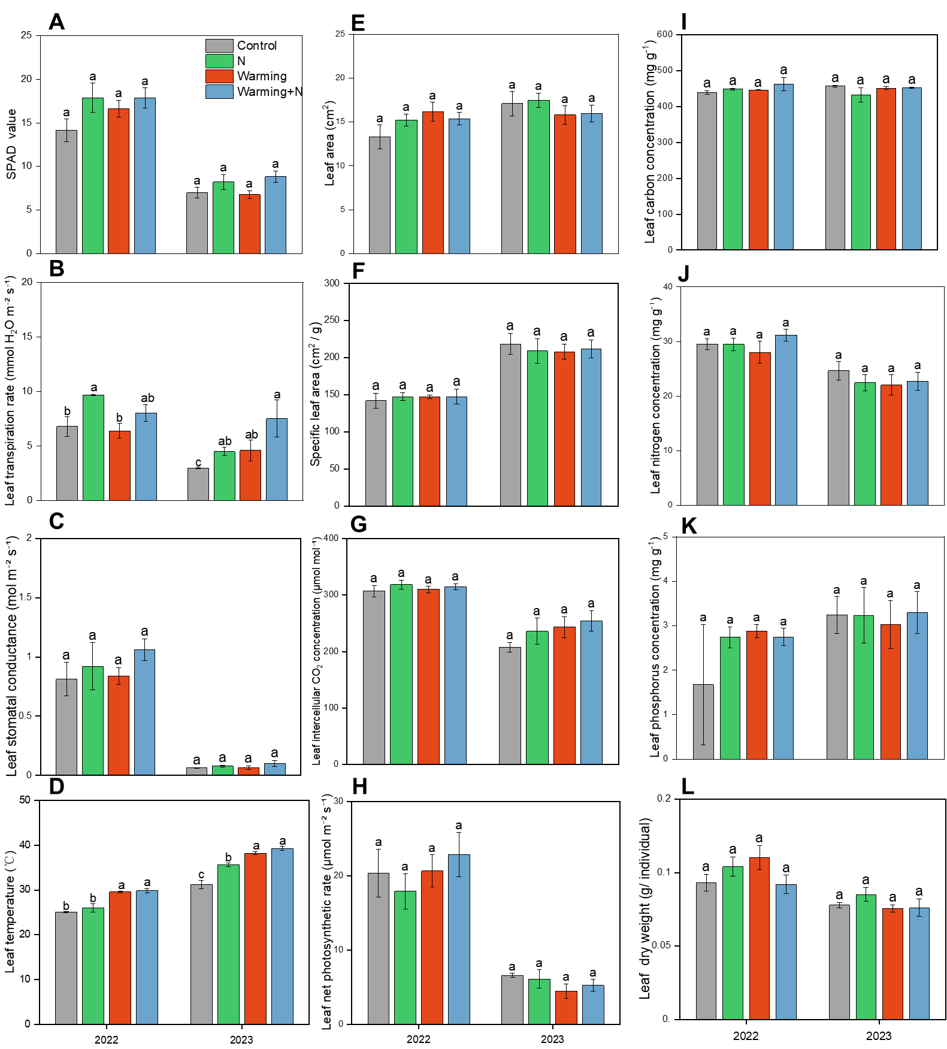
Figure S13 Responses of leaf functional traits for Stipa breviflora to warming and N addition during 2022 and 2023. Lowercase letters indicate significant difference among treatments determined by Tukey’s HSD test at P < 0.05.

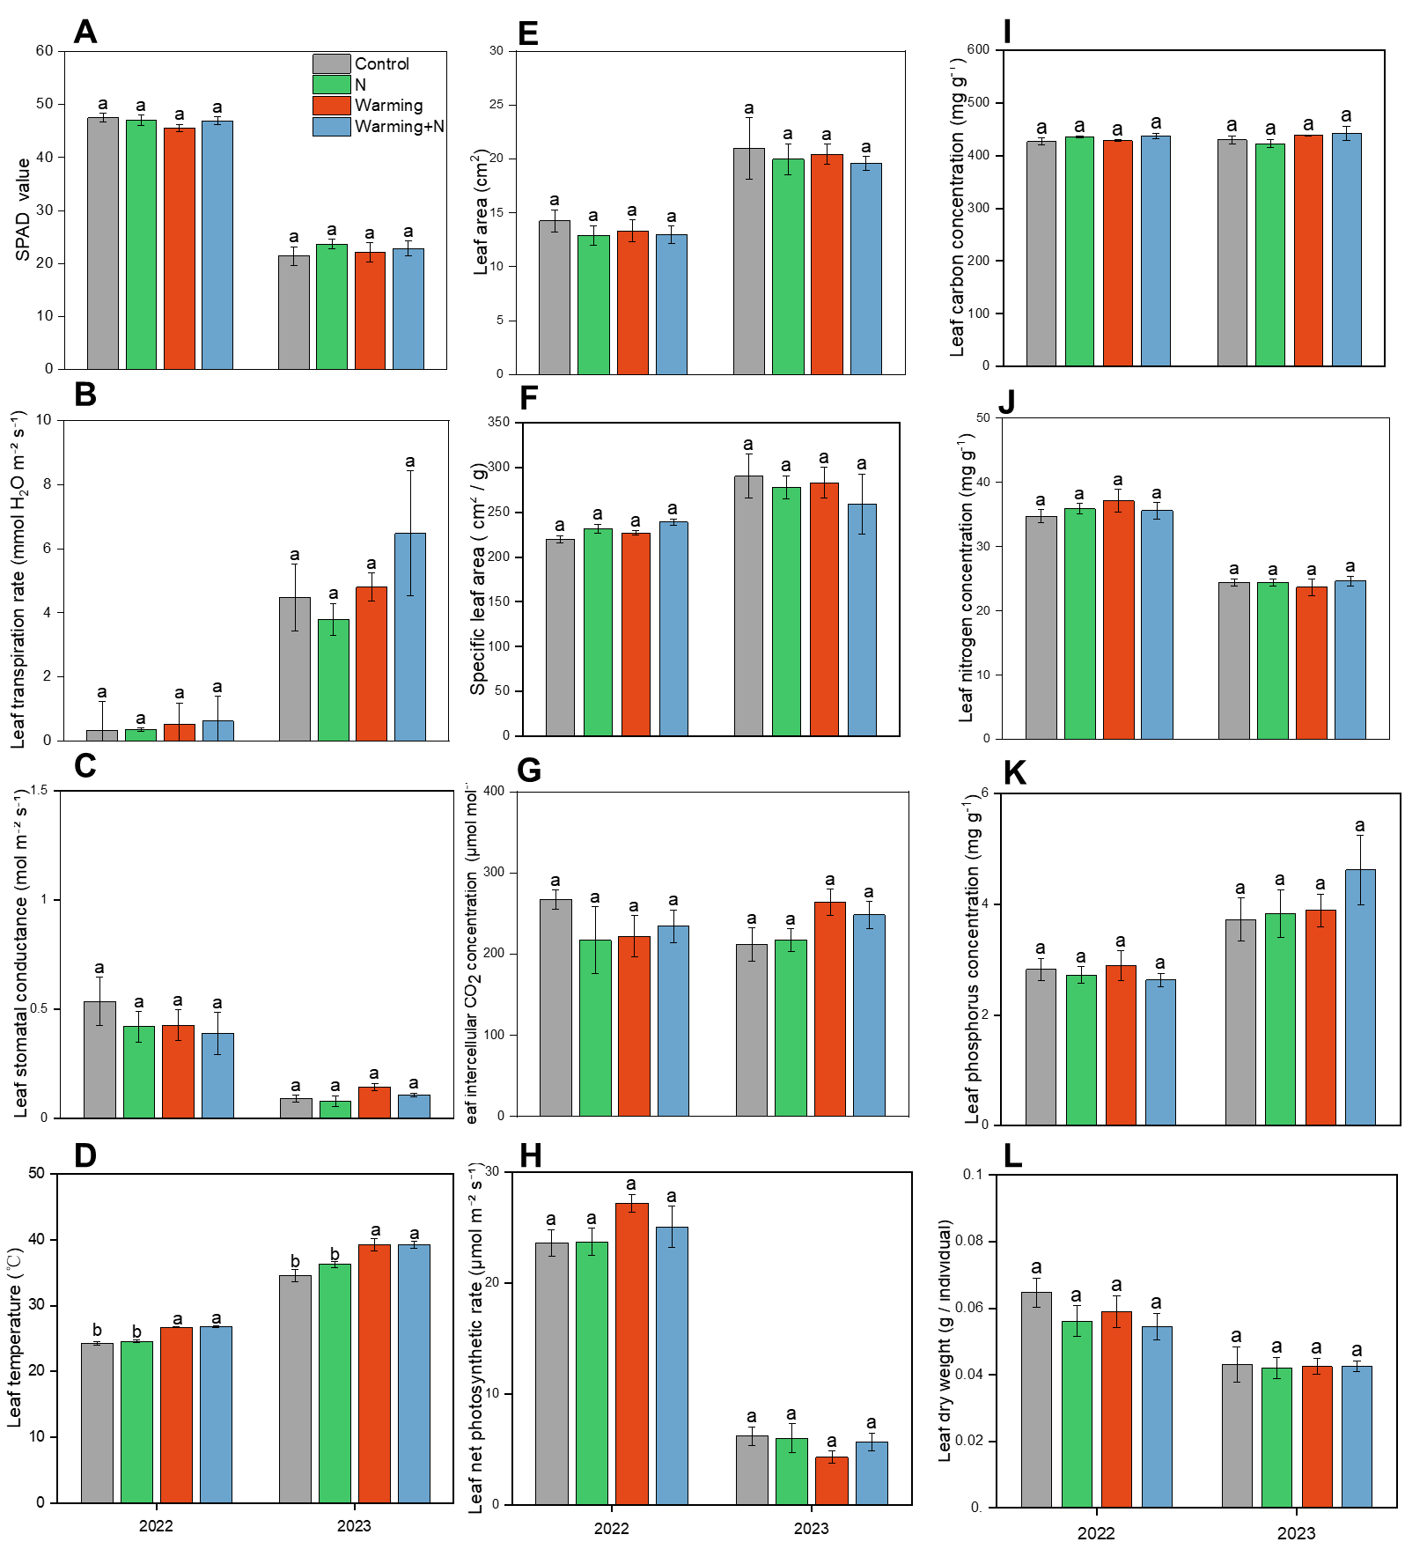
Figure S14 Responses of leaf functional traits for Cleistogenes songorica to warming and N addition during 2022 and 2023. Lowercase letters indicate significant difference among treatments determined by Tukey’s HSD test at P < 0.05.

