Supporting information

Supplemental Figures
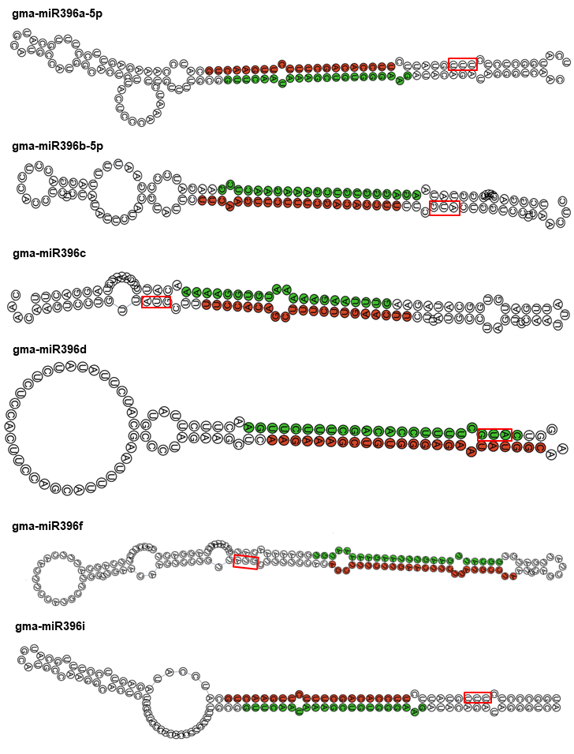
Figure S1. Predicted stem-loop structures of the Gma-miR396 gene family.
The mature miR396 sequences are marked in red circles, miR396* sequences are marked in green circles and the PAM sequences are marked with red boxes. The stem-loop structures of miR396 family members were predicted by the Tbtools software package.

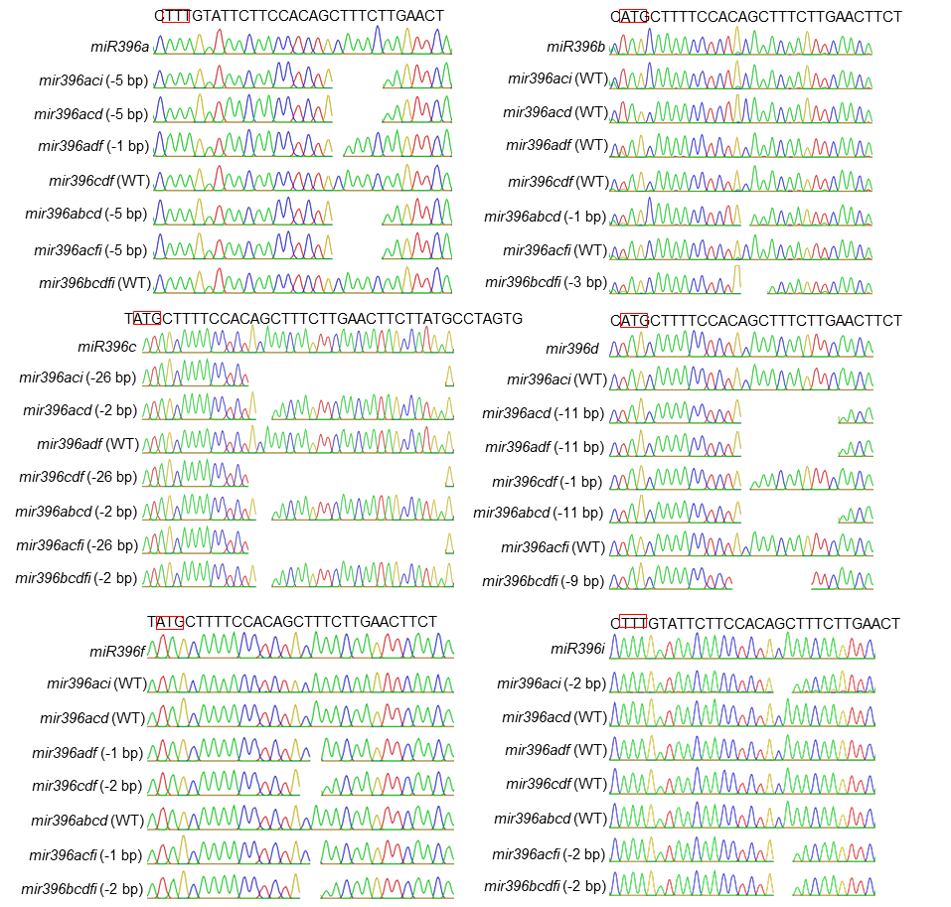

Figure S2. Sanger sequencing of the mir396 mutants.
Determination of the genotypes of different mir396 mutants through Sanger sequencing. The PAM sequences are marked with red boxes. WT, wild type (no mutation); -5 bp, deletion of 5 nucleotides.

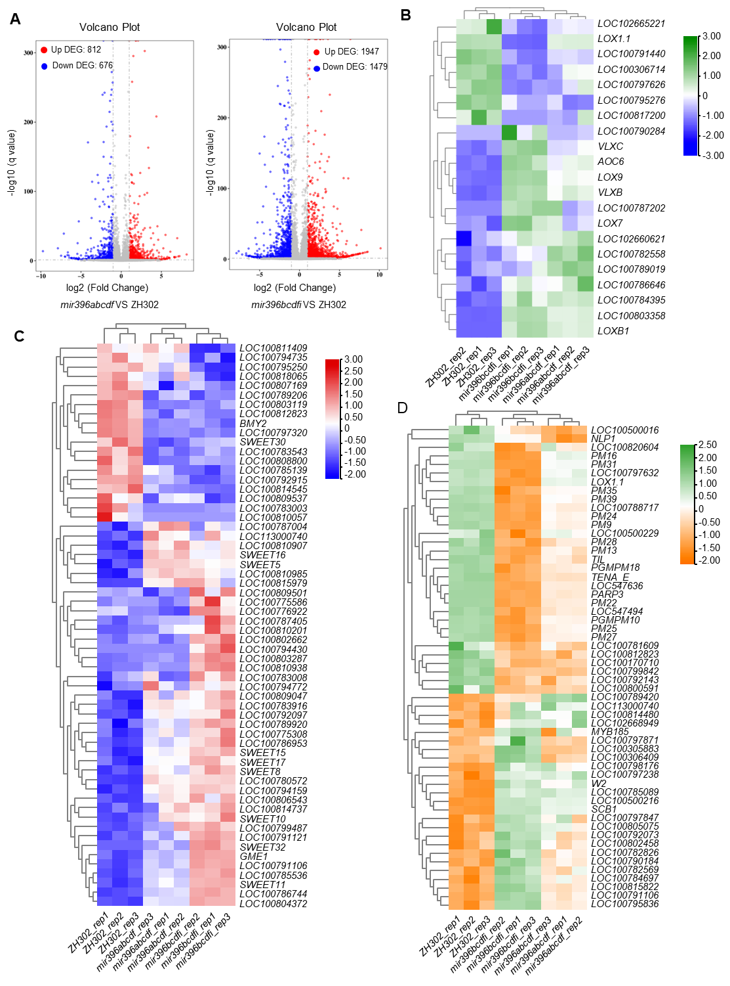

Figure S3. Deferentially expressed genes in mir396abcdf and mir396bcdfi.
(A) Volcano plot of DEGs between ZH302, mir396abcdf and mir396bcdfi. (B-D) DEGs of linoleic acid metabolism (B), starch and sucrose metabolism (C), and seed development (D) in ZH302, mir396abcdf and mir396bcdfi.

Supplemental Tables
Table S1. Genes with altered expression in mir396bcdfi as determined by RNA-seq analysis.
Table S2. Genes with altered expression in mir396abcdf as determined by RNA-seq analysis.
Table S3. Primers used in this study.

