Journal of Integrative Plant Biology
Supplementary Materials for
Predicting community traits along an alpine grassland transect using field imaging spectroscopy

Table S1. The 21 alpine grassland sampling sites on the Tibetan Plateau
SN | LAT (º) | LON (º) | ALT (m) | MAP (mm) | MAT (°C) | PET (mm) | Aridity
XZ-1 | 29.79 N | 91.59 E | 3930 | 384 | 4.55 | 1443 | 0.266
XZ-2 | 29.94 N | 90.73 E | 3950 | 410 | 4.18 | 1408 | 0.291
XZ-3 | 31.02 N | 91.65 E | 4653 | 435 | -1.23 | 1123 | 0.387
XZ-4 | 31.39 N | 90.76 E | 4584 | 427 | -0.51 | 1199 | 0.355
XZ-5 | 31.63 N | 89.43 E | 4618 | 410 | 0.46 | 1291 | 0.317
XZ-6 | 31.78 N | 88.52 E | 4548 | 360 | 1.10 | 1316 | 0.273
XZ-7 | 31.79 N | 87.36 E | 4555 | 242 | 1.20 | 1391 | 0.175
XZ-8 | 31.86 N | 86.08 E | 4761 | 139 | -1.08 | 1280 | 0.109
XZ-9 | 32.10 N | 84.72 E | 4406 | 98 | 0.87 | 1402 | 0.069
XZ-10 | 32.42 N | 83.16 E | 4429 | 76 | -0.36 | 1309 | 0.058
XZ-11 | 32.07 N | 81.98 E | 4597 | 112 | -0.33 | 1321 | 0.085
XZ-12 | 32.42 N | 80.84 E | 4453 | 92 | -1.10 | 1241 | 0.074
XZ-13 | 31.87 N | 80.06 E | 5249 | 224 | -5.19 | 1076 | 0.208
XZ-14 | 31.17 N | 80.84 E | 4549 | 446 | 0.00 | 1187 | 0.375
XZ-15 | 30.71 N | 81.90 E | 4758 | 348 | -0.44 | 1168 | 0.296
XZ-16 | 30.19 N | 83.11 E | 4583 | 292 | 1.17 | 1190 | 0.552
XZ-17 | 29.64 N | 84.32 E | 4659 | 275 | 1.73 | 1235 | 0.223
XZ-18 | 29.21 N | 85.36 E | 4465 | 308 | 3.07 | 1278 | 0.241
XZ-19 | 28.81 N | 86.28 E | 4420 | 386 | 3.39 | 1312 | 0.294
XZ-20 | 29.08 N | 88.02 E | 4263 | 364 | 3.26 | 1345 | 0.271
XZ-21 | 28.90 N | 90.36 E | 4543 | 283 | 1.44 | 1264 | 0.224
Notes: Site name (SN), longitude (LON, º), latitude (LAT, º), altitude (ALT, m), mean annual temperature (MAT, ºC), mean annual precipitation (MAP, mm), potential evapotranspiration (PET, mm), and the aridity index (AI) at the sampling sites.

Table S2. Summary statistics of the measured alpine grassland community traits at the 21 sampling sites on the Tibetan Plateau
Measured traits | n | Min | Mean | Max | SEM | StDev | CV
FVC (%) | 21 | 4.67 | 19.41 | 83.42 | 4.32 | 19.81 | 1.02
CLA (cm² m⁻²) | 21 | 3.44 | 11.28 | 40.60 | 2.05 | 9.41 | 0.83
CHL (mg m⁻²) | 20 | 0.38 | 2.19 | 7.78 | 0.40 | 1.78 | 0.81
CLN (g m⁻²) | 21 | 0.14 | 0.79 | 2.51 | 0.14 | 0.66 | 0.84
ANPP (g m⁻² yr⁻¹) | 21 | 12.51 | 40.80 | 123.46 | 7.03 | 32.21 | 0.79
Notes: FVC, fractional vegetation cover; CLA, community leaf area; CHL, canopy chlorophyll content; CLN, canopy leaf nitrogen concentration; ANPP, aboveground net primary productivity; SEM, standard error of mean; StDev, standard deviation; CV, coefficient of variation.

Table S3. Statistic parameters and model selection for the relationships between fractional vegetation cover (FVC, y1 values) and community leaf area (CLA, y2 values) with spectral vegetation indices (x values) across the alpine grassland transect (n=44). Model selection is based on the AIC values of the linear equations
Traits | VIs | Equation | R² | F value | P value | AIC
FVC | NDVI | y1 = -1.585 x + 75.498 | 0.67 | 83.88 | < 0.001 | 320.91
FVC | EVI | y1 = -2.904 x + 128.028 | 0.73 | 114.6 | < 0.001 | 311.30
FVC | SR | y1 = -2.846 x + 8.999 | 0.63 | 71.92 | < 0.001 | 325.30
FVC | reNDVI | y1 = -0.3014 x + 104.7622 | 0.56 | 54.14 | < 0.001 | 332.77
FVC | CI_{green} | y1 = -5.042 x + 18.646 | 0.58 | 57.19 | < 0.001 | 331.39
FVC | CI_{red edge} | y1 = 4.966 x + 22.206 | 0.51 | 43.41 | < 0.001 | 337.97
FVC | R₇₃₅/R₇₀₀ | y1 = -22.817 x + 28.612 | 0.54 | 48.36 | < 0.001 | 335.49
FVC | R₆₈₅/R₇₃₅ | y1 = 63.708 x - 62.339 | 0.63 | 71.43 | < 0.001 | 325.49
FVC | R₆₈₀/R₅₅₀ | y1 = 87.400 x – 54.495 | 0.50 | 42.40 | < 0.001 | 338.50
FVC | ACI | y1 = -14.406 x + 11.060 | 0.58 | 58.75 | < 0.001 | 330.70
FVC | MTCI | y1 = 5.699 x + 35.006 | 0.54 | 48.99 | < 0.001 | 335.19
FVC | MARI | y1 = -9.120 x + 41.738 | 0.34 | 21.19 | < 0.001 | 351.23
FVC | ARI | y1 = 5.742 x + 3.431 | 0.14 | 6.955 | < 0.05 | 362.46
FVC | PRI | y1 = 36.15 x + 220.45 | 0.05 | 2.436 | > 0.05 | 366.72
CLA | NDVI | y2 = -2.283 x + 54.687 | 0.72 | 109.1 | < 0.001 | 280.98
CLA | EVI | y2 = -1.998 x + 85.119 | 0.67 | 84.48 | < 0.001 | 288.79
CLA | SR | y2 = -3.303 x + 6.565 | 0.69 | 95.17 | < 0.001 | 285.22
CLA | reNDVI | y2 = -2.169 x + 80.575 | 0.69 | 92.56 | < 0.001 | 286.07
CLA | CI_{green} | y2 = -4.045 x + 12.904 | 0.57 | 55.74 | < 0.001 | 300.14
CLA | CI_{red edge} | y2 = 1.682 x + 17.422 | 0.65 | 76.66 | < 0.001 | 291.60
CLA | R₇₃₅/R₇₀₀ | y2 = -19.419 x + 21.958 | 0.65 | 78.32 | < 0.001 | 290.99
CLA | R₆₈₅/R₇₃₅ | y2 = 45.700 x – 46.092 | 0.71 | 103.3 | < 0.001 | 282.70
CLA | R₆₈₀/R₅₅₀ | y2 = 68.222 x – 44.218 | 0.68 | 90.50 | < 0.001 | 286.75
CLA | ACI | y2 = -9.860 x + 7.427 | 0.54 | 49.90 | < 0.001 | 302.84
CLA | MTCI | y2 = 2.409 x + 27.029 | 0.66 | 82.55 | < 0.001 | 289.47
CLA | MARI | y2 = 0.2612 x + 17.8908 | 0.13 | 6.123 | < 0.05 | 331.31
CLA | ARI | y2 = 4.3147 x + 2.1224 | 0.11 | 5.312 | < 0.05 | 332.06
CLA | PRI | y2 = 24.812 x + 156.815 | 0.06 | 2.553 | > 0.05 | 334.70
Notes: NDVI, normalized difference vegetation index; EVI, enhanced vegetation index; SR, simple ratio; reNDVI, red-edge NDVI; CI_{green}, chlorophyll index of green; CI_{red edge}, chlorophyll index of red edge; R₇₃₅/R₇₀₀; R₆₈₅/R₇₃₅; R₆₈₀/R₅₅₀; ACI, anthocyanin content index; MTCI, MERIS terrestrial chlorophyll index; MARI, modified anthocyanin reflectance index; ARI, anthocyanin reflectance index; PRI, photochemical reflectance index.

Table S4. Statistic parameters and model selection for the relationships between canopy chlorophyll content (CHL, y1 values) and canopy leaf nitrogen content (CLN, y2 values) with spectral vegetation indices (x values) across the alpine grassland transect (n=44). Model selection is based on the AIC values of the linear equations
Traits | VIs | Equation | R² | F value | P value | AIC
CHL | NDVI | y1 = -0.3011 x + 10.7513 | 0.67 | 85.38 | < 0.001 | 148.61
CHL | EVI | y1 = -0.3263 x + 17.233 | 0.66 | 80.68 | < 0.001 | 150.26
CHL | SR | y1 = -0.5508 x + 1.3120 | 0.67 | 83.58 | < 0.001 | 149.24
CHL | reNDVI | y1 = -0.2457 x + 15.6508 | 0.62 | 69.52 | < 0.001 | 154.46
CHL | CI_{green} | y1 = -0.7496 x + 2.6198 | 0.56 | 54.46 | < 0.001 | 160.84
CHL | CI_{red edge} | y1 = 0.4981 x + 3.3913 | 0.59 | 59.94 | < 0.001 | 158.41
CHL | R₇₃₅/R₇₀₀ | y1 = -3.5814 x + 4.2547 | 0.59 | 59.7 | < 0.001 | 158.51
CHL | R₆₈₅/R₇₃₅ | y1 = 9.0786 x – 8.9884 | 0.65 | 77.79 | < 0.001 | 151.31
CHL | R₆₈₀/R₅₅₀ | y1 = 12.951 x – 8.215 | 0.57 | 54.84 | < 0.001 | 160.67
CHL | ACI | y1 = -1.9743 x + 1.5228 | 0.55 | 51 | < 0.001 | 162.45
CHL | MTCI | y1 = 0.6260 x + 5.3001 | 0.61 | 66.3 | < 0.001 | 155.75
CHL | MARI | y1 = -0.3811 x + 4.4121 | 0.19 | 9.589 | < 0.01 | 188.38
CHL | ARI | y1 = 0.9403 x + 0.4329 | 0.11 | 5.308 | < 0.05 | 192.19
CHL | PRI | y1 = 4.376 x + 22.958 | 0.03 | 1.276 | > 0.05 | 196.11
CLN | NDVI | y2 = -0.2104 x + 4.0940 | 0.76 | 130.3 | < 0.001 | 45.03
CLN | EVI | y2 = -0.1769 x + 6.2979 | 0.68 | 90.68 | < 0.001 | 56.54
CLN | SR | y2 = -0.32223 x + 0.50685 | 0.77 | 143.0 | < 0.001 | 41.92
CLN | reNDVI | y2 = -0.2221 x + 6.1483 | 0.75 | 125.1 | < 0.001 | 46.40
CLN | CI_{green} | y2 = -0.4109 x + 1.0217 | 0.67 | 84.58 | < 0.001 | 58.61
CLN | CI_{red edge} | y2 = 0.04533 x + 1.37465 | 0.75 | 127.2 | < 0.001 | 45.84
CLN | R₇₃₅/R₇₀₀ | y2 = -1.5635 x + 1.6932 | 0.72 | 109.9 | < 0.001 | 50.60
CLN | R₆₈₅/R₇₃₅ | y2 = 3.3525 x – 3.4106 | 0.73 | 112.2 | < 0.001 | 49.94
CLN | R₆₈₀/R₅₅₀ | y2 = 4.9733 x – 3.2362 | 0.68 | 90.83 | < 0.001 | 56.49
CLN | ACI | y2 = -0.85478 x + 0.58235 | 0.62 | 69.72 | < 0.001 | 64.10
CLN | MTCI | y2 = 0.10643 x + 2.12196 | 0.76 | 135.5 | < 0.001 | 43.70
CLN | MARI | y2 = -0.08639 x + 1.44189 | 0.15 | 7.673 | < 0.01 | 99.77
CLN | ARI | y2 = 0.14647 x + 0.19745 | 0.18 | 9.321 | < 0.01 | 98.33
CLN | PRI | y2 = 1.740 x + 10.795 | 0.05 | 2.245 | > 0.05 | 104.86
Notes: NDVI, normalized difference vegetation index; EVI, enhanced vegetation index; SR, simple ratio; reNDVI, red-edge NDVI; CI_{green}, chlorophyll index of green; CI_{red edge}, chlorophyll index of red edge; R₇₃₅/R₇₀₀; R₆₈₅/R₇₃₅; R₆₈₀/R₅₅₀; ACI, anthocyanin content index; MTCI, MERIS terrestrial chlorophyll index; MARI, modified anthocyanin reflectance index; ARI, anthocyanin reflectance index; PRI, photochemical reflectance index.

Table S5. Statistic parameters and model selection for the relationships between aboveground net primary productivity (ANPP, y values) and spectral vegetation indices (x values) across the alpine grassland transect (n=44). Model selection is based on the AIC values of the linear equations
Trait | VIs | Equation | R² | F value | P value | AIC
ANPP | NDVI | y = -7.404 x + 193.288 | 0.80 | 164.1 | < 0.001 | 374.10
ANPP | EVI | y = -6.636 x + 302.324 | 0.74 | 122.0 | < 0.001 | 384.16
ANPP | SR | y = -12.130 x + 23.689 | 0.80 | 165.4 | < 0.001 | 373.82
ANPP | reNDVI | y = -7.718 x + 288.893 | 0.78 | 149.5 | < 0.001 | 377.34
ANPP | CI_{green} | y = -18.045 x + 49.096 | 0.73 | 114.5 | < 0.001 | 386.22
ANPP | CI_{red edge} | y = 5.099 x + 64.162 | 0.77 | 143.5 | < 0.001 | 378.74
ANPP | R₇₃₅/R₇₀₀ | y = -70.512 x + 79.394 | 0.75 | 126.9 | < 0.001 | 382.87
ANPP | R₆₈₅/R₇₃₅ | y = 160.69 x – 160.86 | 0.76 | 136.3 | < 0.001 | 380.48
ANPP | R₆₈₀/R₅₅₀ | y = 226.75 x – 144.49 | 0.64 | 75.93 | < 0.001 | 398.67
ANPP | ACI | y = -39.270 x + 27.987 | 0.68 | 89.57 | < 0.001 | 393.85
ANPP | MTCI | y = 7.960 x + 99.015 | 0.79 | 153.6 | < 0.001 | 376.41
ANPP | MARI | y = -9.442 x + 80.246 | 0.23 | 2.64 | < 0.01 | 432.82
ANPP | ARI | y = 9.529 x + 9.298 | 0.19 | 9.866 | < 0.01 | 434.81
ANPP | PRI | y = 86.87 x + 536.16 | 0.06 | 12.26 | > 0.05 | 441.41
Notes: NDVI, normalized difference vegetation index; EVI, enhanced vegetation index; SR, simple ratio; reNDVI, red-edge NDVI; CI_{green}, chlorophyll index of green; CI_{red edge}, chlorophyll index of red edge; R₇₃₅/R₇₀₀; R₆₈₅/R₇₃₅; R₆₈₀/R₅₅₀; ACI, anthocyanin content index; MTCI, MERIS terrestrial chlorophyll index; MARI, modified anthocyanin reflectance index; ARI, anthocyanin reflectance index; PRI, photochemical reflectance index.

Table S6. Results of the random forest regression (RFR) for predicting aboveground net primary productivity (ANPP, g m⁻² yr⁻¹) in this study.
 | ANPP predicted by the mean spectral values of green plant pixels in a quadrat image |  | ANPP predicted by the mean spectral values of all pixels  in a quadrat image
 | Randomforest_unfiltered | Randomforest_  filtered (10-fold cross validation) | Randomforest_unfiltered | Randomforest_  filtered (10-fold cross validation)
Number of trees | 1000 | 500 | 1000 | 500
Number of variables tried at each split | 42 | 1 | 42 | 1
Mean of squared residuals | 660.17 | 587.91 | 592.98 | 556.65
% Var explained | 46.54 | 52.40 | 51.98 | 54.93

Figure S1. Maps of climatic factors in the study area
(A) mean annual temperature (MAT, °C), (B) mean annual precipitation (MAP, mm), (C) aridity index (AI), and (D) potential evapotranspiration (PET, mm) at the sampling sites (black dots) on the Tibetan Plateau

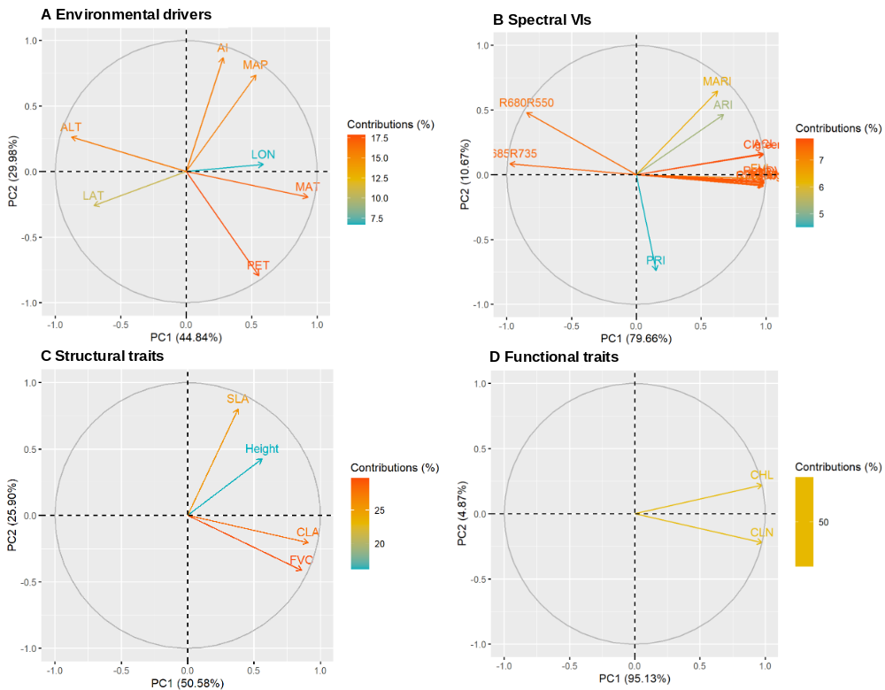
Figure S2. Principal component analyses of (A) environmental drivers, (B) 14 spectral vegetation indices, (C) community structural and (D) functional traits across 18 sites on the Tibetan Plateau
PC, principal component; LON, longitude; LAT, latitude; ALT, altitude; MAT, mean annual temperature; MAP, mean annual precipitation; PET, potential evapotranspiration; AI, aridity index; NDVI, normalized difference vegetation index; EVI, enhanced vegetation index; SR, simple ratio; reNDVI, red-edge NDVI; CI_{green}, chlorophyll index of green; CI_{red edge}, chlorophyll index of red edge; R₇₃₅/R₇₀₀; R₆₈₅/R₇₃₅; R₆₈₀/R₅₅₀; ACI, anthocyanin content index; MTCI, MERIS terrestrial chlorophyll index; MARI, modified anthocyanin reflectance index; ARI, anthocyanin reflectance index; PRI, photochemical reflectance index; FVC, fractional vegetation cover; Height, plant height; SLA, specific leaf area; CLA, community leaf area; CHL, canopy chlorophyll content; CLN, canopy leaf nitrogen concentration.

