Supplemental Figures

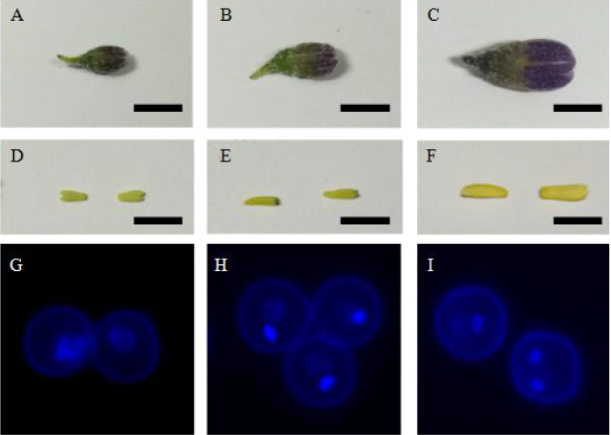

Figure S1. Investigation of different developmental stages of flower buds. A-C, flower buds. D-F, Anthers. G-I microspore staining by DAPI. Tetrad stage (A, D, G), mononucleate stage (B, E, H), binucleate stage (C, F, I). Scale bars represent 5mm.

Figure S2. Ploidy determination of 23 regenerants by flow cytometry. Six lines (SVA4, SVA7, SVA22, SVA23, SVA32, and SVA33) were identified as diploids; their nuclear DNA content was comparable to that of the diploid donor, PI275256. The 17 other regenerants were identified as monoploids since their nuclear DNA content was comparable to that of the monoploid control, GS221 (USDA-ARS, https://www.ars-grin.gov/).

Figure S3. Homozygosity analysis of the 23 anther culture-derived regenerants with 22 donor-polymorphic InDel markers. Polyacrylamide gel electrophoresis (PAGE) of the 22 InDel markers: ‘M’ represents the DL500 DNA marker; ‘D’ and ‘1–23’ represent the donor PI275256 and the 23 regenerated offspring lines (from left to right: SVA1, SVA2, SVA4, SVA5, SVA7, SVA8, SVA9, SVA10, SVA12, SVA14, SVA15, SVA17, SVA18, SVA19, SVA20, SVA21, SVA22, SVA23, SVA28, SVA30, SVA31, SVA32, and SVA33), respectively. For each InDel marker, all the androgenesis-derived lines only possessed one of the parental alleles, indicating that they were homozygous at that locus. * indicates the six diploid lines, SVA4, SVA7, SVA22, SVA23, SVA32, and SVA33.

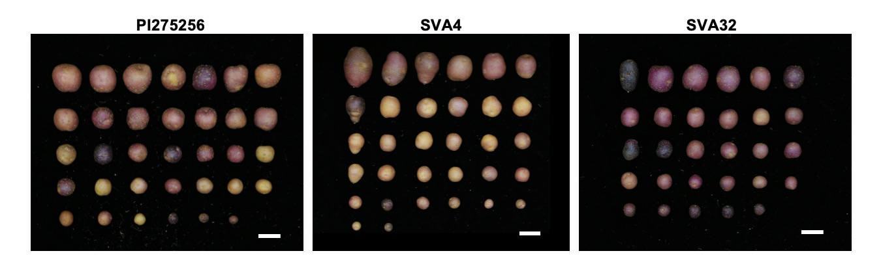
Figure S4. Characteristics of tubers produced by donor line PI275256 and its anther culture-derived diploids, SVA4 and SVA32. Scale bars represent 2 cm.

Supplemental Tables
Line | Average no. of chloroplasts per guard cell | Ploidy
PI275256 | 15.04ª | 2X
SVA1 | 9.12^{b} | 1X
SVA2 | 9.32^{b} | 1X
SVA5 | 8.96^{b} | 1X
SVA8 | 8.83^{b} | 1X
SVA9 | 7.96^{b} | 1X
SVA10 | 8.71^{b} | 1X
SVA12 | 8.5^{b} | 1X
SVA14 | 8.55^{b} | 1X
SVA15 | 7.96^{b} | 1X
SVA17 | 7.72^{b} | 1X
SVA18 | 8.04^{b} | 1X
SVA19 | 7.96^{b} | 1X
SVA20 | 8.24^{b} | 1X
SVA21 | 8.12^{b} | 1X
SVA28 | 8.42^{b} | 1X
SVA30 | 7.16^{b} | 1X
SVA31 | 7.64^{b} | 1X
SVA4 | 15.48ª | 2X
SVA7 | 15.56ª | 2X
SVA22 | 15.28ª | 2X
SVA23 | 15.80ª | 2X
SVA32 | 16.12ª | 2X
SVA33 | 15.60ª | 2X
Table S1. Ploidy determination by counting chloroplast number per guard cell. Average chloroplast number of each regenerated line was calculated by visual examination of 50 stomatal guard cells. Common lowercase letters indicate no significant difference at p = 0.05 (Duncan’s multiple range test).

Line | Ploidy | Raw reads | Read length | Raw Bases | Mean depth | Mapping rate |  |  | Coverage |  |  | Heterozygous SNP number
 |  |  |  |  |  | DM as ref. | SVA19 as ref. |  | DM as ref. | SVA19  as ref. |  | DM, MQ30* | SVA19, MQ30*
PI275256 | 2x | 125,343,328 | 150bp | 18.8G | 22.3× | 55.2% | 27.5% |  | 61.2% | 85.0% |  | 643,461 | 227,598
SVA4 | 2x | 136,889,674 | 150bp | 20.5G | 24.3× | 54.9% | 27.3% |  | 60.7% | 63.5% |  | 322,840 | 226
SVA32 | 2x | 112,182,150 | 150bp | 16.8G | 19.9× | 56.1% | 27.2% |  | 59.7% | 83.8% |  | 271,857 | 3,319
SVA19 | 1x | 113,348,302 | 150bp | 17.0G | 20.1× | - | - |  | - | - |  | - | -

Table S2. Summary of whole-genome resequencing and SNP genotype calling. DM, MQ30* stands for DM1-3 as reference mapping genome and a Mapping Quality of 30; SVA19, MQ30* indicates SVA19 as reference mapping genome with a Mapping Quality of 30.

No. | Marker | Location | Position (Mb) | Forward Primer (5ʹ–3ʹ) | Reverse Primer (5ʹ–3ʹ)
1 | SV1R06 | Chr01 | 57.55 | TCCAAACACCCCTATGTTCC | AAAGTGGAGGACAAATGAGCA
2 | SV2R01 | Chr02 | 14.62 | TGGCAATGGTTATGCTGC | CCCTTCAAATGGTCTTCCAA
3 | SV2R21 | Chr02 | 42.98 | TCCGAGCCTGCTCTGTTT | TCCTCACAGCCCTGTCAAT
4 | SV3R01 | Chr03 | 0.83 | GGCCGGATTAAAGCAGGT | TCTCCGGCTCCTACCAGA
5 | SV3R02 | Chr03 | 8.56 | GCTAGTTGCGTTCACCCG | TGAACAGAAGCCAGATCCAA
6 | SV3R21 | Chr03 | 56.54 | TGAGACGCCATTCTTTTCG | CGCCAATACGAAGCCTTG
7 | SV4R03 | Chr04 | 1.72 | TTGAAGGTTGAAGTGGTGTGA | GGCAGGCAAGAAATCAACA
8 | SV4R09 | Chr04 | 31.87 | TCTCCTGACCACCCTCCA | CGGAATCAGTTTTGGGCTT
9 | SV5R08 | Chr05 | 48.19 | TCCAATTACACCGCCACA | GGGTGAAGCACTTTTTACGTC
10 | SV6R01 | Chr06 | 2.52 | AGGCCAGGGTTTTCCCTT | TGAACCCAAAATGCAACG
11 | SV7R06 | Chr07 | 13.01 | TTCCATAATCGGCCATGC | CCGTAAGGTAGTGCAAAAACG
12 | SV7R18 | Chr07 | 56.58 | GGAATGGAATAGATGGGCAG | GGTTGACCCGCAGTGAAA
13 | SV8R02 | Chr08 | 10.09 | AGTTGGGTTGGGCTGGTT | GAGCTGCTGGCTACTGGAA
14 | SV8R04 | Chr08 | 28.47 | GCAAAGCAGAGTTACTGGCA | AGCATTCGTTCAACAAGGG
15 | SV9R03 | Chr09 | 1.99 | AGCTTTATGCTTTTGTGTCCA | TCAAACGAGGTCCGTGGT
16 | SV10R13 | Chr10 | 56.89 | TAGCATTGTGCGATTGCG | ATCCCAAGAGGGTCACCA
17 | SV11R01 | Chr11 | 0.57 | CGGAAAATGCACACTCTCAA | GAATGGCATGTGAGATTTCCT
18 | SV11R08 | Chr11 | 9.29 | TTGCTATTGGGGTTCTCCTG | AACCCGAGTTCCACCACA
19 | SV11R22 | Chr11 | 41.41 | CGTCCCAGTCTGATGTGG | TGGCCATAACTTGAGCCAAT
20 | SV12R02 | Chr12 | 1.30 | CCAATTGTCCAAACACTTTGA | TGAAGCCTCCACACACCTC
21 | SV12R05 | Chr12 | 3.99 | TGGGCAGCAATAATGCAA | CAAAACCGGGTCCTGCTA
22 | SV12R09 | Chr12 | 52.96 | GTTGCTCACATCCCCTGG | GGCCTTCGCATATTCACG

Table S4. Primers used in this study.

