Drought stress and plant ecotype drive microbiome recruitment in switchgrass rhizosheath
Tie-Yuan Liu^{1,5}, Nenghui Ye⁴, Xinyu Wang¹, Debatosh Das⁵, Yuxiang Tan³, Xiangkai You¹, Mingxiu Long¹, Tianming Hu¹, Lei Dai³, Jianhua Zhang^{5,†} and Mo-Xian Chen^{2,3,†}

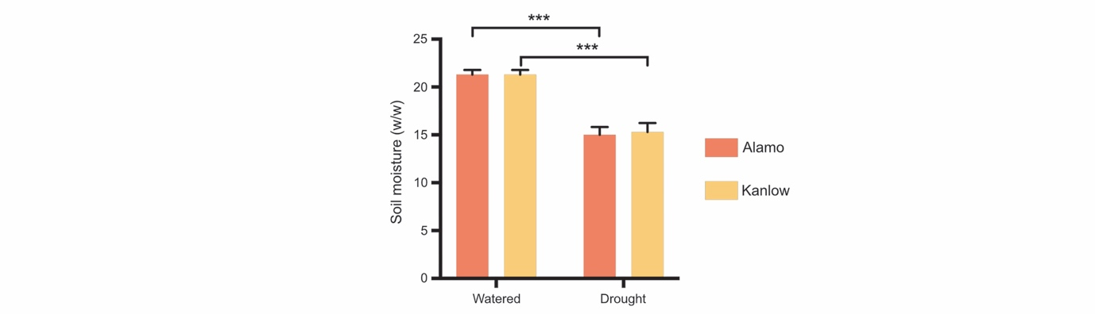
Figure S1. The gravimetric soil water content measured under well-watered and drought conditions
Error bars represent SD values of 10 replicates. ***P < 0.001.

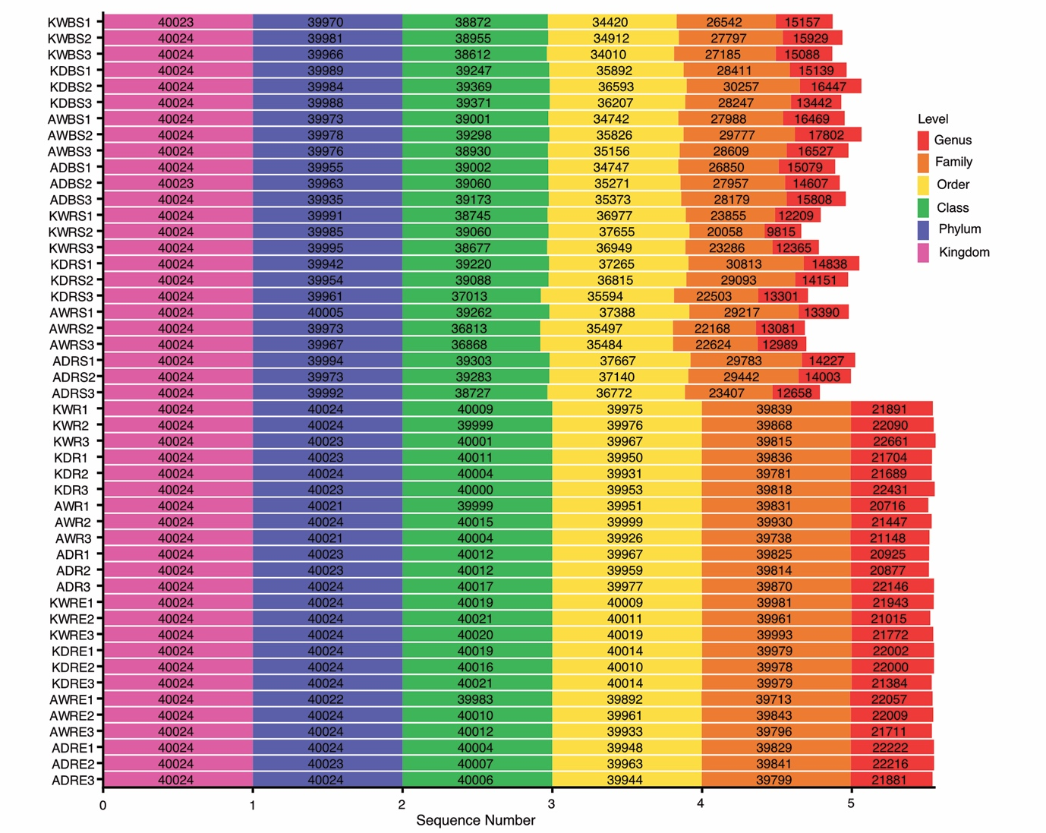
Figure S2. The sequencing quantity for each sample after removing the dubious sequences
The sequence number represents the annotated sequence number at each level. KW, Kanlow under well-watered conditions; KD, Kanlow under drought conditions; AW, Alamo under well-watered conditions; AD, Alamo under drought conditions. BS, bulk soil; RS, rhizosheath soil; R, rhizoplane; RE, root endosphere.

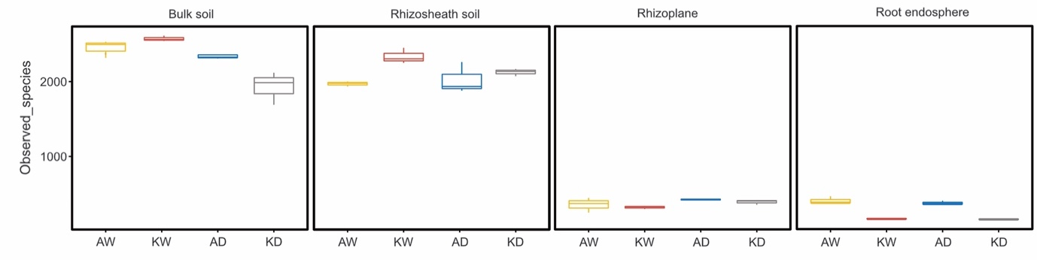
Figure S3. Observed species index representing the change gradient in microbial number from bulk soil to the root endosphere
AW, Alamo under well-watered conditions; KW, Kanlow under well-watered conditions; AD, Alamo under drought conditions; KD, Kanlow under drought conditions.

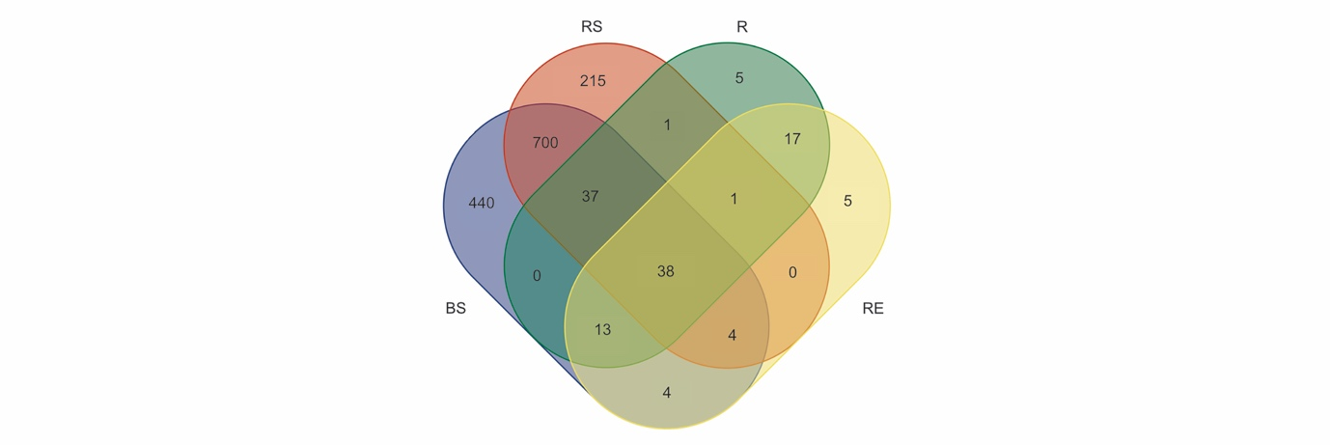
Figure S4. Overlapping and distinct OTUs by four rhizocompartments
Number of OTUs identified from the four rhizocompartments. For each rhizocompartment, we selected OTUs that were shared by Alamo and Kanlow under both well-watered and drought conditions. BS, bulk soil; RS, rhizosheath soil; R, rhizoplane; RE, root endosphere.

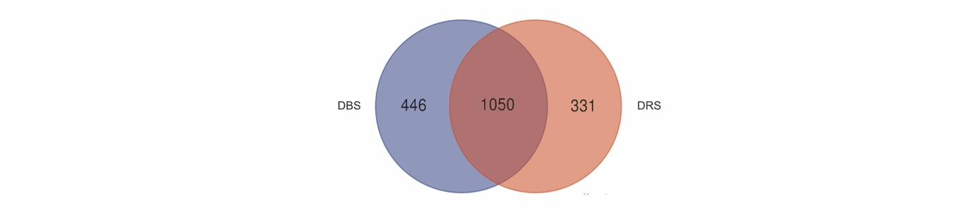
Figure S5. Overlapping and distinct OTUs by drought-treated bulk soil and rhizosheath soil
The selected OTUs in DBS or DRS were shared by Alamo and Kanlow in drought-treated bulk soil or rhizosheath soil, respectively. DBS, drought-treated bulk soil; DRS, drought-treated rhizosheath soil.

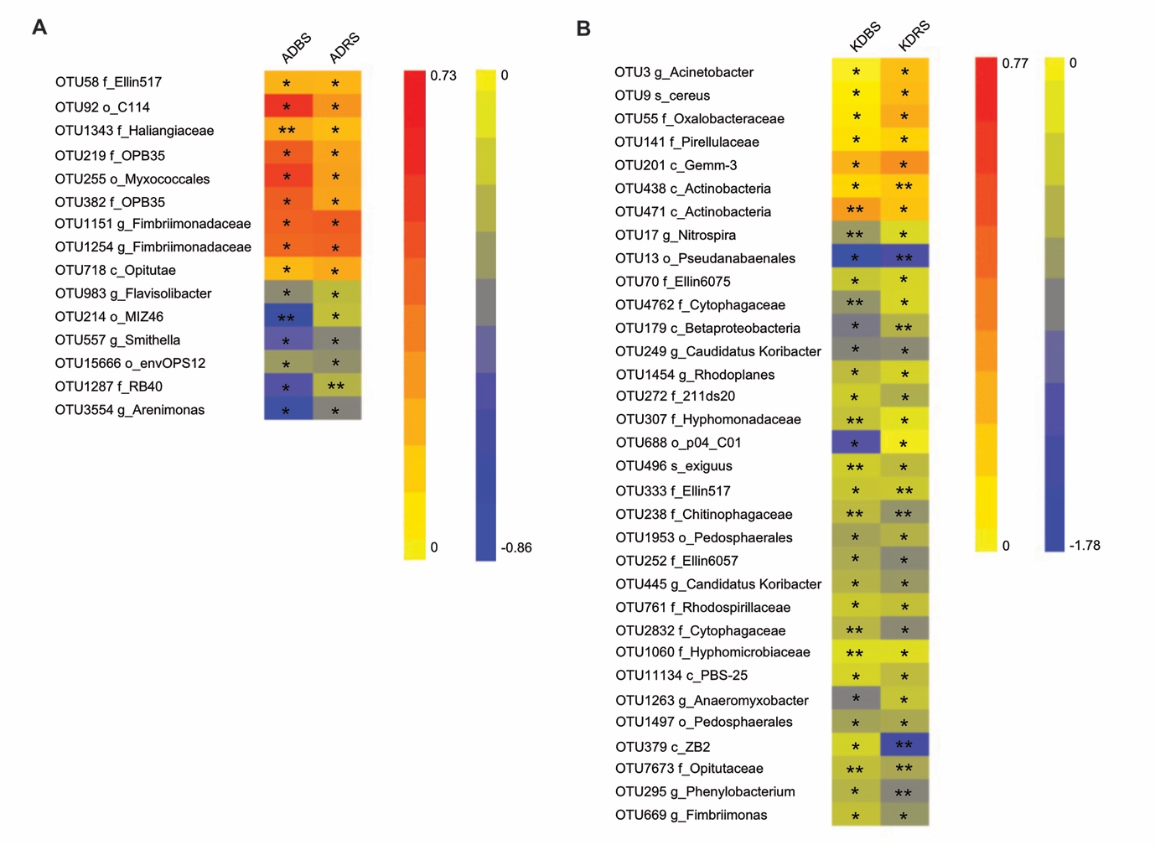
Figure S6. Microbes identified in bulk soil and rhizosheath soil show a consistent response under drought conditions
Microbes with increased or decreased relative abundance under drought conditions of Alamo are shown in (A). Microbes with increased or decreased relative abundance under drought conditions of Kanlow are shown in (B). Log10 values presented here were normalized by well-watered conditions (n=3). Significant differences compared with watered conditions following Student’s t test are denoted by one asterisk (*P < 0.05) or two asterisks (**P < 0.01). A, Alamo; K, Kanlow. BS, bulk soil; RS, rhizosheath soil. W, well-watered; D, drought. The f_, c_, o_, g_ and s_ represent the top-hit annotation level.

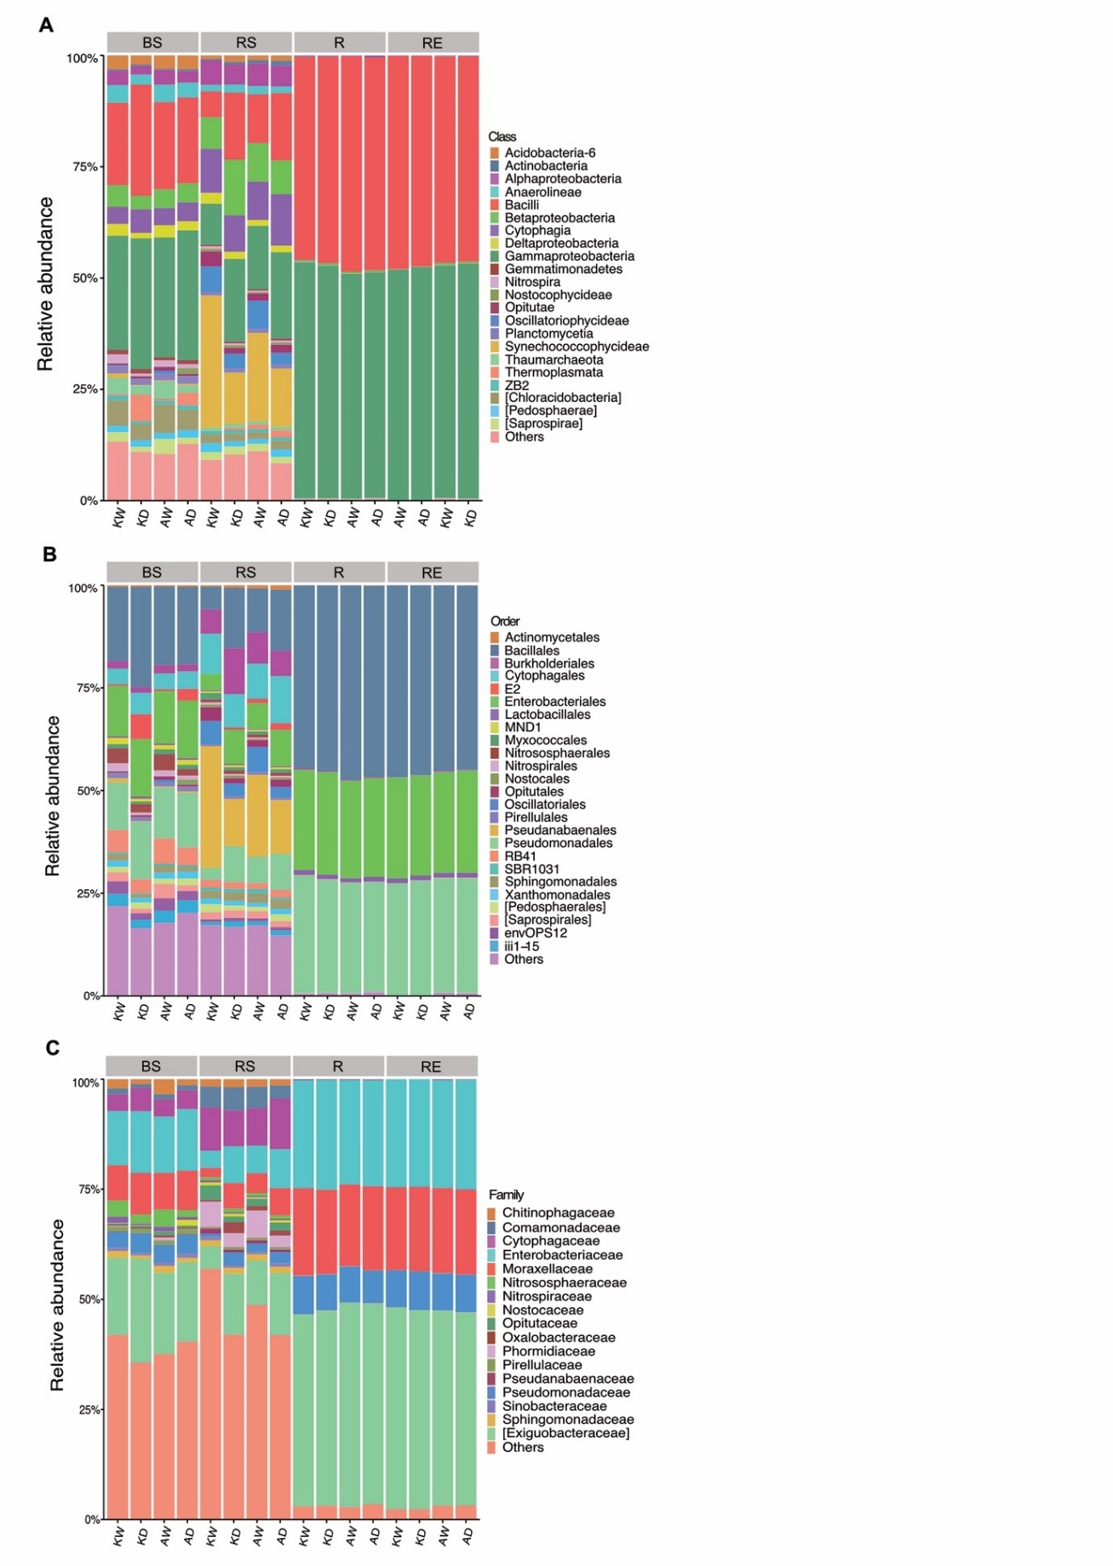
Figure S7. Relative abundances of the most abundant microbes at class (A), order (B) and family (C) level in each group
BS, bulk soil; RS, rhizosheath soil; R, rhizoplane; RE, root endosphere. KW, Kanlow under well-watered conditions; KD, Kanlow under drought conditions; AW, Alamo under well-watered conditions; AD, Alamo under drought conditions.

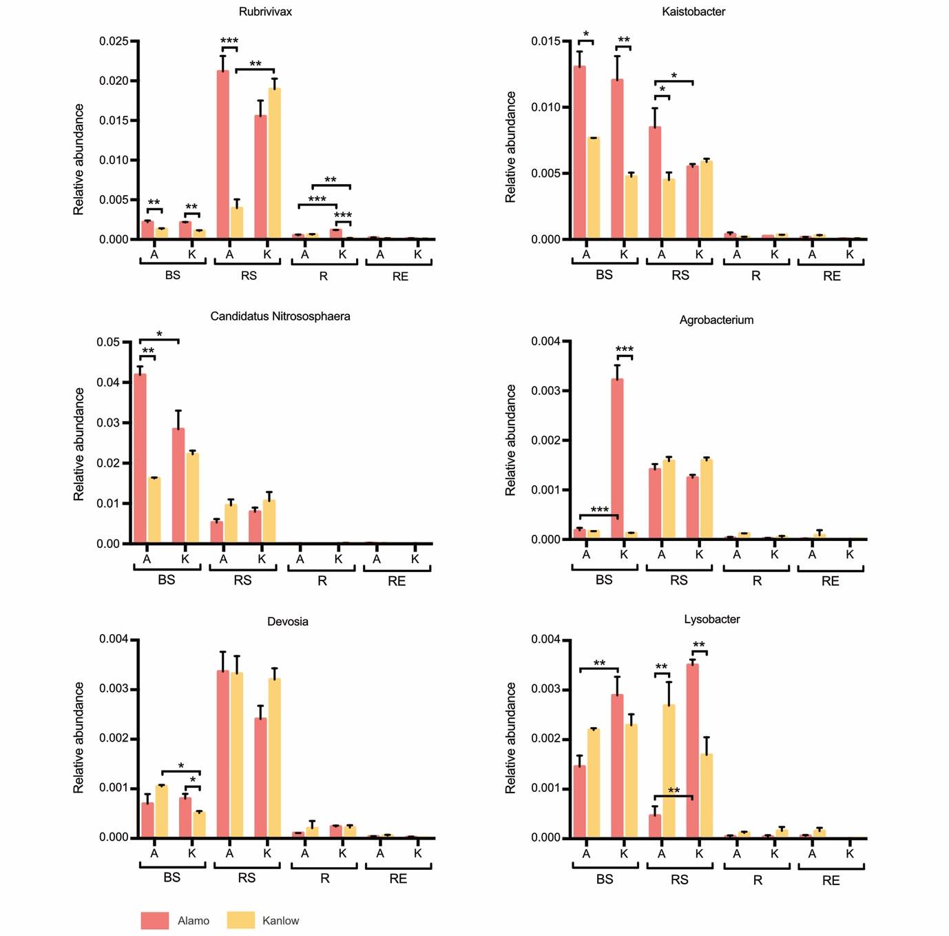

Figure S8. Relative abundance shifts of less abundant genera are affected by drought and plant ecotype
Two-way ANOVA was used to analyze the effects of drought stress and ecotype on relative abundance. Error bars represent SD values of three replicates. *P < 0.05, **P < 0.01 and ***P < 0.001. BS, bulk soil; RS, rhizosheath soil; R, rhizoplane; RE, root endosphere. W, well-watered; D, drought.

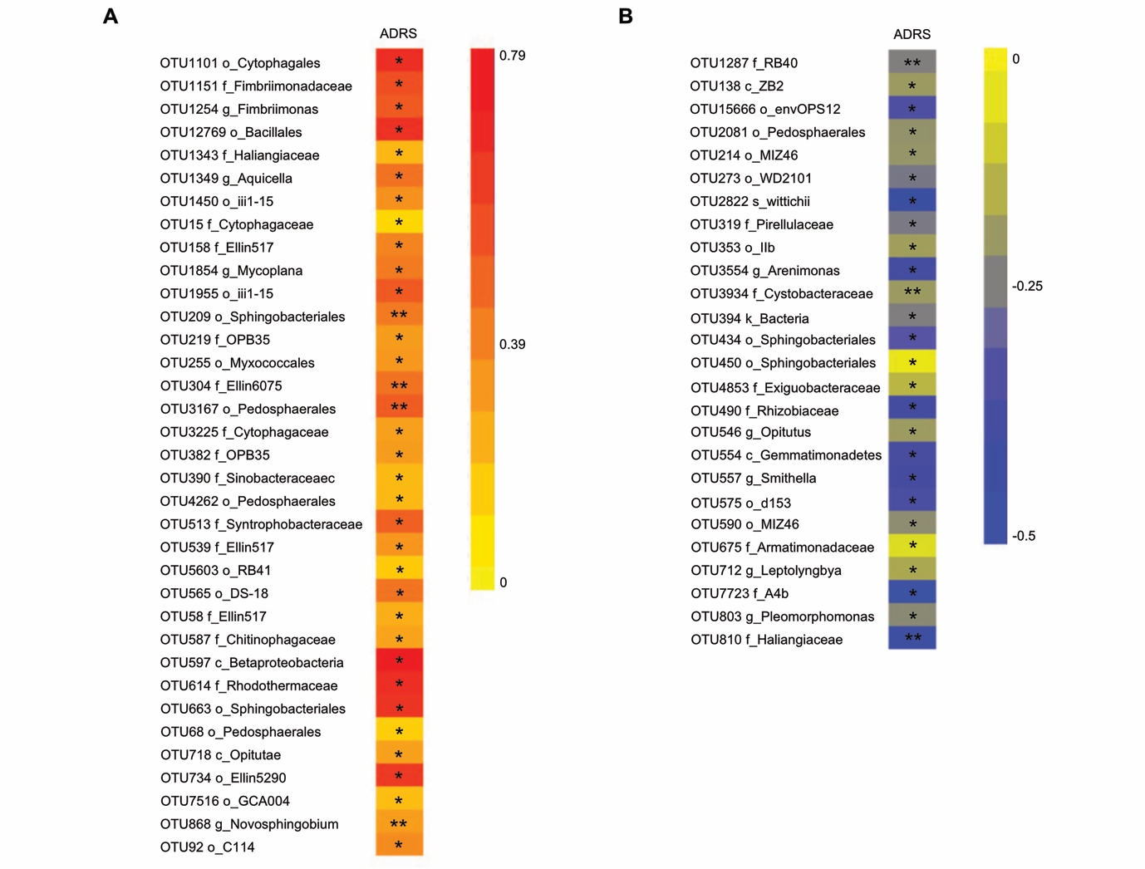
Figure S9. Microbes specifically identified in Alamo rhizosheath soil
(A) Microbes with increased abundance after drought treatment. (B) Microbes with decreased abundance after drought treatment. Log10 values presented here were normalized by well-watered conditions (n=3). Significant differences compared with watered conditions following Student’s t test are denoted by one asterisk (*P < 0.05) or two asterisks (**P < 0.01). A, Alamo. RS, rhizosheath soil. D, drought. The f_, c_, o_, g_ and s_ represent the top-hit annotation level.

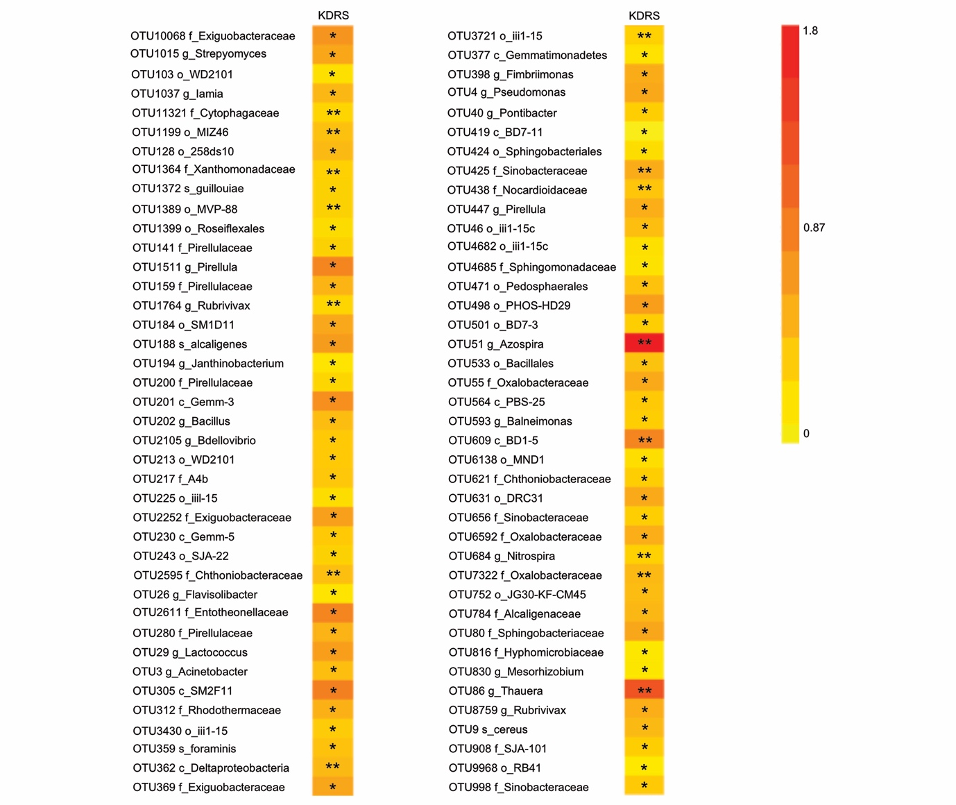
Figure S10. Microbes specifically identified in Kanlow rhizosheath soil had increased abundance after drought treatment
Log10 values presented here were normalized by well-watered conditions (n=3). Significant differences compared with watered conditions following Student’s t test are denoted by one asterisk (*P < 0.05) or two asterisks (**P < 0.01). K, Kanlow. RS, rhizosheath soil. D, drought. The f_, c_, o_, g_ and s_ represent the top-hit annotation level.

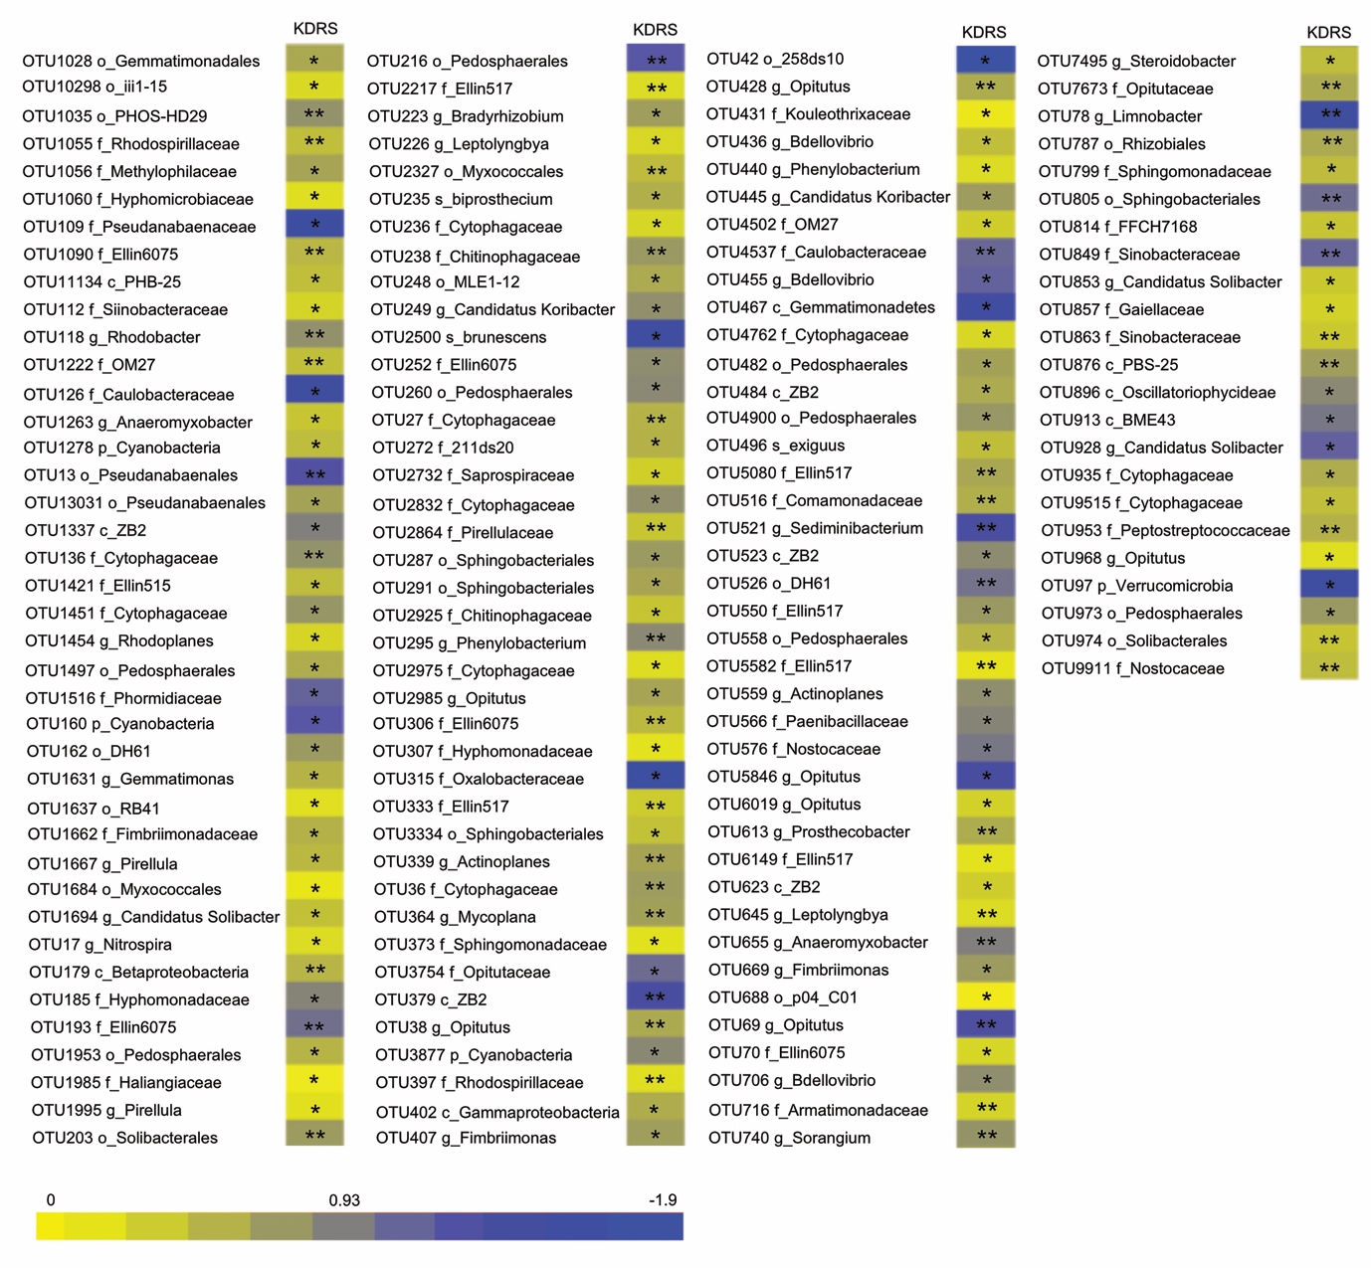
Figure S11. Microbes specifically identified in Kanlow rhizosheath soil had decreased abundance after drought treatment
Log10 values presented here were normalized by well-watered conditions (n=3). Significant differences compared with watered conditions following Student’s t test are denoted by one asterisk (*P < 0.05) or two asterisks (**P < 0.01). K, Kanlow. RS, rhizosheath soil. D, drought. The f_, c_, o_, g_ and s_ represent the top-hit annotation level.

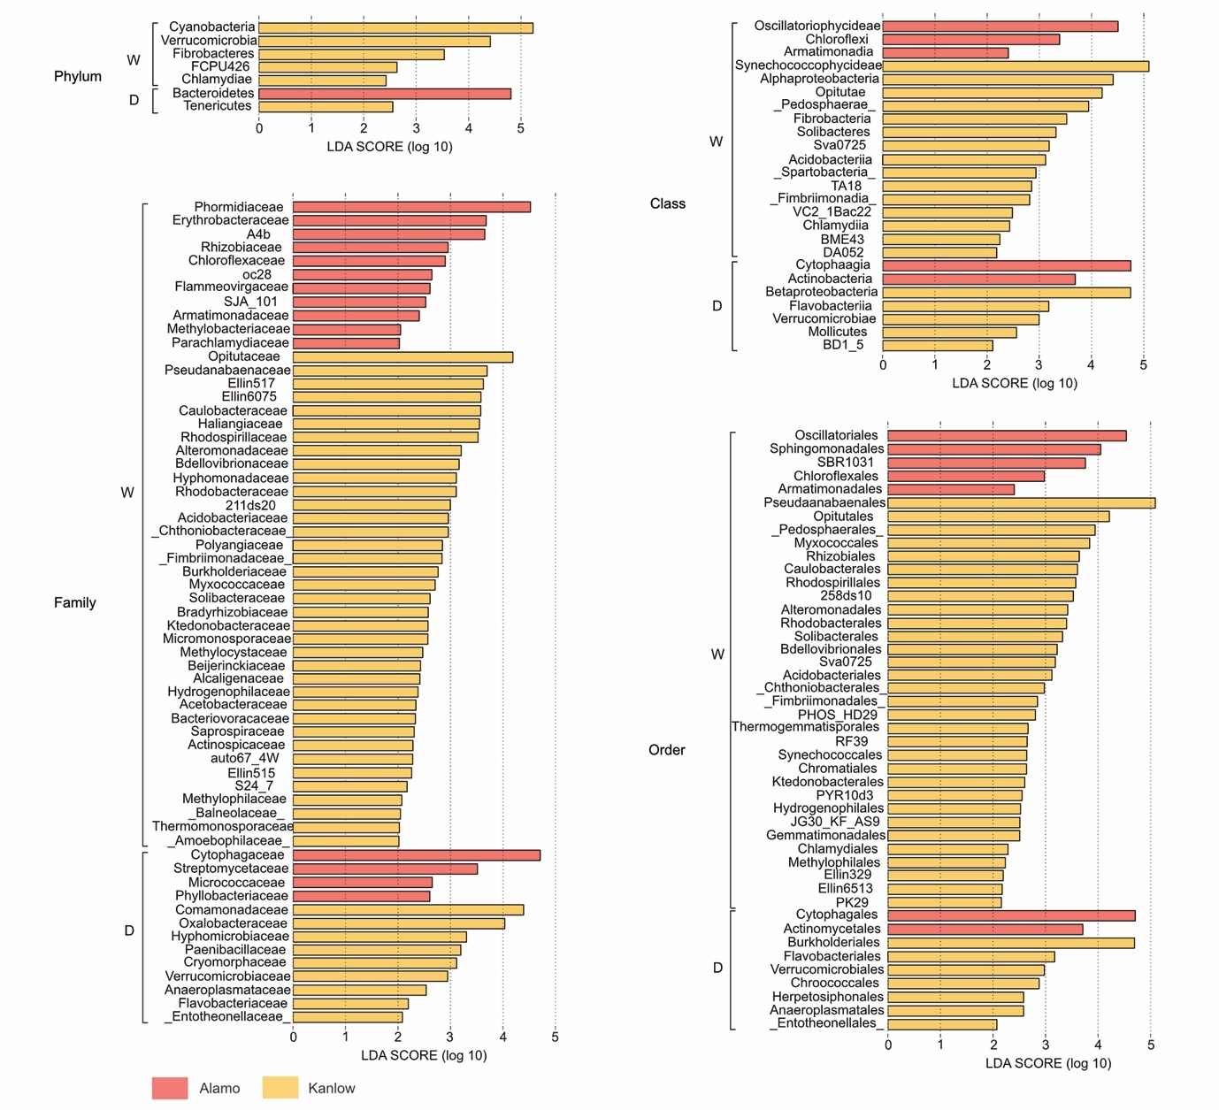
Figure S12. The potential biomarkers identified from phylum level to family level in rhizosheath soil
Linear discriminant analysis of effect size (LEfSe) showing differentially abundant microbes (from phylum level to family level) within drought-treated versus well-watered rhizosheath soil of the two switchgrass ecotypes based on a cut-off of P < 0.05 and an LDA score > 2.0. W represents well-watered conditions, and D represents drought conditions. The length of the bar represents the effect of the corresponding microbe in each group.

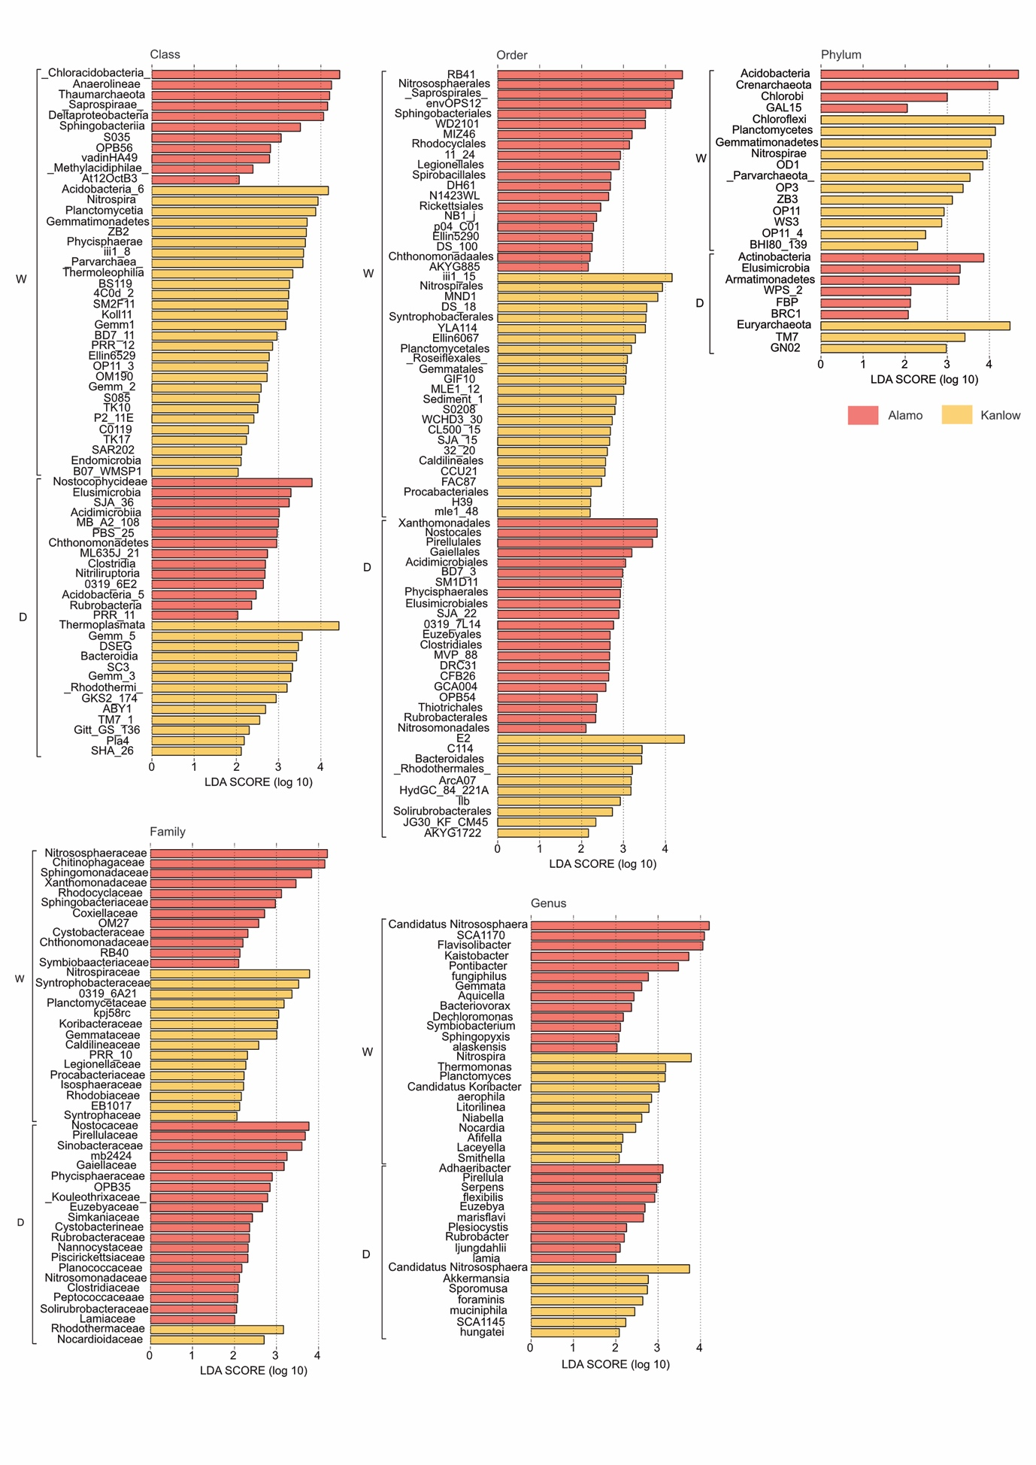
Figure S13. The potential biomarkers identified in bulk soil
Linear discriminant analysis of effect size (LEfSe) showing differentially abundant microbes (from phylum level to genus level) within drought-treated versus well-watered bulk soil of the two switchgrass ecotypes based on a cut-off of P < 0.05 and an LDA score > 2.0. W represents well-watered conditions, and D represents drought conditions. The length of the bar represents the effect of the corresponding microbe in each group.

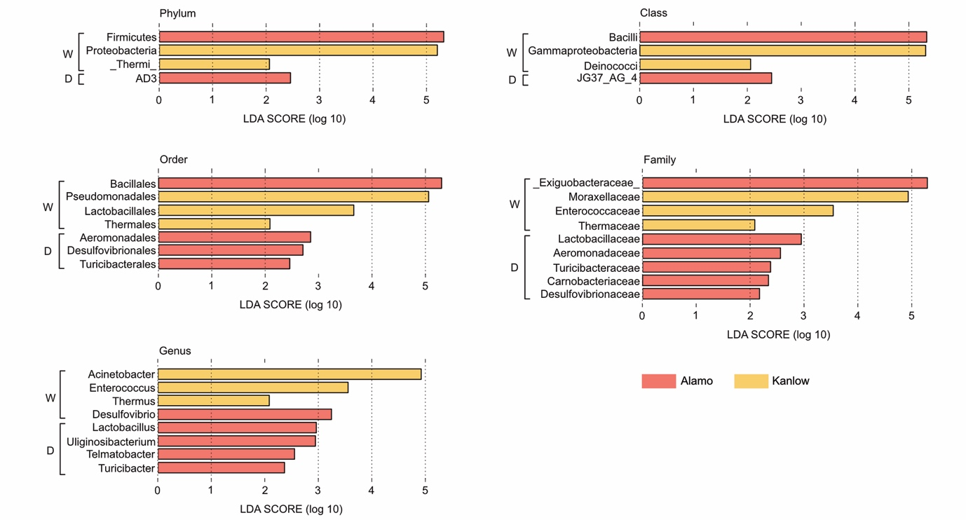
Figure S14. The potential biomarkers identified in rhizoplane
Linear discriminant analysis of effect size (LEfSe) showing differentially abundant microbes (from phylum level to genus level) within drought-treated versus well-watered rhizoplane of the two switchgrass ecotypes based on a cut-off of P < 0.05 and an LDA score > 2.0. W represents well-watered conditions, and D represents drought conditions. The length of the bar represents the effect of the corresponding microbe in each group.

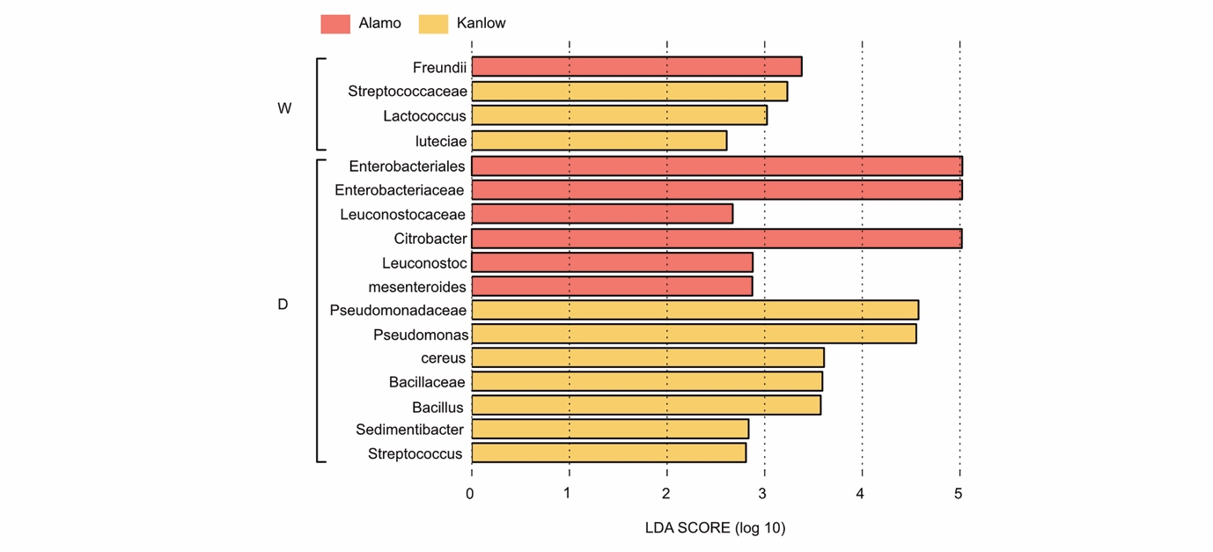
Figure S15. The potential biomarkers identified in root endosphere
Linear discriminant analysis of effect size (LEfSe) showing differentially abundant microbes (from phylum level to genus level) within drought-treated versus well-watered root endosphere of the two switchgrass ecotypes based on a cut-off of P < 0.05 and an LDA score > 2.0. W represents well-watered conditions, and D represents drought conditions. The length of the bar represents the effect of the corresponding microbe in each group.

Table S1. Identification and quantification of OTUs in the16 groups examined in this study

Sample name | No. of OTUs | No. of seqs
KWBS | 2961 | 62990
KDBS | 2314 | 72461
AWBS | 494 | 68649
ADBS | 2734 | 66350
KWRS | 2655 | 53930
KDRS | 2413 | 55583
AWRS | 2197 | 51882
ADRS | 2156 | 46992
KWR | 425 | 69166
KDR | 546 | 69018
AWR | 494 | 68649
ADR | 538 | 60564
KWRE | 206 | 59373
KDRE | 210 | 66972
AWRE | 550 | 66468
ADRE | 535 | 71552
Total | 21428 | 1001393

Table S2. Distinct genera and OTU percentages by well-watered Alamo (AW), drought-treated Alamo (AD), well-watered Kanlow (KW) and drought-treated Kanlow (KD) in rhizosheath soil

Name | No. of OTUs | Percentage | Name | No. of OTUs | Percentage
AW |  |  | AW
Chloronema | 3 | 7.69% | Bdellovibrio | 2 | 5.13%
Clostridium | 2 | 5.13% | Planctomyces | 2 | 5.13%
Sporocytophaga | 2 | 5.13% | Streptomyces | 1 | 2.56%
Sphingopyxis | 1 | 2.56% | Sphingomonas | 1 | 2.56%
Rudanella | 1 | 2.56% | Rhodococcus | 1 | 2.56%
Raoultella | 1 | 2.56% | Pseudomonas | 1 | 2.56%
Pirellula | 1 | 2.56% | Phaeospirillum | 1 | 2.56%
Perlucidibaca | 1 | 2.56% | Paenisporosarcina | 1 | 2.56%
Oscillochloris | 1 | 2.56% | Opitutus | 1 | 2.56%
Methylomicrobium | 1 | 2.56% | Methylobacterium | 1 | 2.56%
Lactococcus | 1 | 2.56% | JG37-AG-70 | 1 | 2.56%
HB2-32-21 | 1 | 2.56% | Gemmata | 1 | 2.56%
Flavisolibacter | 1 | 2.56% | Fimbriimonas | 1 | 2.56%
Cohnella | 1 | 2.56% | Citrobacter | 1 | 2.56%
Chryseobacterium | 1 | 2.56% | Ardenscatena | 1 | 2.56%
Aquicella | 1 | 2.56% | Aquamicrobium | 1 | 2.56%
Adhaeribacter | 1 | 2.56%
KW |  |  | KW
Bdellovibrio | 16 | 10.96% | Planctomyces | 7 | 4.79%
Asteroleplasma | 5 | 3.42% | Lactobacillus | 4 | 2.74%
Candidatus Nitrososphaera | 4 | 2.74% | Candidatus Rhabdochlamydia | 3 | 2.05%
Sporocytophaga | 3 | 2.05% | Phormidium | 3 | 2.05%
Candidatus Koribacter | 3 | 2.05% | Candidatus Solibacter | 2 | 1.37%
Clostridium | 3 | 2.05% | Bacteroides | 1 | 0.43%
Aquicella | 3 | 2.05% | Allobaculum | 3 | 2.05%
Symbiobacterium | 2 | 1.37% | Steroidobacter | 2 | 1.37%
Rhodoplanes | 2 | 1.37% | Raoultella | 2 | 1.37%
Pleomorphomonas | 2 | 1.37% | Opitutus | 2 | 1.37%
Novosphingobium | 2 | 1.37% | Leptolyngbya | 2 | 1.37%
Kaistobacter | 2 | 1.37% | Gemmata | 2 | 1.37%
Gallionella | 2 | 1.37% | Burkholderia | 2 | 1.37%
Azospirillum | 2 | 1.37% | Actinoallomurus | 2 | 1.37%
Candidatus Amoebophilus | 2 | 1.37% | Candidatus Xiphinematobacter | 1 | 0.68%
Variovorax | 1 | 0.68% | Turicibacter | 1 | 0.68%
Thiobacillus | 1 | 0.68% | Telmatospirillum | 1 | 0.68%
Tatlockia | 1 | 0.68% | Sutterella | 1 | 0.68%
Sulfuritalea | 1 | 0.68% | Silvimonas | 1 | 0.68%
SHD-14 | 1 | 0.68% | Salinispora | 1 | 0.68%
Ruminococcus | 1 | 0.68% | Rhodocytophaga | 1 | 0.68%
Rhodobacter | 1 | 0.68% | Rhodanobacter | 1 | 0.68%
Pseudomonas | 1 | 0.68% | Prosthecobacter | 1 | 0.68%
Prevotella | 1 | 0.68% | Polaromonas | 1 | 0.68%
Plesiocystis | 1 | 0.68% | Pirellula | 1 | 0.68%
Phenylobacterium | 1 | 0.68% | Pedosphaera | 1 | 0.68%
Pedomicrobium | 1 | 0.68% | Parachlamydia | 1 | 0.68%
Oscillospira | 1 | 0.68% | OR-59 | 1 | 0.68%
Nostoc | 1 | 0.68% | Mycobacterium | 1 | 0.68%
Methylophaga | 1 | 0.68% | Methylibium | 1 | 0.68%
Merismopedia | 1 | 0.68% | Lysobacter | 1 | 0.68%
Luteibacter | 1 | 0.68% | Kibdelosporangium | 1 | 0.68%
Hyphomonas | 1 | 0.68% | Hyphomicrobium | 1 | 0.68%
Hydrogenophaga | 1 | 0.68% | HB2-32-21 | 1 | 0.68%
Haliangium | 1 | 0.68% | Flavihumibacter | 1 | 0.68%
Fimbriimonas | 1 | 0.68% | Euzebya | 1 | 0.68%
Cylindrospermopsis | 1 | 0.68% | Conexibacter | 1 | 0.68%
Cloacibacterium | 1 | 0.68% | Chondromyces | 1 | 0.68%
Chloronema | 1 | 0.68% | Bryobacter | 1 | 0.68%
Alicyclobacillus | 1 | 0.68% | Acidocella | 1 | 0.68%
Acidicapsa | 1 | 0.68% | Achromobacter | 1 | 0.68%
A17 | 1 | 0.68%
AD |  |  | AD
Planctomyces | 4 | 13.79% | Citrobacter | 4 | 13.79%
Flavisolibacter | 2 | 6.90% | Bacillus | 2 | 6.90%
Acinetobacter | 2 | 6.90% | Xenophilus | 1 | 3.45%
Symbiobacterium | 1 | 3.45% | Rhodoplanes | 1 | 3.45%
Ralstonia | 1 | 3.45% | Pseudomonas | 1 | 3.45%
Paenibacillus | 1 | 3.45% | Nocardioides | 1 | 3.45%
Lysobacter | 1 | 3.45% | Erythrobacter | 1 | 3.45%
Chitinophaga | 1 | 3.45% | Bdellovibrio | 1 | 3.45%
Asteroleplasma | 1 | 3.45% | Ardenscatena | 1 | 3.45%
Altererythrobacter | 1 | 3.45% | Afifella | 1 | 3.45%
KD |  |  | KD
Citrobacter | 5 | 8.06% | Pirellula | 4 | 6.45%
Clostridium | 4 | 6.45% | Pseudomonas | 3 | 4.84%
Bdellovibrio | 3 | 4.84% | Rubrobacter | 2 | 3.23%
Rhodoplanes | 2 | 3.23% | Planctomyces | 2 | 3.23%
Paenibacillus | 2 | 3.23% | Flavisolibacter | 2 | 3.23%
Asteroleplasma | 2 | 3.23% | Akkermansia | 2 | 3.23%
Candidatus Nitrososphaera | 2 | 3.23% | Candidatus Xiphinematobacter | 1 | 1.61%
Thermobaculum | 1 | 1.61% | Streptomyces | 1 | 1.61%
Stenotrophomonas | 1 | 1.61% | Staphylococcus | 1 | 1.61%
Sphingopyxis | 1 | 1.61% | Skermanella | 1 | 1.61%
Pontibacter | 1 | 1.61% | Pilimelia | 1 | 1.61%
Oxalobacter | 1 | 1.61% | Nocardia | 1 | 1.61%
Methanosarcina | 1 | 1.61% | Kocuria | 1 | 1.61%
Kaistobacter | 1 | 1.61% | Inquilinus | 1 | 1.61%
Gemmata | 1 | 1.61% | Caloramator | 1 | 1.61%
Candidatus Koribacter | 1 | 1.61% | Candidatus Entotheonella | 1 | 1.61%
Caldilinea | 1 | 1.61% | Brevibacillus | 1 | 1.61%
Bacteriovorax | 1 | 1.61% | Azohydromonas | 1 | 1.61%
Aquicella | 1 | 1.61% | Adhaeribacter | 1 | 1.61%
Acinetobacter | 1 | 1.61% | A17 | 1 | 1.61%

Table S3. Distinct genera and OTU percentages by well-watered Alamo (AW), drought-treated Alamo (AD), well-watered Kanlow (KW) and drought-treated Kanlow (KD) in rhizoplane

Name | No. of OTUs | Percentage | Name | No. of OTUs | Percentage
AW |  |  | AW
Acinetobacter | 2 | 12.50% | Citrobacter | 2 | 12.50%
Adhaeribacter | 1 | 6.25% | Alicyclobacillus | 1 | 6.25%
Bdellovibrio | 1 | 6.25% | Brachybacterium | 1 | 6.25%
Chryseobacterium | 1 | 6.25% | Leuconostoc | 1 | 6.25%
Mesorhizobium | 1 | 6.25% | Methylibium | 1 | 6.25%
Planctomyces | 1 | 6.25% | Pseudomonas | 1 | 6.25%
Sinorhizobium | 1 | 6.25% | Steroidobacter | 1 | 6.25%
KW |  |  | KW
Citrobacter | 3 | 10.71% | Acinetobacter | 1 | 3.57%
Actinoplanes | 1 | 3.57% | Arthrospira | 1 | 3.57%
Azospirillum | 1 | 3.57% | Bdellovibrio | 1 | 3.57%
Chondromyces | 1 | 3.57% | Corallococcus | 1 | 3.57%
Devosia | 1 | 3.57% | Haliangium | 1 | 3.57%
Hyphomicrobium | 1 | 3.57% | Kaistobacter | 1 | 3.57%
Lactobacillus | 1 | 3.57% | Leptolyngbya | 1 | 3.57%
Mycoplana | 1 | 3.57% | Novosphingobium | 1 | 3.57%
Opitutus | 1 | 3.57% | Oscillospira | 1 | 3.57%
Pirellula | 1 | 3.57% | Planctomyces | 1 | 3.57%
Propionibacterium | 1 | 3.57% | Rhodoplanes | 1 | 3.57%
Rubellimicrobium | 1 | 3.57% | Skermanella | 1 | 3.57%
Sorangium | 1 | 3.57% | Sphingomonas | 1 | 3.57%
AD |  |  | AD
Lactobacillus | 4 | 6.06% | Allobaculum | 3 | 4.55%
Citrobacter | 3 | 4.55% | Planctomyces | 3 | 4.55%
Acinetobacter | 2 | 3.03% | Burkholderia | 2 | 3.03%
Gallionella | 2 | 3.03% | Novosphingobium | 2 | 3.03%
Phenylobacterium | 2 | 3.03% | Rhodoplanes | 2 | 3.03%
Candidatus Solibacter | 2 | 3.03% | Candidatus Xiphinematobacter | 1 | 1.52%
Prevotella | 1 | 1.52% | Acidovorax | 1 | 1.52%
Actinoallomurus | 1 | 1.52% | Alkanindiges | 1 | 1.52%
Altererythrobacter | 1 | 1.52% | Aquicella | 1 | 1.52%
Arenimonas | 1 | 1.52% | Balneimonas | 1 | 1.52%
Bdellovibrio | 1 | 1.52% | Conexibacter | 1 | 1.52%
Coprobacillus | 1 | 1.52% | Desulfovibrio | 1 | 1.52%
Dyadobacter | 1 | 1.52% | Enterococcus | 1 | 1.52%
Flavisolibacter | 1 | 1.52% | Luteibacter | 1 | 1.52%
Lysobacter | 1 | 1.52% | Mycobacterium | 1 | 1.52%
Mycoplana | 1 | 1.52% | Oscillospira | 1 | 1.52%
Paenibacillus | 1 | 1.52% | Paucimonas | 1 | 1.52%
Pedosphaera | 1 | 1.52% | Prevotella | 1 | 1.52%
Candidatus Koribacter | 1 | 1.52% | Phascolarctobacterium | 1 | 1.52%
Pseudomonas | 1 | 1.52% | Pseudonocardia | 1 | 1.52%
Rhodanobacter | 1 | 1.52% | Rhodobacter | 1 | 1.52%
Sphingopyxis | 1 | 1.52% | Streptococcus | 1 | 1.52%
Sulfuritalea | 1 | 1.52% | Telmatobacter | 1 | 1.52%
Thiobacillus | 1 | 1.52% | Turicibacter | 1 | 1.52%
Uliginosibacterium | 1 | 1.52% | Yonghaparkia | 1 | 1.52%
KD |  |  | KD
Citrobacter | 5 | 19.23% | 5-7N15 | 1 | 3.85%
Acinetobacter | 1 | 3.85% | Aeromicrobium | 1 | 3.85%
Aquimonas | 1 | 3.85% | Bacillus | 1 | 3.85%
Bdellovibrio | 1 | 3.85% | Caldilinea | 1 | 3.85%
Cohnella | 1 | 3.85% | Euzebya | 1 | 3.85%
Flavisolibacter | 1 | 3.85% | Flavobacterium | 1 | 3.85%
Glycomyces | 1 | 3.85% | Mesorhizobium | 1 | 3.85%
Methylocaldum | 1 | 3.85% | Mycoplana | 1 | 3.85%
Nevskia | 1 | 3.85% | Nonomuraea | 1 | 3.85%
Plesiocystis | 1 | 3.85% | Pseudomonas | 1 | 3.85%
Rubrivivax | 1 | 3.85% | Sporosarcina | 1 | 3.85%

Table S4. Distinct genera and OTU percentages by well-watered Alamo (AW), drought-treated Alamo (AD), well-watered Kanlow (KW) and drought-treated Kanlow (KD) in root endosphere

Name | No. of OTUs | Percentage | Name | No. of OTUs | Percentage
AW |  |  | AW
Citrobacter | 4 | 10.26% | Acinetobacter | 2 | 5.13%
Cupriavidus | 2 | 5.13% | Pseudomonas | 2 | 5.13%
Thermomonas | 2 | 5.13% | Adhaeribacter | 1 | 2.56%
Anaeromyxobacter | 1 | 2.56% | Bacillus | 1 | 2.56%
Bdellovibrio | 1 | 2.56% | Bradyrhizobium | 1 | 2.56%
BSV43 | 1 | 2.56% | Corallococcus | 1 | 2.56%
Candidatus Koribacter | 1 | 2.56% | Candidatus Nitrososphaera | 1 | 2.56%
Dechloromonas | 1 | 2.56% | Flavisolibacter | 1 | 2.56%
Haliangium | 1 | 2.56% | Hydrogenophaga | 1 | 2.56%
Kaistobacter | 1 | 2.56% | Lactococcus | 1 | 2.56%
Luteolibacter | 1 | 2.56% | Mesorhizobium | 1 | 2.56%
Methylobacterium | 1 | 2.56% | Opitutus | 1 | 2.56%
Paenibacillus | 1 | 2.56% | Paenisporosarcina | 1 | 2.56%
Phenylobacterium | 1 | 2.56% | Planctomyces | 1 | 2.56%
Pseudonocardia | 1 | 2.56% | Smithella | 1 | 2.56%
Sporocytophaga | 1 | 2.56% | Steroidobacter | 1 | 2.56%
KW |  |  | KW
Acinetobacter | 2 | 25.00% | CF231 | 1 | 12.50%
Kocuria | 1 | 12.50% | Methylibium | 1 | 12.50%
Prevotella | 1 | 12.50% | Propionibacterium | 1 | 12.50%
Pseudomonas | 1 | 12.50%
AD |  |  | AD
Citrobacter | 4 | 10.00% | Pseudomonas | 3 | 7.50%
Bdellovibrio | 2 | 5.00% | Chryseobacterium | 2 | 5.00%
Prevotella | 1 | 2.50% | Achromobacter | 1 | 2.50%
Acinetobacter | 1 | 2.50% | Aeromicrobium | 1 | 2.50%
Agromyces | 1 | 2.50% | Arenimonas | 1 | 2.50%
Bacillus | 1 | 2.50% | Caldilinea | 1 | 2.50%
Candidatus Koribacter | 1 | 2.50% | Candidatus Nitrososphaera | 1 | 2.50%
Cohnella | 1 | 2.50% | Dactylosporangium | 1 | 2.50%
Flavobacterium | 1 | 2.50% | Gemmata | 1 | 2.50%
Glycomyces | 1 | 2.50% | Haliangium | 1 | 2.50%
Kribbella | 1 | 2.50% | Leuconostoc | 1 | 2.50%
Mesorhizobium | 1 | 2.50% | Microbacterium | 1 | 2.50%
Mycoplana | 1 | 2.50% | Nevskia | 1 | 2.50%
Nitrospira | 1 | 2.50% | Paenibacillus | 1 | 2.50%
Novosphingobium | 1 | 2.50% | Phascolarctobacterium | 1 | 2.50%
Planctomyces | 1 | 2.50% | Sphingomonas | 1 | 2.50%
Sporosarcina | 1 | 2.50%
KD |  |  | KD
Acinetobacter | 3 | 20.00% | Bacillus | 2 | 13.33%
Azospirillum | 1 | 6.67% | Bifidobacterium | 1 | 6.67%
Citrobacter | 1 | 6.67% | Deinococcus | 1 | 6.67%
Enterococcus | 1 | 6.67% | guillouiae | 1 | 6.67%
Paracoccus | 1 | 6.67% | Pseudomonas | 1 | 6.67%
Sedimentibacter | 1 | 6.67% | Staphylococcus | 1 | 6.67%

Table S5. Overlapping genera and OTU percentages by well-watered Alamo, drought-treated Alamo, well-watered Kanlow and drought-treated Kanlow in each rhizocompartment

Name | No. of OTUs | Percentage | Name | No. of OTUs | Percentage
Rhizosheath soil |  |  | Rhizosheath soil
Kaistobacter | 12 | 5.11% | Dactylosporangium | 1 | 0.43%
Candidatus Nitrososphaera | 11 | 4.68% | Aeromicrobium | 1 | 0.43%
Opitutus | 11 | 4.68% | Pseudonocardia | 1 | 0.43%
Pirellula | 9 | 3.83% | Niabella | 1 | 0.43%
Planctomyces | 9 | 3.83% | Niastella | 1 | 0.43%
Leptolyngbya | 8 | 3.40% | Pontibacter | 1 | 0.43%
Flavisolibacter | 7 | 2.98% | Rhodocytophaga | 1 | 0.43%
Bdellovibrio | 7 | 2.98% | Sporocytophaga | 1 | 0.43%
Citrobacter | 7 | 2.98% | Crocinitomix | 1 | 0.43%
Bacillus | 6 | 2.55% | Chloronema | 1 | 0.43%
Candidatus Koribacter | 5 | 2.13% | Phormidium | 1 | 0.43%
Fimbriimonas | 5 | 2.13% | Pseudanabaena | 1 | 0.43%
Gemmata | 5 | 2.13% | Alicyclobacillus | 1 | 0.43%
Pseudomonas | 5 | 2.13% | Cohnella | 1 | 0.43%
Paenibacillus | 4 | 1.70% | Paenisporosarcina | 1 | 0.43%
Nitrospira | 4 | 1.70% | Enterococcus | 1 | 0.43%
Mycoplana | 4 | 1.70% | Lactococcus | 1 | 0.43%
Devosia | 4 | 1.70% | Clostridium | 1 | 0.43%
Rhodoplanes | 4 | 1.70% | BSV43 | 1 | 0.43%
Mesorhizobium | 4 | 1.70% | Arthrospira | 1 | 0.43%
Acinetobacter | 4 | 1.70% | Asticcacaulis | 1 | 0.43%
Rubellimicrobium | 3 | 1.28% | Balneimonas | 1 | 0.43%
Methylibium | 3 | 1.28% | Bradyrhizobium | 1 | 0.43%
Rubrivivax | 3 | 1.28% | Hyphomicrobium | 1 | 0.43%
Steroidobacter | 3 | 1.28% | Agrobacterium | 1 | 0.43%
Lysobacter | 3 | 1.28% | Sinorhizobium | 1 | 0.43%
Candidatus Solibacter | 2 | 0.85% | Afifella | 1 | 0.43%
Actinoplanes | 2 | 0.85% | Rhodobacter | 1 | 0.43%
Streptomyces | 2 | 0.85% | Novosphingobium | 1 | 0.43%
Rubrobacter | 2 | 0.85% | Sphingobium | 1 | 0.43%
Sediminibacterium | 2 | 0.85% | Acidovorax | 1 | 0.43%
Adhaeribacter | 2 | 0.85% | Delftia | 1 | 0.43%
Streptococcus | 2 | 0.85% | Hydrogenophaga | 1 | 0.43%
Phenylobacterium | 2 | 0.85% | Leptothrix | 1 | 0.43%
Pleomorphomonas | 2 | 0.85% | Limnobacter | 1 | 0.43%
Phaeospirillum | 2 | 0.85% | Limnohabitans | 1 | 0.43%
Sphingomonas | 2 | 0.85% | Janthinobacterium | 1 | 0.43%
Azoarcus | 2 | 0.85% | Dechloromonas | 1 | 0.43%
Anaeromyxobacter | 2 | 0.85% | Peredibacter | 1 | 0.43%
Sorangium | 2 | 0.85% | Corallococcus | 1 | 0.43%
Thermomonas | 2 | 0.85% | Plesiocystis | 1 | 0.43%
DA101 | 2 | 0.85% | Smithella | 1 | 0.43%
Luteolibacter | 2 | 0.85% | Cellvibrio | 1 | 0.43%
Iamia | 1 | 0.43% | Aquicella | 1 | 0.43%
Phycicoccus | 1 | 0.43% | Asteroleplasma | 1 | 0.43%
Agromyces | 1 | 0.43% | OR-59 | 1 | 0.43%
Arthrobacter | 1 | 0.43% | Prosthecobacter | 1 | 0.43%
Rhizoplane |  |  | Rhizoplane
Citrobacter | 12 | 18.46% | Acinetobacter | 10 | 15.38%
Pseudomonas | 3 | 4.62% | Bacillus | 5 | 7.69%
Kaistobacter | 3 | 4.62% | Lactococcus | 2 | 3.08%
Streptococcus | 2 | 3.08% | Rubrivivax | 2 | 3.08%
Devosia | 2 | 3.08% | Enterococcus | 1 | 1.54%
Limnohabitans | 1 | 1.54% | Thermus | 1 | 1.54%
Anoxybacillus | 1 | 1.54% | Geobacillus | 1 | 1.54%
Nitrospira | 1 | 1.54% | Thermomonas | 1 | 1.54%
Janthinobacterium | 1 | 1.54% | Sphingobium | 1 | 1.54%
Stenotrophomonas | 1 | 1.54% | Phormidium | 1 | 1.54%
Lactobacillus | 1 | 1.54% | Agrobacterium | 1 | 1.54%
Staphylococcus | 1 | 1.54% | Steroidobacter | 1 | 1.54%
Cellvibrio | 1 | 1.54% | Flavisolibacter | 1 | 1.54%
Opitutus | 1 | 1.54% | Rhodobacter | 1 | 1.54%
Streptomyces | 1 | 1.54% | Gloeocapsopsis | 1 | 1.54%
Enhydrobacter | 1 | 1.54% | Methylibium | 1 | 1.54%
Sorangium | 1 | 1.54%
Root endosphere |  |  | Root endosphere
Citrobacter | 13 | 25.49% | Acinetobacter | 11 | 21.57%
Pseudomonas | 3 | 5.88% | Bacillus | 2 | 3.92%
Lactococcus | 2 | 3.92% | Streptococcus | 2 | 3.92%
Rubrivivax | 2 | 3.92% | Enterococcus | 1 | 1.96%
Limnohabitans | 1 | 1.96% | Thermus | 1 | 1.96%
Anoxybacillus | 1 | 1.96% | Kaistobacter | 1 | 1.96%
Geobacillus | 1 | 1.96% | Delftia | 1 | 1.96%
Janthinobacterium | 1 | 1.96% | Stenotrophomonas | 1 | 1.96%
Phormidium | 1 | 1.96% | Agrobacterium | 1 | 1.96%
Lactobacillus | 1 | 1.96% | Cellvibrio | 1 | 1.96%
Halomonas | 1 | 1.96% | Gloeocapsopsis | 1 | 1.96%
Enhydrobacter | 1 | 1.96%

