SUPPORTING INFORMATIONS

Regulation of root secondary metabolites by partial root-associated microbiotas under the shaping of licorice ecotypic differentiation in northwest China

Yang Liu¹, Hao Wang¹, Ziheng Peng, Da Li, Weimin Chen, Shuo Jiao*, Gehong Wei*

State Key Laboratory of Crop Stress Biology for Arid Areas, Shaanxi Key Laboratory of Agricultural and Environmental Microbiology, College of Life Science, Northwest A&F University, Yangling, Shaanxi 712100, People's Republic of China

The supporting information includes twelve tables and seven figures
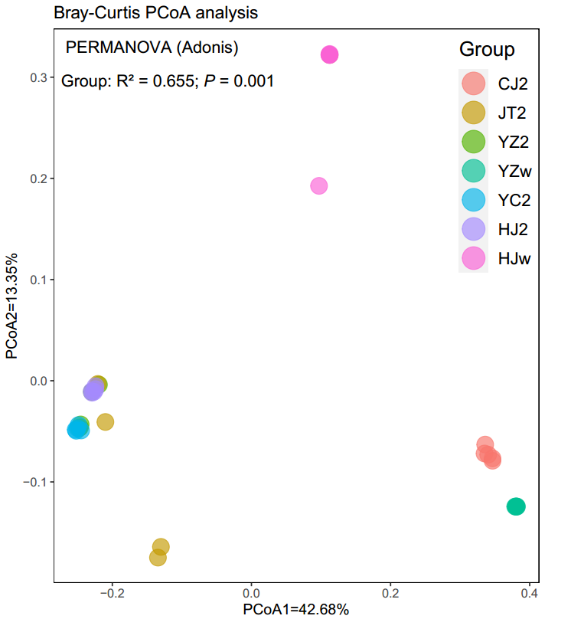
Figure S1. Composition of the plant community among different sampling groups using principal coordinates analysis (PCoA) based on Bray-Curtis distances
The degree of variation explained by the group (R²) and the significance (P values) according to the permutational multivariate analysis of variance (PERMANOVA) are provided. The significance analysis was based on 999 permutation tests. CJ, Changji (Xinjiang); JT, Jinta (Gansu); YZ, Yuzhong (Gansu); YC, Yanchi (Ningxia); HJ, Hangjinqi (Neimeng). 2, licorice cultivated for two years; w, wild licorice.

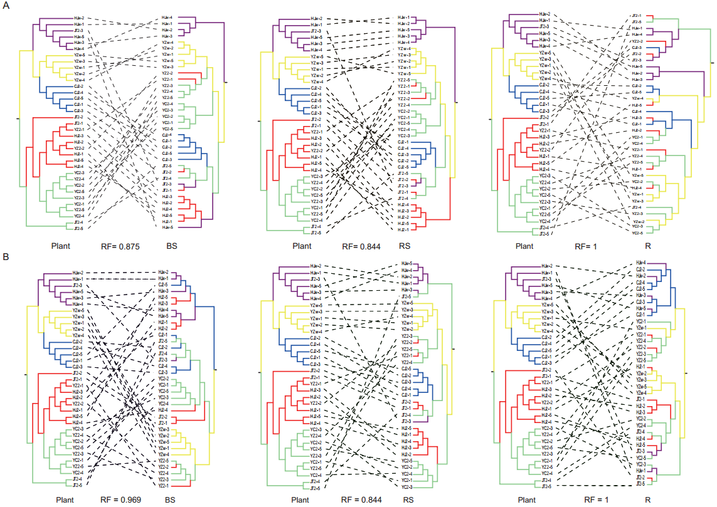
Figure S2. Cophylogenetic trees of licorice and dendrograms ehierarchical clustering based on Unweighted-Unifrac distances of (A) bacterial and (B) fungal microbial communities
Different colors represent different clades. RF, Robinson-Foulds scores; Plant, licorice plant community; BS, bulk soil; RS, rhizosphere soil; R, root endosphere.
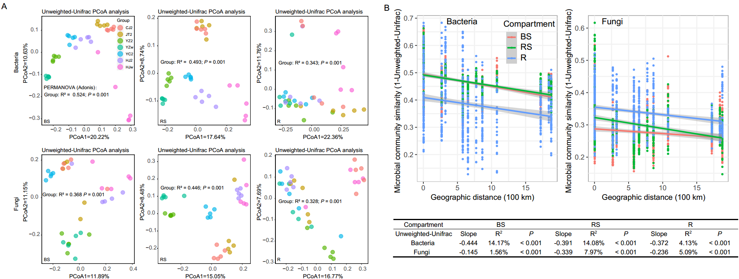
Figure S3. Microbial community composition and dynamics
(A) Microbial community composition among different sampling groups using principal coordinates analysis (PCoA) based on Unweighted-Unifrac distances. The degree of variation explained by the group (R²) and the significance (P-values) according to permutational multivariate analysis of variance (PERMANOVA) are provided. The significance analysis was based on 999 permutation tests. The definitions for the abbreviations are available in Fig. S1. (B) Distance–decay relationships between the microbial community similarity (1 − Unweighted-Unifrac distance) and the geographic distance among the bulk soil and two root-associated compartments across all samples. The rate of microbial community turnover (slopes) with geographic distance; and the fitting degree (R²) and significance (P-values) of the linear fitting model are provided. The shaded region represents the 95% confidence limits of the regression estimates. Abbreviations are available in Figure S2.
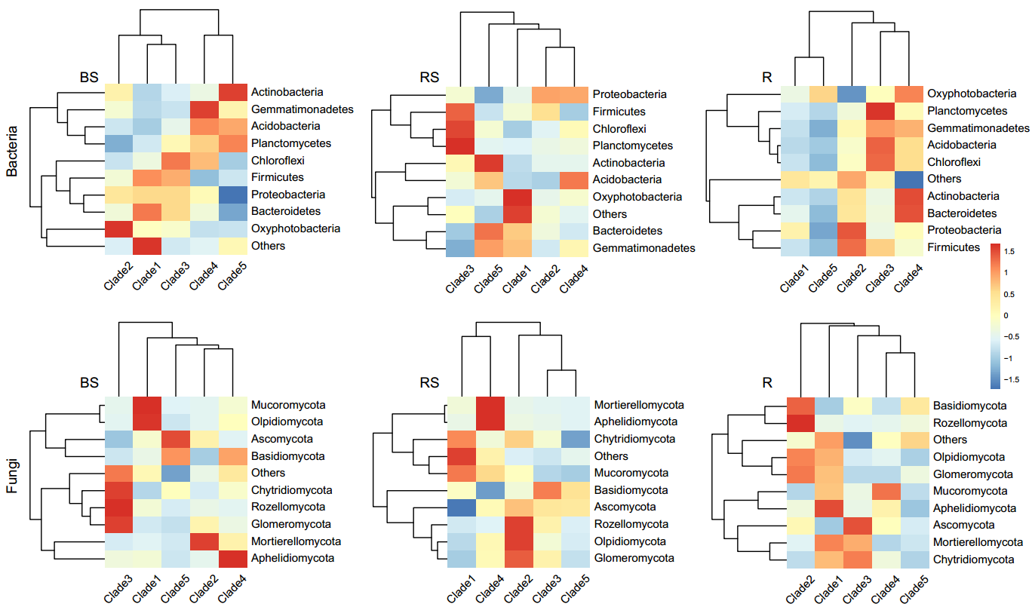
Figure S4. Heatmaps showing the relative abundance of the dominant (top 10) phyla of the microbial communities across the bulk soil and two root-associated compartments among different licorice clades. Abbreviations are available in Figure S2
“Clades” refers to the division of plants according to ecotypic differentiation.
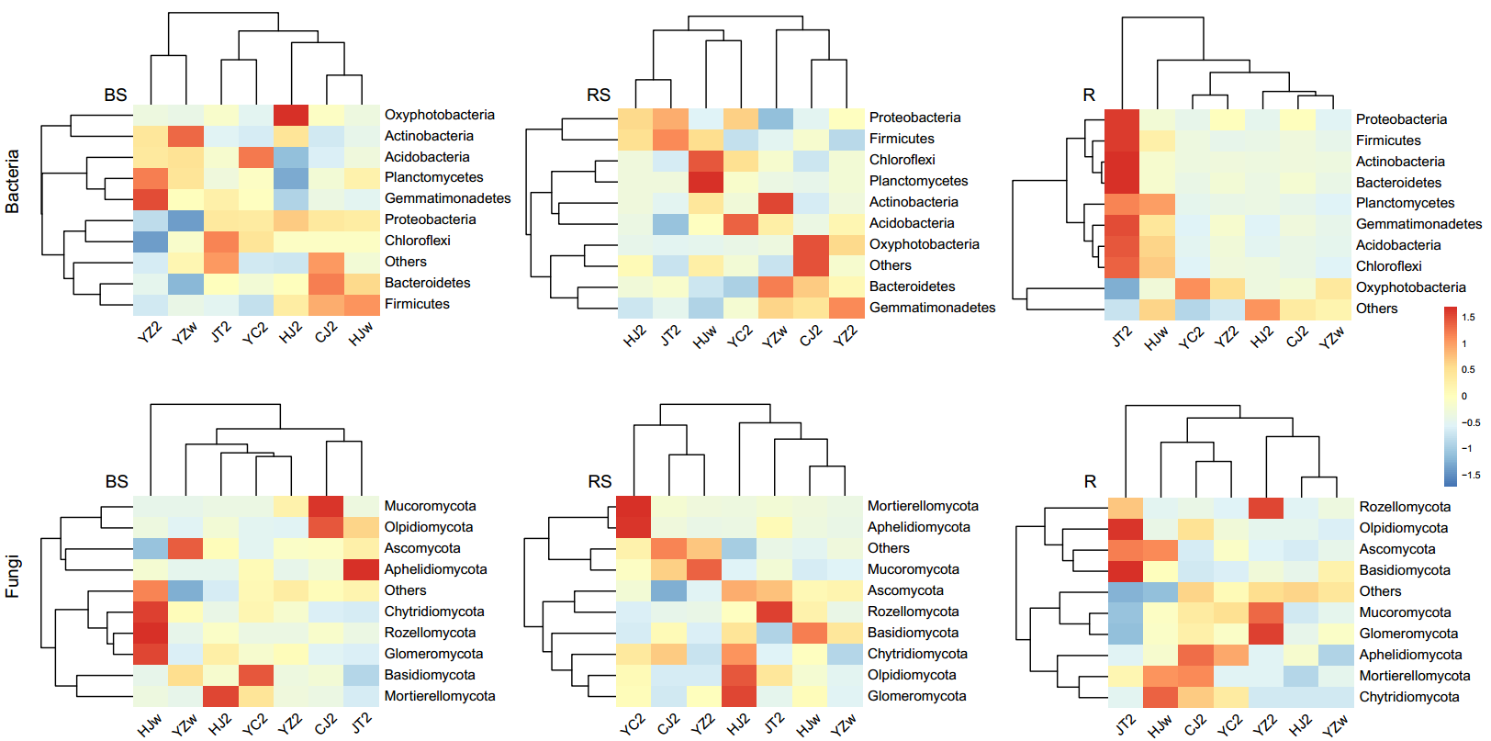
Figure S5. Heatmaps showing the relative abundance of the dominant (top 10) phyla of the microbial communities across the bulk soil and two root-associated compartments among the different sampling groups
Abbreviations are available in Figs. S1 and S2.
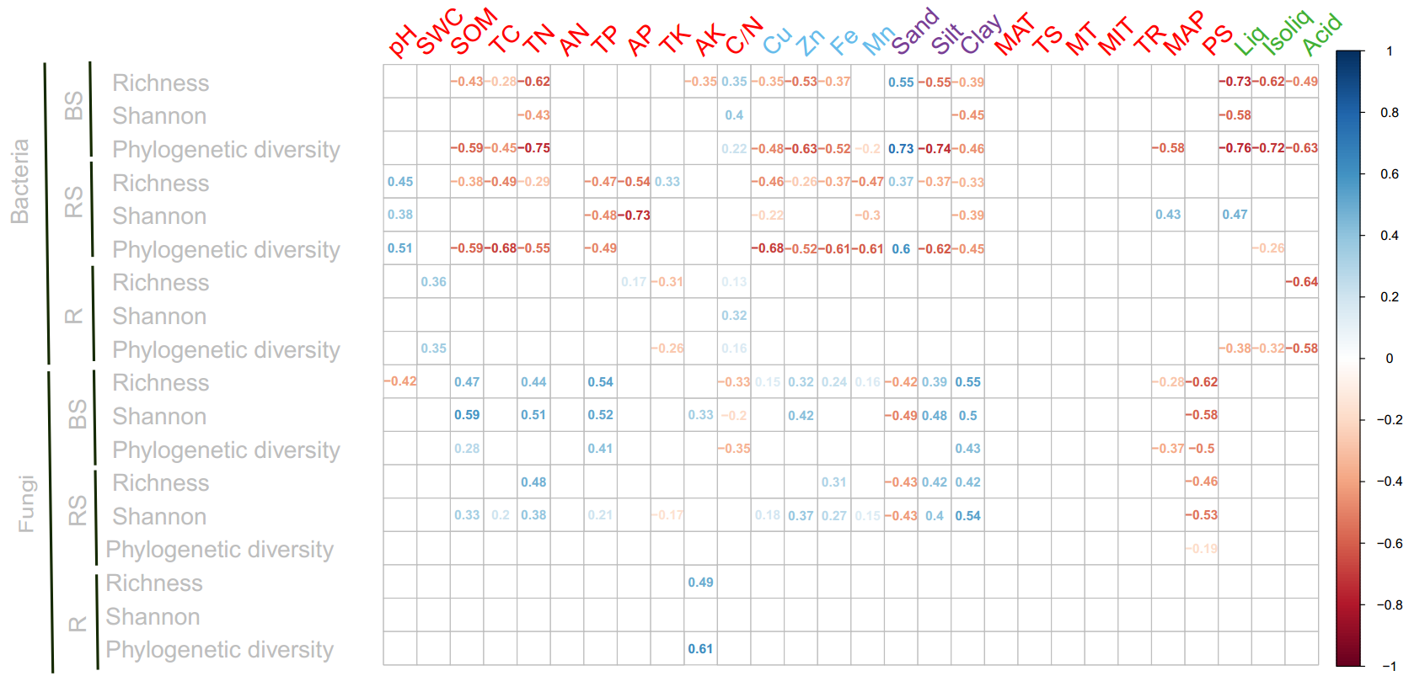
Figure S6. Correlations between microbial alpha diversity indices and edaphic properties, climatic characteristics and root secondary metabolites
The blue and red fonts represent positive and negative coefficients, respectively. Nonsignificant correlations (P > 0.05) are not illustrated. The red font indicates soil primary nutrients and climatic characteristics; the blue font indicates soil micronutrients; the purple font indicates soil texture; and the green font indicates root secondary metabolites.
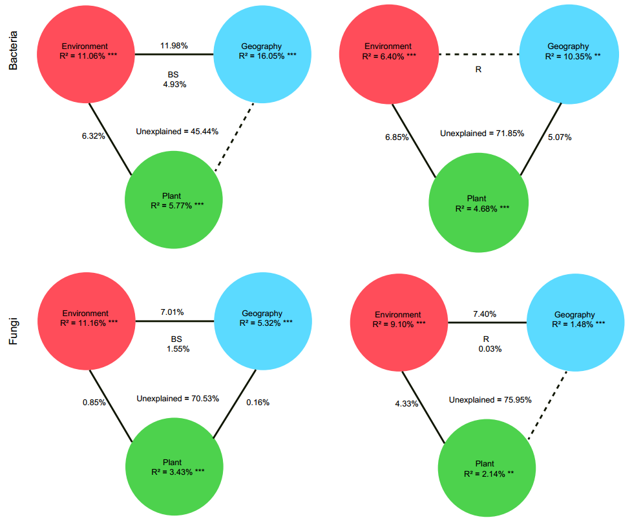
Figure S7. Variation partitioning analysis (VPA) showing the effects of environmental and geographic factors, and plant community, on the microbial community composition in the bulk soil (BS) and root endosphere (R)
Values indicate the percentage of variation significantly explained by each section. The variation explained by single factors corresponds to the effect on the microbial community without the effect of the other factors according to ANOVA permutation tests. ***, P < 0.001; **, P < 0.05; dotted lines, P > 0.05.

Table S1. Summary of the soil types, locations and climatic characteristics of the selected sampling sites in northwestern China
Sites | CJ | JT | YZ | YC | HJ
Soil types | Gray desert | Gray desert | Podsol | Sierozem | Brown desert
GPS coordinates
Latitude (° N) | 44.28 | 40.14 | 36.15 | 37.81 | 39.8
Longitude (° E) | 87.1 | 98.89 | 104.33 | 107.28 | 108.97
Climatic characteristics
MAT(°C) | 9.1 | 8.8 | 6.2 | 7.5 | 6
TS (°C) | 1368.2 | 1113.4 | 901 | 1034.7 | 1129.2
MT(°C) | 33.1 | 30.3 | 23.9 | 27.9 | 27.2
MIT (°C) | -16.5 | -14.8 | -13.9 | -14.9 | -17.2
TR (°C) | 49.6 | 45.1 | 37.8 | 42.8 | 44.4
MAP (mm) | 166 | 75 | 361 | 296 | 314
PS (mm) | 40 | 84 | 87 | 93 | 109
Note: CJ, Changji (Xinjiang); JT, Jinta (Gansu); YZ, Yuzhong (Gansu); YC, Yanchi (Ningxia); HJ, Hangjinqi (Neimeng). MAT, Mean Annual Temperature; TS, Temperature Seasonality; MT, Maximum Temperature of Warmest Month; MIT, Minimum Temperature of Coldest Month; TR, Temperature Annual Range; MAP, Mean Annual Precipitation; PS, Precipitation Seasonality.
Table S2. The differences in the licorice plant community between distinct sampling groups based on pairwise F_{ST} values
Groups | CJ2 | HJ2 | HJw | JT2 | YC2 | YZw | YZ2
CJ2 | - | 0.213 | 0.223 | 0.125 | 0.228 | 0.173 | 0.201
HJ2 | 0.213 | - | 0.217 | 0.034 | 0.062 | 0.32 | 0.011
HJw | 0.223 | 0.217 | - | 0.107 | 0.239 | 0.369 | 0.209
JT2 | 0.125 | 0.034 | 0.107 | - | 0.047 | 0.207 | 0.022
YC2 | 0.228 | 0.062 | 0.239 | 0.047 | - | 0.339 | 0.002
YZw | 0.173 | 0.32 | 0.369 | 0.207 | 0.339 | - | 0.307
YZ2 | 0.201 | 0.011 | 0.209 | 0.022 | 0.002 | 0.307 | -
Note: CJ, Changji (Xinjiang); JT, Jinta (Gansu); YZ, Yuzhong (Gansu); YC, Yanchi (Ningxia); HJ, Hangjinqi (Neimeng). 2, Licorice cultivated for two years; w, wild licorice.
Table S3. Spearman correlations between the licorice plant community, environmental (edaphic and climatic) factors and geographic distances determined using (partial) Mantel tests

Correlation between licorice plant dissimilarity (Bray-Curtis) and: | r | P
Environmental distance | 0.070 | 0.113
Geographic distance | 0.288 | 0.001
Controlling for:
Geographic distance | -0.007 | 0.502
Environmental distance | 0.280 | 0.001
Edaphic distance | 0.077 | 0.09
Climatic distance | 0.078 | 0.111
Controlling for:
Climatic distance | 0.063 | 0.127
Edaphic distance | 0.065 | 0.153
Note: Environmental distance is the environmental heterogeneity (including edaphic and climatic) matrix calculated with Euclidean, and geographic distance is the geographic distance matrix. Edaphic and climatic distances are the soil chemical properties and climate characteristics heterogeneity matrices calculated with Euclidean. Bold values indicate P < 0.05. P-values are one-tailed tests based on 999 permutations.
Table S4. Spearman correlations between the licorice plant community (Bray-Curtis distances), and edaphic, climatic and geographic factors determined using Mantel tests.
Variables | r | P | Variables | r | P
pH | 0.055 | 0.18 | Sand | 0.023 | 0.226
SWC | 0.028 | 0.262 | Silt | 0.020 | 0.235
SOM | -0.038 | 0.746 | Clay | 0.012 | 0.345
TC | 0.108 | 0.012 | MAT | 0.090 | 0.06
TN | 0.009 | 0.382 | TS | 0.080 | 0.099
AN | 0.299 | 0.001 | MT | 0.044 | 0.192
TP | 0.017 | 0.325 | MIT | 0.093 | 0.048
AP | 0.222 | 0.003 | TR | 0.043 | 0.18
TK | 0.086 | 0.06 | MAP | 0.187 | 0.005
AK | 0.095 | 0.049 | PS | 0.122 | 0.021
C/N | 0.114 | 0.042 | Lontitude | 0.288 | 0.001
Cu | -0.022 | 0.642 | Latitude | 0.266 | 0.001
Zn | 0.022 | 0.318
Fe | 0.021 | 0.288
Mn | 0.058 | 0.133
Note: pH, soil pH; SWC, soil water content; SOM, soil organic matter; TC, total carbon; TN, total nitrogen; AN, available nitrogen; TP, total phosphorus; AP, available phosphorus; TK, total potassium; AK, available potassium; C/N, total carbon/nitrogen ratio; Cu, copper; Zn, zinc; Fe, iron and Mn, manganese; MAT, Mean Annual Temperature; TS, Temperature Seasonality; MT, Maximum Temperature of Warmest Month; MIT, Minimum Temperature of Coldest Month; TR, Temperature Annual Range; MAP, Mean Annual Precipitation; PS, Precipitation Seasonality. Bold values indicate P < 0.05. P-values are one-tailed tests based on 999 permutations.
Table S5. The variation in licorice plant community explained by the significantly correlated edaphic, climatic and geographic factors in the multiple regression models (using the first axis of the principal coordinates analysis [PCoA1] based on Bray-Curtis distances)
Variables | Plant community (%)
TC | 3.27
AN | 24.82
AP
AK
C/N | 14.72
MIT
MAP | 11.16
PS | 8.15
Lontitude
Latitude
Total model | (R² = 76.4%, P < 0.001)
Note: TC, total carbon; AN, available nitrogen; AP, available phosphorus; AK, available potassium; C/N, total carbon/nitrogen ratio; MIT, Minimum Temperature of Coldest Month; MAP, Mean Annual Precipitation; PS, Precipitation Seasonality.NA: not statistically significant (P > 0.05).
Table S6. Spearman correlations between the licorice plant community (Bray-Curtis distances) and microbial alpha diversity (based on three alpha diversity indices) determined using Mantel tests
Bacterial alpha diversity | Richness |  |  | Shannon |  |  | Phylogenetic diversity
Compartment | BS | RS | R | BS | RS | R | BS | RS | R
r | 0.140 | -0.032 | 0.043 | 0.140 | 0.079 | 0.012 | 0.155 | -0.030 | 0.063
P | 0.009 | 0.672 | 0.239 | 0.015 | 0.098 | 0.378 | 0.008 | 0.676 | 0.118
Fungal alpha diversity | Richness |  |  | Shannon |  |  | Phylogenetic diversity
Compartment | BS | RS | R | BS | RS | R | BS | RS | R
r | -0.010 | -0.023 | 0.025 | -0.005 | -0.025 | 0.032 | 0.004 | -0.030 | 0.024
P | 0.556 | 0.612 | 0.269 | 0.497 | 0.648 | 0.257 | 0.431 | 0.650 | 0.261
Note: Bold values indicate P < 0.05. P-values are one-tailed tests based on 999 permutations. BS, bulk soil; RS, rhizosphere soil; R, root endosphere.
Table S7. Alpha diversity of the bulk soil and licorice root-associated microbial communities across different plant community clades in northwestern China

Type |  | Bacteria |  |  | Fungi
Compartments | Clades | Richness | Shannon | Phylogenetic diversity | Richness | Shannon | Phylogenetic diversity
BS | 1 | 2715.2±186.75 a | 9.39±0.83 ab | 216.41±10.56 a | 1060±278.33 ab | 6.91±0.73 ab | 406.6±112.6 a
BS | 2 | 2793±309.34 a | 9.77±0.21 b | 208.84±25.38 a | 746.44±241.38 c | 5.48±1.44 bcd | 279.12±86.93 bcd
BS | 3 | 2427.5±339.68 ac | 9.52±0.27 ab | 195.05±13.9 a | 811.83±180.95 bc | 5.98±1.18 ad | 349.68±58.56 ab
BS | 4 | 2531.5±248.7 ab | 9.57±0.26 ab | 188.65±18.75 ab | 1119.6±137.86 a | 7.25±0.22 a | 419.92±59.08 a
BS | 5 | 2127.6±32.2 bcd | 9.21±0.1 ab | 151.31±2.94 cd | 873.2±134.8 ac | 6.37±0.5 ac | 323.26±51.19 ac
RS | 1 | 1632.2±357.04 e | 7.27±1.38 d | 132.18±24.96 cd | 590.2±127.42 c | 4.91±1.07 bcd | 194.97±52.31 df
RS | 2 | 1830.11±236.56 de | 7.98±0.61 cd | 142.23±19.18 cd | 616.78±137.35 c | 4.42±1.34 de | 213.36±45.96 cd
RS | 3 | 2065±201.76 ce | 8.65±0.48 ac | 161.46±15.28 bc | 624.17±181.4 c | 4.91±0.3 cd | 242.92±85 bcd
RS | 4 | 1796.3±170.12 de | 7.82±0.48 cd | 137.43±11.85 cd | 821±170.76 bc | 5.54±1.09 bcd | 258.48±63.75 bcd
RS | 5 | 1779.4±76.66 de | 8.63±0.1 bc | 125.22±5.57 d | 692.4±102.93 c | 5.48±1.05 ad | 214.07±27.43 cde
R | 1 | 162.6±101.18 f | 1.97±0.47 e | 23.79±11.9 e | 200.6±31.81 d | 1.78±0.23 f | 96.2±8.57 efg
R | 2 | 196.44±147.27 f | 2.29±0.7 e | 26.64±13.52 e | 171.33±73.27 d | 2.2±0.93 f | 72.74±23.61 g
R | 3 | 236.83±76.99 f | 1.96±0.3 e | 34.84±8.73 e | 202.5±56.37 d | 2.74±0.96 ef | 89.1±19.46 fg
R | 4 | 163.9±215.36 f | 1.9±1.01 e | 24.06±20.03 e | 179±73.34 d | 2.44±0.8 f | 80±36.51 g
R | 5 | 60.2±7.16 f | 1.73±0.1 e | 12.69±2.03 e | 159±45.59 d | 2.3±0.45 f | 70.42±15.67 fg
Clade | F | 164.93 | 222.93 | 145.89 | 36.45 | 26.62 | 32.06
 | P | < 0.001 | < 0.001 | < 0.001 | < 0.001 | < 0.001 | < 0.001
Note: CJ, Changji (Xinjiang); JT, Jinta (Gansu); YZ, Yuzhong (Gansu); YC, Yanchi (Ningxia); HJ, Hangjinqi (Neimeng). 2, Licorice cultivated for two years; w, wild licorice. Values within the same column followed by different letters indicate significant differences (P < 0.05; One-way ANOVA, Tukey’s HSD test). Bold P-values indicate significant differences (P < 0.05). BS, bulk soil; RS, rhizosphere soil; R, root endosphere. Clades, divisions of plant ecotypic differentiation.
Table S8. Alpha diversity of the bulk soil and licorice root-associated microbial communities across different sampling groups in northwestern China.
Type |  | Bacteria |  |  | Fungi
Compartments | Groups | Richness | Shannon | Phylogenetic diversity | Richness | Shannon | Phylogenetic diversity
BS | CJ2 | 2715.2±186.75 ab | 9.39±0.83 ab | 216.41±10.56 ab | 1060±278.33 ab | 6.91±0.73 ab | 406.6±112.6 ab
BS | JT2 | 2763.6±191.94 ab | 9.83±0.16 a | 209.82±11.49 ac | 822.4±281.38 bd | 5.47±2.04 ad | 319.47±99.94 bce
BS | YZ2 | 2422±25.66 bc | 9.58±0.04 ab | 174.48±2.12 df | 1032.8±174.18 ab | 7.23±0.38 a | 351±72.21 ac
BS | YZw | 2127.6±32.2 cd | 9.21±0.1 ab | 151.31±2.94 fi | 873.2±134.8 ad | 6.37±0.5 ac | 323.26±51.19 bce
BS | YC2 | 2426.4±165.07 bc | 9.39±0.15 ab | 184.1±10.22 cde | 1189.8±40.2 a | 7.27±0.2 a | 456.72±11.78 a
BS | HJ2 | 3007±209.78 a | 9.87±0.24 a | 225.49±16.64 a | 749.2±254.87 bd | 5.74±0.46 ad | 291.78±108.6 bce
BS | HJw | 2384.4±360.97 bc | 9.46±0.26 ab | 193.39±14.86 bcd | 762.8±151.31 bd | 5.83±1.26 ac | 342.89±62.78 acd
RS | CJ2 | 1632.2±357.04 e | 7.27±1.38 d | 132.18±24.96 hi | 590.2±127.42 d | 4.91±1.07 bcde | 194.97±52.31 eh
RS | JT2 | 1659.8±148.15 e | 7.64±0.51 cd | 129.3±10.36 hi | 615±94.99 d | 5.05±0.59 bcd | 190.95±39.78 eh
RS | YZ2 | 1743±161.59 de | 7.75±0.64 cd | 128.54±8.83 hi | 737.4±49.61 bd | 4.86±0.65 cde | 214.4±8.25 deg
RS | YZw | 1779.4±76.66 de | 8.63±0.1 abc | 125.22±5.57 i | 692.4±102.93 cd | 5.48±1.05 ad | 214.07±27.43 deg
RS | YC2 | 1887.2±126.16 de | 7.86±0.41 cd | 145.26±8.44 ghi | 952.4±102.99 abc | 6.41±0.61 ac | 311.1±35.3 bce
RS | HJ2 | 1965.4±208 de | 8.31±0.36 bd | 155.99±12.69 fh | 586.6±164.17 d | 3.75±1.46 df | 230.92±51.89 cef
RS | HJw | 2109.4±190 cd | 8.82±0.28 abc | 165.54±12.92 efg | 609.8±198.96 d | 4.88±0.33 bcde | 245.15±94.83 ce
R | CJ2 | 162.6±101.18 f | 1.97±0.47 ef | 23.79±11.9 jk | 200.6±31.81 e | 1.78±0.23 f | 96.2±8.57 ghi
R | JT2 | 389.4±261.99 f | 2.92±1.3 e | 44.91±23.23 j | 183.6±69.41 e | 2.64±1.38 f | 68.99±19.44 hi
R | YZ2 | 134±76.47 f | 1.94±0.53 ef | 21.12±8.41 jk | 232.8±44.53 e | 1.92±0.53 f | 100.2±19.42 fghi
R | YZw | 60.2±7.16 f | 1.73±0.1 ef | 12.69±2.03 k | 159±45.59 e | 2.3±0.45 f | 70.42±15.67 hi
R | YC2 | 103±33.8 f | 1.53±0.33 f | 18.54±4.93 jk | 155.2±88.02 e | 2.74±0.47 f | 75.48±47.55 hi
R | HJ2 | 100.2±32.59 f | 1.9±0.24 ef | 17.99±5.32 jk | 122.4±22.03 e | 1.92±0.37 f | 56.5±6.84 i
R | HJw | 239±85.87 f | 1.97±0.33 ef | 35.31±9.67 jk | 215.4±52.19 e | 2.92±0.96 ef | 96.7±6.36 ghi
Group | F | 175.58 | 188.63 | 193.13 | 28.12 | 22.31 | 22.98
 | P | < 0.001 | < 0.001 | < 0.001 | < 0.001 | < 0.001 | < 0.001
Note: CJ, Changji (Xinjiang); JT, Jinta (Gansu); YZ, Yuzhong (Gansu); YC, Yanchi (Ningxia); HJ, Hangjinqi (Neimeng). 2, Licorice cultivated for two years; w, wild licorice. Values within the same column followed by different letters indicate significant differences (P < 0.05; One-way ANOVA, Tukey’s HSD test). Bold P-values indicate significant differences (P < 0.05). BS, bulk soil; RS, rhizosphere soil; R, root endosphere.

Table S9. Spearman correlations between the microbial communities, and edaphic and climatic distances determined using (partial) Mantel tests

Type | Bacteria |  |  |  |  |  | Fungi
Compartment | BS |  | RS |  | R |  | BS |  | RS |  | R
Correlation between microbial dissimilarity (Unweighted-Unifrac) and: | r | P | r | P | r | P | r | P | r | P | r | P
Edaphic distance | 0.515 | 0.001 | 0.610 | 0.001 | 0.245 | 0.007 | 0.602 | 0.001 | 0.647 | 0.001 | 0.090 | 0.085
Climatic distance | 0.128 | 0.060 | 0.118 | 0.091 | -0.114 | 0.884 | 0.093 | 0.120 | 0.077 | 0.177 | 0.169 | 0.021
Controlling for:
Climatic distance | 0.504 | 0.001 | 0.603 | 0.001 | 0.272 | 0.009 | 0.597 | 0.001 | 0.646 | 0.001 | 0.061 | 0.176
Edaphic distance | 0.038 | 0.290 | 0.006 | 0.435 | -0.168 | 0.957 | -0.025 | 0.546 | -0.058 | 0.743 | 0.156 | 0.040
Note: Edaphic and climatic distances are the soil chemical properties and climate characteristics heterogeneity matrices calculated with Euclidean. Bold values indicate P < 0.05. P-values are one-tailed tests based on 999 permutations. BS, bulk soil; RS, rhizosphere soil; R, root endosphere.

Table S10 Spearman correlations between the microbial communities, root secondary metabolites and plant community determined using (partial) Mantel tests.
Type | Bacteria |  |  |  |  |  | Fungi
Compartment | BS |  | RS |  | R |  | BS |  | RS |  | R
Correlation between microbial dissimilarity (Unweighted-Unifrac) and: | r | P | r | P | r | P | r | P | r | P | r | P
Secondary metabolites distance | 0.353 | 0.001 | 0.234 | 0.010 | 0.058 | 0.253 | 0.276 | 0.005 | 0.207 | 0.018 | 0.138 | 0.035
Plant community distance | 0.133 | 0.011 | 0.117 | 0.035 | 0.073 | 0.122 | 0.004 | 0.429 | 0.117 | 0.022 | 0.113 | 0.027
Controlling for:
Plant community distance | 0.341 | 0.001 | 0.221 | 0.016 | 0.049 | 0.284 | 0.278 | 0.004 | 0.195 | 0.014 | 0.125 | 0.057
Secondary metabolites distance | 0.092 | 0.070 | 0.088 | 0.083 | 0.066 | 0.149 | -0.035 | 0.726 | 0.092 | 0.073 | 0.097 | 0.052
Note: Secondary metabolites distance is the dominant three licorice root secondary metabolites content matrix calculated with Euclidean. Plant community distance is the licorice plant SNP (single nucleotide polymorphism) matrix calculated with Bray-Curtis distance. Bold values indicate P < 0.05. P-values are one-tailed tests based on 999 permutations. BS, bulk soil; RS, rhizosphere soil; R, root endosphere.
Table S11. Multiple regression on distance matrices (MRM) analysis of the bulk soil and root-associated bacterial communities (Unweighted-Unifrac distance) for each significantly correlated factor
Compartment | Variables | Coefficients | P | Compartment | Variables | Coefficients | P | Compartment | Variables | Coefficients | P
BS (R² = 63%, P < 0.001) | pH | 0.509 | 0.001 | RS (R² = 62.67%, P < 0.001) | pH | 0.490 | 0.001 | R (R² = 20.42%, P < 0.001) | Silt | 1.331 | 0.204
 | Sand | 0.366 | 0.541 |  | Sand | 0.354 | 0.59 |  | pH | 0.338 | 0.003
 | Liq | 0.283 | 0.001 |  | MIT | 0.272 | 0.002 |  | C/N | 0.209 | 0.022
 | MT | 0.236 | 0.249 |  | Liq | 0.166 | 0.007 |  | Fe | 0.154 | 0.341
 | MIT | 0.185 | 0.044 |  | TC | 0.135 | 0.245 |  | AP | 0.125 | 0.191
 | Acid | 0.180 | 0.007 |  | AP | 0.121 | 0.055 |  | TP | 0.045 | 0.762
 | SWC | 0.137 | 0.006 |  | MAP | 0.109 | 0.195 |  | SWC | 0.034 | 0.686
 | TC | 0.122 | 0.376 |  | C.N | 0.097 | 0.09 |  | TN | 0.024 | 0.832
 | Zn | 0.080 | 0.41 |  | TN | 0.092 | 0.211 |  | Cu | -0.013 | 0.942
 | C/N | 0.076 | 0.126 |  | Acid | 0.078 | 0.176 |  | Zn | -0.037 | 0.783
 | MAP | 0.076 | 0.382 |  | SWC | 0.076 | 0.139 |  | SOM | -0.070 | 0.507
 | TK | 0.031 | 0.544 |  | Zn | 0.052 | 0.603 |  | TC | -0.218 | 0.164
 | TN | 0.027 | 0.699 |  | Fe | 0.050 | 0.673 |  | Sand | -1.295 | 0.217
 | Silt | 0.022 | 0.973 |  | AK | -0.006 | 0.921
 | TP | -0.009 | 0.938 |  | Mn | -0.014 | 0.872
 | Fe | -0.020 | 0.851 |  | SOM | -0.036 | 0.613
 | Mn | -0.023 | 0.807 |  | TP | -0.069 | 0.498
 | SOM | -0.126 | 0.065 |  | TK | -0.070 | 0.197
 | Cu | -0.131 | 0.231 |  | Cu | -0.071 | 0.594
 | Clay | -0.186 | 0.005 |  | Clay | -0.089 | 0.169
 | Isoliq | -0.216 | 0.032 |  | PS | -0.136 | 0.161
 | PS | -0.229 | 0.009 |  | Silt | -0.157 | 0.808
 | TR | -0.243 | 0.272 |  | TR | -0.240 | 0.052
Note: pH, soil pH; SWC, soil water content; SOM, soil organic matter; TC, total carbon; TN, total nitrogen; AN, available nitrogen; TP, total phosphorus; AP, available phosphorus; TK, total potassium; AK, available potassium; C/N, total carbon/nitrogen ratio; Cu, copper; Zn, zinc; Fe, iron and Mn, manganese. Liq, liquiritin; Isoliq, isoliquiritin; and Acid, glycyrrhizin. MAT, Mean Annual Temperature; TS, Temperature Seasonality; MT, Maximum Temperature of Warmest Month; MIT, Minimum Temperature of Coldest Month; TR, Temperature Annual Range; MAP, Mean Annual Precipitation; PS, Precipitation Seasonality. R² represents the variation in community dissimilarity that can be explained by the significantly correlated factors. The partial regression coefficients and associated P-values of the final model are reported from permutation test (nperm = 999). Bold values and variables indicate P < 0.05. BS, bulk soil; RS, rhizosphere soil; R, root endosphere.
Table S12. Multiple regression on distance matrices (MRM) analysis of the bulk soil and root-associated fungal communities (Unweighted-Unifrac distance) for each significantly correlated factor
Compartment | Variables | Coefficients | P | Compartment | Variables | Coefficients | P | Compartment | Variables | Coefficients | P
BS (R² =49.57%, P < 0.001) | TS | 0.340502615 | 0.193 | RS (R² =58.13%, P < 0.001) | TS | 0.37221189 | 0.128 | R (R² =18.56%, P < 0.001) | Silt | 2.11085416 | 0.024
 | Cu | 0.279787259 | 0.118 |  | Silt | 0.26680427 | 0.698 |  | TC | 0.33479287 | 0.016
 | TN | 0.276428747 | 0.002 |  | SWC | 0.25518106 | 0.001 |  | TS | 0.26391899 | 0.098
 | pH | 0.229483534 | 0.004 |  | pH | 0.19787994 | 0.013 |  | MAP | 0.21728449 | 0.03
 | SWC | 0.196545303 | 0.003 |  | MIT | 0.19433769 | 0.045 |  | AK | 0.20697544 | 0.003
 | MT | 0.184504322 | 0.359 |  | C/N | 0.19051876 | 0.008 |  | Isoliq | 0.20594436 | 0.1
 | Liq | 0.14491557 | 0.108 |  | TP | 0.14667651 | 0.162 |  | pH | 0.1094483 | 0.227
 | Sand | 0.081122138 | 0.896 |  | Liq | 0.14248141 | 0.016 |  | AN | 0.08048533 | 0.123
 | Acid | 0.079507502 | 0.219 |  | Zn | 0.14213705 | 0.156 |  | SWC | 0.03290495 | 0.58
 | TC | 0.076204178 | 0.625 |  | TN | 0.12403224 | 0.1 |  | Liq | -0.05202834 | 0.588
 | Silt | 0.068928586 | 0.899 |  | Sand | 0.09959048 | 0.888 |  | Fe | -0.24200221 | 0.08
 | Zn | 0.060837185 | 0.59 |  | Cu | 0.09037178 | 0.579 |  | TR | -0.43281431 | 0.038
 | MIT | 0.059440356 | 0.564 |  | AP | 0.0709808 | 0.257 |  | Sand | -2.12737726 | 0.022
 | TP | -0.006097512 | 0.957 |  | Acid | 0.02070814 | 0.73
 | Clay | -0.016365091 | 0.827 |  | SOM | 0.01554442 | 0.815
 | C/N | -0.024264258 | 0.686 |  | Fe | -0.07313884 | 0.591
 | Isoliq | -0.035952503 | 0.749 |  | PS | -0.0833808 | 0.52
 | TK | -0.056902093 | 0.381 |  | Mn | -0.10256694 | 0.293
 | Fe | -0.059447956 | 0.726 |  | TC | -0.13963363 | 0.33
 | Mn | -0.081335865 | 0.457 |  | MT | -0.15580947 | 0.332
 | SOM | -0.088059236 | 0.269 |  | TK | -0.16512577 | 0.004
 | PS | -0.258389335 | 0.08 |  | Clay | -0.18258842 | 0.013
 | TR | -0.525627817 | 0.107 |  | TR | -0.27846087 | 0.313
Note: pH, soil pH; SWC, soil water content; SOM, soil organic matter; TC, total carbon; TN, total nitrogen; AN, available nitrogen; TP, total phosphorus; AP, available phosphorus; TK, total potassium; AK, available potassium; C/N, total carbon/nitrogen ratio; Cu, copper; Zn, zinc; Fe, iron and Mn, manganese. Liq, liquiritin; Isoliq, isoliquiritin; and Acid, glycyrrhizin. MAT, Mean Annual Temperature; TS, Temperature Seasonality; MT, Maximum Temperature of Warmest Month; MIT, Minimum Temperature of Coldest Month; TR, Temperature Annual Range; MAP, Mean Annual Precipitation; PS, Precipitation Seasonality. R² represents the variation in community dissimilarity that can be explained by the significantly correlated factors. The partial regression coefficients and associated P-values of the final model are reported from permutation test (nperm = 999). Bold values and variables indicate P < 0.05. BS, bulk soil; RS, rhizosphere soil; R, root endosphere.

