Supporting Information
PMGD: A Comprehensive Database of Plant Mitochondrial Genomes

Xiaoyue Yang^{1#}, Yuebo Ren^{1#}, Hang Yin^{1,2#}, Zihao Zhao¹, Binyu Shuai¹, Ning Sun¹, Yuanjian Wang¹, Kewang Xu¹, Xiangui Yi¹, Lei Jiang¹, Changwei Bi¹ *, Zefu Wang¹ *

¹ State Key Laboratory of Tree Genetics and Breeding, Co-Innovation Center for Sustainable Forestry in Southern China, Nanjing Forestry University, Nanjing 210037, China
² School of Biological Science & Medical Engineering, Southeast University‌, Nanjing 214135, China

# These authors contributed equally.

* Correspondence:
Zefu Wang (wangzefu@njfu.edu.cn, Dr. Wang is fully responsible for the distribution of all materials associated with this article) and Changwei Bi (bichwei@njfu.edu.cn)

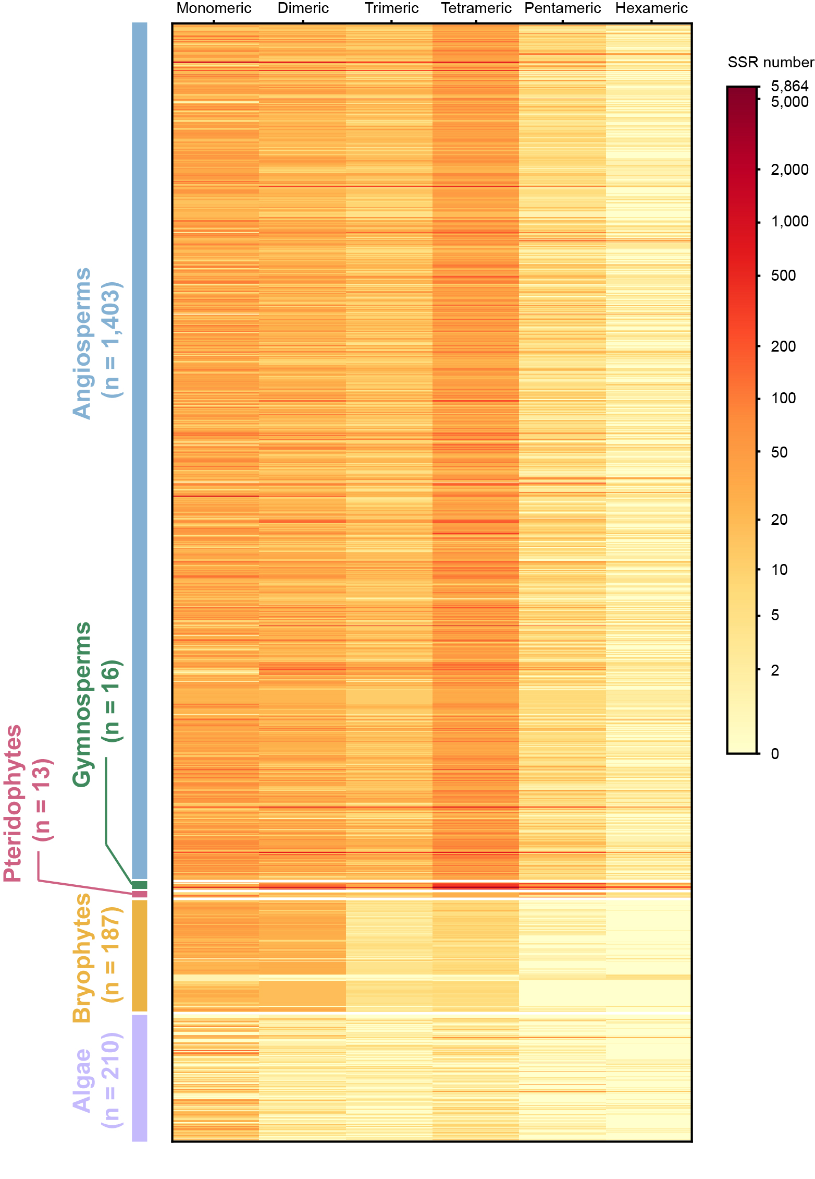
Supplementary Figures
Figure S1. Types and numbers of SSRs in the mitogenomes in PMGD.

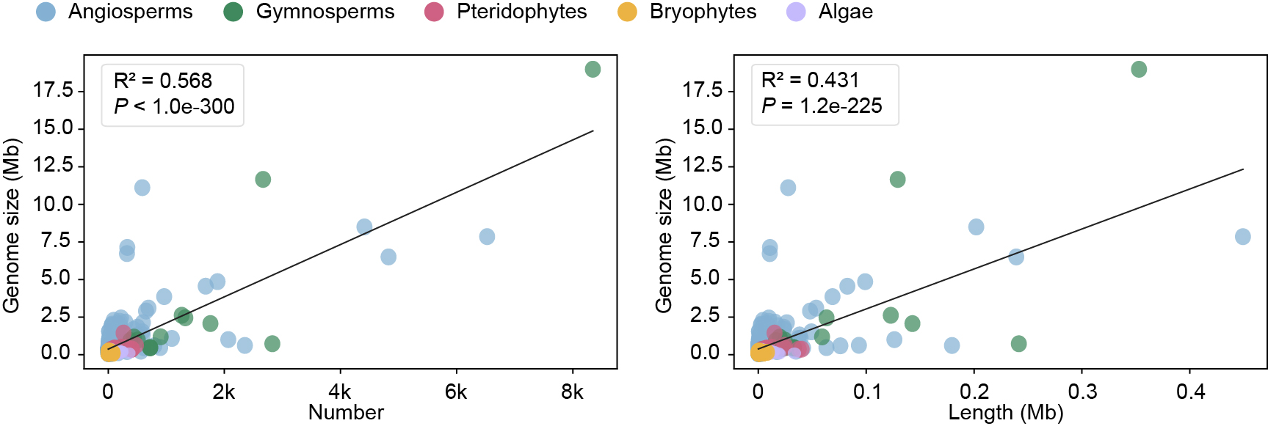
Figure S2. Correlation analysis between genome size and the number and total length of tandem repeats in mitogenomes in PMGD.

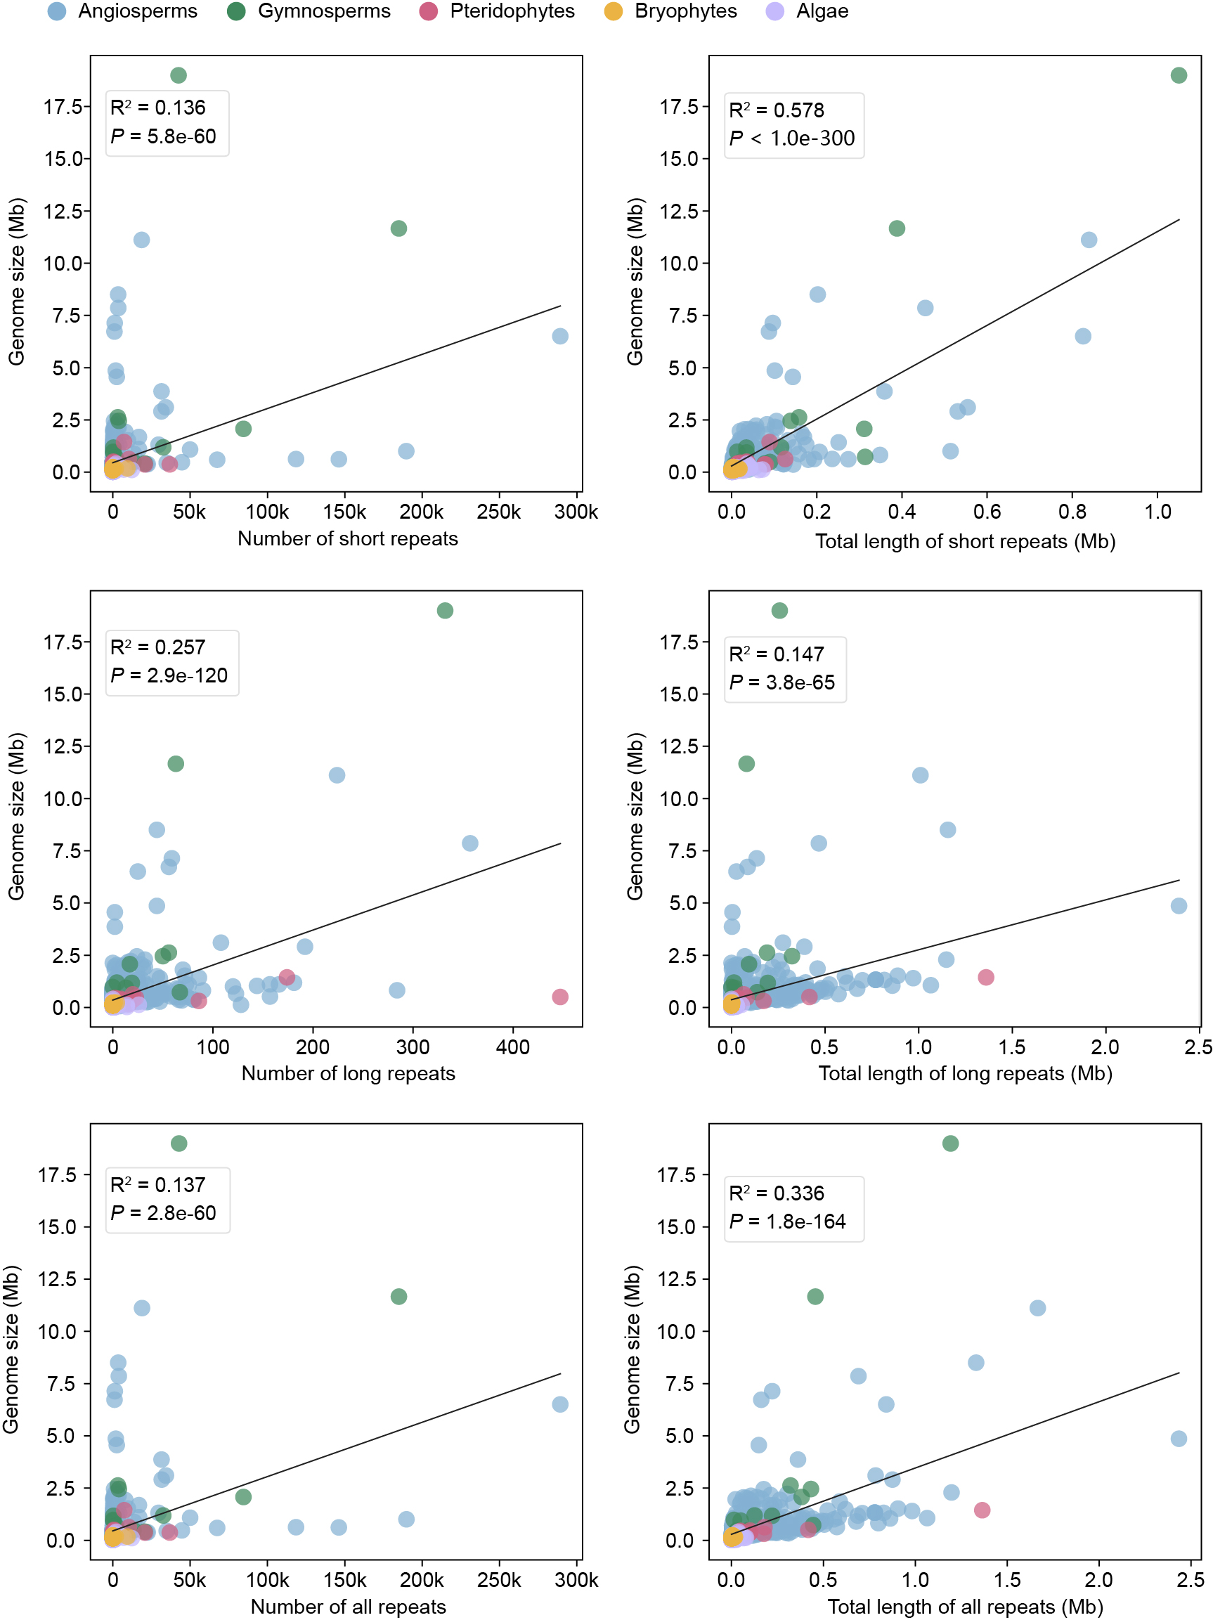
Figure S3. Correlation analysis between genome size and the number and length of identified dispersed repeats in mitogenomes in PMGD.

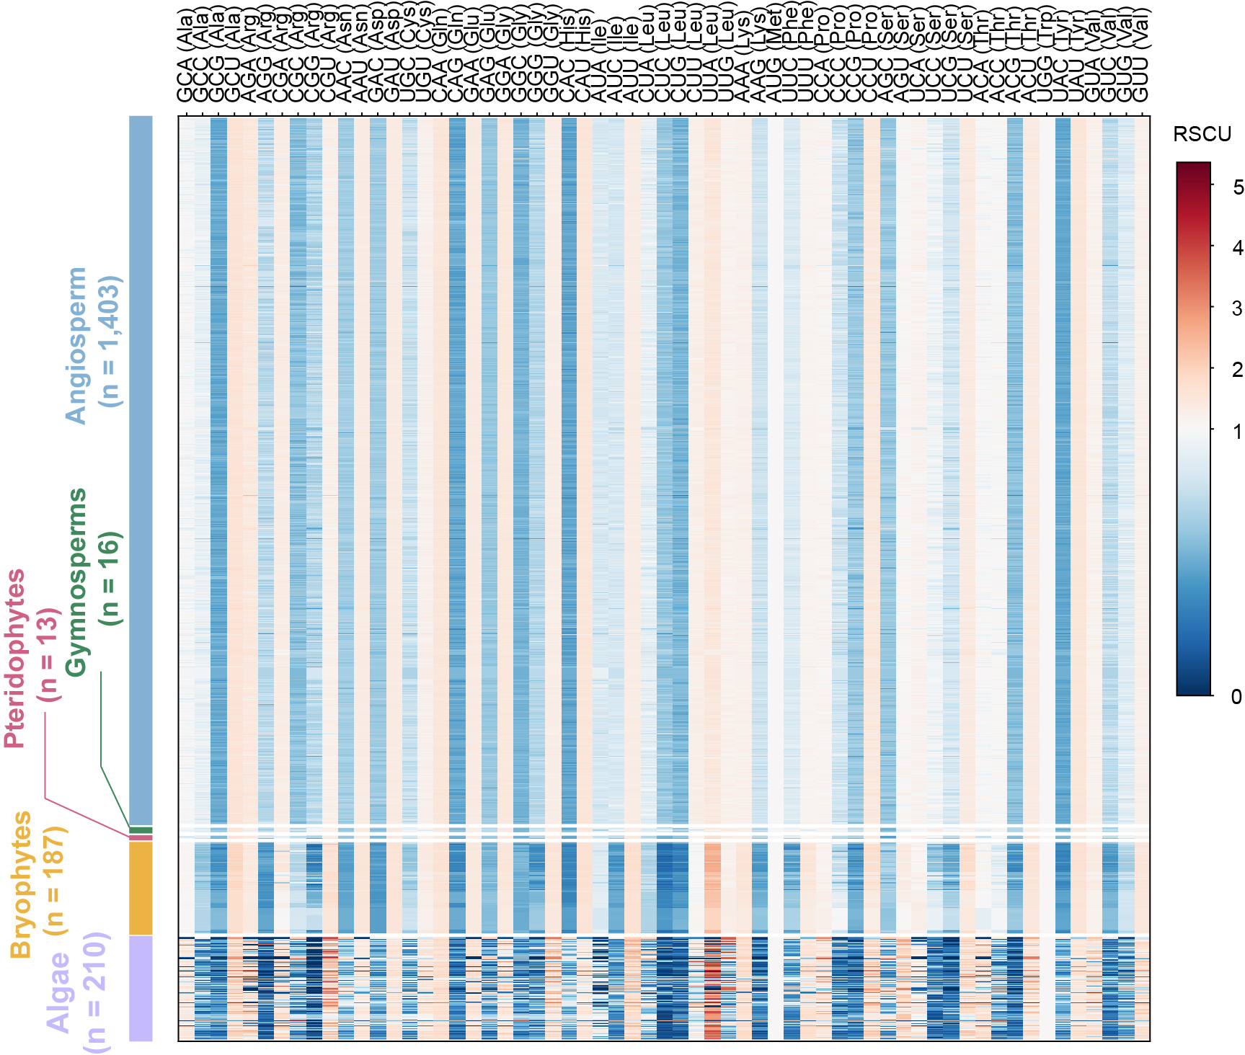
Figure S4. RSCU analysis of mitogenomes in PMGD.

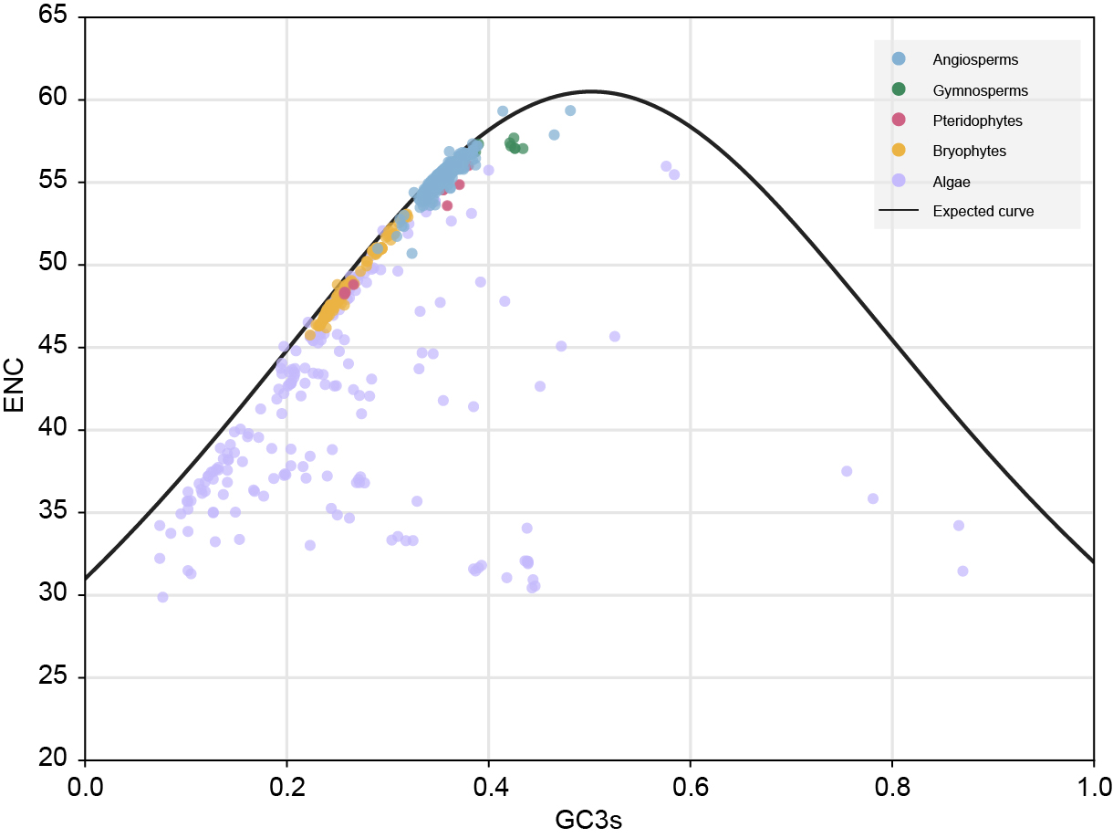
Figure S5. ENC-plot of mitogenomes in PMGD.

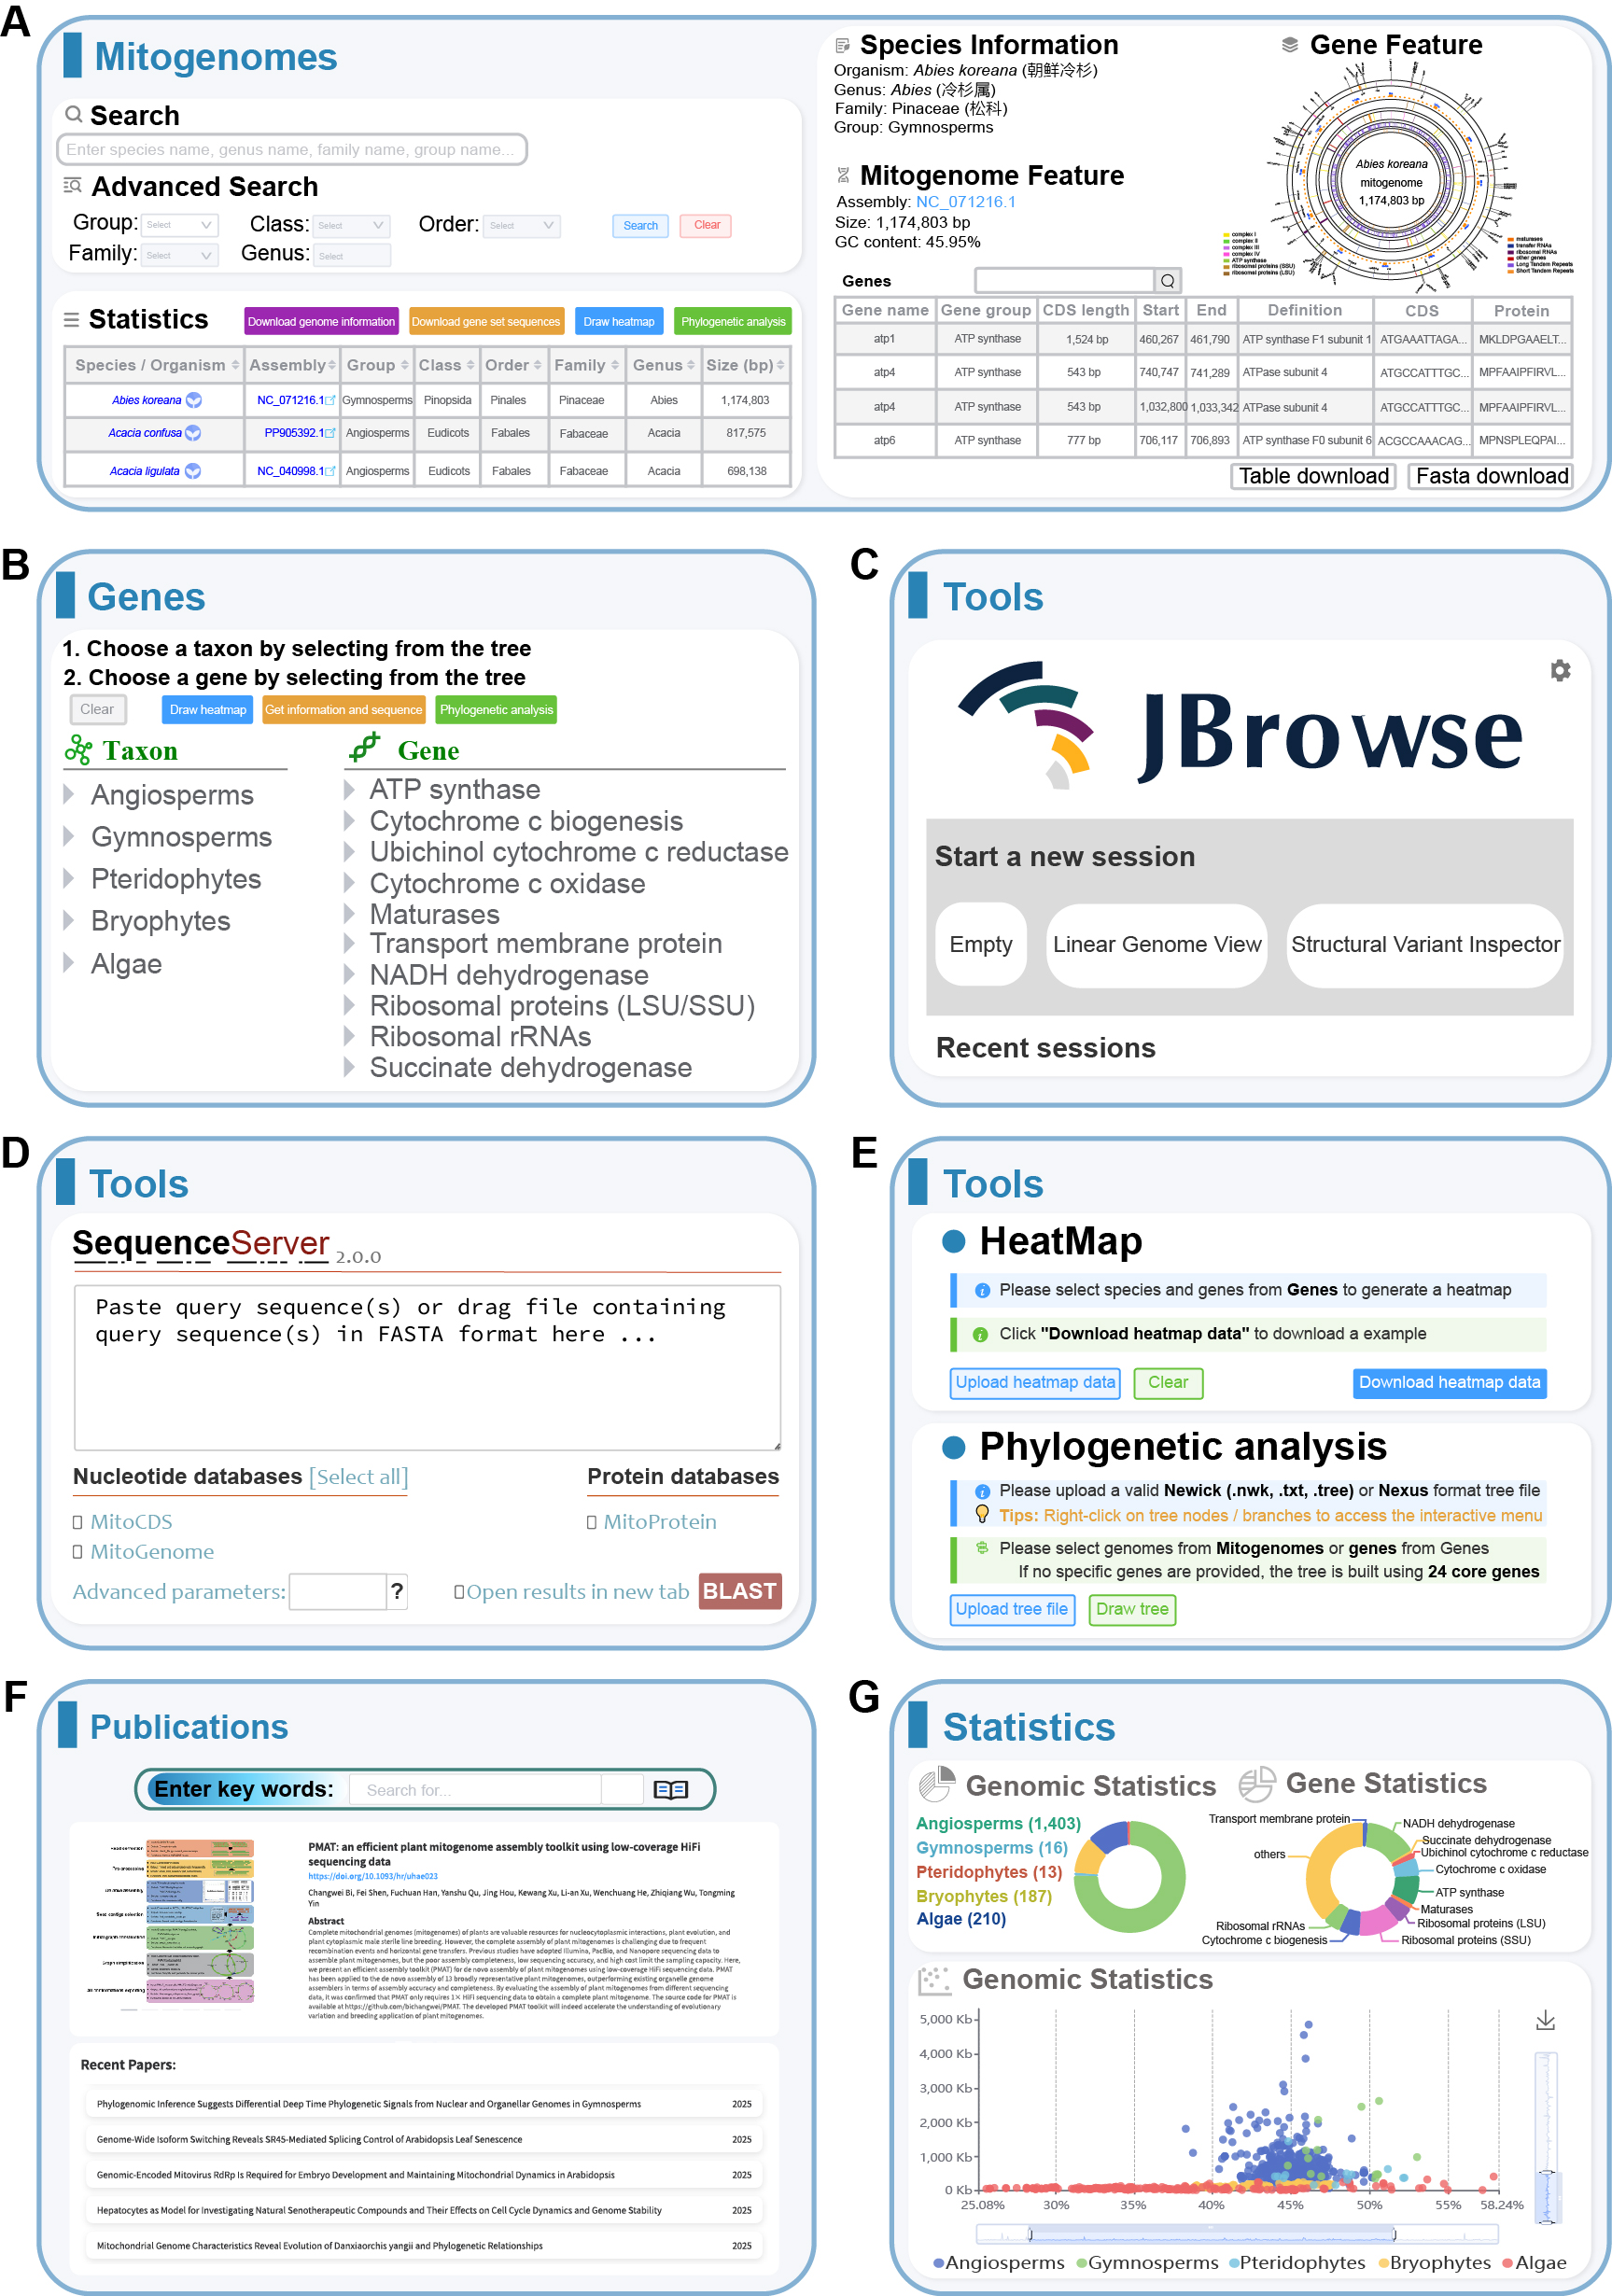
Figure S6. Overview of the modules and tools provided in PMGD. (A) The Mitogenomes module. (B) The Genes module. (C) JBrowse in the Tools module. (D) SequenceServer in the Tools module. (E) HeatMap and Phylogenetic analysis function in the Tools module. (F) The Publications module. (G) The Statistics module.

Materials and Methods

Data sources
Plant mitochondrial genomes (mitogenomes) along with their corresponding GenBank, FASTA and GFF files were batch-downloaded from the Nucleotide Database of the National Center for Biotechnology Information (NCBI, https://www.ncbi.nlm.nih.gov/) (Sayers et al., 2025). We removed sequences labeled “UNVERIFIED” and kept only fully assembled mitogenomes, yielding a final dataset of 1,769 plant mitogenomes. Additionally, 60 complete mitogenomes were de novo assembled using PMAT2/HiMT (Han et al., 2025; Tang et al., 2025) with default parameters. The assembly was performed on HiFi sequencing data obtained from public databases, including the NCBI Sequence Read Archive (SRA), the DNA Data Bank of Japan (DDBJ, https://www.ddbj.nig.ac.jp/), and European Nucleotide Archive (ENA) hosted by the European Bioinformatics Institute (EBI, https://www.ebi.ac.uk/) (Kodama et al., 2025; Madeira et al., 2024). The combination of HiFi reads and organelle-specific assembly tools has greatly mitigated the difficulties in plant mitogenome assembly (He et al., 2022; Kozik et al., 2019; Ni et al., 2025; Xian et al., 2025; Zhou et al., 2025). All assembled genomes were high-quality and gap-free, with contig coverage ranging from 122x to 500x. Meanwhile, the number of core conserved genes in each assembled genome exceeded 20 (Table S2).

Data preprocessing
All angiosperm mitogenomes, including the 60 newly assembled ones, were annotated using the online tool PMGA (Li et al., 2025). Specifically, prior to the annotation, species names were standardized by cleaning the “Organism” field. Descriptors indicating subspecies, isolates, or sample sources, such as “var.”, “isolate”, “cultivar”, “strain”, and “voucher”, were removed or unified to generate standardized taxonomic names. After PMGA annotation, the resulting annotations were compared with those released by NCBI, and erroneous or invalid gene annotations were manually curated and corrected by in-house Python scripts based on Biopython (Cock et al., 2009). In addition, genes identified only by PMGA were incorporated into the final annotation set, thereby improving the accuracy of functional gene annotation. Furthermore, we standardized the nomenclature of mitochondrial genes across all taxonomic groups. For example, orf25 was uniformly renamed as atp4, orfX as mttB, NAD as nad, ccmFN as ccmFn, and mat-R as matR. Roman numerals (e.g., “I”, “II”, and “III”) were converted to Arabic numerals (“1”, “2”, and “3”) to ensure consistent gene terminology throughout the database. Finally, we used the PMGmap to generate mitogenome maps for each species (Zhang et al., 2024).

Information collection
High-resolution images of 368 species in the PMGD were taken by the authors. Taxonomic information in Chinese for each species was standardized according to the online database iPlant (https://www.iplant.cn/). Simple sequence repeat (SSR) analysis was performed for each species using a locally deployed MISA pipeline (Beier et al., 2017) with the repeat unit criteria set to “1-10 2-5 3-4 4-3 5-3 6-3” and maximum interrupt length set to 100 bp. Tandem Repeats Finder Version 4.10.0-rc.2 (Benson, 1999) was used to identify tandem repeats. The core parameters (Match Mismatch Delta PM PI Minscore MaxPeriod) were set to 2, 7, 7, 80, 10, and 50, while all optional parameters were kept as default. Identification of dispersed repeats was conducted by the Python script ROUSFinder2.0 (Wynn & Christensen, 2019) with the minimum repeat length and minimum identity configured to 50 bp and 90%, respectively. In addition, a total of 4,077 publications related to plant mitogenomes, published between 2016 and 2025, were retrieved from the Web of Science.

Database implementation
The PMGD database was developed based on a decoupled front-end and back-end Browser/Server (B/S) architecture. At the data layer, MySQL relational database (https://www.mysql.com/) is employed for structured data storage and efficient management of genomic metadata, species taxonomic information, and gene sequences. The back-end, built on the Spring Boot framework (https://spring.io/), encapsulates core business logic and enables efficient communication with the front-end via RESTful APIs. The front-end leverages the Vue.js framework (https://vuejs.org/) and the Element UI component library (https://element.eleme.io/) to create a responsive interface. The Apache ECharts library (https://echarts.apache.org/zh/index.html) is integrated to support multi-dimensional dynamic data visualization. The system is deployed on a high-performance Nginx web server (https://nginx.org/en/), leveraging its reverse proxy capability to implement separation of static resources and dynamic requests, which significantly improves data transmission efficiency and system stability under high-concurrency conditions.
Data availability
The PMGD (http://www.pmgdb.cn/) is completely free to use and does not require registration for access.

REFERENCES
Beier, S., Thiel, T., Münch, T., Scholz, U., and Mascher, M. (2017). MISA-web: a web server for microsatellite prediction. Bioinformatics 33: 2583–2585.
Benson G. (1999). Tandem repeats finder: a program to analyze DNA sequences. Nucleic Acids Res. 27: 573–580.
Cock, P.J., Antao, T., Chang, J.T., Chapman, B.A., Cox, C.J., Dalke, A., Friedberg, I., Hamelryck, T., Kauff, F., Wilczynski, B., et al. (2009). Biopython: freely available Python tools for computational molecular biology and bioinformatics. Bioinformatics 25: 1422–1423.
Han, F., Bi, C., Chen, Y., Dai, X., Wang, Z., Wu, H., Sun, N., Qu, Y., Yang, Y., Wang, Y., et al. (2025). PMAT2: an efficient graphical assembly toolkit for comprehensive organellar genomes. Imeta 4: e70064.
He, W., Xiang, K., Chen, C., Wang, J., and Wu, Z. (2022). Master graph: an essential integrated assembly model for the plant mitogenome based on a graph-based framework. Brief Bioinform. 24: bbac522.
Kodama, Y., Ara, T., Fukuda, A., Tokimatsu, T., Mashima, J., Kosuge, T., Tanizawa, Y., Tanjo, T., Ogasawara, O., Fujisawa, T., et al. (2025). DDBJ update in 2024: the DDBJ Group Cloud service for sharing pre-publication data. Nucleic Acids Res. 53: D45–D48.
Kozik, A., Rowan, B.A., Lavelle, D., Berke, L., Schranz, M.E., Michelmore, R.W., and Christensen, A.C. (2019). The alternative reality of plant mitochondrial DNA: One ring does not rule them all. PLoS Genet. 15: e1008373.
Li, J., Ni, Y., Lu, Q., Chen, H., and Liu, C. (2025). PMGA: A plant mitochondrial genome annotator. Plant Commun. 6: 101191.
Madeira, F., Madhusoodanan, N., Lee, J., Eusebi, A., Niewielska, A., Tivey, A.R.N., Lopez, R., and Butcher, S. (2024). The EMBL-EBI Job Dispatcher sequence analysis tools framework in 2024. Nucleic Acids Res. 52: W521–W525.
Ni, Y., Li, J., Tan, Y., Shen, G., and Liu, C. (2025). Advance in the assembly of the plant mitochondrial genomes using high-throughput DNA sequencing data of total cellular DNAs. Plant Biotechnol. J. 23: 4944–4965.
Sayers, E.W., Beck, J., Bolton, E.E., Brister, J.R., Chan, J., Connor, R., Feldgarden, M., Fine, A.M., Funk, K., Hoffman, J., et al. (2025). Database resources of the National Center for Biotechnology Information in 2025. Nucleic Acids Res. 53: D20–D29.
Tang, S., Liang, Y., Wu, F., Wu, Y., Li, J., Lin, L., Feng, J., Luan, A., Wang, Y., Xu, C., et al. (2025). HiMT: An integrative toolkit for assembling organelle genomes using HiFi reads. Plant Commun. 6: 101467.
Wynn, E.L., and Christensen, A.C. (2019). Repeats of unusual size in plant mitochondrial genomes: identification, incidence and evolution. G3 (Bethesda) 9: 549–559.
Xian, W., Bezrukov, I., Bao, Z., Vorbrugg, S., Gautam, A., and Weigel, D. (2025). TIPPo: A user-friendly tool for de novo assembly of organellar genomes with high-fidelity data. Mol. Biol. Evol. 42: msae247.
Zhang, X., Chen, H., Ni, Y., Wu, B., Li, J., Burzyński, A., and Liu, C. (2024). Plant mitochondrial genome map (PMGmap): a software tool for the comprehensive visualization of coding, noncoding and genome features of plant mitochondrial genomes. Mol. Ecol. Resour. 24: e13952.
Zhou, C., Brown, M., Blaxter, M.; Darwin Tree of Life Project Consortium; McCarthy, S.A., and Durbin, R. (2025). Oatk: a de novo assembly tool for complex plant organelle genomes. Genome Biol. 26: 235.

